|  |  |  |  |
| --- | --- | --- | --- |
|  | United Nations | ECE/TRANS/WP.15/2020/6 | |
| _unlogo | **Economic and Social Council** | | Distr.: General  19 February 2020  Original: English |

**Economic Commission for Europe**

Inland Transport Committee

**Working Party on the Transport of Dangerous Goods**

**108th** **session**

Geneva, 11–15 May 2020

Item 6 of the provisional agenda

**Interpretation of ADR**

Interpretation problem in sub-section 7.5.2.3

Submitted by the Council on Safe Transportation of Hazardous Articles (COSTHA)[[1]](#footnote-2)\*

Introduction

1. In sub-section 7.5.2.3 of ADR, the following text can be found that is confusing at practical application.

“For the purpose of the application of the prohibitions of mixed loading on one vehicle, no account shall be taken of substances contained in closed containers with complete sides. Nevertheless, the mixed loading prohibitions laid down in 7.5.2.1 concerning mixed loading of packages bearing labels conforming to model Nos. 1, 1.4, 1.5 or 1.6 with other packages, and in 7.5.2.2 concerning mixed loading of explosives of different compatibility groups shall also apply between dangerous goods contained in container and the other dangerous goods loaded on the same vehicle, whether or not the latter goods are enclosed in one or more other containers.”

2. This sub-section contains two sentences. The first sentence allows the mixed loading on one vehicle in closed containers (see Figure 1). The second sentence tells the exceptions from this allowance. These exceptions are label model Nos. 1, 1.4, 1.5 and 1.6 in 7.5.2.1 (Figure 2) and 7.5.2.2 among compatibility groups of Class 1 explosives (Figure 3).

Background

3. This sub-section can also be found in the previous editions of ADR. The earliest edition available on the UNECE website is published in 2001; this sub-section is readable in it. Before 2001, the ADR had different structure. In those editions, the first sentence can be found in marginal 10 405; the second sentence can be found in marginal 11 405, that relates to Class 1 explosives only. During the creation of the new structure, the two sentences were combined. This combination was unsuccessful, because the origin of the two sentences were different. The first is from Class 2-9 dangerous goods, the second is from Class 1. The result, sub-section 7.5.2.3, is now affecting the 4.1+1 and 5.2+1 substances as well. (For the former and current text see Table 1)

4. In RID, this sub-section is *‘(Reserved)’*, since there a protective distance shall be kept.

**Table 1**

| *ADR till 1999* | *ADR from 2001* |
| --- | --- |
|  |  |
| Prohibition of mixed loading with goods contained in a container  **10 405**  For the purpose of the application of the prohibitions of mixed loading on one vehicle, no account shall be taken of substances contained in closed container with complete sides.  Class 1  Prohibitions on mixed loading  **11 403**  Packages bearing label conforming to models Nos. 1, 1.4, 1.5, 1.6 but which are assigned to different compatibility groups shall not be loaded together on one vehicle, unless mixed loading of the corresponding compatibility groups is authorized in the following table: *(mixed loading table for Class 1 compatibility groups, Fig 3)*  **11 405**  (1) The prohibitions of mixed loading of goods laid down in marginal 11 403 shall apply within each container.  (2) The provisions of marginal 11 403 shall apply as between the dangerous goods contained in a container and the other dangerous goods loaded on the same vehicle, whether or not the latter goods are enclosed in one or more containers. | **7.5.2.3** (first sentence)  For the purpose of the application of the prohibitions of mixed loading on one vehicle, no account shall be taken of substances contained in closed containers with complete sides.  **7.5.2.1**  Packages bearing different danger labels shall not be loaded together in the same vehicle or container unless mixed loading is permitted according to the following Table based on the danger labels they bear.  *(mixed loading table for all labels, Fig 2)*  **7.5.2.3** (second sentence)  Nevertheless, the mixed loading prohibitions laid down in 7.5.2.1 concerning mixed loading of packages bearing labels conforming to model Nos. 1, 1.4, 1.5 or 1.6 with other packages, and in 7.5.2.2 concerning mixed loading of explosives of different compatibility groups shall also apply between dangerous goods contained in container and the other dangerous goods loaded on the same vehicle, whether or not the latter goods are enclosed in one or more other containers |

Problem

5. The exceptions listed in the second sentence refer to all kinds of mixed loading prohibitions in section 7.5.2. In this form sub-section 7.5.2.3 is unusable for any cases.

Proposal 1

6. In case of all materials and substances that are under mixed loading prohibition by section 7.5.2 are prohibited to load on one vehicle either enclosed in separated containers or without containers, sub-section 7.5.2.3 has to be deleted completely.

Proposal 2

7. In case of materials and substances that have label model Nos. 4.1+1 or 5.2+1 and other packages containing dangerous goods are allowed to load on one vehicle in closed containers, the second sentence of 7.5.2.3 has to be modified as the following (the new text is underlined, the deleted text is in ~~strikethrough~~).

Option 1

“Nevertheless, the mixed loading prohibitions laid down in 7.5.2.1 and 7.5.2.2 concerning mixed loading of packages of Class 1 explosives ~~bearing labels conforming to model Nos. 1, 1.4, 1.5 or 1.6 with other packages, and in 7.5.2.2 concerning mixed loading of explosives of different compatibility groups~~ shall also apply between dangerous goods contained in container and the other dangerous goods loaded on the same vehicle, whether or not the latter goods are enclosed in one or more other containers.”

Option 2

“For Class 1 explosives only, ~~Nevertheless,~~ the mixed loading prohibitions ~~laid down in 7.5.2.1 concerning mixed loading of packages bearing labels conforming to model Nos. 1, 1.4, 1.5 or 1.6 with other packages, and in 7.5.2.2 concerning mixed loading of explosives of different compatibility groups~~ shall also apply between dangerous goods contained in container and the other dangerous goods loaded on the same vehicle, whether or not the latter goods are enclosed in one or more other containers.”

Figure 1

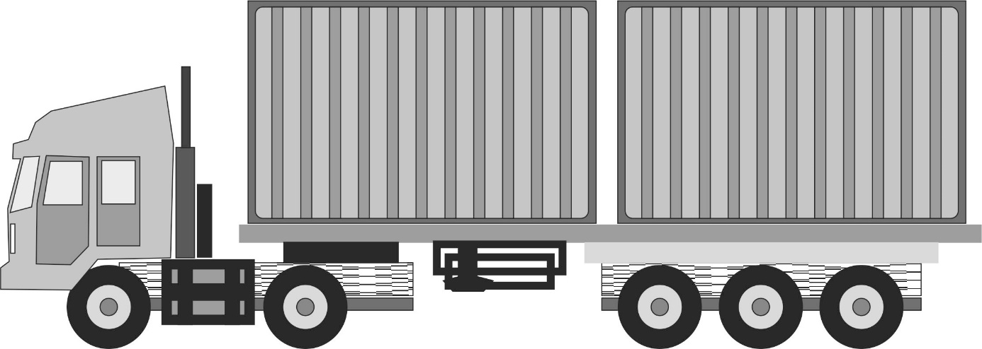

Figure 2: Table in 7.5.2.1

|  |  |  |  |  |  |  |  |  |  |  |  |  |  |  |  |  |  |  |
| --- | --- | --- | --- | --- | --- | --- | --- | --- | --- | --- | --- | --- | --- | --- | --- | --- | --- | --- |
| **Labels Nos.** | **1** | **1.4** | **1.5** | **1.6** | **2.1,**  **2.2,**  **2.3** | **3** | **4.1** | **4.1**  **+ l** | **4.2** | **4.3** | **5.1** | **5.2** | **5.2**  **+ 1** | **6.1** | **6.2** | **7 A, B, C** | **8** | **9,**  **9A** |
| **1** | See 7.5.2.2 | | | |  |  |  |  |  |  | **d** |  |  |  |  |  |  | **b** |
| **1.4** | **a** | **a** | **a** |  | **a** | **a** | **a** | **a** |  | **a** | **a** | **a** | **a** | **a**  **b**  **c** |
| **1.5** |  |  |  |  |  |  |  |  |  |  |  |  |  | **b** |
| **1.6** |  |  |  |  |  |  |  |  |  |  |  |  |  | **b** |
| **2.1, 2.2, 2.3** |  | **a** |  |  | x | x | x |  | x | x | x | x |  | x | x | x | x | x |
| **3** |  | **a** |  |  | x | x | x |  | x | x | x | x |  | x | x | x | x | x |
| **4.1** |  | **a** |  |  | x | x | x |  | x | x | x | x |  | x | x | x | x | x |
| **4.1 + 1** |  |  |  |  |  |  |  | x |  |  |  |  |  |  |  |  |  |  |
| **4.2** |  | **a** |  |  | x | x | x |  | x | x | x | x |  | x | x | x | x | x |
| **4.3** |  | **a** |  |  | x | x | x |  | x | x | x | x |  | x | x | x | x | x |
| **5.1** | **d** | **a** |  |  | x | x | x |  | x | x | x | x |  | x | x | x | x | x |
| **5.2** |  | **a** |  |  | x | x | x |  | x | x | x | x | x | x | x | x | x | x |
| **5.2 + 1** |  |  |  |  |  |  |  |  |  |  |  | x | x |  |  |  |  |  |
| **6.1** |  | **a** |  |  | x | x | x |  | x | x | x | x |  | x | x | x | x | x |
| **6.2** |  | **a** |  |  | x | x | x |  | x | x | x | x |  | x | x | x | x | x |
| **7A, B, C** |  | **a** |  |  | x | x | x |  | x | x | x | x |  | x | x | x | x | x |
| **8** |  | **a** |  |  | x | x | x |  | x | x | x | x |  | x | x | x | x | x |
| **9, 9A** | **b** | **a**  **b**  **c** | **b** | **b** | x | x | x |  | x | x | x | x |  | x | x | x | x | x |

Figure 3: Table in 7.5.2.2

|  |  |  |  |  |  |  |  |  |  |  |  |  |
| --- | --- | --- | --- | --- | --- | --- | --- | --- | --- | --- | --- | --- |
| **Compatibility Group** | **A** | **B** | **C** | **D** | **E** | **F** | **G** | **H** | **J** | **L** | **N** | **S** |
| **A** | X |  |  |  |  |  |  |  |  |  |  |  |
| **B** |  | X |  | **a** |  |  |  |  |  |  |  | X |
| **C** |  |  | X | X | X |  | X |  |  |  | **b  c** | X |
| **D** |  | **a** | X | X | X |  | X |  |  |  | **b  c** | X |
| **E** |  |  | X | X | X |  | X |  |  |  | **b  c** | X |
| **F** |  |  |  |  |  | X |  |  |  |  |  | X |
| **G** |  |  | X | X | X |  | X |  |  |  |  | X |
| **H** |  |  |  |  |  |  |  | X |  |  |  | X |
| **J** |  |  |  |  |  |  |  |  | X |  |  | X |
| **L** |  |  |  |  |  |  |  |  |  | **d** |  |  |
| **N** |  |  | **b  c** | **b  c** | **b  c** |  |  |  |  |  | **b** | X |
| **S** |  | X | X | X | X | X | X | X | X |  | X | X |

1. \* 2020 (A/74/6 (Sect.20) and Supplementary, Subprogramme 2) [↑](#footnote-ref-2)