UN/SCEGHS/39/INF.6
Committee of Experts on the Transport of Dangerous Goods
and on the Globally Harmonized System of Classification
and Labelling of Chemicals
Sub-Committee of Experts on the Globally Harmonized
System of Classification and Labelling of Chemicals 11 June 2020
Thirty-ninth session
Geneva, 8-10 July 2020
Item 2 (i) of the provisional agenda
Classification criteria and related hazard communication:
other issues

Comments on ST/SG/AC.10/C.4/2020/3 "Review of decision logics"
Transmitted by the expert from Germany
1. The expert from Germany wishes to thank the secretariat for the work provided in document ST/SG/AC.10/C.4/2020/3, it is very much appreciated. In addition to that, we appreciate that typos present in the most recent published version have been corrected and that the decision logic has been improved and is much clearer in some places/pieces compared to the most recent published version.
2. In this document, we would like to make some specific proposals and raise additional issues for future consideration regarding decision logics in the GHS. According to their nature, we have structured our proposals as follows:
(a) Corrections where errors where accidently introduced in the course of the transfer to the new software (see paragraph 3 and Annex 1).
(b) Proposals aiming at simplification regarding the layout (see paragraphs 4 to 10 and Annex 2).
(c) Proposals aiming at consistent use of terminology, wording and symbols (see paragraphs 11 to 15 and Annex 2).
(d) Suggestions regarding more fundamental issues aiming at consistent structure of the decision logics (see paragraphs 16 to 17).
Corrections
3. We found that the decision logics in the physical hazards section are correctly taken over from the most recent published version of the GHS. With respect to the health hazards and the environmental hazards section we identified some transfer errors that we specified in Annex I.
Simplifications regarding layout
4. Based on the decision logics provided by the secretariat, the expert from Germany would like to make a few suggestions for simplification.
5. Elements that are purely layout gadgets but do not convey any message should be avoided. It is therefore proposed to refrain from using "shadows" as currently used for the boxes and the arrows.

6. As mentioned before, we would appreciate if the decision logics would conform to the international standard ISO 5807 (which is an adoption of ANSI symbols), nowadays applied in many work areas for depicting all kinds of processes. According to this standard, the following symbols are used (amongst others):
Terminator: Indicates the beginning and ending of a program or sub-process. Represented as a stadium, oval or rounded (fillet) rectangle. They usually contain the word "Start" or "End", or another phrase signalling the start or end of a process, such as "submit inquiry" or "receive product".
Decision: Shows a conditional operation that determines which one of the two paths the program will take. The operation is commonly a yes/no question or true/false test. Represented as a diamond (rhombus).
Process: Represents a set of operations that changes value, form, or location of data. Represented as a rectangle.
Document: Single documents represented as a rectangle with a wavy base
Off-page connector: A labelled connector for use when the target is on another page. Represented as a home plate-shaped pentagon.
7. We understand that using the diamond as stipulated for decision making is not practical because it allows for much less text than a rectangle. This is already challenging for some of the boxes in English but might be even more challenging for other languages. Therefore, we would agree to using rectangles for decision making boxes as foreseen by the secretariat.
8. Apart from that, we should try to stick to ISO 5807 and internationally acknowledged conventions as close as possible. Therefore, we would like to suggest using the terminator as foreseen for the start and the end. The decision logics in the GHS aim at summarizing the classification process. Thus, the outcome is a classification (or the decision that no classification is needed). This is not a document and we therefore do not need to use the more complicated and spacious form foreseen for documents (rectangle with a wavy base). The much simpler terminator form would be appropriate.
9. We also would like to recommend that arrows are aligned with the other arrows as far as possible, see decision logic 3.3.1 for an example (3rd "yes"-arrow). The example as shown in Annex 2 shows also how that could be handled.
10. If it is agreed that the purpose of the decision logics in the GHS is depicting the classification process (as also explicitly stated before the decision logics in the GHS) but not aiming at labelling information (for that we have Annex 1, now freshly revised), we could simplify even more: We could remove labelling information, i.e. the symbol and the signal word (one could also wonder why we indicate the symbol and the signal word but not the hazard statement anyway).
Consistent use of terminology, wording and symbols in the text
11. In addition, when looking through the decision logics of the GHS, we found that they are inconsistent with regard to the use of the symbols >, ≥, < and ≤. For example, they are not used in decision logic 2.2 for flammable gases whereas they are used in the decision logics for aerosols (sometimes it is even done inconsistently within a decision logic, see for example that for oxidizing liquids). We therefore would like to decide on consistent use (or not-use) of these symbols. For the sake of further simplifying and shortening the text, we would be in favour of consistently using the symbols instead of the much longer wording (for example "equal to or greater than").

12. Furthermore, we found that the starting point is worded differently even in cases where it is absolutely equivalent. For example, for flammable gases it is "The substance/mixture is a gas", whereas it is "Gaseous substance or mixture of gases" for oxidizing gases. We suggest using consistent wording (where appropriate) here as well, for example "Gaseous substance/mixture for classification" or "Liquid substance/mixture for classification" or even shorter "Liquid for classification" or "Substance/mixture for classification" where the physical state is not known.
13. In addition to the previous point, we suggest a consistent use of the prefix “substance” or “mixture” at the beginning of the 1st decision box in a decision tree, e.g. the word “mixture” has been added at the beginning of the 1st decision box in decision logic 3.8.2, but not in decision logic 3.1.2.
14. We also found that in the "classification-terminator" sometimes the wording "Not classified" is used (see for example oxidizing gases) and sometimes "Not classified as …" (see for example flammable gases). We suggest also consistent terminology here and would prefer "Not classified as …" because the substance might still be classified in other hazard classes.
15. In Annex 2, you can find an example of the design of a decision logic according to our above proposals regarding simplification of layout and consistent use of wording and symbols (paragraphs 4 to 13) It corresponds to the first decision logic given in document ST/SG/AC.10/C.4/2020/3 (prepared with MS Visio, as requested by the secretariat).
More fundamental issues aiming at consistent structure of the decision logics
16. In addition to these rather specific points, we would like to take the opportunity to raise the following general points for future discussion and deem it useful to develop Guiding principles for the design of decision logics for the purpose of consistency throughout the different sections of the GHS:
(a) Strategy of using, structuring and formatting figure captions/headings and subheadings;
(b) Consistent use of footnotes throughout the document;
(c) Consistent use of decimal digits;
(d) Strategy of text formatting, i.e. highlighting subtle, but important, differences in wording, e.g. in consecutive decision boxes, to aid the readers’ understanding, e.g. bold font for “the additivity approach may not apply” vs. “the additivity approach applies”;
(e) How and when sections of the text body should be referred to in figures?;
(f) Improving the format of input from another decision logic by using systematic symbols for connectors (see example “off-page connector” in the table in paragraph 6 of this document); this applies e.g. to decision logic 4.1.1 on mixtures for the arrow introducing and referring to contents of the “Values for mixtures from decision logic 4.1.2”, which could be supported by a connector symbol.
17. Moreover, we identified in certain decision logics that the message was not quite clear with respect to the way decisions should be taken. For example, the answering option “No” from box 2 to box 3 does not seem to be an ideal option with regards to the questions asked and the information flow in decision logic 3.8.2 and 3.9.2. On that background a future update might improve certain decision logics. We would propose to take that into account for further work on the chapters.
Request to the Sub-Committee
18. The Sub-Committee is invited to consider the specific proposals for corrections and improvement of the decision logics as described above in paragraphs 3 to 15 and shown in Annex 1 and 2 and to consider the general issues as raised in paragraphs 16 to 17.

Annex I
Errors accidently introduced in the course of the transfer to the new software
This Annex outlines and specifies the transfer errors identified in the health hazards and the environmental hazards section between the original version, the most recent published version of the GHS, and the work provided in document ST/SG/AC.10/C.4/2020/3.
We illustrate the individual transfer errors with screenshots of the respective decision trees concerned highlighting the potential error to facilitate the review and correction process of those.
1. Decision logic 3.1.2
(a) In the ATE calculation box as outlined in the screenshot below, we recommend to move the word “where” to its previous position like in the original version, the most recent published version of the GHS, i.e. after the formula introducing the variables. Subsequently the comma has to be removed. This has been transferred correctly in other decision trees containing formulas, such as decision logic 4.1.2.
(b) In addition, it would look clearer, if the “=” equal signs would be aligned.
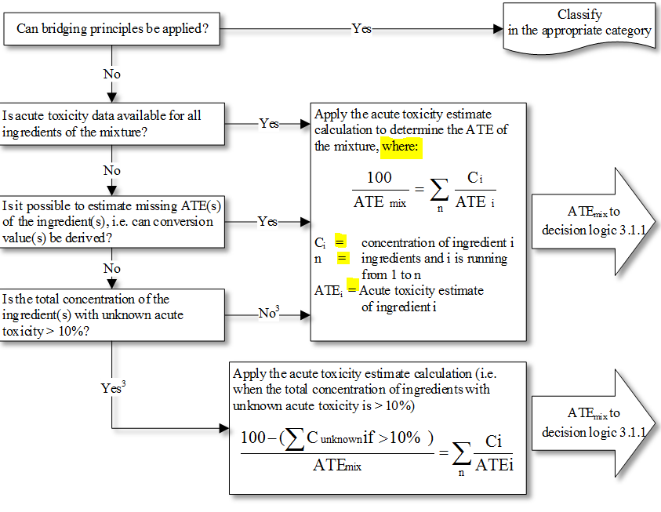

2. Decision logic 3.4.1 and decision logic 3.4.2
We recommend to amend the last decision box in accordance with the original documents wording and add a “≥” prior to the indicated concertation as outlined in the screenshot below. Those are missing in the current version of the decision tree compared to the most recent published version of the GHS.
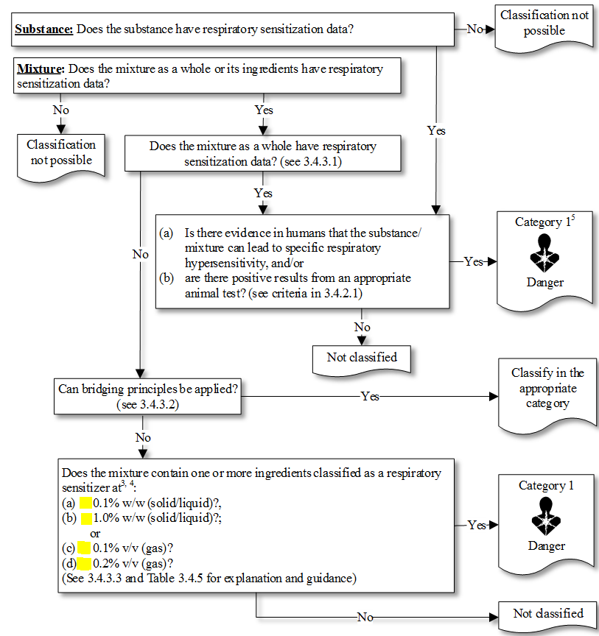

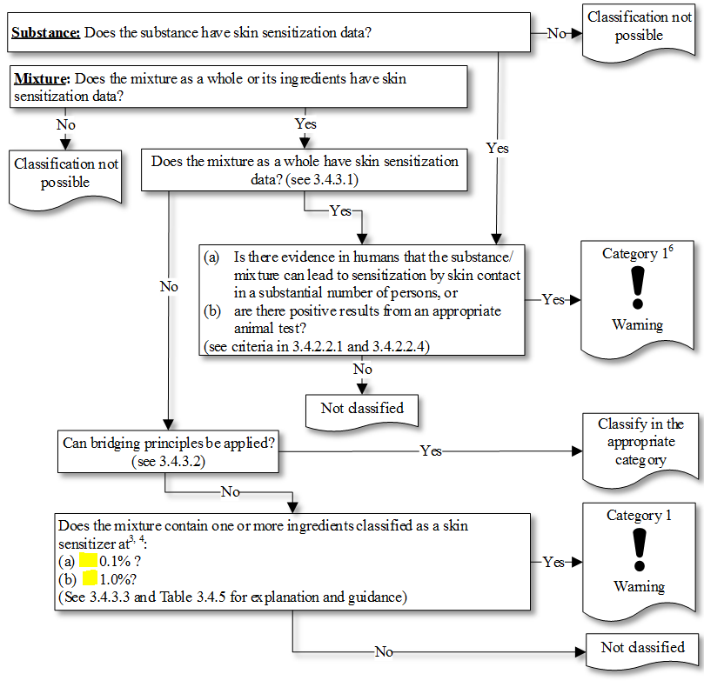

3. Decision logic 3.8.2
We would recommend to delete the dot “.” following the question mark in the last decision box.
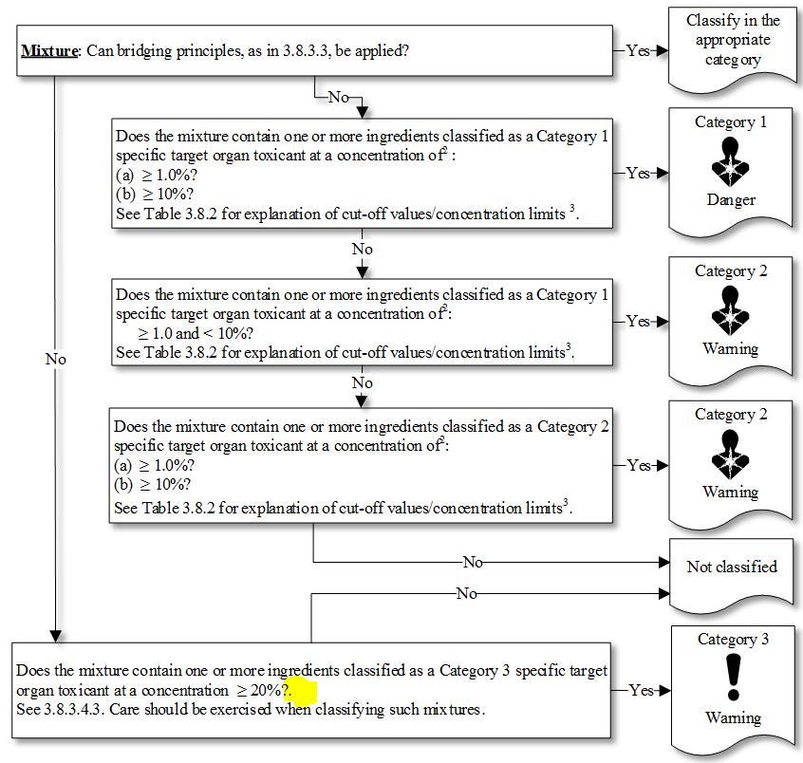
4. Decision logic 4.1.1 [mixture]
We recommend to amend the answering label “No” resulting in Acute aquatic toxicity Cat.1 to “Yes” based on the original document.
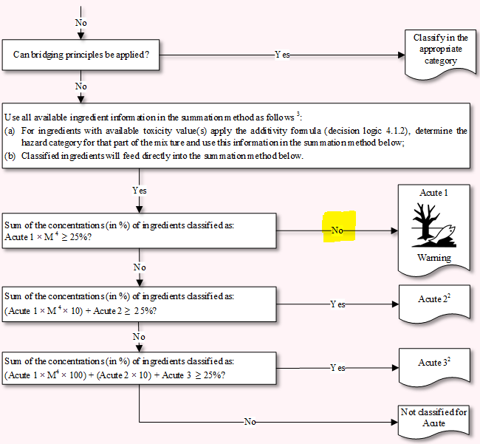
Annex II
Simplification and consistency of decision logics
In the following, an example of the design of a decision logic according to our above proposals regarding simplification of layout and consistent use of wording and symbols is shown. It corresponds to the first decision logic given in document ST/SG/AC.10/C.4/2020/3 (prepared with MS Visio, as requested by the secretariat).
Chapter 2.2: Flammable gases
Decision logic 2.2 for flammable gases, part 1

