UN/SCETDG/57/INF.50

Committee of Experts on the Transport of Dangerous Goods
and on the Globally Harmonized System of Classification
and Labelling of Chemicals 27 November 2020
Sub-Committee of Experts on the Transport of Dangerous Goods
Fifty-seventh session

Geneva, 30 November-8 December 2020
Item 4 (e) of the provisional agenda
Electric storage systems: sodium-ion batteries
Comment on ST/SG/AC.10/C.3/2020/45/Rev.1 – answers to the comments made on the virtual platform and consequential amendments
Transmitted by the experts from France and the United Kingdom
Introduction
1. A lot of positive comments were made for this proposal on the virtual platform and we would like to thank those who commented with proposals to improve the text. Nevertheless, some new points were raised that require clarification.
2. In order to ease the discussions during the Sub-Committee we drafted this information document to provide a clear amended proposal and provide some answers to the questions and suggestions that have been raised. The revised text appears in Annex I. Modified text is presented in red with a yellow background. It contains a comprehensive final proposal.
New amendments
3. Concerning the editorial amendments suggested by other delegations, we introduced almost all of those that have been proposed except for the introduction of a separate subsection for sodium ion tests in the Manual of Tests and Criteria. We don't believe this is necessary as they are already presented in their own table separate to those required for lithium batteries. Concerning the proposal from Canada to delete the words “using organic electrolyte” we agree it would simplify the drafting. We were not sure if it could be accepted by all members in the Sub-Committee so we placed these words in square bracket (and blue background) whenever they appear and added a note under 2.9.5. It makes it easy for the subcommittee to identify and make a quick decision on that simple editorial matter. We believe that this would also satisfy the second comment from Belgium.
4. Concerning substantial amendments:
- Comments have been made about the amount of testing required for sodium ion batteries/cells noting that these are not identical to the ones required for lithium batteries and cells. We do not have any concerns with aligning the testing requirements and have modified the document accordingly. However, it should be noted that in the case of sodium ion batteries, testing discharged batteries has no meaning as the batteries are not active in a discharged state. This is different to lithium ion batteries/cells which makes total full implementation of lithium battery testing irrelevant to sodium ion batteries/cells.

- Concerning the comments received in relation to sodium ion batteries contained in equipment under the new special provision XXX, we have added a new paragraph similar to the provisions in special provision 188 covering the same issue for lithium ion batteries contained in equipment.
- In special provision XXX we agree batteries would need to be in conformity with 2.9.5 a), b), d), e) and f) as these are met by their design, but not c) because under the special provision they must be shorted already. We have added the relevant references to make this amendment.
- Concerning the transition period mentioned in special provision 348 we are happy to follow the majority’s view.
- Concerning the comments made on special provisions 376 and 377, we didn't see the need to introduce any new amendments. Sodium ion batteries are similar to lithium batteries in their behavior (although less energetic), and as such there is no reason not to use both types of batteries on the same equipment or a need to separate them as they would not generate any additional hazard when mixed.
Explanation of the testing data presented in INF.9
5. All design types that have been shown to us are capable of passing the tests as defined in section 38.3 of the Manual of Tests and Criteria successfully. Their energy density goes approximately from 100 Wh/kg to 150 Wh/kg.
6. This is the reason why we didn't present results of testing only according 38.3 of the Manual of Tests and Criteria but also according to more abusive procedures to verify and demonstrate how the batteries would behave in worse situations.
7. Thanks to the additional information brought forward by KFI in document ST/SG/AC.10/C.3/2020/65 we believe there is enough data to be able to make a decision. We have seen comments saying otherwise and requests have been made for further testing. However, it is difficult to give any relevant answer if it is not precisely explained:
- What kind of additional justification is expected and for what purpose?
- What kind of additional test would be relevant and what should we look for when performing these tests?
General comments and conclusions on proposals 1 to 4
8. We consider that both the qualitative data about their electrochemistry, the organic electrolytes that are being used that are similar to the ones used in lithium ion batteries, as well as test results showing that under some conditions sodium ion batteries could be capable of a thermal runaway (although of lower energy than some lithium ion batteries), makes these new batteries similar in terms of hazard to lithium ion batteries. Especially the summary on the first page of the Annex to document ST/SG/AC.10/C.3/2020/65 which shows that the gas emission in the event of a reaction is very close to the one observed from lithium batteries, causing inter-alia the risk of a flammable atmosphere.
9. The energy density of the most powerful sodium ion batteries is higher than the energy density of the less energetic lithium ion batteries (see figure in Annex II of this paper). The less energetic sodium ion batteries have an energy density close to Ni-MH batteries (the subject of low energy density batteries will be dealt with in a separate point).
10. It is therefore important to avoid transporting poorly designed sodium ion batteries that would pose a risk in transport. The best way to verify that the design type is suitable for transport is to perform the tests as provided for in section 38.3 of the Manual of Tests and Criteria, with some slight changes taking account of the fact that sodium ion batteries when fully discharged are not reactive anymore. This also justifies the exemption applied to the transport of shorted sodium ion batteries (SP XXX).
11. The issue concerning sodium ion batteries has been discussed for more than two bienniums now and we believe that the proposals are well advanced and properly drafted as we have sought to address all the comments made during this time. We have noted the cautious comment from China on the on-line platform referring to the fact that transport of these batteries should made under the same conditions as lithium batteries. We would like to emphasize that this exactly what proposals 1 to 4 achieve. From a drafting point only, creating a simple reference to this principle in a special provision is not practicable as it makes it difficult to deal with some specific points regarding sodium ion batteries.
12. Currently, if one applies the principles of the Model Regulations, sodium ion batteries and cells should be carried under UN 3292, in the same way that lithium ion batteries were previously assigned to the only entry for lithium batteries in the past before the new entry for lithium-ion batteries was adopted. This is irrelevant because sodium batteries are currently under class 4.3 which totally misrepresents the hazard of sodium ion batteries.
13. Concerning developments in industry, we are now far beyond the stage where only a few prototypes are being carried. Only with the few companies we are aware of in Europe, we know that during the next three years about one million shipments will take place mainly between Europe and China, India and Australia. In particular, it has been brought to our attention that European companies are working in cooperation with Chinese companies to produce such batteries and that soon a lot of shipments will be necessary for commercial delivery as well as for proof of concept operations. It is therefore necessary to make an urgent decision on a proper way to transport these batteries.
14. Therefore, we would like the Sub-Committee to seriously consider the adoption of proposals 1 to 4 at this session. If this is not accepted, we would like at least to agree on the principle and the possibility to use them to define special authorizations and derogations under which transport may be permitted, in the meantime.
Specific comments on document ST/SG/AC.10/C.3/2020/65 and the comments made by KFI and proposal 5
15. We thank KFI for the useful information given in ST/SG/AC.10/C.3/2020/65. However, we do not always share the interpretation of the presented results. Also, we believe it is not possible to regulate the general case based on properties of one very specific segment. As already said, some sodium ion batteries may have an energy density up to 150 Wh/kg and this may be superior to the energy density of some lithium ion batteries.
16. The way KFI proposes to follow has already been considered by the Sub-Committee and has not been accepted.
17. However, we recognize that the idea to exempt some battery types that have a very low energy density has some merit. But for the moment there is no good way to define the appropriate threshold for such an exemption.
18. Furthermore, we do not totally agree with the interpretation KFI make of all its test results. In our view test 3A clearly shows signs of a thermal runaway (an uncontrolled increase in the temperature of a cell or battery driven by exothermic process). Also the level of gas released, if concerning the totality of a load, would be a big concern for safety. One additional factor to be considered here is the ability for such reactions to propagate in a load of such cells or batteries.
19. We have performed a propagation test on a sodium ion cell with a medium energy density (90 Wh/kg - see Annex III) and it shows that some sodium ion cells may successfully pass the test. We believe that before deciding on proposal 5 the issue of propagation should be better assessed.
20. Maybe the criteria for allowing the transport under an exemption such as the one in proposal 5 could include, a specification of the low energy density, a small size of battery/cell, and the ability to successfully pass a propagation test.
Annex I
Amended proposals 1 to 5 according to the last comments
Proposal 1
21. In 3.2.2 change the proper shipping name of UN 3292 to read:
“BATTERIES CONTAINING METALLIC SODIUM OR SODIUM ALLOY or CELLS CONTAINING METALLIC SODIUM OR SODIUM ALLOY”
Consequential amendments for proposal 1
22. In the Alphabetical Index of Substances and Articles:
Amend the following entries to read as follows:
“BATTERIES, CONTAINING METALLIC SODIUM OR SODIUM ALLOY” | 4.3 | 3292
“CELLS, CONTAINING METALLIC SODIUM OR SODIUM ALLOY” | 4.3 | 3292
And, insert the following new entry:
“Batteries, sodium nickel chloride, see | 4.3 | 3292
COMMENT – this last addition is proposed in relation to a comment from the expert from Switzerland during the July online discussions concerning the appropriate UN entry for sodium nickel chloride batteries.
Proposal 2
23. In 3.2.2, add two entries in the dangerous goods list as follow:
UN No. | Name and description | Class or division | Subsi-diary hazard | UN packing group | Special provisions | Limited quantities | Packaging and IBCs
 |  |  |  |  |  |  | Packing instruction | Special packing provisions
XXXX | SODIUM ION BATTERIES USING ORGANIC ELECTROLYTE | 9 |  |  | 188  230  310  348  376  377  384  XXX  YYY  ZZZ | 0 | P903  P908  P909  P910  P911  LP903  LP904  LP905  LP906
XXXY | SODIUM ION BATTERIES USING ORGANIC ELECTROLYTE CONTAINED IN EQUIPMENT or SODIUM ION BATTERIES USING ORGANIC ELECTROLYTE PACKED WITH EQUIPMENT | 9 |  |  | 188  230  310  348  360  376  377  384  XXX  YYY  ZZZ | 0 | P903  P908  P909  P910  P911  LP903  LP904  LP905  LP906
Proposal 3
24. In Chapter 2.9, add a new 2.9.5 as follows:
“2.9.5 Sodium Ion batteries using organic electrolyte
Cells and batteries, cells and batteries contained in equipment, or cells and batteries packed with equipment containing sodium ion, which are a rechargeable electrochemical system where the positive and negative electrode are both intercalation or insertion compounds, constructed with no metallic sodium (or sodium alloy) in either electrode and using an organic non aqueous compound as electrolyte, shall be assigned to UN Nos. XXXX or XXXY as appropriate.
NOTE1: intercalated sodium exists in an ionic or quasi-atomic form in the lattice of the electrode material.
[NOTE2: In these regulations the words ‘sodium ion cells or batteries’ refer to sodium ion using organic electrolyte cells or batteries.] ”
They may be transported under these entries if they meet the following provisions:
(a) Each cell or battery is of the type proved to meet the requirements of applicable tests of the Manual of Tests and Criteria, part III, sub-section 38.3.
(b) Each cell and battery incorporates a safety venting device or is designed to preclude a violent rupture under conditions normally encountered during transport;
(c) Each cell and battery is equipped with an effective means of preventing external short circuits;
(d) Each battery containing cells or a series of cells connected in parallel is equipped with effective means as necessary to prevent dangerous reverse current flow (e.g., diodes, fuses, etc.);
(e) Cells and batteries shall be manufactured under a quality management program as prescribed under 2.9.4 (e) i to ix
(f) Manufacturers and subsequent distributors of cells or batteries shall make available the test summary as specified in the Manual of Tests and Criteria, Part III, sub-section 38.3, paragraph 38.3.5.”
Consequential amendments for proposals 2 and 3
25. Following the adoption of the two new entries related to sodium ion batteries, consequential amendments would be necessary to Chapter 2.9, some special provisions in Chapter 3.3, packing instructions in section 4.1.4 and the Manual of Tests and Criteria section 38.3 concerning testing.
Amendments to part 2
26. In 2.9.2, Assignment to Class 9, after the sentence for AMMONIUM NITRATE BASED FERTILIZERS add the following:
“XXXX SODIUM ION BATTERIES USING ORGANIC ELECTROLYTE
XXXY SODIUM ION BATTERIES USING ORGANIC ELECTROLYTE CONTAINED IN EQUIPMENT or SODIUM ION BATTERIES USING ORGANIC ELECTROLYTE PACKED WITH EQUIPMENT”
Amendments to special provisions
27. In Chapter 3.3, amend the special provisions in 3.3.1 as follows:
188 “(a) For a lithium metal or lithium alloy cell, the lithium content is not more than 1 g, and for a lithium ion or sodium ion [using organic electrolyte] cell, the Watt-hour rating is not more than 20 Wh”
“(b) For a lithium metal or lithium alloy battery the aggregate lithium content is not more than 2 g, and for a lithium ion or sodium ion battery, the Watt-hour rating is not more than 100 Wh. Lithium ion and sodium ion [using organic electrolyte] batteries subject to this provision shall be marked with the Watt-hour rating on the outside case, except those lithium ion batteries manufactured before 1 January 2009;”
COMMENT – Sodium ion batteries were not commercially manufactured prior to 2009 so it is not necessary to specify a date after which the requirement for the Watt-hour rating applies.
“(c) Each lithium cell or battery meets the provisions of 2.9.4 (a), (e), (f) if applicable and (g) or for sodium ion [using organic electrolyte] cells or batteries, the requirements of 2.9.5 (a), (e) and (f);”
“(f) Each package shall be marked with the appropriate lithium or sodium ion [using organic electrolyte] battery mark, as illustrated at 5.2.1.9;”
In the penultimate sentence of the final paragraph of (f) amend as:
“When packages are placed in an overpack, the lithium or sodium ion [using organic electrolyte] battery mark shall either be clearly visible or be reproduced on the outside of the overpack and the overpack shall be marked with the word “OVERPACK”.
In the third to last paragraph of special provision 188, amend to read as follows:
“As used above and elsewhere in these Regulations, “lithium content” means the mass of lithium in the anode of a lithium metal or lithium alloy cell. As used in this special provision “equipment” means apparatus for which the lithium cells or batteries will provide electrical power for its operation.”
COMMENT– ‘Lithium’ is deleted as the definition of “equipment” in this special provision applies to both lithium and sodium ion batteries.
230 “Lithium cells and batteries may be transported under this entry if they meet the provisions of 2.9.4. Sodium ion [using organic electrolyte] cells and batteries may be transported under this entry if they meet the provisions of 2.9.5.”
296 “d) Electric storage batteries (Class 8) and lithium or sodium ion [using organic electrolyte] batteries (Class 9);”
328 In the last paragraph: “When lithium metal, or lithium, ion or sodium ion [using organic electrolyte] batteries are contained in the fuel cell system, the consignment shall be consigned under this entry and under the appropriate entries for UN 3091 LITHIUM METAL BATTERIES CONTAINED IN EQUIPMENT, or UN 3481 LITHIUM ION BATTERIES CONTAINED IN EQUIPMENT or UN XXXY SODIUM ION BATTERIES USING ORGANIC ELECTROLYTE CONTAINED IN EQUIPMENT ”
360 In the first sentence: “Vehicles only powered by lithium metal batteries, or lithium ion batteries or sodium ion [using organic electrolyte] batteries shall be classified under the entry UN 3171 battery-powered vehicle.”
348 “Lithium Bbatteries manufactured after 31 December 2011 and sodium ion [using organic electrolyte] batteries manufactured after 31 December [2023/5] shall be marked with the Watt-hour rating on the outside case.”
376 “Lithium ion or sodium ion [using organic electrolyte] cells or batteries and lithium metal cells or batteries identified as being damaged or defective such that they do not conform to the type tested according to the applicable provisions of the Manual of Tests and Criteria shall comply with the requirements of this special provision.”
In the third paragraph after the NOTE, amend to read as follows:
“Cells and batteries shall be transported according to the provisions applicable to UN 3090, UN 3091, UN 3480, and UN 3481, or UN XXXX and UN XXXY as appropriate, except Special Provision 230 and as otherwise stated in this special provision.”
377 “Sodium ion [using organic electrolyte], Llithium ion and lithium metal cells and batteries and equipment containing such cells and batteries transported for disposal or recycling, either packed together with or packed without non-lithium or non-sodium batteries, may be packaged in accordance with packing instruction P909 of 4.1.4.1.
These cells and batteries are not subject to the requirements of section 2.9.4. or 2.9.5. Additional exemptions may be provided under the conditions defined by modal transport regulations.
Packages shall be marked “LITHIUM BATTERIES FOR DISPOSAL”, “SODIUM ION BATTERIES FOR DISPOSAL”, or “LITHIUM BATTERIES FOR RECYCLING” or “SODIUM ION BATTERIES FOR RECYCLING”.
Amendments to Packing Instructions
28. Amend the following packing instructions in 4.1.4 as follows:
P903
“This instruction applies to UN Nos. 3090, 3091, 3480, and 3481, XXXX and XXXY.
For the purpose of this packing instruction, “equipment” means apparatus for which the lithium cells or batteries will provide electrical power for its operation.”
P905
“(c) Electric storage batteries (Class 8), and lithium batteries and sodium-ion [using organic electrolyte] batteries (Class 9) shall be disconnected or electrically isolated and secured to prevent any spillage of liquid; and”
P908
“This instruction applies to damaged or defective lithium ion cells and batteries and damaged or defective lithium metal cells and batteries, including those contained in equipment, of UN Nos. 3090, 3091, 3480, and 3481, XXXX and XXXY.”
P909
“This packing instruction applies to UN Nos. 3090, 3091, 3480, and 3481, XXXX and XXXY transported for disposal or recycling, either packed together with or packed without non-lithium or non-sodium batteries:”
“(2) However, lithium ion or sodium ion [using organic electrolyte] cells with a Watt-hour rating of not more than 20 Wh, lithium ion or sodium ion [using organic electrolyte] batteries with a Watt-hour rating of not more than 100 Wh, lithium metal cells with a lithium content of not more than 1 g and lithium metal batteries with an aggregate lithium content of not more than 2 g may be packed in accordance with the following:”
P910
“This instruction applies to UN Nos. 3090, 3091, 3480, and 3481, XXXX and XXXY production runs consisting of not more than 100 cells or batteries and to pre-production prototypes of cells or batteries when these prototypes are transported for testing.”
P911
“This instruction applies to damaged or defective cells and batteries of UN Nos. 3090, 3091, 3480, and 3481, XXXX and XXXY liable to rapidly disassemble, dangerously react, produce a flame or a dangerous evolution of heat or a dangerous emission of toxic, corrosive or flammable gases or vapours under normal conditions of transport.”
(2) Amend footnote ª(b) as follows:
“The list of hazards expected in case of thermal runaway for the cell or battery type, in the condition it is transported (e.g. usage of an inner packaging, state of charge (SOC), use of sufficient non-combustible, electrically non-conductive and absorbent cushioning material etc.), shall be clearly identified and quantified; the reference list of possible hazards for lithium cells or batteries (e.g. rapidly disassemble, dangerously react, produce a flame or a dangerous evolution of heat or a dangerous emission of toxic, corrosive or flammable gases or vapours) can be used for this purpose. The quantification of these hazards shall rely on available scientific literature;”
LP903
“This instruction applies to UN Nos. 3090, 3091, 3480, and 3481, XXXX and XXXY.”
LP904
“This instruction applies to single damaged or defective batteries and to single items of equipment containing damaged or defective cells and batteries of UN Nos. 3090, 3091, 3480, and 3481, XXXX and XXXY.”
LP905
“This instruction applies to UN Nos. 3090, 3091, 3480, and 3481, XXXX and XXXY production runs consisting of not more than 100 cells or batteries and to pre-production prototypes of cells or batteries when these prototypes are transported for testing.”
LP906
“This instruction applies to damaged or defective batteries of UN Nos. 3090, 3091, 3480, and 3481, XXXX and XXXY liable to rapidly disassemble, dangerously react, produce a flame or a dangerous evolution of heat or a dangerous emission of toxic, corrosive or flammable gases or vapours under normal conditions of transport.”
(2) Amend footnote ª(b) as follows:
“The list of hazards expected in case of thermal runaway for the battery type, in the condition it is transported (e.g. usage of an inner packaging, state of charge (SOC), use of sufficient non-combustible, electrically non-conductive and absorbent cushioning material etc.), shall be clearly identified and quantified; the reference list of possible hazards for lithium batteries (e.g. rapidly disassemble, dangerously react, produce a flame or a dangerous evolution of heat or a dangerous emission of toxic, corrosive or flammable gases or vapours) can be used for this purpose. The quantification of these hazards shall rely on available scientific literature;”
Consequential amendments to the Manual of Tests and Criteria
29. Amend Section 38.3 as follows:
“38.3 Lithium metal, and lithium ion and sodium ion batteries
38.3.1 Purpose
This section presents the procedures to be followed for the classification of lithium metal, and lithium ion and sodium ion cells and batteries (see UN Nos. 3090, 3091, 3480, and3481, XXXX and XXXY, and the applicable special provisions of Chapter 3.3 of the Model Regulations).
NOTE: In this section the words ‘sodium ion cells or batteries’ refer to sodium ion [using organic electrolyte] cells or batteries.”
“38.3.2 Scope
38.3.2.1 All lithium cell types shall be subjected to tests T.1 to T.6 and T.8. All non-rechargeable lithium battery types, including those composed of previously tested cells, shall be subjected to tests T.1 to T.5. All rechargeable lithium battery types, including those composed of previously tested cells, shall be subjected to tests T.1 to T.5 and T.7. In addition, rechargeable single cell lithium batteries with overcharge protection shall be subjected to test T.7. A component lithium cell that is not transported separately from the battery it is part of needs only to be tested according to tests T.6 and T.8. A component lithium cell that is transported separately from the battery shall be subjected to tests T.1 to T.6 and T.8. A lithium cell or battery that is an integral part of the equipment it is intended to power that is transported only when installed in the equipment, may be tested in accordance with the applicable tests when installed in the equipment.”
“38.3.2.2 Sodium ion, Llithium metal and lithium ion cells and batteries shall be subjected to the tests, as required by special provisions 188 and 230 of Chapter 3.3 of the Model Regulations prior to the transport of a particular cell or battery type. Cells or batteries which differ from a tested type by:”
“38.3.2.3 For the purposes of classification, the following definitions apply:
Large battery means a lithium metal battery or lithium ion battery with a gross mass of more than 12 kg.”
Introduce a new definition for Sodium ion cell or battery as follows:
“Sodium ion cell or battery means a rechargeable electrochemical cell or battery where the positive and negative electrode are both intercalation or insertion compounds (intercalated sodium exists in an ionic or quasi-atomic form in the lattice of the electrode material) constructed with no metallic sodium (or sodium alloy) in either electrode and using an organic non-aqueous compound as electrolyte.”
“Small battery means a lithium metal battery or lithium ion battery with a gross mass of not more than 12 kg.”
Introduce a new heading for sub section 38.3.3 as follows:
“38.3.3 Number and condition of cells and batteries to be tested
When a cell or battery type has to be tested under this sub section, the number and condition of cells and batteries of each type to be tested are as follows:”
renumber the current 38.3.3 as
“38.3.3.1 Testing of lithium cells and batteries”
Modify the heading of (a) (b) (c) (d) (e) of the new 38.3.3.1 as follows:
“ (a) When testing primary lithium cells and batteries under tests T.1 to T.5 the following shall be tested in the quantity indicated:”
“ (b) When testing rechargeable lithium cells and batteries under tests T.1 to T.5 the following shall be tested in the quantity indicated:”
“ (c) When testing primary and rechargeable lithium cells under test T.6, the following shall be tested in the quantity indicated:”
“ (d) When testing rechargeable lithium batteries or rechargeable single cell lithium batteries under test T.7, the following shall be tested in the quantity indicated:”
“ (e) When testing primary and rechargeable lithium cells and component cells under test T.8, the following shall be tested in the quantity indicated:”
Insert the following new paragraph and sub-paragraphs:
“38.3.3.2 Testing of sodium ion cells and batteries:
(a) When testing rechargeable sodium ion cells and batteries under tests T.1 to T.5 the following shall be tested in the quantity indicated:
(i) five cells at first cycle, in fully charged states;
(ii) five cells after 25 cycles ending in fully charged states;
(iii) four small batteries at first cycle, in fully charged states;
(iv) four small batteries after 25 cycles ending in fully charged states;
(v) two large batteries at first cycle, in fully charged states; and
(vi) two large batteries after 25 cycles ending in fully charged states.
(b) When testing for component cells of rechargeable sodium ion batteries under test T.5, three cells at first cycle at 50 % of the design rated capacity and [three] cells after 25 cycles ending at 50 % of the design rated capacity.
(c) When testing rechargeable sodium ion cells or rechargeable single cell sodium ion batteries under test T.6, the following shall be tested in the quantity indicated:
- (i) five cells or single cell batteries at first cycle, in fully charged states;
- (ii) five cells or single cell batteries after 25 cycles ending in fully charged states; and
- (iii) for component cells of rechargeable batteries, five cells at first cycle at 50 % of the design rated capacity and five cells after 25 cycles ending at 50 % of the design rated capacity.
(d) When testing rechargeable sodium ion batteries or rechargeable single cell sodium ion batteries under test T.7, the following shall be tested in the quantity indicated:
- (i) four single cell batteries at first cycle, in fully charged states;
- (ii) four small batteries at first cycle, in fully charged states;
- (iii) four small batteries after 25 cycles ending in fully charged states;
- (iv) two large batteries at first cycle, in fully charged states;
- (v) two large batteries after 25 cycles ending in fully charged states; and
(vi) batteries or single cell batteries not equipped with battery overcharge protection that are designed for use only as a component in another battery or in equipment, which affords such protection, are not subject to the requirements of this test.
(e) When testing a fully charged sodium ion battery assembly, with a Watt-hour rating of not more than 6 200 Wh, that is assembled from batteries that have passed all applicable tests, one assembled battery in a fully charged state shall be tested under tests T.3, T.4 and T.5, and, in addition, test T.7 in the case of a rechargeable battery.
(f) When sodium ion batteries that have passed all applicable tests are electrically connected to form a fully charged battery, with a Watt-hour rating of more than 6 200 Wh, the assembled battery does not need to be tested if the assembled battery is of a type that has been verified as preventing:
(i) Overcharge;
(ii) Short circuits; and
(iii) Over discharge between the batteries.”
Renumber existing 38.3.3.1 as 38.3.3.3:
“38.3.3.13 Provisions 38.3.2.1, and 38.3.3.1 and 38.3.3.2 are summarized in the following tables.
“Table 38.3.2: Summary table of required tests for lithium primary cells and batteries”
“Table 38.3.3: Summary table of required tests for lithium rechargeable cells and batteries”
Insert a new table in 38.3.3.2 as follows:
“Table 38.3.4: Summary table of required tests for sodium ion rechargeable cells and batteries
Rechargeable cells and batteries
 |  | T.1 | T.2 | T.3 | T.4 | T.5 | T.6 | T.7ª | T.8 | Sum^{d}
Cells not transported separately from a battery | first cycle, 50 % charged state |  |  |  |  | 5 |  |  |  | 10
 | 25th cycle, 50 % charged state |  |  |  |  | 5
Cells | first cycle, fully charged state | 5 |  |  |  |  | 5 |  |  | 20
 | 25th cycle, fully charged state | 5 |  |  |  |  | 5
Single cell batteries^{b} | first cycle, fully charged state | 5 |  |  |  |  | 5 | 4 |  | 24
 | 25th cycle, fully charged state | 5 |  |  |  |  | 5
Small batteries | first cycle, fully charged state | 4 |  |  |  |  |  | 4 |  | 16
 | 25th cycle, fully charged state | 4 |  |  |  |  |  | 4
Large batteries | first cycle, fully charged state | 2 |  |  |  |  |  | 2 |  | 8
 | 25th cycle, fully charged state | 2 |  |  |  |  |  | 2
Batteries assembled  with tested batteries  ≤ 6 200 Wh | fully charged state |  |  | 1 |  |  |  | 1 |  | 2
Batteries assembled  with tested batteries  > 6 200 Wh^{c} |  |  |  |  |  |  |  |  |  | 0
ª Batteries or single cell batteries not equipped with battery overcharge protection that are designed for use only as a component in another battery or in equipment, which affords such protection, are not subject to the requirements of this test;
^{b} Except for the T.7 Overcharge test, a single cell battery containing one tested cell does not require testing unless a change in cell design could result in the failure of any test;
^{c} If the assembled battery is of a type that has been verified as preventing:
(i) Overcharge;
(ii) Short circuits; and
(iii) Over discharge between the batteries.
^{d} The sum represents the number of tests required, not the number of cells or batteries tested.”
Amend section 38.3.5 as follows:
“38.3.5 Lithium Cell and battery test summary
The following test summary shall be made available:
Lithium cCell or battery test summary in accordance with sub-section 38.3
of Manual of Tests and Criteria
(f) Description of cell or battery to include at a minimum:
(i) Sodium ion, lithium ion or lithium metal cell or battery;”

Proposal 4
30. It is proposed to add in 3.3.1 a special provision XXX for the transport of shorted sodium-ion cells and batteries.
“XXX Sodium-ion cells and batteries [using organic electrolyte] and sodium-ion cells and batteries [using organic electrolyte] contained in or packed with equipment, prepared and offered for transport, are not subject to other provisions of these Regulations if they meet the following:
(a) The cell/battery is short-circuited, in a way that the cell or battery does not contain electrical energy. The short-circuiting of the cell/battery shall be easily verifiable (e.g., busbar between terminals).
(b) Each cell or battery meets the provisions of 2.9.5 (a), (b), (d), (e)and (f);
(c) Each package shall be marked according to 5.2.1.9;
(d) Except when cells or batteries are installed in equipment, each package shall be capable of withstanding a 1.2 m drop test in any orientation without damage to cells or batteries contained therein, without shifting of the contents so as to allow battery to battery (or cell to cell) contact and without release of contents;".
(e) Cells and batteries when installed in equipment shall be protected from damage. When batteries are installed in equipment, the equipment shall be packed in strong outer packagings constructed of suitable material of adequate strength and design in relation to the packaging’s capacity and its intended use unless the battery is afforded equivalent protection by the equipment in which it is contained.”

And to add a special provision YYY drafted as follows that would be assigned to UN 3292, UN 2795 and the new entries for sodium ion cells and batteries:
“YYY Sodium-ion batteries using an aqueous alkali electrolyte shall be transported as UN 2795 BATTERIES, WET, FILLED WITH ALKALI, electric storage.”
Consequential amendments for proposal 4
31. To allow appropriate hazard identification, the current “lithium battery mark” should be applicable to sodium ion batteries.
Amend 5.2.1.9 as follows:
“5.2.1.9 Lithium or sodium ion battery mark
5.2.1.9.1 Packages containing lithium or sodium ion [using organic electrolyte] cells or batteries prepared in accordance with special provision 188 shall be marked as shown in Figure 5.2.5.
5.2.1.9.2 The mark shall indicate the UN number, preceded by the letters “UN”, i.e. “UN 3090” for lithium metal cells or batteries, or “UN 3480” for lithium ion cells or batteries, or “UN XXXX” for sodium ion [using organic electrolyte] cells or batteries. Where the lithium cells or batteries are contained in, or packed with, equipment, the UN number, preceded by the letters “UN”, i.e. “UN 3091”, or “UN 3481” or “UN XXXY” as appropriate shall be indicated. Where a package contains lithium cells or batteries assigned to different UN numbers, all applicable UN numbers shall be indicated on one or more marks.

Figure 5.2.5
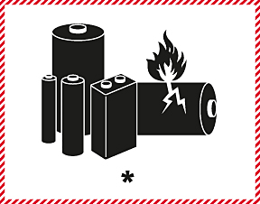
*
**
Minimum dimension 100 mm
Minimum dimension 100 mm
Lithium or sodium ion battery mark
* Place for UN number(s)
** Place for telephone number for additional information
The mark shall be in the form of a rectangle or a square with hatched edging. The dimensions shall be a minimum of 100 mm wide × 100 mm high and the minimum width of the hatching shall be 5 mm. The symbol (group of batteries, one damaged and emitting flame, above the UN number(s) for lithium ion or lithium metal batteries or cells) shall be black on white or suitable contrasting background. The hatching shall be red. If the size of the package so requires, the dimensions may be reduced to not less than 100 mm wide × 70 mm high. Where dimensions are not specified, all features shall be in approximate proportion to those shown.”
“5.2.2.1.13.1 Packages containing articles or articles transported unpackaged shall bear labels according to 5.2.2.1.2 reflecting the hazards established according to 2.0.5. If the article contains one or more lithium or sodium ion [using organic electrolyte] batteries with, for lithium metal batteries, an aggregate lithium content of 2 g or less, and for lithium ion or sodium ion [using organic electrolyte] batteries, a Watt-hour rating of 100 Wh or less, the lithium or sodium ion battery mark (Figure 5.2.5) shall be affixed to the package or unpackaged article. If the article contains one or more lithium or sodium ion [using organic electrolyte] batteries with, for lithium metal batteries, an aggregate lithium content of more than 2 g and for lithium ion or sodium ion [using organic electrolyte] batteries, a Watt-hour rating of more than 100 Wh, the lithium battery label (5.2.2.1.2.2 No. 9A) shall be affixed to the package or unpackaged articles.”
COMMENT – reference to 5.2.2.1.N° 9A in 5.2.2.1.13.1 is probably a mistake and should be corrected although it is not directly related to the subject of sodium ion batteries.
Proposal 5
32. If the data allows to make a positive decision in relation to paragraphs 12 and 13 above, it is proposed to adopt a new special provision YYY under new entries XXXX and XXXY prescribing requirements for low energy batteries as follows:
“YYY Sodium ion [using organic electrolyte] cells and batteries that have an energy density of [XX Wh/kg]* or less and when protected against short circuit shall, if containing a dangerous good, be transported as articles under an appropriate entry for that dangerous good or if not containing any dangerous goods may be transported as not subject to these regulations. Equipment containing either of these types may be transported as not subject to these regulations provided installed batteries are protected against short circuit.”
* COMMENT - The value of the energy density must be precisely defined according to test data.

Annex II
Energy density to the different battery technology
(Kubota et al., The chemical record, 2018)

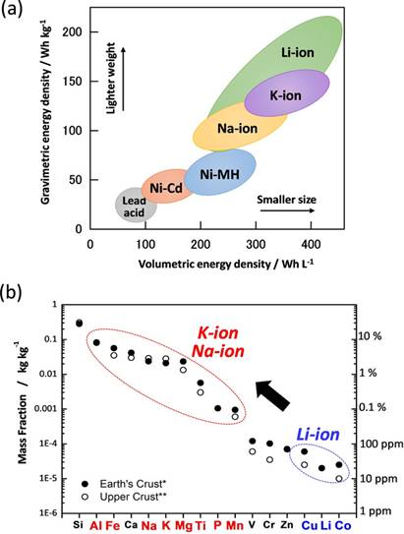

Annex III
Propagation test on a sodium ion battery
- In complement of doc. ST/SG/AC.10/C.3/2020/45, that proposes the creation of a new UN number for Na-ion batteries and consequential transport conditions. This document provides useful test result on 18650 Na-ion cells. The test protocol used is similar to the one proposed in the informal working group for hazard-based classification of Li-ion batteries. The cell tested has an energy density of 90Wh/kg.
Test protocol (from IWG)
- The test plan is described as below
Experimental Setup:
Six (6) 18650 cells, 100% SoC
Parallel configuration (not electrically connected)
1 T/C on first cell, 1 T/C on each remaining cell
Insulation on all sides
Experimental Procedure:
Cells are touching each other
Heat 1st cell at defined heating rate (here 9°C/min)
Turn heater off when first cell goes into thermal runaway (temperature jump above 200C)
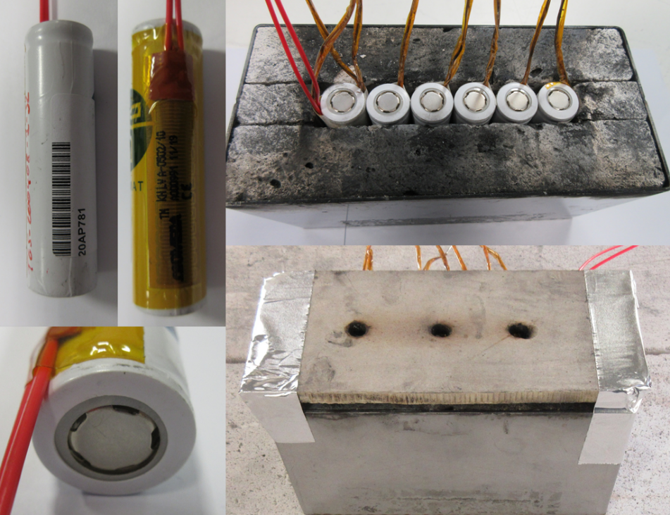
Figure 1: propagation test set-up
Test results
- The figure 2 shows extract of the video of the test. The thermally abused cell reacted, partially ejected its jelly roll and fumes were emitted. No flame was observed. The other cells did not react and kept their 4.11 V voltage after the test.

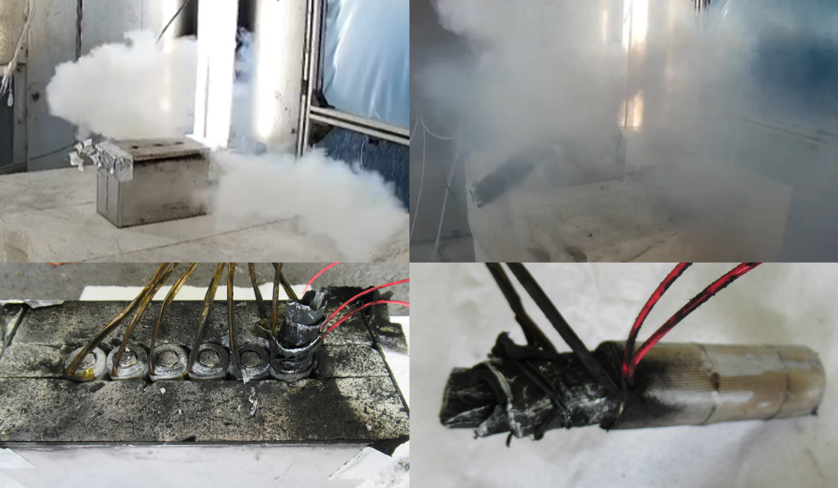
Figure 2: extracts from the test video and set-up after the test
- The figure 3 presents the temperature recorded during the test. The cell reaction occurs when the cell reaches 155°C and the maximal temperature recorded is 183°C. The temperature recorded on the other cells stay below 75°C confirming that the thermal runaway did not propagate.

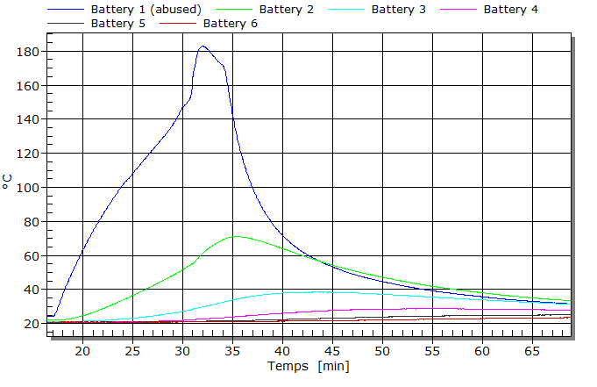
Figure 3 : temperature recording during the propagation test on Na-ion batteries
- The figure 4 presents the gas analysis result performed by on-line FTIR measurement. Around 1 L of gas has been quantified. Since no inflammation were observed, the major component of the gas mixture are the solvent from the electrolyte.
