UN/SCETDG/57/INF.32

Committee of Experts on the Transport of Dangerous Goods
and on the Globally Harmonized System of Classification
and Labelling of Chemicals 22 October 2020
Sub-Committee of Experts on the Transport of Dangerous Goods
Fifty-seventh session

Geneva, 30 November - 8 December 2020
Item 6 (b) of the provisional agenda
Miscellaneous proposals for amendments to the Model Regulations on the Transport of Dangerous Goods: packagings
Multiwall Water Resistant Paper Bags (5M2)
Transmitted by the Observer from Turkey
Introduction
1. In 6.1.4.18.2 requirements for 5M2 bags are defined as follows:
“6.1.4.18.2 Bags 5M2: to prevent the entry of moisture, a bag of four plies or more shall be made waterproof by the use of either a water resistant ply as one of the two outermost plies or a water resistant barrier made of a suitable protective material between the two outermost plies; a bag of three plies shall be made waterproof by the use of a water resistant ply as the outermost ply. Where there is a danger of the substance contained reacting with moisture or where it is packed damp, a waterproof ply or barrier, such as double-tarred kraft paper, plastics-coated kraft paper, plastics film bonded to the inner surface of the bag, or one or more inner plastics liners, shall also be placed next to the substance. Joins and closures shall be waterproof.”
Interpretation
2. Turkey requests interpretation of ‘water resistance’ via answers to examples below. Following figures represent ply structures of different paper bags. Which figures can be regarded as water resistant according to the first sentence of 6.1.4.18.2 so that classified under 5M2?
Figure 1 (a) Figure 1 (b)
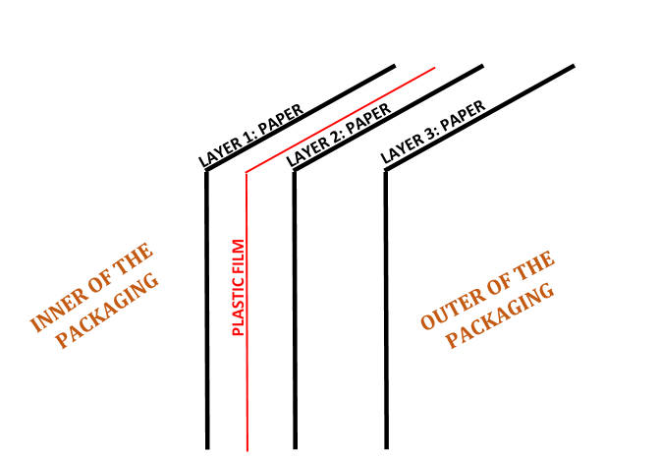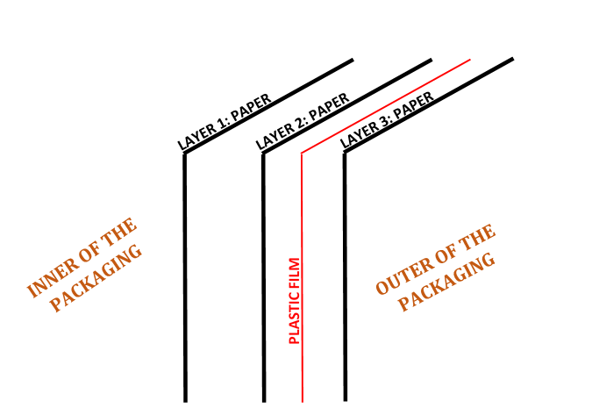

Figure 2 (a) Figure 2 (b)
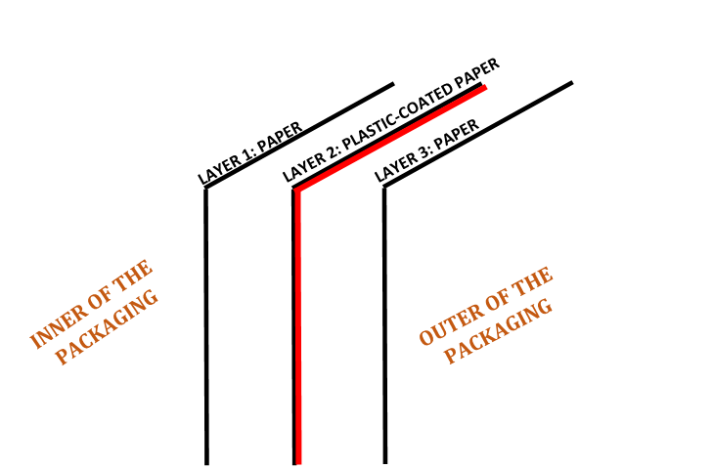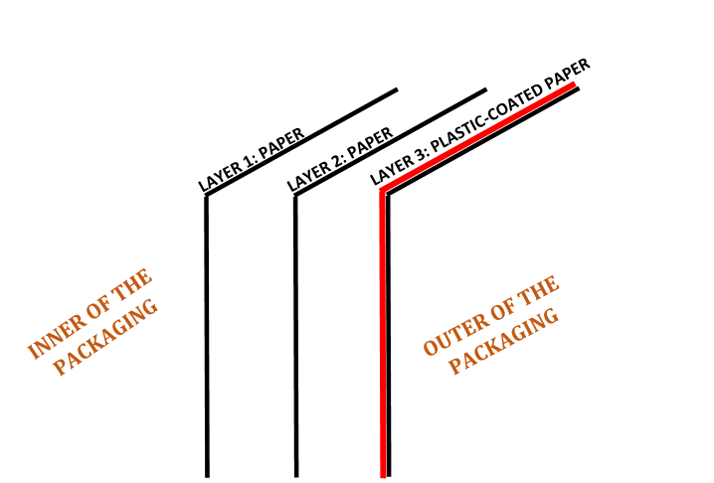

Figure 3
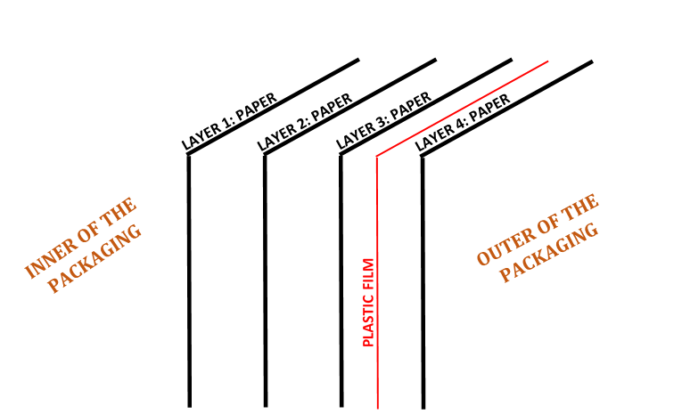

Figure 4
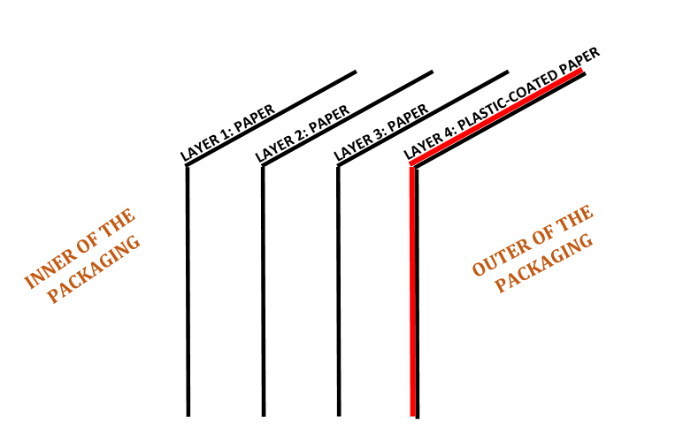
3. In order for air release, some manufacturers make micro holes on one or more layers of ‘paper bags with plastic film’ or ‘paper bags with plastic-coated layer’. These micro holes are particularly on plastic film or plastic-coated layer, but additionally paper layers may have micro holes, as well. Perforations are also listed in EN ISO 16106:2020 as specification for 5M2 bags. Do these micro holes compromise the water resistance of 5M2 bags?
4. Is there any additional control or test to assess ‘water resistance’ other than checking ply structure?
_______________

