UN/SCETDG/57/INF.13

Committee of Experts on the Transport of Dangerous Goods
and on the Globally Harmonized System of Classification
and Labelling of Chemicals 24 June 2020
Sub-Committee of Experts on the Transport of Dangerous Goods
Fifty-seventh session

Geneva, 29 June-8 July 2020
Item 2 (b) of the provisional agenda
Explosives and related matters: improvement of test series 8
Recommendations on Test Series 8: Applicability of Test Series 8 (d)
Transmitted by the Institute of Makers of Explosives (IME)
Introduction
- At the fifty-fourth session of the Sub-Committee of Experts on the Transport of Dangerous Goods, this Sub-committee’s Working Group on Explosives (EWG) recommended and the Sub-Committee approved, the CanmetCERL Minimum Burning Pressure (MBP) test, Test 8(e). The 8(e) test is used to further examine ammonium nitrate emulsions (ANEs) that produce positive outcomes, which are suspected to be false positives, in the 8(c) Koenen Test if the tested ANEs met certain criteria. For those specific ANEs, if the 8(e) test is passed, classification as an oxidizing substance under UN 3375 is appropriate.
- If ANEs are to be transported in bulk, they must also be subjected to the 8(d) Vented Pipe test to determine suitability for containment, as an oxidizing substance, in portable tanks. Such containment is integral to the primary method of ANEs transport. Since the Vented Pipe test is, in effect, a larger scale Koenen Test, the same limitations of the Koenen Test for those ANEs described above are also encountered during the 8(d) test. This claim is supported by experimental data that show that ANEs that fail the 8(c) test also fail the 8(d) test.
- This paper proposes that the MBP test, which measures an intrinsic property of the substance (the minimum burning pressure), is also effective in determining suitability of the ANEs for containment in portable tanks.
- All figures referred to in this document may be found in the Annex hereto.
Background
- Certain ANEs that are candidates for classification as UN 3375, have shown to give false positives in the 8(c) Koenen Test. This is due to the high water content of these ANEs compared to the substances tested in the 1950s when the Koenen Test was first introduced. Higher water content means a relatively lower reactivity of ANEs which translates into prolonged heating and weakening of the steel tube of the test vessel and ultimately causes tube bursting yielding false positives.
- To address this limitation of the Koenen Test for ANEs, the EWG recommended to the TDG Sub-Committee, and the Sub-Committee approved, the inclusion of the minimum burning pressure (MBP) test 8(e) to further evaluate those ANEs with suspected false positive Koenen Test outcomes. To be acceptable for classification as UN 3375 under this new test scheme, the following conditions must be met: a reaction time in the Koenen Test (TS 8(c)) longer than 60 seconds and a water content of the candidate ANE greater than 14%. ANEs that are subject to the 8(e) test must register a minimum burning pressure equal to or greater than 5.6 Mpa to be accepted under UN 3375.
- The TS 8(d) or Vented Pipe Test, which, as noted above, is in effect a scaled-up Koenen Test, is required for ANEs if these substances are to be contained in portable tanks. The fact that classification of some ANEs will not be governed by the Koenen Test and instead by the MBP test creates an issue for these substances since the likelihood of failing the TS 8(d) is almost a certainty.
Discussion
- The alternative test (TS 8(e) – Minimum Burning Pressure) was included in the Manual of Tests and Criteria, Seventh revised edition (2019). TS 8(e) measures a fundamental property of the substance and allows a path for classification of ANEs as UN 3375 provided they show negative test results for TS 8(a) and TS 8(b), satisfy criteria limits of a reaction time in TS 8(c) greater than 60 seconds, has a minimum water content greater than 14% w/w, and registers a Minimum Burning Pressure equal to or greater than 5.6 MPa.
- The MBP is an intrinsic property of an energetic material. At pressures below the MBP a substance cannot sustain burning, regardless of the mass and amount of energy used to ignite it. Hence, unlike the Vented Pipe Test, which is targeted to study the effect of scale when the ANE is transported in a portable tank, the MBP is independent of scale as it is an intrinsic property of the substance.
- In informal document INF.27 (55th session) (IME), it was shown that the TS 8(d) did not provide a suitable level of discrimination in test outcomes between Division 5.1 and Division 1.5 (based on water content of the ANEs), and it was proposed that ANEs that satisfy the acceptance criteria of the TS 8(e) test should not be subjected to the TS 8(d) and can be considered suitable for transport in portable tanks as oxidizing substances based on satisfactory TS 8(e) results. The EWG was sympathetic to the proposal from IME but requested more supporting data before a final position could be taken by the EWG. The current document is offered in fulfillment of that request.
- In Figure 1, the outcomes are shown of numerous TS 8(d)(i) tests where the fuel composition of the ANE has been varied with respect to emulsifier and oil composition. All samples tested met the compositional requirements of Special Provision 309 that applies to UN 3375 ANEs.
a) The abscissa represents increasing levels of emulsifier (surfactant) within the ANE. It is well understood in industry that there is a minimum level of emulsifier required to maintain an ANE of sufficient quality for use, indicated in Figure 1 by Line (a). Below that surfactant level, the ANEs are unlikely to be of practical industry use.
b) The ordinate in Figure 1 represents the proportion of non-petrochemical-based oil (vegetable oil) included in the ANE fuel phase. Samples with zero vegetable oil content are also included (Samples 10-18) and these formulations would contain petrochemical-based oils.

c) TS 8(d)(i) sample results indicate either negative or positive results in Figure 1.
d) ANEs that fail the Koenen test must have a water content above 14%. The ANE samples that failed the 8(d)(i) test had water contents above this threshold. This can be seen in Figure 2.
e) ANEs that fail the Koenen Test must also have reaction times greater than 60 seconds. ANE samples that failed the 8(d)(i) test are given in Figure 3 and it can be seen that all samples had reaction times above 60 seconds, with many of them greater than 100 seconds.
f) The threshold MBP for samples to pass the 8(e) test is 5.6 MPa. The samples of ANEs that failed the TS 8(d)(i) test have predicted MBPs well above the threshold value, and this is shown in Figure 4, where the MBPs, which are dependent on the water content, were calculated from a linear regression (R² = 0.988) of MBP as a function of water content in AN-based oxidizer system ANEs as presented in Badeen et al. (2014) .
- Figure 5 shows the burst pressure for portable tanks compared to the vessels used for the Koenen and Vented Pipe Tests (UN/SCETDG/49/INF.60). The burst pressures for portable tanks are in the range of 2-8 Bar, or 0.2 to 0.8 MPa. In the event of a fire, the ANE close to the tank walls exposed to the fire will have a higher temperature than the bulk ANE. Since the substance has poor thermal conductivity the bulk will continue to remain close to ambient temperature and thus the portable tank will fail well before the ANE reaches its MBP.
- The charts in Figures 1 to 4 show that ANE samples that fail the 8(d)(i) test are bona fide UN 3375 as they satisfy the criteria for consideration of the 8(e) test, and furthermore they also have MBPs (calculated according to the method described in paragraph 11.f., and based on the data of Badeen et al. (2014)³) that are well above the MBP threshold of 5.6MPa (or 56 Bar).
- In Figure 1, it can also be seen that there appears to be an indicative boundary between positive and negative results, indicated as Line (b). This line is however arbitrary since the ANE samples being divided would be UN 3375 and therefore Division 5.1 substances. Figure 1 demonstrates inconsistencies in TS 8(d)(i) for a range of products that are all eligible for classification in Division 5.1. This finding is not surprising since the 8(d)(i) test is in effect a scaled-up Koenen Test, which has been shown to have limitations for certain ANEs..
Proposal
- ANEs that satisfy the acceptance criteria of the 8(e) test should not be subjected to the 8(d) test and can be considered suitable for containment in portable tanks as oxidizing substances based on their MBPs that far exceed the pressures that portable tanks will fail.
- Amend footnote « b » of Table 18.1 in section 18.2 of the MTC as shown below (new text indicated by blue underscored text):
^{b} These tests are intended for evaluating the suitability of ANEs for containment in portable tanks as an oxidizing substance. ANEs that satisfy the acceptance criteria of Test 8 (e) need not be subjected to Test 8(d) as they are already considered suitable for containment in portable tanks as an oxidizing substance.
- Amend the first paragraph of Section 18.7.1.1 of the MTC as shown below (new text indicated by blue underscored text):
This test is not intended for classification but is included in this Manual for evaluating the suitability for containment in portable tanks as an oxidizing substance. ANEs that satisfy the acceptance criteria of Test 8 (e) need not be subjected to Test 8 (d) as they are already considered suitable for containment in portable tanks as an oxidizing substance.
- Amend Section 18.8.1.1 of the MTC as shown below (new text indicated by blue underscored text):

18.8.1.1 Introduction
This test is used to determine the sensitiveness of a candidate ammonium nitrate emulsion or suspension or gel, intermediate for blasting explosive, to the effect of intense localized thermal ignition under high confinement. This test can be performed in case of a positive ("+") result in Test 8(c) when the time to reaction in this test has exceeded 60 seconds and the substance has a water content greater than 14 %.
This test is also applicable for determining the suitability of ANEs for containment in portable tanks as an oxidizing substance.
- Amend Section 18.8.1.4.1 of the MTC as shown below (new text indicated by blue underscored text):
18.8.1.4.1 The result is considered positive ("+") and the substance should not be classified in Division 5.1 if the MBP is less than 5.6 MPa (800 psig). Substances with MBPs equal to or greater than 5.6 MPa (800 psig) are considered suitable for containment in portable tanks as an oxidizing substance (see 18.8.1.1).

Annex
Figures Referred to in Document

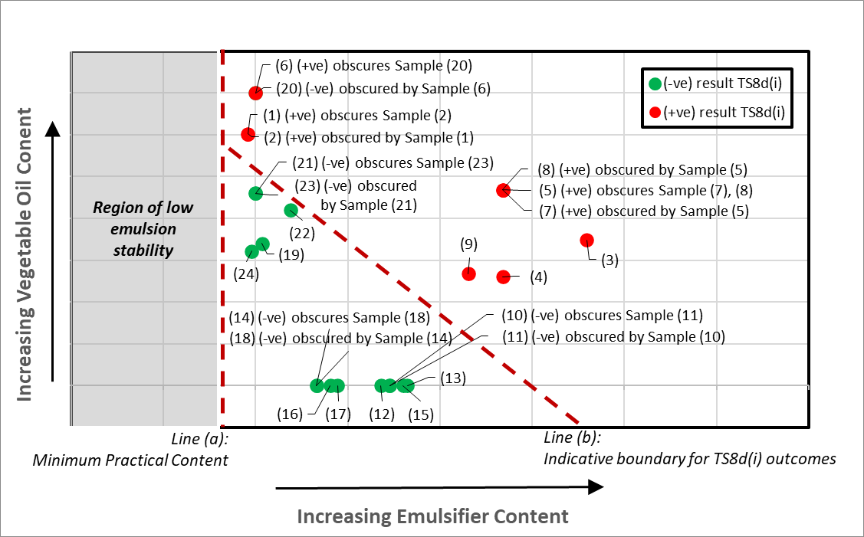
Figure 1: TS 8(d)(i) Outcomes for Ammonium Nitrate Emulsions with varying Fuel and Emulsifier Content
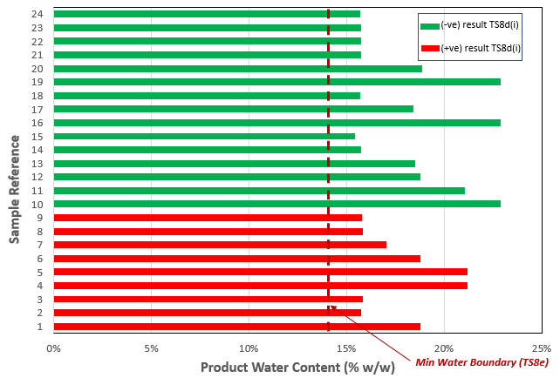
Figure 2: Water Content of Ammonium Nitrate Emulsions with varying Fuel and Emulsifier Content corresponding to Figure 1

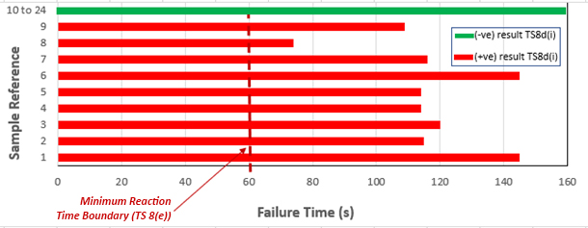
Figure 3: Koenen Test (TS 8c) Reaction Times for Ammonium Nitrate Emulsions with varying
Fuel and Emulsifier Content corresponding to Figure 1.
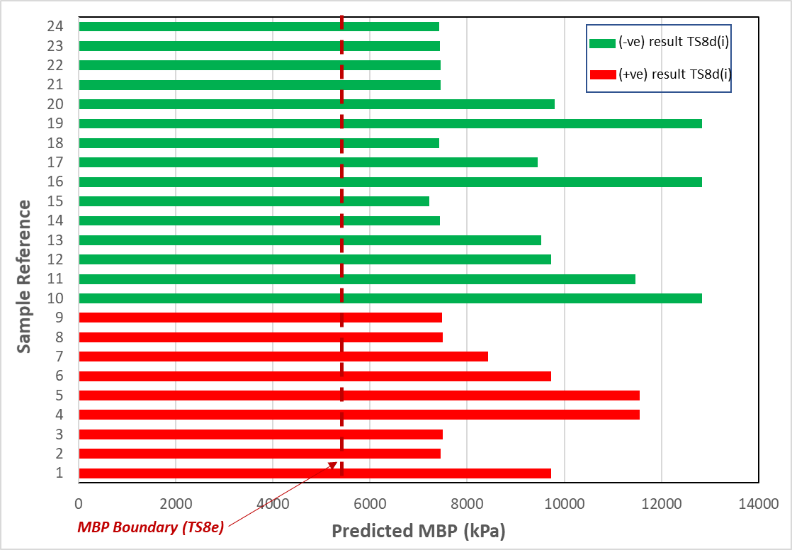
Figure 4: Predicted Minimum Burning Pressure for Ammonium Nitrate Emulsions with varying Fuel and Emulsifier Content corresponding to Figure 1. Note: MBP values were calculated according to the method described in paragraph 11.f. and based on the data of Badeen et al. (2014)

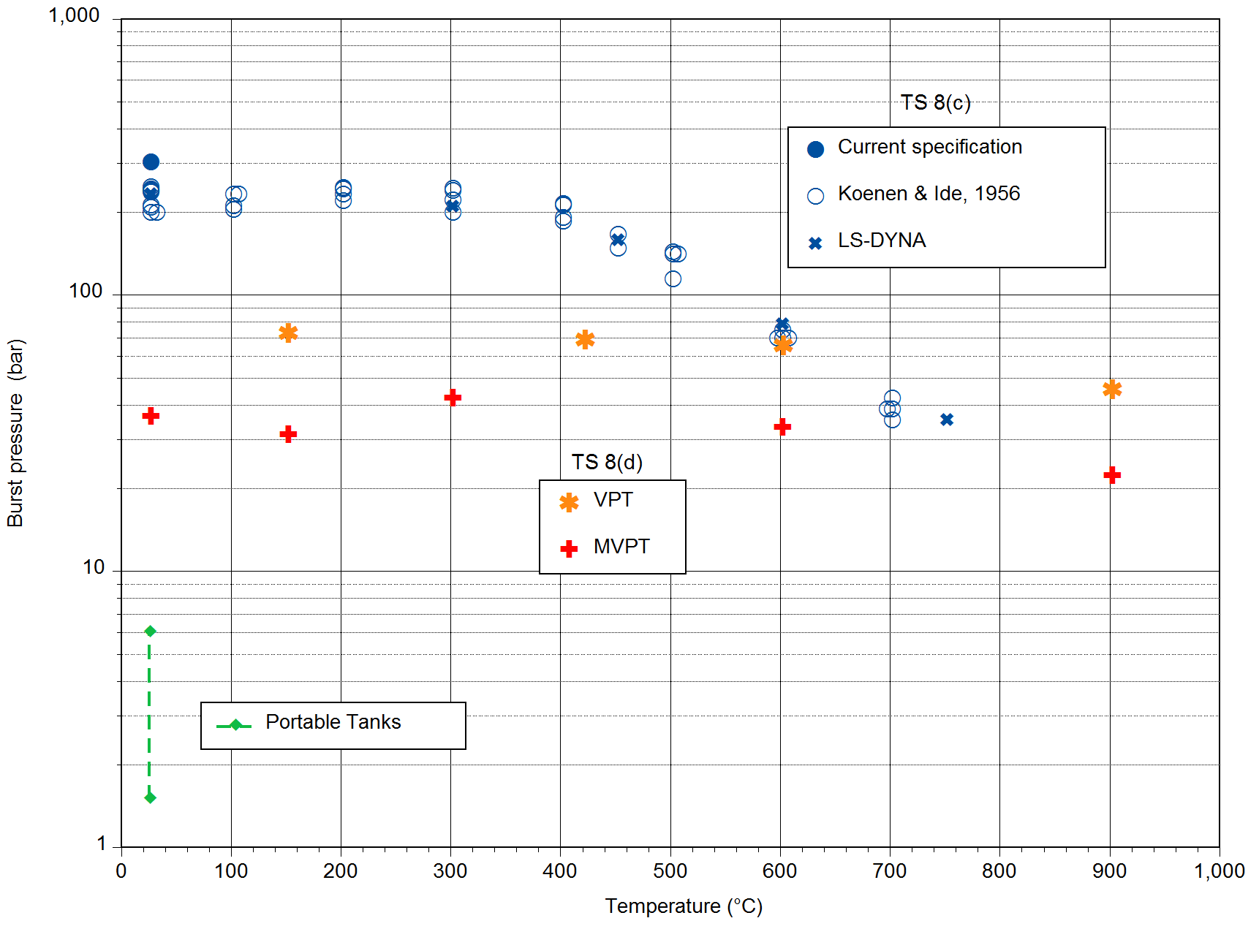
Key:
VPT = Vented Pipe Test (TS 8(d)(i))
MVPT = Modified Vented Pipe Test (TS 8(d)(ii))
Figure 5. Burst Pressure for Portable Tanks and 8(c) and 8(d) Tests
___________________

Hereafter referred to as “MTC”
Informal document INF.55, para. 5 (55th session)
C. Badeen, S. Goldthorp, R. Turcotte, H. Feng, S.K. Chan, I. Alilovic, Effect of Ingredients on the Minimum Burning Pressure of Ammonium Nitrate Emulsions, Proceedings of the 40th Annual Conference on Explosives and Blasting Techniques, International Society of Explosives Engineers, Denver, CO, USA, February 2014.
C. Badeen, S. Goldthorp, R. Turcotte, H. Feng, S.K. Chan, I. Alilovic, Effect of Ingredients on the Minimum Burning Pressure of Ammonium Nitrate Emulsions, Proceedings of the 40th Annual Conference on Explosives and Blasting Techniques, International Society of Explosives Engineers, Denver, CO, USA, February 2014.

