|  |  |  |  |
| --- | --- | --- | --- |
|  | United Nations | ST/SG/AC.10/C.3/2020/65 | |
| _unlogo | **Secretariat** | | Distr.: General  21 September 2020  Original: English |

**Committee of Experts on the Transport of Dangerous Goods  
and on the Globally Harmonized System of Classification  
and Labelling of Chemicals**

**Sub-Committee of Experts on the Transport of Dangerous Goods**

**Fifty-seventh session**

Geneva, 30 November-8 December 2020  
Item 4 (e) of the provisional agenda

**Electric storage systems: sodium-ion batteries;**

Low energy density sodium ion battery testing

Transmitted by KiloFarad International (KFI)[[1]](#footnote-2)

Introduction

1. KiloFarad International (KFI) is grateful to the authors of document ST/SG/AC.10/C.3/2020/45 on sodium ion batteries in permitting KFI the opportunity to comment prior to its submission. As the document notes that among sodium ion batteries currently under development there are widely varying energy densities. At the present, lower energy density sodium ion battery technology offers the most promise in the immediate future. Their primary usage will be in storing electrical energy for stationary use purposes. Sodium ion batteries offer a more environmentally friendly alternative to other battery technologies such as lithium ion batteries in that the materials of construction are commonly available and may be acquired with less environmental impact. They are also less costly to produce. It may be expected that they will offer a competitive advantage to high energy batteries in applications where the size of the battery storage facility is less of a concern. Such batteries will soon enter production.

2. These low energy density sodium ion batteries may be transported at a low energy state. The energy transport risk is less than that of other batteries that may be transported as non-dangerous as provided by the International Civil Aviation Organization (ICAO) Technical Instruction in accordance with special provision A123. Further it is KFI’s opinion that these low energy sodium ion batteries may also be transported in accordance with ICAO TI A123 which reads:

“A123 This entry applies to Batteries, electric storage, not otherwise listed in Table 3-1. Examples of such batteries are: alkali-manganese, zinc-carbon and nickel-cadmium batteries. Any electrical battery or battery-powered device, equipment or vehicle having the potential of a dangerous evolution of heat must be prepared for transport so as to prevent:

(a) A short circuit (e.g. in the case of batteries, by the effective insulation of exposed terminals; or, in the case of equipment, by disconnection of the battery and protection of exposed terminals); and

(b) Unintentional activation.

The words “not restricted” and the special provision number A123 must be provided on the air waybill when an air waybill is issued.”

3. KFI, in commenting on the draft of document ST/SG/AC.10/C.3/2020/45 prior to its submission, advocated for relief from regulation for low energy density batteries and is grateful to the authors in making provision for them by way of Proposal 5 in document ST/SG/AC.10/C.3/2020/45.

4. KFI notes with interest that testing results carried out on a sodium ion battery of unspecified energy density by France and the United Kingdom in informal document INF.9 (fifty-seventh session) and in this document provide testing on a low density sodium ion cell that will soon be in production and distribution. Testing was carried out in accordance with UL 9540A, Test Method for Evaluating Thermal Runaway Fire Propagation in Battery Energy Storage Systems.

5. UL 9540A was developed to address potential safety concerns associated with the use of batteries in buildings as identified by fire services. The tests conducted for certification under this standard are deemed to represent worst case scenarios under use conditions which may pose added risks to those normally posed in transport such as high temperature exposure. Some tests are generally comparable to those of the Manual of Tests and Criteria, part III, sub-section 38.3 applicable to lithium batteries while others exceed what is required for lithium batteries (e.g., nail penetration).

6. The tested cell has an energy density of 22 Wh/kg which is considerably lower than the energy density of many batteries classified as non-dangerous under the regulations (see ICAO TI A123).

Test Results

7. Test results are provided in Annex 1. The tests are extreme and do not reflect conditions normally encountered in transport. For example, cells were tested fully charged whereas they are transported at a very low state of charge. High temperature conditions in the external heating test far exceed temperatures anticipated in normal transportation.

Discussion of Results

8. The test results demonstrate a high degree of safety. Venting in overcharge testing did not evolve flammable gases (vapor concentration of vented gas was 5.24 percent of the lower flammable limit). Considering the short circuit test results, a temperature rise of approximately 45 °C was measured in the case of short circuiting a fully charged cell. The maximum measured temperature of approximately 65 °C is insufficient to result in fire. To put the tests and results in perspective or comparison to other dangerous goods requirements:

(a) the outside surface temperature of a package containing an oxygen generator (UN 3356) may not exceed 100 °C upon activation of a generator in accordance with P500. Even in the case of a fully charged short circuited sodium ion cell the outside temperature of the cell would not approach 100 °C;

(b) Nickel metal hydride batteries (UN 3496) are regulated for sea transport. They are not regulated in other modes. Regulation by sea was based on accidents when they were stowed adjacent to heated bunker fuel tanks with resultant fires. The test sodium ion cell was subjected to a 400 °C temperature without resulting in fire. That temperature far exceeds the temperature of bunker tanks onboard ships, suggesting that the subject sodium ion cell is substantially safer than nickel metal hydride batteries that are generally transported unregulated except as noted by sea; and

(c) like batteries wet non-spillable (UN 2800) that may be transported unregulated, there is no free liquid.

Proposal

9. Based on the information provided, it is KFI’s opinion that the low energy density sodium ion cells described pose no safety risk that justifies regulation as a dangerous good. They may safely be transported in a low charge state without being subject to regulation in the manner provided for other batteries in accordance with ICAO TI A123. KFI recommends that a provision be made to exempt sodium ion cells of low energy density such as the subject cell from regulation under the Model Regulations.

10. KFI welcomes the views of the Sub-Committee and can share additional information on the tests in the Annex as well as test data based on a number of other tests performed on the subject cell as part of the rigorous UL certification requirements.

Annex

UL 9540A Test method for evaluating thermal runaway fire propagation in cell energy storage systems, third edition

Cell level test report on Model V6.0 “Prussian Blue Cell”

Summary of UL 9540A Test Results (excerpts of the report)

Cell Level Test Model #: V6.0

UL Project 4789109222

[Cell Design:](#_bookmark0) Pouch, Cell Chemistry Sodium Ion, Energy Capacity 4.6 Ah, Nominal Voltage 1.56 V, Weight 305 g

[Thermal Runaway Methodology:](#_bookmark4) Short Circuit, External Heating, Overcharge, Nail Penetration

[Cell Surface Temperature on Front of Enclosure at Gas Venting:](#_bookmark5) 83.44 °C\* [Cell Surface Temperature at Thermal Runaway:](#_bookmark6) N/A – Thermal Runaway Not Observed

[Gas Volume:](#_bookmark7) 77.5 L

[Gas Composition:](#_bookmark5) H2: 35.7 %, CO: 26.25 %, CO2: 24.59 %, THC: 13.46 %

Note: \* Cell surface temperature measured during test #6.

For each of the 4 test methods implemented to induce thermal runaway, no thermal runaway was observed with the Natron Energy, Inc model V6.0 cell under test.

UL 9540A Test Report for Natron Energy, Inc.

Cell Energy Storage Description  
 Cell Energy Storage System Configuration

Table 1 – Product details

|  |  |
| --- | --- |
| **Cell** | |
| Manufacturer | Natron Energy, Inc |
| Model Number | V6.0 |
| Chemistry | Sodium Ion |
| Electrical Ratings | 1.56 V 4.6 Ah |
| Dimensions | 194 mm x 246 mm x 5.1 mm |
| Cell Weight | 305 g |
| Construction Description | Pouch |
| UL Certifications | ANSI/CAN/UL 1973, BBGA2/8 File MH63828 |
|  | |
| Figure 1 – Photo of cell | |

Thermal Runaway Methodology

The propensity for a cell to experience thermal runaway was examined through several different methodologies covering mechanical, thermal, and electrically induced events. The methods and parameters below were intended to place the most stress on the cell to attempt inducing thermal runaway. Thermal runaway is defined as the incident when an electrochemical cell increases its temperature through self-heating in an uncontrollable fashion. The thermal runaway progresses when the cell’s generation of heat is at a higher rate than the heat it can dissipate. This may lead to fire, explosion and gassing.

A summary of the evaluated thermal runaway methodologies is included in Table 5.

**Table 5 – Thermal Runaway Methodologies**

|  |  |  |  |
| --- | --- | --- | --- |
| **Test** | **Stress** | **Methodology** | **Test Parameters** |
| 1 | Electrical | Short Circuit | Direct short across positive and negative terminals |
| 2 | Thermal | External Heating | 4-7 °C/min with no holding temperature |
| 3 | Electrical | Overcharge | Constant current, voltage increased 1 V/min |
| 4 | Mechanical | Nail Penetration | Through external casing from short side through internal  cell |
| 5 | Electrical | Overcharge | Constant current, voltage increased 1 V/min |
| 6 | Electrical | Overcharge | Gas Composition, same methodology as test 5 |

Cell Level Test Results

Test 1 – Demonstration of Thermal Runaway Propensity by Short Circuit

**Table 6: Test initiation details**

|  |  |
| --- | --- |
| **Test Initiation Details** | |
| Test Date | 2019/09/18 |
| Test Start Time | 08:41 AM |
| Initial Lab Temperature | 20.5 °C |
| Initial Relative Humidity | 46% RH |

Figure 6 shows the surface temperatures measured during the test, in which no venting nor thermal runaway was observed. The open circuit voltage prior to the start of the test was 1.77 V. A contactor was closed to complete the circuit, at the initiation of the test. The current measured at the initial short circuit was approximately 796 A. The current across the short was drastically decreasing through the test. No venting or thermal runway was observed based on visual observations and temperature measurements of the cell enclosure. All temperatures were reducing after the initial short circuit event. At the end of testing, when current was 0 and temperatures were returning to near ambient, at approximately 27 minutes, the contactor was opened.

**Figure 6: Surface temperatures measured on cell**

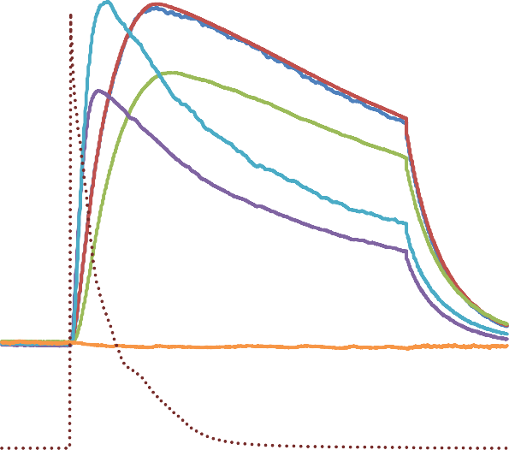

Short Circuit Test

70

900

800

60

700

50

600

TC1 - Top Middle

TC2 - Bottom Middle

40

500

TC3 - Side

400

30

300

20

200

100

TC4 - Postive Terminal

TC5 - Expected Vent Ambient

Voltage

Current

10

0

0

-100

0 100

200

Time, Seconds

300

400

Temperature, C and Voltage, V

Test 2 – Demonstration of Thermal Runaway Propensity by External Heating

**Table 7 – Test initiation details**

|  |  |
| --- | --- |
| **Test Initiation Details** | |
| Test Date | 2019/09/18 |
| Test Start Time | 1:29 PM |
| Initial Lab Temperature | 20.5 °C |
| Initial Relative Humidity | 46% RH |

Figure 9 shows the surface temperatures measured during the test, in which cell venting was observed through the seams of the cell pack but thermal runaway was not observed. The open circuit voltage of the cell prior to the test was 1.78 V. Heaters were place on both faces of the cell. Kapton tape was used to secure the heaters to the cell. TC5, just outside of the heater on the case, was heated at a rate of 4-7 °C per minute until the heater reached approximately 400 °C. At this time the heater failed causing the heater itself to catch on fire. The heater power supply was shut off and the cell temperatures were further monitored. There was no observance of fire from the cell internally.

**Figure 9: Surface temperatures and electrical parameters measured on cell**

External Heating

500

2

450

1.8

400

1.6

1.4

350

1.2

300

1

TC1 - Top Middle

TC2 - Bottom Middle

250

0.8

200

0.6

150

0.4

TC3 - Side

TC4 - Positive Terminal TC5 - Expected Vent Ambient

Voltage

100

0.2

50

0

0

-0.2

0 100 200 300 400 500

Time, Minutes

Temperature, C

Voltage, V

Test 3A – Demonstration of Thermal Runaway Propensity by Overcharge #1

**Table 8: Test initiation details**

|  |  |
| --- | --- |
| **Test Initiation Details** | |
| Test Date | 2019/09/19 |
| Test Start Time | 08:18 AM |
| Initial Lab Temperature | 21.0 °C |
| Initial Relative Humidity | 47% RH |

Figure 13 shows the surface temperatures measured during the test, in which cell venting was observed through the seams of the cell pack but thermal runaway was not observed. The open circuit voltage of the cell prior to the test was 1.73 V. The power supply used to charge the cell was placed in a constant voltage mode, where the voltage was increased by 1 V every minute. During the test, the cell enclosure breached and a flame was observed in the cell when the supply was at 26 V. This occurred at approximately 26 minutes into the test. The power supply was left on for an additional 10 minutes after the initial breach was observed. When the power supply was turned off at approximately minute 35, the flames self-extinguished. Due to this, a second heating test was performed under Test #5 shown later in the report where the power supply was immediately turned off upon observation of the cell enclosure breaching.

**Figure 13: Surface temperatures measured on cell**

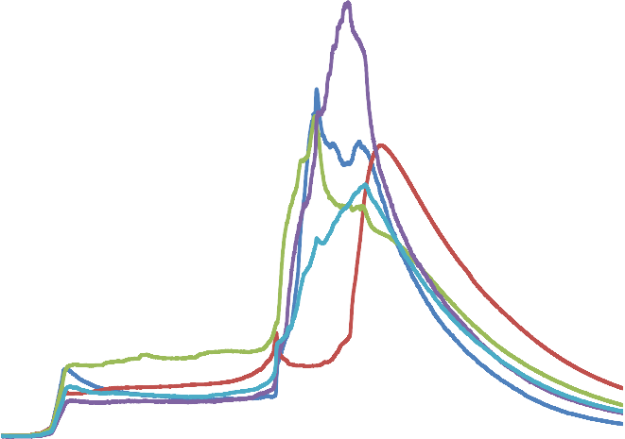

Overcharge Test #1

300

30

250

25

200

20

150

15

100

10

50

0

5

0

10

20

30

40

50

60

-50

0

Time, Minutes

TC1 - Top Middle   
TC2 - Bottom Middle TC3 - Side

TC4 - Positive Terminal TC5 - Expected Vent Ambient

Current

Voltage

Temperature, C and Current, A

Voltage, V

Test 4 – Demonstration of Thermal Runaway Propensity by Nail Penetration

**Table 9: Test initiation details**

|  |  |
| --- | --- |
| **Test Initiation Details** | |
| Test Date | 2019/09/19 |
| Test Start Time | 01:01 PM |
| Initial Lab Temperature | 21.0 °C |
| Initial Relative Humidity | 47% RH |

Figures 16 show the surface temperatures measured during the test, in which no cell venting nor thermal runaway was observed. The open circuit voltage prior to the start of the test was 1.77 V. An 8 mm diameter nail, 125 mm long, was used to penetrate through the side of the cell in order to puncture through the entire cell. The nail increased in temperature slightly due to the friction of the nail as it passed through the cell. There was no change in status after nail penetration. The test was concluded after 38 minutes.

**Figure 16**: **Surface temperatures measured on cell**

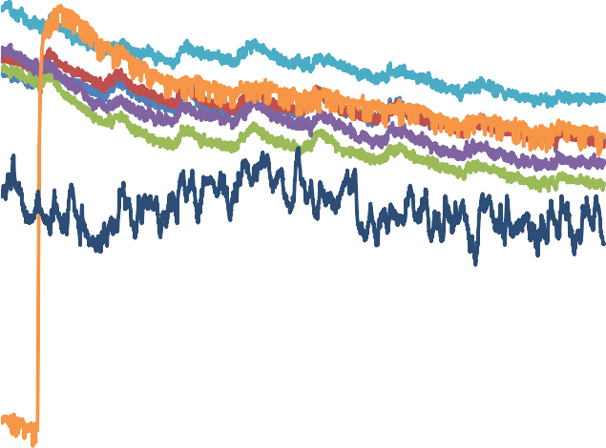

Nail Penentration

22.5

2

1.8

22

1.6

1.4

21.5

TC1 - Top Middle

1.2 TC2 - Bottom Middle TC3 - Side

21 1

TC4 - Positive Terminal

0.8

20.5

0.6

0.4

TC5 - Expected Vent

TC6 - Nail Ambient Voltage

20

0.2

19.5

0

0 5 10 15 20 25 30 35 40

Time, Minutes

Temperature, C

Voltage, V

**Figure 17:** **Nail Penetration Setup**

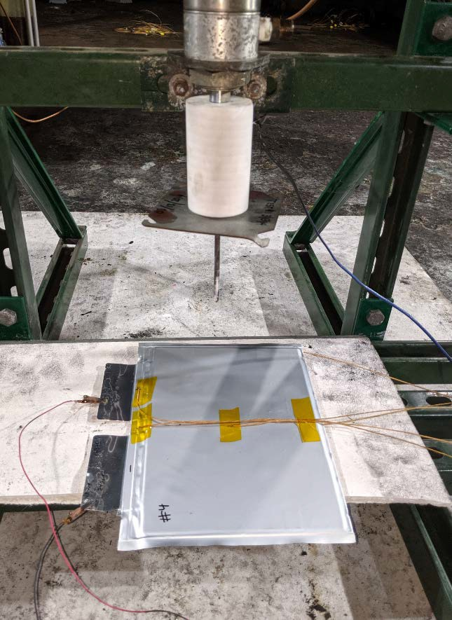

**Figure 18**: **Nail Entry and Exit**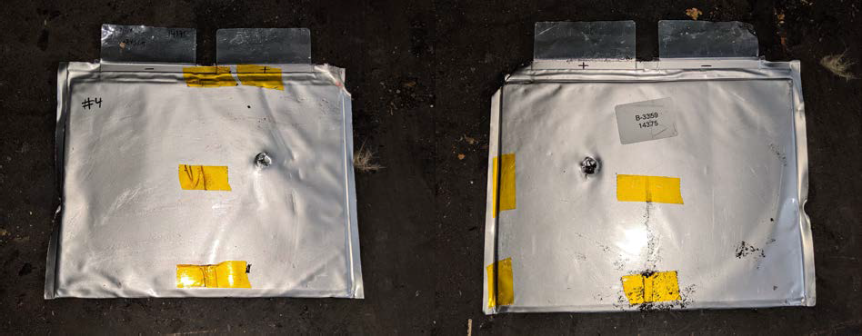

Test 5 – Demonstration of Thermal Runaway Propensity by Overcharge #2

**Table 10: Test initiation details**

|  |  |
| --- | --- |
| **Test Initiation Details** | |
| Test Date | 2019/09/19 |
| Test Start Time | 02:03 PM |
| Initial Lab Temperature | 22.5 °C |
| Initial Relative Humidity | 47% RH |

Figure 19 shows the surface temperatures measured during the test, in which cell venting was observed through the seams of the cell pack but thermal runaway was not observed. The open circuit voltage of the cell prior to the test was 1.76 V. The power supply used to charge the cell was placed in a constant voltage mode, where the voltage was increased by 1V every minute. During the test, the cell enclosure breached and a flame was observed in the cell when the supply was at 32 V. This occurred at approximately 35 minutes into the test. The power supply was immediately shut off after the initial breach was observed with flaming. When the power supply was turned off, the flames self-extinguished.

**Figure 19: Surface temperatures measured on cell**

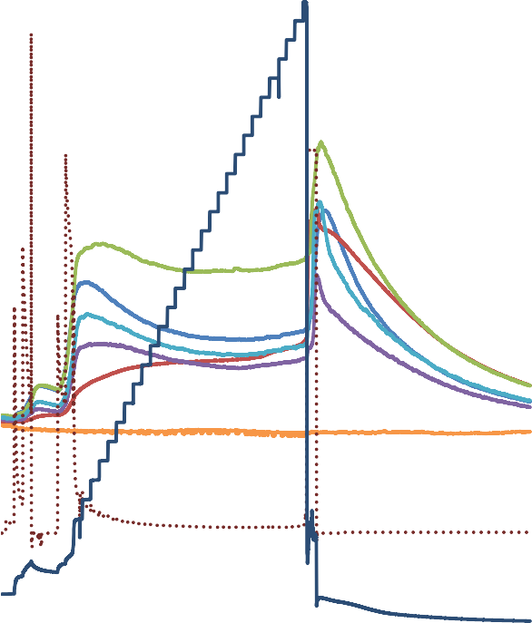

Overcharge Test #2

120

35

100

30

80

25

60

20

TC1 - Top Middle

TC2 - Bottom Middle

TC3 - Side

TC4 - Positive Terminal

40

15

TC5 - Expected Vent

Ambient

20

10

Current

Voltage

0

5

0 10 20 30 40 50 60 70

-20

0

Time, Minutes

Temperature, C and Current, A

Voltage, V

Summary of Cell Test Results

Cell Vent and Thermal Runaway Results

A summary of cell venting times and temperatures, and thermal runaway time and temperatures are presented in Table 15.

**Table 15: Summary of measurements collected in Cell Level Tests 1 - 6**

|  |  |  |  |  |  |
| --- | --- | --- | --- | --- | --- |
| **Test** | **Test Method** | **Venting Time (mm:ss)** | **Venting Temperature (°C)** | **Thermal Runway Time**  **(mm:ss)** | **Thermal Runway Temperature (°C)** |
| 1 | Short Circuit | Not Observed | N/A | Not Observed | N/A |
| 2 | Heating | 64:05 | 476.14\* | Not Observed | N/A |
| 3 | Overcharge #1 | 26:34 | 239.6\*\* | Not Observed | N/A |
| 4 | Nail Penetration | Not Observed | N/A | Not Observed | N/A |
| 5 | Overcharge #2 | 35:55 | 81.85 | Not Observed | N/A |
| 6 | Gas Composition  (Overcharge) | 19:46 | 83.44 | Not Observed | N/A |

\*The increased temperature was due to the heater being increased to 475 °C

\*\*The increased temperature was due to the sustained fire when the power supply for charging was left on.

Thermal runaway was not observed in any of the 5 tests, therefore repeat tests were not required.

Cell Venting Gas Analysis

The total amount of gas collected from the cell after venting was 77.5 L at Normal Temperature and Pressure (NTP), over a period of approximately 4 minutes. Flammability properties were determined empirically:

* LFL: 5.24 %
* Pmax: 121.1 psig
* Su: 85 cm/sec

Test record No. 1

SAMPLES:

Samples of the Prussian Blue Cell, Model V6.0 as indicated below and constructed as described herein, was submitted by the manufacturer for examination and test.

|  |  |  |  |  |
| --- | --- | --- | --- | --- |
| Model | Cell Chemistry | Cell Shape | Nominal Voltage Rating, V DC | Capacity, Ah |
| V6.0 | Sodium Ion | Pouch | 1.56 | 4.6 |

GENERAL:

Test results relate only to the items tested.

The following tests were conducted on Model LFP36130200-100AH.

|  |  |  |
| --- | --- | --- |
| TEST | Standard | Test Location |
| SHORT CIRCUIT: (At Room Temperature) | ANSI/CAN/UL 1973 Appendix E | UL NBK |
| CELL IMPACT | ANSI/CAN/UL 1973 Appendix E | UL NBK |
| DROP IMPACT | ANSI/CAN/UL 1973 Appendix E | UL NBK |
| HEATING | ANSI/CAN/UL 1973 Appendix E | UL NBK |
| OVERCHARGE | ANSI/CAN/UL 1973 Appendix E | UL NBK |
| FORCED DISCHARGE | ANSI/CAN/UL 1973 Appendix E | UL NBK |
| PROJECTILE | ANSI/CAN/UL 1973 Appendix E | UL NBK |

The test methods and results of the above tests have been reviewed and found in accordance with the requirements in the Standard for Batteries for Use in Stationary, Vehicle Auxiliary Power and Light Electric Rail (LER) Applications, ANSI/CAN/UL 1973, Second Edition, Dated February 07, 2018.

Test record summary

The results of this investigation, including construction review and testing, indicate that the products evaluated comply with the applicable requirements in the Second Edition of ANSI/CAN/UL 1973, the Standard for Batteries for Use in Stationary, Vehicle Auxiliary Power and Light Electric Rail (LER) Applications, Dated February 07, 2018, and therefore, such products are judged eligible to bear UL’s Mark as described on the Conclusion Page of this Report.

Any information and documentation involving UL Mark services are provided on behalf of UL LLC (UL) or any authorized licensee of UL.

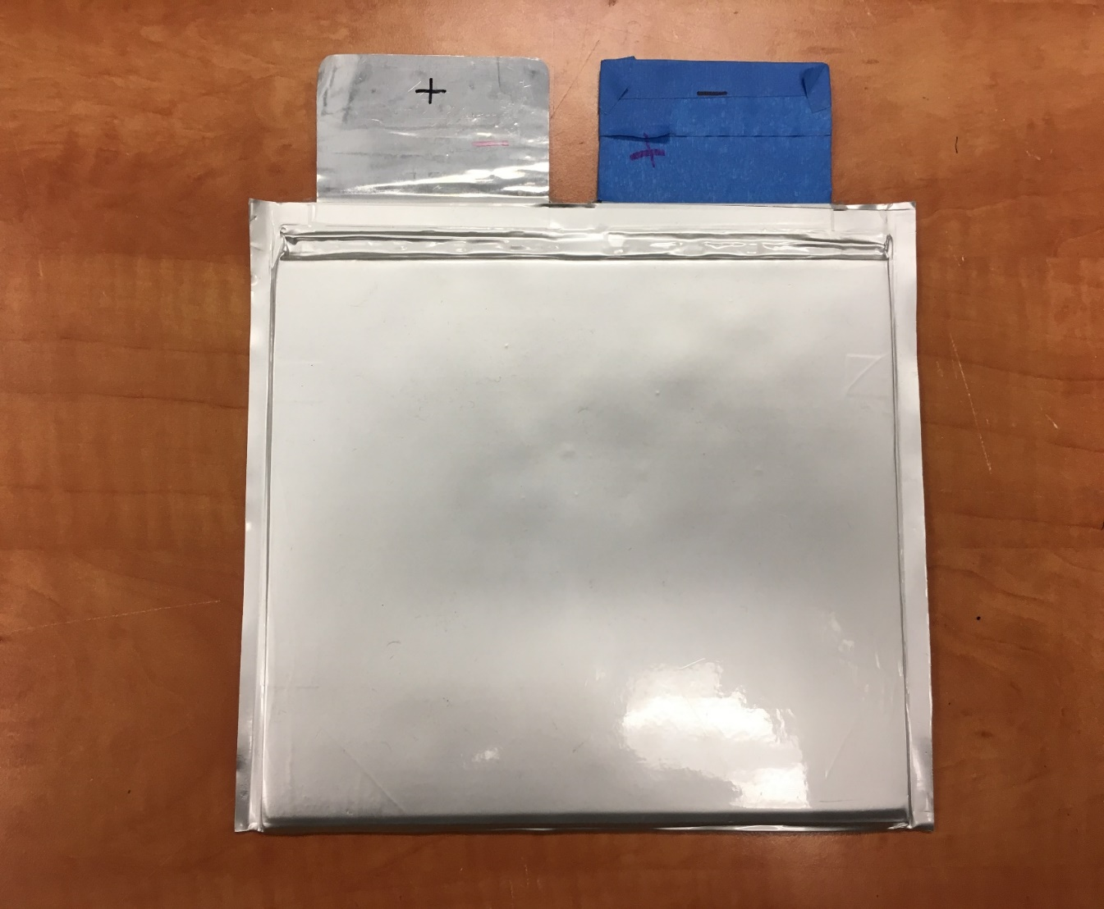

1. 2020 (A/74/6 (Sect.20) and Supplementary, Subprogramme 2). [↑](#footnote-ref-2)