|  |  |  |  |
| --- | --- | --- | --- |
|  | United Nations | ST/SG/AC.10/C.3/2020/39 | |
| _unlogo | **Secretariat** | | Distr.: General  9 April 2020  Original: English |

**Committee of Experts on the Transport of Dangerous Goods  
and on the Globally Harmonized System of Classification  
and Labelling of Chemicals**

**Sub-Committee of Experts on the Transport of Dangerous Goods**

**Fifty-seventh session**

Geneva, 29 June-8 July 2020  
Item 6 (a) of the provisional agenda

**Miscellaneous proposals for amendments to the**

**Model Regulations on the Transport of Dangerous Goods:**

**marking and labelling**

Optical differentiation of labels/placards for gases

Submitted by the experts from Spain and the International Association of Fire and Rescue Services (CTIF)[[1]](#footnote-2)

Background information

1. In the July 2019 session, Spain and CTIF presented a joint proposal for the optical differentiation of labels and placards for gases (see ST/SG/AC.10/C.3/2019/19).

2. The problem that Spain and CTIF intend to solve is that, for different labels corresponding to different classes, the labels can only be differentiated by the numbers indicated in the lower part of the label. This occurs for labels 2.1 and 3, and labels 2.3 and 6, and causes difficulties to distinguish the labels from a distance. Spain and CTIF proposed to differentiate these labels by including into the lower half of labels 2.1 and 2.3 the symbol corresponding to the gas bottle, that can now already be found in the upper half of label 2.2.

3. This modification of the labels would solve the difficulties for the first emergency responders (police, firefighters, etc.) to distinguish easily one label from another. This is essential as a possible mix up of the present labels could lead to erroneous responses at the site of an accident.

4. After discussion of the proposal, it was decided to create an informal correspondence working group to continue the work of this topic (see ST/SG/AC.10/C.3.110, paragraphs 72-75). The correspondence working group meetings were attended by 30 members, representing competent authorities, concerned industry and firefighter associations and started as a platform for the exchange of arguments for and against the general idea of amending the labels for Class 2.

5. At the fifty-sixth session in December 2019 of the Sub-Committee, Spain and CTIF presented informal document INF.37 (56th session), which included a summary of the main aspects that had been discussed by the informal correspondence working group until that date.

6. In that informal document, different aspects that would reinforce the need to differentiate the labels and placards of Class 2 from others were mentioned:

(a) Visual differences improve easy recognition. Symbols can be easily interpreted, also by a wide public. Easy to read without specific training, increases awareness.

(b) Improves safety message worldwide, specifically for first responders.

(c) Avoid mixing up of labels and wrong attachment.

(d) First responders are not a homogenous community, tasks, competence, equipment and training in dangerous goods vary.

(e) Safety distances in incidents involving gas are higher than involving liquids/solids, need to be aware of the hazard without approaching too much.

7. Different difficulties to modify the labels were shown, too:

(a) Industry has 2 billions cylinders worldwide.

(b) The gas bottles themselves are easily recognizable as containing gas, even if gas tanks and other vehicles carrying gas bottles may not be as easily recognizable.

(c) Other sources of information may be available, which give a more complete information, but have to be decoded first:

(i) Orange plate, indicating UN number.

(ii) UN number written on the label in some geographical areas.

(d) Transitional period:

(i) For labels, long transitional periods would be needed and to avoid high costs, the labels could be changed during periodic inspection.

(ii) Confusion may exist during the period of coexistence.

8. Additionally, informal document INF.40 (56th session), transmitted jointly by the World LPG Association (WLPGA) and Liquid Gas Europe (LGE), further elaborated on these arguments.

9. When these proposals were discussed in the plenary, the Sub-Committee agreed on the need to provide clear information on hazard to first responders and to find a practical solution. Nevertheless, several experts were not convinced that the proposed changes would improve the hazard communication and raised concerns about their implications from a cost-benefit perspective, while others expressed their support because they believe that all the aid that can be provided to firefighters and other first responders will have a positive impact on the outcome of their interventions and in their safety. After an exchange of views in plenary, the experts from Spain and CTIF volunteered to lead an informal working group which met in the margins of the plenary.

10. In this informal meeting of the working group the main conclusion was that alternative solutions could be interesting as a possible compromise, listing the following options:

(a) Include the text «gas» in the label or placard.

(b) Include the text «flammable gas» or «toxic gas» in the label or placard.

(c) Include the text mentioned in the options a) or b) plus the UN number on the label or placards, as it is already included in the Model Regulations as an option and some countries are using this option already.

11. Spain and CTIF presented another informal document (UN/SCETDG/56/INF.55) summarizing the conclusions reached by that group. Spain and CTIF pointed out that the inclusion of a text into the label, if this option was chosen, should be mandatory to really allow a differentiation of the labels.

12. The group did not think it was interesting to open the scope of the work to other labels and placards.

13. Additionally, the group agreed on the need to first introduce labels and placards on tanks and big cylinders with shorter transition periods, and then, for small cylinders, longer transition periods would be needed (15 years like the maximum periodicity in between inspections on cylinders). Also, digitalization was mentioned as a possible help in future to complement information.

Analysis

14. For different labels corresponding to different classes, the labels are only differentiated by the numbers indicated in the lower part of the label. This occurs for labels 2.1 and 3, and labels 2.3 and 6:

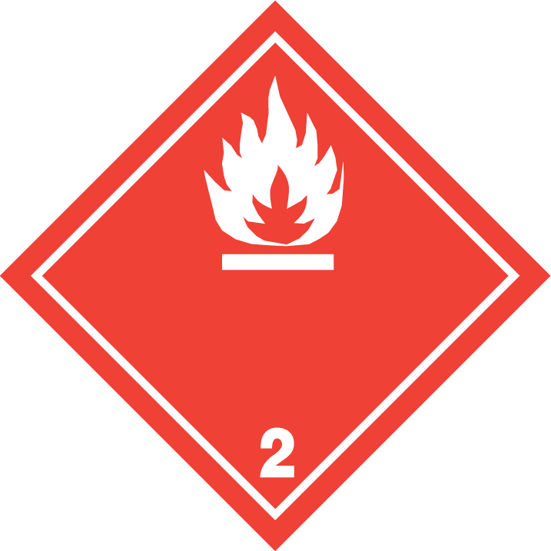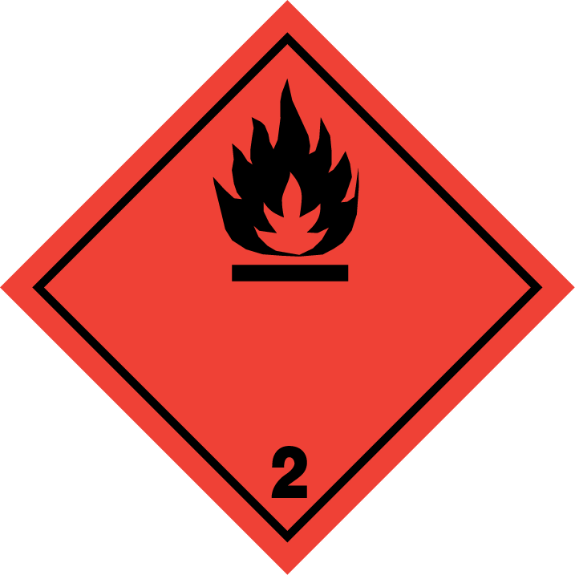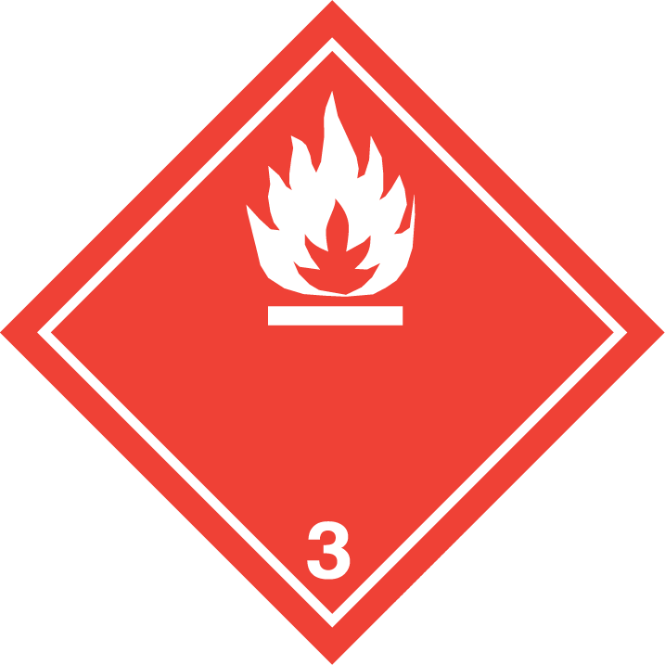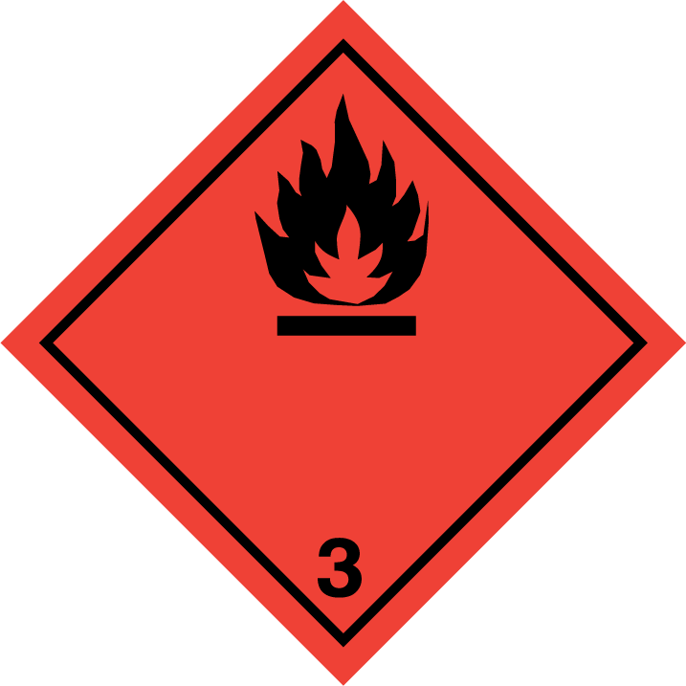

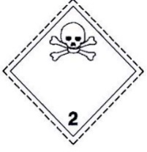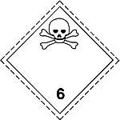

15. This situation can create difficulties for the first emergency responders (police, firefighters, etc.), which should be able to distinguish easily one label from another, even from a distance. A possible mix up could lead to erroneous responses at the site of an accident.

16. Responses to incidents with flammable gases are very different from those involving flammable liquids, and the responses also differ between a toxic gas and a toxic liquid or solid. Visibility and identifying the physical state from a distance is a very important issue, as safety distances vary with the physical state of the substance.

17. Labels 2.1 and 2.3 have the same colour and symbol (flame and crossbones) like labels 3 and 6, respectively, the only difference being the class number indicated in the lower part of the label. These labels could be differentiated from others by including the symbol of the gas cylinder (taken from label 2.2 as shown below) or an additional text into them. Both options are analysed below.

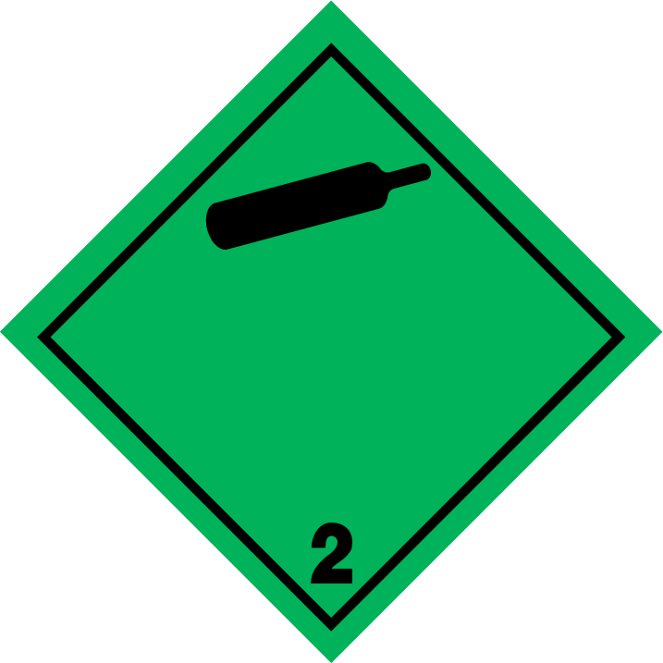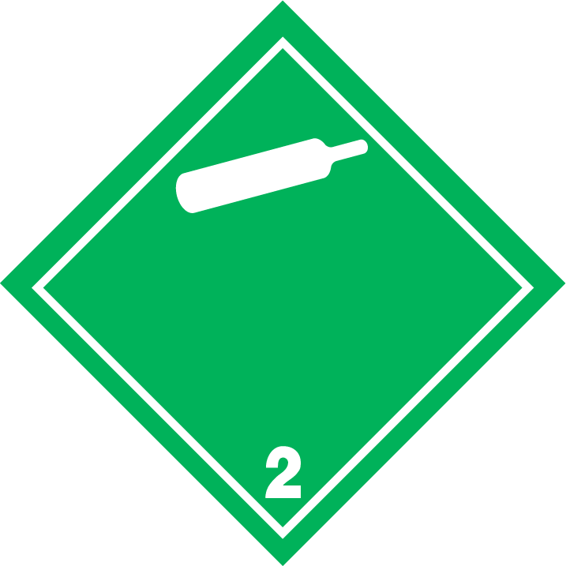

Option 1: Adding a “Gas cylinder symbol” into the label

18. One possibility to differentiate labels 2.1 and 2.3 from labels 3 and 6 could be to introduce the gas bottle symbol into the lower half of the labels.

19. A similar approach, including a symbol into the lower half of the label, has already been adopted for the 9A label. A possible design could be as follow:

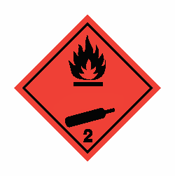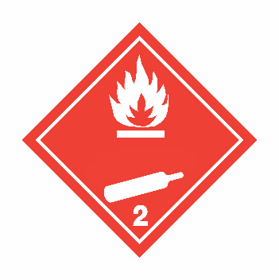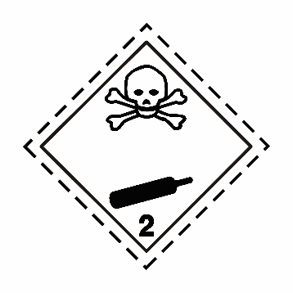

20. In this design, the label remains like in its present design, and the gas cylinder, already clearly associated to gases, would be included into the lower half. All gas labels would then include the symbol for the gas cylinder, and this would allow an easy recognition of these labels from the distance. The gas cylinder symbol is now included into label 2.2, and is well known and identified as gas.

21. This solution would have the advantage that the information would be "readable" and understandable as a pictorial symbol, not depending on the language. As a disadvantage, those countries currently requiring already the inclusion of some text (gas, flammable gas/toxic gas) would have redundant information in the label.

22. The design proposed here is different than the one presented in previous proposals (see ST/SG/AC.10/C.3/2019/19), as the symbol has been placed in such a way that the center of the label is free, to make it possible in an easy way to introduce there text or UN numbers, if required by any regional legislation.

Option 2: Adding text to the label

23. Adding text into the labels 2.1 and 2.3 would also permit to differentiate these labels from others. In this case, there are two options to include:

(a) the text « gas » into the labels lower part, or

(b) the text « flammable gas » or « toxic gas » into the lower part of the labels.

24. Both options have the advantage that, as is already mentioned in 5.2.2.2.1.3 that it is possible to include such a text, some countries already apply this solution as mandatory, and therefore it would be easier for all stakeholders to further implement this solution.

25. In addition to this text, the UN number, if desired, is a possibility already permitted by the Model Regulations. Nevertheless, the mandatory inclusion of the UN number into the label was considered not necessary, as the goal of differentiating gases from liquids or solids is better achieved by including a more general information related specifically to the gaseous state.

Option 2A

26. As it was mentioned before, responses to incidents with gases are very different from those involving liquids, and the responses also differ between a toxic gas, flammable gas, liquid or solid. Visibility and identifying the physical state from a distance are very important.

27. For that reason, the essential information to be included in the label is “gas” and the word "gas", in general, is very similar (gas/gaz) in several languages (English, French, Spanish, German, Portuguese …), and therefore would be more easily understandable. A possible design could be as follows:

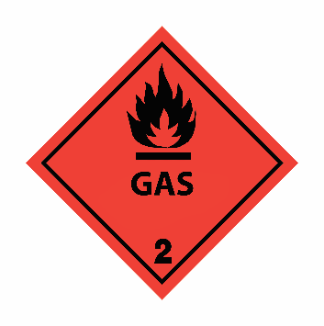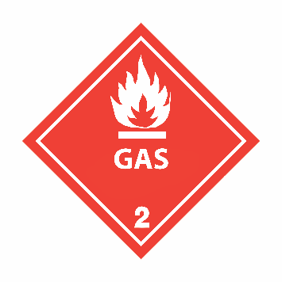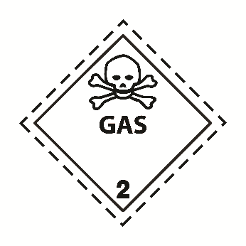

28. However, in the official UN languages there would be significant differences in the words for “gas” in the different languages, as shown below.

|  |  |
| --- | --- |
| **Official UN languages** | **Text** |
| English | gas |
| French | gaz |
| Chinese | 加油站 |
| Arabic | غاز |
| Spanish | gas |
| Russian | газ |

Option 2B

29. Some countries already require to include “flammable gas” or “toxic gas” in the labels, and this would certainly ease the insertion of "flammable gas" or "toxic gas” and its implementation for some of the stakeholders. Nevertheless, the additional text in English is not so understandable in other languages. The information "toxic" or ""is already clearly conveyed by the flammable/toxic pictogram in the upper half of the label.

30. A possible design could be as follows:

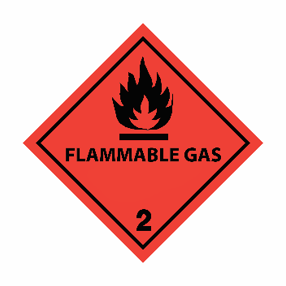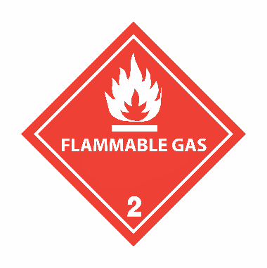 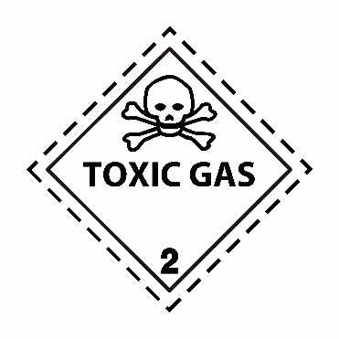

31. Countries which have been using the descriptive words on labels for many years do not refer any concerns raised by industry or Emergency Services in relation to this label. It would seem reasonable to grant a continuity to this system.

32. After a discussion in the informal working group, considering all the arguments given by the different authorities and associations, it seems that the best option in between the two options including texts, would be to require at least the insertion of the text « gas » into the labels lower part, and to leave as an option to substitute this text by a more detailed text, such as « flammable gas » or « toxic gas ».

Main benefits of the proposed amendments

33. In all the cases, the additional symbol/text would enhance safety, as it would permit to differentiate the labels clearly signaling the gas content. Clear information on the gaseous state can prevent possible accidents, which is important for first responders, but also for all stakeholders involved in the supply chain. What may seem a small advantage of a very short time to get the correct information, take decisions and adapt correctly to the situation, may be an essential advantage for the first responders. For technicians working in the gas supply chain it may be easy to identify a tank for liquids from a tank for gases, but for those who are not working with them on a daily basis, it may be a difficult task.

34. All of the above-mentioned circumstances are particularly important because emergency responders are not a homogenous community; they have different levels of competence, equipment and training in dangerous goods. In many countries firefighters are volunteers and don’t have easy access to continuous training. This symbol/text would enable to transmit clear information to all, including the general public, without approaching the tanker/truck, minimizing exposure and the resulting risks.

35. The new labels could be included into the modal regulations with a very long transitional period. As the new labels only add information to the existing ones, there is little risk that they could cause confusion or be mistaken.

Proposals

36. Following the discussions in the working group, Spain and CTIF present to the Sub-Committee two different alternate options, one proposing to include the symbol of the gas bottle and another one to include the text “gas” in the lower part.

Proposal 1

37. The expert from Spain and CTIF propose to modify labels 2.1 and 2.3 to include the gas receptacle symbol into the lower part of the label.

38. Therefore, the expert from Spain and CTIF propose to modify 5.2.2.2.2 for label numbers 2.1 and 2.3. Deleted text is ~~stricken through~~, new text is underlined; for the specimen labels of labels 2.1 and 2.3, only the new labels are shown, as it is not possible to strike through or underline the labels in the existing text.

|  |  |  |  |  |  |  |  |
| --- | --- | --- | --- | --- | --- | --- | --- |
| **Label model No.** | **Division or Category** | **Symbol and symbol colour** | **Background** | **Figure in bottom corner (and figure colour)** | **Specimen labels** | | **Note** |
| **Class 2: Gases** | | | | | | | |
| 2.1 | Division 2.1: Flammable gases | Flame in upper half: black or white  Gas cylinder in lower half: black or white  (except as provided for in 5.2.2.2.1.6 d)) | Red | 2  (black or white)  (except as provided for in 5.2.2.2.1.6 d)) | 2_1 negra_botella hueco para escribir ACOPLAR | 2_1 blanca_botella hueco para escribir ACOPLAR | - |
| 2.2 | Division 2.2:  Non-flammable, non-toxic gases | Gas cylinder: black or white | Green | 2  (black or white) |  |  | - |
| 2.3 | Division 2.3: Toxic gases | Skull and crossbones in upper half: black  Gas cylinder in lower half: black | White | 2  (black) | 2_3 calabera_botella acoplar | | - |

39. As a consequential amendment, 5.2.2.2.1.3 should be modified, including the following new third sentence:

“5.2.2.2.1.3 With the exception of labels for division 1.4, 1.5 and 1.6 of Class 1, the upper half of the label shall contain the pictorial symbol and the lower half shall contain the class or division number 1,2,3,4,5.1,5.2,6,7,8 or 9 as appropriate. However, for label model No. 9A, the upper half of the label shall only contain the seven stripes of the symbol and the lower half shall contain the group of batteries of the symbol and the class number. Labels for division 2.1 and 2.3 shall additionally contain a symbol for the gas cylinder in the lower half of the label. Except for label model No. 9A, the label may include such text as the UN number, or words describing the hazard class (e.g. “flammable”) in accordance with 5.2.2.2.1.5 provided that the text does not obscure or detract from the other required label elements.”

Proposal 2

40. The expert from Spain and CTIF propose to modify labels 2.1 and 2.3 to include the word « gas » into the lower part of the label. The inclusion of the text « flammable gas » or « toxic gas » instead of only « gas » should be left as an additional option, for those regions where its authorities require it.

41. The expert from Spain and CTIF propose to modify 5.2.2.2.2 for label numbers 2.1 and 2.3. Deleted text is ~~stricken through~~, new text is underlined; for the specimen labels of labels 2.1 and 2.3, only the new labels are shown, as it is not possible to strike through or underline the labels in the existing text.

|  |  |  |  |  |  |  |  |
| --- | --- | --- | --- | --- | --- | --- | --- |
| **Label model No.** | **Division or Category** | **Symbol and symbol colour** | **Background** | **Figure in bottom corner (and figure colour)** | **Specimen labels** | | **Note** |
| **Class 2: Gases** | | | | | | | |
| 2.1 | Division 2.1: Flammable gases | Flame: black or white  (except as provided for in 5.2.2.2.1.6 d)) | Red | 2  (black or white)  (except as provided for in 5.2.2.2.1.6 d)) | 2_1 negra_botella GAS acoplar | 2_1 blanca_botella GAS acoplar | Text (mandatory), black or white (same colour as symbol) in lower half of the label: “GAS” |
| 2.2 | Division 2.2:  Non-flammable, non-toxic gases | Gas cylinder: black or white | Green | 2  (black or white) |  |  | - |
| 2.3 | Division 2.3: Toxic gases | Skull and crossbones: black | White | 2  (black) |  | | Text (mandatory), black in lower half of the label: “GAS” |

42. As a consequential amendment, 5.2.2.2.1.3 should be modified, including the following new third sentence:

“5.2.2.2.1.3 With the exception of labels for division 1.4, 1.5 and 1.6 of Class 1, the upper half of the label shall contain the pictorial symbol and the lower half shall contain the class or division number 1,2,3,4,5.1,5.2,6,7,8 or 9 as appropriate. However, for label model No.9A, the upper half of the label shall only contain the seven stripes of the symbol and the lower half shall contain the group of batteries of the symbol and the class number. Labels for division 2.1 and 2.3 shall contain the text « gas » in the lower half of the label; this text may be substituted by the texts “flammable gas” or “toxic gas”, respectively. Except for label model No.9A, the label may include such text as the UN number, or words describing the hazard class (e.g. “flammable”) in accordance with 5.2.2.2.1.5 provided that the text does not obscure or detract from the other required label elements.”

Additional amendments common for all options

Transition periods

43. A transitional period for these labels, of at least 6 years for tanks and big cylinders and 15 years for small cylinders (like the typical LPG bottles), to allow that older models of labels may still be used and to permit the changes in the labels to be made at the occasion of periodic revisions, thus reducing the cost and simplifying the implementation of this measure.

44. To permit a transition period for cylinders of 15 years, and a shorter transitional period of 4 years for placards, notes to 5.2.2.2.1.2 and 5.3.1.2.1 should be included, and a reference to these should be included in a note to 5.2.2.2.2.

45. Under 5.2.2.2.2 a note should be added:

*“****NOTE:*** *For continued use of the labels 2.1 and 2.3 as described in 5.2.2.2.2 in the twenty-first revised edition of the Recommendations on the Transport of Dangerous Goods, see notes under 5.2.2.2.1.2 and 5.3.1.2.1.”*

46. In 5.2.2.2.1.2. add the following note:

*“****NOTE 2:*** *The labels 2.1 and 2.3 described in 5.2.2.2.2 in the twenty-first revised edition of the Recommendations on the Transport of Dangerous Goods used on gas cylinders may continue to be applied until 31 December 2036”.*

47. To permit a transition period for placards of 4 years in the modal regulations, a note to 5.3.1.2.1 should be added:

“***NOTE:*** *The placards corresponding to the labels 2.1 and 2.3 described in 5.2.2.2.2 in the twenty-first revised edition of the Recommendations on the Transport of Dangerous Goods may continue to be applied until 31 December 2027”.* Maintaining symbols, numbers, lines and text in one colour.

48. In general, symbols, numbers and text shall be all in black (see 5.2.2.2.1.6), except in the cases provided for in 5.2.2.1.6 a)-d). Nevertheless, to stress that all of these elements, together with the lines, should always be in the same colour, a slight clarification could be included into 5.2.2.2.1.6:

“5.2.2.2.1.6 The symbols, text, lines and numbers shall be shown in black in all labels except for:

(a) The Class 8 label, where the text (if any) and class number shall appear in white;

(b) Labels with entirely green, red or blue backgrounds where they may be shown in white. Symbols, numbers, lines and text (if any) shall all be all the same colour;

(c) The Division 5.2 label, where the symbol may be shown in white; and

(d) The Division 2.1 label displayed on cylinders and gas cartridges for liquefied petroleum gases, where they may be shown in the background colour of the receptacle if adequate contrast is provided.”

1. 2020 (A/74/6 (Sect.20) and Supplementary, Subprogramme 2 [↑](#footnote-ref-2)