|  |  |  |  |
| --- | --- | --- | --- |
|  | United Nations | ST/SG/AC.10/C.3/2020/39/Rev.1 | |
| _unlogo | **Secretariat** | | Distr.: General  9 September 2020  Original: English |

**Committee of Experts on the Transport of Dangerous Goods  
and on the Globally Harmonized System of Classification  
and Labelling of Chemicals**

**Sub-Committee of Experts on the Transport of Dangerous Goods**

**Fifty-seventh session**

Geneva, 30 November-8 December 2020  
Item 6 (a) of the provisional agenda

**Miscellaneous proposals for amendments to the**

**Model Regulations on the Transport of Dangerous Goods:**

**marking and labelling**

Optical differentiation of placards for gases

Submitted by the experts from Spain and the International Association of Fire and Rescue Services (CTIF)[[1]](#footnote-2)

Revision

Background information

1. This document is a revision of document ST/SG/AC.10/C.3/2020/39 initially prepared for the June/July session of the Sub-Committee, which included two different alternative options.

2. The first option proposed to modify labels 2.1 and 2.3 to include the gas receptacle symbol into the lower part of the label and the second one also proposed to modify labels 2.1 and 2.3 but to include the word « gas » into the lower part of the label (leaving the inclusion of the text « flammable gas » or « toxic gas » instead of only « gas » as an additional option, for those regions where its authorities require yet or could require to include the text “gas” in the lower part).

3. Due to the COVID-19 situation, the fifty-seventh TDG session was postponed, but Spain and CITF received written comments from several delegations through the UN platform and had an online discussion on the proposals presented. Spain and CTIF are grateful for the interest in the subject, and for the search of a constructive solution to it. The position of the delegations as shared in the written comments and online discussion were divided. Looking for a solution, the American and French delegations suggested the possibility of including additional symbols/language only in the placards and not in the labels.

4. This alternative proposal had already been briefly discussed in one of the lunchtime working groups in Geneva in past sessions, but at that moment, it was decided that this would not be a desirable option.

5. However, in view of the current state of discussions, Spain and CTIF sent a consultation to the working group on 15 July 2020, to which, due to the summer time and COVID-19 restraints, not many delegations have been able to answer before the time of submission of documents, to confirm if this solution could be acceptable.

6. The proposals presented in this document intend to propose a written formal text for the option of modifying only the placards, in the case the working group could support this option according to its discussions in autumn.

Analysis

7. The alternative analysed in this document would imply to modify only the placards, but not the labels 2.1 and 2.3 for flammable and toxic gases. Not modifying the labels would diminish the costs of the measure a lot, as the individual cylinders would not need an updated label. Meanwhile, the principal goal to ensure good visibility and recognition from the distance for first responders would be achieved with the modified placards.

8. Nevertheless, this would not be the usual approach, as normally the labels and placards are alike, and may not be desirable, even if there exist already exceptions to this situation (see paragraph 22).

Proposal

9. Spain and CTIF present to the Sub-Committee two different alternate options, the first proposing to include the symbol of the gas bottle in the lower part of the placard and the second to include the text “gas” in the lower part of the placard. As we mentioned before, in both cases, the labels would not be modified, only the placards.

Proposal 1

10. The expert from Spain and CTIF propose to modify the placards corresponding to Class 2, only for Division 2.1 and 2.3, to include the gas receptacle symbol into the lower part of the placard.

11. Therefore, the expert from Spain and CTIF propose to modify 5.3.1.2.1 including the following new sixth sentence (new text is underlined):

“5.3.1.2.1 Except as provided in 5.3.1.2.2 for the Class 7 placard, and in 5.3.2.3.2 for the environmentally hazardous substance mark, a placard shall be configured as shown in Figure 5.3.0.

#### Figure 5.3.0

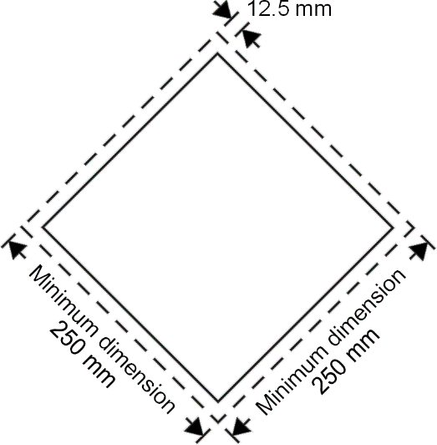

Placard (except for class 7)

The placard shall be in the form of a square set at an angle of 45 degrees (diamond-shaped). The minimum dimensions shall be 250 mm x 250 mm (to the edge of the placard). The line inside the edge shall be parallel and 12.5 mm from the outside of that line to the edge of the placard. The symbol and line inside the edge shall correspond in colour to the label for the class or division of the dangerous goods in question. For Class 2, Division 2.1 (Flammable gases) and Division 2.3 (Toxic gases), the placard shall include additionally the symbol of a gas cylinder (black or white) in the lower part of the placard (see Figure 5.3.1). The placard shall display the number of the class or division (and for goods in Class 1, the compatibility group letter) of the dangerous goods in question in the manner prescribed in 5.2.2.2 for the corresponding label, in digits not less than 25 mm high. Where dimensions are not specified, all features shall be in approximate proportion to those shown.

Figure 5.3.1

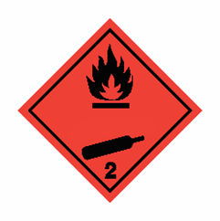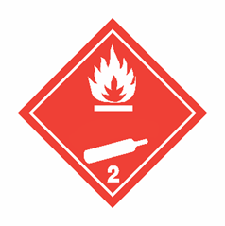 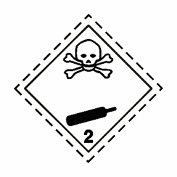

Placards for Division 2.1 Placards for Division 2.3 ”

Proposal 2

12. Alternatively it is proposed to modify the placards corresponding to Class 2, only for Division 2.1 and 2.3, to include the word « gas » into the lower part of the placard.

13. Through the voluntary application, or following the requirements of regional provisions, of the last sentence of 5.2.2.2.1.3, the text « flammable gas » or « toxic gas » can be included instead of only « gas ».

14. Therefore, the expert from Spain and CTIF propose to modify 5.3.1.2.1 including the following new sixth sentence (new text is underlined):

“5.3.1.2.1 Except as provided in 5.3.1.2.2 for the Class 7 placard, and in 5.3.2.3.2 for the environmentally hazardous substance mark, a placard shall be configured as shown in Figure 5.3.0.

#### Figure 5.3.0



Placard (except for class 7)

The placard shall be in the form of a square set at an angle of 45 degrees (diamond-shaped). The minimum dimensions shall be 250 mm x 250 mm (to the edge of the placard). The line inside the edge shall be parallel and 12.5 mm from the outside of that line to the edge of the placard. The symbol and line inside the edge shall correspond in colour to the label for the class or division of the dangerous goods in question. For Class 2, Division 2.1 (Flammable gases) and Division 2.3 (Toxic gases), the placard shall include the text “GAS”, black or white (same colour as symbol) into the lower part of the placard (see Figure 5.3.1). The placard shall display the number of the class or division (and for goods in Class 1, the compatibility group letter) of the dangerous goods in question in the manner prescribed in 5.2.2.2 for the corresponding label, in digits not less than 25 mm high. Where dimensions are not specified, all features shall be in approximate proportion to those shown.

Figure 5.3.1

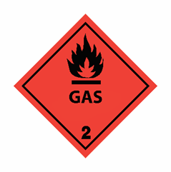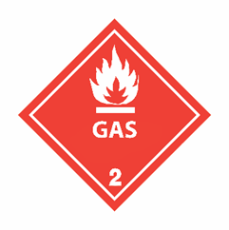 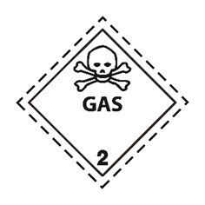

Placards for Division 2.1 Placards for Division 2.3 ”

Display of UN Numbers on placards for Division 2.1 and 2.3

15. For gases transported in tank cargo transport units (including on each component of a multicompartment tank cargo transport unit), the UN number shall be displayed as required in 5.3.2.1 of the Model Regulation.

16. For both proposals as mentioned in paragraphs 11 and 14 above, this possibility has considered to define the dimensions of the bottle symbol (proposal 1) or text (proposal 2) with an appropriate position and size to leave place for including the UN number in the placard, although, as mentioned in 5.3.2.1.3, it is also possible to include the UN number on an orange rectangular to be placed immediately adjacent to each placard.

17. An example of proposal 1 and 2 including also the UN numbers in the placard could be the following:

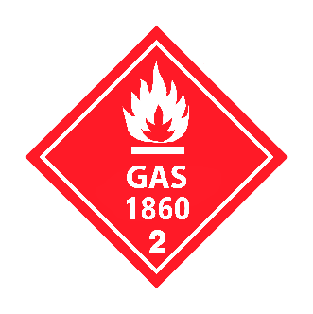



\* location of class or division number

\*\* location of UN number

Main benefits of the proposed amendments

18. As it was commented in previous documents, in all the cases, the additional symbol/text would enhance safety, as it would permit to differentiate the placards clearly signaling the gas content. Clear information on the gaseous state can prevent possible accidents, which is important for first responders, but also for all stakeholders involved in the supply chain. What may seem a small advantage of a very short time to get the correct information, take decisions and adapt correctly to the situation, may be an essential advantage for the first responders. For technicians working in the gas supply chain it may be easy to identify a tank for liquids from a tank for gases, but for those who are not working with them on a daily basis, it may be a difficult task.

19. All of the above-mentioned circumstances are particularly important because emergency responders are not a homogenous community; they have different levels of competence, equipment and training in dangerous goods. In many countries, firefighters are volunteers and do not have easy access to continuous training. This symbol/text would enable to transmit clear information to all, including the general public, without approaching the tanker/truck, minimizing exposure and the resulting risks.

20. Comparing with the proposal included in document ST/SG/AC.10/C.3/2020/39, this revised proposal would diminish the costs of the measure a lot, and would ensure a good visibility and recognition from the distance because in practice, a pictogram or a text on a placard would be ever seen by emergency responders better than in a reduced label on the shoulder or the neck of a cylinder.

21. So, this potential solution meets both the stated goal of improving recognition, and thus appropriate and timely response to incidents, and mitigates costs and downstream impacts associated with the change but, it is important to note that this would not be the usual approach, as normally the labels and placards are alike.

22. There are precedents for having differences in between labels and placards:

* For Class 7, the placard is unlike any of the 4 different labels (even if carrying a “big label” is allowed for certain cases) (see 5.3.1.1.5.1).
* For Class 9, the placard always shows label 9, and never 9A (this regulation is included into the modal regulation, and not in the Model Regulation) (see for example RID 5.3.1.1.4).

23. The new proposals included in this document are essentially the opposite of the way handled for the amendment to the Class 9 label to include the battery symbol. The symbol is required on the label, but when the modes incorporated it, they did not require the symbol on the placard. The rational shall be that the specific identification of the material (e.g., lithium battery versus other random Class 9) is more important to those with direct exposure to the package itself, instead of the entire containerized load. Nevertheless, for division 2.1 and 2.3, it seems that the identification is most important and thus simply the placards could be amended.

24. In addition to the American and French delegations, written comments were received in June 2020 through the UNECE platform, and lend some credence to this idea, that a primary concern should be improving the possibility of awareness to responders through placarding improvements and identification at a distance.

25. Spain and CTIF agree that a final decision on the different options shall be made at the November 2020, on the basis of the discussions at the working group in autumn.

Transitional period

26. For these placards, a transitional period of at least 4 years shall be added to allow that older placards may still be used and to permit the changes in the placards.

27. To permit a transition period for placards of 4 years in the modal regulations, a note to 5.3.1.2.1 should be added:

“***NOTE:*** *The placards corresponding to the labels 2.1 and 2.3 described in 5.2.2.2.2 in the twenty-first revised edition of the Recommendations on the Transport of Dangerous Goods may continue to be applied until 31 December 2027”.*

Additional amendments

28. As a consequential amendment, in Chapter 5.3, all the figures from 5.3.1 onwards shall be renumbered.

29. In general, symbols, numbers and text shall be all in black (see 5.2.2.2.1.6), except in the cases provided for in 5.2.2.1.6 a)-d). Nevertheless, to stress that all of these elements, together with the lines, should always be in the same colour, a slight clarification could be included into 5.2.2.2.1.6 as follows:

“5.2.2.2.1.6 The symbols, text, lines and numbers shall be shown in black in all labels except for:

(a) The Class 8 label, where the text (if any) and class number shall appear in white;

(b) Labels with entirely green, red or blue backgrounds where they may be shown in white. Symbols, numbers, lines and text (if any) shall all be all the same colour;

(c) The Division 5.2 label, where the symbol may be shown in white; and

(d) The Division 2.1 label displayed on cylinders and gas cartridges for liquefied petroleum gases, where they may be shown in the background colour of the receptacle if adequate contrast is provided.”

1. 2020 (A/74/6 (Sect.20) and Supplementary, Subprogramme 2) [↑](#footnote-ref-2)