|  |  |  |  |
| --- | --- | --- | --- |
|  | United Nations | ST/SG/AC.10/C.3/2020/35 | |
| _unlogo | **Secretariat** | | Distr.: General  8 April 2020  Original: English |

**Committee of Experts on the Transport of Dangerous Goods  
and on the Globally Harmonized System of Classification  
and Labelling of Chemicals**

**Sub-Committee of Experts on the Transport of Dangerous Goods**

**Fifty-seventh session**

Geneva, 29 June-8 July 2020  
Item 6 (b) of the provisional agenda

**Miscellaneous proposals for amendments to the Model Regulations   
on the Transport of Dangerous Goods: packagings**

Scope of 4G packaging and the translation of the Chinese version

Transmitted by the expert from China[[1]](#footnote-2)

Introduction

1. In the recommendations on the Transport of Dangerous Goods Model Regulations, codes which consisted of Arabic number and a capital letter are used for designating types of UN packaging. It is pointed out in 6.1.2.6 that letter “G” indicates the packaging material “Fibreboard”. In 6.1.4.12 on the packaging 4G “Fibreboard boxes”, it is stated that “strong and good quality solid or double –faced corrugated fibreboard (single or multiwall) shall be used, appropriate to the capacity of the box and to its intended use” (see 6.1.4.12). However, in 6.1.4.7 which explains that “1G” means “Fibre drums”, the statement can be found that “The body of the drum shall consist of multiple plies of heavy paper or fibreboard (without corrugations) firmly glued or laminated together”. It seems that, in these two paragraphs, the letter “G” does not indicate the same packaging material. However, in the French version, the letter “G” indicates the packaging material “carton” and this word is used in 1G and 4G.

2. According to the Chinese standard system on packaging materials, the two terms, “fibreboard” and “corrugated fibreboard” refer to two different packaging materials. Examples of “corrugated fibreboard boxes” and “corrugated fibreboard” are shown in Figure 1 and Figure 2 respectively. And “fibreboard box” is shown in Figure 3.

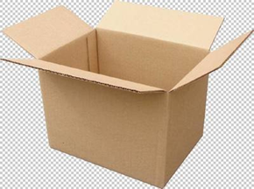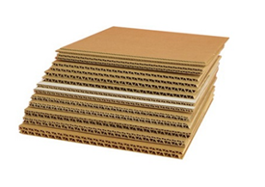

Figure 1: corrugated fibreboard box Figure 2: corrugated fibreboard

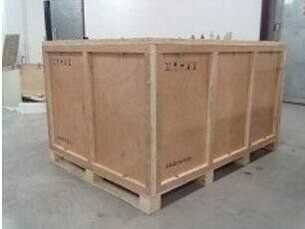

Figure 3: fibreboard box



Figure 4: Single wall corrugated fibreboard



Figure 5 Typical double wall corrugated fibreboard

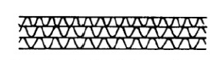

Figure 6 Typical triple wall corrugated fibreboard

3. In British Standard BS 1133 packaging code, two types of fibreboard are used for the construction of cases as follows: a) solid fibreboard and b) corrugated fibreboard (see BS 1133 Section 7: Paper and board wrappers, bags and containers, Subsection 7.5 Fibreboard cases and fitments, Chapter 5.1 Types of fibreboard). And, corrugated fibreboard can be further divided into single-wall, double-wall and triple-wall corrugated fibreboard (shown in Figures 4 to 6 above). Based on these descriptions, “corrugated fibreboard” in BS 1133 packaging code refers to the same materials as in the Chinese standard system on packaging material.

4. However, there is an inconsistency existing in the Chinese version of the Model Regulations. “Corrugated fibreboard”and“fibreboard，corrugated”are translated into two Chinese terms, one term is used in packing instruction P134, LP 102 (in column “inner packaging” under the class of “sheet”), PP95 in packing instruction P520 and in 6.1.4.12.1 (twice). The other term appears in 6.5.5.4.17（twice）, 6.5.5.5.3（twice）and 6.6.4.4.1.

5. A lithium battery has the advantages of small size and high energy, which is more and more widely used in industries, and the need of transportation of lithium battery and its equipment is increasing. At present, lithium batteries in China are mainly transported by road, air and sea. Some of the packaging used in the transport is a corrugated fibreboard box shown in Figure 1, with the packaging code marked on the UN packaging as “4G”.

Proposal

6. The experts from China invite sub-committee to discuss the following issues:

7. We would like to ask the sub-committee to clarify whether “fibreboard” in the English version and “carton” in the French version mean the same material.

8. We would also like to ask the Sub-Committee to clarify whether the term "Fibreboard" in 4G in the Model Regulations contains the "corrugated fibreboard" described in BS 1133 and whether the fibreboard (without corrugations) in 6.1.4.7.1 is a solid fibreboard.

9. If 4G contains the corrugated fibreboard material shown in the figures above, it is recommended that the relevant content of the Chinese version of the Model Regulations could be revised by using the terms in the Chinese national standards GB/T6544-2008, in order to normalize the two different translations and facilitate the understanding of Chinese enterprises and management departments. The Chinese expert will submit a marked-up revised copy and ask for the secretariat’s assistance to forward this request to the UN linguistic services.

10. If the "Fibreboard" in 4G of the Model Regulations does not contain the "corrugated fibreboard" as described in the figures above, it is recommended that the "corrugated fibreboard" should be illustrated in the relevant sections of the Model Regulations to avoid misuse by enterprises and to ensure the safety of the transport of goods.

1. 2020 (A/74/6 (Sect.20) and Supplementary, Subprogramme 2) [↑](#footnote-ref-2)