|  |  |  |  |
| --- | --- | --- | --- |
|  | United Nations | ST/SG/AC.10/C.3/112/Add.1 | |
| _unlogo | **Secretariat** | | Distr.: General  7 January 2020  English  Original: English and French |

**Committee of Experts on the Transport of Dangerous Goods  
and on the Globally Harmonized System of Classification  
and Labelling of Chemicals**

**Sub-Committee of Experts on the Transport of Dangerous Goods**

Report of the Sub-Committee of Experts on the Transport of Dangerous Goods on its fifty-sixth session

held in Geneva from 4 to 10 December 2019

Addendum

Contents

Annexes

*Page*

I. Draft amendments to the seventh revised edition of the Manual of Tests and Criteria (ST/SG/AC.10/11/Rev.7) 2

II. Draft amendments to the twenty-first revised edition of the Recommendations on the   
Transport of Dangerous Goods, Model Regulations (ST/SG/AC.10/1/Rev.21) 8

III. Corrections to the twenty-first revised edition of the Recommendations on the   
Transport of Dangerous Goods, Model Regulations (ST/SG/AC.10/1/Rev.21) 21

Annex I

Draft amendments to the seventh revised edition of the Manual of Tests and Criteria (ST/SG/AC.10/11/Rev.7)

Section 20

[20.3.3.3 In the first sentence, after “differential scanning calorimetry” add “(DSC)”.

Modify the last sentence to read as follows: “If differential scanning calorimetry is used, the onset temperature is defined as the temperature of the first noticeable exothermic effect (i.e. the heat production signal leaves the baseline).”]

*(Reference document: ST/SG/AC.10/C.3/2019/64, as amended)*

[20.3.4 Insert a new section 20.3.4 to read as follows:

“**20.3.4 Thermal stability of samples and temperature control assessment for transport**

20.3.4.1 The provisions in this section are only applicable to samples of sections 2.4.2.3.2.4 (b) and 2.5.3.2.5.1 in cases where the SADT is not known.

20.3.4.2 If the decomposition onset in a DSC measured in accordance with 20.3.3.3 is found at 160 °C or above, the estimated SADT of the sample may be assumed to be greater than 55 °C. According to 2.4.2.3.4 of the Model Regulations, temperature control is not required in such cases. Isolated small exotherms less than 20 J/g preceding the main decomposition may be neglected.

20.3.4.3 For purposes of determining the need for temperature control, a thermal stress test based on DSC measurements may be applied as follows: A DSC is measured as outlined in 20.3.3.3 for the sample as offered for transport. A second sample is taken, and thermal stress is applied by tempering the sample in the closed DSC crucible at a defined constant temperature over a certain period of time. In standard cases, a 24-hour stress time is deemed sufficient. The stressed sample is then cooled to room temperature before being subjected to a DSC measurement at the same heating rate as before. If the decomposition behavior remains unchanged by comparison of the two DSCs in terms of decomposition onset, shape of curve, and energy within a measurement uncertainty of 10 %, the sample is considered stable at the applied stress temperature. For flat peaks with a maximum heat production of 0.2 W/g a deviation of 25 % is tolerable in temperature ranges below 250 °C and 40 % above this limit. If the stress test is passed according to these criteria at 60 °C, then no temperature control is required.

20.3.4.4 If the sample fails the stress test at 60 °C, then the same procedure should be applied at decreasing temperatures in steps of 10 K until the decomposition behavior remains unchanged. That temperature should be deemed the estimated SADT of the sample, and the control and emergency temperatures may then be derived in accordance with section 28.2.3 and table 28.2.

20.3.4.5 Examples for passing the thermal stress test are shown in figure 20.2. Figure 20.3 contains examples of samples failing the stress test. A flow chart for the procedure is given in figure 20.4.

**Figure 20.2: Examples of samples passing the thermal stress test**

Example 1:

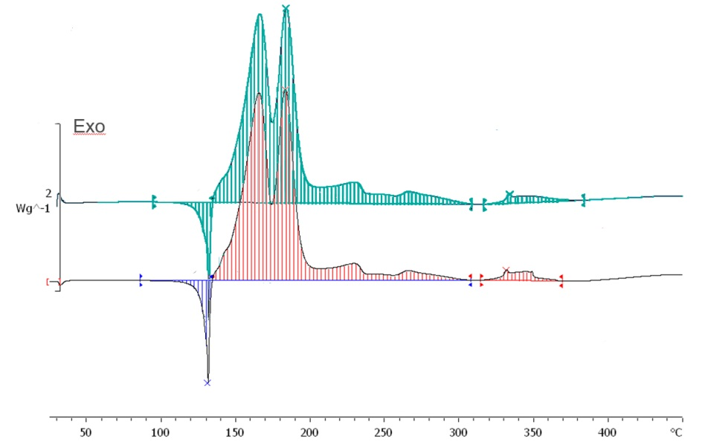

1813 J/g

1703 J/g

95 J/g

106 J/g

Original sample

Sample after thermal stress (60 °C / 24 h)

Example 2:

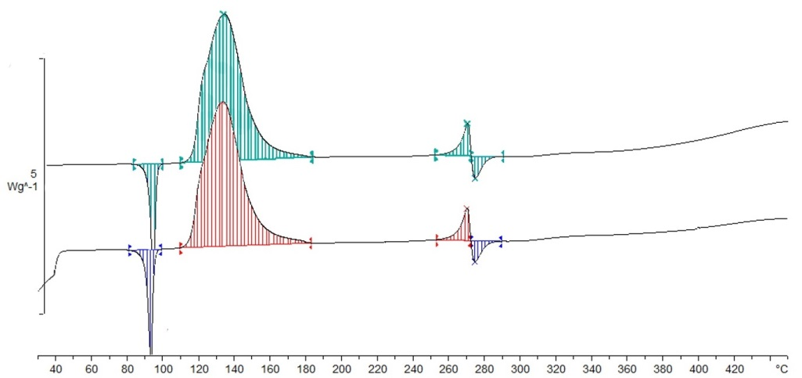

Exo

1414 J/g

1449 J/g

150 J/g

165 J/g

71 J/g

51 J/g

73 J/g

53 J/g

Original sample

Sample after thermal stress (60 °C / 24 h)

Example 3:

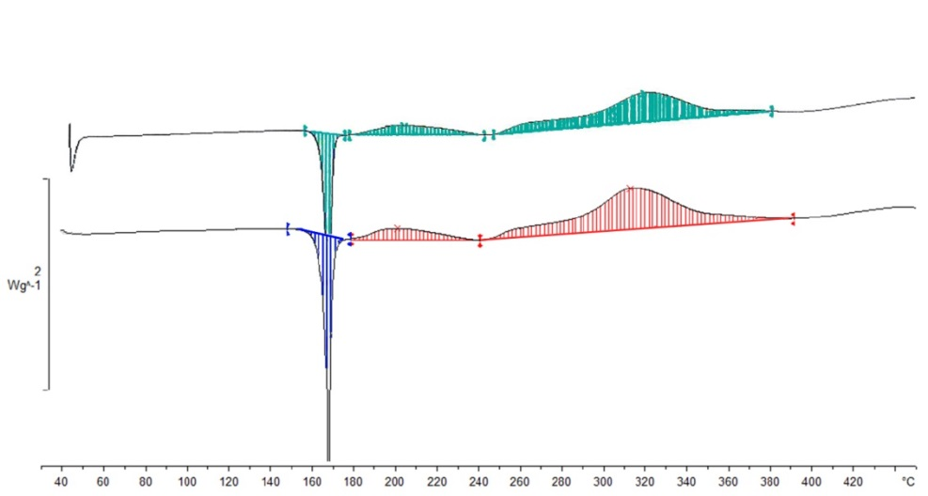

Exo

83 J/g

416 J/g

66 J/g

166 J/g

383 J/g

164 J/g

Original sample

Sample after thermal stress (75 °C / 24 h)

Example 4:

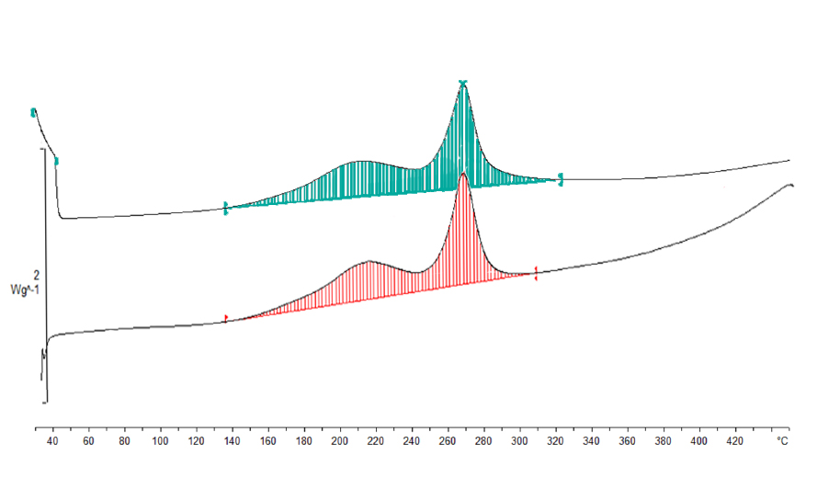

Exo

731 J/g

690 J/g

Original sample

Sample after thermal stress (65 °C / 24 h)

Example 5:

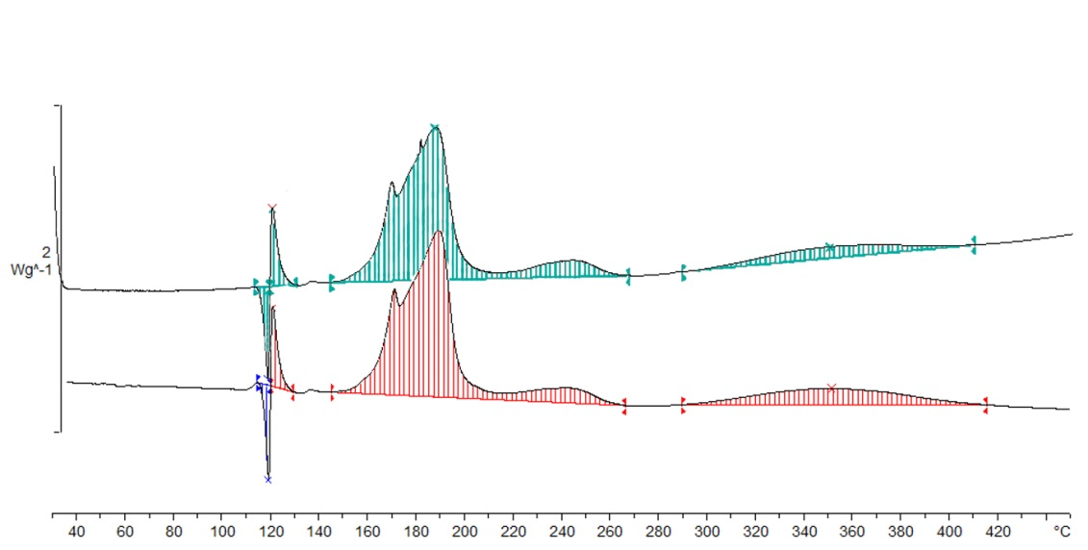

539 J/g

545 J/g

30 J/g

33 J/g

88 J/g

25 J/g

138 J/g

23 J/g

Original sample

Sample after thermal stress (65 °C / 24 h)

Exo

**Figure 20.3: Examples of samples failing the thermal stress test**

Example 1:

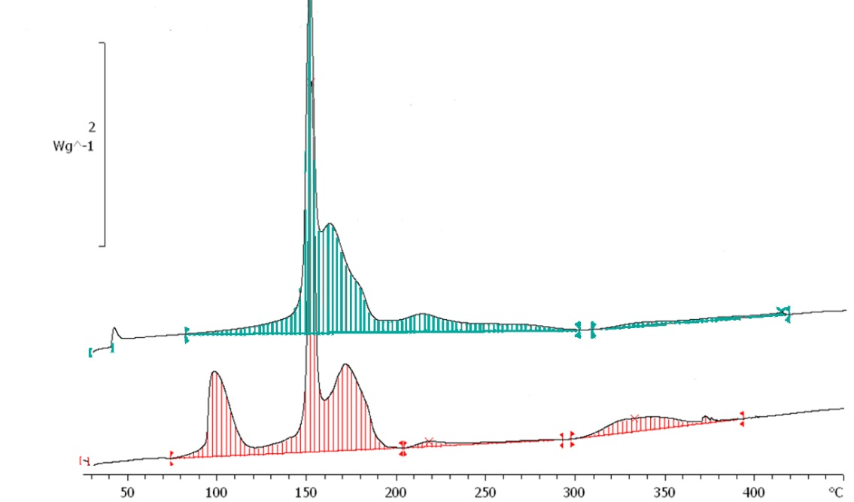

Exo

1416 J/g

1136 J/g

Sample after 60 °C / 24 h

Original sample

Fail due to degradation (loss of energy > 10 %)

Fail due to different  
peak shape

Example 2:

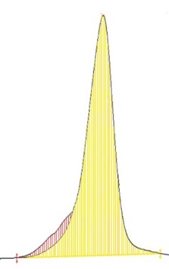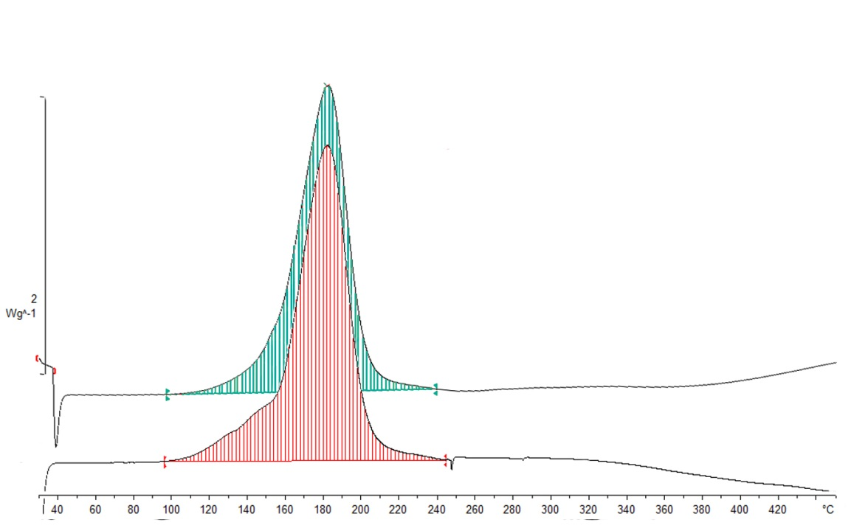

Fail due to different  
peak shape in spite of tolerable energy loss

Exo

1532 J/g

1438 J/g

Sample after  
60 °C / 24 h

Original sample

Shoulder of peak missing after thermal stress

**Overlay of graphs**

**Figure 20.4: Flow chart scheme for the assessment of thermal stability of samples according to 20.3.4**

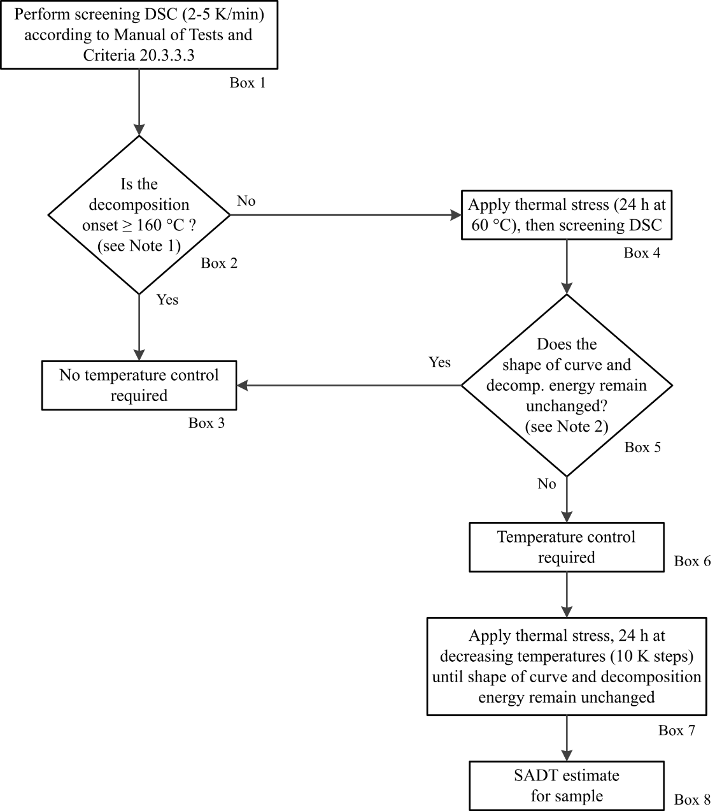

***NOTE 1:*** *Isolated small exotherm (< 20 J/g) preceding the main decomposition may be neglected;*

***NOTE 2:*** *General tolerance for energy comparison due to measurement uncertainty: 10%. For flat peaks with a maximum heat production of 0.2 W/g a deviation of 25 % is tolerable in temperature ranges below 250 °C and 40 % above this limit.*”]

*(Reference document: ST/SG/AC.10/C.3/2019/64, as amended)*

[Renumber figures 20.2 and 20.3 to 20.5 and 20.6 respectively.]

*(Reference document: ST/SG/AC.10/C.3/2019/64, as amended)*

Section 37

37.4.1 Delete.

*(Reference document: ST/SG/AC.10/C.3/2019/71)*

37.4.1.1 Renumber to 37.4.1.

*(Reference document: ST/SG/AC.10/C.3/2019/71)*

Add the following new 37.4.1.1:

“37.4.1.1 Introduction

This test is used for determining the corrosive properties of liquids and solids that may become liquid as a substance corrosive to metal, packing group III/category 1.”

*(Reference document: ST/SG/AC.10/C.3/2019/71)*

Renumber paragraphs 37.4.2, 37.4.3, 37.4.4, 37.4.4.1 and 37.4.4.2 to become 37.4.1.2, 37.4.1.3, 37.4.1.4, 37.4.1.4.1 and 37.4.1.4.2 respectively and update cross references in section 37.4 accordingly.

*(Reference document: ST/SG/AC.10/C.3/2019/71)*

37.4.2 (Renumbered 37.4.1.2) (b) Amend to read as follows:

“(b) Steel type S235JR+CR (1.0037, resp. St 37-2), S275J2G3+CR (1.0144, resp.   
St 44-3), ISO 3574, Unified Numbering System (UNS) G10200 or SAE 1020.”

*(Reference document: ST/SG/AC.10/C.3/2019/39, proposals 2 and 3)*

Section 38

38.3.3 (d) In the last paragraph, after “another battery”, add “, vehicle,”.

*(Reference document: ST/SG/AC.10/C.3/2019/50)*

38.3.3 (g) At the end, add the following new paragraphs:

“For an assembled battery not equipped with overcharge protection that is designed for use only as a component in another battery, in equipment, or in a vehicle, which affords such protection:

- the overcharge protection shall be verified at the battery, equipment or vehicle level, as appropriate, and

- the use of charging systems without overcharge protection shall be prevented through a physical system or process controls.”

*(Reference document: ST/SG/AC.10/C.3/2019/50, as amended)*

Annex II

Draft amendments to the twenty-first revised edition of the Recommendations on the Transport of Dangerous Goods, Model Regulations (ST/SG/AC.10/1/Rev.21)

Chapter 1.2

1.2.1 In the definition for “Bundle of cylinders” replace “an assembly of cylinders” by “a pressure receptacle comprising an assembly of cylinders or cylinder shells”.

*(Reference document: informal document INF.25)*

1.2.1 Add the following new note under the definition of “Closure”:

“***NOTE:*** *For pressure receptacles, closures are, for example, valves, pressure relief devices, pressure gauges or level indicators.*”

*(Reference document: informal document INF.25)*

1.2.1 Amend the definition for “Cryogenic receptacle” to read as follows:

“*Closed cryogenic receptacle* means a transportable thermally insulated pressure receptacle for refrigerated liquefied gases of a water capacity of not more than 1 000 litres;”

*(Reference document: informal document INF.25)*

1.2.1 In the definition for “Cylinder”, delete “transportable”.

*(Reference document: informal document INF.25)*

1.2.1 In the definition for “Metal hydride storage system”, replace “receptacle” by “pressure receptacle shell”.

*(Reference document: informal document INF.25)*

1.2.1 In the definition for “Pressure drum”, delete “transportable”.

*(Reference document: informal document INF.25)*

1.2.1 In the definition for “Pressure receptacle”, after “Pressure receptacle”, add “means a transportable receptacle intended for holding substances under pressure including its closure(s) and other service equipment and”.

*(Reference document: informal document INF.25)*

1.2.1 In the definition for “Tube”, delete “transportable”.

*(Reference document: informal document INF.25)*

1.2.1 Amend the definition for “Working pressure” to read as follows:

“*Working pressure*

(a) For a compressed gas means the settled pressure ~~of a compressed gas~~ at a reference temperature of 15 °C in a full pressure receptacle;

(b) For UN 1001 acetylene, dissolved means the calculated settled pressure at a uniform reference temperature of 15 °C in an acetylene cylinder containing the specified solvent content and the maximum acetylene content;

(c) For UN 3374 acetylene, solvent free the working pressure corresponds to the working pressure which was calculated for the equivalent cylinder for UN 1001 acetylene, dissolved.”

*(Reference document: informal document INF.25)*

1.2.1 Add the following new definitions:

*“Inner vessel,* for a closed cryogenic receptacle, means the pressure vessel intended to contain the refrigerated liquefied gas;”

*“Pressure receptacle shell* means a cylinder, a tube a pressure drum or a salvage pressure receptacle without its closures or other service equipment, but including any permanently attached device(s) (e.g. neck ring, foot ring, etc.);

***NOTE:*** *The terms “cylinder shell”, “pressure drum shell” and “tube shell” are also used.”*

*“Service equipment* of a pressure receptacle means closure(s), manifold(s), piping, porous, absorbent or adsorbent material and any structural devices, e.g. for handling;”

*(Reference document: informal document INF.25)*

Chapter 2.8

2.8.3.2 In the second sentence, replace “OECD Test Guidelines1,2,3,4” by “OECD Test Guidelines Nos. 4041, 4352, 4313 or 4304”. In the third sentence, replace “OECD Test Guidelines1,2,3,4” by “one of these or non-classified in accordance with OECD Test Guideline No. 4395,”. In the fourth sentence, delete “*in vitro*”. At the end, add the following new sentence: [“If the test results indicate that the substance or mixture is corrosive, but the test method does not allow discrimination between packing groups, it shall be assigned to packing group I if no other test results indicate a different packing group.”.]

Add a footnote 5 to read “5 *OECD Guideline for the testing of chemicals No. 439 “In Vitro Skin Irritation: Reconstructed Human Epidermis Test Method” 2015*”.

*(Reference document:* *ST/SG/AC.10/C.3/2019/53) (replaces the amendment in the annex to document ST/SG/AC.10/C.3/110)*

2.8.3.3 (c) (ii) Delete “or a similar type”.

*(Reference document: ST/SG/AC.10/C.3/2019/39, proposal 1)*

Chapter 3.2, dangerous goods list

For UN 3269 and UN 3527, replace “E0” by “See SP 340 in Chapter 3.3” in column (7b).

*(Reference document: ST/SG/AC.10/C.3/2019/47, second option)*

For UN 3538, add “396” in column (6).

*(Reference document: informal document INF.53)*

Chapter 3.3

SP 188 (f) Delete note 1 and renumber “***NOTE 2***” to “***NOTE***”.

*(Reference document: informal document INF.21)*

Add the following new special provision:

“396 Large and robust articles may be transported with connected gas cylinders with the valves open regardless of 4.1.6.1.5 provided:

(a) The gas cylinders contain nitrogen of UN 1066 or compressed gas of UN 1956 or compressed air of UN 1002;

(b) The gas cylinders are connected with the article through pressure regulators and fixed piping in such a way that the pressure of the gas (gauge pressure) in the article does not exceed 35 kPa (0.35 bar);

(c) The gas cylinders are properly secured so that they cannot move in relation to the article and are fitted with strong and pressure resistant hoses and pipes;

(d) The gas cylinders, pressure regulators, piping and other components are protected from damage and impacts during transport by wooden crates or other suitable means;

(e) The transport document includes the following statement “Transport in accordance with special provision 396”;

(f) Cargo transport units containing articles transported with cylinders with open valves containing a gas presenting a risk of asphyxiation are well ventilated and are marked in accordance with 5.5.3.6.”.

*(Reference document: informal document INF.53 as editorially amended)*

Chapter 4.1

4.1.4.1, P903 (2) In the first sentence, at the beginning, replace “cells or batteries” by “a cell or a battery” and at the end, delete “, and assemblies of such cells or batteries”.

*(Reference document: ST/SG/AC.10/C.3/2019/60, as amended)*

4.1.4.1, P903 (4) and (5), penultimate sentence Transfer the phrase “when intentionally active” to the beginning of the sentence to read: “When intentionally active, devices such as radio frequency identification (RFID) tags, watches and temperature loggers, which are not capable of generating a dangerous evolution of heat, may be transported in strong outer packagings.”.

*(Reference document: informal document INF.34, and consequential amendment)*

4.1.4.2, IBC02 In special packing provision B15, replace “of composite IBCs with a rigid plastics inner receptacle” by “of rigid plastics inner receptacles of composite IBCs”.

*(Reference document: informal document INF.14)*

4.1.6.1.6 Add to the end of the first sentence “and taking into account the lowest pressure rating of any component”.

Insert the following new second sentence: “Service equipment having a pressure rating lower than other components shall nevertheless comply with 6.2.1.3.1.”

Delete the final sentence.

*(Reference document: informal document INF.25)*

4.1.6.1.10 In the first sentence, insert “closed” before “cryogenic receptacles” and replace “P205 or P206” with “P205, P206 or P208”.

*(Reference document: informal document INF.25)*

Chapter 4.3

4.3.1.15 Replace indents (a) to (i) with the following indents (a) to (c):

“(a) Bends, cracks or breaks in the structural or supporting members and any damage to service or operational equipment that affects the integrity of the container;

(b) Any distortion of the overall configuration or any damage to lifting attachments or handling equipment interface features great enough to prevent proper alignment of handling equipment, mounting and securing chassis or vehicle, or insertion into ships' cells; and, where applicable.

(c) Door hinges, door seals and hardware that are seized, twisted, broken, missing, or otherwise inoperative.”

*(Reference document: ST/SG/AC.10/C.3/2019/40)*

Chapter 5.1

5.1.5.1.3 Amend to read as follows:

“5.1.5.1.3 A competent authority may approve provisions under which consignments that do not satisfy all the applicable requirements of these Regulations may be transported under special arrangement (see 1.5.4).”

*(Reference document: ST/SG/AC.10/C.3/2019/70, proposal 2)*

Chapter 5.2

5.2.1.7.1 At the third indent, replace “cryogenic receptacles” with “closed and open cryogenic receptacles”.

*(Reference document: informal document INF.25)*

5.2.1.7.2 (a) Replace “cryogenic receptacles” with “closed and open cryogenic receptacles”.

*(Reference document: informal document INF.25)*

Chapter 6.2

6.2.1.1.1 After “Pressure receptacles” delete “and their closures”. At the end of the sentence replace “transport” with “transport and intended use”.

*(Reference document: informal document INF.25)*

6.2.1.1.4 At the end of the sentence replace “used” with “welded”.

*(Reference document: informal document INF.25)*

6.2.1.1.5 In the first sentence replace “cylinders, tubes, pressure drums” with “pressure receptacle shells”.

In the final sentence after “The test pressure of a cylinder” insert “shell”.

*(Reference document: informal document INF.25)*

6.2.1.1.6 At the beginning of the first and the second sentences replace “Pressure receptacles” with “Cylinders or cylinder shells”.

In the final sentence replace the first “pressure receptacle” with “cylinder shell”, the second and third “pressure receptacle” with “cylinder”.

*(Reference document: informal document INF.25)*

6.2.1.1.8.2 In the third and fourth sentences replace “pressure receptacle” with “inner vessel”.

At the end of the fourth sentence replace “fittings” with "service equipment".

*(Reference document: informal document INF.25)*

6.2.1.1.9 At the end of the heading replace “*pressure receptacles for acetylene”* with *“acetylene cylinders”.*

In the first sentence replace “Pressure receptacles” with “Cylinder shells”.

In (a) replace “pressure receptacle” with “cylinder shell”.

In the final sentence replace “compatible with the pressure receptacle” with “compatible with those parts of the cylinder that are in contact with it".

*(Reference document: informal document INF.25)*

6.2.1.2.1 After “Construction materials of pressure receptacles” delete “and their closures”.

*(Reference document: informal document INF.25)*

6.2.1.2.2 At the beginning of the first sentence, after “Pressure receptacles”, delete “and their closures”.

*(Reference document: informal document INF.25)*

6.2.1.3.1 Replace “Valves, piping and other fittings” with “Service equipment” and replace “excluding pressure relief devices” with “excluding porous, absorbent or adsorbent material, pressure relief devices, pressure gauges or indicators”.

*(Reference document: informal document INF.25)*

6.2.1.3.2 Amend to read as follows:

“6.2.1.3.2 Service equipment shall be configured or designed to prevent damage and unintended opening that could result in the release of the pressure receptacle contents during normal conditions of handling and transport. All closures shall be protected in the same manner as is required for valves in 4.1.6.1.8. Manifold piping leading to shut-off valves shall be sufficiently flexible to protect the shut-off valves and the piping from shearing or releasing the pressure receptacle contents.”

*(Reference document: informal document INF.25)*

6.2.1.3.3 Replace “shall be fitted with devices” with “shall be fitted with handling devices”.

*(Reference document: informal document INF.25)*

6.2.1.4.1 Delete the second sentence beginning “Pressure receptacles…”.

*(Reference document: informal document INF.25)*

6.2.1.4.3 Insert a new paragraph 6.2.1.4.3 to read:

“6.2.1.4.3 Pressure receptacle shells and the inner vessels of closed cryogenic receptacles shall be inspected tested and approved by an inspection body.”

*(Reference document: informal document INF.25)*

6.2.1.4.4 Insert a new paragraph 6.2.1.4.4 as follows:

“6.2.1.4.4 For refillable cylinders, pressure drums and tubes the conformity assessment of the shell and the closure(s) may be carried out separately. In these cases, an additional assessment of the final assembly is not required.

For bundles of cylinders, the cylinder shells and the valve(s) may be assessed separately, but an additional assessment of the complete assembly is required.

For closed cryogenic receptacles, the inner vessels and the closures may be assessed separately, but an additional assessment of the complete assembly is required.

For acetylene cylinders, conformity assessment shall compriseeither:

(a) one assessment of conformity covering both the cylinder shell and the contained porous material; or

(b) a separate assessment of conformity for the empty cylinder shell and an additional assessment of conformity covering the cylinder shell with the contained porous material.”

*(Reference document: informal document INF.25)*

6.2.1.5.1 In the first sentence replace “closed cryogenic receptacles and metal hydride storage systems,” with “closed cryogenic receptacles, metal hydride storage systems and bundles of cylinders,” and after “the applicable design standards” insert “or recognised technical codes”.

In the line before (a), replace “pressure receptacles” with “pressure receptacle shells”.

In (d), at the end delete “of the pressure receptacles”.

In (e), replace “neck threads” with “threads used to fit closures”.

In the line before (g), replace “all pressure receptacles” with “all pressure receptacle shells”.

In (g), replace “pressure receptacles” with “pressure receptacle shells”.

In (h), both sentences, replace “pressure receptacles” with “pressure receptacle shells”.

In (i) replace “pressure receptacles” with “pressure receptacle shells”.

In (j) replace “pressure receptacles” with “cylinder shells”.

After (j) insert the following new provisions:

“On an adequate sample of closures:

(k) Verification of materials;

(l) Verification of dimensions;

(m) Verification of cleanliness;

(n) Inspection of completed assembly;

(o) Verification of the presence of marks.

For all closures:

(p) Testing for leakproofness”.

*(Reference document: informal document INF.25)*

6.2.1.5.2 Amend to read as follows:

“6.2.1.5.2 Closed cryogenic receptacles shall be subjected to testing and inspection during and after manufacture in accordance with the applicable design standards or recognized technical codes including the following:

On an adequate sample of inner vessels:

(a) Testing of the mechanical characteristics of the material of construction;

(b) Verification of the minimum wall thickness;

(c) Inspection of the external and internal conditions;

(d) Verification of the conformance with the design standard or code;

(e) Inspection of welds by radiographic, ultrasonic or other suitable non-destructive test method according to the applicable design and construction standard or code.

For all inner vessels:

(f) A hydraulic pressure test. The inner vessel shall meet the acceptance criteria specified in the design and construction technical standard or technical code;

***NOTE:*** *With the agreement of the competent authority, the hydraulic pressure test may be replaced by a test using a gas, where such an operation does not entail any danger.*

(g) Inspection and assessment of manufacturing defects and either repairing them or rendering the inner vessel unserviceable;

(h) An inspection of the marks.

On an adequate sample of closures:

(i) Verification of materials;

(j) Verification of dimensions;

(k) Verification of cleanliness;

(l) Inspection of completed assembly;

(m) Verification of the presence of marks.

For all closures:

(n) Testing for leakproofness.

On an adequate sample of completed closed cryogenic receptacles:

(o) Testing the satisfactory operation of service equipment;

(p) Verification of the conformance with the design standard or code.

For all completed closed cryogenic pressure receptacles:

(q) Testing for leakproofness.”

*(Reference document: informal document INF.25)*

6.2.1.5.3 In the first sentence replace “receptacles” with “pressure receptacle shells”.

*(Reference document: informal document INF.25)*

6.2.1.5.4 Insert the following new paragraph:

“6.2.1.5.4 For bundles of cylinders the cylinder shells and closures shall be subjected to initial inspection and tests specified in 6.2.1.5.1. An adequate sample of frames shall be proof load tested to two times the maximum gross weight of the bundles of cylinders.

Additionally, all manifolds of bundle of cylinders shall undergo a hydraulic pressure test and all the completed bundles of cylinders shall undergo a leakproofness test.

***NOTE:*** *With the agreement of the competent authority, the hydraulic pressure test may be replaced by a test using a gas, where such an operation does not entail any danger.”*

*(Reference document: informal document INF.25)*

6.2.1.6.1 Replace (c) and (d) with the following.

“(c) Checking of the threads either:

(i) if there is evidence of corrosion; or

(ii) if the closures or other service equipment are removed;

(d) A hydraulic pressure test of the pressure receptacle shell and, if necessary, verification of the characteristics of the material by suitable tests;”

In note 2, replace “*pressure test of cylinders or tubes”* with “*pressure test of cylinder shells or tube shells”*

Amend note 3 to read as follows:

“***NOTE 3:*** *The check of internal conditions of 6.2.1.6.1 (b) and the hydraulic pressure test of 6.2.1.6.1 (d) may be replaced by ultrasonic examination carried out in accordance with ISO 18119:2018 for seamless steel and seamless aluminium alloy cylinder shells. For a transitional period until 31 December 2024 the standard ISO 10461:2005 +A1:2006 may be used for seamless aluminium alloy cylinders and ISO 6406:2005 may be used for seamless steel cylinder shells for this same purpose.*”

Insert the following new note 4:

“***NOTE 4:*** *For bundles of cylinders the hydraulic test specified in (d) above shall be carried out on the cylinder shells and on the manifold.*”

Replace current (e) and add a new (f) as follows:

“(e) Check of service equipment, if to be reintroduced into service. This check may be carried out separately from the inspection of the pressure receptacle shell;

(f) A leakproofness test of bundles of cylinders after reassembly.”

*(Reference documents: informal document INF.25 and ST/SG/AC.10/C.3/2019/43, proposal 3, as amended by informal document INF.24)*

6.2.1.6.2 Replace “Pressure receptacles” with “Cylinders”.

*(Reference document: informal document INF.25)*

6.2.1.7.2 Amend as follows:

“6.2.1.7.2 “A proficiency test of the manufacturers of pressure receptacle shells and the inner vessels of closed cryogenic receptacle shall in all instances be carried out by an inspection body approved by the competent authority of the country of approval. Proficiency testing of manufacturers of closures shall be carried out if the competent authority requires it. This test shall be carried out either during design type approval or during production inspection and certification.”

6.2.2 In note 2, delete “and service equipment” after “UN pressure receptacles”.

*(Reference document: informal document INF.25)*

6.2.2.1.1 In the first sentence replace “UN cylinders” with “refillable UN cylinder shells”.

In the table delete the rows for “ISO 11118:1999” and “ISO 11118:2015”.

Innote 1, replace “*composite cylinders”* with “*composite cylinder shells*”.

Innote 2, in the first sentence, replace “*composite cylinders”* with “*composite cylinder shells*”. In the second sentence, replace “*cylinders”* with “*composite cylinder shells*”. In the last sentence replace “*cylinder”* with *“cylinder shell”.*

*(Reference document: informal document INF.25)*

6.2.2.1.2 In the first sentence replace “UN tubes” with “UN tube shells”.

In the table, in the row for ISO 11515:2013, replace “Until further notice” with “Until 31 December 2026”. Add a new row beneath this row as follows:

|  |  |  |
| --- | --- | --- |
| ISO 11515:2013 + Amd 1:2018 | Gas cylinders – Refillable composite reinforced tubes of water capacity between 450 L and 3000 L – Design, construction and testing | Until further notice |

Innote 1, replace “*composite tubes”* with “*composite tube shells*”.

Innote 2, replace “*composite tubes”* with “*composite tube shells*” in the first and second sentence. In the last sentence replace “*tube” with “tube shell”.*

*(Reference documents: informal document INF.25 and ST/SG/AC.10/C.3/2019/43, proposal 1, as amended by informal document INF.24)*

6.2.2.1.4 Replace “UN cryogenic receptacles” with “UN closed cryogenic receptacles”.

*(Reference document: informal document INF.25)*

6.2.2.1.6 In the first sentence, replace “The standard shown below” with “The following standard”.

In the second sentence replace “UN cylinder” with “UN cylinder or UN cylinder shell”.

Replace the current notewith the following:

“***NOTE****: Changing one or more cylinders or cylinder shells of the same design type, including the same test pressure, in an existing UN bundle of cylinders does not require a new conformity assessment of the existing bundle. Service equipment of the bundle of cylinders can also be replaced without requiring a new conformity assessment if it complies with the design type approval.*”

*(Reference document: informal document INF.25)*

6.2.2.1.8 In the table, in the row for ISO 21172-1:2015, replace “Until further notice” with “Until 31 December 2026”. Add the following new row to the table after ISO 21172-1:2015:

|  |  |  |
| --- | --- | --- |
| ISO 21172-1:2015 + Amd 1:2018 | Gas cylinders – Welded steel pressure drums up to 3 000 litres capacity for the transport of gases – Design and construction – Part 1: Capacities up to 1 000 litres; | Until further notice |

*(Reference document: ST/SG/AC.10/C.3/2019/43, proposal 2)*

6.2.2.1.9 Insert a new paragraph and table as follows:

“6.2.2.1.9 The following standards apply to the design, construction and initial inspection and test of non-refillable UN cylinders except that the inspection requirements related to the conformity assessment system and approval shall be in accordance with 6.2.2.5.

|  |  |  |
| --- | --- | --- |
| **Reference** | **Title** | **Applicable for manufacture** |
| ISO 11118:1999 | Gas cylinders – Non-refillable metallic gas cylinders – Specification and test methods | Until 31 December 2020 |
| ISO 13340:2001 | Transportable gas cylinders – Cylinder valves for non-refillable cylinders – Specification and prototype testing | Until 31 December 2020 |
| ISO 11118:2015 | Gas cylinders – Non-refillable metallic gas cylinders – Specification and test methods | Until further notice |

”.

*(Reference document: informal document INF.25)*

6.2.2.2 In the first sentence delete “pressure receptacle”.

*(Reference document: informal document INF.25)*

6.2.2.3 Replace the title “**Service equipment**” with “**Closures and their protection**”

*(Reference document: informal document INF.25)*

6.2.2.3 Replace the first sentence with “The following standards apply to the design, construction, and initial inspection and test of closures and their protection:”

In the first table, delete the row for ISO 13340:2001.

*(Reference document: informal document INF.25)*

6.2.2.4 Amend the first sentence to read “The following standards apply to periodic inspection and testing of UN pressure receptacles:”.

In the first table, in the rows for ISO 6406:2005 and ISO 10461:2005/A1:2006, replace “Until further notice” with “Until 31 December 2024”. Add the following new row to the table after ISO 6406:2005:

|  |  |  |
| --- | --- | --- |
| ISO 18119:2018 | Gas cylinders – Seamless steel and seamless aluminium-alloy gas cylinders and tubes – Periodic inspection and testing | Until further notice |

In the first table, in the row for ISO 10460:2005, replace “Until further notice” with “Until 31 December 2024”. Add the following new row to the table after ISO 10460:2005:

|  |  |  |
| --- | --- | --- |
| ISO 10460:2018 | Gas cylinders – Welded aluminium-alloy, carbon and stainless steel gas cylinders – Periodic inspection and testing. | Until further notice |

Delete the row for ISO 11623:2002.

*(Reference documents: informal document INF.25 and ST/SG/AC.10/C.3/2019/43, proposal 3 (as amended), 4 and 5)*

6.2.2.5 At the beginning of 6.2.2.5 renumber 6.2.2.5.1 as 6.2.2.5.0 and insert the following new Note at the end (after the definition of “Verify”).

“***NOTE:*** *In this subsection when separate assessment is used the term pressure receptacle shall refer to pressure receptacle, pressure receptacle shell, inner vessel of the closed cryogenic receptacle or closure, as appropriate.*”

*(Reference document: informal document INF.25)*

6.2.2.5.1 Insert a new paragraph 6.2.2.5.1 to read as follows:

“6.2.2.5.1 The requirements of 6.2.2.5 shall be used for the conformity assessments of pressure receptacles. Paragraph 6.2.1.4.3 gives details of which parts of pressure receptacles may be conformity assessed separately. However, the requirements of 6.2.2.5 may be replaced by requirements specified by the competent authority in the following cases:

(a) conformity assessment of closures;

(b) conformity assessment of the complete assembly of bundles of cylinders provided the cylinder shells have been conformity assessed in accordance with the requirements of 6.2.2.5; and

(c) conformity assessment of the complete assembly of closed cryogenic receptacles provided the inner vessel has been conformity assessed in accordance with the requirements of 6.2.2.5.”

*(Reference document: informal document INF.25)*

6.2.2.5.4.9 (c) Replace the existing text with: “As required by the pressure receptacle standard or technical code, carry out or supervise the tests of pressure receptacles as required for design type approval.”

*(Reference document: informal document INF.25)*

6.2.2.5.4.9 Add the following new sentence at the end of the penultimate paragraph: “If it was not possible to evaluate exhaustively the compatibility of the materials of construction with the contents of the pressure receptacle when the certificate was issued, a statement that compatibility assessment was not completed shall be included in the design type approval certificate.”.

*(Reference document: informal document INF.25)*

6.2.2.7 Amend the Note by replacing “6.2.2.9 and marking” with “6.2.2.9, marking” and inserting at the end “and marking requirements for closures are given in 6.2.2.11”.

*(Reference document: informal document INF.25)*

6.2.2.7.1 In the first sentence replace “pressure receptacles” with “pressure receptacle shells and closed cryogenic receptacles”.

At the end of the second sentence, delete “on the pressure receptacle”.

In the third sentence, after “neck of the pressure receptacle” insert “shell”.

*(Reference document: informal document INF.25)*

6.2.2.7.2 (b) At the end, insert the following new note:

“***NOTE:*** *For acetylene cylinders the standard ISO 3807 shall also be marked.*”

*(Reference document: informal document INF.25)*

6.2.2.7.2, after (e) Insert the following new note:

“***NOTE:*** *When an acetylene cylinder is conformity assessed in accordance with 6.2.1.4.3 (b) and the inspection bodies for the cylinder shell and the acetylene cylinder are different, their respective marks (d) are required. Only the initial inspection date (e) of the completed acetylene cylinder is required. If the country of approval of the inspection body responsible for the initial inspection and test is different a second mark (c) shall be applied.*”

*(Reference document: informal document INF.25)*

6.2.2.7.3 (g) In the second sentence, replace “mass of valve, valve cap” with “mass of closure(s), valve protection cap”.

*(Reference document: informal document INF.25)*

6.2.2.7.3 (i) At the end insert the following note:

“***NOTE:*** *When a cylinder shell is intended for use as an acetylene cylinder (including the porous material), the working pressure mark is not required until the acetylene cylinder is completed.*”

*(Reference document: informal document INF.25)*

6.2.2.7.3 (j) In the first sentence replace “liquefied gases and refrigerated liquefied gases” with “liquefied gases, refrigerated liquefied gases and dissolved gases”.

*(Reference document: informal document INF.25)*

6.2.2.7.3 (k) and (l) Replace paragraphs (k) and (l) with the following.

“(k) In the case of cylinders for UN 1001 acetylene, dissolved:

(i) the tare in kilograms consisting of the total of the mass of the empty cylinder shell, the service equipment (including porous material) not removed during filling, any coating, the solvent and the saturation gas expressed to three significant figures rounded down to the last digit followed by the letters "KG". At least one decimal shall be shown after the decimal point. For pressure receptacles of less than 1 kg, the mass shall be expressed to two significant figures rounded down to the last digit;

(ii) the identity of the porous material (e.g.: name and trademark); and

(iii) the total mass of the filled acetylene cylinder in kilograms followed by the letters “KG”;

(l) In the case of cylinders for UN 3374 acetylene, solvent free:

(i) the tare in kg consisting of the total of the mass of the empty cylinder shell, service equipment (including porous material) not removed during filling and any coating expressed to three significant figures rounded down to the last digit followed by the letters "KG". At least one decimal shall be shown after the decimal point. For pressure receptacles of less than 1 kg, the mass shall be expressed to two significant figures rounded down to the last digit;

(ii) the identity of the porous material; and

(iii) the total mass of the filled acetylene cylinder in kilograms followed by the letters “KG”;”

*(Reference document: informal document INF.25)*

6.2.2.7.4 (n) After the existing text insert the following new note:

“***NOTE:*** *If the manufacturer of the acetylene cylinder and the manufacturer of the cylinder shell are different, only the mark of the manufacturer of the completed acetylene cylinder is required.*”

*(Reference document: informal document INF.25)*

6.2.2.8 In the titlereplace “**pressure receptacles**”with “**cylinders**”.

*(Reference document: informal document INF.25)*

6.2.2.8.1 In the first sentence replace “pressure receptacles” with “cylinders”.

In the second sentence replace “pressure receptacle” with “cylinder”.

In the third sentence replace “pressure receptacle” at the first occurrence with “cylinder shell” and at the second occurrence with “cylinder”.

In the fifth sentence (penultimate sentence) replace “pressure receptacles” with “cylinders” twice.

*(Reference document: informal document INF.25)*

6.2.2.8.3 In the note, replace “pressure receptacles” with “cylinders”.

*(Reference document: informal document INF.25)*

6.2.2.10.1 Replace “cylinders” with “cylinder shells”.

Insert a new second sentence as follows: “Individual closures in a bundle of cylinders shall be marked in accordance with 6.2.2.11.”.

*(Reference document: informal document INF.25)*

6.2.2.10.3 (b) In the first sentence replace the phrase in brackets with “cylinder shells and service equipment”.

In the second sentence after “tare” delete “mass”.

*(Reference document: informal document INF.25)*

6.2.2.11 Insert a new paragraph 6.2.2.11 as follows:

“**6.2.2.11 Marking of closures for refillable UN pressure receptacles**

For closures the following permanent marks shall be applied clearly and legibly, (e.g. stamped, engraved or etched):

(a) Manufacturer’s identification mark;

(b) Design standard or design standard designation;

(c) Date of manufacture (year and month or year and week) and

(d) The identity mark of the inspection body responsible for the initial inspection and test, if applicable.

The valve test pressure shall be marked when it is less than the test pressure which is indicated by the rating of the valve filling connection.”

*(Reference document: informal document INF.25)*

Chapter 6.5

6.5.1.1.2 Amend to read as follows:

“6.5.1.1.2 The requirements for IBCs in 6.5.3 are based on IBCs currently in use. In order to take into account progress in science and technology, there is no objection to the use of IBCs having specifications different from those in 6.5.3 and 6.5.5, provided that they are equally effective, acceptable to the competent authority and able to successfully fulfil the requirements described in 6.5.4 and 6.5.6. Methods of inspection and testing other than those described in these Regulations are acceptable, provided they are equivalent.”

*(Reference document: informal document INF.13, as amended) (replaces the amendment in the annex to document ST/SG/AC.10/C.3/110)*

6.5.5.3.2 After the first sentence, add the following new sentence: “Except for recycled plastics material as defined in 1.2.1, no used material other than production residues or regrind from the same manufacturing process may be used.”.

*(Reference document: ST/SG/AC.10/C.3/2019/51)*

6.5.5.3.5 Delete.

*(Reference document: ST/SG/AC.10/C.3/2019/51)*

6.5.5.4.6 After the first sentence, add the following new sentence: “Except for recycled plastics material as defined in 1.2.1, no used material other than production residues or regrind from the same manufacturing process may be used.”.

*(Reference document: ST/SG/AC.10/C.3/2019/51)*

6.5.5.4.9 Delete.

*(Reference document: ST/SG/AC.10/C.3/2019/51)*

Chapter 7.1

7.1.1.6 Replace “The interior and exterior” by “The interior and the exterior”. After the existing paragraph add the following new text:

“The cargo transport unit shall be checked to ensure it is structurally serviceable, that it is free of possible residues incompatible with the cargo and that the interior floor, walls and ceiling, where applicable, are free from protrusions or deterioration that could affect the cargo inside and that freight containers are free of damages that affect the weather-tight integrity of the container, when required.

Structurally serviceable means that the cargo transport unit is free from major defects in its structural components. Structural components of cargo transport units for multimodal purpose are e.g. top and bottom side rails, top and bottom end rails, corner posts, corner fittings and, for freight containers, door sill, door header and floor cross members. Major defects include:

(a) Bends, cracks or breaks in structural or supporting members and any damage to service or operational equipment that affects the integrity of the unit;

(b) Any distortion of the over-all configuration or any damage to lifting attachments or handling equipment interface features great enough to prevent proper alignment of handling equipment, mounting and securing on chassis, vehicle or wagon, or insertion into ships' cells; and, where applicable;

(c) Door hinges, door seals and hardware that are seized, twisted, broken, missing or otherwise inoperative.

***NOTE:*** *For filling portable tanks and multiple-element gas containers (MEGCs), see Chapter 4.2. For filling bulk containers, see Chapter 4.3.*”

*(Reference document: ST/SG/AC.10/C.3/2019/40)*

Delete 7.1.3.3.1 and renumber 7.1.3.3.2 accordingly.

*(Reference document: ST/SG/AC.10/C.3/2019/40)*

Annex III

Corrections to the twenty-first revised edition of the Recommendations on the Transport of Dangerous Goods, Model Regulations (ST/SG/AC.10/1/Rev.21)

Chapter 1.2, 1.2.1, definition of “Self-accelerating decomposition temperature (SADT)”

The correction does not apply to the English version.

*(Reference document: informal document INF.38)*

Chapter 2.1, 2.1.3.5.2, first sentence

For the existing text, *substitute*

Assignment of fireworks to UN Nos. 0333, 0334, 0335 or 0336, and assignment of articles to UN 0431 for those used for theatrical effects meeting the definition for article type and the 1.4G specification in the default fireworks classification table in 2.1.3.5.5 may be made on the basis of analogy, without the need for Test Series 6 testing, in accordance with the default fireworks classification table in 2.1.3.5.5.

*(Reference document: ST/SG/AC.10/C.3/2019/69)*

Chapter 2.7, 2.7.2.4.1.3 (f)

*For* shall apply *read* applies

Chapter 2.7, 2.7.2.4.1.4 (c)

*For* shall apply *read* applies

Chapter 2.7, 2.7.2.4.1.7 (e)

*For* shall apply *read* applies

*(Reference document: informal document INF.38)*

Chapter 3.3, SP 241

The two corrections do not apply to the English version.

*(Reference document: informal document INF.52)*

Chapter 3.3, SP 309

*For* an ANE *read* an ammonium nitrate emulsion, suspension or gel, intermediate for blasting explosives (ANE)

*(Reference document: informal document INF.38)*

Chapter 3.3, SP 310

*Delete* and packaged in accordance with P908 of 4.1.4.1 or LP904 of 4.1.4.3 as applicable

*(Reference document: ST/SG/AC.10/C.3/2019/54)*

Chapter 3.3, SP 376, Note, introductory sentence

The correction does not apply to the English version.

Chapter 3.3, SP 376, Note, indent (b)

The correction does not apply to the English version.

Chapter 3.3, SP 376, Note, indent (e)

The correction does not apply to the English version.

*(Reference document: informal document INF.38)*

Chapter 3.3, SP 377

*Delete* and packaged in accordance with P908 of 4.1.4.1 or LP904 of 4.1.4.3 as applicable

*(Reference document: ST/SG/AC.10/C.3/2019/54)*

Chapter 4.1, 4.1.1.10, end of introductory paragraph before the indents, beginning of indent (b) and beginning of indent (c)

The correction does not apply to the English version.

Chapter 4.1, 4.1.1.10, end of indent (b)

The correction does not apply to the English version.

Chapter 4.1, 4.1.4.1, P400 (2) and (3), second sentence

The correction does not apply to the English version.

*(Reference document: informal document INF.38)*

Chapter 4.1, 4.1.4.1, Packing instruction P622, Additional requirement 1

For the existing text, *substitute*

Fragile articles shall be contained in either a rigid inner packaging or a rigid intermediate packaging.

*(Reference document: ST/SG/AC.10/C.3/2019/69)*

Chapter 4.1, 4.1.4.1, Packing instruction P622, Additional requirement 4

*For* to at least 165 g *read* of at least 165 g

Chapter 4.1, 4.1.4.1, Packing instruction P622, Additional requirement 4

*For* to at least 480 g *read* of at least 480 g

Chapter 4.1, 4.1.4.1, Packing instruction P622, Additional requirement 7

The correction does not apply to the English version.

Chapter 4.1, 4.1.4.3, Packing instruction LP622, Additional requirement 4

*For* to at least 165 g *read* of at least 165 g

Chapter 4.1, 4.1.4.3, Packing instruction LP622, Additional requirement 4

*For* to at least 480 g *read* of at least 480 g

Chapter 4.1, 4.1.4.3, Packing instruction LP622, Additional requirement 7

The correction does not apply to the English version.

Chapter 5.1, 5.1.5.3.2, first paragraph

The correction does not apply to the English version.

*(Reference document: informal document INF.38)*

Chapter 6.1, 6.1.3.13, last sentence (twice)

For *must* read *shall*

*(Reference document: ST/SG/AC.10/C.3/2019/69)*

Chapter 6.1, 6.1.3.13, last sentence

The second correction does not apply to the English version.

*(Reference document: informal document INF.38)*

Chapter 6.3, 6.3.5.3.2.2, in the introductory sentence after “in the shape of a drum”

*Insert* or a jerrican

Chapter 6.3, 6.3.5.3.2.2 (a) and (b)

*For* chime *read* edge

Chapter 6.3, 6.3.5.3.2.2 (c)

*For* side *read* body or side

*(Reference document: informal document INF.23)*

**Chapter 6.4, 6.4.23.12 (a)**

*For* A/132/B(M)F-96 *read* A/132/B(M)F

**Chapter 6.4, 6.4.23.12 (a)**

*For* A/132/B(M)F-96T *read* A/132/B(M)FT

**Chapter 6.4, 6.4.23.12 (a)**

*For* A/139/IF-96 *read* A/139/IF

**Chapter 6.4, 6.4.23.12 (a)**

*For* A/145/H(U)-96 *read* A/145/H(U)

**Chapter 6.4, 6.4.23.12 (b)**

*For* A/132/B(M)F-96 *read* A/132/B(M)F

**Chapter 6.4, 6.4.23.12 (b)**

*For* CH/28/B(M)F-96 *read* CH/28/B(M)F

**Chapter 6.4, 6.4.23.12 (c)**

*For* A/132/B(M)F-96 (Rev.2) *read* A/132/B(M)F (Rev.2)

**Chapter 6.4, 6.4.23.12 (c)**

*For* A/132/B(M)F-96(Rev.0) *read* A/132/B(M)F (Rev.0)

**Chapter 6.4, 6.4.23.12 (d)**

*For* A/132/B(M)F-96(SP503) *read* A/132/B(M)F (SP503)

*(Reference document: ST/SG/AC.10/C.3/2019/70, proposal 1)*

Chapter 6.5, 6.5.2.1.3, last sentence

*For* a packaging *read* an IBC

Chapter 6.5, 6.5.2.1.3, last sentence

*For* must *read* shall

*(Reference document: ST/SG/AC.10/C.3/2019/69)*

Chapter 6.5, 6.5.2.13, last sentence

The third correction does not apply to the English version.

*(Reference document: informal document INF.38)*

Chapter 6.6, 6.6.3.4, last sentence (twice)

For *must* read *shall*

*(Reference document: ST/SG/AC.10/C.3/2019/69)*

Chapter 6.6, 6.6.3.4, last sentence

The second correction does not apply to the English version.

**Chapter 7.1, 7.1.8.3.3 (b)**

*For* radiation limits *read* dose rate limits

*(Reference document: informal document INF.38)*