Proposal for amendments to ECE/TRANS/WP.29/GRVA/2019/19
This document proposes amendments to ACSF of Category B1

Proposed changes are marked in red.

- Proposal

UN Regulation No. 79, insert a new sentence in paragraph 5.6.2.1.1., to read:
"5.6.2.1.1. The activated system shall at any time, within the boundary conditions, ensure that the vehicle does not cross a lane marking for lateral accelerations below the maximum lateral acceleration specified by the manufacturer ay_{smax}.
It is recognised that the maximum lateral acceleration specified by the vehicle manufacturer ay_{smax} may not be achievable under all conditions (e.g. inclement weather, different tyres fitted to the vehicle, laterally sloped roads). The system shall not deactivate or unreasonably switch the control strategy in these other conditions.
The system may exceed the specified value ay_{smax} by not more than 0.3 m/s², while not exceeding the maximum value specified in the table in paragraph 5.6.2.1.3. of this Regulation.
Notwithstanding the sentence above, for time periods of not more than 2 s the lateral acceleration of the system may exceed the specified value ay_{smax} by not more than 40%, while not exceeding the maximum value specified in the table in paragraph 5.6.2.1.3. of this Regulation by more than 0.3 m/s²."

Annex 8, paragraph 2.1. amend to read:
“2.1. Lane markings
The lane markings on the road used for the tests shall be in line with one of those described in Annex 3 of UN Regulation No. 130. The markings shall be in good condition and of a material conforming to the standard for visible lane markings. The lane-marking layout used for the tests shall be recorded in the test report.
The width of the lane shall be minimum 3.5 m, for the purpose of the tests of this annex. At the manufacturer's discretion and with the agreement of the Technical Service a lane with a width of less than 3,5 m may be used, if the correct function of the system on roads with wider lanes can be demonstrated.
The test shall be performed under visibility conditions that allow safe driving at the required test speed.
The vehicle manufacturer shall demonstrate, through the use of documentation, compliance with all other lane markings identified in Annex 3 of UN Regulation No. 130. Any of such documentation shall be appended to the test report.”

Annex 8, paragraph 2.4., amend to read:
"2.4. Lateral acceleration
The position representing the centre of gravity, at which the lateral acceleration shall be measured, shall be determined in agreement between the vehicle manufacturer and the Technical Service. The position at which the lateral acceleration is measured and the centre of gravity of the vehicle shall be identified in the test report.
The lateral acceleration shall be measured without taking into account the additional effects due to the movements of the vehicle body (e.g. roll of sprung mass).
The lateral acceleration and the lateral jerk at vehicle's center of gravity shall be determined. The raw lateral acceleration data shall be measured closest as possible to the position of the vehicle's center of gravity. The position at which the lateral acceleration is measured and the centre of gravity of the vehicle shall be identified in the test report. The sampling rate shall be at least 100 Hz.
To determine the lateral acceleration, the raw data shall be filtered by applying a fourth order Butterworth filter with a cut-off frequency of 0,5Hz.
To determine the lateral jerk, the 500ms moving average of the time derivation of the filtered lateral acceleration shall be considered.
The lateral acceleration data at the vehicle center of gravity shall be determined by removing additional effects due to the movements of the vehicle body (e.g. roll of sprung mass) and by correcting for sensor placement via the use of coordinate transformation. As reference, the intermediate axis vehicle coordinate system as described in ISO 8855:2011 shall be used."

Annex 8, paragraph 3.2.3.1. amend to read (text not amended in document GRVA-2019-19):
3.2.3.1.
The vehicle speed shall remain in the range from Vsmin up to Vsmax.
The vehicle shall be driven without any force applied by the driver on the steering control (e.g. by removing the hands from the steering control) with a constant speed on a curved track with lane markings at each side.
The necessary lateral acceleration to follow the curve shall be between 80 and 90 per cent of the minimum value specified in the table of paragraph 5.6.2.1.3. of this Regulation. the maximum lateral acceleration specified by the vehicle manufacturer aysmax.
The driver shall then apply a force on the steering control to override the system intervention and leave the lane.
The force applied by the driver on the steering control during the overriding manoeuvre shall be recorded.”

- Justifications
- paragraph 2.1 – lane width
When testing on a lane that is narrower this does not make fulfilling the requirements regarding jerk or lane keeping easier but rather more difficult.
Since many test tracks provide lanes of less width than 3,5m, the manufacturer should be permitted to perform the tests on theses tracks also.
- paragraph 2.4 – coordinate system
The vehicle coordinate system according to ISO 8855:2011 describes a coordinate system where the x and y axes are fixed to the vehicle, so when the vehicle rolls, the gravitation will have an effect on the vehicle’s lateral acceleration. Since the aim of this paragraph is to remove external influences, the intermediate coordinate system according to ISO 8855:2011 should be referenced instead, where the x and y axes always remain parallel to the ground plane.
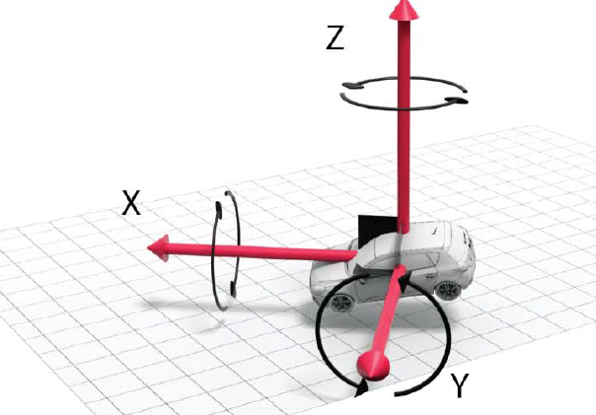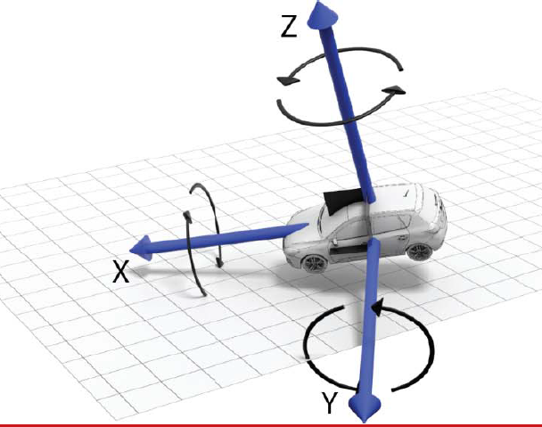
Intermediate system acc. to ISO 8855:2011 Vehicle system acc. to ISO 8855:2011
- paragraph 5.6.2.1.1. “Lateral acceleration”
Especially tyres have a massive influence on vehicle dynamics. While the vehicle very easily reaches the defined value of aysmax with very agile tyres, more stable tyres will prevent the vehicle from achieving the same level of lateral acceleration upon the same input. And due to safety limits of the steering system the system cannot simply increase the input in order to achieve that same level of lateral acceleration. Therefor it is necessary to recognize that these influences have an effect on the achievable lateral acceleration.
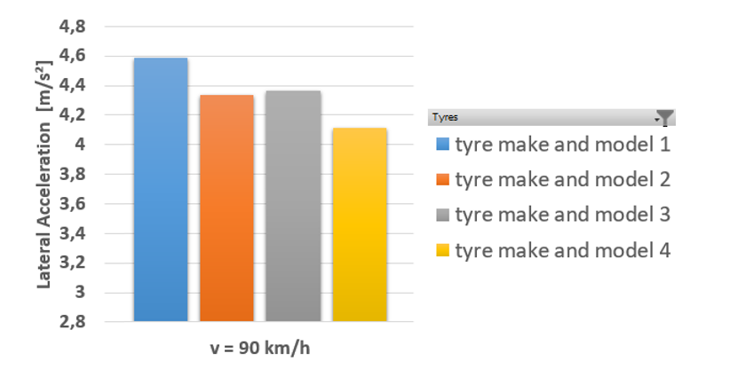
The above diagram compares the achieved lateral acceleration of a vehicle depending on different make and models of tyres being fitted to the vehicle, while the steering system always provides the exact same output. It can be seen that the lateral acceleration resulting from the same steering output differs by more than 0,5m/s2 when fitted with different tyres. [each bar represents the average achieved lateral acceleration of 6 overall test runs, where 3 tests runs with each tyre were performed steering to the left and 3 test runs were performed steering to the right, and all influences other than tyres were being kept constant]
- Annex 8, paragraph 3.2.3.1. Overriding Force test
The test procedure as defined today represents a good/best case. Due to the low lateral accelerations the tests need to be performed on tracks with very big radiuses (> 600 m) where test results are similar to testing on straight roads (radius infinite). In these conditions there are no counterforces acting on the steering control, which would need to be additionally overridden (like counterforces resulting from castor).
If the limit of 50 N to override the system shall be considered as a maximum that might appear in normal traffic situations, the typical counterforces when driving a curve should be taken into account. The proposed change/modification of the test procedure covers steering counterforces within the use case of the system and brings the text in line with the requirements in paragraph 3.2.1.1 of Annex 8.

