Draft Supplement 6 to the 07 series of amendments

Draft Supplement 1 to the 08 series of amendments

to UN Regulation No. 16 (Safety-belts))

Submitted by the expert from the International Organization of Motor Vehicle Manufacturers

The text reproduced below was prepared by the expert from the International Organization of Motor Vehicle Manufacturers (OICA). The proposal aims at addressing the requirements for Safety Belt Reminders in some particular vehicle designs and at clarifying the current text of the transitional provisions.

I. Proposal

Paragraph 8.4.4.2, add a new sentence to read:

"8.4.4.2. The visual warning shall indicate at least all rear seating positions to allow the driver to identify, while facing forward as seated on the driver seat, any seating position in which the safety-belt is unfastened. For vehicles that have information on the occupancy status of the rear seats, the visual warning does not need to indicate unfastened safety-belts for unoccupied seating positions. **Seats, which can be moved to different positions within the vehicle (e.g. floor rail mounted), shall at least indicate when any rear safety belt is unfastened"**

Add a new Paragraph 15.5.6 (and renumber accordingly) as follows:

15.4. As from the official date of entry into force of the 07 series of amendments, no Contracting Party applying this Regulation shall refuse to grant or refuse to accept type approvals under this UN Regulation as amended by the 07 series of amendments. Contracting Parties shall continue to grant extensions of approvals to the preceding series of amendment.

15.4.1. As from 1 September 2019, Contracting Parties applying this Regulation shall not be obliged to accept type approvals to the preceding series of amendments that were first issued on or after 1 September 2019.

15.4.2. A safety-belt reminder is not compulsory on removable rear seats and on any seat in a row in which there is a suspension seat, for the purpose of granting type-approval to the 07 series of amendment, until 1 September 2022. These exemptions shall remain applicable in the case of extensions of approvals first granted before 1 September 2022.

15.4.3. Until 1 September 2021, Contracting Parties applying this Regulation shall accept type approvals to the preceding series of amendments that were first issued before 1 September 2019.

15.4.4. As from 1 September 2021, Contracting Parties applying this Regulation shall not be obliged to accept type approvals issued to the preceding series of amendments to this Regulation.

15.4.5. Notwithstanding paragraph 15.4.4., Contracting Parties applying the Regulation shall continue to accept UN type approvals of safety-belts and restraint systems to the preceding series of amendments to the Regulation.

15.4.6. Notwithstanding paragraph 15.4.4, Contracting Parties applying the Regulation shall continue to accept type approvals to the preceding series of amendments to the Regulation, for vehicles which are not affected by the changes introduced by the 07 series of amendments."

15.5. As from the official date of entry into force of the 08 series of amendments, no Contracting Party applying this Regulation shall refuse to grant or refuse to accept type approvals under this Regulation as amended by the 08 series of amendments.

15.5.1. As from 1 September 2020, Contracting Parties applying this Regulation shall not be obliged to accept type approvals to the preceding series of amendments that were first issued on or after 1 September 2020.

15.5.2. Until 1 September 2022, Contracting Parties applying this Regulation shall accept type approvals to the preceding series of amendments that were first issued before 1 September 2020.

15.5.3. As from 1 September 2022, Contracting Parties applying this Regulation shall not be obliged to accept type approvals issued to the preceding series of amendments to this Regulation.

15.5.4. Notwithstanding paragraph 15.5.3., Contracting Parties applying this Regulation shall continue to accept type approvals of safety-belts and restraint systems to the preceding series of amendments to the UN Regulation.

15.5.5. Notwithstanding paragraph 15.5.3., Contracting Parties applying this Regulation shall continue to accept type approvals to the preceding series of amendments to this Regulation, for vehicles which are not affected by the changes introduced by the 08 series of amendments.

**15.5.6. Notwithstanding paragraphs 15.5.1. and 15.5.3., contracting parties applying this Regulation shall continue to accept exemptions according to paragraph 15.4.2 if the vehicle was first approved to the 07 or the 08 series of amendments to this Regulation before 1 September 2022.**

**These exemptions shall remain applicable in the case of extensions of approvals first granted before 1 September 2022.**

15.5.~~6~~**7**. Contracting Parties applying this Regulation shall not refuse to grant type approvals according to any preceding series of amendments to this Regulation or extensions thereof.

II. Justification

Paragraphs 8.4.4.2:

M1 vehicles can have rear seats which can be moved around within the vehicle: they can be installed in different locations within the vehicle as shown in the figure below.

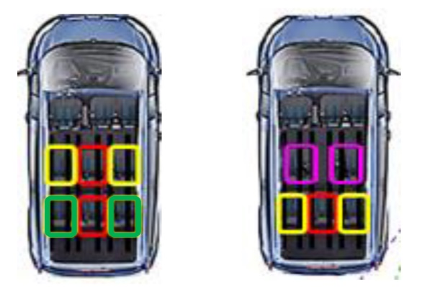

Or

According to the current requirements of § 8.4.4.2, even such seats must allow identification where they are located when the belt is unfastened. OICA therefore proposes that, for such seats, only an indicator would be needed to detect unfastened belts, without actually identifying the exact location of the seat in the vehicle.

Transitional provisions:

In the transitional provisions of UN R16.07 (Safety Belt Reminders), § 15.4.2 defines the exemption for removable and for suspension seats: new approvals to UN R16.07 can be granted till 1 September 2022 even if these seats are not equipped with SBR. For these special cases, the exemption remains applicable indefinitely (extensions and new registrations, provided the original approval was granted before 1 September 2022.

However, with the introduction of UN R16.08 (new airbag labelling requirements), and especially § 15.5.1 and § 15.5.3, there is a risk of misinterpretation, such that the exemption mentioned above would be unintentionally cancelled. OICA therefore proposes the addition of a new paragraph to clarify that the exemption in question remains applicable and therefore remains acceptable, to all approvals to UN R16.07 or UN R16.08 originally granted prior to 1 September 2022.