|  |  |  |  |
| --- | --- | --- | --- |
|  | United Nations | ECE/TRANS/WP.29/GRSP/65 | |
| _unlogo | **Economic and Social Council** | | Distr.: General  18 June 2019  Original: English |

**Economic Commission for Europe**

Inland Transport Committee

**World Forum for Harmonization of Vehicle Regulations**

**Working Party on Passive Safety**

**Sixty-fifth session**

Geneva, 13–17 May 2019

Report of the Working Party on Passive Safety on its   
sixty-fifth session

Contents

*Paragraphs Page*

I. Attendance 1–2 3

II. Adoption of the agenda (agenda item 1) 3 3

III. UN Global Technical Regulation No. 7 (Head restraints) (agenda item 2) 4–6 3

IV. UN Global Technical Regulation No. 9 (Pedestrian safety) (agenda item 3) 7–9 4

A. Proposal for Amendment 2 (Phase 2) 7 4

B. Proposal for Amendment 3 8 4

C. Proposal for Amendment 4 9 5

V. UN Global Technical Regulation No. 13 (Hydrogen and Fuel Cells Vehicles)   
 (agenda item 4) 10–12 5

VI. Harmonization of side impact dummies (agenda item 5) 13 6

VII. UN Global Technical Regulation No. 20 (Electric vehicle safety) (agenda item 6) 14–15 6

VIII. UN Regulation No. 14 (Safety-belt anchorages) (agenda item 7) 16 6

IX. UN Regulation No. 16 (Safety-belts) (agenda item 8) 17–18 6

X. UN Regulation No. 17 (Strength of seats) (agenda item 9) 19–21 7

XI. UN Regulation No. 22 (Protective helmets) (agenda item 10) 22–23 7

XII. UN Regulation No. 29 (Cabs of commercial vehicles) (agenda item 11) 24 8

XIII. UN Regulation No. 44 (Child Restraint Systems) (agenda item 12) 25 8

XIV. UN Regulation No. 80 (Strength of seats and their anchorages (buses))   
(agenda item 13) 26 8

XV. UN Regulation No. 94 (Frontal collision) (agenda item 14) 27–28 9

XVI. UN Regulation No. 95 (Lateral collision) (agenda item 15) 29 9

XVII. UN Regulation No. 100 (Electric power trained vehicles) (agenda item 16) 30–31 9

XVIII. UN Regulation No. 111 (Uniform provisions concerning the approval of tank vehicles of categories N and O with regard to rollover stability)   
(agenda item 17) 32 10

XIX. UN Regulation No. 127 (Pedestrian safety) (agenda item 18) 33 10

XX. UN Regulation No. 129 (Enhanced Child Restraint Systems)   
(agenda item 19) 34–35 10

XXI. UN Regulation No. 134 (Hydrogen and Fuel Cells Vehicles (HFCV))   
(agenda item 20) 36 11

XXII. UN Regulation No. 135 (Pole Side Impact) (PSI)) (agenda item 21) 37 11

XXIII. UN Regulation No. 136 (Electric Vehicles of category L (EV-L)) (agenda item 22) 38 11

XXIV. UN Regulation No. 137 (Frontal impact with focus on restraint systems)   
(agenda item 23) 39–40 11

XXV. UN Regulation No. 145 (ISOFIX anchorage systems, ISOFIX top tether anchorages and i-Size seating positions) (agenda item 24) 41 11

XXVI. Mutual Resolution No. 1 (agenda item 25) 42 12

XXVII. Securing of children in buses and coaches (agenda item 26) 43–45 12

XXVIII. Exchange of views on Vehicle Automation (agenda item 27) 46 12

XXIX. Other business (agenda item 28) 47–60 13

A. Exchange of information on national and international requirements on passive safety 47–53 13

B. Definitions and acronyms in Regulations under GRSP responsibilities 54 14

C. UN Regulation No. 0 (International Whole Vehicle Type Approval) 55 14

D. Highlights of the March 2019 session of WP.29 56 15

E. Three-dimensional H-point machine 57 15

F. Intelligent transport systems 58 15

G. UN Regulation No. 21 (Interior fittings) 59 15

H. Tributes 60 15

XXX. Provisional agenda for the next session (agenda item 29) 61 15

Annexes

I. List of informal documents (GRSP-65-…) distributed without an official symbol during the session 17

II. Draft amendments to UN Regulation No. 17 (Strength of seats) 20

III. Draft amendments to UN Regulation No. 44 (Child Restraint Systems) 21

IV. Draft amendments to UN Regulation No. 80 (Strength of seats and their anchorages (buses)) 22

V. Draft amendments to UN Regulation No. 129 (Enhanced Child Restraint Systems) 24

VI. Draft amendments to UN Regulation No. 135 (Pole Side Impact) (PSI)) 26

VII. UN Regulation No. 21 (Interior fittings) 27

VIII. List of GRSP informal working groups 28

I. Attendance

1. The Working Party on Passive Safety (GRSP) held its sixty-fifth session in Geneva from 13 to 17 May 2019, chaired by Mr. J. Wan Lee (Republic of Korea) due to absence of Mr. N. Nguyen (United States of America) and in compliance with Rule 13 of the Rules of Procedure (TRANS/WP.29/690/Rev.1). Experts from the following countries participated in the work following Rule 1(a) of the Rules of Procedure of the World Forum for Harmonization of Vehicle Regulations (WP.29) (ECE/TRANS/WP.29/690/Rev.1): Belgium, Canada, China, Czechia, Finland, France, Germany, India, Italy, Japan, Netherlands, Norway, Poland, Republic of Korea, Russian Federation, South Africa, Spain, Sweden, Switzerland United Kingdom of Great Britain and Northern Ireland and United States of America. An expert from the European Commission (EC) participated. Experts from the following non-governmental organizations participated: American Automotive Policy Council (AAPC), Consumers International (CI), European Association of Automotive Suppliers (CLEPA), Federation International de l'Automobile (FIA), Federation Internationale de Motocyclisme (FIM), Global New Car Assessment Programme (Global NCAP), International Motorcycle Manufacturers Association (IMMA), International Organization of Motor Vehicle Manufacturers (OICA) and International Motor Vehicle Inspection Committee (CITA).

2. Annex I of this report lists the informal documents distributed during the session.

II. Adoption of the agenda (agenda item 1)

*Documentation*: ECE/TRANS/WP.29/GRSP/2019/1  
Informal documents GRSP-65-05 and GRSP-65-25

3. GRSP considered and adopted the agenda (ECE/TRANS/WP.29/GRSP/2019/1) proposed for the sixty-fifth session, running order (GRSP-65-05) and annotations   
(GRSP-65-25). GRSP informal working groups are listed in Annex VIII of this report.

III. UN Global Technical Regulation No. 7 (Head restraints) (agenda item 2)

*Documentation*: ECE/TRANS/WP.29/GRSP/2019/5  
ECE/TRANS/WP.29/GRSP/2019/8  
ECE/TRANS/WP.29/GRSP/2019/10  
Informal documents GRSP-65-24, GRSP-65-30, GRSP-65-31 and GRSP-65-32

4. The expert from Germany introduced GRSP-65-32, to present the proposed Amendment 2 (GRSP-65-24 superseding ECE/TRANS/WP.29/GRSP/2019/5) to UN GTR No. 7 (Phase 2 of the UN GTR on head restraints), jointly prepared with the experts from Japan and the Netherlands. He explained that the proposal has removed several square brackets and therefore solving the main issues. He added that the draft amendment would introduce: (a) injury criteria focusing on Neck Injury Criteria (NIC) namely upper and lower neck flexion and extension, (b) BioRID as an option for contracting parties to Hybrid III still and (c) procedure for establishing the height of the head restraint based on the head contact rather than at its absolute height. He clarified that the proposal that would need still some changes, will be complemented by a proposal of Addendum 1 to the Mutual Resolution No. 1 to insert drawings and specifications of the BioRID, to be presented at the December 2019 session of GRSP. Moreover, the experts from France and Russian Federation announced that they would not need the translation of the BioRID manual or other dummy specification and can be dealt with in English only. GRSP noted that all these specifications, when they would be submitted, shall need a disclaimer letter from the dummy manufacturer concerning copyright claims and that they might be upload on the M.R.1 website without any copyright infringements.

5. In the same time, the expert from Japan introduced the ninth status report of the Informal Working Group (IWG) on Head Restraints (GRSP-65-31). The expert from CLEPA withdrew ECE/TRANS/WP.29/GRSP/2019/8 and introduced GRSP-65-30 superseding ECE/TRANS/WP.29/GRSP/2019/10 amending the static options of the proposal.

6. Finally, GRSP experts were invited to provide comments to GRSP-65-24 to the expert from Japan by 13 September 2019. Moreover, GRSP requested the secretariat to distribute GRSP-65-30 and GRSP-65-31 with an official symbol and agreed to seek consent of WP.29 and AC.3 to extend the mandate of the IWG until June 2020.

IV. UN Global Technical Regulation No. 9 (Pedestrian safety) (agenda item 3)

A. Proposal for Amendment 2 (Phase 2)

*Documentation*: ECE/TRANS/WP.29/GRSP/2019/4  
Informal documents GRSP-65-01 and GRSP-65-02

7. The expert from Germany, on behalf of the Chair of the pedestrian safety IWG, introduced the amendment to M.R.1 for the new Addendum 3 to M.R.1 (ECE/TRANS/WP.29/GRSP/2019/4), incorporating drawings, specifications and the manual of the Flex Pedestrian Legform Impactor (FlexPLI): GRSP-65-01 and GRSP-65-02. The experts from France and the Russian Federation confirmed that the manual and technical specifications should not be translated. However, it was noted that GRSP-65-01 and GRSP-65-02 would not be displayed on the WP.29 website until a disclaimer letter would be provided (see para. 4). Finally, GRSP adopted ECE/TRANS/WP.29/GRSP/2019/4 unamended. The secretariat was requested to submit the proposal as Amendment 2 to M.R.1 for consideration and vote at the November 2019 sessions of WP.29 and AC.3.

B. Proposal for Amendment 3

*Documentation:* ECE/TRANS/WP.29/GRSP/2012/2  
ECE/TRANS/WP.29/GRSP/2014/5  
Informal document GRSP-65-17

8. The expert from Germany introduced GRSP-65-17, explaining that the intention of the pedestrian protection test procedures as described in UN GTR No. 9 and UN Regulation No. 127 was to deliver an adequate level of protection for pedestrians in accidents up to an impact velocity of 40 km/h. International Harmonized Research Agenda research has shown that the cumulative frequency curves versus vehicle impact speed for pedestrian injuries and their respective injury causing parts showed that 58 per cent of the child head abbreviated injury scale (AIS) 2+ injuries were addressed to a vehicle impact speed up to 40 km/h, 40 per cent to adult head AIS2+ injuries and 50 per cent of the adult leg AIS2+ injuries respectively. He added that test procedures described in UN Regulation No. 127 and UN GTR No. 9 were meant to represent worst case scenarios. However, it was agreed that this was not the case for all possible scenarios and that also at lower impact speeds higher injury risk could occur due for example to different heights of the vehicle because of adjustable suspension systems. The representative from OICA reminded that during the type approval process the worst case scenario will be considered. GRSP agreed to keep GRSP-65-17 as an informal document for the December 2019 session of GRSP, awaiting further rationales to develop a proposal of amendments.

C. Proposal for Amendment 4

9. The expert from the Republic of Korea, on behalf of the Chair of the IWG on Deployable Pedestrian Protection Systems (DPPS) informed GRSP about the work progress of the IWG. He explained that the group had its fourth meeting in Paris (12-14 March 2019) and that there were some controversial issues remaining such as a verification impactor which was used for testing the ability of the system to determine the most difficult to detect pedestrian within the appropriate pedestrian stature range. Moreover, he also mentioned that the defining of the head impact test area in case of a deployable pedestrian protection system remained an issue. Moreover, he noted that were few contracting parties attending IWG meetings regularly and encouraged broader participation. He also invited experts of concerned parties to have a web-meeting to resolve the above issues before the next meeting, scheduled in September in London. GRSP agreed to resume consideration on this agenda item at its December 2019 session.

V. UN Global Technical Regulation No. 13 (Hydrogen and Fuel Cells Vehicles) (agenda item 4)

10. The expert from the United States of America, on behalf of the co-sponsors (Japan, Republic of Korea, European Union) informed GRSP that the Chair (United States of America) of the Hydrogen and Fuel Cells Vehicles (HFCV) UN GTR IWG Phase 2, Mr. Nha Nguyen, had retired from the Federal service and was replaced by Mr. Martin Koubek. He provided GRSP with the details of the next IWG meeting, scheduled for 17 to 20 June 2019 in Tianjin, China.

11. The expert from Japan, on behalf of the co-sponsors (Japan, Republic of Korea, European Union) informed GRSP on the work progress of the IWG and provided a summary of some of the most relevant topic of discussion of the last IWG meeting (5 to 7 March 2019) held in Vancouver, Canada. He explained that the meeting was well attended by representatives from various contracting parties, motor vehicle manufacturers, container industries, standard organizations, and academia. He added that the IWG continued the discussions on technical issues such as requirements for heavy duty vehicles and buses, material compatibility, high pressure system reliability, and fire tests and that research and test results we presented. He specified that the five Task Forces (TF) provided their state of progress and issues:

(a) TF No.1 – Heavy-duty trucks and buses had extensively discussed the difference of the fuel system to those in light-duty vehicles.  TF proposed the revised scope to add heavy-duty vehicles to the categorization of current UN GTR;

(b) TF No. 2 - Fuelling receptacle requirements, had planned to submit a final proposal for fuelling receptacle requirements at the next working group meeting;

(c) TF No. 3 - Recommendations for test procedures, had progressed well and should complete its work by the summer of 2019;

(d) TF No. 4 - Fire test, also progressed well and is scheduled to complete its work in 2019;

(e) TF No. 5 - Recommendations from ISO TC197, had recommended a technical information proposal for the rationale section.

12. He finally concluded that IWG aimed to complete its work by the 2020 mandate.

VI. Harmonization of side impact dummies (agenda item 5)

13. The Chair of GRSP reminded GRSP about the decision of the National Highway Transport Safety Administration (NHTSA) to no longer chair the IWG due to a lack of resources. He recalled the statement of the expert from Germany at the December 2017 session of GRSP (ECE/TRANS/WP.29/GRSP/62, para. 10) that the addenda of M.R.1 which incorporates anthropomorphic test device (crash test dummies) specifications, particularly of side impact dummies (e.g. World Side Impact Dummy fiftieth percentile), be completed as soon as possible. The experts from OICA and Germany underlined that the issue is not limited to cover harmonization of side impact dummies, but all tools used in the UN Regulations. They also stressed that UN GTR No. 14 and UN Regulation No. 135 are linked to an ISO standard. This could lead to legal uncertainty as standards are copyright-protected and in addition are changed more frequently. However, GRSP agreed to focus efforts on tools covered by UN Regulations under its responsibility underlining that the lack of work progress would cause problems at the level of type approval and certification procedures. Therefore, GRSP urged its experts to find a solution for the chairmanship of the group.

VII. UN Global Technical Regulation No. 20 (Electric vehicle safety) (agenda item 6)

14. The expert of the United States of America, informed GRSP that the United States America Chair of the EV GTR IWG, Mr. Nha Nguyen would retire and be replaced by Mr. Ezana Wondimneh. He also updated GRSP on the details of the next meeting, scheduled to take place in Tokyo, Japan (11 to 14 June 2019).

15. The expert from Japan, on behalf of the co-sponsors (China, Japan, European Union and the members of IWG GTR No. 20, Phase 2) reported on the work progress of the IWG meeting of EVS-GTR, Phase 2. GRSP was informed that the last session had been held on 23 and 24 January in Detroit, United States of America. He reported that the meeting had been well represented by various contracting parties, motor vehicle and battery manufacturers and standard organizations. He added that IWG had continued discussions on technical issues, i.e. thermal propagation, water immersion, toxicity and gas management and three-dimensional vibration.  As previously reported, IWG was currently conducting research and running tests on thermal propagation and toxicity. He added that the white paper on thermal propagation was ongoing. However, some main items, including field incident data, had not reached consensus and that IWG members would continue to discuss and resolve the items at the next meeting. He concluded that other significant technical discussions included water immersion and vibration of the battery system and that IWG aimed to complete its work by the 2021 mandate. The expert of OICA stressed the need for the various discussion items to be justified by facts and figures.

VIII. UN Regulation No. 14 (Safety-belt anchorages)   
(agenda item 7)

16. No new information was provided under this agenda item.

IX. UN Regulation No. 16 (Safety-belts) (agenda item 8)

*Documentation*: ECE/TRANS/WP.29/GRSP/2018/25  
ECE/TRANS/WP.29/GRSP/2019/6  
Informal documents GRSP-65-08 and GRSP-65-09

17. The expert from OICA introduced GRSP-65-08 with a presentation (GRSP-65-09), aimed to introduce an alternative (at the choice of the manufacturer) to the airbag switch-off for frontal airbags in combination with rearward-facing child restraint systems in the rear seat. With a new test procedure, the manufacturer can demonstrate that deactivation of the airbag is not needed. He explained that the proposal aimed to promote new airbag technologies while ensuring the current level of protection for children in rearward faced CRS. GRSP agreed to resume discussion on this subject at its December 2019 session and requested the secretariat to distribute GRSP-65-08 with an official symbol.

18. The expert from CLEPA introduced ECE/TRANS/WP.29/GRSP/2019/6 to clarify which modification of the vehicle type or the safety-belt or restraint system shall be notified to the Type Approval Authority. GRSP agreed to combine ECE/TRANS/WP.29/GRSP/2019/6 with ECE/TRANS/WP.29/GRSP/2018/25 to extend the requirements for the safety-belt reminder installation not only to the driver's seat (see ECE/TRANS/WP.29/GRSP/64, para. 15). GRSP finally agreed with both proposals, neither amended, and requested the secretariat to submit ECE/TRANS/WP.29/GRSP/2019/6 and ECE/TRANS/WP.29/GRSP/2018/25 as Supplement 12 to the 06 series of amendments to UN Regulation No. 16 and as Supplement 5 to the 07 series of amendments, for consideration and vote at the November 2019 sessions of WP.29 and AC.1.

X. UN Regulation No. 17 (Strength of seats) (agenda item 9)

*Documentation*: ECE/TRANS/WP.29/GRSP/2019/7  
ECE/TRANS/WP.29/GRSP/2019/9  
Informal documents GRSP-65-04, GRSP-65-18-Rev.1 and   
GRSP-65-19

19. The expert from Finland introduced GRSP-65-04 to raise concerns on head-restraint installation, testing and other interpretations issues. The expert from Germany introduced GRSP-65-18-Rev.1, proposing an amendment to the definition of integrated, detachable and separate head-restraints. The expert from OICA noted that Amendment 1 to UN GTR No. 7 dealt with definitions of such head-restraints and suggested that the transposition of UN GTR No. 7, Phase 2 into the UN Regulation would solve the issue. In the same time, he urged that cross references between the UN Regulation and the UN GTR be consistent. So, he proposed to establish a Task Force (TF) to complete harmonization of the two Regulations. The expert from Germany endorsed the establishment of TF but proposed to keep GRSP-65-18-Rev.1 separated from other proposals of alignment to the UN GTR.

20. Finally, GRSP agreed with the proposal of the expert from OICA to establish a TF and to combine GRSP-65-18-Rev.1 once the proposal of amendments to align UN Regulation No. 17 with UN GTR No. 7 were finalized. In the meantime, GRSP agreed to defer discussion on ECE/TRANS/WP.29/GRSP/2019/7 and ECE/TRANS/WP.29/GRSP/2019/9 to its December 2019 session. Moreover, the secretariat was requested to distribute GRSP-65-18-Rev.1, as a new series of amendments with an official symbol at its December 2019 session.

21. The expert from Germany introduced GRSP-65-19, proposing a Corrigendum to the UN Regulation. GRSP adopted GRSP-65-19, as reproduced in Annex II to the report and requested the secretariat to submit it as Corrigendum 2 to Revision 5 and as Corrigendum 1 to the 09 series of amendments to UN Regulation No. 17, for consideration and vote at the November 2019 sessions of WP.29 and AC.1.

XI. UN Regulation No. 22 (Protective helmets) (agenda item 10)

*Documentation*: ECE/TRANS/WP.29/GRSP/2019/11

22. The expert from Italy, Chair of IWG on Protective Helmets (IWG-PH), informed GRSP about the work progress of the group which had last convened on 13 May 2019 in Geneva. He explained that IWG had examined and, in principle, agreed on ECE/TRANS/WP.29/GRSP/2019/11. He underlined that the proposal would be further updated by IWG, according to the results of ongoing research and that the main goal of the proposal was rotational acceleration requirements. The expert from Germany stated that the proposal should be considered as a two-step approach. He clarified that rotational acceleration needed keener research. He added that the proposed, agreed amendment was a compromise stemming from the existing requirements of the UN Regulation. He stated that the draft amendment should be revised within the next two years to incorporate research results. The experts from France and the Netherlands agreed with the expert from Germany and clarified that research should be kept ongoing to incorporate better solutions in the future.

23. GRSP agreed to resume discussion on this subject at its December 2019 session on the basis of a revised version of ECE/TRANS/WP.29/GRSP/2019/11, submitted by IWG.

XII. UN Regulation No. 29 (Cabs of commercial vehicles) (agenda item 11)

*Documentation*: ECE/TRANS/WP.29/GRSP/2019/2

24. The expert from Germany introduced ECE/TRANS/WP.29/GRSP/2019/2, proposing tolerances for the position of the loading device during the test. GRSP adopted ECE/TRANS/WP.29/GRSP/2019/2, not amended. The secretariat was requested the secretariat to submit ECE/TRANS/WP.29/GRSP/2019/2 as Supplement 5 to the 03 series of amendments to UN Regulation No. 29, for consideration and vote at the November 2019 sessions of WP.29 and AC.1.

XIII. UN Regulation No. 44 (Child Restraint Systems) (agenda item 12)

*Documentation*: Informal documents GRSP-65-20 and GRSP-65-28

25. The expert from Germany introduced GRSP-65-20 aimed at introducing clarifications on the direction of the vertical component of the chest acceleration, to provide consistency on the test performed by different Technical Services on Child Restraint Systems in accordance to paragraph 7.1.4.2.2. of the UN Regulation. The expert from CLEPA introduced GRSP-65-28 which superseded GRSP-65-20. Finally, GRSP adopted GRSP-65-28 as reproduced in Annex III of this report. The secretariat was requested to submit GRSP-65-28 as Supplement 17 to the 04 series of amendments to UN Regulation No. 44, for consideration and vote at the November 2019 sessions of WP.29 and AC.1.

XIV. UN Regulation No. 80 (Strength of seats and their anchorages (buses)) (agenda item 13)

*Documentation*: ECE/TRANS/WP.29/GRSP/2018/10  
Informal document GRSP-65-29-Rev.1

26. The expert from Germany informed GRSP that TF on UN Regulation No. 80 had not started work due to the absence of new proposals as an alternative to the previous proposal ECE/TRANS/WP.29/GRSP/2018/10, that had aimed at removing Appendix 5 (static test requirements and procedure) from UN Regulation No. 80. The expert from OICA introduced GRSP-65-29-Rev.1 which proposed a compromise to the complete deletion of the static test as the static test will provide the basis for a simpler testing of small projects or Class I vehicles~~.~~ He proposed a two-step approach: (a) the first step was presented with GRSP-65-29 Rev.1 with more stringent requirement for the attachments and fittings of the seat and (b) the second step would be a revision of the static and dynamic test. The expert from the United Kingdom acknowledged the need of small manufacturers to retain a static test as alternative and supported the proposal as a viable compromise. The experts from Finland, Italy and Russian Federation expressed similar views. The expert from Germany acknowledged that GRSP-65-29-Rev.1 had partially solved the problem of construction and fixation, and thus should be intended as a compromise that could be improved in the future. The expert from the Netherlands suggested that in the future, only the dynamic test should be used. Finally, GRSP adopted GRSP-65-29-Rev.1, as reproduced in Annex IV of this report. The secretariat was requested to submit GRSP-65-29-Rev.1 as new 04 series of amendments to UN Regulation No. 80, for consideration and vote at the November 2019 sessions of WP.29 and AC.1.

XV. UN Regulation No. 94 (Frontal collision) (agenda item 14)

*Documentation*: Informal document GRSP-65-14

27. Referring to the presentation of the revised General Safety Regulation of the European Union (see agenda item 28 (a)), the expert from EC introduced GRSP-65-14 aimed at broadening the scope to cover, e.g. heavy vans and Sport Utility Vehicles, and proposing an evacuation of occupants through a front door in a crash instead of displacement systems for the front seats. He also mentioned that the dates proposed of entry into force of the draft supplement to the UN Regulation were needed to trigger those of the General Safety Regulation. The expert from Italy suggested a new series of amendments instead of a supplement. The expert from OICA argued that the proposal was demanding for manufacturers of N1 vehicles and that further discussions on this proposal should start shortly. He added that the provisions for electric vehicles would be amended by the transposition of UN GTR No. 20 into UN Regulation No. 94 in near future so contracting parties should carefully agree on transitional provisions. Therefore, he proposed to establish a TF to cover all crash configurations. The expert from Germany endorsed the proposed TF as the most viable solution.

28. GRSP agreed with establishing a TF, led by EC and handed over   
GRSP-65-14 as a reference, awaiting an official document delivered by TF before the deadline for submission of official documents of 13 September 2019.

XVI. UN Regulation No. 95 (Lateral collision) (agenda item 15)

*Documentation*: Informal document GRSP-65-13

29. The expert from EC, introduced GRSP-65-13, on the same subjects introduced under agenda items 14 and 28 (a) in the framework of lateral impact. He also added that barrier structure would be updated at a later stage. GRSP agreed to hand over GRSP-65-13 to TF (see para. 28 above).

XVII. UN Regulation No. 100 (Electric power trained vehicles) (agenda item 16)

*Documentation*: ECE/TRANS/WP.297GRSP/2019/3  
Informal documents GRSP-65-07 and GRSP-65-33-Rev.1

30. The experts from the Netherlands and OICA introduced GRSP-65-33-Rev.1 (superseding ECE/TRANS/WP.297GRSP/2019/3) which proposed functional safety requirements that focused on other categories of vehicles other than M1. The expert from the United States of America reminded GRSP that harmonization shall be kept when UN GTR No. 20 was transposed into UN Regulation No. 100. GRSP agreed to distribute GRSP-65-33-Rev.1 with an official symbol to the December 2019 session of GRSP, awaiting a proposal of amendments that align UN Regulation No. 100 to UN GTR No. 20.

31. The expert from the Russian Federation introduced GRSP-65-07, proposing further improvement of functional safety requirements. The expert from Japan suggested that this extensive revision of safety requirements should be handed over to the IWG on UN GTR No. 20, Phase 2 to be compared or aligned with their ongoing work on the UN GTR. GRSP agreed with the proposal of Japan and to refer it to IWG UN GTR No. 20, Phase 2 and, to resume discussion at its December 2019 session.

XVIII. UN Regulation No. 111 (Uniform provisions concerning the approval of tank vehicles of categories N and O with regard to rollover stability) (agenda item 17)

32. No new proposal was provided under this agenda item (see para. 46 below).

XIX. UN Regulation No. 127 (Pedestrian safety) (agenda item 18)

*Documentation*: Informal document GRSP-65-21

33. Referring to agenda item 3(b) (see paragraph 8 above), the expert from Germany suggested postponing discussion on GRSP-65-21 to allow careful consideration of the new provisions of the General Safety Regulation of the European Union, which had proposed an extension of the head impact zone. GRSP agreed to defer discussion of GRSP-65-21 to its December 2019 session and to distribute it with an official symbol.

XX. UN Regulation No. 129 (Enhanced Child Restraint Systems) (agenda item 19)

*Documentation*: ECE/TRANS/WP.29/GRSP/2019/12  
Informal documents GRSP-65-06 and GRSP-65-27-Rev.1.

34. The expert from CLEPA introduced ECE/TRANS/WP.29/GRSP/2019/12 and its amendment, GRSP-65-27-Rev.1. He explained that the proposal introduced the booster cushion without a backrest, and concluded the development of UN Regulation No. 129. GRSP adopted ECE/TRANS/WP.29/GRSP/2019/12, as amended by Annex V to this report, and requested the secretariat to submit it as Supplement 3 to the 03 series of amendments to UN Regulation No. 129, for consideration and vote at the November 2019 sessions of WP.29 and AC.1.

35. The expert from GlobalNCAP also introduced GRSP-65-06 proposing limit values for the chest vertical acceleration of Q-dummies during dynamic testing of Enhanced Child Restraint Systems (ECRS). The expert from CLEPA expressed general concern and raised a time reservation. The expert from United Kingdom stated that a permanent solution was needed. He added that this was not the case to implement the chest vertical acceleration but rather to develop the upper neck tension force on the basis of available data. The expert from EC stated that discussion should be deferred until data was available. The expert from CLEPA expressed similar view and suggested collecting support data before the December 2019 session of GRSP. The Chair of GRSP suggested to create a TF led by a representative of a contracting party to coordinate efforts. GRSP agreed, in principle, with the proposal of Chair and agreed to resume discussion at its December 2019 session on the basis of the outcome of above-mentioned TF research. At the same time GRSP requested the secretariat to distribute GRSP-65-06 with an official symbol at its next session.

XXI. UN Regulation No. 134 (Hydrogen and Fuel Cell Vehicles (HFCV)) (agenda item 20)

36. No new information was provided under this agenda item.

XXII. UN Regulation No. 135 (Pole Side Impact) (PSI))   
(agenda item 21)

*Documentation*: ECE/TRANS/WP.29/GRSP/2019/13  
Informal document GRSP-65-36

37. The expert from France introduced ECE/TRANS/WP.29/GRSP/2019/13, clarifying that rear doors on the impacted side which were not directly struck by the pole, might be subjected to heavy loads. He proposed a similar amendment that had already been adopted for UN Regulation No. 95. The expert from OICA introduced GRSP-65-36, agreed with the expert from France to delete the applied force on the front door. Finally, GRSP adopted ECE/TRANS/WP.29/GRSP/2019/13, as amended by Annex VI to this report and requested the secretariat to resume discussion at its May 2019 session and to submit it as Supplement 2 to the original series and to the 01 series of amendments to UN Regulation No. 135, for consideration and vote at the November 2019 sessions of WP.29 and AC.1.

XXIII. UN Regulation No. 136 (Electric Vehicles of category L   
(EV-L)) (agenda item 22)

38. No new information was provided under this agenda item.

XXIV. UN Regulation No. 137 (Frontal impact with focus on restraint systems) (agenda item 23)

*Documentation*: Informal document GRSP-65-12

39. The expert from EC, introduced GRSP-65-12, covering the same subjects introduced under agenda items 14, 15 and 28 (a) on frontal impact with focus on restraint systems. GRSP agreed to hand over GRSP-65-12 to the TF (see paras. 28 and 29 above).

40. The expert from CI reminded GRSP also to include the L7 category of vehicles as proposed at the previous sessions. He announced an official proposal to cover this category of vehicles by the December 2019 session of GRSP. The expert from IMMA argued that the L7 category of vehicles was too broad and suggested that a clear definition be established in the Consolidated Resolution on the Construction of Vehicles (R.E.3). He also questioned the huge growth of L7 categories as announced by GlobalNCAP. The expert of GlobalNCAP insisted that his statement was based on data published by the UK Transport Research Laboratory (TRL) which indicated L7 quadricycles as part of the future of mobility. The expert of EC, informed GRSP that provisions of UN Regulation No. 137 on L7 category of vehicles would not be mandatory in the European Union but would request voluntary testing. Finally, GRSP agreed to resume discussion on this subject at its December 2019 session.

XXV. UN Regulation No. 145 (ISOFIX anchorage systems, ISOFIX top tether anchorages and i-Size seating positions) (agenda item 24)

*Documentation*: Informal document GRSP-65-34

41. The expert from GlobalNCAP introduced a presentation (GRSP-65-34) that highlighted cases of ISOFIX anchorage ruptures of forward-facing CRS. He then proposed to review the UN Regulation that allowed deformations and load configuration tests. The expert from CLEPA stated that these failures should be further investigated, and requested more time and data. The expert from GlobalNCAP clarified that he was only highlighting the issue and was not a position to quantify the number of failures. The expert from OICA requested that all available findings should be analysed to identify the causes. Finally, GRSP agreed to create a group of interested experts to coordinate the research, and to resume discussion on this agenda item awaiting further evidence at its December 2019 session.

XXVI. Mutual Resolution No. 1 (agenda item 25)

42. Discussion was concluded under agenda items 2, 3(a) and 5 (see paras. 4, 7 and 13).

XXVII. Securing of children in buses and coaches (agenda item 26)

*Documentation*: Informal documents GRSP-65-11 and GRSP-65-26

43. The expert from Spain introduced GRSP-65-11, showing that there were no specific requirements for children travelling in buses and coaches, unlike children in passenger cars. She added that specifications in UN Regulations Nos. 44 and 129 were only to secure children on M1 category of vehicles. Therefore, she stated that it was time to establish requirements for securing children in M2 and M3 vehicles, based on real accidents in these type of vehicles with the priority of avoiding ejection of occupants. She therefore proposed to develop a new UN Regulation for securing children in buses and coaches and to establish an IWG to develop the work. The expert from Sweden introduced GRSP-65-26, showing that generally, buses in his country were not designed for the transportation of children. The expert from the United States of America provided information through links to how children were transported in his country:

[www.nhtsa.gov/road-safety/school-bus-safety](http://www.nhtsa.gov/road-safety/school-bus-safety)  
<http://schoolbusfacts.com/wp-content/uploads/2017/01/SafetyFeatures.pdf>  
[www.youtube.com/watch?v=szJxbC01V8k&feature=youtu.be](http://www.youtube.com/watch?v=szJxbC01V8k&feature=youtu.be)  
[www.youtube.com/watch?v=Q8sk8PodMMw&feature=youtu.be](http://www.youtube.com/watch?v=Q8sk8PodMMw&feature=youtu.be)

44. The expert from EC underlined how the rate of wearing safety-belts was dramatically low in buses. He suggested that wearing should be combined with safety-belt reminders and that a study on cost-benefit analysis on their presence on buses would be considered in the work of the IWG proposed by the expert from Spain. The experts from Germany, Japan, Republic of Korea, Russian Federation, Sweden, CLEPA and GlobalNCAP supported the proposal to establish an IWG and to provide a contribution.

45. Finally, GRSP agreed to seek consent of WP.29 at its June 2019 session to establish an IWG on "Securing of Children in buses and coaches" and to request the secretariat to inform the Working Party on General Safety (GRSG) at its October 2019 session.

XXVIII. Exchange of views on Vehicle Automation (agenda item 27)

*Documentation*: ECE/TRANS/WP.29/2019/2 and ECE/TRANS/WP.29/2019/34

46. The secretary of the Working Party on Automated/Autonomous and Connected Vehicles (GRVA) introduced ECE/TRANS/WP.29/2019/2 and ECE/TRANS/WP.29/2019/34 on priority topics for automated and connected vehicles. The expert from the United States of America stressed that even though automated vehicles were different from conventional vehicles for many aspects, crashworthiness remained relevant. He clarified that ECE/TRANS/WP.29/2019/2 did not yet include the work tasks of GRSP and was mainly a list of tasks for GRVA. He added that this document should be considered a living document and that crashworthiness should be included. He mentioned a few examples of passenger compartment configurations (e.g. passengers lying down or facing the side, lack of a steering wheel), and he added that these different dynamics would involve passengers in a crash. The expert from Germany endorsed the statement of the expert from the United States of America. He added that new tools and computer simulations should be validated. He urged to start a list of detailed subjects as soon as possible that would be examined during the December 2019 session of GRSP. The expert from the United States of America clarified that the vehicle automation was managed by WP.29 and the Executive Committee of the 1998 Agreement (AC.3) and not by GRVA. He suggested that the expert from Germany raise this issue at WP.29 and AC.3. He reiterated his statement (as per ECE/TRANS/WP.29/2019/2) that currently, ECE/TRANS/WP.29/2019/34 mainly referred to GRVA tasks and that other topics related to crashworthiness should be addressed by GRSP. Finally, GRSP agreed to resume discussion at its December 2019 session, awaiting feedback from WP.29 and AC.3 at their June 2019 sessions.

XXIX. Other business (agenda item 28)

A. Exchange of information on national and international requirements on passive safety

*Documentation*: Informal documents GRSP-64-26, GRSP-65-16, GRSP-65-22,   
GRSP-65-23 and GRSP-65-35

47. The expert from the EC introduced GRSP-65-16, explaining the content of the amended General Safety Regulation of the European Union. The new requirements aimed to reduce or to eliminate accidents and injuries in road transport. Moreover, he added that in addition to the safety measures to protect vehicle occupants, the implementation of specific measures to prevent fatalities and injuries of vulnerable users, such as cyclists and pedestrians. As a follow-up, he introduced a new proposal of amendments to UN Regulations (see agenda items Nos. 14, 15 and 23).

48. The expert from the Republic of Korea introduced GRSP-65-22, explaining that his Government had been trying to reinforce safety regulations on school bus that would secure the traffic safety of children. He added that several regulations have been introduced into KMVSS, such as mandatory installation of stop sign, rear view camera and alarm system when driving in reverse, speed limiter and assistant stairs for getting on/off. He mentioned that last year the Government of Korea had improved the road traffic act so that operation of device in school bus would be mandated to check if all children had gotten off. He explained that the Korean vehicle safety regulations had also been amended to specify requirements on this device and that relevant requirements were added that apply to all kinds of school buses, such as an unloading child confirmation alert system. The additions referred to the requirements of Californian law in the United States of America.

49. The expert from Italy, introduced GRSP-64-26, explaining that Italian national law supported the obligatory use Unattended Child Reminder Systems by fiscal incentives and information campaigns.

50. Finally, GRSP agreed to establish a new agenda item on the subject of "Children left in cars" and resume discussion at its December 2019 session.

51. The expert from Korea introduced GRSP-65-23, explaining the Korean safety regulations on micromobility. He explained that the safety regulations were based on requirements of L7 category vehicle from regulation 168/2013 of the European Union and opinions from manufacturers. He added that this kind of vehicle should be considered as a new category of vehicles and not as a motorcycle category. He further explained four major categories in passive safety for this vehicle: (a) door latch and hinge, (b) strength of safety-belt anchorages, (c) seat anchorages and (d) test of electrical safety of high-voltage system through crash tests. He concluded that a test plan would cover in the future all the main collision configurations with the aim of introducing proper injury criterion for micromobility in KNCAP.

52. The expert from Germany introduced GRSP-65-35, providing information on impact attenuating devices to protect motorcyclists from guardrail posts. The expert from the Republic of Korea expressed a strong interest to develop more effective guard rails for all types of vehicles. The Chair of GRSP underlined that vehicle safety and road barriers shall be triggered to better improve road safety. The expert from Russian Federation fully supported the importance of safe guardrail design and suggested that WP.29 and the Global Forum for Road Traffic Safety (WP.1) should cooperate on this subject. He suggested that a UN Regulation should be developed on this subject. The expert from IMMA underlined the importance of motorcycle friendly infrastructure as part of a safe system design. He supported the proposal to start an exchange on this issue between the relevant fora. The expert from the United States of America informed GRSP that the Federal Highway Administration provides solutions and initiatives to promote safe guardrails:

https://safety.fhwa.dot.gov/

Moreover, he also informed GRSP that the American Association of State Highway and Transportation Officials had developed a "Roadside Design Guide" and a "Manual for Assessing Safety Hardware", available at:

[www.transportation.org/](http://www.transportation.org/)

53. Finally, GRSP agreed to report to the June 2019 session of WP.29 on this issue and receive guidance.

B. Definitions and acronyms in Regulations under GRSP responsibilities

54. GRSP noted that a number of new activities, particularly under the 1998 Agreement, should be revised by his experts to keep acronyms consistent in present and future GRSP work. Furthermore, the expert from EC mentioned that currently in UN Regulations, terminology (likely with the same meaning) concerning head injury needed clarifications: Head Acceptance Criterion (HAC) (UN Regulation No. 80), Head Injury Criterion (HIC) and Head Performance Criteria (HPC). GRSP agreed to resume discussion on this subject at its December 2019 session.

C. UN Regulation No. 0 (International Whole Vehicle Type Approval)

*Documentation*: Informal document GRSP-65-10

55. The expert from Japan, on behalf of the IWVTA Ambassador of GRSP, informed GRSP about IWVTA IWG progress and introduced GRSP-65-10 on the six UN Regulations that GRSP had been asked to prioritise as candidates to be inserted in Annex IV of UN Regulation No. 0: UN Regulations Nos. 44, 129, 134, 135, 137, and 145. The expert from CLEPA stated that UN Regulation No. 129 should also be on the priority list to protect children, even though some countries were still considering UN Regulation No. 44. GRSP agreed in principle with the priority list proposed by   
GRSP-65-10 and agreed to resume discussion on this subject at its December 2019 session.

D. Highlights of the March 2019 session of WP.29

56. The Secretary reported on the highlights of the 177th session of WP.29 (ECE/TRANS/WP.29/1145).

E. Three-dimensional H-point machine

57. The representative of Spain, on behalf of the Chair of the three-dimensional H-point machine IWG, by reiterating his statement (ECE/TRANS/WP.29/GRSP/64, para. 54), that since the IWG had not progressed as expected, the group would be dissolved and its activity could eventually be handed over to a new group on developing M.R.1 (see para. 13).

F. Intelligent transport systems

58. No new information was provided under this agenda item.

G. UN Regulation No. 21 (Interior fittings)

*Documentation*: Informal documents GRSP-65-03

59. The expert from France introduced GRSP-65-03 to clarify rounded edge requirements for parts of an opening roof. GRSP adopted the proposal as reproduced in Annex VII to this report and requested the secretariat to submit it as Supplement 4 to the 01 series of amendments to UN Regulation No. 21, for consideration and vote at the November 2019 sessions of WP.29 and AC.1.

H. Tributes

*Documentation*: Informal document GRSP-65-15

60. GRSP noted that Mr. N. Nguyen (United States of America), Chair of GRSP, would no longer attend the sessions. GRSP listened to his farewell letter, read by the secretariat on his behalf (GRSP-65-15), acknowledged his commitment as Chair of GRSP and continued contributions during all the years of his participation in the sessions. GRSP wished Mr. Nguyen all the best in his future activities and recognized his commitment with a long applause.

XXX. Provisional agenda for the next session (agenda item 29)

61. The sixty-sixth session is scheduled to be held in Geneva from 10 December (9.30 a.m.) to 13 December (12.30 p.m.) 2019. GRSP noted that the deadline for the submission of official documents to the secretariat is 13 September 2019, twelve weeks prior to the session. GRSP agreed to the following provisional agenda:

1. Adoption of the agenda.

2. UN Global Technical Regulation No. 7 (Head restraints).

3. UN Global Technical Regulation No. 9 (Pedestrian safety):

(a) Proposal for Amendment 3;

(b) Proposal for Amendment 4.

4. UN Global Technical Regulation No. 13 (Hydrogen and Fuel Cell Vehicles).

5. Harmonization of side impact dummies.

6. UN Global Technical Regulation No. 20 (Electric vehicle safety).

7. UN Regulation No. 14 (Safety-belt anchorages).

8. UN Regulation No. 16 (Safety-belts).

9. UN Regulation No. 17 (Strength of seats).

10. UN Regulation No. 22 (Protective helmets).

11. UN Regulation No. 29 (Cabs of commercial vehicles).

12. UN Regulation No. 44 (Child Restraint Systems).

13. UN Regulation No. 80 (Strength of seats and their anchorages (buses)).

14. UN Regulation No. 94 (Frontal collision).

15. UN Regulation No. 95 (Lateral collision).

16. UN Regulation No. 100 (Electric power-train vehicles).

17. UN Regulation No. 111 (Uniform provisions concerning the approval of tank vehicles of categories N and O with regard to rollover stability).

18. UN Regulation No. 127 (Pedestrian safety).

19. UN Regulation No. 129 (Enhanced Child Restraint Systems).

20. UN Regulation No. 134 (Hydrogen and Fuel Cell Vehicles).

21. UN Regulation No. 135 (Pole Side Impact).

22. UN Regulation No. 136 (Electric Vehicles of Category L).

23. UN Regulation No. 137 (Frontal impact with focus on restraint systems).

24. UN Regulation No. 145 (ISOFIX anchorage systems, ISOFIX top tether anchorages and i-Size seating positions).

25. Mutual Resolution No. 1.

26. Securing of children in buses and coaches.

27. Exchange of views on vehicle automation.

28. Election of officers.

29. Other business:

(a) Exchange of information on national and international requirements on passive safety;

(b) Definitions and acronyms in Regulations under GRSP responsibilities;

(c) UN Regulation No. 0 (International Whole Vehicle Type Approval);

(d) Highlights of the June and November 2019 sessions of WP.29;

(e) Intelligent transport systems;

(f) Children left in cars.

Annex I

[English only]

List of informal documents (GRSP-65-…) distributed without an official symbol during the session

| *No.* | *Transmitted by* | *Agenda item* | *Language* | *Title* | *Follow-up* |
| --- | --- | --- | --- | --- | --- |
| 01 | IWG GTR9 PH2 | 2 | E | Drawings and specifications of Flexible PedestrianLegform Impactor (FlexPLI), as part of Addendum 3 of Mutual Resolution No.1 | (d) |
| 02 | IWG GTR9 PH2 | 2 | E | User Manual of Flexible Pedestrian Legform Impactor (FlexPLI), as part of Addendum 3 of Mutual Resolution No.1 | (d) |
| 03 | France | 28(g) | E | Proposal for supplement 04 to the 01 series of amendments to Regulation No. 21 (Interior fittings) | (d) |
| 04 | Finland | 9 | E | Definition of head restraint | (a) |
| 05 | GRSP/Chair | 1 | E | Running order of the 65th session of GRSP | (a) |
| 06 | GlobalNCAP/ ANEC/CI | 19 | E | Proposal for Amendment to UN Regulation No.129 | (d) |
| 07 | Russian Federation | 16 | E | Proposal for the 03 series of amendments to UN Regulation No.100 (Electric power-trained vehicles) | (c) |
| 08 | OICA | 8 | E | Proposal for Supplement 5 to the 07 series of amendments and for Supplement 1 to 08 series of amendments to UN Regulation No. 16 (Safety-belts) | (b) |
| 09 | OICA | 8 | E | Additional Test Methods to ensure robust deployment of Airbag as alternative to airbag switch off / deactivation | (a) |
| 10 | GRSP-IWVTA Ambassador | 28 | E | Candidate items for GRSP technical regulations applicable to IWVTA Phase 2 (2018 – 2022) | (a) |
| 11 | Spain | 26 | E | Securing of children in buses and coaches | (a) |
| 12 | EC | 23 | E | Amendment to UN Regulation No. 137(Frontal impact with focus on restraint systems) | (b) |
| 13 | EC | 15 | E | Proposal for the 04 series of Amendments to UN Regulation No. 95(Lateral collision) | (c) |
| 14 | EC | 14 | E | Amendment to UN Regulation No. 94 (Frontal collision) | (b) |
| 15 | GRSP Chair | 28(h) | E | Farewell letter | (a) |
| 16 | EC | 28(a) | E | Type-approval requirements for motor vehicles as regards general safety | (a) |
| 17 | Germany | 3(b) | E | Proposal for Amendment 3 to UN GTR No. 9 (Pedestrian safety) | (b) |
| 18/ Rev.1 | Germany | 9 | E | Proposal for Supplement 5 to the 08 series of amendment to UN Regulation No. 17 and for Supplement 2 to the 09 series of amendment to UN Regulation No. 17 | (b) |
| 19 | Germany | 9 | E | Proposal for corrigenda to Revision 5 and to the 09 series of amendment of UN Regulation No. 17 (Strength of seats) | (d) |
| 20 | Germany | 12 | E | UN Regulation No. 44 - Uniform provisions concerning the approval of restraining devices for child occupants of power- driven vehicles ("Child Restraint Systems") | (a) |
| 21 | Germany | 18 | E | Proposal of Supplement to the 00, 01 and 02 series of amendments to UN Regulation No. 127 (Pedestrian Safety) | (b) |
| 22 | Republic of Korea | 28(a) | E | Status of Korean Safety Regulation on Sleeping Child Check System | (a) |
| 23 | Republic of Korea | 28(a) | E | Korean Safety Regulations on Micro Mobility related to passive safety | (a) |
| 24 | IWG Phase 2 GTR7 | 2 | E | Proposal for Amendment 1 (Phase 2) of UN Global Technical Regulation No. 7 (Head restraints) | (b) |
| 25 | GRSP Chair | 1 | E | GRSP 65th session **-** Internal annotations to the agenda | (a) |
| 26 | Sweden | 26 | E | Securing of children in buses and coaches | (a) |
| 27/ Rev.1 | CLEPA | 19 | E | Amendments to ECE/TRANS/WP.29/GRSP/2019/12 | (d) |
| 28 | CLEPA | 12 | E | Supplement 17 to the 04 series of amendments to UN Regulation No. 44 (Child Restraint Systems) | (d) |
| 29/ Rev.1 | OICA | 13 | E | Proposal for the 04 series of amendments to UN Regulation No. 80 (Strength of seats and their anchorages (buses)) | (d) |
| 30 | CLEPA | 2 | E | Proposal for amendment 1 (Phase 2) to Global Technical Regulation N° 7 (Head Restraints) - amendments to ECE/TRANS/WP.29/GRSP/2019/10 | (b) |
| 31 | Japan | 2 | E | Draft 9th progress report of the informal group on Phase 2 of gtr No. 7 | (b) |
| 32 | IWG GTR7 PH2 | 2 | E | Introduction to Revision of GTR 7 - Official Document ECE/TRANS/WP.29/GRSP/2019/5 and GRSP-65-24 | (a) |
| 33/ Rev.1 | Netherlands/ OICA | 16 | E | UN Regulation No. 100 (Electric power trained vehicles) | (b) |
| 34 | GlobalNCAP | 24 | E | Failures of ISOFIX anchorages | (a) |
| 35 | Germany | 28(a) | E | Impact Attenuating Devices to Protect Motorcyclists from Guardrail Posts | (c) |
| 36 | France/OICA | 21 | E | Proposal for Supplement 2 to the 00 and 01 series of amendments of Regulation No. 135 (Pole Side Impact) - amendment to ECE/TRANS/WP.29/GRSP/2019/13 | (d) |

*Notes*:

(a) Consideration completed or superseded.

(b) Continue consideration at the next session with an official symbol.

(c) Continue consideration at the next session as an informal document.

(d) Adopted and to be submitted to WP.29.

Annex II

Draft amendments to UN Regulation No. 17 (Strength of seats)

**Adopted text based on GRSP-65-19 (see para. 21 of this report)**

*Paragraph 6.4.3.5.,* correct to read:

"6.4.3.5. The distance X, provided for in paragraph **5.12.** above, between the tangent Y and the displaced reference line is measured."

Annex III

**Draft amendments to UN Regulation No. 44 (Child Restraint Systems)**

**Adopted text based on GRSP-65-28 (see paragraph 25 of this report)**

*Amend paragraph 7.1.4.2.2.* to read:

"7.1.4.2.2.  The vertical component of the acceleration from the abdomen towards the head, **“-z”, when** **the measurement procedures defined in paragraph 8.5 of this document** are followed, shall not exceed 30 g except during periods whose sum does not exceed 3 ms. **The measurement procedures defined in paragraph 8.5 of this document follow those of ISO 6487 with SAE J211 sign convention, as shown in Figure A.**

**Figure A**

**SAE J211 sign convention**

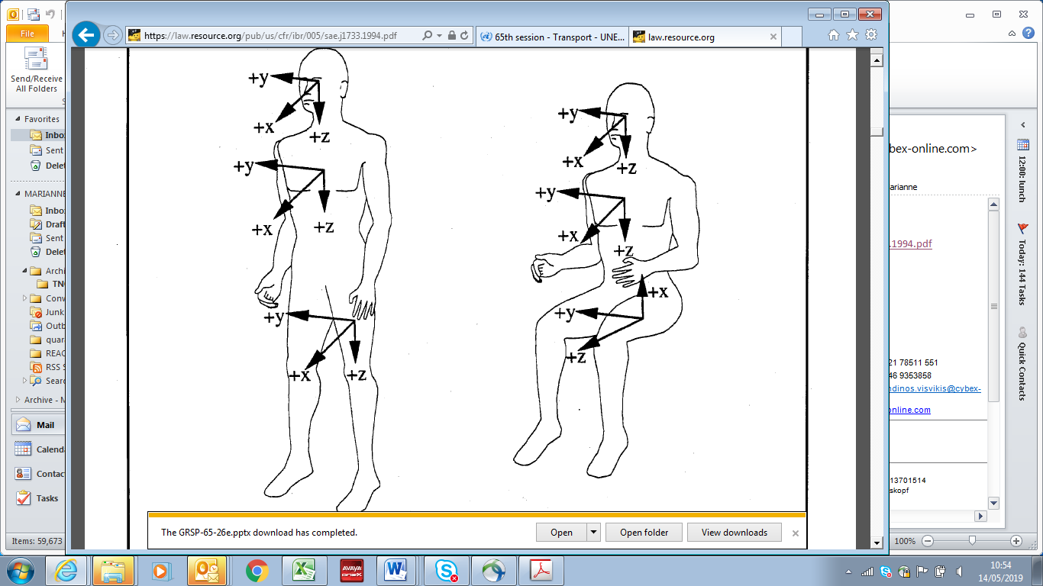"

Annex IV

Draft amendments to UN Regulation No. 80 (Strength of seats and their anchorages (buses))

**Adopted text based on GRSP-65-28 (see para. 29 to the report)**

*Paragraph 4.3.,* amend to read:

"4.3. An approval number shall be assigned to each type approved. Its first two digits (at present **04**, corresponding to the **04** series of amendments) ..."

*Insert new paragraph 5.5.,* amend to read:

**"5.5 Static test in Appendix 5 is not permitted if the seat is attached to the vehicle structure by means of any clamping without mechanical fixation. Mechanical fixation means a positive locking of the seat that prevents the seat from moving in the driving direction.**

*Paragraph 5.5. (former),* renumber as paragraph 5.6

*Insert new Paragraphs 12.10 to 12.14,* to read:

**"12.10. As from the official date of entry into force of the 04 series of amendments, no Contracting Party applying this UN Regulation shall refuse to grant or refuse to accept UN type-approvals under this UN Regulation as amended by the 04 series of amendments.**

**12.11. As from 1 September 2021, Contracting Parties applying this UN Regulation shall not be obliged to accept UN type-approvals to the preceding series of amendments, first issued after 1 September 2021.**

**12.12. Until 1 September 2022, Contracting Parties applying this UN Regulation shall accept UN type-approvals to the preceding series of amendments, first issued before 1 September 2021.**

**12.13. As from 1 September 2022, Contracting Parties applying this UN Regulation shall not be obliged to accept type-approvals issued to the preceding series of amendments to this Regulation.**

**12.14. Contracting Parties applying this UN Regulation shall not refuse to grant UN type-approvals according to any preceding series of amendments to this UN Regulation or extensions thereof."**

*Paragraph 7*, amend to read:

"7. Conformity of production

The conformity of production procedures shall comply with those set out in the Agreement, (**Schedule** **1** E/ECE/TRANS/505/Rev.**3**), with the following requirements:"

*Annex 3,* amend to read:

"Annex 3

Arrangements of approval mark

1. Arrangement in the approval mark for a seat

**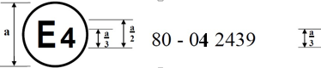**

The above approval mark affixed to a seat shows that the seat type concerned has, with regard to the strength of the seats, the test being carried out in accordance with paragraph 2 of Annex 4, been approved in the Netherlands (E4) under number 0**4**2439. The approval number indicates that the approval was granted in accordance with the requirements of Regulation No. 80 as amended by the 0**4** series of amendments.

2. Arrangement in the approval mark for a vehicle type

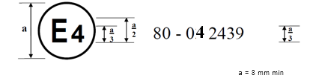

The above approval mark, affixed to a vehicle, shows that this type of vehicle has been approved in the Netherlands (E4) under number 0**4**2439 with regard to the strength of the anchorages on the vehicle. The approval number indicates that the approval was granted in accordance with the requirements of Regulation No. 80 as amended by the 0**4** series of amendments."

Annex V

Draft amendments to UN Regulation No. 129 (Enhanced Child Restraint Systems)

Amendments adopted to ECE/TRANS/WP.29/GRSP/2019/12 (see para. 34 to this report)

…

*Insert new paragraph 2.3.4.,* to read:

"2.3.4. "Universal booster cushion" (Non-Integral Universal Enhanced Child Restraint System without a backrest) is a category of Enhanced Child Restraint System without a backrest primarily designed for use in all i-Size and all Universal seating positions. **If fitted, ISOFIX attachments are stowable.**"

*Insert new paragraph 4.8.3. to 4.8.5.,* to read:

"4.8.3.

…

**Universal booster cushion**

**i-Size compatible**

**Universal**

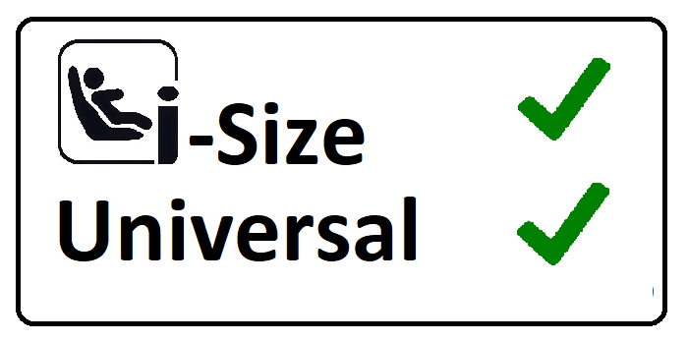

…"

*Insert new paragraph 6.1.3.6.,* to read:

"6.1.3.6. …

**Figure 2  
Ruler of measurement device**

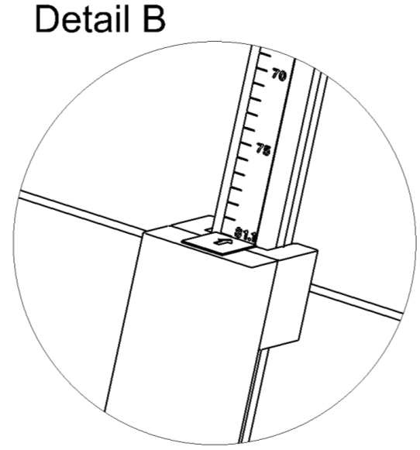

**75**

**70**

Ruler showing sitting height of child

**…**"

*Annex 2,* amend to read:

"Annex 2

1. Arrangements of the approval mark

….

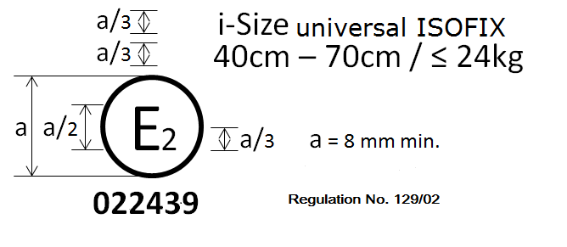

**UN Regulation No. 129/03**

**032450**

Specific vehicle booster cushion

125 cm–**1**50 cm

…"

*Annex 26*, amend to read:

"Annex 26

**Lower torso body block test**

Figure 1

**Manikin block (based on truncated P10)**

**Material: Expanded polystyrene (EPS) (40 to 45 g/l) or alternative non-deformable material**

…"

Annex VI

Draft amendments to UN Regulation No. 135 (Pole Side Impact) (PSI))

Amendments adopted to ECE/TRANS/WP.29/GRSP/2019/13 (see para. 37 to this report)

*Paragraph 5.4.2.1*, amend to read:

"5.4.2.1. The door shall remain latched;

…

**Figure**

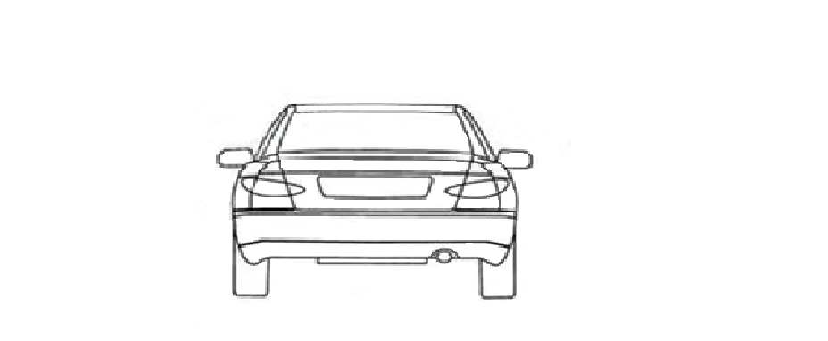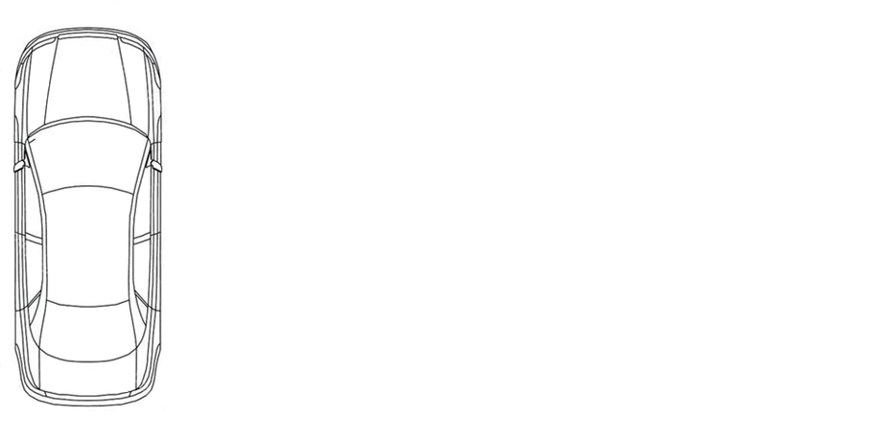

90° +/- 5°

90° +/- 5°

400N

400N

Z

Y

X

Y

**"**

Annex VII

Draft amendments to UN Regulation No. 21 (Interior fittings)

**Adopted text based on GRSP-65-03 (see para. 59 to the report)**

*Paragraph 5.5.1.2*, amend to read:

"5.5.1.2.  In addition, the **manual** opening and operating devices shall : […]"

Annex VIII

[English only]

List of GRSP informal working groups

|  |  |  |  |
| --- | --- | --- | --- |
| *Informal working group* | *Chair* | *Expiry date of the mandate [pending WP.29 decision]* | *Secretary* |
| Harmonized side impact dummies | Mr. David SUTULA (USA)  Phone: +1 202 366 32 73  Fax: +1 202 493 29 90  Email: david.sutula@dot.gov | Suspended |  |
| Head Restraints  (GTR7-Phase 2) | Mr. Bernard FROST (UK)  Phone: +44‑(0)207 9442107  Fax: +44‑(0)207 9449623  Email: [bernie.frost@dft.gsi.gov.uk](mailto:bernie.frost@dft.gsi.gov.uk_) | [June 2020] | OICA |
| UN GTR No. 9 on Pedestrian Safety Deployable – Pedestrian Protection Systems (DPPS) | Mr. Jin Seop PARK (Republic of Korea)  Email: jspark@kotsa.or.kr | June 2020 | OICA |
| UN GTR No. 20 (EVS) – Phase 2 | Mr.Ezana WONDIMNEH (USA), (vice-chaired by China, Japan and the European Union) Phone: +1 202 366 2117 Fax: +1 202 493 2990 Email: ezana.wondimneh@dot.gov | December 2021 | Japan |
| Three-dimensional H-point machine | Mr. Luis. MARTINEZ (Spain)  Phone: +34 91 336 53 00  Fax: +34 91 336 53 02  Email: [luis.martinez@upm.es](mailto:luis.martinez@upm.es) | [Dissolved] |  |
| UN GTR No. 13 (HFCV) – Phase 2 | Mr. Martin KOUBEK(USA)(co-chaired by Japan and vice-chaired by China and Republic of Korea)  Phone: +1 3017620806 Email: martin.koubek@dot.gov | December 2020 | […] |
| Protective helmets | Mr. Luca ROCCO  Phone: +39 06 4158 3268  Fax: +39 06 4158 3253  Email: [luca.rocco@mit.gov.it](mailto:luca.rocco@mit.gov.it) | December 2019 |  |
| [Securing children in buses and coaches | Ms. Marta ANGLES  Phone: +34 977 166 020  Fax: ++34 977 166 009  Email: mangles@idiada.com] | […] |  |