|  |  |  |  |
| --- | --- | --- | --- |
|  | United Nations | ECE/TRANS/WP.29/GRSP/2019/13 | |
| _unlogo | **Economic and Social Council** | | Distr.: General  22 February 2019  Original: English |

**Economic Commission for Europe**

Inland Transport Committee

**World Forum for Harmonization of Vehicle Regulations**

**Working Party on Passive Safety**

**Sixty-fifth session**

Geneva, 13-17 May 2019

Item 21 of the provisional agenda

**UN Regulation No. 135 (Pole Side Impact)**

Proposal for Supplement 2 to the 00 and 01 series of amendments of Regulation No. 135 (Pole Side Impact)

Submitted by the expert from France [[1]](#footnote-2)\*

The text reproduced below was prepared by the experts from France. It proposes a supplement to UN Regulation No. 135 to include similar requirements and test protocol for door opening evaluation as already adopted for UN Regulation No. 95 during the sixty-third session of the Working Party on Passive Safety (GRSP) (ECE/TRANS/WP.29/ GRSP/63, para. 27 modified by annex VIII). The modifications to the current text of UN Regulation No. 135 are marked in bold for new characters and strikethrough for deleted characters.

**I. Proposal**

*Paragraph 5.4.2.1*, amend to read:

"5.4.2.1. The door shall remain latched;

**This requirement is deemed to be fulfilled:**

**(a) if it is clearly visible, that the door lock is latched; or**

**(b) if the door does not open under a static tractive force of at least 400 N in the y-direction applied to the door, according to the Figure below, as close as possible to the window sill and to the edge of the door opposite to the hinged side, except to the door handle itself.**

**Figure**

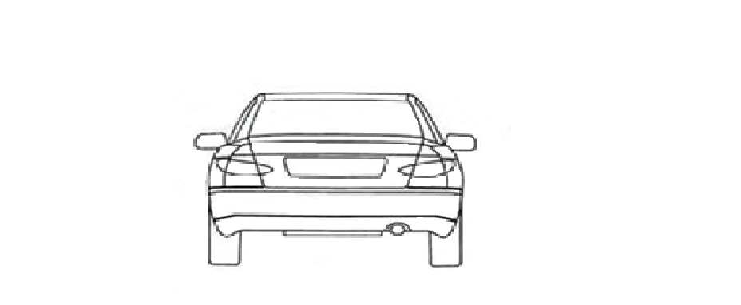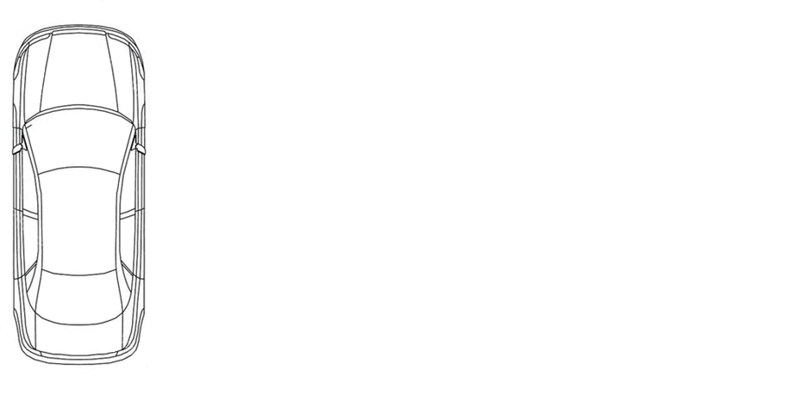

90° +/- 5°

90° +/- 5°

90° +/- 5°

400N

400N

400N

Z

Y

X

Y

**"**

**II. Justification**

During a pole test in accordance with UN Regulation No. 135, rear doors on the impacted side are not directly struck by the pole but may be subjected to heavy loads, and the assessment of the level of closure may not be obvious due to high local strain. This proposal gives the opportunity to switch to an objective evaluation in case of doubt, as was recently incorporated into UN Regulation No. 95.

1. \* In accordance with the programme of work of the Inland Transport Committee for 2018–2019 (ECE/TRANS/274, para. 123 and ECE/TRANS/2018/21/Add.1, Cluster 3.1), the World Forum will develop, harmonize and update UN regulations to enhance the performance of vehicles. The present document is submitted in conformity with that mandate. [↑](#footnote-ref-2)