Proposal for amendments to the proposal for the 04 series of amendments to UN Regulation No. 26 (External projection for passenger cars – document GRSG/2019/34)
Submitted by the expert from OICA*
The text reproduced below was prepared by the expert from OICA to clarify requirements in UN Regulation No. 26 on windscreen wipers. It is based on document ECE/TRANS/WP.29/GRSG/2019/34 submitted by France. The modifications to the document GRSG/2019/34 are marked in red characters.
I. Proposal
Paragraphs 6.4. to 6.4.2., amend to read:
"6.4. Windscreen wipers
6.4.1. The windscreen wiper fittings shall be such that the wiper shaft (number 1 in Figure 0) is furnished with a protective casing (number 1.1 in Figure 0) which has a radius of curvature meeting the requirements of paragraph 5.4. above and an end surface area of not less than 150 mm². The holder (head and main part, i.e. numbers 2, 2.1 in Figure 0) are is designed with a radius of curvature meeting the requirements of paragraph 5.4. above. In the case of rounded covers, these shall have a minimum projected area of 150 mm² when measured not more than 6.5 mm from the point projecting furthest. These requirements shall also be met by rear window wipers and headlamp wipers.
6.4.2. Paragraph 5.4. shall not apply to the wiper blades (number 4 in Figure 0), or to any supporting members (number 3 in Figure 0) if present, to main part (number 2.1 in Figure 0) if present, to second holder (number 2.2 in Figure 0) if present, to the functional hinge between the holder head and the holder (number 5 in Figure 0) if present, or to the junction between the main and the second holder (number 6 in Figure 0) if present. However, these units shall be so made as to have no sharp angles or pointed or cutting parts.

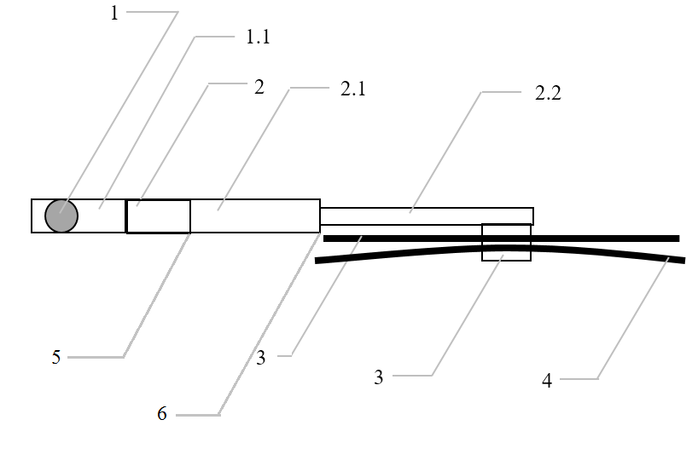
Figure 0 - Example of parts distribution

1 – Wiper shaft
1.1 – Protective casing
2 – Holder head
2.1 – Main holder
2.2 – Second holder
3 – Supporting members
4 – Wiper blades
5 – Functional hinge
6 – Junction between the main and second holder"

Insert new paragraphs 12.8. to 12.10., to read:
"12.8. As from the official date of entry into force of the 04 series of amendments, no Contracting Party applying this Regulation shall refuse to grant approval under this Regulation as amended by the 04 series of amendments.
12.9. As from 24 months after the date of entry into force of the 04 series of amendments, Contracting Parties applying this Regulation shall grant approvals only if the vehicle type to be approved meets the requirements of this Regulation as amended by the 04 series of amendments.
12.10. Starting 36 months after the entry into force to the 04 series of amendments to this Regulation, Contracting Parties applying this Regulation may refuse first national registration (first entry into service) of a vehicle which does not meet the requirements of the 04 series of amendments to this Regulation."
II. Justification
- There is to date no evidence or data that would justify a change in requirements of this regulation
- The impact of the proposed amendment by France is huge as it would affect wiper design of over several billion vehicles without any estimated safety benefit
(see explanatory presentation in a separate informal document for additional information)
- The vehicles and parts approved to UN R26 meet all the requirements of the regulation and are hence designed to meet paragraph 6.4., including complying with its last sentence as well “However, these units shall be so made as to have no sharp angles or pointed or cutting parts.”
- OICA is concerned that the change introduced by France for clarity increases the stringency of the regulation.

