Proposal for a amend the document GRE-82-25 transmitted by GRE-IWG SLR.
The text reproduced below was prepared by expert from Poland. The modifications are marked in bold for new and strikethrough for deleted characters.

I. Proposal

Paragraph 6.2.6 and related sub-paragraphs, amend to read:
…

0.5 m < h < 1.0 m:
the minimum vertical inclination limit is -0.2 %
and
the maximum vertical inclination limit is - 1.4 % to headlamp mounting height 0.7 m, then is increasing linearly, in relation to the dipped-beam headlamp mounting height, from - 1.4 % to - 2.3 %;

1.0 m < h < 1.2 m:
the minimum vertical inclination limit increasing linearly, in relation to the dipped-beam headlamp mounting height,
from - 0.2 % to – 1.0 %
and
the maximum vertical inclination limit increasing linearly, in relation to the dipped-beam headlamp mounting height,
from – 2.3 % to - 2.45 %;

For category N₃G (off-road) vehicles, where the headlamps exceed a height of 1,200 mm the limits for the vertical inclination of the cut-off shall be between: -1.5 per cent and -3.5 per cent

1.2 m < h < 1.5 m:
the minimum vertical inclination limit increasing linearly, in relation to the dipped-beam headlamp mounting height,
from - 1 % to - 2.2 %
and
the maximum vertical inclination limit increasing linearly, in relation to the dipped-beam headlamp mounting height,
from - 2.45 % to - 3.1 %;

0.5 m < h < 0.7 m:
the minimum vertical inclination limit is -0.2 %
and
the maximum vertical inclination limit is - 1.4 %

0.7 m < h < 1.0 m:
the minimum vertical inclination limit is -0.2 %
and
the maximum vertical inclination limit increasing linearly, in relation to the dipped-beam headlamp mounting height,
from – 1.4 % to - 2.05 %;

1.0 m < h < 1.2 m:
the minimum vertical inclination limit increasing linearly, in relation to the dipped-beam headlamp mounting height,
from - 0.2 % to – 1.0 %
and
the maximum vertical inclination limit increasing linearly, in relation to the dipped-beam headlamp mounting height,
from – 2.05 % to - 2.45 %;

For category N₃G (off-road) vehicles, where the headlamps exceed a height of 1,200 mm the limits for the vertical inclination of the cut-off shall be between: -1.5 per cent and -3.5 per cent

1.2 m < h < 1.5 m:
the minimum vertical inclination limit increasing linearly, in relation to the dipped-beam headlamp mounting height,
from - 1 % to - 2.2 %
and
the maximum vertical inclination limit increasing linearly, in relation to the dipped-beam headlamp mounting height,
from - 2.45 % to - 3.1 %;

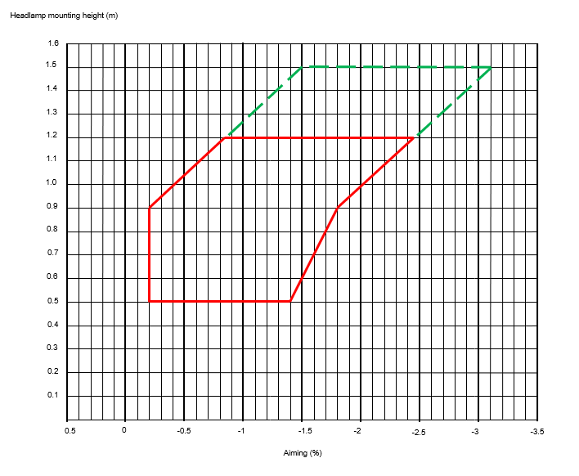
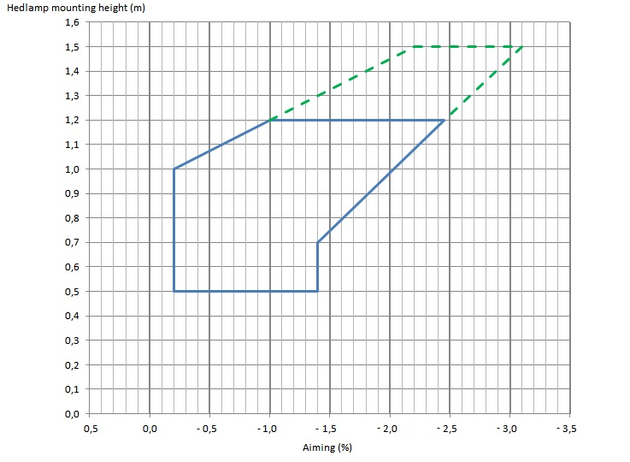

Annex 9, paragraph 1.3.2 amend to read:

“1.3.2. Variation of inclination with load
The variation of the dipped-beam downward inclination as a function of the loading conditions specified within this section shall remain within the range defined in p. 6.2.6.1.2.:

0.5 m < h < 0.9 m
0% minimum vertical inclination and -1,7 % to -2,1 % maximum vertical inclination, in relation to the dipped-beam headlamp mounting height.

0.9 m < h < 1.2 m:
0%to -0,55 % minimum vertical inclination increasing linearly, in relation to the dipped-beam headlamp mounting height and
-2,1 % to -2,75 % maximum vertical inclination limit increasing linearly, in relation to the dipped-beam headlamp mounting height

1.2 m < h < 1.5 m:
-0.55 % to -1.2 % minimum vertical inclination increasing linearly, in relation to the dipped-beam headlamp mounting height and
-2.75 % to -3.4 % maximum vertical inclination limit increasing linearly, in relation to the dipped-beam headlamp mounting height.

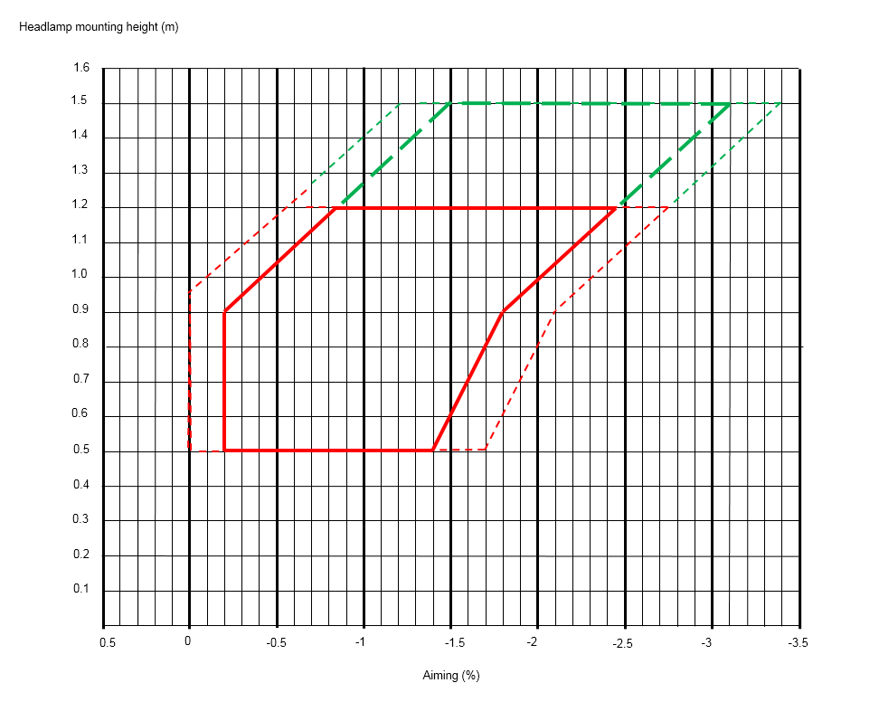

II. Justification

- Segment A-B. There is no valid technical justification for this proposal. The IWG VGL Group has identified two proposals during its work:
- Segment A'-C-C 'as a expression of the minimum road illumination range of 50 m.
- Segment A''-B and B-C as an expression of insufficiently substantiated industry demand to maintain a 1.6% inclination for each headlight height above the road surface.

Segment A-B is an artificial creation without technical justification and cannot be accepted.
Poland may agree to a compromise solution (line A-B') as a concession to the industrial lobby to half the value between points A' and A'' as an arbitrary but constant value of 1.4% down. The same value should be maintained until meeting the A'-C-C' line.

2. Segment D-D 'is an artificial extension of the segment E-D and it has no correct technical justification. The correct course of this segment is specified in documents GRE-79-23, GRE-79-24 and VGL-10-09 (line 6, segment E'-D ''), as the same glare conditions regardless of the reflector mounting height.

3. The IWG-VGL group proposed that the CoP requirements would be the same as for the type-approval. Therefore, Poland will not support the proposal to extend them by another 0.4%. (p. 1.3.2 Annex 9 in the GRE-82-25), because adding the uncertainty of inclination measurement in real conditions and taking into account the unevenness of the diagnostic floor, there is a real danger that the cut-line will be above the horizon and the range of road illumination will be shortened below the acceptable distances.

