|  |  |  |  |
| --- | --- | --- | --- |
|  | United Nations | ECE/TRANS/WP.29/GRE/2019/10 | |
| Description: _unlogo | **Economic and Social Council** | | Distr.: General  1 February 2019  Original: English |

**Economic Commission for Europe**

Inland Transport Committee

**World Forum for Harmonization of Vehicle Regulations**

**Working Party on Lighting and Light-Signalling**

**Eighty-First session**

Geneva, 15-18 April 2019

Item 5 of the provisional agenda

**Regulations Nos. 37 (Filament lamps), 99 (Gas discharge light sources), 128 (Light emitting diodes light sources) and the Consolidated Resolution on the common specification of light source categories.**

**Proposal for amendment [7] to the Consolidated Resolution on the common specification of light source categories (R.E.5)**

**Submitted by the expert from the International Automotive Lighting and Light Signalling Expert Group (GTB)[[1]](#footnote-2)\***

The text reproduced below was prepared by the expert from GTB to introduce new LED substitute light source categories W5W/LEDK and WY5W/LED in the Consolidated Resolution on the common specification of light source categories (R.E.5) (ECE/TRANS/WP.29/1127). The modifications to the existing text of the Resolution are marked in bold for new or strikethrough for deleted characters. This proposal is supported by informal document GRE-81-04.

1. Proposal

*The Status Table*, amendto read:

“Status table

This consolidated version of this Resolution contains all provisions and amendments adopted so far by the World Forum for Harmonization of Vehicle Regulations (WP.29) and is valid from the date as indicated in the following table until the date on which the next revision of this Resolution becomes valid:

|  |  |  |  |  |
| --- | --- | --- | --- | --- |
| *Version of the Resolution* | *Date \* as from which the version is valid* | *Adopted by WP.29* | | *Clarification* |
| *Session No.* | *Amendment document No.* |
| Original | 22.06.2017 | 170 | ECE/TRANS/WP.29/1127 | Based upon Annexes 1 of Regulations:   * No. 37, up to and including Supplement 44 * No. 99, up to and including Supplement 11 * No. 128, up to and including Supplement 5 |
| [2] | [2018-xx-xx] | [174] | [ECE/TRANS/WP.29/2018/32] | Amended details in sheets:  C21W/2, H1/1, H3/1, H3/2, H4/4, H9/1, H11/2, H13/4, H14/1, H15/5, H20/3, H20/4, HIR2/1, HS6/1, P13W/3, P21W/1, P21/5W, P27/7W/3, PSX26W/3, R5W/1, R10W/1, T1.4W/1, W15/5W/1, W21/5W/1, WT21W/1 |
| [3] | [2018-xx-xx] | [174] | [ECE/TRANS/WP.29/2018/33/Rev.1] | Introduction of new light emitting diode (LED) forward lighting light source categories L1A/6 and L1B/6 as a package with Supplement [7] to Regulation No.128 |
| [4] | [2019-xx-xx] | [177] | [ECE/TRANS/WP.29/2019/xx] | Amendment to light source categories LR4 as a package with Supplement [8] to Regulation No.128 |
| [5] | [2019-xx-xx] | [177] | [WP.29/2019/xx] | Introduction of new LED substitute light source category PY21W/LED as a package with Supplement [8] to Regulation No.128 |
| [6] | [2019-xx-xx] | [179] | [WP.29/2019/xx] | Introduction of new LED substitute light source categories C5W/LED and R5W/LED |
| **[7]** | **[2019-xx-xx]** | **[179]** | **[WP.29/2019/xx]** | **Introduction of new LED substitute light source categories W5W/LEDK and WY5W/LED** |

\* This date is the date of adoption of the amendment to the Resolution by WP.29 or the date of entering into force of an amendment to Regulation No. 37, 99 or 128 adopted by AC.1 as a package with the amendment to the Resolution in the same session of WP.29.

“

*Group 4,* amend to read:

“

|  |  |  |  |  |
| --- | --- | --- | --- | --- |
| ***Group 4*** | | | | |
| ***LED substitute light source categories1 only for use in lamps approved with filament light source(s) of its counterpart light source category*** | | | | |
|  |  |  |  |  |
|  | ***Category*** |  | ***Counterpart filament light source category*** | ***Sheet number(s)*** |
|  | C5W/LEDK | 2 | C5W | C5W/LED/1 to 4 |
|  | PY21W/LED |  | PY21W | PY21W/LED/1 to 4 |
|  | R5W/LED |  | R5W | R5W/LED/1 to 4 |
|  | **W5W/LEDK** | **2** | **W5W** | **W5W/LED/1 to 4** |
|  | **WY5W/LED** |  | **WY5W** | **W5W/LED/1 to 4** |

**1** not for use in conformity of production control of lamps.

**2** **not for use behind red and amber lenses**

**“**

*Annex 3, List of sheets for LED light sources and their sequence,* amend to read:

“

|  | *Sheet number(s)* |  |
| --- | --- | --- |
|  | C5W/LED/1 to 4 |  |
|  | LR1/1 to 5 |  |
|  | LW2/1 to 5 |  |
|  | L3/1 to 6 |  |
|  | LR4/1 to 5 |  |
|  | L5/1 to 6 |  |
|  | PY21W/LED/1 to 4 |  |
|  | R5W/LED/1 to 4 |  |
|  | **W5W/LED/1 to 4** |  |

“

*Annex 3,*

*After sheet R5W/LED/1 to 4*, insert new sheets W5W/LED/1 to 4, to read:

(see following pages; one page per sheet):

**“ Category W5W/LEDK, WY5W/LED Sheet W5W/LED/1**

The drawings are intended only to illustrate the essential dimensions (in mm) of the LED light source.

Figure 1

**Main drawing**

**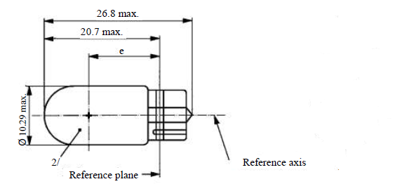**

Table 1

**Essential electrical and photometrical characteristics of the LED light source**

| *Dimensions in mm* | | | *LED light sources of normal production* | | *Standard LED light sources* |
| --- | --- | --- | --- | --- | --- |
| e 2 | | | 12.7 nom. | | 12.7 nom. |
| Cap WX2.1x9.5d in accordance with IEC Publication 60061 (sheet 7004-91A-1) | | | | | |
| *Electrical and photometric characteristics* | | | *4* | *7* | *4* |
| Rated values | | Volts | 12 | 24 | 12 |
| Watts | 2 | | 2 |
| Test voltage | | Volts (DC) | 13.5 | 28.0 | 13.5 |
| Objective values  W5W/LEDK | Power | Watts | 2.0 max. | 2.5 max. | 2.0 max |
| Electrical current | mA | (at 9-16V DC)  30min.  185max. | (at 16-32V DC)  30min.  185max | (at 9-16V DC)  30min.  185max |
| Luminous flux 1 | lm | 50 ± 20 % 3 | | 50 ± 10 % 3 |
| Luminous flux 1 | lm | (at 9 V DC)  9 min. | (at 16 V DC)  5 min. | (at 9 V DC)  9 min. |
| Objective values 5  WY5W/LED | Power | Watts | 2.0 max. | 2.5 max. | 2.0 max. |
| Electrical current | mA | (at 9-16V DC)  30min.  185max. | (at 16-32V DC)  30min.  185max | (at 9-16V DC)  30min.  185max. |
| Luminous flux 6 | lm | 30 ± 20 % 3 | | 30 ± 10 % 3 |
| Luminous flux 6 | lm | (at 9 V DC)  5 min. | (at 16 V DC)  3 min | (at 9 V DC)  5 min. |

1 The light emitted shall be white, without a correlated colour temperature restriction.

2 To be checked by means of a “box system”, sheet W5W/LED/2

3 The value measured at elevated ambient air temperature of 80°C shall be at least 70% of this value

4 In case of a failure of any of the light emitting elements (open circuit failure), the LED light source shall either still comply to the requirements concerning luminous flux and luminous intensity distribution or stop emitting light whereby, in the latter case, the electrical current draw, when operated between 12 V and 14 V, shall be less than 10 mA

5 Operated in flashing mode for 30 minutes (frequency = 1.5 Hz, duty cycle 50 per cent ON, 50 per cent OFF) and measured in the ON-state of flashing mode after 30 minutes of operation

6 The light emitted shall be amber

7 In case of a failure of any of the light emitting elements (open circuit failure), the LED light source shall either still comply to the requirements concerning luminous flux and luminous intensity distribution or stop emitting light whereby, in the latter case, the electrical current draw, when operated between 24 V and 28 V, shall be less than 10 mA

**Category W5W/LEDK, WY5W/LED Sheet W5W/LED/2**

Screen projection requirements

The following test is intended to define the requirements for the apparent light emitting area of the LED light source and to determine whether the light emitting area is correctly positioned relative to the reference axis and reference plane in order to check compliance with the requirements.

The position of the light emitting area is checked by a box system defined in Figure 2 when operated at test voltage, which shows the projections when viewing along the direction  = 0° (top view), = ± 45° (inclined view) and  = +/- 90° (front, rear view) in the plane C0 (C,  as defined in Figure 3).

Where:

A=A1+A2+A3 and B=B1+B2+B3 and C=C1+C2+C3

The proportion of the total luminous flux emitted into the viewing direction from the area(s)

A, B and C together shall be 70 per cent or more

B shall be 20 per cent or more

A and C shall each be more than 15 per cent

A1, B1 and C1 together shall be less than 50 per cent

A2, B2 and C2 together shall be more than 20 per cent

A3, B3 and C3 together shall be less than 50 per cent

Figure 2

**Box definition of the light emitting area**

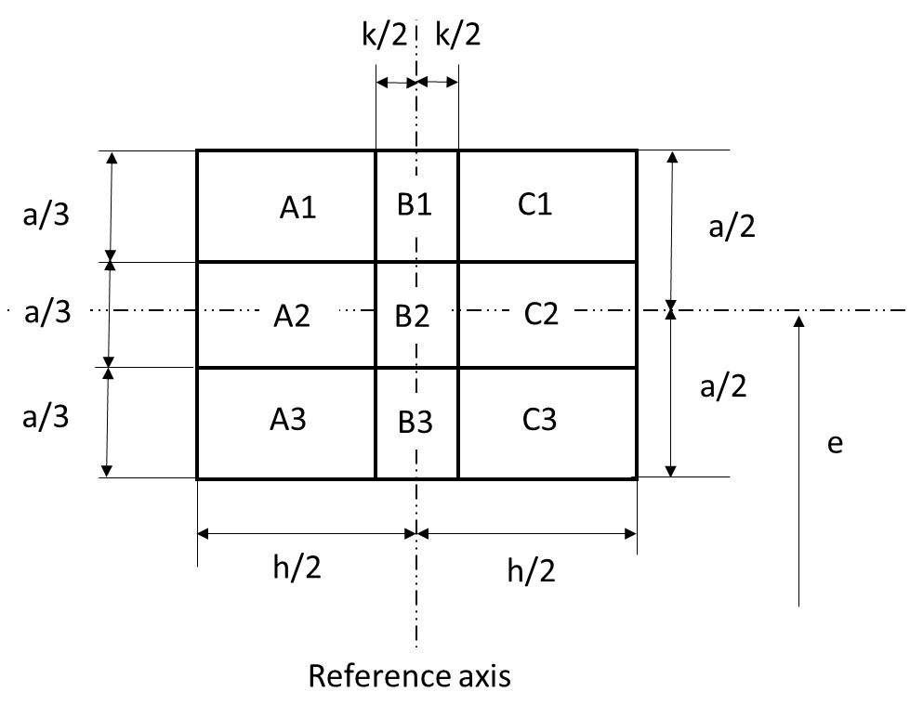

Table 2

**Dimensions of the box system in figure 2**

|  |  |  |  |
| --- | --- | --- | --- |
| *Dimensions in mm* | *a* | *h* | *k* |
| All views  (as specified above) | 6.0 | 8.0 | 1.5 |

**Category W5W/LEDK, WY5W/LED Sheet W5W/LED/3**

Normalized luminous intensity distribution

The following test is intended to determine the normalized luminous intensity distribution of the light source in the C-planes as described in Figure 3 when operated at test voltage. The intersection of the reference axis and the reference plane is used as the coordinate system origin.

The light source is mounted on a flat plate with the corresponding holder features. The plate is fixed to the goniometer table by a bracket, so that the reference axis of the light source lines up with one of the rotating axis of the goniometer. The corresponding measurement set-up is described in Figure 3.

Luminous intensity data is recorded with a standard photo-goniometer. The measurement distance should be chosen appropriately in order to make sure that the detector is located in the far field of the light distribution.

The measurements shall be performed in C-planes, which contain the reference axis of the light source. The C-planes to be measured shall be C0, C30 and C330. The test points for each plane and multiple polar angles γ are specified in Table 3.

The measured luminous intensity values, normalised to the measured luminous flux of the individual light source under test, shall be converted to normalised luminous intensity values of a 1000 lm light source. These data shall comply with the tolerance band as defined in Table 3.

Figure 3  
**Setup to measure the luminous intensity distribution**

**(Definition of C-Planes and angle )**

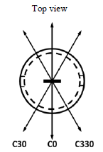

**C30**

**C0**

**C330**

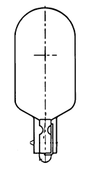



C-planes: see CIE publication 70-1987, "The measurement of absolute intensity distributions".

**Category W5W/LEDK, WY5W/LED Sheet W5W/LED/4**

Table 3

**Test point values of normalized intensity in the planes C0, C30, C330**

|  |  |  |  |  |
| --- | --- | --- | --- | --- |
|  | LED light source of normal production | | Standard LED light source | |
|  | Minimum intensity  (cd/klm) | Maximum intensity  (cd/klm) | Minimum intensity  (cd/klm) | Maximum intensity  (cd/klm) |
| -100° | 60 | 140 | 80 | 120 |
| -75° | 60 | 140 | 80 | 120 |
| -50° | 60 | 140 | 80 | 120 |
| -25° | 60 | 140 | 80 | 120 |
| 0° | 60 | 140 | 80 | 120 |
| 25° | 60 | 140 | 80 | 120 |
| 50° | 60 | 140 | 80 | 120 |
| 75° | 60 | 140 | 80 | 120 |
| 100° | 60 | 140 | 80 | 120 |

The luminous intensity distribution as described in Table 3 shall be substantially uniform, i.e. in between two adjacent grid points the relative luminous intensity requirement is calculated by linear interpolation using the two adjacent grid points.

“

**II. Justification**

While the GTB “LED substitute light sources” proposal has been under consideration in the GRE Task Force on Substitutes and Retrofits (TF SR), a request was made to develop both 12V and 24V substitute light sources for the W(Y)5W filament counterparts. On the condition that LED substitutes are approved to be included into the UN regulatory system, this is a proposal for addition to R.E.5 of new LED substitute categories W5W/LEDK and WY5W/LED in both 12 V and 24 V versions. The categories were developed taking into account informal document GRE-80-02 on equivalence criteria (photometric, electrical, dimensional and thermal), including among others: near-field photometry, far-field photometry, colour, spectral content, failure behaviour, minimum and maximum electrical current, voltage behaviour, thermal behaviour, mechanical dimensions, cap. An equivalence report is also provided in GRE-81-04. This proposal is brought in line with the LED substitute light sources proposal that was adopted in 80th session of GRE, in particular with respect to the requirements on the correlated colour temperature in R128, paragraph 3.12.4. Accordingly, the suffix “K” in the category name (W5W/LEDK) is introduced to indicate that there is no correlated colour temperature restriction on the white light for this category. The W5W/LEDK also has a unique base keying. The International Electrotechnical Commission (IEC) cap is of a design that incorporates an interlock in accordance with what is proposed by TF SR (see GRE-80-02) for caps of substitute light sources, and adopted at the eightieth session of GRE.

1. \* In accordance with the programme of work of the Inland Transport Committee for 2018–2019 (ECE/TRANS/274, para. 123 and ECE/TRANS/2018/21/Add.1, cluster 3.1), the World Forum will develop, harmonize and update UN Regulations in order to enhance the performance of vehicles. The present document is submitted in conformity with that mandate. [↑](#footnote-ref-2)