|  |  |  |  |
| --- | --- | --- | --- |
|  | United Nations | ECE/TRANS/WP.29/2019/126 | |
| Description: _unlogo | **Economic and Social Council** | | Distr.: General  3 September 2019  Original: English |

**Economic Commission for Europe**

Inland Transport Committee

**World Forum for Harmonization of Vehicle Regulations**

**179th session**

Geneva, 12-15 November 2019

Item 4.15 of the provisional agenda

**1958 Agreement:  
Proposal for amendments to the Consolidated Resolution**

**on the common specification of light source categories (R.E.5)**

Proposal for amendment 4 to the Consolidated Resolution on the common specification of light source categories (R.E.5)

Submitted by the Working Party on Lighting and Light-Signalling[[1]](#footnote-2)\*

The text reproduced below was adopted by the Working Party on Lighting and Light-Signalling (GRE) at its eighty-first session (ECE/TRANS/WP.29/GRE/81, paras.13 and 14). It is based on ECE/TRANS/WP.29/GRE/2019/9, ECE/TRANS/WP.29/GRE/2019/10 and Annex III to the report. It is submitted to the World Forum for Harmonization of Vehicle Regulations (WP.29) and to the Administrative Committee (AC.1) for consideration at their November 2019 sessions.

Amendment 4 to the Consolidated Resolution on the common specification of light source categories (R.E.5)

*The Status table*, amendto read:

“**Status table**

This consolidated version of this Resolution contains all provisions and amendments adopted so far by the World Forum for Harmonization of Vehicle Regulations (WP.29) and is valid from the date as indicated in the following table until the date on which the next revision of this Resolution becomes valid:

|  |  |  |  |  |
| --- | --- | --- | --- | --- |
| *Version of the Resolution* | *Date \* as from which the version is valid* | *Adopted by WP.29* | | *Clarification* |
| *Session No.* | *Amendment document No.* |
| Original | 22.06.2017 | 170 | ECE/TRANS/WP.29/1127 | Based upon Annexes 1 of Regulations:   * No. 37, up to and including Supplement 44 * No. 99, up to and including Supplement 11 * No. 128, up to and including Supplement 5 |
| 1 | 14.03.2018 | 174 | ECE/TRANS/WP.29/2018/32 | Amended details in sheets:  C21W/2, H1/1, H3/1, H3/2, H4/4, H9/1, H11/2, H13/4, H14/1, H15/5, H20/3, H20/4, HIR2/1, HS6/1, P13W/3, P21W/1, P21/5W, P27/7W/3, PSX26W/3, R5W/1, R10W/1, T1.4W/1, W15/5W/1, W21/5W/1, WT21W/1 |
| 2 | 16.10.2018 | 174 | ECE/TRANS/WP.29/2018/33/Rev.1 | Introduction of new light emitting diode (LED) forward lighting light source categories L1A/6 and L1B/6 as a package with Supplement 7 to Regulation No.128 |
| 3 | [15.10.2019] | 177 | ECE/TRANS/WP.29/2019/29 | * Introduction of a new LED substitute light source category PY21W/LED as a package with Supplement 9 to UN Regulation No.128 * Amendment to light source categories LR4 as a package with Supplement 9 to UN Regulation No.128 |
| 4 | [xx.xx.2020] | 179 | ECE/TRANS/WP.29/2019/126 | * Introduction of new LED substitute light source categories C5W/LED and R5W/LED * Introduction of new LED substitute light source categories W5W/LEDK and WY5W/LED * Editorial corrections and further modifications to amendment 3 (ECE/TRANS/WP.29/2019/29) |

\* This date is the date of adoption of the amendment to the Resolution by WP.29 or the date of entering into force of an amendment to UN Regulation No. 37, 99 or 128 adopted by AC.1 as a package with the amendment to the Resolution at the same session of WP.29.

”

*Group 4,* amend to read:

“

|  |  |  |  |  |
| --- | --- | --- | --- | --- |
| ***Group 4*** | | | | |
| ***LED substitute light source categories1 only for use in lamps approved with filament light source(s) of its counterpart light source category*** | | | | |
|  |  |  |  |  |
|  | ***Category*** |  | ***Counterpart filament light source category*** | ***Sheet number(s)*** |
|  | C5W/LEDK | 2 | C5W | C5W/LED/1 to 4 |
|  | PY21W/LED |  | PY21W | PY21W/LED/1 to 4 |
|  | R5W/LED |  | R5W | R5W/LED/1 to 4 |
|  | **W5W/LEDK** | **2** | **W5W** | **W5W/LED/1 to 4** |
|  | **WY5W/LED** |  | **WY5W** | **W5W/LED/1 to 4** |

**1** not for use in conformity of production control of lamps.

**2** **not for use behind red and amber lenses**

**“**

*Annex 3, List of sheets for LED light sources and their sequence,* amend to read:

“

|  | *Sheet number(s)* |  |
| --- | --- | --- |
|  | C5W/LED/1 to 4 |  |
|  | LR1/1 to 5 |  |
|  | LW2/1 to 5 |  |
|  | L3/1 to 6 |  |
|  | LR4/1 to 5 |  |
|  | L5/1 to 6 |  |
|  | PY21W/LED/1 to 4 |  |
|  | R5W/LED/1 to 4 |  |
|  | **W5W/LED/1 to 4** |  |

”

*Annex 3,*

*Before sheet LR1/1,* insert new sheets C5W/LED/1 to 4, to read (see following pages; one page per sheet):

**“ Category C5W/LEDK Sheet C5W/LED/1**

The drawings are intended only to illustrate the essential dimensions (in mm) of the LED light source.

Figure 1

Reference plane

**Main drawing**

Table 1

f

b/2

b/2

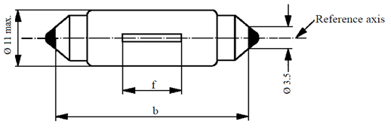

f

Ø 11 max.

Reference axis

Ø 3.5

**Essential electrical and photometrical characteristics of the LED light source**

| *Dimensions in mm* | | | *LED light sources of normal production* | | | *Standard LED light source* |
| --- | --- | --- | --- | --- | --- | --- |
| *min.* | *nom.* | *max.* |
| b 1/ | | | 34.0 | 35.0 | 36.0 | 35±0.5 |
| e 2/ | | |  | 0.0 |  | 0.0 |
| f 2/ | | |  | 9.0 |  | 9.0 |
| Cap SVX8.5 in accordance with IEC Publication 60061 (sheet 7004-81A-1) | | | | | | |
| *Electrical 5/ and photometric characteristics* | | | | | | |
| Rated values | | Volts | 12 | | | 12 |
| Watts | 2 | | | 2 |
| Test voltage | | Volts | 13.5 | | | 13.5 |
| Objective values | Watts | | 2 max. | | | 2 max. |
| Electrical current (in mA at 9-16V DC) | | 30 min.  170 max. | | | |
| Luminous flux 3/  (in lm at 13.5 V DC) | | 45 ± 20 % 4/ | | | 45 ± 10 % 4/ |
| Luminous flux 3/  (in lm at 9 V DC) | | 9 min. | | | 9 min. |

1 This dimension corresponds to a distance between two apertures of 3.5 mm diameter each bearing against one of the caps.

2 To be checked by a “box system”, see Figure 2.

3 The light emitted from LED light source shall be white, without a correlated colour temperature restriction.

4The value measured at elevated ambient air temperature of 80°C shall be at least 70% of this value.

5 In case of a failure of any of the light emitting elements, the LED light source shall either still comply to the requirements concerning luminous flux and luminous intensity distribution or stop emitting light whereby in the latter case the electrical current draw, when operated between 12 V and 14 V, shall be less than 10 mA.

**Category C5W/LEDK Sheet C5W/LED/2**

Screen projection requirements

The following test is intended to define the requirements for the apparent light emitting area of the LED light source and to determine whether the light emitting area is correctly positioned relative to the reference axis and reference plane in order to check compliance with the requirements.

The position of the light emitting area is checked by means of a box system defined by the projections when viewing along the direction  = 0° (top view)**,**  = 90° (front view)**,**  =180° (bottom view)**,**  = 270° (rear view),inclined views  = 45°,  = 135°,  = 225° and  = 315°, in the plane C0 (C,  as defined in Figure 3).

The proportion of the total luminous flux emitted into these viewing directions from the area(s) as defined in figure 2:

• A, B and C together shall be 70 per cent or more;

• B shall be 20 per cent or more;

• A and C shall each be 15 per cent or more.

Figure 2

**Box definition of the light emitting area**

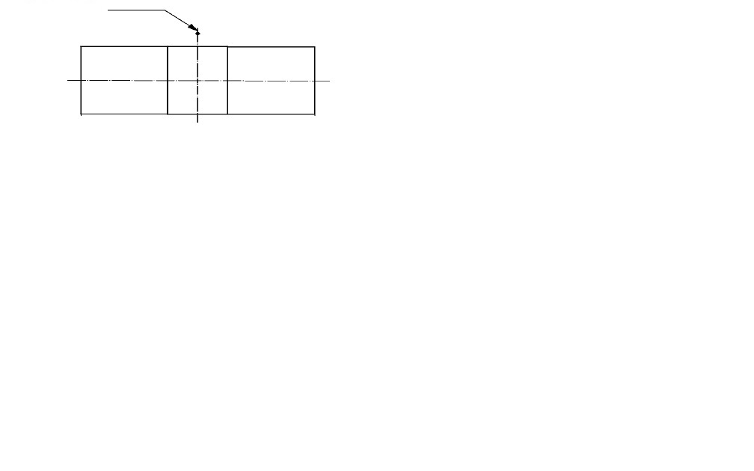

Reference plane

C

B

A

a

Reference axis

a

h3

h2

h1

h2

Table 2

**Dimensions of the box system in figure 2**

|  |  |  |  |
| --- | --- | --- | --- |
| *Dimension (mm)* | *a* | *h1, h3* | *h2* |
| All views  (as specified above) | 2.5 | 6 | 2 |

**Category C5W/LEDK Sheet C5W/LED/3**

Normalized luminous intensity distribution

The following test is intended to determine the normalized luminous intensity distribution of the light source in the C-planes as described in figure 3. The intersection of the reference axis and the reference plane is used as the coordinate system origin.

The light source is mounted on a flat plate with the corresponding holder features. The plate is fixed to the goniometer table by a bracket, so that the reference axis of the light source lines up with one of the rotating axis of the goniometer. The corresponding measurement set-up is described in figure 3.

Luminous intensity data is recorded with a standard photo-goniometer. The measurement distance should be chosen appropriately in order to make sure that the detector is located in the far field of the light distribution.

The measurements shall be performed in C-planes, where C0 shall be the reference plane of the light source. The C-planes to be measured shall be C0, C30 and C330. The test points for each plane and multiple polar angles γ are specified in Table 3.

The measured luminous intensity values, normalised to the measured luminous flux of the individual light source under test, shall be converted to normalised luminous intensity values of a 1000 lm light source. These data shall comply with the tolerance band as defined in Table 3.

Figure 3  
**Setup to measure the luminous intensity distribution**

**(Definition of C-Planes and angle )**

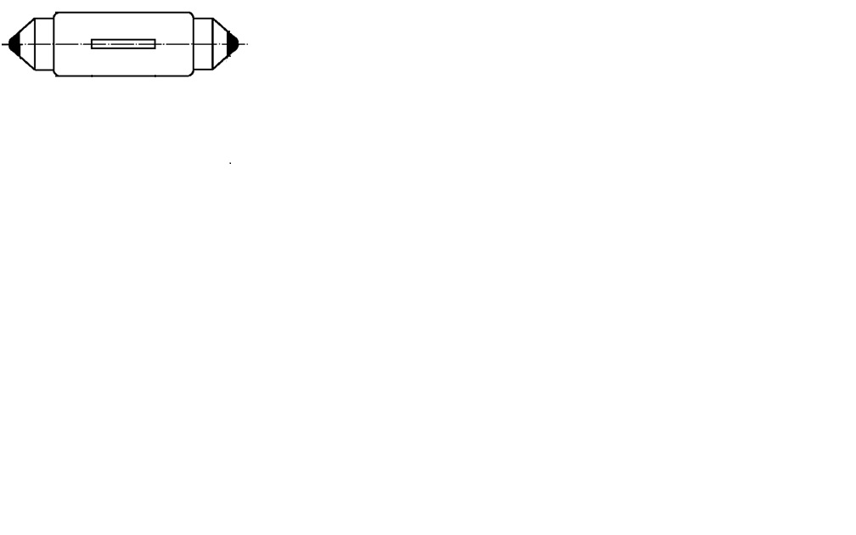

C0

C330

C30

Reference axis

Reference plane

****

Top view

Side view

C-planes: See CIE publication 70-1987, "The measurement of absolute intensity distributions".

**Category C5W/LEDK Sheet C5W/LED/4**

Table 3

**Test point values of normalized intensity in the planes C0, C30, C330**

|  |  |  |  |  |
| --- | --- | --- | --- | --- |
|  | *LED light source of normal production* | | *Standard LED light source* | |
| *γ* | *Minimum intensity  in cd /1000 lm* | *Maximum intensity  in cd /1000 lm* | *Minimum intensity  in cd /1000 lm* | *Maximum intensity  in cd /1000 lm* |
| -175° | 60 | 140 | 80 | 120 |
| -150° | 60 | 140 | 80 | 120 |
| -125° | 60 | 140 | 80 | 120 |
| -100° | 60 | 140 | 80 | 120 |
| -75° | 60 | 140 | 80 | 120 |
| -50° | 60 | 140 | 80 | 120 |
| -25° | 60 | 140 | 80 | 120 |
| 0° | 60 | 140 | 80 | 120 |
| 25° | 60 | 140 | 80 | 120 |
| 50° | 60 | 140 | 80 | 120 |
| 75° | 60 | 140 | 80 | 120 |
| 100° | 60 | 140 | 80 | 120 |
| 125° | 60 | 140 | 80 | 120 |
| 150° | 60 | 140 | 80 | 120 |
| 175° | 60 | 140 | 80 | 120 |

The luminous intensity distribution as described in Table 3 shall be substantially uniform, i.e. in between two adjacent grid points the relative luminous intensity.”

*Sheet PY21W/LED/1, table 1,* amend to read:

"Table 1

**Essential electrical and photometric characteristics of LED light sources**

| *Dimensions in mm* | | *LED light sources of normal production* | | | | | | *Standard LED light source* | |
| --- | --- | --- | --- | --- | --- | --- | --- | --- | --- |
|  | *nom.* | | |  | | *nom.* | |
| e 2/ | |  | 31.8 | | |  | | 31.8 | |
| h 2/ | |  | 9.0 | | |  | | 9.0 | |
| β 2/ | |  | 90° | | |  | | 90° | |
| Cap BAU15s-3(110°) in accordance with IEC Publication 60061 (sheet 7004-19A-1) | | | | | | | | |
| *Electrical and photometric characteristics* | | *5/* | | | *6/* | | | *5/* |
| Rated values | Volts | 12 | | | 24 | | | 12 | |
| Watts 3/ | 7 | | | | | | 7 | |
| Test voltage | Volts | 13.5 | | | 28.0 | | | 13.5 | |
| Objective values | Watts 3/ | 9 max. | | | 10 max. | | | 9 max. | |
| Electrical current (in mA) 3/ | (at 9–16V DC)  150 min.  750 max. | | (at 16–32V DC)  75 min.  375 max. | | | (at 9–16V DC)  150 min.  750 max. | | |
| Luminous flux3/, 4/ (in lm) | 280 ± 20 % | | | 280 ± 20 % | | | 280 ± 10 % | |
| Luminous flux3/ (in lm) | (at 9 V DC)  56 min. | | | (at 16 V DC)  30 min. | | | (at 9 V DC)  56 min. | |

1 The light emitted from the LED light source shall be amber.

2 To be checked by means of a "Box-System"; sheet PY21W/LED/2.

3 Operated in flashing mode for 30 minutes (frequency = 1.5 Hz, duty cycle 50 per cent ON, 50 per cent OFF) and measured in the ON-state of flashing mode after 30 minutes of operation.

4The value measured at elevated ambient temperature of 80°C shall be at least 65 per cent of this value.

5 In case of a failure of any of the light emitting elements, the LED light source shall either still comply to the requirements concerning luminous flux and luminous intensity distribution or stop emitting light whereby/in the latter case the electrical current draw, when operated between 12 V and 14 V, shall be less than 50 mA.

6 In case of a failure of any of the light emitting elements, the LED light source shall either still comply to the requirements concerning luminous flux and luminous intensity distribution or stop emitting light whereby/in the latter case the electrical current draw, when operated between 24 V and 28 V, shall be less than 25 mA."

*After sheet PY21W/LED*, insert new sheets R5W/LED/1 to 4 and W5W/LED/1 to 4, to read (see following pages; one page per sheet):

**“ Category R5W/LED Sheet R5W**/**LED/1**

The drawings are intended only to illustrate the essential dimensions (in mm) of the LED light source

Figure 1  
**Main drawing**

f

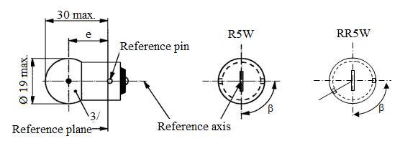

Reference axis

1/

Reference plane

Reference pin

Ø 19 max.

30 max.

R5W

ß

e

Table 1

**Essential electrical and photometric characteristics of the LED light source**

| *Dimensions in mm* | | | *LED light sources of normal production* | | | | *Standard LED light source* |
| --- | --- | --- | --- | --- | --- | --- | --- |
| *min.* | *nom.* | | *max.* | *nom.* |
| e 2/ | | |  | 19.0 | |  | 19.0 |
| f 2/ | | |  | 4.0 | |  | 4.0 |
| β 2/ | | |  | 90° | |  | 90° |
| R5W/LED: Cap BA15s-3(110°) in accordance with IEC Publication 60061 (sheet 7004-19A-1) | | | | | | | |
| *Electrical and photometric characteristics* | | *4/* | | | *5/* | | *4/* |
| Rated values | Volts | 12 | | | 24 | | 12 |
| Watts | 2 | | | | | 2 |
| Test voltage | Volts | 13.5 | | | 28.0 | | 13.5 |
| Objective values | Watts | 2 max. | | | 2 max. | | 2 max. |
| Electrical current (in mA) | (at 9-16V DC)  30 min.  170 max. | | | (at 16-32V DC)  30 min.  170 max. | | (at 9-16V DC)  30 min.  170 max. |
| Luminous flux 1/, 3/  (in lm at 13.5 V DC) | 50 ± 20 % | | | | | 50 ± 10 % |
| Luminous flux 1/  (in lm at 9 V DC) | 10 min. | | |  | | 10 min. |

1 The light emitted from LED light source shall be white, for R5W/LED with a maximum correlated colour temperature of 3000K.

2 To be checked by means of a “box system”, sheet R5W/2/LED/2.

3The value measured at elevated ambient temperature of 80°C shall be at least 70% of this value.

4 In case of a failure of any of the light emitting elements, the LED light source shall either still comply to the requirements concerning luminous flux and luminous intensity distribution or stop emitting light whereby /in the latter case the electrical current draw, when operated between 12 V and 14 V, shall be less than 10 mA.

5 In case of a failure of any of the light emitting elements, the LED light source shall either still comply to the requirements concerning luminous flux and luminous intensity distribution or stop emitting light whereby /in the latter case the electrical current draw, when operated between 24 V and 28 V, shall be less than 10 mA.

**Category R5W/LED Sheet R5W**/**LED/2**

Screen projection requirements

The following test is intended to define the requirements for the apparent light emitting area of the LED light source and to determine whether the light emitting area is correctly positioned relative to the reference axis and reference plane in order to check compliance with the requirements.

The position of the light emitting area is checked by a box system defined by the projections when viewing along the direction  = 0° (top view),  = ± 45° (inclined view) and  = ± 90° (front, rear view) in the plane C0 (C,  as defined in Figure 3).

The proportion of the total luminous flux emitted into these viewing directions from the area(s) as defined in figure 2:

• A, B and C together shall be 70 per cent or more;

• B shall be 20 per cent or more;

• A and C shall each be more than 15 per cent.

Figure 2

**Box definition of the light emitting area**

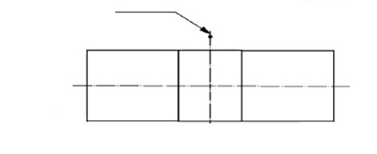

A

C

a

e

Reference axis

a

h

h

k

k

B

6/

5/

Table 2

**Dimensions of the box system in figure 2**

|  |  |  |  |
| --- | --- | --- | --- |
| *Dimensions in mm* | *a* | *h* | *k* |
| Top view ( = 0°) | 3 | 4 | 0.5 |
| Inclined views ( = ± 45°) | 4.5 | 4 | 0.5 |
| Front/ Rear view ( = ± 90°) | 3 | 4 | 0.5 |

6 This dot and dash line applies to front and rear view only.

**Category R5W/LED Sheet R5W**/**LED/3**

Normalized luminous intensity distribution

The following test is intended to determine the normalized luminous intensity distribution of the light source in the C-planes as described in figure 3. The intersection of the reference axis and the parallel plane to the reference plane in distance e is used as the coordinate system origin.

The light source is mounted on a flat plate with the corresponding holder features. The plate is fixed to the goniometer table by a bracket, so that the reference axis of the light source lines up with one of the rotating axis of the goniometer. The corresponding measurement set-up is described in figure 3.

Luminous intensity data is recorded with a standard photo-goniometer. The measurement distance should be chosen appropriately in order to make sure that the detector is located in the far field of the light distribution.

The measurements shall be performed in C-planes, which contain the reference axis of the light source. The C-planes to be measured shall be C0, C30 and C330. The test points for each plane and multiple polar angles  are specified in Table 3.

The measured luminous intensity values, normalised to the measured luminous flux of the individual light source under test, shall be converted to normalised luminous intensity values of a 1000 lm light source. These data shall comply with the tolerance band as defined in Table 3.

Figure 3  
**Illustration of C,**  **System**

Top view

Side view

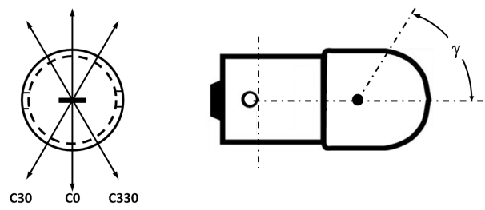

C-planes: see CIE publication 70-1987, "The measurement of absolute intensity distributions".

**Category R5W/LED Sheet R5W**/**LED/4**

Table 3 **Test point values of normalized intensity in the planes C0, C30, C330**

|  |  |  |  |  |
| --- | --- | --- | --- | --- |
| *γ* | *LED light source of normal production* | | *Standard LED light source* | |
|  | *Minimum intensity  in cd /1000 lm* | *Maximum intensity  in cd /1000 lm* | *Minimum intensity  in cd /1000 lm* | *Maximum intensity  in cd /1000 lm* |
| -100° | 60 | 140 | 80 | 120 |
| -75° | 60 | 140 | 80 | 120 |
| -50° | 60 | 140 | 80 | 120 |
| -25° | 60 | 140 | 80 | 120 |
| 0° | 60 | 140 | 80 | 120 |
| 25° | 60 | 140 | 80 | 120 |
| 50° | 60 | 140 | 80 | 120 |
| 75° | 60 | 140 | 80 | 120 |
| 100° | 60 | 140 | 80 | 120 |

The luminous intensity distribution as described in Table 3 shall be substantially uniform, i.e. in between two adjacent grid points the relative luminous intensity requirement is calculated by linear interpolation using the two adjacent grid points.”

**“ Category W5W/LEDK, WY5W/LED Sheet W5W/LED/1**

The drawings are intended only to illustrate the essential dimensions (in mm) of the LED light source.

Figure 1

**Main drawing**

**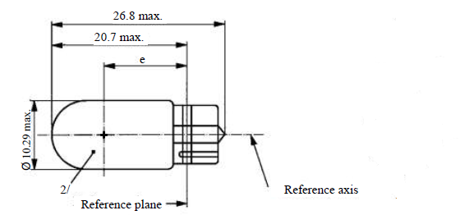**

Table 1

**Essential electrical and photometrical characteristics of the LED light source**

| *Dimensions in mm* | | | *LED light sources of normal production* | | *Standard LED light sources* |
| --- | --- | --- | --- | --- | --- |
| e 2 | | | 12.7 nom. | | 12.7 nom. |
| Cap WX2.1x9.5d in accordance with IEC Publication 60061 (sheet 7004-91A-1) | | | | | |
| *Electrical and photometric characteristics* | | | *4* | *7* | *4* |
| Rated values | | Volts | 12 | 24 | 12 |
| Watts | 2 | | 2 |
| Test voltage | | Volts (DC) | 13.5 | 28.0 | 13.5 |
| Objective values  W5W/LEDK | Power | Watts | 2.0 max. | 2.5 max. | 2.0 max |
| Electrical current | mA | (at 9-16V DC)  30min.  185max. | (at 16-32V DC)  30min.  185max | (at 9-16V DC)  30min.  185max |
| Luminous flux 1 | lm | 50 ± 20 % 3 | | 50 ± 10 % 3 |
| Luminous flux 1 | lm | (at 9 V DC)  9 min. | (at 16 V DC)  5 min. | (at 9 V DC)  9 min. |
| Objective values 5  WY5W/LED | Power | Watts | 2.0 max. | 2.5 max. | 2.0 max. |
| Electrical current | mA | (at 9-16V DC)  30min.  185max. | (at 16-32V DC)  30min.  185max | (at 9-16V DC)  30min.  185max. |
| Luminous flux 6 | lm | 30 ± 20 % 3 | | 30 ± 10 % 3 |
| Luminous flux 6 | lm | (at 9 V DC)  5 min. | (at 16 V DC)  3 min | (at 9 V DC)  5 min. |

1 The light emitted shall be white, without a correlated colour temperature restriction.

2 To be checked by means of a “box system”, sheet W5W/LED/2

3 The value measured at elevated ambient air temperature of 80°C shall be at least 70% of this value

4 In case of a failure of any of the light emitting elements (open circuit failure), the LED light source shall either still comply to the requirements concerning luminous flux and luminous intensity distribution or stop emitting light whereby, in the latter case, the electrical current draw, when operated between 12 V and 14 V, shall be less than 10 mA

5 Operated in flashing mode for 30 minutes (frequency = 1.5 Hz, duty cycle 50 per cent ON, 50 per cent OFF) and measured in the ON-state of flashing mode after 30 minutes of operation

6 The light emitted shall be amber

7 In case of a failure of any of the light emitting elements (open circuit failure), the LED light source shall either still comply to the requirements concerning luminous flux and luminous intensity distribution or stop emitting light whereby, in the latter case, the electrical current draw, when operated between 24 V and 28 V, shall be less than 10 mA

**Category W5W/LEDK, WY5W/LED Sheet W5W/LED/2**

Screen projection requirements

The following test is intended to define the requirements for the apparent light emitting area of the LED light source and to determine whether the light emitting area is correctly positioned relative to the reference axis and reference plane in order to check compliance with the requirements.

The position of the light emitting area is checked by a box system defined in Figure 2 when operated at test voltage, which shows the projections when viewing along the direction  = 0° (top view), = ± 45° (inclined view) and  = +/- 90° (front, rear view) in the plane C0 (C,  as defined in Figure 3).

Where:

A=A1+A2+A3 and B=B1+B2+B3 and C=C1+C2+C3

The proportion of the total luminous flux emitted into the viewing direction from the area(s)

A, B and C together shall be 70 per cent or more

B shall be 20 per cent or more

A and C shall each be more than 15 per cent

A1, B1 and C1 together shall be less than 50 per cent

A2, B2 and C2 together shall be more than 20 per cent

A3, B3 and C3 together shall be less than 50 per cent

Figure 2

**Box definition of the light emitting area**

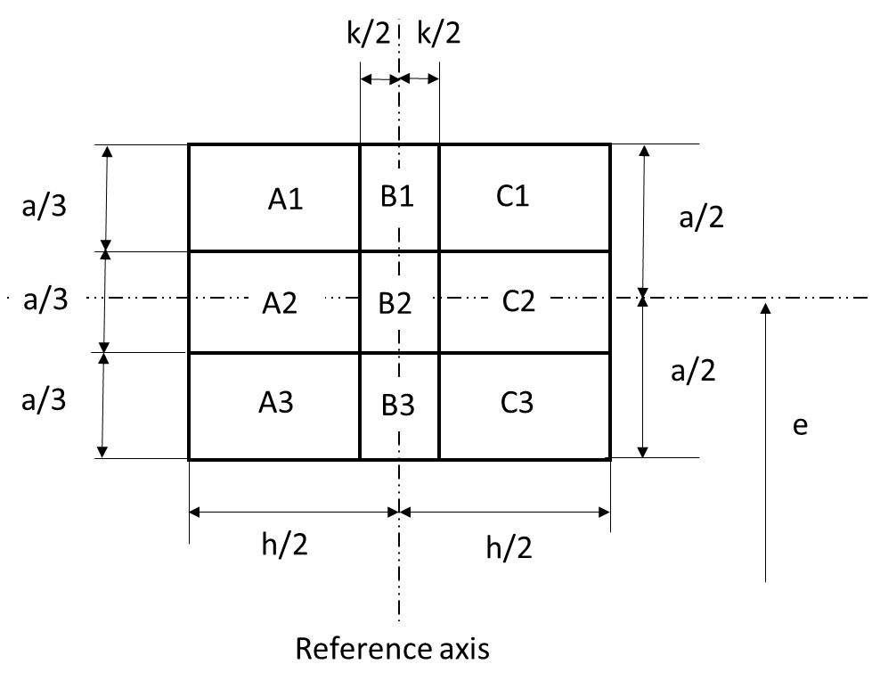

Table 2

**Dimensions of the box system in figure 2**

|  |  |  |  |
| --- | --- | --- | --- |
| *Dimensions in mm* | *a* | *h* | *k* |
| All views  (as specified above) | 6.0 | 8.0 | 1.5 |

**Category W5W/LEDK, WY5W/LED Sheet W5W/LED/3**

Normalized luminous intensity distribution

The following test is intended to determine the normalized luminous intensity distribution of the light source in the C-planes as described in Figure 3 when operated at test voltage. The intersection of the reference axis and the reference plane is used as the coordinate system origin.

The light source is mounted on a flat plate with the corresponding holder features. The plate is fixed to the goniometer table by a bracket, so that the reference axis of the light source lines up with one of the rotating axis of the goniometer. The corresponding measurement set-up is described in Figure 3.

Luminous intensity data is recorded with a standard photo-goniometer. The measurement distance should be chosen appropriately in order to make sure that the detector is located in the far field of the light distribution.

The measurements shall be performed in C-planes, which contain the reference axis of the light source. The C-planes to be measured shall be C0, C30 and C330. The test points for each plane and multiple polar angles γ are specified in Table 3.

The measured luminous intensity values, normalised to the measured luminous flux of the individual light source under test, shall be converted to normalised luminous intensity values of a 1000 lm light source. These data shall comply with the tolerance band as defined in Table 3.

Figure 3  
**Setup to measure the luminous intensity distribution**

**(Definition of C-Planes and angle )**

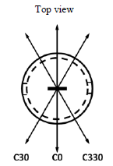

**C30**

**C0**

**C330**

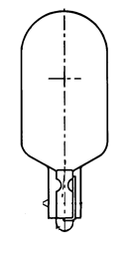



C-planes: see CIE publication 70-1987, "The measurement of absolute intensity distributions".

**Category W5W/LEDK, WY5W/LED Sheet W5W/LED/4**

Table 3

**Test point values of normalized intensity in the planes C0, C30, C330**

|  |  |  |  |  |
| --- | --- | --- | --- | --- |
|  | LED light source of normal production | | Standard LED light source | |
|  | Minimum intensity  (cd/klm) | Maximum intensity  (cd/klm) | Minimum intensity  (cd/klm) | Maximum intensity  (cd/klm) |
| -100° | 60 | 140 | 80 | 120 |
| -75° | 60 | 140 | 80 | 120 |
| -50° | 60 | 140 | 80 | 120 |
| -25° | 60 | 140 | 80 | 120 |
| 0° | 60 | 140 | 80 | 120 |
| 25° | 60 | 140 | 80 | 120 |
| 50° | 60 | 140 | 80 | 120 |
| 75° | 60 | 140 | 80 | 120 |
| 100° | 60 | 140 | 80 | 120 |

The luminous intensity distribution as described in Table 3 shall be substantially uniform, i.e. in between two adjacent grid points the relative luminous intensity requirement is calculated by linear interpolation using the two adjacent grid points.

“

1. \* In accordance with the programme of work of the Inland Transport Committee for 2018–2019 (ECE/TRANS/274, para. 123 and ECE/TRANS/2018/21/Add.1, cluster 3.1), the World Forum will develop, harmonize and update UN Regulations in order to enhance the performance of vehicles. The present document is submitted in conformity with that mandate. [↑](#footnote-ref-2)