 | INF.16
Economic Commission for Europe  Inland Transport Committee  Working Party on the Transport of Dangerous Goods  Joint Meeting of Experts on the Regulations annexed to the  European Agreement concerning the International Carriage  of Dangerous Goods by Inland Waterways (ADN)  (ADN Safety Committee)  Thirty-fifth session  Geneva, 26-30 August 2019  Item 3 (c) of the provisional agenda  Implementation of the European Agreement concerning the  International Carriage of Dangerous Goods by Inland Waterways (ADN):  interpretation of the Regulations annexed to ADN |  | 19 July 2019  English
Proposal of adaption of ADN 8.3.5 “Work on board”
Transmitted by EBU/ESO
Related documents: Informal document INF.15 of the 34th session (EBU/ESO),
ECE/TRANS/WP.15/AC.2/70, paragraph C, sub 4
- Introduction
- The barge industry wishes to maintain their ships in good shape, to be able to present itself as a safe and responsible mode of transport. Regularly, maintenance of the paintings of the barges is performed, therefore.
- According to ADN 8.3.5 on board of tank vessels and dry cargo vessels, it is not allowed to execute repair or maintenance work, that requires the use of an open flame (“hot work”) or the use of electric current, or work that is liable to cause sparks. Other types of work are not specifically prohibited.
- From a safety perspective, the current ADN 8.3.5. might not always be relevant, but restricts the possibilities to maintain the vessels in any circumstances but is not based on the actual applicable safety risks. Meeting the explosion protection requirements in the ADN-2019 which are based on the ATEX-directive, the barge industry concluded ADN 8.3.5 is not that varicolored as the ATEX-directive is, and therefore, introduced INF.15 in the 34rd session. The background was the wish to maintain barges in a safe, practical and especially a clear way.
- With INF.15, EBU/ESO proposed the ADN Safety Committee, to clarify the details of ‘work on board’ and to align the provisions for ‘work’ with the ATEX-directive. In the 34rd session, EBU/ESO offered -and was invited to- work out a proposal clarifying the areas that would need further consideration and the issues encountered with the current provisions.

- Follow up
In line with INF.15 of the 34rd session, EBU/ESO considered the topic, based on 2 points of view and proposes:
- An investigation of the last part of the sentence of ADN 8.3.5; with the aim to clarify “work that is liable to cause sparks”. This means a closer look towards sparks, based on a risk assessment in relation to the necessary activities, such as polishing, grinding, chipping of rust and painting, to maintain the vessels. It is not always clear which activity, using which tool is “liable to cause sparks”.
- An investigation of the various circumstances, as a nuance of this “black-white” description in the current 8.3.5. ATEX is based on the risks by substances with flammable properties, present. If there are no circumstances present, ATEX is not applicable. How could this be safely compared to ADN 8.3.5, regarding substances for which no explosion protection is required, and therefore, cannot form an explosive mixture?
Assistance and report of an independent ATEX-expert
- EBU/ESO have asked an independent ATEX-expert (HSE-Advies, the Netherlands) to compare the ATEX-directive with ADN 8.3.5, based on specific activities (as part of ‘work’) on board, including the different circumstances, in relation to products and their properties. In the appendix of this document, the report of HSE-Advies is added, which should be the basis of a discussion.
- Proposal
- As this topic goes slightly into details, EBU/ESO would like to propose to ask the ADN Safety Committee to mandate the Informal Working Group of Substances to work out a text proposal of ADN 8.3.5, based on the content of this report, attached.
- Others
- To facilitate the discussion, a translation of specific activities is available in English and German.
Name of activity ENG | Name of activity German | Name of activity NL
chipping rust with manual hammer | Manuell Rost entfernen mittels Hammer | roest bikken met hand-bikhamer
chipping rust with pneumatic hammer with copper berryllium needles | Rost entfernen mittels pneumatischem Hammer mit Kupfer Beryllium Nadeln | roest bikken met pneumatische bikhamer met koper beryllium naalden
sanding | Abschmirgeln | schuren
pneumatic sanding machine on painting | Lack abschmirgeln mittels pneumatischer Schleifmachine | verf opschuren met een lucht gedreven schuurmachine
cutting iron | Schleifen | slijpen

Appendix
Memorandum
To | : Centraal Bureau voor de Rijn- & Binnenvaart, Attn. Mr. M. Zevenbergen
Date | : 12 July 2019
Prepared by | : ing. G.A. Jansen
Subject | : ADN 8.3.5 “Work on board”
Project number | : 101433.400
Index number | : 001
Status | : Final
1 INTRODUCTION
If a barge is carrying any goods governed by ADN, the barge must comply with ADN. The barge must have a certificate of approval (ADN 8.6.1) and a vessel substance list (according to ADN 1.16.1.2.5).
Also, any carriage of goods governed by ADN shall be accompanied by a dangerous goods transport document (ADN 5.4.1).
According to ADN 3.2.4.3 item I., anti-explosion protection is required for:
- substances with a flashpoint ≤ 60 °C;
- substances that must be transported while heated to a temperature less than 15 K from their flash-point;
- flammable gases.
For all other substances there is no anti-explosion protection required.
The locations on board where anti-explosion protection is required are listed in ADN. The classification of zones where anti-explosion protection is required is comparable with the classification of zones as mentioned in Directive 1999/92/EC (see 1.2.1 of ADN, Classification of zones (see Directive 1999/92/CE)).
Also the types of protection (see 1.2.1 of ADN, Types of protection (see IEC 60079-0:2011)) and the requirements for flame arrestors are based on the European harmonized standards for Directive 2014/34/EU.
The ATEX Directive 2014/34/EU covers equipment and protective systems intended for use in potentially explosive atmospheres. The directive defines the essential health and safety requirements and conformity assessment procedures, to be applied before products are placed on the EU market.
European harmonised standards for Directive 2014/34/EU are produced by the European Standardisation Organisations. Their references are published in the Official Journal of the European Union (OJEU).
1.1 THE BARGING INDUSTRY
According to ADN 8.3.5 on board of tank vessels and dry cargo vessels it is not allowed to
execute repair or maintenance work on board that requires the use of an open flame (“hot
work”) or requires the use of electric current or work that is liable to cause sparks in the cargo area respectively the protected area. Other types of work are not specifically prohibited.

Projectnr.: 101433-400
Volgnr.: 01
Datum: 12 July 2019

The barging industry faces a couple of practical problems here, given the fact that ships have to be maintained. This doesn’t mean “hot work” but the conservation of the ship and her equipment, which means activities such as polishing, grinding, chipping of rust and painting, that is being performed by crew.
To maintain the barge, the following activities can be carried out on board.
- Chipping rust with manual hammer.
- Chipping rust with pneumatic hammer with copper berryllium needles.
- pneumatic rotating sanding machine on painting.
- Cutting iron.
If there are no substances on the vessel substance list (according to ADN 1.16.1.2.5) where anti- explosion protection is required (according to ADN 3.2.4.3 item I) the following activities can be carried out on board to maintain the barge.
- Chipping rust with manual hammer.
- Chipping rust with pneumatic hammer with steel or copper berryllium needles.
- Pneumatic rotating sanding machine on painting.
Cutting iron should be on ship yard only, after extensive gas free procedure, gas free declared and certified by a person approved by the competent authority (ADN 7.2.3.7.6).
According to the Directive 1999/92/EC, the above mentioned activities can also be executed when there are no substances present.
Therefore also according to ADN, the ad. a. to c. mentioned activities could be allowed when there are no substances on the dangerous goods transport document (ADN 5.4.1) where anti- explosion protection is required (according to ADN 3.2.4.3 item I).
If there are substances on the dangerous goods transport document (ADN 5.4.1) where anti- explosion protection is required (according to ADN 3.2.4.3 item I) the following analysis can be made.
Ad. a. Chipping rust with manual hammer
The European standard EN 1127-1:2011 Explosive atmospheres — Explosion prevention and protection — Part 1: Basic concepts and methodology is published in the Official Journal (2018/C 371/101).
Annex A of the EN 1127-1:2011 provides information for the use of tools in explosive atmospheres. See below.

Projectnr.: 101433-400
Volgnr.: 01
Datum: 12 July 2019

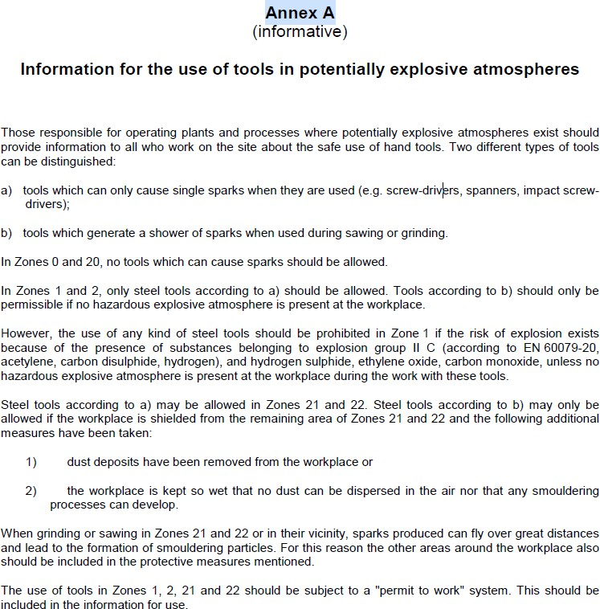
Based on the information for the use of tools in potentially explosive atmospheres as mentioned in Annex A of the EN 1127-1:2011, tools which can only cause single sparks when they are used (e.g. screw-drivers, spanners, impact screw-drivers) and any kind of steel tools can be used in zone 1 and 2 if the risk of explosion exists because of the presence of substances belonging to explosion group II A and II B, according to EN 60079- 20 (EN 60079-20 is similar and replaced by IEC 60079-20-1).
Therefore also according to ADN, chipping rust with manual steel hammer, could not be considered as effective ignition sources and could be used at a location where anti- explosion protection are required (comparable with zone 1 and 2) with the presence of substances belonging to explosion group II A and II B (according to the vessel substance list (according to ADN 1.16.1.2.5) or the dangerous goods transport document (ADN 5.4.1)).

Projectnr.: 101433-400
Volgnr.: 01
Datum: 12 July 2019
Ad. b. Chipping rust with pneumatic hammer with copper berryllium needles
According to § 52 of the ATEX 2014/34/EU Guidelines, manufacturers have to match a level of protection for the users of the equipment which corresponds to the use that the manufacturer prescribes for the equipment in the product information, under the conditions of use which can be reasonably foreseen. This is particularly relevant in the cases where misuse of the equipment is possible/likely, even if ATEX equipment is normally used by trained operators.
The consequence for manufacturers is that they have to consider the conditions of use which can be reasonably foreseen prior to placing equipment on the market.
Manufacturers have to look beyond what they consider the intended use of the equipment and place themselves in the position of the average user of a particular product and envisage in what way they would reasonably consider to use the product.
The European standard EN ISO 80079-36:2016 Explosive atmospheres – Part 36: Non- electrical equipment for explosive atmospheres – Basic method and requirements is also published in the Official Journal (2018/C 371/101).
According to the ISO 80079-36, ignition sources generated by impact need to be considered.
If the pneumatic hammer with copper berryllium needles is ATEX II 2G marked according to the ATEX Directive 2014/34/EU with the required explosion group (based on the vessel substance list (according to ADN 1.16.1.2.5) or dangerous goods transport document (ADN 5.4.1)), the pneumatic hammer with copper berryllium needles can be used within locations where anti-explosion protection is required.
When, according to the Directive 1999/92/EC, the pneumatic hammer with copper berryllium needles is ATEX II 2G marked according to the ATEX Directive 2014/34/EU with the required explosion group, the pneumatic hammer with copper berryllium needles can be used within locations where explosive atmospheres can be present (zone 1 and 2).
Therefore also according to ADN, the pneumatic hammer with copper berryllium needles ATEX II 2G marked according to the ATEX Directive 2014/34/EU with the required explosion group (based on the vessel substance list (according to ADN 1.16.1.2.5) or dangerous goods transport document (ADN 5.4.1)), could be used within locations where anti-explosion protection (comparable with zone 0, 1 and 2) is required.
Ad. c. Pneumatic rotating sanding machine on paint
As mentioned before, according to § 52 of the ATEX 2014/34/EU Guidelines, manufacturers have to match a level of protection for the users of the equipment which corresponds to the use that the manufacturer prescribes for the equipment in the product information, under the conditions of use which can be reasonably foreseen. This is particularly relevant in the cases where misuse of the equipment is possible/likely, even if ATEX equipment is normally used by trained operators.

Projectnr.: 101433-400
Volgnr.: 01
Datum: 12 July 2019
The consequence for manufacturers is that they have to consider the conditions of use which can be reasonably foreseen prior to placing equipment on the market.
As mentioned under b., the European standard EN ISO 80079-36:2016 Explosive atmospheres – Part 36: Non-electrical equipment for explosive atmospheres – Basic method and requirements is published in the Official Journal (2018/C 371/101).
According to the EN ISO 80079-36, hot surfaces generated by friction need to be considered.
According to this standard, a relative contact speed of 1 m/s is often used as the limit value below which friction ignition sources are not capable to ignite an explosive atmosphere.
In practice, a pneumatic rotating sanding machine has a rpm of more than 10.000 with a diameter of the sanding disc of 76 – 150 mm. Therefore the contact speed is much more than 1 m/s.
Based on this, pneumatic rotating sanding machine on paint cannot be used within locations where anti-explosion protection is required.
According to the Directive 1999/92/EC, the use of pneumatic rotating sanding machine on paint is allowed when there are no flammable substances present or in a non- hazardous area.
Therefore also according to ADN, the use of pneumatic rotating sanding machine on paint could be allowed:
- when there are no substances on the dangerous goods transport document (ADN 5.4.1) where anti-explosion protection is required (according to ADN 3.2.4.3 item I); or
- outside the locations where anti-explosion protection is required (comparable with zone 0, 1 and 2).
According to the EN ISO 80079-36, a relative contact speed of 1 m/s is often used as the limit value below which friction ignition sources are not capable to ignite an explosive atmosphere.
Flat sander machines will not give a relative contact speed more than 1 m/s. According to the Directive 1999/92/EC, flat sander machines are therefore allowed within a location where explosive atmospheres can be present (zone 1 and 2).
Also sanding by hand will not give a relative contact speed more than 1 m/s. According to the Directive 1999/92/EC, sanding by hand is therefore allowed within a location where explosive atmospheres can be present (zone 1 and 2).

Projectnr.: 101433-400
Volgnr.: 01
Datum: 12 July 2019
Therefore also according to ADN, sanding by hand could be allowed within locations where anti-explosion protection (comparable with zone 0, 1 and 2) is required.
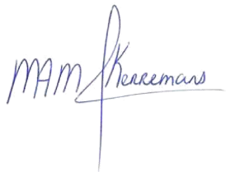
Bilthoven, 12 July 2019

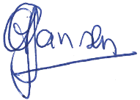
ing. G.A. Jansen M. Kerremans
Manager HSE-advies Certified Senior Safety Expert 030-2748855
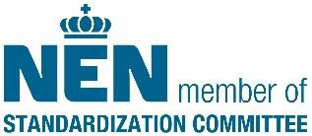

Pagina 6 van 6

