INF.14
Economic Commission for Europe
Inland Transport Committee
Working Party on the Transport of Dangerous Goods
107th session 4 November 2019
Geneva, 11-15 November 2019
Item 6 of the provisional agenda
Interpretation of ADR
Interpretation problem in sub-section 7.5.2.3
Transmitted by COSTHA (Council on Safe Transportation of Hazardous Articles)
Introduction
1. In sub-section 7.5.2.3 of ADR, the following text can be found that is confusing at practical application.
„For the purpose of the application of the prohibitions of mixed loading on one vehicle, no account shall be taken of substances contained in closed containers with complete sides. Nevertheless, the mixed loading prohibitions laid down in 7.5.2.1 concerning mixed loading of packages bearing labels conforming to model Nos. 1, 1.4, 1.5 or 1.6 with other packages, and in 7.5.2.2 concerning mixed loading of explosives of different compatibility groups shall also apply between dangerous goods contained in container and the other dangerous goods loaded on the same vehicle, whether or not the latter goods are enclosed in one or more other containers.”
2. This sub-section contains two sentences. The first sentence allows the mixed loading on one vehicle in closed container (see Figure 1). The second sentence tells the exceptions from this allowance. These exceptions are label model Nos. 1, 1.4, 1.5 and 1.6 in 7.5.2.1 and 7.5.2.2 among compatibility groups of Class 1 explosives (see Figures 2 and 3).
3. This sub-section can also be found in the previous versions. The earliest edition available on the UNECE website is published in 2001; this sub-section is readable in it. Before 2001, the ADR had different structure. In those editions, the first sentence can be found only at marginal 10 400. In RID, this sub-section is ‘(Reserved)’.
Problem
4. The exceptions listed in the second sentence refer to all kinds of mixed loading prohibitions in section 7.5.2. In this form the sub-section 7.5.2.3 is unusable for any cases.
Proposal 1
5. In case of all materials and substances that are under mixed loading prohibition by section 7.5.2 are prohibited to load on one vehicle either enclosed in separated containers or without containers, sub-section 7.5.2.3 has to be erased completely.
Proposal 2
6. In case of materials and substances that have label model Nos. 4.1+1 or 5.2+1 and other packages containing dangerous goods are allowed to load on one vehicle in closed containers, the second sentence has to be modified as the following.
„Nevertheless, the mixed loading prohibitions laid down in 7.5.2.1 and 7.5.2.2 concerning mixed loading of packages of Class 1 explosives bearing labels conforming to model Nos. 1, 1.4, 1.5 or 1.6 with other packages, and in 7.5.2.2 concerning mixed loading of explosives of different compatibility groups shall also apply between dangerous goods contained in container and the other dangerous goods loaded on the same vehicle, whether or not the latter goods are enclosed in one or more other containers.”

Figure 1

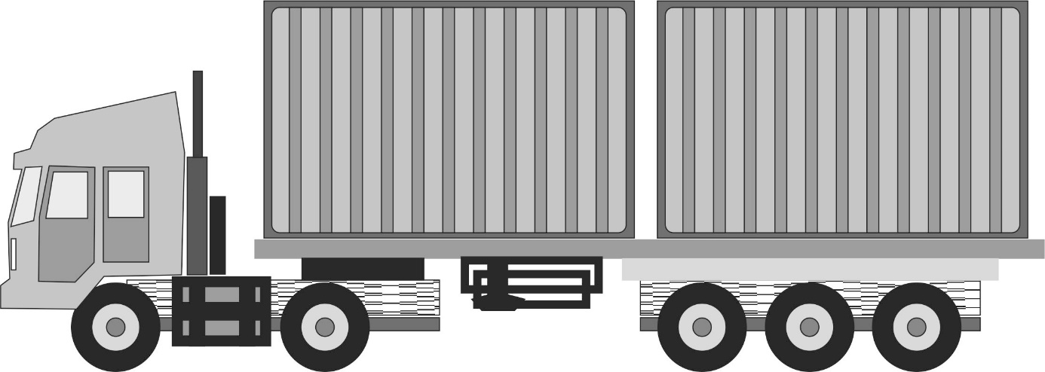

Figure 2

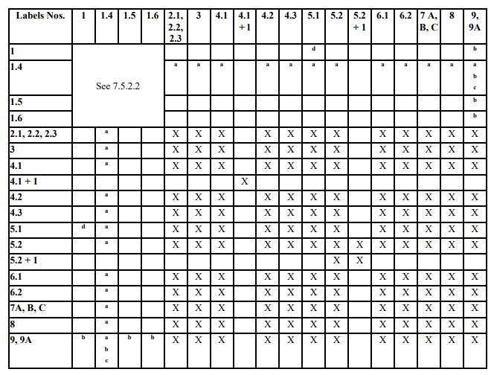

Figure 3

