INF.6
Economic Commission for Europe
Inland Transport Committee
Working Party on the Transport of Dangerous Goods
106th session 295 April 2019
Geneva, 13-17 May 2019
Item 6 (a) of the provisional agenda:
Proposals for amendments to annexes A and B of ADR:
construction and approval of vehicles
9.2.1 Braking system for EX/II vehicles of
categories O₁ and O₂
Transmitted by the Government of Sweden
Introduction
The Government of Sweden would like to raise a question concerning EX/II-approval of category O₁ trailers (maximum mass of 750 kg) and category O₂ trailers (maximum mass between 750 kg and 3.5 tonnes) and whether a braking system should be required that automatically brakes the trailer to a stop if the coupling device separates while the trailer is in motion.
Currently, ADR does not include any specific requirements concerning braking for either EX/II or EX/III vehicles of categories O₁ and O₂, but refer to UN Regulation No.13, Annex 5. However, UN Regulation No.13, Annex 5, only states that EX/III vehicles of categories O₁ and O₂ must be equipped with a braking system that automatically brakes the trailer to a stop if the coupling device separates while the trailer is in motion. EX/II vehicles are not mentioned. See extracts from ADR and R13 under “Background information” below.
Compared to EX/II vehicles, the maximum permissible net mass of explosives is larger on EX/III vehicles according to sub-section 7.5.5.2.1 in ADR. However, what concerns an O₁ trailer, it is not possible to legally carry any larger amounts on an O₁ trailer than what is also allowed on an EX/II vehicle (except for explosives with classification code 1.1A). Since these trailers might be practical to use in connection to e.g. demolition work, we believe these kind of transport units might be quite common. For the aforementioned reasons, we would like to ask for the view of the WP.15-meeting on the following:
- Would it be appropriate to introduce the same braking requirement for EX/II vehicles of categories O₁ and O₂ as applicable to EX/III vehicles in paragraph 2.4 of UN Regulation No.13, Annex 5?

Background information
Extract from ADR
9.2.3 | BRAKING EQUIPMENT | EX/II | EX/III | AT | FL
9.2.3.1 | General provisions | X | X | X | X
 | Anti-lock braking system | Xe | X^{d,e} | X^{d,e} | X^{d,e} | ^{d} Applicable to motor vehicles (tractors and rigid vehicles) with a maximum mass exceeding 16 tonnes and motor vehicles authorized to tow trailers (i.e. full-trailers, semi-trailers and centre axle-trailers) with a maximum mass exceeding 10 tonnes. Motor vehicles shall be equipped with a category 1 anti-lock braking system.  Applicable to trailers (i.e. full-trailers, semi-trailers and centre axle-trailers) with a maximum mass exceeding 10 tonnes. Trailers shall be equipped with a category A anti-lock braking system.  ^{e} Applicable to all motor vehicles and applicable to trailers with a maximum mass exceeding 3.5 tonnes, first registered (or which entered into service if registration is not mandatory) after 31 March 2018.
 | Endurance braking system | X^{f} | X^{g} | X^{g} | X^{g} | ^{f} Applicable to motor vehicles with a maximum mass exceeding 16 tonnes or authorized to tow a trailer with a maximum mass exceeding 10 tonnes first registered after 31 March 2018. The endurance braking system shall be of type IIA.  ^{g} Applicable to motor vehicles with a maximum mass exceeding 16 tonnes or authorized to tow a trailer with a maximum mass exceeding 10 tonnes. The endurance braking system shall be of type IIA.

9.2.3 Braking equipment

9.2.3.1 General provisions

9.2.3.1.1 Motor vehicles and trailers intended for use as transport units for dangerous goods shall fulfil all relevant technical requirements of UN Regulation No.134, as amended, in accordance with the dates of application specified therein.

9.2.3.1.2 EX/II, EX/III, FL and AT vehicles shall fulfil the requirements of UN Regulation No.13⁴, Annex 5.

9.2.3.2 (Deleted)

Comment: Consequently, neither an anti-lock braking system nor an endurance braking system seem to be required for an EX/II vehicle of category O₁ or O₂ since these vehicles have a maximum mass of 750 kg and 3,5 tonnes respectively.

Extract from UN Regulation No.13

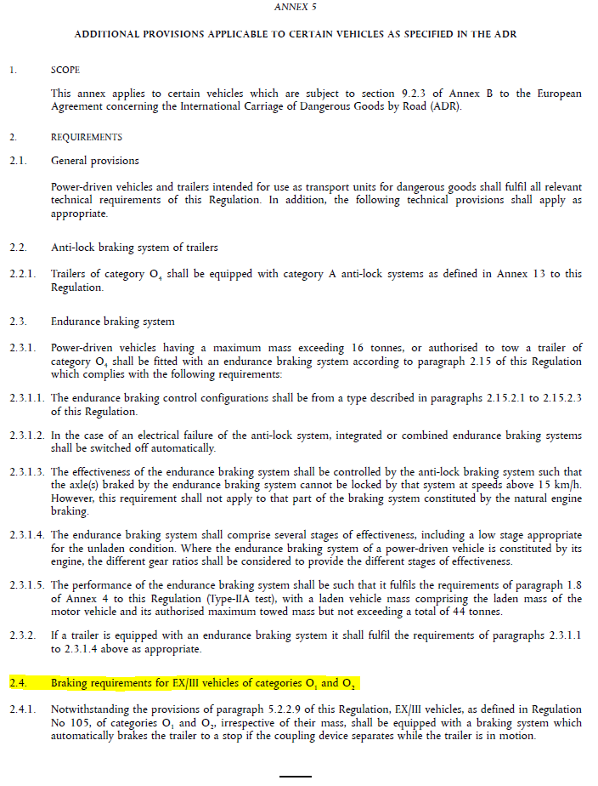

Comment: Annex 5 specifically states that category O₁ and O₂ EX/III vehicles must be equipped with a braking system that automatically brakes the trailer to a stop if the coupling device separates while the trailer is in motion. EX/II vehicles are not mentioned.

_____________

4 UN Regulation No. 13 (Uniform provisions concerning the approval of vehicles of categories M, N and O with regard to braking).

