|  |  |  |  |
| --- | --- | --- | --- |
|  | United Nations | ST/SG/AC.10/C.4/2019/9 | |
| _unlogo | **Secretariat** | | Distr.: General  13 September 2019  Original: English |

**Committee of Experts on the Transport of Dangerous Goods  
and on the Globally Harmonized System of Classification  
and Labelling of Chemicals**

**Sub-Committee of Experts on the Globally Harmonized  
System of Classification and Labelling of Chemicals**

**Thirty-eighth session**

Geneva, 11-13 December 2019

Item 2 (h) of the provisional agenda

**Classification criteria and related hazard communication:**

**other issues**

References to the Model Regulations, numbering of criteria in tables 2.3.1 and 3.2.2, correction to Annex 7 (example 10) and design of decision logics

Note by the secretariat[[1]](#footnote-2)\*

Reference to the Model Regulations in the GHS

1. Chapter 1.2 of the GHS contains the list of definitions and abbreviations most commonly used in the GHS. The references to the Model Regulations currently read:

“***Recommendations on the Transport of Dangerous Goods, Model Regulations*** *means the latest revised edition of the United Nations publication bearing this title, and any published amendment thereto.”.*

2. Throughout the text of the GHS, the Model Regulations are inconsistently referred to as:

* *UN Recommendations on the Transport of Dangerous Goods, Model Regulations*;
* *Model Regulations*;
* *UN Model Regulations*;
* *UN Model Regulations on the Transport of Dangerous Goods. Model Regulations*; and
* *UN Model Regulations on the Transport of Dangerous Goods*.

3. In order to simplify, shorten and harmonise all references to this publication through the GHS, and to make them consistent with the terminology used in other publications when referring to the Model Regulations, the secretariat would like to invite the Sub-Committee to consider the proposal below.

Proposal

4. In Chapter 1.2, amend the definition of “***Recommendations on the Transport of Dangerous Goods, Model Regulations***” to read as follows:

“***UN Model Regulations*** means the Model Regulations annexed to the latest revised edition of the Recommendations on the Transport of Dangerous Goods published by the United Nations”.

Consequential amendment:

Replace all existing references (see paragraph 2 above) with “UN Model Regulations”.

Numbering of criteria in tables 2.3.1 and 3.2.2

5. Criteria in the tables of each chapter of parts 1 to 4 of the GHS are usually numbered with letters to facilitate referencing when needed, while minimizing the risk of confusion with the numbering used to identify classification categories. This principle is applied consistently in the GHS except for tables 2.3.1 and 3.2.2. To solve this inconsistency, the secretariat would like to invite the Sub-Committee to consider the proposal below.

Proposal

6. In Chapter 2.3, table 2.3.1, under the column “Criteria”:

* Replace “(1)”, “(2)” and “(3)” with “(a)”, “(b)” and “(c)”;
* Replace “(a)”, “(b)”, “(c)” with “(i)”, “(ii)” and “(iii)”.

7. In Chapter 3.2, table 3.2.2, under the column “Criteria”:

* Replace “(1)”, “(2)” and “(3)” with “(a)”, “(b)” and “(c)”.

Correction to Annex 7, example 10

8. The secretariat has been informed of a printing error in example 10 of annex 7, in the figure showing the inner receptacle label under case scenario B, where it appears that the mention “Read full label enclosed” is missing (for reference, see the consolidated list of amendments to the GHS in document ST/SG/AC.10/46/Add.3).

9. The Sub-Committee is invited to note that the following correction will be included in a corrigendum to the eighth revised edition of the GHS. The correction does not apply to the French version.

Correction

“**Annex 7, example 10, scenario B**

Replace the figure with an example of an inner receptacle label for sample 1, with the figure below:

”

Design of decision logics in the GHS

10. Decision logics in the GHS are made of shaded text boxes and arrows and their design has been kept unchanged since the first edition of the GHS.

11. Following a series of software updates, the secretariat started to experience difficulties with the decision logics already several years ago, when preparing the consolidated revised editions of the GHS. These problems are due to file incompatibility issues between successive versions of the text processing program.

12. Although until now the secretariat managed to overcome these difficulties, new incompatibility problems have appeared recently, and the measures taken in the past to solve them are no longer valid. An example of some of the problems encountered is shown in the figure below.

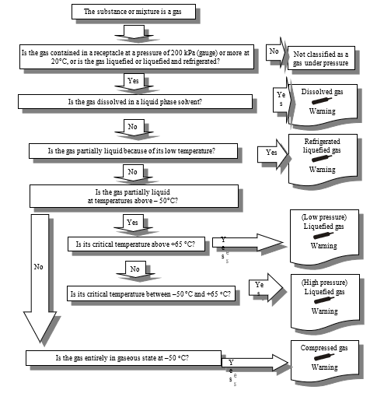

Action requested

13. In view of the above, the secretariat invites the Sub-Committee to note that for the next edition of the GHS, all decision logics will be converted into a format compatible with the most recent version of text processing program in use and that this may imply changes to the current design of the decision logics.

1. \* In accordance with the programme of work of the Sub-Committee for 2019-2020 approved by the Committee at its ninth session (see ST/SG/AC.10/C.3/108, paragraph 141 and ST/SG/AC.10/46, paragraph 14). [↑](#footnote-ref-2)