UN/SCETDG/56/INF.40

Committee of Experts on the Transport of Dangerous Goods
and on the Globally Harmonized System of Classification
and Labelling of Chemicals 29 November 2019
Sub-Committee of Experts on the Transport of Dangerous Goods
Fifty-sixth session

Geneva, 4-11 December 2019
Item 6 (a) of the provisional agenda
Miscellaneous proposals for amendments to the Model Regulations on the Transport of Dangerous Goods: Marking and labelling
Optical differentiation of labels/placards for gases
Transmitted by the World LPG Association (WLPGA) and Liquid Gas Europe (LGE)
Introduction
1. This document provides additional information as support for the discussion related to informal document INF.37 (56th session) submitted by Spain and CTIF (International Association of Fire and Rescue Services).
2. The LPG industry welcomes the continuation of the discussions, wishes to thank Spain and CTIF for their initiative and would like to provide some additional information and views that may help the coming discussions.
The LPG industry view and justification
3. The initial proposal was understood as aiming to address issues related to emergency response in Road Transport incidents and specifically related to Road Tankers. However, as known, the related labels have a much wider application, and touch also other areas where the relative benefits of the proposal are less obvious.
4. When for example applied on LPG cylinders (or other similar cylinders), the change can be seen as of almost no value, since the shape/look of the cylinder itself on which the label is attached, makes very clear its gaseous character.
5. When applied to Rail Transport, it is also seen as not adding any significant benefits, since the Rail Wagons transporting gases are also easily and immediately identifiable as such.
6. The type of erroneous responses of the emergency services (and also their frequency), that could be possibly corrected or improved with the addition of the “cylinder” icon on the label is also not clear, the LPG industry is not aware of such erroneous responses and their consequences, and it has indeed searched for such. A good knowledge, evidence is needed always of problems encountered to allow evaluation of the risks and the corrective measures. Any additional related information during the coming discussion would be much appreciated.
7. Today, it is becoming more and more imperative to apply risk-based decision-making principles, especially when the impact of the decisions is at large scale.
8. The placards, in Road, Rail, Maritime transport, displaying the product UN number (example below), and in fact also in larger dimensions and with additional fire resistance requirements, provide all the information needed on the product and with visibility from a distance, for rapid and effective emergency response. Yes, indeed, the UN number may need some “decoding” to identify the name of the product, but every emergency service is in direct “radio contact” with its control center that can provide immediately the answer (and even a simple “google search” today provides this in seconds). The need for competent and well-trained emergency services must also not be underestimated, capable of knowing very quickly the product in question and the actions to take..
9. In many countries, the additional text “FLAMMABLE GAS” is already used in the labels and placards today, providing the visibility and recognition that the present proposal is aiming at and this may be even clearer as recognition than the cylinder symbol proposed. Why not to follow this existing and applied today practice if indeed more visibility is needed?
10. A mandatory inclusion of the cylinder icon, as per proposal, would most probably not allow any more the use of the UN number or the “FLAMMABLE GAS” text on the label or placard. Is this not maybe a backwards step?

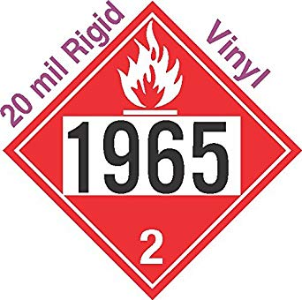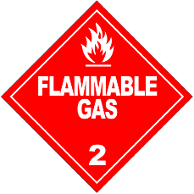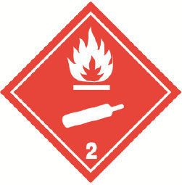

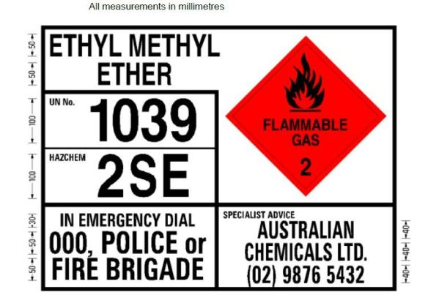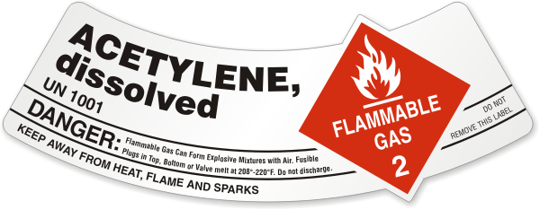

11. Relying only on the information about the gaseous character of the product through the “cylinder icon”, without the knowledge of the exact product (through the UN number), may even impact negatively the emergency response activity.
12. More than 2 billion cylinders in circulation worldwide will have to be equipped with new labels, but for what benefit realy? Compared to the “FLAMMABLE GAS” text on many labels today, the graphical display of only a “cylinder icon”, is it not less visibility, clarity?
13. An LPG cylinder, with the 2.1 label stamped/painted on it, usually it is repainted again after 10 or even 15 years, during its periodic requalification, when a new label could be applied to it.
14. Various documents, Safety Data Sheets, procedures, training materials, all will have to be updated to reflect the change.
15. Specifically now in the EU, regarding SDSs, there is also a clear link to REACH and CLP. The CLP regulation clearly states that the “under pressure” symbol is not needed for LPG, already classified as a flammable gas. This may cause future uncertainties in classifications if UN Model Regulation (and ADR) comes into conflict with CLP.
16. There has been no cost benefit analysis of this proposed change and with no recorded incidents, related specifically to visibility, misreading of the labels/placards, it is very difficult to assess the benefit vs cost or/and other implementation difficulties that this change may bring.
17. The LPG industry is keen to hear more during the coming meeting about the benefits of this change and its justification and would encourage all participants to contribute.

18. With the present knowledge and information in hand, it believes that the benefits of the “cylinder icon” proposal are not sufficiently justified and, in some countries, may even be a backwards step towards the aim of better visibility and clarity, for safe and effective emergency response.
19. In countries where it is believed that the emergency response services may need additional visibility and clarity, the additional text “FLAMMABLE GAS” or the UN number, as it is already the case today in some countries, can be always used in labels and placards.
20. Hence, the LPG industry, with the knowledge at present, cannot see yet the necessity of the proposed change in the UN Model Regulations.

