UN/SCETDG/55/INF.38

Committee of Experts on the Transport of Dangerous Goods
and on the Globally Harmonized System of Classification
and Labelling of Chemicals 27 June 2019
Sub-Committee of Experts on the
Transport of Dangerous Goods
Fifty-fifth session

Geneva, 1-5 July 2019
Item 4 (e) of the provisional agenda
Electric storage systems: sodium-ion batteries
Sodium-ion batteries – comments on document ST/SG/AC.10/C.3/2019/35
Transmitted by the expert from France
Introduction
- At the forty-eighth (informal document INF.6), fiftieth (informal document INF.13) fifty-second (informal document INF.11), fifty-third (document ST/SG/AC.10/C.3/2018/3) and fifty-fifth sessions (document ST/SG/AC.10/C.3/2019/35) of the Sub-Committee, the expert from the United Kingdom presented a series of informal and formal documents leading to the proposal of the addition of a new special provision for transport of sodium-ion batteries.
- This proposal would assign sodium ion batteries to UN 3292 and allow the transport of shorted or discharged sodium-ion batteries under the UN 3292 without being subject to any provision of these regulation if they meet the following:
«(a) Cells and batteries are transported in a shorted or discharged state; and
(b) Cells, batteries and equipment containing cells and/or batteries are packed in packaging that meets the general provisions of 4.1.1.1 and 4.1.1.2. Large robust batteries may be transported on pallets or in suitable handling devices.”
- France thanks the expert from the United Kingdom for bringing this subject to the Sub-Committee and agrees that a proper regulation for this emerging technology is timely and should be included in the twenty-second revised edition of the Model Regulation, published in two years from now.
Comments on the proposal by the United Kingdom
- All the elements brought by the expert from the United Kingdom made clear that electrical or mechanical abuse during transport of shorted or fully discharged sodium-ion batteries do not cause any serious hazards.
- Nonetheless several points are in our view justifying to propose some amendments to the proposal from the United Kingdom:

6. Shorted and discharged batteries are not similar in relation with transport safety, even if they both present a low hazard when transported: a shorted cell can be easily controlled (presence of an electronic conductor between the two terminals) whereas it is not possible to verify the State Of Charge of a battery easily. For the same reason, the shorted condition could be valid only at cell level and not for assembly of cells (modules, packs) referred as batteries in the Model Regulation.
7. This proposal would in our view create a problem with non-shorted sodium-ion batteries by leaving them with a restrictive and non-suited regulation ( the one applicable to Sodium batteries UN 3292). Not all current technologies can be stored shorted without impacting future use (capacity loss…). It might also interfere with development of new technologies, eventually not capable to be stored shorted.
8. Even with shorted batteries, the risk of thermal runaway cause by an excessive heat exposure can not be ignored. Current technologies and electrolytes used seems to be fairly thermally stable, but nothing prevents the use of any kind of electrolytes in the future. A simple thermal test similar to the requirements in the Manual of Tests and Criteria, part III, Subsection UN 38.3 T.2 appears useful. Therefore some design type testing seems justified
9. Using the same UN number for sodium-ion and sodium metal batteries would give a false information to first responders. Sodium metal is indeed classified as water reactive and, in case of fire, first responders would avoid the use of water whereas it would be the best extinction agent to use in the case of a fire of sodium-ion batteries. It also creates inconsistencies with how lithium batteries are addressed in the Model Regulations.
10. This proposal raises also concern about the transport of used sodium-ion batteries. It seems difficult to think that end-users will short their batteries before disposing it. Batteries transported for recycling will then be considered as sodium-metal batteries and transported with the current restrictive regulation.
11. Abusive tests have been run on 18650 Na-ion cells and are presented in annex 1. They show that even for well-designed cells, temperature increase in the event of an external short circuit is important and close to the limit value of 170°C, defined in UN 38.3 for Li-ion batteries. It is then reasonable to assume that some poorly designed cells might fail some tests from UN 38.3. It is preferable not to allows such designs to be transported.
Proposal
12. Taking the previous points into account and considering that sodium-ion batteries is a product with the potential to be transported in large quantities and which needs specific requirements, France supports the effort of the United Kingdom to regulate Sodium-ion batteries and cells but is of the opinion that creating a dedicated UN number would be better in this case.
13. This number would be used for Sodium ion cell or battery: meaning a rechargeable electrochemical cell or battery in which the positive and negative electrode are both intercalation compounds (intercalated sodium exist in an ionic or quasi-atomic form in the lattice of the electrode material) constructed with no metallic sodium in either electrode.
14. The applicable provisions (classification, packing instructions etc…) would be close to those applicable to Lithium-ion cells and batteries and would not be difficult to draft
15. On this basis, sodium-ion batteries would have to pass the already well know design type tests in UN 38.3, with some minor adaptations, to be transported.
16. Shorted cells would be exempted by a special provision or subject to only minimal requirements as appropriate considering materials brought by the expert of the United Kingdom and elements presented in Annex 1.
17. As a new biennium is starting we believe that it is possible to initiate and finalize a work consisting in checking the current requirements applicable to lithium-ion batteries in order to draft a text that, with only a few modifications, would be relevant for Sodium-ion batteries. France is willing to work with the expert from the United-Kingdom and other concerned parties to achieve this work in the biennium.

Annex 1
Abusive tests results on 18650 Na-ion cells
Various abusive tests have been done on 18650 format Na-ion cells. These tests were not intended to be conform to UN38.3 procedures. They show nonetheless that, especially in the case of the external short circuit (presented in figure 2), the temperature increase is important and close to the limit temperature fixed in UN38.3 for Li-ion batteries, even in the case of well-designed cells. Nail puncture of a cell (presented in figure 6), sometime considered to be representative of an internal short circuit, causes a comparable temperature increase.
Results for over discharged cell (0 V) presented in figure 3, 5 and 7 are in agreement with previous result presented by the United Kingdom and confirm the absence of reaction of cells at a potential close to 0 V.
- Altitude simulation:
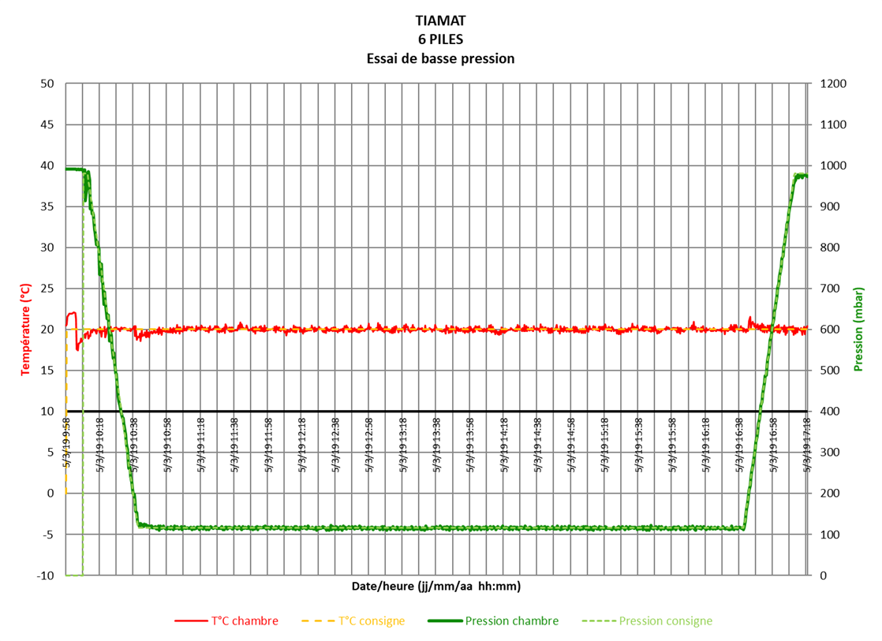
Figure 1 : Altitude simulation test result for fully charged cells
Sample 1: Pass
Sample 2: Pass
Sample 3: Pass
- External short circuit
Sample state of charge: 100%
R _{short circuit}: 3,7 mΩ
T_{amb}: 22°C
T_{max} reached: 131°C
Fully charged cell:
Figure 2 : External short-circuit test result for a fully charged cell

Over discharged cell (0V):

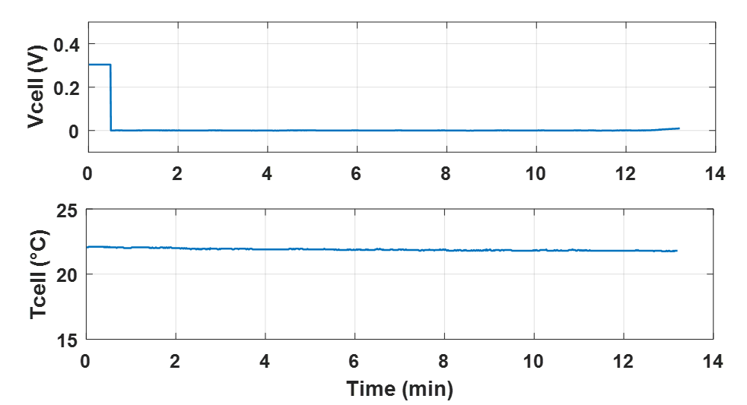
Figure 3 : External short-circuit test result for a fully discharged cell (0V)
- Crush
Crushing speed: 15 cm/s

Fully charged cell:
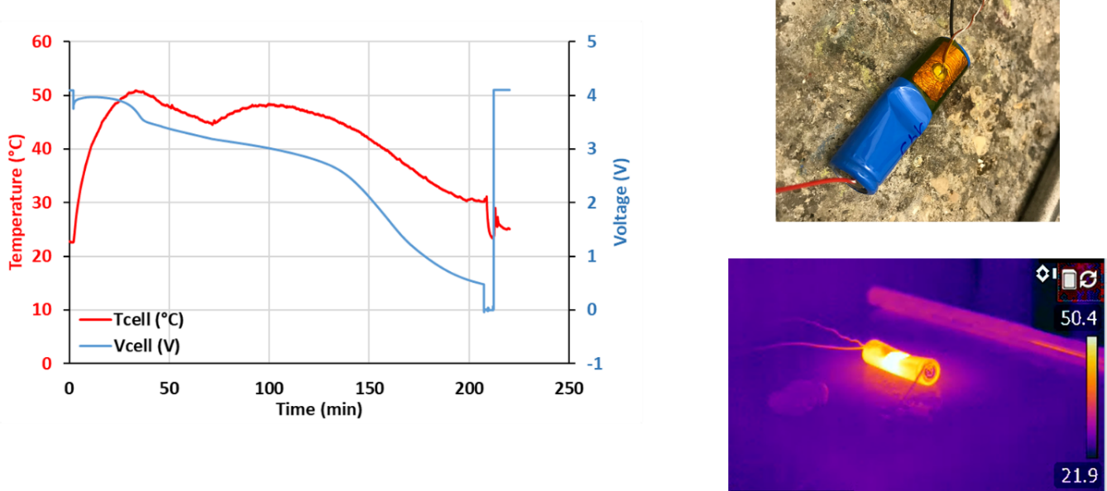
Figure 4: Crush test result for a fully charged cell
Over discharged cell (0V):

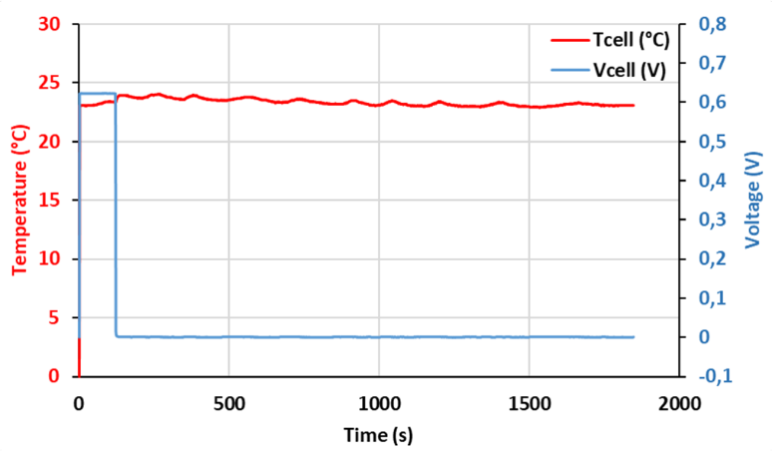
Figure 5 : Crush test result for a fully discharged cell

- Nail penetration (simulation of internal short circuit)

Fully charged cell:
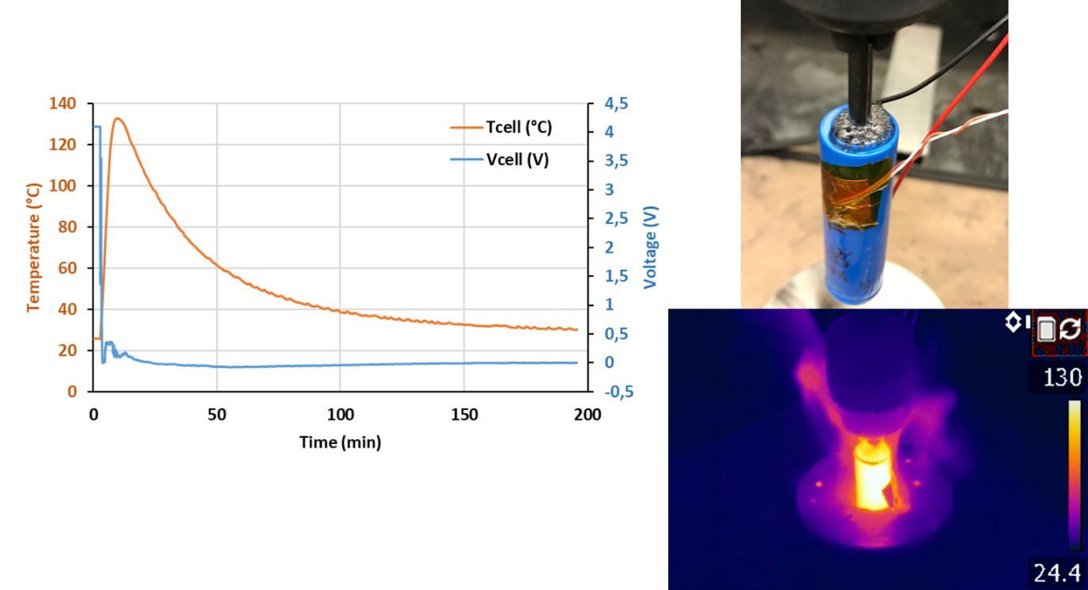
Figure 6 : Results of nail penetration test for a fully charged battery

Over discharged cell (0V):

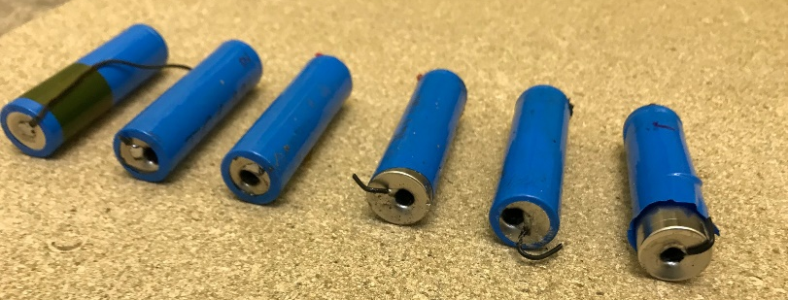

Figure 7 : Results of nail penetration test for a fully discharged cell (0V)
___________________

