UN/SCETDG/55/INF.29

Committee of Experts on the Transport of Dangerous Goods
and on the Globally Harmonized System of Classification
and Labelling of Chemicals 18 June 2019
Sub-Committee of Experts on the Transport of Dangerous Goods
Fifty-fifth session

Geneva, 1-5 July 2019
Item 4 (c) of the provisional agenda
Electric storage systems: transport provisions
Proposal to add state of charge (SOC) provision to lithium-ion cells and batteries during transportation
Transmitted by representative of the People's Republic of China
Introduction & Background
- At the twenty-sixth, twenty-seventh and twenty-ninth sessions of the Sub-Committee, PRBA - The Rechargeable Battery Association presented a number of proposals and documents (ST/SG/AC.10/C.3/2004/96e, ST/SG/AC.10/C.3/2005/13, ST/SG/AC.10/C.3/2005/43 and ST/SG/AC.10/C.3/2005/44) regarding state of charge (SOC) limit to lithium-ion cells and batteries during transportation. These documents demonstrated that lithium-ion cells and batteries are safer when they are at lower state of charge (SOC).
- Lithium-ion cells and batteries have many advantages, such as high voltage platform, good cycle life, high energy density, significant cost reduction and so on. They have been industrialized in more and more fields such as consumer electronic equipment, transportation vehicles (electric vehicles) and energy storage. While the scale of lithium-ion cells and batteries industry is expanding rapidly and the transportation volume of lithium-ion cells and batteries is also increasing day by day, the safety of lithium-ion cells and batteries during transportation is also attracting wide attention around the world.
- The safety risk grade of lithium-ion cells and batteries during transportation is mainly related to their thermal stability. The main factors affecting thermal stability of lithium-ion cells and batteries are chemical system and state of charge (SOC). A lot of research results show that for same lithium-ion cells and batteries, the thermal stability of lithium-ion cells and batteries becomes worse as the SOC increases. That means, with the increase of the SOC of lithium-ion cells and batteries, the safety risks in transportation also increases. When some NCM lithium-ion cells and batteries are in high state of charge (60% SOC), triggering their thermal runaway could cause fire. These substances usually consist of organic molecules, which are building blocks, intermediates, or active ingredients for pharmaceutical or agricultural chemicals. Although not designed to be explosives of Class 1, many of these substances carry functional groups listed in tables A6.1 and/or A6.3 in Annex 6 (screening procedures) of the Manual of Tests and Criteria, indicating potential explosive or self-reactive properties.
- ICAO TI has clearly stipulated that the SOC of UN3480 lithium-ion cells and batteries during transportation should not exceed 30%. Apart from air transport, there is no uniform regulation on the SOC of lithium-ion cells and batteries in other transport methods. As a result, companies use different SOC when lithium-ion cells and batteries are transported by land or waterway, leading to uncontrollable safety risk. Excessive SOC will increase the safety risk of transporting lithium-ion cells and batteries, but insufficient SOC of lithium-ion cells and batteries during transportation or storage can cause risk of excessive discharge of lithium-ion cells and batteries from their normal self-discharge, thus affecting the normal usage of lithium-ion cells and batteries. Therefore, it is necessary to specify reasonable SOC of lithium-ion batteries, especially lithium-ion cells and batteries with large capacity in < Recommendation on the transport of dangerous goods model regulation>.
Analysis and verification
- According to the cathode materials used, the present mainstream lithium ion batteries include lithium iron phosphate (LFP), nickel cobalt manganese oxide (NCM), nickel cobalt aluminum oxide (NCA) and lithium cobalt oxide (LCO). LFP batteries will only smoke in most thermal runaway scenarios regardless of the SOC, since LFP batteries has the good thermal stability. While NCM/NCA batteries as well as LCO battery behave quite differently under thermal runaway when they are in different SOC. Below analysis and verification are based on the NCM batteries which battery type is most popular in the future. An overview of the current classification criteria is shown in figure 1. For reasons of simplification, special cases such as pyrotechnics, articles and ammonium nitrate emulsions, suspensions or gels (ANEs) are summarized as “intentional explosives” and not discussed in this document since they are not relevant for the context.
Materials analysis
- On material level, the thermal stability of lithium ion battery is mainly characterized by the lithium ion intercalation state and heat generation.
- The lithium ion intercalation state in anode material is dependent on the SOC for the same battery. As shown in Figure 1, more lithium ion intercalates into the anode material as the SOC increases, leading to poor thermal stability.
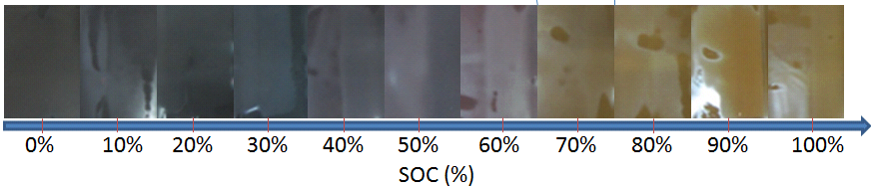
Figure 1. Effect of state of charge (SOC) on lithium ion intercalation state
- The heat generation is dependent on the SOC for the same battery. Differential scanning calorimetry is used to investigate the NCM cathode and graphite anode materials at different SOC, and the results showed that: lithium ion cells and batteries at 30% SOC have good thermal stability, the anode material generates much less heat than that at 50%-70% SOC, and the temperature for cathode exothermic reaction is much higher than that at 50%-70% SOC
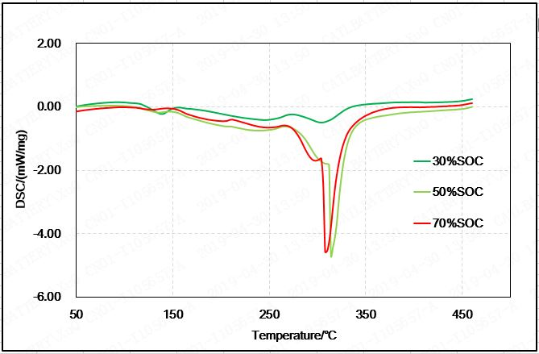
Figure 2. The heat generation of anode materials with different state of charge (SOC)
- As shown in Figure 2, for the battery at 50%-70% SOC, severe exothermic reaction happens with a lot of heat when heating the anode material at 300℃. While no obvious exothermic reaction happens at 300℃ for the anode at 30% SOC.
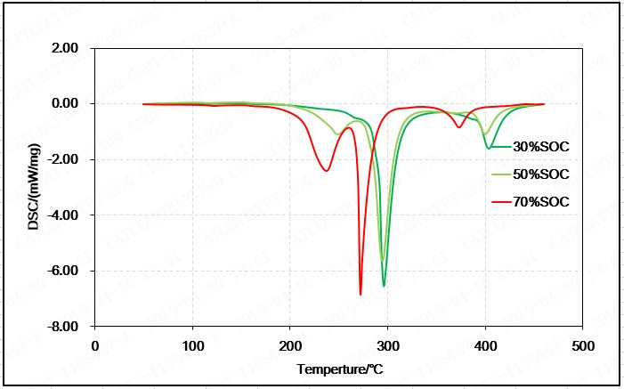
Figure 3. The temperature of exothermic reaction of cathode materials with different state of charge (SOC)
Thermal runaway test of NCM battery
- The NCM cell with different SOC are triggered to thermal runaway by heating, and the thermal behaviors under each condition are observed to evaluate the safety.
- As listed in Table 1, 51Ah NCM cell with different SOC are triggered to thermal runaway by heating, and the results are quite different:
  - SOC 10%-30%: mild reaction, while smoke only, no sparks and no fire;
  - SOC 40%: a lot of white smoke mixed with black smoke, no sparks and no fire;
  - SOC 50%: a lot of white smoke mixed with sparks, no fire;
  - SOC 60%-100%: fire.

Table 1. Thermal runaway test results of the NCM batteries with different state of charge (SOC) by heating
No. | State of charge (SOC) | Photo before triggering | Photo of thermal runaway | Photo after triggering | Test result
1 | 10% | 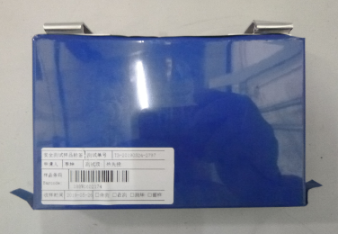 |  | 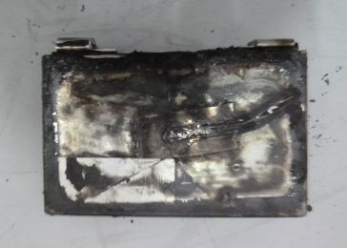 | White smoke, no sparks and no fire;
2 | 20% | 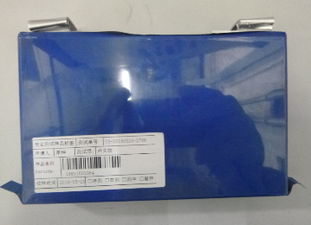 |  | 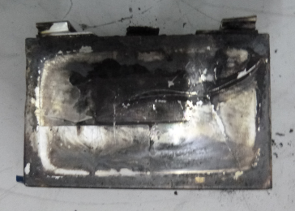 | White smoke, no sparks and no fire;
3 | 30% | 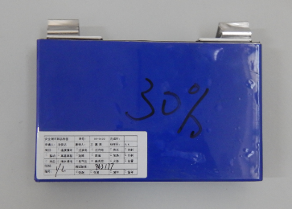 |  | 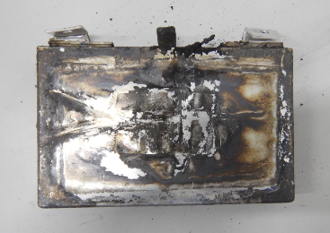 | White smoke, no sparks and no fire;
4 | 40% | 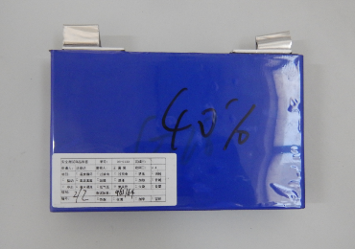 |  | 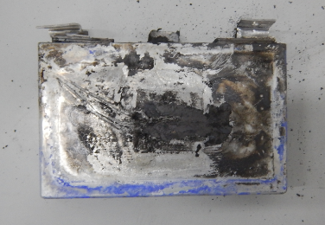 | A lot of white smoke mixed with black smoke
5 | 50% | 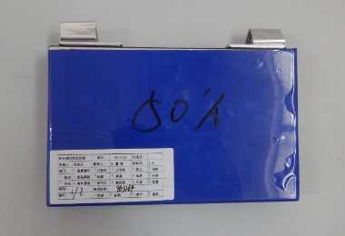 |  | 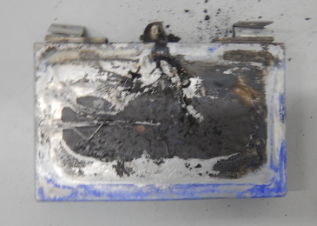 | A lot of white smoke mixed with sparks
6 | 60% | 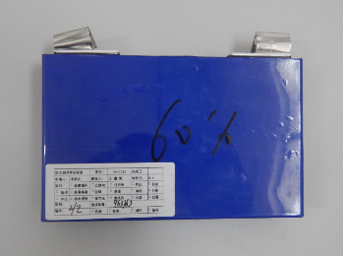 |  | 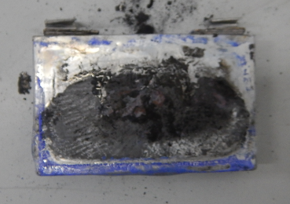 | Fire
7 | 70% | 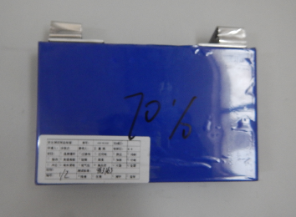 |  | 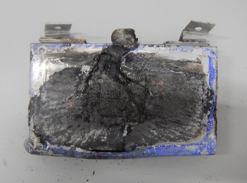 | Fire
8 | 80% | 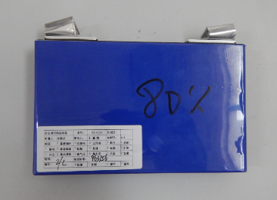 |  | 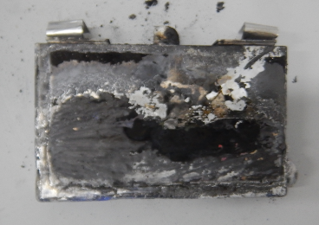 | Fire
9 | 90% | 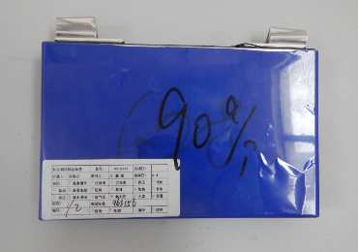 |  | 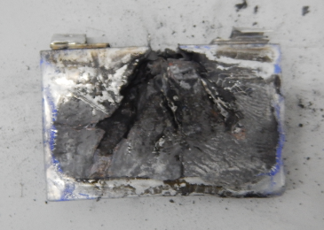 | Fire
10 | 100% | 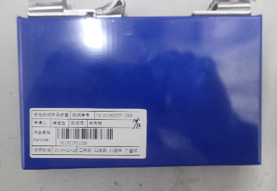 |  | 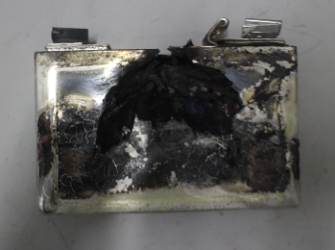 | Fire
- If Class 1 is rejected due to insufficient thermal stability, a classification as a self-reactive substance will apply (see below).
Thermal runaway test of LFP battery
- The LFP battery with 100% SOC is triggered to thermal runaway by heating, and only some white smoke could be observed as in Table 2.
- The technical report (EVS 1541-616) in the revision of the global technical regulation UN GTR No.20 mentioned that more than 200 different LFP cells were triggered to thermal runaway by heating or overcharging, and no fire occurred.

Table 2. Thermal runaway test result of the LFP battery triggered by heating
No. | State of charge (SOC) | Photo before triggering | Photo of thermal runaway | Photo after triggering | Test result
1 | 100% |  | 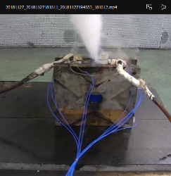 |  | White smoke, no sparks and no fire;
Self-discharge character
- The self-discharge rate of lithium ion cells and batteries with 30% SOC at 25℃ ambient temperature conditions is usually not faster than 2% per month (similar conclusions can be found in ICAO document DGP-WG/15-IP/1 in 2015). Severe environmental conditions could accelerate the self-discharge rate, however it could not exceed 3% per month even at 45℃ conditions. Therefore, the lithium ion cells and batteries with 30% SOC could afford transportation and storage for as long as 10 months even at harsh transportation conditions. However, the transportation of lithium ion cells and batteries usually takes less than 3 months
Definition of State of charge
- ST/SG/AC.10/C.3/2004/96 of PRBA had given the recommendation of definition: “State of charge means the available capacity in a cell or battery, after a charge or discharge operation, usually expressed as a percentage of the cell or battery’s rated capacity”. There is a similar definition for traction battery in ISO 6469-1: 2019 “available capacity of an RESS or RESS subsystem expressed as a percentage of rated capacity”. The definition from ST/SG/AC.10/C.3/2004/96 of PRBA is more suitable to the Manual of Tests and Criteria.
Conclusion
- Material mechanism analysis and verification results show that the safety of lithium-ion cells and batteries has a strong correlation with their SOC. The higher the SOC is, the worse the thermal stability and safety of lithium-ion batteries are.
- Material mechanism analysis and verification results show that the thermal stability and safety of lithium-ion cells and batteries are fairly good when SOC is 30%.
Proposal
1. Add a special provision for UN3480 in chapter 3.2 of the Model Regulation:
SP xxx.

2. Add a provision to Chapter 3.3 of the Model Regulation:
xxx The state of charge (SOC) of lithium-ion cells and batteries during transportation shall not exceed 30% of their rated capacity when they meet the following conditions.
  - Large lithium-ion cell with total mass of more than 500g;
  - Large lithium-ion battery with total mass of more than 12kg or battery consisting of large lithium-ion cell which is heavier than 500g.
3. Add the definition of state of charge (SOC) in Chapter 38.3.2.3 of the Manual of Tests and Criteria as follow:
State of Charge (SOC):
Refers to the available capacity of a battery or cell after charging or discharging operations, usually expressed as a percentage of the rated capacity of the battery and cell. (Refer to ST/SG/AC.10/C.3/2004/96 and ISO 6469-1:2019)
References
(i) DGP-WG/15-IP11 IP/1: Dangerous goods panel (DGP) working group meeting (DGP-WP/15), Montreal, 27 April to 1 May 2015. Implications of adopting a state of charge (Presented by PRBA – The Rechargeable Battery Association) <www.icao.int/safety/DangerousGoods/DGPWG15/DGPWG.15.IP.001.5.en.pdf
(ii) ST/SG/AC.10/C.3/2004/96: Sub-Committee of Experts on the Transport of Dangerous Goods, Twenty-sixth session, 29 November-3 December 2004. Changes to Special Provision 188 for Lithium Batteries and UN Manual of Tests and Criteria, Transmitted by the Portable Rechargeable Battery Association (PRBA). <www.unece.org/fileadmin/DAM/trans/doc/2004/ac10c3/ST-SG-AC10-C3-2004-96e.pdf
(iii) EVS1541-616 [CHN] Thermal propagation research update, fifteenth session, 21st-23rd March 2018. https://wiki.unece.org/display/trans/EVS+15th+session.
(iv) ISO 6469-2019: Electrically propelled road vehicles Safety specifications Part 1: Rechargeable energy storage system (RESS)

