UN/SCETDG/55/INF.27

Committee of Experts on the Transport of Dangerous Goods
and on the Globally Harmonized System of Classification
and Labelling of Chemicals 14 June 2019
Sub-Committee of Experts on the Transport of Dangerous Goods
Fifty-fifth session

Geneva, 1-5 July 2019
Item 2 (b) of the provisional agenda
Explosives and related matters: improvement of test series 8
Recommendations on Test Series 8: Applicability of Test Series 8 (d)
Transmitted by the Institute of Makers of Explosives (IME)
Introduction
1. At the fifty-fourth session of the Sub-committee of experts on the Transport of Dangerous Goods the Working Group on Explosives introduced the minimum burning pressure (MBP) test to further evaluate ammonium nitrate emulsions (ANEs) that produce positive outcomes in the 8 (c) Koenen Test. If these ANEs meet certain criteria and pass the 8 (e) test, they can be considered for classification as UN 3375 (Division 5.1). Designated as Test Series 8(e), the test was approved by the ninth session of the TDG/GHS committee and will appear in the seventh revision of the Manual of Tests and Criteria once published.
2. If ANEs are to be transported in portable tanks they must also be subjected to the 8 (d) vented pipe test to determine suitability for containment in portable tanks as an oxidizing substance for such transport. Since the vented pipe test is, in effect, a larger scale Koenen Test, the same limitations of the Koenen Test for certain ANEs also apply to the 8 (d) test. This paper proposes that the MBP test, which measures an intrinsic property of the substance, is sufficient to confirm the suitability of ANEs for containment and transport in a portable tank.
Background
3. Ammonium nitrate emulsions (ANEs), defined as UN 3375, have shown to give false positives in the 8 (c) Koenen Test. This is a consequence of the high water content and relatively lower reactivity of ANEs compared to the substances tested in the 1950s when the Koenen Test was developed. The prolonged heating required for ANEs results in weakening of the steel tube and hence produces false positives.
4. To address this limitation of the Koenen Test for ANEs, the Explosives Working Group in December approved the minimum burning pressure (MBP) test 8 (e) to classify ANEs where the Koenen Test reaction time exceeds 60 seconds and the substance’s water content is greater than 14 %.
5. The 8 (d) Test, which is in effect a scaled-up Koenen Test, is considered as one suitable test for ANEs if these substances are to be transported in portable tanks as an oxidizing substance. The fact that classification of some ANEs will not be governed by the Koenen Test and instead by the MBP test creates an issue for these substances since the likelihood of a false positive in the 8 (d) test is almost a certainty.
Discussion
6. One critical reason for introducing the MBP 8 (e) test alternative to 8 (c) was the inability of the Koenen Test to differentiate between ANEs of widely varying water contents, a key determinant of ANE reactivity. This issue is demonstrated in Figure 1 (reproduced from informal document INF.22 (53rd session)) that clearly shows the superior differentiation capability of the 8 (e) test.
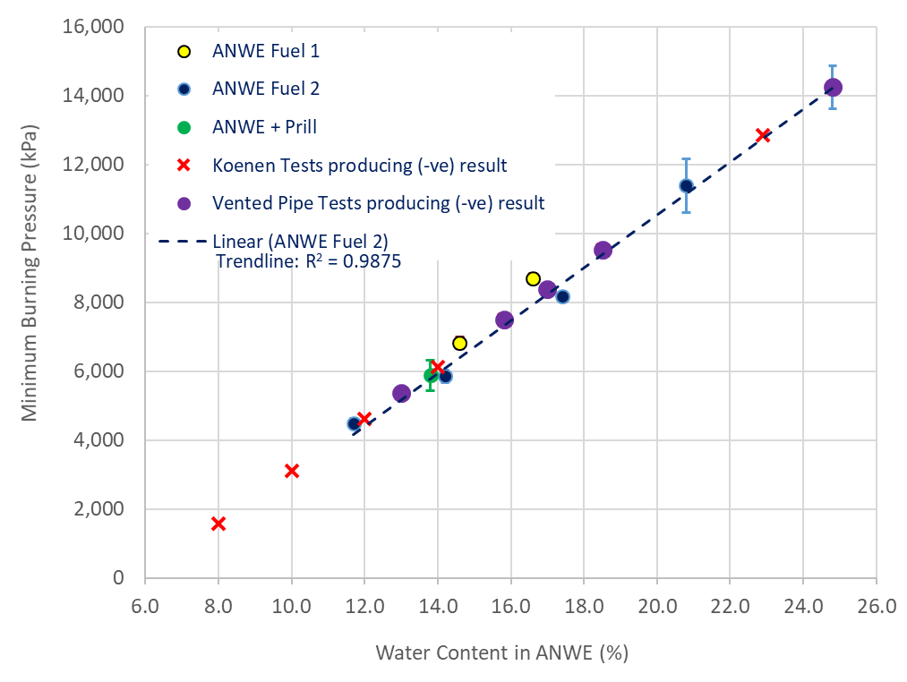
Figure 1: Comparison of Koenen, VPT, and MBP Tests for Ammonium Nitrate and Water-based Emulsion (ANWE) products with varying Water Content. (MBP data after (1))
7. A similar issue with lack of discrimination of water content has been identified in the Vented Pipe Test (8 (d)). Figure 1 shows results of 8 (d) test outcomes for ANEs as a function of their MBP for different water contents, and using a consistent fuel phase to that of ammonium nitrate and water-based emulsions (ANWE) Fuel 2.
8. Table 1 summarizes Vented Pipe Tests outcomes for a wide range of ANEs, pure AN prill, ANFO, and aluminized ANFO. The ANFO and aluminized ANFO results are referenced from work carried out by the US Bureau of Mines (Bajpayee, 1991) showing clearly that Div 1.5 products (ANFO with varying concentrations of aluminum powder) gave negative results (i.e. passed) in the 8(d) test. This reinforces the issue of the 8(d) test failing to provide differentiated testing between ANEs of widely varying water contents.
Table 1: Vented Pipe Test outcomes
Test Description | Test Details | Water Content in ANWE* (%w/w) | Calculated MBP** (MPa) | Test Outcome
ANWE with Fuel 2 | Reference (2) | 24.8 | 14.2 | Negative
ANWE with Fuel 2 | Reference (2) | 18.5 | 9.5 | Negative
ANWE with Fuel 2 | Reference (3) | 17 | 8.4 | Negative
ANWE with Fuel 2 | Reference (2) | 15.8 | 7.5 | Negative
ANWE with Fuel 2 | Reference (3) | 13 | 5.4 | Negative
AN Prill 100%w/w | Reference (2) | 0 | Not applicable*** | Negative
ANFO  (94% Prill, 6% Fuel Oil) | Reference (4) | 0 | Not applicable*** | Negative
Aluminised ANFO  98% ANFO, 2% Al | Reference (4) | 0 | Not applicable*** | Negative
Aluminised ANFO  96% ANFO, 4% Al | Reference (4) | 0 | Not applicable*** | Negative
Aluminised ANFO  94% ANFO, 6% Al | Reference (3) | 0 | Not applicable*** | Negative
Notes:
* Ammonium nitrate and water-based emulsions
** As described by Reference (1)
*** Note: Minimum Burning Pressure measurement of discrete solids, such as AN prills and ANFO are not physically applicable.
REFERENCES
(1) C. Badeen, S. Goldthorp, R. Turcotte, H. Feng, S.K. Chan, I. Alilovic, Effect of Ingredients on the Minimum Burning Pressure of Ammonium Nitrate Emulsions, Proceedings of the 40th Annual Conference on Explosives and Blasting Techniques, International Society of Explosives Engineers, Denver, CO, USA, February 2014.
(2) Orica internal testing for UN Test Series 8 d(i) with ANWE Fuel Type 2.
(3) Orica internal testing for UN Test Series 8 d(ii) with ANWE Fuel Type 2.
(4) Bajpayee, T.S., (1991), Comparative Evaluation of Large Scale Vented Vessel Bonfire and Deflagration-to-Detonation Transition Tests of Blasting Agents, U.S. Bureau of Mines Report, Pittsburgh, PA., June 1991. Test data indicated for ANFO comprising 94% AN Prill, 6% Fuel Oil, and 0% Water.
9. The results in Figure 1 and Table 1 show that the 8(d) test cannot differentiate between a Div 5.1 and Div 1.5 substance, which highlights its limited usefulness in predicting the behavior of an ANEs during transport in a portable tank.
Proposal
10. ANEs that satisfy the acceptance criteria of the 8(e) test should not be subjected to the 8(d) test and can be considered suitable for transport in portable tanks as oxidizing substances based on the 8(e) results.
11. The text in footnote « b » of Table 18.1 would be amended to read (new text indicated by blue underscored text):
^{b} These tests are intended for evaluating the suitability of ANEs for containment in portable tanks as a oxidizing substance. ANEs that satisfy the acceptance criteria of Test 8 (e) of Section 18.8 are excluded from the need to conduct these tests.
12. Section 18.7.1.1 would be amended to read (new text indicated by blue underscored text):
This test is not intended for classification but is included in this Manual for evaluating the suitability for containment in portable tanks as an oxidizing substance. Those ANEs that have passed the 8 (e) test of Section 18.8 need not be subjected to the 8 (d) test.
_________________

United Nations Recommendations on the Transport of Dangerous Goods, Manual of Tests and Criteria, Rev. 6 (ST/SG/AC.10/11/Rev.6) as amended at the ninth TDG/GHS Committee session (ST/SG/AC.10/46/Add.2, p. 29)

