UN/SCETDG/55/INF.18

Committee of Experts on the Transport of Dangerous Goods
and on the Globally Harmonized System of Classification
and Labelling of Chemicals 11 June 2019
Sub-Committee of Experts on the Transport of Dangerous Goods
Fifty-fifth session

Geneva, 1-5 July 2019
Item 4 (a) of the provisional agenda
Electric storage systems: testing of lithium batteries

Transport requirements for small, wireless audio headphones, hearing aids, and charging cases
Transmitted by the Medical Device Battery Transport Council (MDBTC) and PRBA - The Rechargeable Battery Association
Introduction
- There has been confusion with various entities in the supply chain regarding the dangerous goods classification and package marking and labelling of small, wireless audio headphones like earbuds, hearing aids, and their associated charging cases. This document is intended to help resolve this confusion for what is becoming a fast-growing segment of the portable electronic and hearing aid industries.

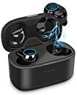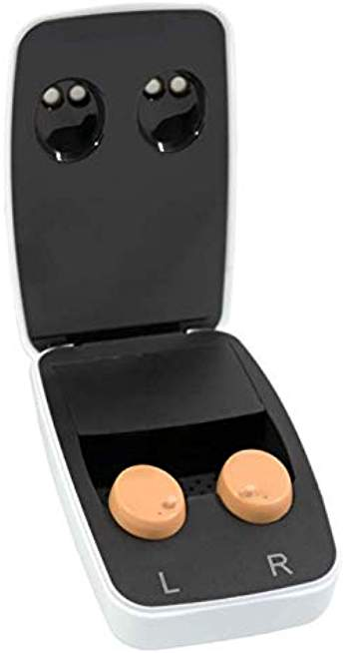

- Small, wireless audio headphones (e.g., earbuds) and hearing aids like those shown above have a small lithium ion cell in each “bud” rated at less than 20 Wh. The charging cases also contain a small lithium ion cell or battery rated at less than 20 Wh or 100 Wh.

- There are varying opinions on whether wireless audio headphones and hearing aids that are shipped in a charging case should be transported as “UN3481, lithium ion batteries contained in equipment” or “UN3481, Lithium ion batteries packed with equipment.” It has even been suggested that packages containing these devices must be marked with both UN3480 and UN3481. We strongly disagree with this opinion.
- These devices are a relatively new electronic products on the market that are not clearly addressed in the current Special Provisions or Packing Instructions applicable to lithium ion batteries and equipment packed with or containing these batteries (or cells). When shipped as an entire unit (e.g., charging case with audio headphones or hearing aids inside the charging case) we believe the appropriate description should be “UN3481, Lithium ion batteries packed with equipment.”
- We therefore would appreciate comments on the proposal below from members of the Sub-Committee to prepare a Working document for the fifty-sixth session.
Proposal
- In Special Provision 188, add a new paragraph (i) to read:
- When lithium ion battery-powered hearing aids or audio headphones (e.g., earbuds) are shipped in or with a charging case, they shall be transported as “UN 3481, Lithium ion batteries packed with equipment”

