Submitted by the experts from CLEPA and OICA Informal document GRVA-01-22
1st GRVA, 25-28 September 2018
Agenda item 6(d)

Proposal for a Supplement to the 03 series of amendments
to UN Regulation No. 79

- Background
The proposed changes are in red and based on formal document ECE/TRANS/WP.29/GRVA/2018/2.

- Proposal
Amend 5.6.4.6.4.
5.6.4.6.4. The lateral movement of the vehicle towards the intended lane shall not start earlier than 1 second after the start of the lane change procedure. Additionally, the lateral movement to approach the lane marking and the lateral movement necessary to complete the lane change manoeuvre shall be completed as one continuous movement.
The lane change manoeuvre shall not be initiated before a period of 3.0 seconds and not later than 5.0 seconds after the deliberate action of the driver described in paragraph 5.6.4.6.2. above.
The lateral movement may be initiated automatically or by a second deliberate action of the driver, as per Annex 9.

Paragraph 5.6.4.6.7., amend to read:
5.6.4.6.7. The direction indicator shall remain active throughout the whole period of the lane change manoeuvre and shall be automatically deactivated by the system no later than 0.5 seconds after the resumption of ACSF of Category B1 lane keeping function as described in paragraph 5.6.4.6.6 above. Automatic deactivation by the system of the direction indicator is only required if the lane change manoeuvre is initiated automatically without a second deliberate action."

Add a new Annex 9:

Annex 9 – description of lane change procedure of ACSF category C
The following drawings summarizes the requirements specified in paragraph 5.6.4.
1. Case where the lateral movement is initiated automatically:
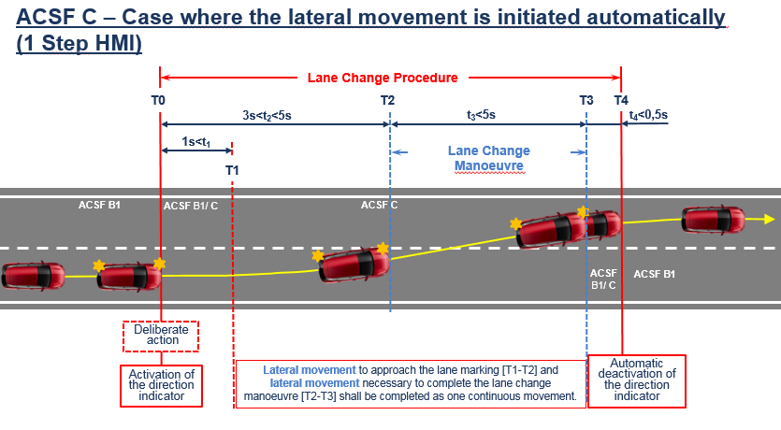
2. Case where the lateral movement is initiated by a second deliberate action of the driver:
