**Proposal for collective amendments to 00, 01 and 02 series of amendments of UN Regulation No. 127 - PEDESTRIAN SAFETY PERFORMANCE**

The text reproduced below has been prepared by the expert from Germany to amend the definitions and specifications as well as the Annex 1, Part 1.

The modifications to the current text of the Regulation are marked in bold for new or strikethrough for deleted characters.

1. **Proposal of Supplement 2 the 00 series of amendments to UN Regulation No. 127**

*Paragraph 2.26.*, amend to read:

"2.26. "*Normal ride attitude*" means the vehicle positioned on a flat horizontal surface with its mass in running order, with the tyres inflated to manufacturer recommended pressures, the front wheels in the straight-ahead position and with a passenger mass placed on the front passenger seat. The front seats are placed at the nominal mid-track position. The suspension shall be set in normal running condition as specified by the manufacturer for a speed of 40 km/h. **If the vehicle is equipped with a system, which could change the vehicle height while driving (e.g. active suspension) additional specifications according to paragraph 5.3. shall be applied."**

*Insert new paragraph 5.3.:*

"**5.3***.* **If the vehicle is equipped with a system, which could change the vehicle height at the front axle more than [20 mm] for driving speeds from [25 km/h] up to 40 km/h, the manufacturer shall provide information to the technical service, that the biomechanical thresholds defined in paragraph 5.1. and 5.2. are met for all relevant impact areas at the modified vehicle height. For this, the manufacturer can use either the impact speeds defined in paragraph 5.1 and 5.2 or he can use the impact speed corresponding to the vehicle height.**"

*Annex 1*, Part 1, paragraph 9.23.1., amend to read:

"9.23.1. A detailed description, including photographs and/or drawings, of the vehicle with respect to the structure, the dimensions, the relevant reference lines and the constituent materials of the frontal part of the vehicle (interior and exterior) shall be provided. This description shall include detail of any active protection system installed **and any system, which could change the vehicle height at the front axle while driving (e.g. active suspension).**"

1. **Proposal for Supplement 1 to the 01 series of amendments to UN Regulation No. 127**

"2.28. "*Normal ride attitude*" means the vehicle positioned on a flat horizontal surface with its mass in running order, with the tyres inflated to manufacturer recommended pressures, the front wheels in the straight-ahead position and with a passenger mass placed on the front passenger seat. The front seats are placed at the nominal mid-track position. The suspension shall be set in normal running condition as specified by the manufacturer for a speed of 40 km/h. **If the vehicle is equipped with a system, which could change the vehicle height while driving (e.g. active suspension) additional specifications according to paragraph 5.3. shall be applied.**"

*Insert new paragraph 5.3.,* to read:

*"***5.3***.* **If the vehicle is equipped with a system, which could change the vehicle height at the front axle more than [20 mm] for driving speeds from [25 km/h] up to 40 km/h, the manufacturer shall provide information to the technical service, that the biomechanical thresholds defined in paragraph 5.1. and 5.2. are met for all relevant impact areas at the modified vehicle height. For this, the manufacturer can use either the impact speeds defined in paragraph 5.1 and 5.2 or he can use the impact speed corresponding to the vehicle height.**"

*Annex 1*, Part 1, paragraph 9.23.1., amend to read:

"9.23.1. A detailed description, including photographs and/or drawings, of the vehicle with respect to the structure, the dimensions, the relevant reference lines and the constituent materials of the frontal part of the vehicle (interior and exterior) shall be provided. This description shall include detail of any active protection system installed **and any system, which could change the vehicle height at the front axle while driving (e.g. active suspension).**"

1. **Proposal for Supplement 1 to the 02 series of amendments to UN Regulation No. 127**

"2.29. "*Normal ride attitude*" means the vehicle positioned on a flat horizontal surface with its mass in running order, with the tyres inflated to manufacturer recommended pressures, the front wheels in the straight-ahead position and with a passenger mass placed on the front passenger seat. The front seats are placed at the nominal mid-track position. The suspension shall be set in normal running condition as specified by the manufacturer for a speed of 40 km/h. **If the vehicle is equipped with a system, which could change the vehicle height while driving (e.g. active suspension) additional specifications according to paragraph 5.3. shall be applied.**"

*Insert new paragraph 5.3.:*

*"***5.3.****If the vehicle is equipped with a system, which could change the vehicle height at the front axle more than [20 mm] for driving speeds from [25 km/h] up to 40 km/h, the manufacturer shall provide information to the technical service, that the biomechanical thresholds defined in paragraph 5.1. and 5.2. are met for all relevant impact areas at the modified vehicle height. For this, the manufacturer can use either the impact speeds defined in paragraph 5.1 and 5.2 or he can use the impact speed corresponding to the vehicle height.**"

*Annex 1*, Part 1, paragraph 9.23.1., amend to read:

"9.23.1. A detailed description, including photographs and/or drawings, of the vehicle with respect to the structure, the dimensions, the relevant reference lines and the constituent materials of the frontal part of the vehicle (interior and exterior) shall be provided. This description shall include detail of any active protection system installed **and any system, which could change the vehicle height at the front axle while driving (e.g. active suspension).**"

**IV. Justification**

UN Regulation No. 127 addresses impacts with a pedestrian up to 40 km/h. Therefore, an impact velocity of 11.1 m/s (40 km/h) has been chosen to address a large amount of MAIS 1+ pedestrian accidents (see diagram below).

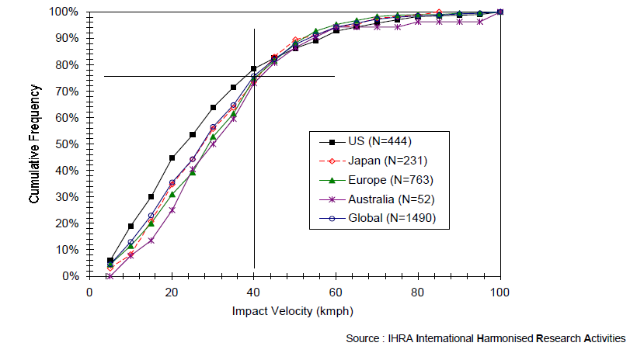

Source: Informal Group on Pedestrian Safety – 1st meeting (4-5 September 2002). INF GR / PS / 3. IHRA accident study,

Since active suspensions are available, it is possible to realise a system, which could change the vehicle height while driving (up to a defined driving speed e.g. up to 39 km/h). With such a system it is possible to raise up the suspension for driving offroad (SUVs mostly) or driving in a car park (sportscars). In this context, there have been discussions with some manufacturers about the relevance to pedestrian protection. Since the vehicle height has an influence on the headform test area (WAD) and on the test results for legform tests, all possible vehicle heights up to a driving speed of 11.1 m/s (40 km/h) should be considered to be relevant for the impact with a pedestrian. The proposal is a clarification on this issue.

To ensure, that such an active suspension system is considered for type approval in any case, there should be a detailed description in the information document.

Due to the fact, that extensions for an existing vehicle type concerning UN Regulation No. 127 are still possible according to 00 and 01 series of amendments, the proposal is relevant for all series of amendments of the UN Regulation No. 127.