DEFINITION OF HEAD RESTRAINT
In TAAM (Type Approval Authorities Meeting) held in Utrecht in June 2018 Finland raised a question concerning definition of a head restraint. The question concerned a problem of when the head restraint shall be tested in case the head restraint is not mandatory in the vehicle category in question. The wording of the UN Regulation No. 17 (see point 5.5) does not define what kind of seat is fitted or capable of being fitted with head restraint and different interpretations may be drawn.
UN Regulation No. 17 paragraphs concerned:
2.12. "Head restraint" means a device whose purpose is to limit the rearward displacement of an adult occupant's head in relation to his torso in order to reduce the danger of injury to the cervical vertebrae in the event of an accident;
2.12.1. "Integrated head restraint" means a head restraint formed by the upper part of the seat-back. Head restraints meeting the definitions of paragraphs 2.12.2. or 2.12.3. below but which can only be detached from the seat or the vehicle structure by the use of tools or by partial or complete removal of the seat covering, meet the present definition;
2.12.2. "Detachable head restraint" means a head restraint consisting of a component separable from the seat designed for insertion and positive retention in the seat-back structure;
2.12.3. "Separate head restraint" means a head restraint consisting of a component separate from the seat, designed for insertion and/or positive retention in the structure of the vehicle
…
5.5. Special requirements for seats fitted or capable of being fitted with head restraints
…
5.9. In the case of head restraints integral with the seat-back, the area to be considered is: Above a plane perpendicular to the reference line at 540 mm from the R point. Between two vertical longitudinal planes passing at 85 mm on either side of the reference line. In this area, one or more gaps which regardless of their shape can show a distance "a" of more than 60 mm when measured as described in paragraph 6.7. below, are permitted provided that, after the additional test under paragraph 6.4.3.3.2. below, the requirements of paragraph 5.12. below are still met.
The original TAAM question:
In vehicles of category for example N3 and M3 head restraints aren’t mandatory, but if installed they must fulfill the requirements laid in Regulation No. 17 concerning head restraints. However the definition of head restraint is unclear when it comes to what should be viewed as constituting a head restraint: for example, can any seatback extending beyond the 540 mm from reference point as given in item 5.9. be viewed as having integrated head restraint and thus being subject to testing accordingly, or should it be in the power of the manufacturer declare whether or not the seat in question has integrated head restraint?
The question divided opinions and it was agreed that the question should be brought in the attention of GRSP. Finland would like to hear opinions if the wording has been found to be problematic and if the wording should be amended.

Example pictures of typical class I bus seats:
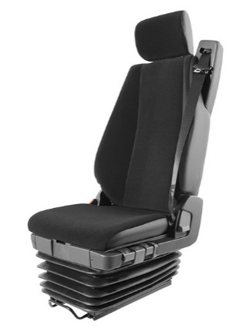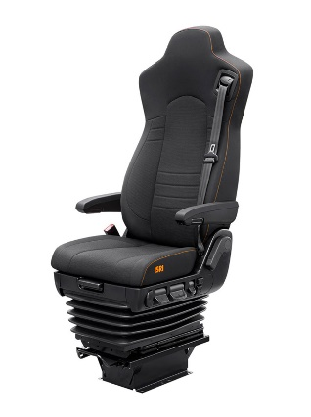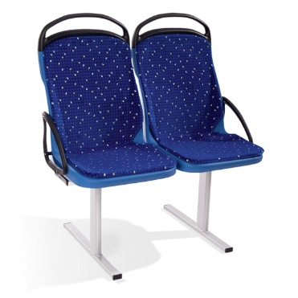
Finland sees that the wording should support the interpretation that seats described in two leftmost pictures, which provides support for head, should be tested and the group of seats described in the rightmost picture does not need to be tested.
___________________

