Proposal for Supplement 5 to the 02 series of amendments to UN Regulation No. 129
Submitted by the expert from Spain
The text reproduced below was prepared by the expert from Spain on behalf of the Technical Services Group (TSG) on UN Regulation No. 129. The modifications to the current text of Regulation are marked in bold for new or strikethrough for deleted characters.
I. Proposal
Annex 2., amend to read:
Arrangements of the approval mark
…
In case of combinations, for example an Enhanced Child Restraint System, that is approved as an i-Size Booster seat from 100 cm – 125 cm and from 125 cm – 150 cm as an Specific Vehicle Booster seat, the approval marked is to be combined as given below.
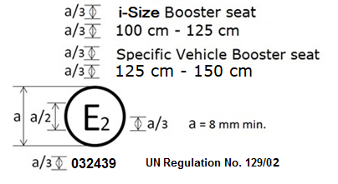
Combinations can only be made for those allowed by paragraph 3.2.2.

Arrangements of the module mark in combination with an approval mark
Current examples given to be deleted and replaced by the following:
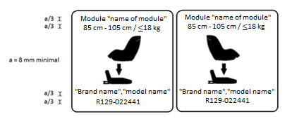
The Enhanced Child Restraint System module bearing the above module mark capable of being used for the 40 cm - 70 cm size range and mass limit of 24 kg; it is approved under the number 022439 to be used in combination with device approved according to UN Regulation No. 129 under the same number 022439. The approval number indicates that the approval was granted in accordance with the requirements of the Regulation concerning the approval of Enhanced Child Restraint Systems used on-board of motor vehicles as amended by the 02 series of amendments

The Enhanced Child Restraint System module bearing the above module marks is capable of being used in a rearward facing mode with the base "brand name and model name", for the 85 cm - 105 cm size range and with a mass limit of 18 kg; approved according to UN Regulation No. 129-02 under the number 022441.
The Enhanced Child Restraint System module bearing the above marks is also capable of being used in a forward facing mode with the base "brand name and model name", for the 85 cm - 105 cm size range and with a mass limit of 18 kg; approved according to UN Regulation No. 129-02 under the same number 022441.
The approval number indicates that the approval was granted in accordance with the requirements of the UN Regulation concerning the approval of Enhanced Child Restraint Systems used on-board motor vehicles as amended by the 02 series of amendments.
Examples of the symbols to be used on the module mark are given in the figures below. As chosen by the Enhanced Child Restraint Systems manufacturer, one of the symbols or an equivalent shall be used on the module mark.
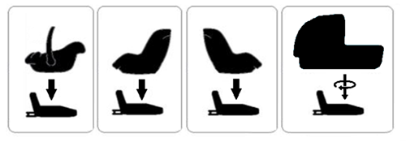
II. Justification
1. Combinations of approval marks can be made as long as the categories are able to be combined (category wise as given in paragraph 3.2.2 and as long as it is one approval number)
2. By combining approval marks, space on the Enhanced Child Restraint can be saved and more space is available for clear installation and use instructions.
3. Create a consistency between technical services and approval authorities.
4. The current layout of the module label in R129/02 is technically seen impossible if you require the label to be, as is stated in the regulation. Since the example been given is in a rectangle shape, with the module and base placed next to each other and combined with a plus mark, while the given symbols are on top of each other and combined with an arrow mark.
4. Create a consistency between labels for 02 series products and 03 series products.

