Collective amendments to UN Regulations Nos. 16, 44, 94, 129 and 137

Submitted by the expert from the European Commission

The text reproduced below was prepared by the expert from the European Commission to harmonize information in the airbag warning label on the correct installation of Child Restraint Systems (CRS) on a passenger seat with an activated frontal airbag. It is based on working document ECE/TRANS/WP.29/GRSP/2017/27 and informal documents GRSP-61-29 and GRSP-62-14. The modifications to the current text of the UN Regulations are marked in bold for new or strikethrough for deleted characters.

I. Proposal for the 08 series of Amendments to UN Regulation No. 16 (Safety belts)

*Insert new paragraphs 8.1.8. and 8.1.8.1.,* to read:

"**8.1.8. The vehicle shall carry information to the effect that it is equipped with frontal protection airbags for seats.**

**8.1.8.1. For a vehicle fitted with an airbag assembly intended to protect the driver, this information shall consist of the inscription "AIRBAG" located in the interior of the circumference of the steering wheel; this inscription shall be durably affixed and easily visible**"

*Paragraph 8.1.8.*, renumber as 8.1.8.2. and amend to read:

"8.1.8.2. Every passenger seating position which is fitted with a frontal protection airbag shall be provided with a warning against the use of a rearward-facing child restraint in that seating position. ~~As a minimum~~, This information shall consist of a label containing clear warning pictograms as indicated below:

**Figure 1**

**Warning label**

…

The overall dimensions **of the label** shall be at least 120 x 60 mm or the equivalent area.

The label ~~shown above~~ may be adapted in such a way that the layout differs from the example **shown here** ~~above~~; however, the content shall meet the **precise** ~~above~~ prescriptions. **Furthermore, no other type of information shall be included on the label unless it is placed outside a clearly marked rectangle with at least the overall dimensions as required above. In derogation to the aforementioned, a part number, bar code or similar identification mark not exceeding 8 mm x 35 mm or the equivalent area may be placed on the label.**

**It shall also be ensured that no deviations in the shape and orientation of the provided pictograms are permitted, notably that any customised appearance of the prescribed pictogram images shall be prohibited, with the exception of the hand with pointing index finger and the open face booklet with letter 'i' on its right page provided that they are clearly recognisable as such.**

**Small irregularities concerning line thickness, label imprinting and other relevant production tolerances shall be accepted.**

**Figure 2**

**Pictogram according to ISO 2575:2004 - Z.01 that shall be used and that shall have an outer diameter of at least 38 mm**

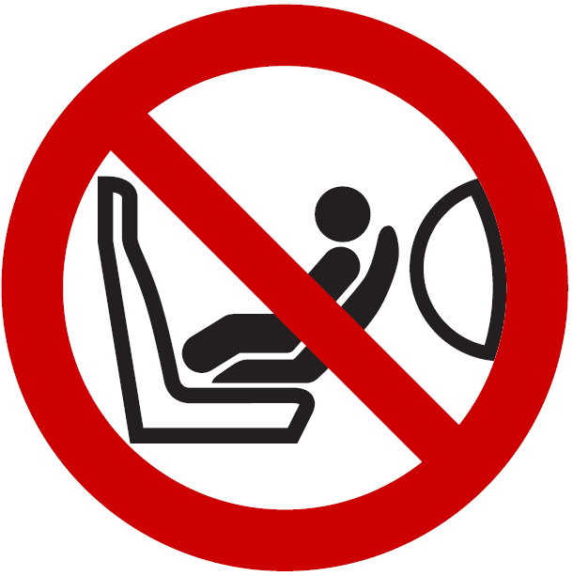

**Figure 3**

**Pictogram depicting airbag deployment danger that shall be used and that shall measure 40 mm in width and 28 mm in height or proportionally larger**

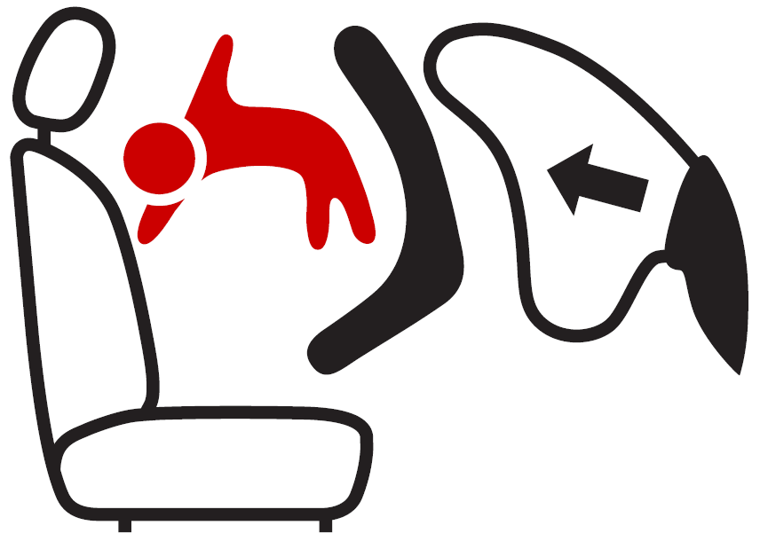

"

*Paragraph 8.1.9.*, renumber as 8.1.8.3. and amend to read:

"8.1.8.3. In the case of a frontal protection airbag **placed before** ~~in~~ the front passenger seat**s**, the warning shall be durably affixed … interior of the vehicle.

If the vehicle … at all times.

In the case of a frontal protection airbag for other **passenger** seats in the vehicle … child restraint on that seat.

This paragraph and paragraph ~~8.1.8..~~ **8.1.8.2.** do not apply to those **passenger** seating positions equipped with a device which automatically deactivates the frontal protection airbag assembly when any rearward facing child restraint is installed.

*Insert new paragraph 8.1.7.4.*, to read:

“**8.1.7.4. Paragraphs 8.1.7.1. – 8.1.7.3. shall not apply to a driver’s seat.**"

*Paragraph 8.1.10.*, renumber as 8.1.8.4. and amend to read:

"8.1.10. Detailed information, making reference to the warning, shall be contained in the owner's manual of the vehicle; as a minimum, this information shall include at least the following text :

"NEVER use a rearward facing child restraint on a seat protected by an ACTIVE AIRBAG in front of it, DEATH or SERIOUS INJURY to the CHILD can occur" *

_______________

* Unrelated to type approval, **Contracting Parties may specify in which languages the text shall be provided with each vehicle placed on the market at the point of sale within their territory.**

The text shall …"

*Paragraph 8.1.11.*, renumber as 8.1.9.

*Paragraph 15.5.*, renumber as 15.4.1.

*Paragraph 15.6.*, renumber as 15.4.2.

*Paragraph 15.7.*, renumber as 15.4.3.

*Paragraph 15.8.*, renumber as 15.4.4.

*Paragraph 15.9.*, renumber as 15.4.5.

*Paragraph 15.10.*, renumber as 15.4.6.

*Insert new paragraphs 15.5. to 15.5.7.*, to read:

"**15.5. As from the official date of entry into force of the 08 series of amendments, no Contracting Party applying this UN Regulation shall refuse to grant or refuse to accept UN type approvals under this UN Regulation as amended by the 08 series of amendments.**

**15.5.1. As from 1 September 2020, Contracting Parties applying this UN Regulation shall not be obliged to accept UN type approvals to the preceding series of amendments that were first issued on or after 1 September 2020.**

**15.5.2. Until 1 September 2022, Contracting Parties applying this UN Regulation shall accept UN type approvals to the preceding series of amendments that were first issued before 1 September 2020.**

**15.5.3. As from 1 September 2022, Contracting Parties applying this Regulation shall not be obliged to accept type approvals issued to the preceding series of amendments to this Regulation.**

**15.5.4. Notwithstanding paragraph 15.5.3., Contracting Parties applying the UN Regulation shall continue to accept UN type approvals of safety-belts and restraint systems to the preceding series of amendments to the UN Regulation.**

**15.5.5 Notwithstanding paragraph 15.5.3., Contracting Parties applying the UN Regulation shall continue to accept UN type approvals to the preceding series of amendments to the UN Regulation, for vehicles which are not affected by the changes introduced by the 08 series of amendments.**

**15.5.6. Contracting Parties applying this UN Regulation shall not refuse to grant UN type-approvals according to any preceding series of amendments to this UN Regulation or extensions thereof."**

*Annex 2*, amend to read:

"Annex 2

Arrangements of approval marks

1. Arrangements of the vehicle approval marks concerning the installation of safety-belts

Model A

(See paragraph 5.2.4. of this Regulation)

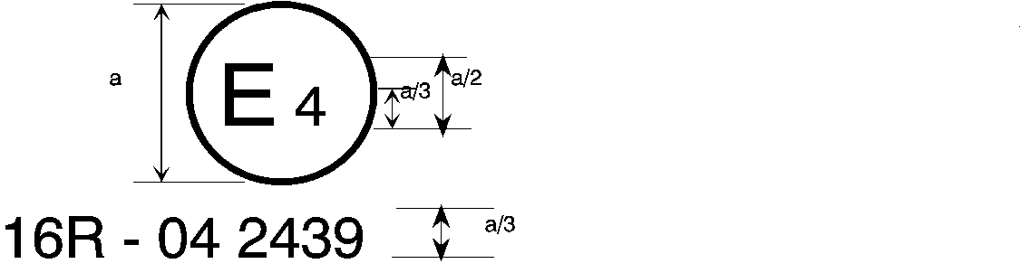

08 2439

The above approval mark affixed to a vehicle shows that the vehicle type concerned has, with regard to safety-belts, been approved in the Netherlands (E 4) pursuant to Regulation No. 16. The approval number indicates that the approval was granted according to the requirements of Regulation No. 16 as amended by the **08** series of amendments.

Model B

(See paragraph 5.2.5. of this Regulation)

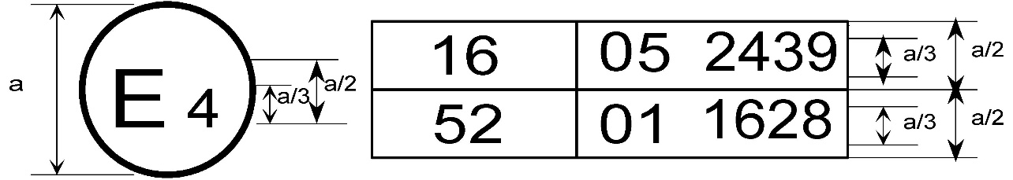

08 2439

The above approval mark affixed to a vehicle shows that the vehicle type concerned has been approved in the Netherlands (E 4) pursuant to Regulations Nos. 16 and 52.1 The approval numbers indicate that, at the dates when the respective approvals were given, Regulation No. 16 included the **08** series of amendments and Regulation No. 52 the 01 series of amendments.

*_____________*

1 The second number is given merely as an example."

2. Arrangements of the safety-belt approval marks (see paragraph 5.3.5. of this Regulation)



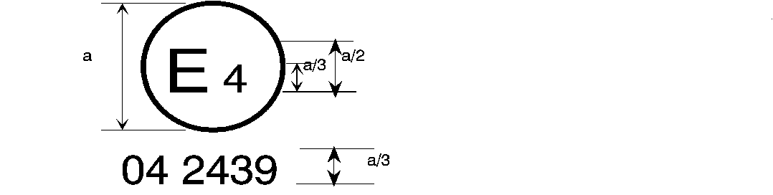

06 2439

a = 8 mm min.

The belt bearing the above approval mark is a three-point belt ("A"), fitted with an energy absorber ("e") and approved in the Netherlands (E 4) under the number 062439, the Regulation already incorporating the 06**, 07 or 08** series of amendments at the time of approval.

###### B → 4 m



06 2489

The belt bearing the above approval mark is a lap belt ("B"), fitted with a retractor, type 4, with multiple sensitivity (m) and approved in the Netherlands (E 4) under the number 062489, the Regulation already incorporating the 06**, 07 or 08** series of amendments at the time of approval.

*Note:* The approval number and additional symbol(s) shall be placed close to the circle and either above or below the "E" or to left or right of that letter. The digits of the approval number shall be on the same side of the "E" and orientated in the same direction. The additional symbol(s) shall be diametrically opposite the approval number. The use of roman numerals as approval numbers should be avoided so as to prevent any confusion with other symbols.

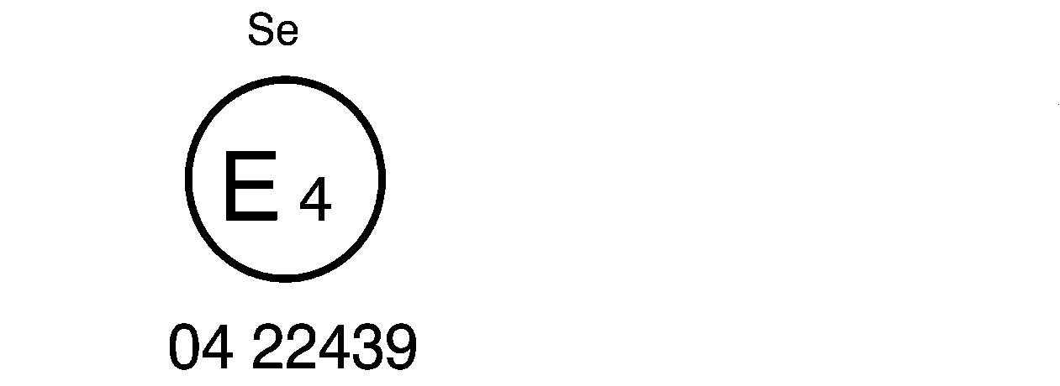

06 22439

The belt bearing the above approval mark is a special type belt ("S"), fitted with an energy absorber ("e") and approved in the Netherlands (E 4) under the number 0622439, the Regulation already incorporating the 06**, 07 or 08** series of amendments at the time of approval.

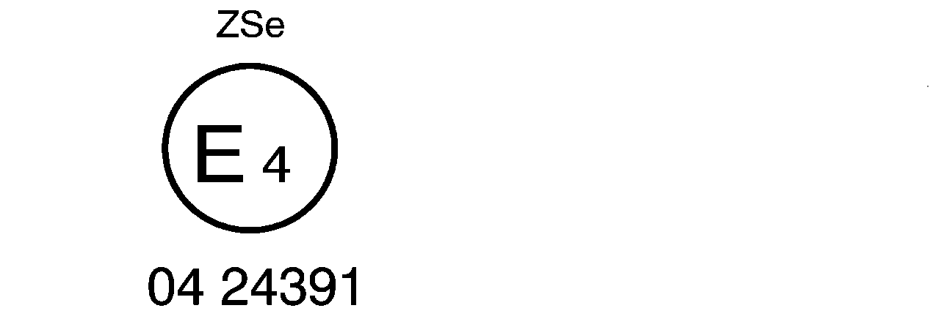

06 24391

5

The belt bearing the above approval mark is part of a restraint system ("Z"), it is a special type belt ("S") fitted with an energy absorber ("e"). It has been approved in the Netherlands (E 4) under the number 0624391, the Regulation already incorporating the 06**, 07 or 08** series of amendments at the time of approval.



a ≥ 8 mm

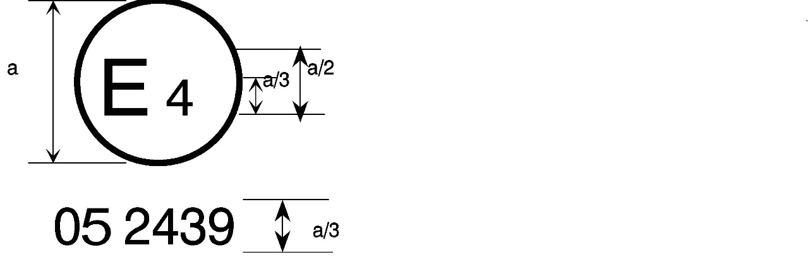

06 2439

a = 8 mm min.



The belt bearing this type approval mark is a three-point belt ("A") with a multiple-sensitivity ("m") type 4N ("r4N") retractor, in respect of which type approval was granted in the Netherlands ("E 4") under number 062439, the Regulation already incorporating the 06**, 07 or 08** series of amendments at the time of approval. This belt shall not be fitted to vehicles of category M1.

**Aer4m**

**E4**

**AIRBAG**

**062439**

The safety-belt bearing this type approval mark is a three-point belt ("A") fitted with an energy absorber ("e"), approved as meeting the specific requirements of paragraph 6.4.1.3.3. of this Regulation, and with a multiple-sensitivity ("m") type 4 ("r4") retractor, in respect of which type approval was granted in the Netherlands ("E 4") under the approval number 062439. The first two digits indicate that the Regulation already incorporated the 06**, 07 or 08** series of amendments at the time of the approval. This safety-belt has to be fitted to a vehicle equipped with an airbag in the given seating position."

II. Proposal for Supplement 15 to the 04 series of Amendments to UN Regulation No. 44 (Child restraint systems)

*Paragraph 4.4.*, amend to read:

"4.4. On the visible inner surface (including the **inside surface of a** side wing beside the child's head) in the approximate area where the child's head rests within the child restraint system, rearward facing restraints shall have the ~~following~~ **shown** label permanently attached ~~(the information shown is a minimum)~~.

~~Label minimum size: 60 x 120 mm.~~

**The overall dimensions of the label shall be at least 120 x 60 mm or the equivalent area.**

**The label may be adapted in such a way that the layout differs from the example shown here; however, the content shall meet the precise prescriptions. Furthermore, no other type of information shall be included on the label unless it is placed outside a clearly marked rectangle with at least the overall dimensions as required above. In derogation to the aforementioned, a part number, bar code or similar identification mark not exceeding 8 mm x 35 mm or the equivalent area may be placed on the label.**

**It shall also be ensured that no deviations in the shape and orientation of the provided pictograms are permitted, notably that any customised appearance of the prescribed pictogram images shall be prohibited, with the exception of the hand with pointing index finger and the open face booklet with letter 'i' on its right page provided that they are clearly recognisable as such.**

**Small irregularities concerning line thickness, label imprinting and other relevant production tolerances shall be accepted.**

The label shall … any configuration.

**Figure A**

**Warning label**

…

**Figure B**

**Pictogram according to ISO 2575:2004 - Z.01 that shall be used and that shall have an outer diameter of at least 38 mm**



**Figure C**

**Pictogram depicting airbag deployment danger that shall be used and that shall measure 40 mm in width and 28 mm in height or proportionally larger**



"

III. Proposal for Supplement 1 to the 03 series of Amendments to UN Regulation No. 94 (Frontal collision protection)

*Paragraphs 6.1. to 6.1.1.*, shall be deleted.

*Paragraph 6.1.2.*, renumber as 6.1. and amend to read:

"**6.1.** For a vehicle fitted with ~~a passenger~~ airbag **assemblies** intended to protect **the driver** **and** occupants other than the driver, **compliance with paragraphs 8.1.8. to 8.1.9. of UN Regulation No 16 as amended by the 08 Series of amendments shall be demonstrated as from 1 September 2020 for new vehicle types. Before this date the relevant requirements of the preceding Series of amendments apply**."

*Paragraphs 6.2. to 6.2.3.*, shall be deleted.

*Paragraph 8*, amend to read:

"8. Conformity of production

The conformity of production procedures shall comply with those set out in the Agreement, ~~Appendix 2~~ **Schedule** **1** (E/ECE/324 - E/ECE/TRANS/505/Rev.**3**), with the following requirements:"

IV. Proposal for Supplement 5 to the 01 series of Amendments, Supplement 4 to the 02 series of Amendments and Supplement 1 to the 03 series of amendments to UN Regulation No. 129 (Enhanced child restraint systems)

*Paragraph 4.4.*, amend to read:

"4.4. On the visible inner surface (including the **inside surface of a** side wing beside the child's head) in the approximate area where the child's head rests within the child restraint system, rearward facing restraints shall have the ~~following~~ **shown** label permanently attached ~~(the information shown is a minimum)~~.

~~Label minimum size: 60 x 120 mm.~~

**The overall dimensions of the label shall be at least 120 x 60 mm or the equivalent area.**

**The label may be adapted in such a way that the layout differs from the example shown here; however, the content shall meet the precise prescriptions. Furthermore, no other type of information shall be included on the label unless it is placed outside a clearly marked rectangle with at least the overall dimensions as required above. In derogation to the aforementioned, a part number, bar code or similar identification mark not exceeding 8 mm x 35 mm or the equivalent area may be placed on the label.**

**It shall also be ensured that no deviations in the shape and orientation of the provided pictograms are permitted, notably that any customised appearance of the prescribed pictogram images shall be prohibited, with the exception of the hand with pointing index finger and the open face booklet with letter 'i' on its right page provided that they are clearly recognisable as such.**

**Small irregularities concerning line thickness, label imprinting and other relevant production tolerances shall be accepted.**

The label shall … any configuration.

**Figure A**

**Warning label**

…

**Figure B**

**Pictogram according to ISO 2575:2004 - Z.01 that shall be used and that shall have an outer diameter of at least 38 mm**



**Figure C**

**Pictogram depicting airbag deployment danger that shall be used and that shall measure 40 mm in width and 28 mm in height or proportionally larger**



"

*Paragraph 10*, amend to read:

"10. Conformity of production and routine tests

The conformity of production procedures shall comply with those set out in the Agreement, ~~Appendix 2~~ **Schedule** **1** (E/ECE/324 - E/ECE/TRANS/505/Rev.**3**), with the following requirements:"

V. Proposal for Supplement 2 to the 01 series of Amendments to UN Regulation No. 137 (Frontal collision with focus on restraint systems)

*Paragraphs 6.1. to 6.1.1.*, shall be deleted.

*Paragraph 6.1.2.*, renumber as 6.1. and amend to read:

"**6.1.** For a vehicle fitted with ~~a passenger~~ airbag **assemblies** intended to protect **the driver** **and** occupants other than the driver, **compliance with paragraphs 8.1.8. to 8.1.9. of UN Regulation No. 16 as amended by the 08 Series of amendments shall be demonstrated as from 1 September 2020 for new vehicle types. Before this date the relevant requirements of the preceding Series of amendments apply**."

*Paragraphs 6.2. to 6.2.3.*, shall be deleted.

*Paragraph 8*, amend to read:

"8. Conformity of production

The conformity of production procedures shall comply with those set out in the Agreement, ~~Appendix 2~~ **Schedule** **1** (E/ECE/324 - E/ECE/TRANS/505/Rev.**3**), with the following requirements:"

VI. Justification

1. It has become evident that some vehicle manufacturers are adding random information to the airbag warning label to the detriment of child safety. This dilutes the compulsory information aimed to protect children transported in cars.

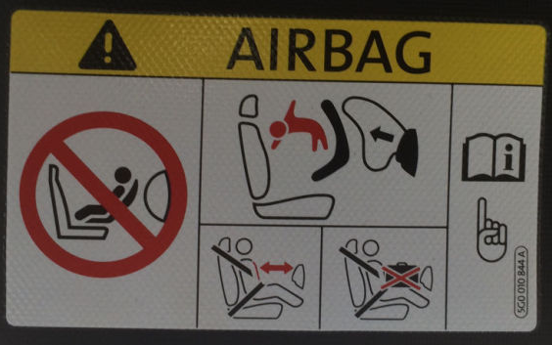

**This intrusive information is not related to child safety and thus reduces the clarity, putting children at risk**

2. The text on the warning to not use a rearward facing child restraint on a seat protected by an active airbag shall be included in the owner’s manual. Moreover, this warning shall be provided in all official languages of the country or countries where the vehicle could reasonably be expected to be registered. However, certain vehicle types are sold in the European Union market with the important warning only in one official language of the country where the vehicle is initially shipped by the manufacturer. Since, child safety should be one of the top priorities for all vehicle manufacturers, the relevant requirements are more explicitly clarified.

3. Moreover, it seems that there are diverging interpretations on the wording: ‘pictogram images shall be grouped, exact or larger’. Notably, pictogram images do not appear exactly as prescribed by the relevant regulations. It seems that altered versions are being authorised despite the clear rules, as shown in the examples below.

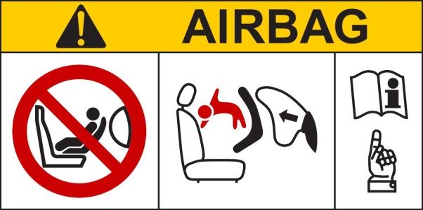

**Label as prescribed in the regulations**

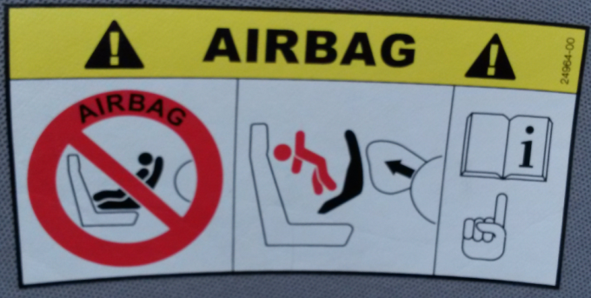 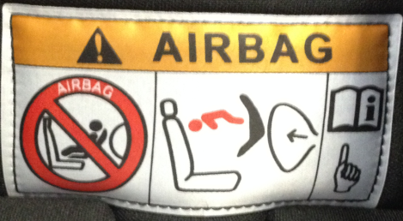

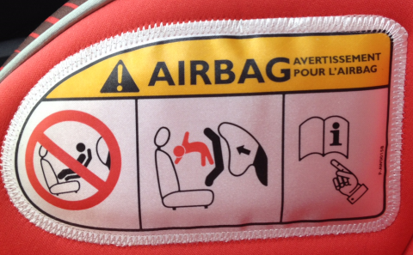 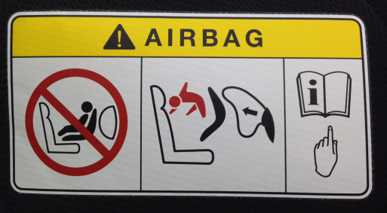

**Labels as found in the field with altered pictogram images**

4. Only in very rare cases the warning label is in conformity

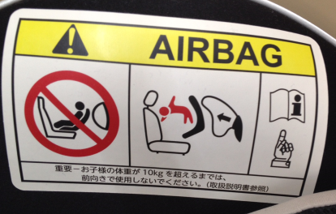

**Label as found in the field with exact pictogram images and additional information outside the prescribed area**

5. To provide the same harmonized basis for all those involved in the development, production and approval process of the warning labels, clarifications on what is and what is not permitted are deemed necessary.

6. For simplification purposes, it was requested to include the relevant provisions only in Regulation No. 16, and to delete them from Regulation Nos. 94 and 137. To avoid an unintended omission of the warning label that protects small children in motor vehicles, a reference to the new provisions in Regulation No. 16 has been included in Regulation Nos. 94 and 137.

7. The concrete provisions are proposed for the 08 series of amendments or Regulation No. 16 along with transitional provisions as explicitly requested by OICA.

8. The revised text in Regulation Nos. 44 and 129 provides considerably more flexibility in terms of label configuration, so no transitional provisions have been requested.