|  |  |  |  |
| --- | --- | --- | --- |
|  | United Nations | ECE/TRANS/WP.29/GRSP/64 | |
| _unlogo | **Economic and Social Council** | | Distr.: General  24 January 2019  Original: English |

**Economic Commission for Europe**

Inland Transport Committee

**World Forum for Harmonization of Vehicle Regulations**

**Working Party on Passive Safety**

**Sixty-fourth session**

Geneva, 11–14 December 2018

Report of the Working Party on Passive Safety on its   
sixty-fourth session

Contents

*Paragraphs Page*

I. Attendance 1–2 3

II. Adoption of the agenda (agenda item 1) 3 3

III. UN Global Technical Regulation No. 7 (Head restraints) (agenda item 2) 4–6 3

IV. UN Global Technical Regulation No. 9 (Pedestrian safety) (agenda item 3) 7–8 4

A. Proposal for Amendment 2 (Phase 2) 7 4

B. Proposal for Amendment 3 8 4

C. Proposal for Amendment 4 9 5

V. UN Global Technical Regulation No. 13 (Hydrogen and Fuel Cells Vehicles)   
 (agenda item 4) 10 5

VI. Harmonization of side impact dummies (agenda item 5) 11 5

VII. UN Global Technical Regulation No. 20 (Electric vehicle safety) (agenda item 6) 12–13 6

VIII. UN Regulation No. 14 (Safety-belt anchorages) (agenda item 7) 14 6

IX. UN Regulation No. 16 (Safety-belts) (agenda item 8) 15 6

X. UN Regulation No. 17 (Strength of seats) (agenda item 9) 16–17 7

XI. UN Regulation No. 22 (Protective helmets) (agenda item 10) 18 7

XII. UN Regulation No. 29 (Cabs of commercial vehicles) (agenda item 11) 19 7

XIII. UN Regulation No. 44 (Child Restraint Systems) (agenda item 12) 20–21 8

XIV. UN Regulation No. 80 (Strength of seats and their anchorages (buses))   
(agenda item 13) 22 8

XV. UN Regulation No. 94 (Frontal collision) (agenda item 14) 23 8

XVI. UN Regulation No. 95 (Lateral collision) (agenda item 15) 24 9

XVII. UN Regulation No. 100 (Electric power trained vehicles) (agenda item 16) 25 9

XVIII. UN Regulation No. 111 (Uniform provisions concerning the approval of tank vehicles of categories N and O with regard to rollover stability)   
(agenda item 17) 26 9

XIX. UN Regulation No. 127 (Pedestrian safety) (agenda item 18) 27–28 9

XX. UN Regulation No. 129 (Enhanced Child Restraint Systems)   
(agenda item 19) 29–37 10

XXI. UN Regulation No. 134 (Hydrogen and Fuel Cells Vehicles (HFCV))   
(agenda item 20) 38 12

XXII. UN Regulation No. 135 (Pole Side Impact) (PSI)) (agenda item 21) 39 12

XXIII. UN Regulation No. 136 (Electric Vehicles of category L (EV-L)) (agenda item 22) 40 12

XXIV. UN Regulation No. 137 (Frontal impact with focus on restraint systems)   
(agenda item 23) 41 12

XXV. UN Regulation No. 145 (ISOFIX anchorage systems, ISOFIX top tether anchorages and i-Size seating positions) (agenda item 24) 42 12

XXVI. Mutual Resolution No. 1 (agenda item 25) 43 12

XXVII. Securing of children in buses and coaches (agenda item 26) 44–45 12

XXVIII. Exchange of views on Vehicle Automation (agenda item 27) 46 13

XXIX. The strategy of the Inland Transport Committee (agenda item 28) 47 13

XXX. Election of officers (agenda item 29) 48 13

XXXI. Other business (agenda item 30) 49–55 13

A. Exchange of information on national and international requirements on passive safety 49–50 13

B. Definitions and acronyms in Regulations under the responsibilities of GRSP 51 14

C. UN Regulation No. 0 (International Whole Vehicle Type Approval) 52 14

D. Highlights of the June and November 2018 sessions of WP.29 53 14

E. Three-dimensional H-point machine 54 14

F. Intelligent transport systems 55 14

XXXII. Provisional agenda for the next session (agenda item 31) 56 14

Annexes

I. List of informal documents (GRSP-64-…) distributed without an official symbol during the session 16

II. Draft amendments to UN Regulation No. 14 (Safety-belt anchorages) 19

III. Draft amendments to UN Regulation No. 17 (Strength of seats) 20

IV. Draft amendments to UN Regulation No. 44 (Child Restraint Systems) 21

V. Draft amendments to UN Regulation No. 129 (Enhanced Child Restraint Systems) 23

VI. Draft amendments to UN Regulation No. 145 (ISOFIX anchorage systems, ISOFIX top tether anchorages and i-Size seating positions) 34

VII. List of GRSP informal working groups 35

I. Attendance

1. The Working Party on Passive Safety (GRSP) held its sixty-fourth session in Geneva from 11 to 14 December 2018, chaired by Mr. N. Nguyen (United States of America). Experts from the following countries participated in the work following Rule 1(a) of the Rules of Procedure of the World Forum for Harmonization of Vehicle Regulations (WP.29) (ECE/TRANS/WP.29/690/Rev.1): Australia, Canada, China, Czechia, France, Germany, India, Italy, Japan, Netherlands, Norway, Poland, Republic of Korea, Russian Federation, South Africa, Spain, Sweden, Switzerland and United States of America. An expert from the European Commission (EC) participated. Experts from the following non-governmental organizations participated: Consumers International (CI), European Association of Automotive Suppliers (CLEPA), Federation International de l'Automobile (FIA), Federation Internationale de Motocyclisme (FIM), Global New Car Assessment Programme (Global NCAP), International Motorcycle Manufacturers Association (IMMA), International Organization of Motor Vehicle Manufacturers (OICA) and World Bicycle Industry Association (WBIA).

2. The informal documents distributed during the session are listed in Annex I of this report.

II. Adoption of the agenda (agenda item 1)

*Documentation*: ECE/TRANS/WP.29/GRSP/2018/23  
Informal documents GRSP-64-17-Rev.1 and GRSP-64-18

3. GRSP considered and adopted the agenda (ECE/TRANS/WP.29/GRSP/2018/23) proposed for the sixty-fourth session, running order (GRSP-64-17-Rev.1) and annotations (GRSP-64-18). GRSP informal working groups are listed in Annex VII of this report.

III. UN Global Technical Regulation No. 7 (Head restraints) (agenda item 2)

*Documentation*: ECE/TRANS/WP.29/GRSP/2018/27  
Informal documents GRSP-64-38, GRSP-64-39-Rev.1, GRSP-64-40 and GRSP-64-44

4. The expert from Germany introduced GRSP-64-38, to present the proposed Amendment 2 (GRSP-64-39-Rev.1 superseding ECE/TRANS/WP.29/GRSP/2018/27) to UN GTR No. 7 (Phase 2 of the UN GTR on head restraints), jointly prepared with the experts from Japan and the Netherlands. He explained that the proposal still has several items, in several square brackets, to be solved. However, he added that the draft amendment would introduced five main changes to the UN GTR:

(a) Procedure for establishing the height of the head restraint base on the head contact rather than at its absolute height;

(b) Height measurement test procedure;

(c) Deletion of the backset measurement test procedure using the H-point machine method;

(d) Introduction of the backset measurement test procedure using the R-point method; and

(e) Introduction of the dynamic performance test procedure, by using the Biomechanical Rear Impact Dummy (BioRID) and empirical criteria instead of biomechanical (due to the absence of an absolute medical definition of whiplash) to establish seat performance.

5. In the same time, the expert from Japan introduced the eighth status report of the Informal Working Group (IWG) on Head Restraints. The expert from OICA suggested that both UN GTR No. 7 and UN Regulation No. 17 be kept aligned. However, he added that if, at this time, it was difficult to maintain alignment, he urged GRSP to at least amend UN Regulation No. 17 to include the outcome of the IWG work. The expert from CLEPA introduced GRSP-64-44, expressing concerns on repeatability and reproducibility of BioRID test results and suggesting permissible variations to the injury criteria. GRSP noted that a proposal for amendments to Mutual Resolution No. 1 (M.R.1), which incorporated drawings and specifications of the BioRID dummy would possibly be presented at the May 2019 session of GRSP.

6. Finally, GRSP experts were invited to provide comments to GRSP-64-39-Rev.1 and GRSP-64-40 to the expert from Japan by the end of January 2019. Moreover, it was agreed that IWG organize a webex meeting to allow the expert from Japan to submit an official proposal of amendments, which would also incorporate GRSP-64-25 (see para. 16 of this report) by 15 February 2019.

IV. UN Global Technical Regulation No. 9 (Pedestrian safety) (agenda item 3)

A. Proposal for Amendment 2 (Phase 2)

7. The expert from Germany, on behalf of the Chair of the pedestrian safety IWG, informed GRSP that a proposal for the new Addendum 3 to M.R.1, incorporating drawings and specifications of the Flex Pedestrian Legform Impactor (FlexPLI), would be introduced at the May 2019 session of GRSP on the basis of a template that was being developed by the Phase 2 IWG on UN GTR No. 7 (see para. 5 above).

B. Proposal for Amendment 3

*Documentation*: ECE/TRANS/WP.29/GRSP/2012/2  
ECE/TRANS/WP.29/GRSP/2014/5

8. The expert from the United States of America, informed GRSP that his administration had previously planned to issue a Notice of Proposed Rule-Making (NPRM)to adopt Phase 1 of GTR No. 9. However, he added that given higher priorities, the NPRM would not be published in a foreseeable future. The expert from OICA expressed his intention to continue to work on harmonizing UN GTR No. 9 with UN Regulation No. 127 which had already incorporated the proposed amendment. He suggested that at the March 2019 session of the Executive Committee of the 1998 Agreement (AC.3), the Chair of GRSP could explain the current situation and explore the possibility that the amendment to the UN GTR can be submitted for vote by AC.3. The Chair of GRSP confirmed that this subject would be mentioned during his highlights of GRSP December 2018 session and that possible solutions would be explored.

C. Proposal for Amendment 4

*Documentation*: Informal document GRSP-64-36

9. The expert from the Republic of Korea, Chair of the IWG on Deployable Pedestrian Protection Systems (DPPS) introduced GRSP-64-36 to inform GRSP about the status of the IWG work. He explained that the group had last convened in Geneva on 11 December 2018. He added that the group was working to develop new and more detailed requirements to ensure that deployable systems were correctly activated as designed to protect pedestrians and other vulnerable road users. He underlined that among the major issues was the validation of the Head Impact Time (HIT) determination procedure and that the group was considering both numerical simulation and physical dummy testing. The expert from OICA stated that when numerical simulation was conducted, the manufacturer should provide supporting evidence showing the appropriateness of the simulation tool and suitable biofidelity and kinematics of the chosen numerical models. Therefore, he recommended that the walking posture of the model should be in M.R.1. and be updated regularly. The expert from the Republic of Korea concluded that IWG also was considering the development of a corresponding proposal to amend UN Regulation No. 127. GRSP agreed to resume consideration on this agenda item at its May 2019 session.

V. UN Global Technical Regulation No. 13 (Hydrogen and Fuel Cells Vehicles) (agenda item 4)

10. The expert from the United States of America, on behalf of the co-sponsors (Japan, Republic of Korea, European Union) and the members of the IWG on UN Global Technical Regulation (UN GTR) No. 13 - Phase 2, informed GRSP about the group's progress. He reported that the last IWG meeting had been held in Brussels from 9 to 11 October 2018, and had been attended by more than sixty representatives from various contracting parties, motor vehicle and container industries, standard organizations and academia. He added that experts had continued discussing major technical items for Phase 2, requirements for heavy vehicles and buses, material compatibility, tank stress rupture, fire test parameters and clarification of existing UN GTR test procedures. The next IWG meeting was scheduled for March 2019. He added that the five Task Forces (TF) had provided their state of progress and issues:

(a) TF No.1 - Heavy duty vehicles and buses, had an extended discussion as the fuel system is significantly different than those in light duty vehicles. The requirements needed to be well thought out due to differences in architecture, usage and application. TF had begun monthly web meetings to identify relevant topics and to hold discussions;

(b) TF No. 2 - Fuelling receptacle requirements, had planned to submit a draft proposal for fuelling receptacle requirements at the next working group meeting;

(c) TF No. 3 - Recommendations for test procedures, was progressing well and should complete its work by the summer of 2019;

(d) TF No. 4 - Fire test, was also progressing well and was scheduled to complete its work in 2019;

(e) TF No. 5 - Recommendations from ISO TC197, had recommended a technical information proposal for the rationale section.

VI. Harmonization of side impact dummies (agenda item 5)

11. The Chair of GRSP reminded GRSP about the decision of the National Highway Transport Safety Administration (NHTSA) to no longer be IWG Chair due to lack of resource. He recalled the statement of the expert from Germany at the December 2017 session of GRSP (ECE/TRANS/WP.29/GRSP/62, para. 10) that the addenda of M.R.1 which incorporates anthropomorphic test device (crash test dummies) specifications, particularly of side impact dummies (e.g. World Side Impact Dummy fiftieth percentile), be completed as soon as possible. Therefore, he encouraged Germany finding a solution for the chairmanship of the group.

VII. UN Global Technical Regulation No. 20 (Electric vehicle safety) (agenda item 6)

12. The expert of the United States of America, on behalf of the co-sponsors (European Union, China and Japan) and the members of the IWG GTR No. 20, Phase 2, reported on the work progress of the group. He said that the IWG had met in Sweden from 11 to 13 September 2018. He expressed that the IWG continued the discussions on major technical issues, such as thermal propagation, water immersion, toxicity and gas management, and 3D vibration. He noted that "The White Paper" on the topic of thermal propagation was discussed extensively and updated. He added that the IWG also discussed issues regarding water immersion and vibration of the battery system and raised fundamental concerns on: (a) lack of field data and justification for the water immersion requirement and (b) vibration requirement is mainly for reliability/durability instead of for safety purpose. He finally announced that IWG aimed to complete its work by 2021 and that the next meeting of the IWG was planned from 22 to 24 January 2019, in Detroit, United States of America.

13. The expert from OICA underlined the complexity of the work involved to cover all areas not strictly related to electric vehicles and urged participation from the experts on frontal and lateral collisions, with expertise from the different fields of UN Regulations annexed to the 1958 Agreement. The Chair of GRSP clarified that the aim of IWG was not to regulate crash tests of electric vehicles instead the aim is to develop pass/fail criteria after the crash tests. However, he clarified that in parallel to the framework of IWG activities, a subgroup had been established to align UN Regulation No. 100 with UN GTR No. 20. He suggested inviting experts on UN Regulations Nos. 94 and 95 to participate in the activities of that subgroup. The expert from Japan announced that he was closely working with the experts from OICA and EC to present an informal proposal for a new series of amendments to align UN Regulation No. 100 with Phase 1 of UN GTR No. 20 by the May 2019 session of GRSP.

VIII. UN Regulation No. 14 (Safety-belt anchorages)   
(agenda item 7)

*Documentation*: Informal document GRSP-64-12

14. The expert from France introduced GRSP-64-12 which corrected a typo error in the communication annex of UN Regulation No. 14. GRSP adopted GRSP-64-12 (reproduced in Annex II) and requested the secretariat to submit it as Corrigendum 1 to Supplement 6 to the 07 series of amendments to UN Regulation No. 14, for consideration and vote at the June 2019 sessions of WP.29 and AC.1.

IX. UN Regulation No. 16 (Safety-belts) (agenda item 8)

*Documentation*: ECE/TRANS/WP.29/GRSP/2018/25

15. The expert from the Netherlands introduced ECE/TRANS/WP.29/GRSP/2018/25 to correct the type approval communication to extend the requirements for the safety-belt reminder installation not only to the driver's seat. Since, the proposed amendment would entail broader technical aspects, GRSP agreed to incorporate it in a further proposal of amendments to UN Regulation No. 16. Finally, GRSP agreed to resume discussion on this subject at its May 2019 session.

X. UN Regulation No. 17 (Strength of seats) (agenda item 9)

*Documentation*: ECE/TRANS/WP.29/GRSP/2018/34  
Informal documents GRSP-64-21, GRSP-64-25 and GRSP-64-37

16. The experts from Japan and EC introduced GRSP-64-37 on the proposal of amendments (ECE/TRANS/WP.29/GRSP/2018/34) to UN Regulation No. 17 (Strength of seats) that would align it with Phase 2 of UN GTR No. 7 (see para. 5 above). The expert from CLEPA introduced GRSP-64-25, to clarify static alternative provisions of UN GTR No. 7, Phase 2 and modifications to the allowed range of tolerances to backset retention and to the energy dissipation test. GRSP agreed to hand over GRSP-64-25 to the IWG for its possible integration in the proposal of amendments to UN Regulation No. 17 and to the draft amendment to UN GTR No. 7. GRSP agreed to resume discussion on this subject at its May 2019 session on the basis of the progress of the IWG work.

17. The expert from Germany introduced GRSP-64-21, to clarify the possibility of installing side facing seats in certain bus categories (M2 and M3 of Classes A and I). GRSP adopted the proposal as reproduced in Annex III to the report and requested the secretariat to submit it as Supplement 1 to the 09 series of amendments to UN Regulation No. 17, for consideration and vote at the June 2019 sessions of WP.29 and AC.1.

XI. UN Regulation No. 22 (Protective helmets) (agenda item 10)

18. The expert from Italy, Chair of the IWG on Protective Helmets (IWG-PH), informed GRSP about the work progress of the group which had last convened on 10 December 2018 in Geneva. He explained that IWG had examined a first draft proposal that received support to explore specific items (e.g. electronic equipment, rotational testing and so on). The expert from Germany suggested a two-phase work plan on the draft amendments to the UN Regulation: (a) Phase 1 introduces the most needed modifications and changes and (b) Phase 2 introduces test technology that requires research and longer discussion. The expert from the Netherlands expressed concerns on the tight deadline of the IWG mandate (December 2019). The expert from CI stated that the first priority of his organization was to improve safety and supported the proposal from the expert of Germany. Finally, GRSP agreed with the plan proposed by the IWG: (a) provide an updated version of the proposal to its experts and receive comments by end of January 2019, (b) organize a webex meeting during the first week of February 2019, (c) submit an official proposal by 15 February 2019, (d) receive new comments by April 2019 and (e) possibly submit an informal document amending the official proposal by the GRSP May 2019 session.

XII. UN Regulation No. 29 (Cabs of commercial vehicles) (agenda item 11)

*Documentation*: Informal documents GRSP-62-11

19. GRSP resumed discussion of GRSP-62-11 on proposed tolerances for the position of the loading device during the test. GRSP noted that the proposal had already been agreed in principle during the sixty-second GRSP session (ECE/TRANS/WP.29/GRSP/62, para. 20). The expert from OICA requested further consultation on the proposal and GRSP requested the secretariat to distribute GRSP-62-11 with an official symbol at its May 2019 session.

XIII. UN Regulation No. 44 (Child Restraint Systems) (agenda item 12)

*Documentation*: ECE/TRANS/WP.29/GRSP/2018/26  
Informal documents GRSP-64-32, GRSP-64-33 and GRSP-64-35-Rev.1

20. The expert from IC introduced GRSP-64-32 which explained that for the forthcoming entry into force of "Phase 3" of UN Regulation No. 129 (belted Enhanced Child Restraint Systems (ECRS)), all groups and categories except Group III on forward-facing non-integral CRS would be covered. Accordingly, he explained that belted CRS could be still approved according to UN Regulation No. 44 for an undefined period. He therefore proposed to phase out this category of CRS (ECE/TRANS/WP.29/GRSP/2018/26). The proposal received comments on the transitional provisions and GRSP considered GRSP-64-35-Rev.1. Finally, GRSP adopted ECE/TRANS/WP.29/GRSP/2018/26, as amended by Annex IV to this report, and requested the secretariat to submit it as Supplement 16 to the 04 series of amendments to UN Regulation No.44, for consideration and vote at the June 2019 sessions of WP.29 and AC.1.

21. The expert from CI introduced GRSP-64-33 on the Child Restraint System Evaluation Programme (PESRI), conducted in Latin American countries and sponsored by FIA, Global NCAP and CI research and tests. He highlighted that from this programme had emerged several regulatory irregularities, poor market surveillance and easily-granted approvals. The experts from other contracting parties stated that in their countries, market surveillance was an issue for child restraint systems and protective helmets.

XIV. UN Regulation No. 80 (Strength of seats and their anchorages (buses)) (agenda item 13)

*Documentation*: ECE/TRANS/WP.29/GRSP/2018/10  
Informal documents GRSP-64-19 and Add.1, GRSP-64-22 and   
GRSP-64-23

22. The expert from Germany introduced GRSP-64-22 and   
GRSP-64-23 superseding ECE/TRANS/WP.29/GRSP/2018/10, aimed at removing Appendix 5 (static test requirements and procedure) from UN Regulation No. 80 (GRSP-64-22) and at improving the dynamic test (GRSP-64-23) in two different series of amendments. The expert from OICA suggested that both tests be maintained as alternatives and that the static test be improved as a first step. The expert from Italy supported the approach of the expert from OICA. The expert from the Russian Federation introduced GRSP-64-19 and Add.1, proposing to include the assessment of the dummy neck injury criteria into the dynamic test of the UN Regulation. The Chair of GRSP suggested creating a task force of concerned parties led by Germany to provide a revised official document that would incorporate GRSP-64-19 and other comments submitted to the secretariat by 15 February 2019. The expert from Germany agreed with the Chair's proposal and the expert from OICA offered his contribution in drafting the revised document.

XV. UN Regulation No. 94 (Frontal collision) (agenda item 14)

23. No new information was provided under this agenda item.

XVI. UN Regulation No. 95 (Lateral collision) (agenda item 15)

24. No new information was provided under this agenda item.

XVII. UN Regulation No. 100 (Electric power trained vehicles) (agenda item 16)

*Documentation*: Informal document GRSP-64-24

25. GRSP noted GRSP-64-24, tabled by the expert from the Netherlands to extend the functional safety in UN Regulation No. 100 to other categories of vehicles. Referring to the work in progress of aligning UN Regulation No. 100 to UN GTR No. 20, the expert from OICA suggested to include this proposal in the programme of work of the IWG on UN GTR No. 20. Finally, GRSP agreed to resume discussion on this agenda item and requested the secretariat to distribute GRSP-64-24 with an official symbol at its May 2019 session.

XVIII. UN Regulation No. 111 (Uniform provisions concerning the approval of tank vehicles of categories N and O with regard to rollover stability) (agenda item 17)

26. No new proposal was provided under this agenda item (see para. 46 below).

XIX. UN Regulation No. 127 (Pedestrian safety) (agenda item 18)

*Documentation*: Informal document GRSP-64-20

27. The expert from Germany introduced GRSP-64-20, to clarify different interpretations on vehicle configuration testing in the presence of active suspensions, which arose in off-road driving (SUVs mostly) or driving in a car park (sports cars). He concluded that since the vehicle height had an influence on the headform test area and on the test results for legform tests, all possible vehicle heights up to a driving speed of 11.1 m/s (40 km/h) should be considered relevant for impact with a pedestrian. The expert of OICA agreed that the issue raised by Germany was valid and that there was a need to avoid different interpretations, but this needs to be studied carefully, also in relation to the normal procedure of "worst case definition".  He added that this would entail new requirements, therefore needing a series of amendments and transitional provisions. He also added that this issue should be considered in the ongoing WP.29 discussions on the performance of vehicles outside the test boundaries defined in the various UN Regulations.  The expert from the Netherlands suggested developing simulation models to check worst case testing. The expert from OICA stressed that testing a vehicle in all potential configurations would be unrealistic and therefore welcomed the statements from the Netherlands. He referred to the work on the certification of automated vehicles whereby an additional 3-pillar approach was considered to address automation: (a) test track, (b) road test and (c) simulation and audit of development process.

28. The Chair of GRSP suggested establishing a group of interested experts to further develop the proposal. GRSP agreed with the proposal of its Chair. The expert from Germany announced a possible meeting before 15 February 2019, to submit a new official proposal. Finally, GRSP requested the secretariat to keep GRSP-64-20 as a reference in the agenda of the May 2019 session.

XX. UN Regulation No. 129 (Enhanced Child Restraint Systems) (agenda item 19)

*Documentation*: ECE/TRANS/WP.29/GRSP/2018/24  
ECE/TRANS/WP.29/GRSP/2018/28  
ECE/TRANS/WP.29/GRSP/2018/29  
ECE/TRANS/WP.29/GRSP/2018/30  
ECE/TRANS/WP.29/GRSP/2018/31  
ECE/TRANS/WP.29/GRSP/2018/32  
ECE/TRANS/WP.29/GRSP/2018/33  
Informal documents GRSP-64-01, GRSP-64-02-Rev.1, GRSP-64-03-Rev.1, GRSP-64-04-Rev.1, GRSP-64-05-Rev.1, GRSP-64-06, GRSP-64-07, GRSP-64-08-Rev.1, GRSP-64-09, GRSP-64-10, GRSP-64-11, GRSP-64-15, GRSP-64-16-Rev.1, GRSP-64-27, GRSP-64-28, GRSP-64-29, GRSP-64-30-Rev.1, GRSP-64-31, GRSP-64-34, GRSP-64-42 and GRSP-64-43.

29. The expert from Spain introduced GRSP-64-06, GRSP-64-02-Rev.1, GRSP-64-03-Rev.1, GRSP-64-04-Rev.1 and GRSP-64-05-Rev.1 which aimed at providing better provisions for the dummy's head displacement when surpassing the reference plane DE during frontal and rear impact tests of forward facing Enhanced Child Restraint Systems (ECRS). She explained that these documents were revised proposals and have already been introduced at the May 2018 session of GRSP (ECE/TRANS/WP.29/GRSP/63, para. 33) to provide better rationales for the sled test. GRSP adopted GRSP-64-02-Rev.1, GRSP-64-03-Rev.1, GRSP-64-04-Rev.1 and GRSP-64-05-Rev.1 as reproduced in Annex V to this report. The secretariat was requested to submit GRSP-64-02-Rev.1 as draft Supplement 9 to the original version of UN Regulation No. 129, GRSP-64-03-Rev.1 as draft Supplement 6 to the 01 series of amendments, GRSP-64-04-Rev.1 as draft Supplement 5 to the 02 series of amendments and GRSP-64-05-Rev.1 as draft Supplement 2 to the 03 series of amendments to UN Regulation No. 129 for consideration and vote at the June 2019 sessions of WP.29 and AC.1.

30. The expert from Spain also introduced GRSP-64-10 to present GRSP-64-07, GRSP-64-08-Rev.1 and GRSP-64-09 which aimed at updating the arrangements of the approval mark. GRSP adopted GRSP-64-07, GRSP-64-08-Rev.1, GRSP-64-09 and GRSP-64-31 as reproduced in Annex V to this report. The secretariat was requested to submit GRSP-64-08-Rev.1 and GRSP-64-31 as part of (see para. 29) draft Supplement 5 to the 02 series of amendments, GRSP-64-07 and GRSP-64-09 as part of (see para. 29) draft Supplement 2 to the 03 series of amendments to UN Regulation No. 129 for consideration and vote at the June 2019 sessions of WP.29 and AC.1.

31. The expert from CLEPA introduced ECE/TRANS/WP.29/GRSP/2018/24 to clarify the definition of "infant carrier" and ECE/TRANS/WP.29/GRSP/2018/28 to clarify that certain user information was displayed sufficiently. The expert from Spain introduced GRSP-64-28 to improve the consistency of the information. GRSP adopted ECE/TRANS/WP.29/GRSP/2018/24 and ECE/TRANS/WP.29/GRSP/2018/28 as amended by Annex V to this report. The secretariat was requested to submit ECE/TRANS/WP.29/GRSP/2018/24 as part of (see paras. 29 and 30) draft Supplement 2 to the 03 series of amendments and ECE/TRANS/WP.29/GRSP/2018/28 as part of (see para. 29) draft Supplement 9 to the original version of UN Regulation No. 129, as part of (see paras. 29 and 30) Supplement 6 to the 01 series of amendments, as part of (see paras. 29 and 30) draft Supplement 5 to the 02 series of amendments and as part of (see paras. 29 and 30) draft Supplement 2 to the 03 series of amendments to UN Regulation No. 129 for consideration and vote at the June 2019 sessions of WP.29 and AC.1.

32. The expert from CLEPA withdrew ECE/TRANS/WP.29/GRSP/2018/31 and introduced GRSP-64-42 to clarify that conformity of production (COP) testing should be conducted using the same requirements which were effective at the time of the initial approval or any later applicable extension. The expert from Italy suggested that a similar requirement could be handed over to other UN Regulations to ensure consistency of COP testing. GRSP adopted GRSP-64-42 as reproduced in Annex V. The secretariat was requested to submit GRSP-64-42 as part of (see paras. 29–31) draft Supplement 5 to the 02 series of amendments and as part of (see paras. 29–31) draft Supplement 2 to the 03 series of amendments to UN Regulation No. 129 for consideration and vote at the June 2019 sessions of WP.29 and AC.1.

33. The expert from Spain introduced GRSP-64-30-Rev.1, to clarify the installation sequence of an infant carrier on the test bench. GRSP adopted GRSP-64-30-Rev.1 as reproduced in Annex 5 and requested the secretariat to submit it as part of (see paras. 29–32) draft Supplement 2 to the 03 series of amendments to UN Regulation No. 129 for consideration and vote at the June 2019 sessions of WP.29 and AC.1.

34. The expert from the Netherlands introduced GRSP-64-34, amending ECE/TRANS/WP.29/GRSP/2018/33, aiming at achieving a proper legalized use of non-permanent fixed inserts in UN Regulation No. 129. GRSP adopted ECE/TRANS/WP.29/GRSP/2018/33 as amended by Annex 5 to this report and requested the secretariat to submit it as part of (see paras. 29–33) draft Supplement 2 to the 03 series of amendments to UN Regulation No. 129 for consideration and vote at the June 2019 sessions of WP.29 and AC.1.

35. The expert from CLEPA introduced a summary of all the documents that he had submitted (GRSP-64-29) and presented GRSP-64-16-Rev.1 on the draft 04 series of amendments to UN Regulation No. 129 (ECE/TRANS/WP.29/GRSP/2018/29 complemented by GRSP-64-15) aimed at including in the scope of the UN Regulation: (a) non-integral Universal ECRS with no backrest (i-Size booster cushion) and (b) non-integral Specific vehicle ECRS with no backrest (Specific vehicle booster cushion). Moreover, the expert from CLEPA introduced a consolidated text of all the comments received (GRSP-64-43). The expert from Germany argued that the definition of i-Size was associated with an additional side-impact test to assess protection of children when the vehicle was involved in such a collision and to ensure that children under fifteen months travel in the rearward facing position. Therefore, he stated that he opposed associating the above proposed new categories of ECRS with the i-Size definition to avoid confusion among users. The expert from Japan supported the opinion of the expert from Germany. The experts from IC and EC endorsed the inclusion of such ECRS in the scope of UN Regulation No. 129 to definitively phase out UN Regulation No. 44. Finally, GRSP agreed to resume discussion on this subject at its May 2019 session. Therefore, GRSP agreed to defer the discussion on parallel amendments to other series of amendments affected by the draft 04 series of amendments (ECE/TRANS/WP.29/GRSP/2018/30, ECE/TRANS/WP.29/GRSP/2018/32 and GRSP-64-27) at its May 2019 session. Moreover, the secretariat was requested to keep GRSP-64-27 as a reference in the agenda and to distribute GRSP-64-43 with an official symbol at the next session of GRSP.

36. The expert from the Russian Federation introduced GRSP-64-01 to align the Russian text with the English version. The expert from France introduced a similar proposal (GRSP-64-11) to align the French text. GRSP adopted GRSP-64-01 and GRSP-64-11 as reproduced in Annex V to this report. The secretariat was requested to submit GRSP-64-01 as draft Corrigendum 3 to the original text of UN Regulation No. 129 and GRSP-64-11 as draft Corrigendum 1 to the 03 series of amendments to UN Regulation No. 129 for consideration and vote at the June 2019 sessions of WP.29 and AC.1.

37. Finally, the Chair of GRSP recommended establishing a task force of interested experts to streamline discussions on draft amendments to the UN Regulation. GRSP agreed with the proposal of its Chair and agreed to resume discussion on the basis of the outcome of meetings of the above-mentioned task force.

XXI. UN Regulation No. 134 (Hydrogen and Fuel Cell Vehicles (HFCV)) (agenda item 20)

38. No new information was provided under this agenda item.

XXII. UN Regulation No. 135 (Pole Side Impact) (PSI))   
(agenda item 21)

*Documentation*: Informal document GRSP-64-14

39. The expert from France introduced GRSP-64-14, clarifying that rear doors on the impacted side which were not directly struck by the pole, might be subjected to heavy loads. He therefore proposed a similar amendment already adopted for UN Regulation No. 95. The expert from OICA requested a study reservation. Finally, GRSP agreed to resume discussion at its May 2019 session and requested the secretariat to distribute GRSP-64-14 with an official symbol.

XXIII. UN Regulation No. 136 (Electric Vehicles of category L   
(EV-L)) (agenda item 22)

40. No new information was provided under this agenda item.

XXIV. UN Regulation No. 137 (Frontal impact with focus on restraint systems) (agenda item 23)

41. No new information was provided under this agenda item.

XXV. UN Regulation No. 145 (ISOFIX anchorage systems, ISOFIX top tether anchorages and i-Size seating positions) (agenda item 24)

*Documentation*: Informal document GRSP-64-13-Rev.1

42. The expert from France introduced GRSP-63-13-Rev.1, to correct a typo error in the communication annex of UN Regulation No. 145. GRSP adopted GRSP-63-13-Rev.1 as reproduced in Annex VI to this report. The secretariat was requested to submit GRSP-64-13-Rev.1 as draft Corrigendum 1 to the original text of UN Regulation No. 145 for consideration and vote at the June 2019 sessions of WP.29 and AC.1

XXVI. Mutual Resolution No. 1 (agenda item 25)

43. Discussion was concluded under agenda items 3(a) and 5 (see paras. 7 and 11).

XXVII. Securing of children in buses and coaches (agenda item 26)

44. The expert from the Russian Federation encouraged a full discussion on how to secure children in buses. He indicated that possible solutions would be the widespread use of four- or three-points safety-belts, these last with flexible straps to move the height of the effective anchorages. However, he indicated that the use of CRS would be advisable. He encouraged the use of UN Regulation No. 129, with possible adaptations, to regulate the transport of children in buses. He suggested the possibility of establishing a group of interested expert on this subject to speed up solutions. The experts from France, Germany and Spain urged a solution. The Chair of GRSP stated that NHTSA had conducted research and testing on this topic and offered to share the results of the research at the May 2019 session of GRSP. The expert from the Russian Federation and Sweden also announced testing experience and statistics on this subject and their intention to also share results at the next session.

45. Finally, GRSP agreed on the relevance of this subject and encouraged its experts to develop a strategic plan on this subject.

XXVIII. Exchange of views on Vehicle Automation (agenda item 27)

*Documentation*: Informal document GRSP-64-45

46. GRSP noted GRSP-64-45 on the decision of WP.29 to convert the Working Party on Brakes and Running Gear (GRRF) into the Working Party on Automated/Autonomous and Connected Vehicles (GRVA) and to reallocate certain tasks of GRRF to other GRs (ECE/TRANS/WP.29/1139, para. 33). GRSP also noted the recommendation of WP.29 that GRSP should insert UN Regulation No. 111 into its programme of work. The Chair of GRSP suggested that the group start exploring which areas under the responsibility of GRSP should be revised by developing vehicle automation. Thus, he indicatively mentioned topics such as safety-belts, frontal impact and seat strength and volunteered to provide a more complete list at the May 2019 session of GRSP.

XXIX. The strategy of the Inland Transport Committee (agenda item 28)

47. No new information was provided under this agenda item.

XXX. Election of Officers (agenda item 29)

48. In compliance with Rule 37 of the Rules of Procedure (ECE/TRANS/WP.29/690/Rev.1), GRSP called for the election of officers. The representatives of the contracting parties, present and voting, unanimously re-elected Mr. N. Nguyen (United States of America) as Chair and Mr. J.W. Lee (Republic of Korea) as Vice-Chair for the sessions of GRSP scheduled in the year 2019.

XXXI. Other business (agenda item 30)

A. Exchange of information on national and international requirements on passive safety

*Documentation*: Informal documents GRSP-64-41 and GRSP-64-26

49. The expert from Japan introduced GRSP-64-41 on the current research programme in his country on improving pedestrian safety. He added that notwithstanding successful national regulatory efforts, pedestrians still accounted for the largest proportion of recent fatal traffic accidents. He concluded that performance protection such as at A-pillar would be increased by airbag deployment.

50. Finally, GRSP agreed to defer discussion on GRSP-64-26 to its May 2019 session due to the lack of time.

B. Definitions and acronyms in Regulations under GRSP responsibilities

51. No new information was provided under this agenda item.

C. UN Regulation No. 0 (International Whole Vehicle Type Approval)

52. The expert from Japan, on behalf of the new IWVTA Ambassador of GRSP, informed GRSP about the progress of the IWVTA IWG. He added that IWG had started its work on Phase 2 in May and had conveyed some proposals to the November 2018 session of WP.29. He clarified that WP.29 had agreed on the proposed "road map for IWVTA Phase 2", inviting all GRs to review "candidates of UN regulations to be added to Annex 4 of UN Regulation No. 0". He clarified that GRSP was asked to decide on the priority of six candidate UN Regulations, Nos. 44, 129, 134, 135, 137, and 145. He reported that the new IWVTA Ambassador had already prepared a plan including priority of the candidate items to be discussed with interested parties of GRSP prior to the May 2019 session of GRSP. He finally encouraged GRSP experts to contact him to participate in the above-mentioned preparatory work.

D. Highlights of the June and November 2018 sessions of WP.29

53. The Secretary reported on the highlights of the 175th and 176th sessions of WP.29 (ECE/TRANS/WP.29/1139 and ECE/TRANS/WP.29/1142).

E. Three-dimensional H-point machine

54. The Chair of GRSP informed the group, on behalf of the Chair of the three-dimensional H-point machine IWG, by reiterating his statement (ECE/TRANS/WP.29/GRSP/63, para. 50), that since the IWG had not progressed as expected, the activity of this IWG could be eventually be handed over to a new group on the development of the M.R.1 (see para. 11).

F. Intelligent transport systems

55. GRSP noted that the status of the implementation of the road map on intelligent transport systems would be discussed at the February 2019 session of the Inland Transport Committee.

XXXII. Provisional agenda for the next session (agenda item 31)

56. The sixty-fifth session is scheduled to be held in Geneva from 13 May (2.30 p.m.) to 17 (12.30 p.m.) May 2018. GRSP noted that the deadline for the submission of official documents to the secretariat is 15 February 2019, twelve weeks prior to the session. GRSP agreed to the following provisional agenda:

1. Adoption of the agenda.

2. UN Global Technical Regulation No. 7 (Head restraints).

3. UN Global Technical Regulation No. 9 (Pedestrian safety):

(a) Proposal for Amendment 2 (Phase 2);

(b) Proposal for Amendment 3;

(c) Proposal for Amendment 4.

4. UN Global Technical Regulation No. 13 (Hydrogen and Fuel Cell Vehicles).

5. Harmonization of side impact dummies.

6. UN Global Technical Regulation No. 20 (Electric vehicle safety).

7. UN Regulation No. 14 (Safety-belt anchorages).

8. UN Regulation No. 16 (Safety-belts).

9. UN Regulation No. 17 (Strength of seats).

10. UN Regulation No. 22 (Protective helmets).

11. UN Regulation No. 29 (Cabs of commercial vehicles).

12. UN Regulation No. 44 (Child Restraint Systems).

13. UN Regulation No. 80 (Strength of seats and their anchorages (buses)).

14. UN Regulation No. 94 (Frontal collision).

15. UN Regulation No. 95 (Lateral collision).

16. UN Regulation No. 100 (Electric power-train vehicles).

17. UN Regulation No. 111 (Uniform provisions concerning the approval of tank vehicles of categories N and O with regard to rollover stability)

18. UN Regulation No. 127 (Pedestrian safety).

19. UN Regulation No. 129 (Enhanced Child Restraint Systems).

20. UN Regulation No. 134 (Hydrogen and Fuel Cell Vehicles (HFCV)).

21. UN Regulation No. 135 (Pole Side Impact (PSI)).

22. UN Regulation No. 136 (Electric Vehicles of Category L (EV-L)).

23. UN Regulation No. 137 (Frontal impact with focus on restraint systems).

24. UN Regulation No. 145 (ISOFIX anchorage systems, ISOFIX top tether anchorages and i-Size seating positions).

25. Mutual Resolution No. 1.

26. Securing of children in buses and coaches.

27. Exchange of views on vehicle automation.

28. Other business:

(a) Exchange of information on national and international requirements on passive safety;

(b) Definitions and acronyms in regulations under GRSP responsibilities;

(c) UN Regulation No. 0 (International Whole Vehicle Type Approval);

(d) Highlights of the March 2019 sessions of WP.29;

(e) Three-dimensional H-point machine;

(f) Intelligent transport systems.

Annex I

[English only]

List of informal documents (GRSP-64-…) distributed without an official symbol during the session

| *No.* | *Transmitted by* | *Agenda item* | *Language* | *Title* | *Follow-up* |
| --- | --- | --- | --- | --- | --- |
| 01 | Russian Federation | 19 | E | Proposal for draft Corrigendum 3 (Russian only) to the original version of Regulation No. 129 (Enhanced Child Restraint Systems) | (d) |
| 02/ Rev.1 | Spain | 19 | E | Proposal for Supplement 9 to the 00 series of amendments to Regulation No. 129 | (d) |
| 03/ Rev.1 | Spain | 19 | E | Proposal for Supplement 6 to the 01 series of amendments to Regulation No. 129 | (d) |
| 04/ Rev.1 | Spain | 19 | E | Proposal for Supplement 5 to the 02 series of amendments to Regulation No. 129 | (d) |
| 05/ Rev.1 | Spain | 19 | E | Proposal for Supplement 2 to the 03 series of amendments to Regulation No. 129 | (d) |
| 06 | Spain | 19 | E | Proposal for Supplement 2 to the 03 series of amendments to UN Regulation No. 129 | (a) |
| 07 | Spain | 19 | E | Proposal for Supplement 2 to the 03 series of amendments to UN Regulation No. 129 | (d) |
| 08/ Rev.1 | Spain | 19 | E | Proposal for Supplement 5 to the 02 series of amendments to UN Regulation No. 129 | (d) |
| 09 | Spain | 19 | E | Proposal for Supplement 2 to the 03 series of amendments to UN Regulation No. 129 | (d) |
| 10 | Spain | 19 | E | Technical Service Group (TSG) UN Regulation No. 129.02 and UN Regulation No. 129.03 series of amendment - Approval Label Updates  Explanatory Notes (GRSP-64-07 to GRSP-64-09) | (d) |
| 11 | France | 19 | E | Proposal for Corrigendum 1 to 03 Series of amendments of Regulation No. 129 (Enhanced Child Restraint Systems) | (d) |
| 12 | France | 7 | E | Proposal for Corrigendum 1 to Supplement 6 to the 07 series of amendments of Regulation No. 14 (Safety-belt anchorages) | (d) |
| 13/ Rev.1 | France | 24 | E | Proposal for Corrigendum 1 to 00 Series of amendments of Regulation No. 145 (Isofix anchorage systems) | (d) |
| 14 | France | 21 | E | Proposal for Supplement 2 to the 00 and 01 series of amendments of Regulation No. 135 (Pole Side Impact**)** | (b) |
| 15 | CLEPA | 19 | E | Proposal for the 04 series of amendments to UN Regulation No. 129 | (a) |
| 16/ Rev.1 | CLEPA | 19 | E | Introduction of Booster Cushions in UN Regulation No. 129 | (a) |
| 17/ Rev.1 | GRSP Chair | 1 | E | GRSP sixty fourth session running order | (a) |
| 18 | France | 1 | E | GRSP sixty fourth session **-** Internal annotations to the agenda | (a) |
| 19 | Russian Federation | 13 | E | Proposal for amendments to document ECE/TRANS/WP.29/GRSP/2018/10 | (a) |
| 19/ Add.1 | Russian Federation | 13 | E | Proposal for amendments to document ECE/TRANS/WP.29/GRSP/2018/10 | (a) |
| 20 | Germany | 18 | E | Proposal for collective amendments to 00, 01 and 02 series of amendments of UN Regulation No. 127 - Pedestrian safety | (a) |
| 21 | Germany | 9 | E | Proposal for amendments to Regulation No. 17 (Strength of seats) | (d) |
| 22 | Germany | 13 | E | Proposal for the 04 series of amendments to UN Regulation No. 80 (Strength of seats and their anchorages (buses)) | (a) |
| 23 | Germany | 13 | E | Proposal for the 05 series of amendments to Regulation No. 80 (Strength of seats and anchorages (buses)) | (a) |
| 24 | The Netherlands | 16 | E | Proposal for the 02 series of amendments to UN Regulation No. 100 (Electric power trained vehicles) | (b) |
| 25 | CLEPA | 9 | E | Proposal for 10 series of amendments to Regulation No. 17 (Strength of seat) | (a) |
| 26 | Italy | 30(a) | E | New Legislation for  Systems to Prevent Small Children from Being Left Unattended in Vehicles | (c) |
| 27 | CLEPA | 19 | E | Proposal of amendments to ECE/TRANS/WP.29/GRSP/2018/32 | (a) |
| 28 | CLEPA | 19 | E | Proposal of amendments to ECE/TRANS/WP.29/GRSP/2018/28 | (d) |
| 29 | CLEPA | 19 | E | Sixty fourth GRSP Document Summary - December 2018 - CLEPA | (a) |
| 30/ Rev.1 | Spain | 19 | E | Proposal for Supplement 2 to the 03 series of amendments to UN Regulation No. 129 | (d) |
| 31 | Spain | 19 | E | Proposal for Supplement 5 to the 02 series of amendments to UN Regulation No. 129 | (d) |
| 32 | CI | 12 | E | Phasing out belted integral UN Regulation No. 44 CRS | (a) |
| 33 | CI | 12 | E | Child Restraint System Evaluation Programme (PESRI) | (a) |
| 34 | The Netherlands | 19 | E | Proposal for a Supplement 2 to the 03 series of amendments to UN Regulation No. 129 (Enhanced child restraint systems) | (d) |
| 35/ Rev.1 | CI | 12 | E | Proposal for Supplement 16 to the 04 series of amendments to UN Regulation No. 44 (Child Restraint Systems) | (d) |
| 36 | Rep. of Korea | 3(c) | E | Status Report of the Informal Working Group of Deployable Pedestrian Protection Systems (IWG-DPPS) | (a) |
| 37 | Japan and EC | 9 | E | Introduction to Revision of UN Regulation No. 17 Proposal Document ECE/TRANS/WP.29/GRSP/2018/34 - Alignment to GTR No. 7 (head restraints) | (a) |
| 38 | Germany | 2 | E | Introduction to Revision of GTR 7 - ECE/TRANS/WP.29/GRSP/2018/27 | (a) |
| 39/ Rev.1 | Japan, Germany and the Netherlands | 2 | E | Proposal for Amendment 1 Phase 2 of the UN GTR No. 7 | (a) |
| 40 | Japan | 2 | E | Draft 8th progress report of the informal group on Phase 2 of UN GTR No. 7 (Head restraints UN GTR Phase2) | (a) |
| 41 | Japan | 30(a) | E | Pedestrian Safety Research in Japan | (a) |
| 42 | CLEPA | 19 | E | Proposal for Supplement 5  to the 02 series and Supplement 2 to the 03  series of amendments to UN Regulation No. 129 | (d) |
| 43 | CLEPA | 19 | E | Proposal for the 04 series of amendments to UN Regulation No. 129 | (c) |
| 44 | CLEPA | 2 | E | Dynamic criteria BioRID | (a) |
| 45 | Secretariat | 27 | E | Working Party on Automated/Autonomous and Connected Vehicles (GRVA) | (a) |

*Notes*:

(a) Consideration completed or superseded.

(b) Continue consideration at the next session with an official symbol.

(c) Continue consideration at the next session as an informal document.

(d) Adopted and to be submitted to WP.29.

Annex II

Draft amendments to UN Regulation No. 14 (Safety-belt anchorages)

**Adopted text based on GRSP-64-12 (see para. 14 of this report)**

*Annex 1, item 7,* correct to read:

"7. Utilises ISOFIX exemption permitted by paragraph 5.3.8.8. **or** **5.3.8.9.** of this Regulation: Yes/No 2/"

Annex III

**Draft amendments to UN Regulation No. 17 (Strength of seats)**

**Adopted text based on GRSP-64-21 (see paragraph 17 of this report)**

*Paragraph 1.*, scope, amend to read:

"1. Scope

This Regulation applies to:

(a) Vehicles of categories M1 and N[[1]](#footnote-2) with regard to the strength of seats and their anchorages and with regard to their head restraints;

(b) Vehicles of categories M2 and M31 with regard to seats not covered by Regulation No. 80, in respect of the strength of seats and their anchorages, and in respect of their head restraints;

(c) Vehicles of category M1 with regard to the design of the rear parts of seat backs and the design of devices intended to protect the occupants from the danger resulting from the displacement of luggage in a frontal impact.

It does not apply to vehicles with regard to side-facing or rearward-facing seats, or to any head restraint fitted to these seats, **with the exception vehicles of category M2 and M3 of classes A and I, subject to the provisions of paragraph 5.1.1.**"

Annex IV

Draft amendments to UN Regulation No. 44 (Child Restraint Systems)

**Amendments adopted to ECE/TRANS/WP.29/GRSP/2018/26 (see para. 20 to the report)**

*Paragraph 6.1.3.*, amend to read:

# "6.1.3. …

…

| *Group category* | | *Universal (1)* | | *Semi-universal (2)* | | *Restricted* | | *Specific vehicle* | |
| --- | --- | --- | --- | --- | --- | --- | --- | --- | --- |
| *CRS* | *ISOFIXCRS* | *CRS* | *ISOFIXCRS* | *CRS* | *ISOFIXCRS* | *CRS* | *ISOFIXCRS* |
| 0 | Carry-cot | A**(3)** | NA | A**(3)** | A(3) | A**(3)** | NA | A**(3)** | A(3) |
|  |  |  |  |  |  |  |  |  |
| Rearward facing | A**(3)** | NA | A**(3)** | A (3) | A**(3)** | NA | A**(3)** | A(3) |
| 0+ | Rearward facing | A**(3)** | NA | A**(3)** | A(3) | A**(3)** | NA | A**(3)** | A(3) |
| I | Rearward facing | A**(3)** | NA | A**(3)** | A(3) | A**(3)** | NA | A**(3)** | A(3) |
| Forward facing  (integral) | A**(3)** | A (3) | A**(3)** | A(3) | A**(3)** | NA | A**(3)** | A(3) |
| Forward facing  (non-integral) | NA | NA | NA | NA | NA | NA | NA | NA |
| Forward facing  (non-integral – see paragraph 6.1.12.) | A**(3)** | NA | A**(3)** | NA | A**(3)** | NA | A**(3)** | A(3) |
| II | Rearward facing | A**(3)** | NA | A**(3)** | NA | A**(3)** | NA | A**(3)** | A**(3)** |
| Forward facing  (integral) | A**(3)** | NA | A**(3)** | NA | A**(3)** | NA | A**(3)** | A**(3)** |
| Forward facing  (non-integral) | A(3) | NA | A**(3)** | NA | A**(3)** | NA | A**(3)** | A**(3)** |
| III | Rearward facing | A**(3)** | NA | A**(3)** | NA | A**(3)** | NA | A**(3)** | A**(3)** |
| Forward facing  (integral) | A**(3)** | NA | A**(3)** | NA | A**(3)** | NA | A**(3)** | A**(3)** |
| Forward facing  (non-integral) | A | NA | A | NA | A | NA | A | A |
| With:  CRS: Child restraint system  A: Applicable  NA: Not Applicable  \_\_\_\_\_\_\_\_\_\_\_\_\_\_\_\_\_\_\_\_\_\_  (1) ISOFIX universal CRS means forward facing restraints for use in vehicles with positions equipped with ISOFIX anchorages system and a top tether anchorage.  …  **(3)** New approvals and extensions will be granted in accordance with paragraphs 17.16 **to 17.21.** | | | | | | | | | |

"

*Paragraphs 17.16. to 17.19.,* amend to read:

"17.16. As from 1 September 2017, no new approvals shall be granted under this Regulation to integral class child restraint systems of groups 0, 0+ and 1 that are equipped with ‘ISOFIX attachments’ (as specified in paragraph 6.3.2. of this Regulation). CRS that form part of a multi-group child restraint systems that are also approved for group 2 and above are exempted until **1 September 2020.**

17.17. As from 1 September 2020, no extensions shall be granted under this Regulation to integral class child restraint systems of groups 0, 0+ and I that are equipped with ‘ISOFIX attachments’ (as specified in paragraph 6.3.2. of this Regulation). CRS that form part of a multi-group child restraint systems that are also approved for group 2 and above are exempted until **1 September 2022.**

17.18. As from 1 September 2019, no new approvals shall be granted under this Regulation to non-integral class forward facing child restraint systems of group 2 or group 2/3. CRS that form part of a multi-group child restraint systems that are also approved for group 1 and above are exempted until **1 September 2020.**

17.19. As from 1 September 2023, no extensions shall be granted under this Regulation to non-integral class forward facing child restraint systems of group 2 or group 2/3. CRS that form part of a multi-group child restraint systems that are also approved for group 1 and above are exempted until **1 September 2022.**"

*Insert new paragraphs* ***17.20.*** *and* ***17.21****.,* to read:

"17.20. As from 1 September 2020, no new approvals shall be granted under this Regulation to child restraint systems other than Group **3.**

17.21. As from 1 September 2022, no extensions shall be granted under this Regulation to child restraint systems other than Group **3.**"

Annex V

Draft amendments to UN Regulation No. 129 (Enhanced Child Restraint Systems)

Adopted text based on GRSP-64-02-Rev.1 and GRSP-64-03-Rev.1 (see para. 29 to this report)

*Paragraph 6.6.4.4.1.1., amend to read:*

"6.6.4.4.1.1. Forward facing Enhanced Child Restraint Systems

Head excursion: No part of the head of the dummy shall pass beyond the planes BA, DA and DE as defined in Figure 1 below. **However, the head of the dummy may pass beyond the DE plane, if there is part of the child restraint structure, i.e. head pad or backrest, behind the head of the dummy, at the point the head passes the DE plane.**"

This shall be judged up to 300 ms or the moment that the dummy has come to a definitive standstill whatever occurs first."

Adopted text based on GRSP-64-04-Rev.1 and GRSP-64-05-Rev.1 (see para. 29 to this report)

*Paragraphs 6.6.4.4.1.1. and 6.6.4.4.1.1.1.,* amend to read:

"6.6.4.4.1.1. Forward facing Enhanced Child Restraint Systems

Head excursion: No part of the head of the dummy shall pass beyond the planes BA, DA and DE as defined in Figure 1 below. **However,** **the head of the dummy may pass beyond the DE plane, if there is part of the child restraint structure, i.e. head pad or backrest, behind the head of the dummy, at the point the head passes the DE plane.**"

This shall be judged up to 300 ms or the moment that the dummy has come to a definitive standstill whatever occurs first.

Except for booster seats when testing using Q10 dummy where:

(a) The value in relation to the DA plane is 840 mm; and

(b) The value in relation to the BA plane is 550 mm; and

(c) The rebound phase is not considered for the assessment of the plane DA and DE.

6.6.4.4.1.1.1. Where a test is conducted in accordance with paragraph 6.6.4.1.6.2. **or paragraph 6.6.4.1.8.2.** above, a tolerance of +10 per cent shall be applicable to the head excursion value distance between Cr point and plane AB."

**Figure 1**

**Arrangement for testing a forward-facing device**

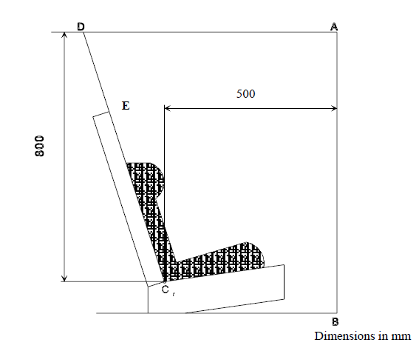"

Adopted text based on GRSP-64-07 (see para. 30 to this report)

*Annex 2., the example of approval markings only,* amend to read:

"1. Arrangements of the approval mark

*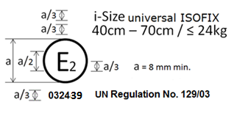*

…

*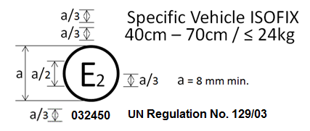*

…

*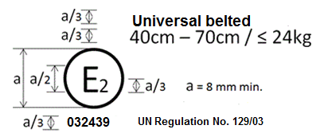*

*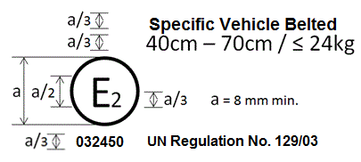*

…

*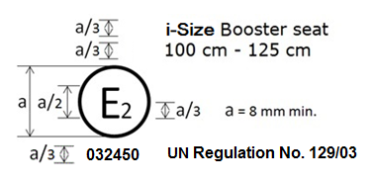*

…

*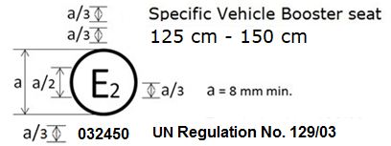*

The Enhanced Child Restraint System bearing the above approval mark… 125 cm - 150 cm size range…

2. Arrangements of the approval mark in combination with a module mark

*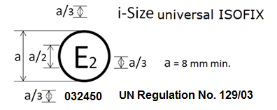*

…

*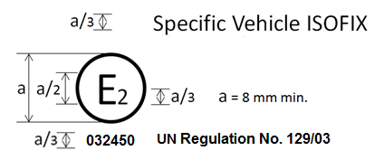*

…"

Adopted text based on GRSP-64-08-Rev.1 (see para. 30 to this report)

*Annex 2., amend to read:*

"Arrangements of the approval mark

…

**In case of combinations, for example an Enhanced Child Restraint System, that is approved as an i-Size Booster seat from 100 cm – 125 cm and from 125 cm – 150 cm as a Specific Vehicle Booster seat, the approval marked is to be combined as given below.**

*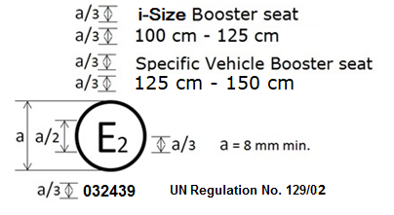*

**Combinations can only be made for those allowed by paragraph 3.2.2.**

**Arrangements of the module mark in combination with an approval mark**

*Current examples given to be deleted and replaced by the following:*

*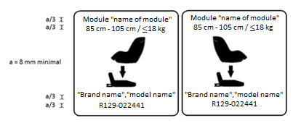*

**The Enhanced Child Restraint System module bearing the above module marks is capable of being used in a rearward facing mode with the base "brand name and model name", for the 85 cm**–**105 cm size range and with a mass limit of 18 kg; approved according to UN Regulation No. 129-02 under the number 022441.**

**The Enhanced Child Restraint System module bearing the above marks is also capable of being used in a forward facing mode with the base "brand name and model name", for the 85 cm**–**105 cm size range and with a mass limit of 18 kg; approved according to UN Regulation No. 129-02 under the same number 022441.**

**The approval number indicates that the approval was granted in accordance with the requirements of the UN Regulation concerning the approval of Enhanced Child Restraint Systems used on-board motor vehicles as amended by the 02 series of amendments.**

**Examples of the symbols to be used on the module mark are given in the figures below. As chosen by the Enhanced Child Restraint Systems manufacturer, one of the symbols or an equivalent shall be used on the module mark.**

**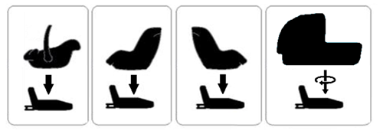**"

Adopted text based on GRSP-64-09 (see para. 30 to this report)

*Annex 2., amend to read:*

"1. Arrangements of the approval mark

…

**In case of combinations, for example an Enhanced Child Restraint System, that is approved as an i-Size Booster seat from 100 cm**–**125 cm and from 125 cm**–**150 cm as a Specific Vehicle Booster seat, the approval marked is to be combined as given below.**

*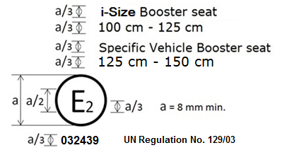*

**Combinations can only be made for those allowed by paragraph 3.2.2."**

Adopted text based on GRSP-64-31 (see para. 30 to this report)

*Annex 2., amend to read:*

"**Arrangements of the approval mark**

*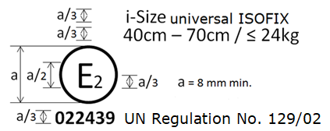*

…

*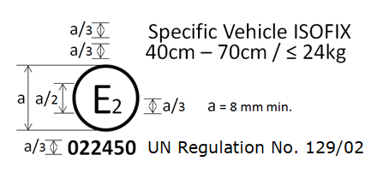*

…

*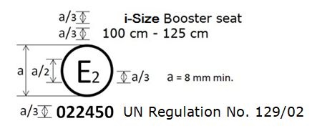*

…

*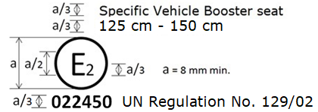*

The Enhanced Child Restraint System bearing the above approval mark…125 cm–150 cm size range…

Amendments adopted to ECE/TRANS/WP.29/GRSP/2018/24 (see para. 31 of this report)

…

*Insert a new paragraph 6.1.2.8.,* to read:

"**6.1.2.8 An infant carrier shall be designed to accommodate children up to 87 cm as a maximum stature**."

…

Amendments adopted to ECE/TRANS/WP.29/GRSP/2018/28 (see para. 31 of this report)

*Paragraph 4.5*., amend to read:

"4.5. **…**

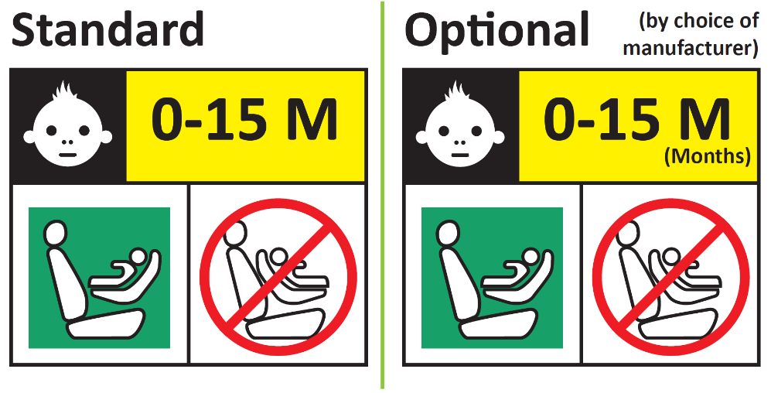

**Forbidden sign – red**

**Label outline, vertical and horizontal lines black**

**Square – green**

**Background white**

**Top symbol white on black background**

**All text black on yellow or amber background**

**Background white**

**…**

*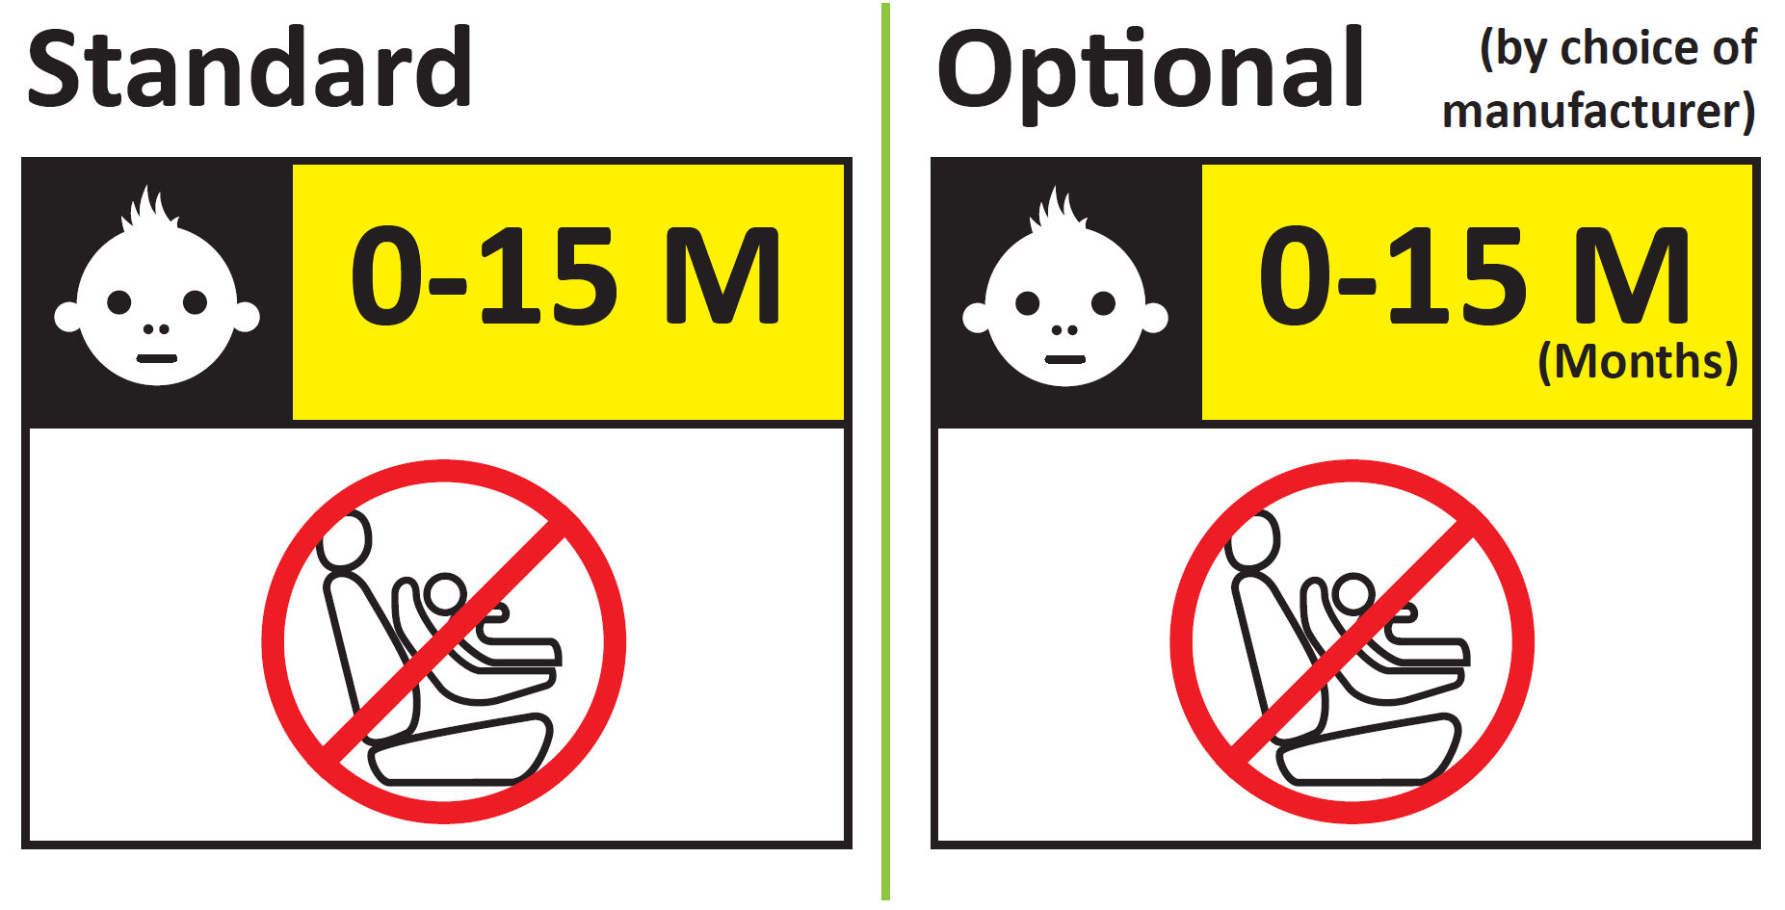***"**

Adopted text based on GRSP-64-42 (see para. 32 to this report)

*Paragraph 10.2.,* amend to read:

"10.2. The minimum requirements for conformity of production control procedures set forth in Annex 12 to this Regulation shall be complied with.

**The conformity of production procedures and all assessments shall follow the regulatory provisions applied at the time of the approval or, if applicable, extensions thereof.**"

Adopted text based on GRSP-64-30-Rev.1 (see para. 33 to this report)

*Paragraph 7.1.3.5.2.3.,* amend to read:

"*7.1.3.5.2.3.* … Distribute the slack evenly throughout the harness.

**In the case of an infant carrier, the dummy shall be restrained in the Enhanced Child Restraint System before it is installed on the test bench. All other requirements of the paragraph shall be fulfilled as described above.**"

Amendments adopted to ECE/TRANS/WP.29/GRSP/2018/33 (see para. 34 of this report)

*Insert a new paragraph 2.6.2*., to read:

"2.62. "Insert" means a part of an ECRS that provides..."

*Paragraph 4.10.*, amend to read:

"**4.10. Any removable insert, shall have a permanently attached label to indicate the brand, model and size range of the Enhanced Child Restraint System to which it belongs. The minimum size of the label shall be 40 x 40 mm or the equivalent area.**"

*Paragraph 4.10. (former)*, renumber as paragraph 4.11.

*Paragraph 6.2.1.1.*, amend to read:

"6.2.1.1. The restraint of the child shall give the required protection in any position specified for the Enhanced Child Restraint System;

**Inserts shall form only one layer on the seat surface. This does not preclude the use of additional “comfort” inserts, provided they are not needed to comply with the requirements of the regulation.**

For "Special Needs Restraints" the primary means of restraint shall give the required protection in any intended position of the Enhanced Child Restraint System without the use of the additional restraining devices which may be present;"

Adopted text based on GRSP-64-01 (see para. 36 to this report)

*Paragraph 6.6.4.3.1,* *Table 3,* amend to read*:*

«

| *Критерий* | *Сокращение* | *Ед. измер.* | *Q0* | | *Q1* | | *Q1,5* | | *Q3* | *Q6* |
| --- | --- | --- | --- | --- | --- | --- | --- | --- | --- | --- |
| Критерий травмирования головы (только в случае соприкосновения при испытании в транспортном средстве) | HPC\* (15) |  | 600 | | 600 | | 600 | | 800 | 800 |
| Ускорение головы 3 мс | Голова  3 мс | g | 75 | | 75 | | 75 | | 80 | 80 |
| ~~Сила напряжения~~ **Сжимающая сила верхней части** шеи | Fz | Н | | Только для целей мониторинга\*\* | | | | | | |
| ~~Скорость движения~~ **Изгибающий момент верхней части** шеи | My | Нм | | Только для целей мониторинга\*\*\* | | | | | | |
| Ускорение грудной клетки 3 мс | Грудная клетка 3 мс | g | | 55 | | 55 | | 55 | 55 | 55 |

»

*Paragraph 6.6.4.5.2.,* amend to read:

«Дополнительные критерии оценки степени травмирования при боковом ударе

| *Критерий* | *Сокращение* | *Ед. измер.* | *Q0* | *Q1* | *Q1,5* | *Q3* | *Q6* |
| --- | --- | --- | --- | --- | --- | --- | --- |
| Критерий травмирования головы | HPC (15) |  | 600 | 600 | 600 | 800 | 800 |
| Ускорение головы 3 мс | Голова  3 мс | g | 75 | 75 | 75 | 80 | 80 |
| **Сжимающая сила верхней части** шеи | Fz | Н | Только для целей мониторинга\* | | | | |
| **Изгибающий момент верхней части** шеи | Mx | Нм | Только для целей мониторинга\*\* | | | | |

»

*Paragraph 7.5., Table 3,* amend to read*:*

«

|  |  |  |
| --- | --- | --- |
| *Тип измерения* | *КЧХ (FH)* | *Предельная частота (FN)* |
| Ускорение тележки | 600 | см. ISO 6487, приложение A |
| Нагрузки, действующие на ремень | 600 | см. ISO 6487, приложение A |
| Ускорение грудной клетки | 600 | см. ISO 6487, приложение A |
| Ускорение головы | 1 000 | 1,650 Гц |
| **Сжимающая сила верхней части** шеи | 600 |  |
| **Изгибающий момент верхней части** шеи | 600 |  |
| Отклонение грудной клетки | 600 |  |

»

*Paragraph 8.1.,* amend to read:

«В протоколе испытания указывают результаты всех испытаний и измерений, включая следующие данные:

a) тип устройства, использовавшегося для испытания (устройство для обеспечения ускорения или замедления);

b) общий показатель изменения скорости;

c) скорость тележки непосредственно перед ударом (только для замедляющих салазок);

d) кривая ускорения или замедления в течение всего периода изменения скорости тележки и, по меньшей мере, 300 мс;

e) время (в мс), соответствующее максимальному смещению головы манекена при проведении динамического испытания;

f) место пряжки во время испытаний, если оно может изменяться;

g) любая неисправность или поломка;

h) следующие критерии манекена: HIC, ускорение головы 3 мс, ~~сила напряжения~~ **сжимающая сила верхней части** шеи, ~~скорость движен~~ия **изгибающий момент верхней части** шеи, отклонение грудной клетки; и

i) сила поясного ремня.»

Adopted text based on GRSP-64-11 (see para. 36 to this report)

*Paragraph 4.3 of the french version*, amend to read:

« 4.3 Les informations suivantes doivent être clairement indiquées sur le produit :

a) L’orientation du dispositif amélioré de retenue pour enfants par rapport au véhicule ;

b) La (les) gamme(s) de taille pour lesquelles le dispositif amélioré de retenue pour enfants est prévu en centimètres ;

c) La masse corporelle maximum admissible pour le dispositif **intégral** amélioré de retenue pour enfants, en kilogrammes. ».

Annex VI

Draft amendments to UN Regulation No. 145 (ISOFIX anchorage systems, ISOFIX top tether anchorages and i-Size seating positions)

Adopted text based on GRSP-64-13-Rev.1 (see para. 42 to this report)

*Annex 1, item 6,* correct to read:

"6. Utilises ISOFIX exemption permitted by paragraph 5.3.**8.** **or** **5.3.9.** of this Regulation: Yes/No 2/"

Annex VII

[English only]

List of GRSP informal working groups

|  |  |  |  |
| --- | --- | --- | --- |
| *Informal working group* | *Chair* | *Expiry date of the mandate [pending WP.29 decision]* | *Secretary* |
| Harmonized side impact dummies | Mr. David Sutula (USA)  Phone: +1 202 366 32 73  Fax: +1 202 493 29 90  Email: david.sutula@dot.gov | Suspended |  |
| Head Restraints  (GTR7-Phase 2) | Mr. Bernard Frost (UK)  Phone: +44‑(0)207 9442107  Fax: +44‑(0)207 9449623  Email: [bernie.frost@dft.gsi.gov.uk](mailto:bernie.frost@dft.gsi.gov.uk_) | June 2019 | OICA |
| UN GTR No. 9 on Pedestrian Safety Deployable – Pedestrian Protection Systems (DPPS) | Mr. Jin Seop Park (Republic of Korea)  Email: jspark@kotsa.or.kr | June 2020 | OICA |
| UN GTR No. 9 (Pedestrian Safety)  (GTR9-Phase 2) | Mr. Richard Damm (Germany)  Phone: +49 (0) 228 99 300 4302 Fax: +49 (0) 228 99 300 807 4302 Email: richard.damm@bmvi.bund.de | December 2018 | OICA |
| UN GTR No. 20 (EVS) – Phase 2 | Mr. N. Nguyen (USA), (vice-chaired by China and the European Union) Phone: +1 202 366 69 34 Fax: +1 202 493 29 90 Email: [nha.nguyen@dot.gov](mailto:nha.nguyen@dot.gov) | December 2021 | Japan |
| Three-dimensional H-point machine | Mr. L. Martinez (Spain)  Phone: +34 91 336 53 00  Fax: +34 91 336 53 02  Email: [luis.martinez@upm.es](mailto:luis.martinez@upm.es) | […] |  |
| UN GTR No. 13 (HFCV) | Mr. N. Nguyen (USA)  Phone: +1 202 366 69 34 Fax: +1 202 493 29 90 Email: [nha.nguyen@dot.gov](mailto:nha.nguyen@dot.gov) Mr. M. Takahashi (Japan) | December 2020 | […] |
| Protective helmets | Mr. Luca Rocco  Phone: +39 06 4158 3268  Fax: +39 06 4158 3253  Email: [luca.rocco@mit.gov.it](mailto:luca.rocco@mit.gov.it) | December 2019 |  |

1. As defined in the Consolidated Resolution on the Construction of Vehicles (R.E.3.), document ECE/TRANS/WP.29/78/Rev.3, para. 2 - [www.unece.org/trans/main/wp29/wp29wgs/wp29gen/wp29resolutions.html](http://www.unece.org/trans/main/wp29/wp29wgs/wp29gen/wp29resolutions.html) [↑](#footnote-ref-2)