|  |  |  |  |
| --- | --- | --- | --- |
|  | United Nations | ECE/TRANS/WP.29/GRSP/63 | |
| _unlogo | **Economic and Social Council** | | Distr.: General  14 June 2018  Original: English |

**Economic Commission for Europe**

Inland Transport Committee

**World Forum for Harmonization of Vehicle Regulations**

**Working Party on Passive Safety**

**Sixty-third session**

Geneva, 14-18 May 2018

Report of the Working Party on Passive Safety on its   
sixty-third session

Contents

*Paragraphs Page*

I. Attendance 1–2 3

II. Adoption of the agenda (agenda item 1) 3 3

III. UN Global Technical Regulation No. 7 (Head restraints) (agenda item 2) 4 3

IV. UN Global Technical Regulation No. 9 (Pedestrian safety) (agenda item 3) 5–7 4

A. Proposal for Amendment 2 (Phase 2) 5 4

B. Proposal for Amendment 3 6 4

C. Proposal for Amendment 4 7 4

V. UN Global Technical Regulation No. 13 (Hydrogen and Fuel Cells Vehicles)   
 (agenda item 4) 8 5

VI. Harmonization of side impact dummies (agenda item 5) 9–10 5

VII. UN Global Technical Regulation on electric vehicles (agenda item 6) 11–12 5

VIII. UN Regulation No. 11 (Door latches and hinges) (agenda item 7) 13–14 6

IX. UN Regulation No. 14 (Safety-belt anchorages) (agenda item 8) 15–16 6

X. UN Regulation No. 16 (Safety-belts) (agenda item 9) 17–18 6

XI. UN Regulation No. 17 (Strength of seats) (agenda item 10) 19–20 7

XII. UN Regulation No. 22 (Protective helmets) (agenda item 11) 21 7

XIII. UN Regulation No. 29 (Cabs of commercial vehicles) (agenda item 12) 22 7

XIV. UN Regulation No. 44 (Child Restraint Systems) (agenda item 13) 23 8

XV. UN Regulation No. 80 (Strength of seats and their anchorages)   
(agenda item 14) 24–25 8

XVI. UN Regulation No. 94 (Frontal collision) (agenda item 15) 26 8

XVII. UN Regulation No. 95 (Lateral collision) (agenda item 16) 27 9

XVIII. UN Regulation No. 100 (Electric power trained vehicles) (agenda item 17) 28 9

XIX. UN Regulation No. 127 (Pedestrian safety) (agenda item 18) 29 9

XX. UN Regulation No. 129 (Enhanced Child Restraint Systems)   
(agenda item 19) 30–36 9

XXI. UN Regulation No. 134 (Hydrogen and Fuel Cells Vehicles (HFCV))   
(agenda item 20) 37 11

XXII. UN Regulation No. 135 (Pole Side Impact) (PSI)) (agenda item 21) 38 11

XXIII. UN Regulation No. 136 (Electric Vehicles of category L (EV-L))(agenda item 22) 39 11

XXIV. UN Regulation No. 137 (Frontal impact with focus on restraint systems)   
(agenda item 23) 40–41 11

XXV. Collective amendments to UN Regulations Nos. 16, 44, 94, 129 and 137   
(agenda item 24) 42–43 12

XXVI. Securing of children in buses and coaches (agenda item 25) 44 12

XXVII. Other business (agenda item 26) 45–54 13

A. Exchange of information on national and international requirements on passive safety 45–46 13

B. Definitions and acronyms in Regulations under the responsibilities of GRSP 47 13

C. Development of the International Whole Vehicle Type Approval (IWVTA) system and involvement of the Working Parties (GRs) 48 13

D. Highlights of the March 2018 sessions of WP.29 49 13

E. Three-dimensional H-point machine 50 14

F. Intelligent transport systems 51 14

G. UN Regulation No. 145 (ISOFIX anchorage systems, ISOFIX top tether anchorages and i-Size seating positions) 52 14

H. Mutual Resolution No. 1 53 14

I. Tributes 54 14

XXVIII. Provisional agenda for the next session (agenda item 27) 55 14

Annexes

I. List of informal documents (GRSP-63-…) distributed without an official symbol during the session 16

II. Draft Terms of Reference for the Informal Working Group on Deployable Pedestrian Protection Systems (IWG-DPPS) 19

III. Proposition d’amendements au Règlement no 11 (Serrures et organes de fixation des portes) 21

IV. Draft amendments to UN Regulation No. 14 (Anchorages of safety-belts) 22

V. Draft amendments to UN Regulation No. 16 (Safety-belts) 23

VI. Draft amendments to UN Regulation No. 17 (Strength of seats) 25

VII. Terms of Reference for the informal working group of Regulation No. 22 (Protective Helmets) 26

VIII. Draft amendments to UN Regulation No. 95 (Lateral collision) 28

IX. Draft amendments to UN Regulation No. 129 (Enhanced Child Restraint Systems) 29

X. Collective draft amendments to UN Regulations Nos. 16, 44, 94, 129 and 137 32

XI. List of GRSP informal working groups 39

I. Attendance

1. The Working Party on Passive Safety (GRSP) held its sixty-third session in Geneva from 14 to 18 May 2018, chaired by Mr. N. Nguyen (United States of America). Experts from the following countries participated in the work following Rule 1(a) of the Rules of Procedure of the World Forum for Harmonization of Vehicle Regulations (WP.29) (TRANS/WP.29/690, Amend. 1 and 2): Belgium, Canada, China, Czechia, France, Germany, India, Italy, Japan, Netherlands, Norway, Poland, Republic of Korea, Russian Federation, South Africa, Spain, Sweden, Switzerland, United Kingdom of Great Britain and Northern Ireland (United Kingdom) and United States of America. An expert from the European Commission (EC) participated. Experts from the following non-governmental organizations participated: Consumers International, European Association for the Coordination of Consumer Representation in Standardization (ANEC), European Association of Automotive Suppliers (CLEPA), European Cyclists' Federation, Federation International de l'Automobile (FIA), Global New Car Assessment Programme (Global NCAP), International Motor Vehicle Inspection Committee (CITA), International Motorcycle Manufacturers Association (IMMA), International Organization of Motor Vehicle Manufacturers (OICA) and World Bicycle Industry Association (WBIA).

2. The informal documents distributed during the session are listed in Annex I of this report.

II. Adoption of the agenda (agenda item 1)

*Documentation*: ECE/TRANS/WP.29/GRSP/2018/1  
Informal document GRSP-63-06

3. GRSP considered and adopted the agenda (ECE/TRANS/WP.29/GRSP/2018/1 and Add.1) proposed for the sixty-third session with the new agenda items 26 (g), 26 (h), 26 (i) and 27 as well as the running order (GRSP-63-06). The list of GRSP informal working groups are listed in Annex XI of this report.

III. UN Global Technical Regulation No. 7 (Head restraints) (agenda item 2)

*Documentation*: ECE/TRANS/WP.29/GRSP/2015/34

4. The expert from the United Kingdom, on behalf of the Chair of the Informal Working Group (IWG) on UN Global Technical Regulation (UN GTR) No. 7 - Phase 2, informed GRSP that the IWG had not made progress in its activities and that no new information for the future development of the UN GTR to report. The expert from the United States of America informed GRSP that the Vehicle Research Testing Centre of the National Highway Traffic Safety Administration (NHTSA) will resume and finalize its testing activity on the injury criteria by the end of 2018.

IV. UN Global Technical Regulation No. 9 (Pedestrian safety) (agenda item 3)

A. Proposal for Amendment 2 (Phase 2)

*Documentation*: ECE/TRANS/WP.29/GRSP/2018/2  
ECE/TRANS/WP.29/GRSP/2018/3

5. The expert from Germany, on behalf of the Chair of the IWG, introduced the consolidated text of draft Amendment 2 to UN GTR No. 9 (ECE/TRANS/WP.29/GRSP/2018/2), which incorporates: (a) the flexible pedestrian legform impactor (FlexPLI), and (b) the new bumper test area and on the Injury Assessment Values (IARVs). He also introduced the final progress report of the IWG ECE/TRANS/WP.29/GRSP/2018/3. As suggested by the expert from the Republic of Korea, he announced that a possible amendment of part I of the UN GTR (statement of technical rationale and justification) would be introduced in the future to reflect the activity of the IWG on Deployable Pedestrian Protection Systems (DPPS). GRSP recommended Amendment 2 (ECE/TRANS/WP.29/GRSP/2018/2) and the final progress report (ECE/TRANS/WP.29/GRSP/2018/3) both not amended, for establishment in the global registry. The secretariat was requested to submit the proposal and the final report to WP.29 and to the Executive Committee of the 1998 Agreement (AC.3) for consideration and vote at their November 2018 sessions as draft Amendment 2 to UN GTR No. 9.

B. Proposal for Amendment 3

*Documentation*: ECE/TRANS/WP.29/GRSP/2012/2  
ECE/TRANS/WP.29/GRSP/2014/5

6. The expert from the United States of America informed GRSP that NHTSA had initiated a Notice of the Proposed Rulemaking for establishing the current requirements for head form tests, as proposed by GRSP. had been on hold due to other priorities at NHTSA. The expert from EC recommended a fast-tracking process to ensure harmonization.

C. Proposal for Amendment 4

*Documentation*: Informal documents GRSP-63-19 and GRSP-63-20

7. The expert from the Republic of Korea informed GRSP that the Task Force on DPPS had become an IWG at the March 2018 sessions of WP.29 and AC.3 (see ECE/TRANS/WP.29/1137, paras. 44 and 155). However, he regretted the limited participation from contracting parties of both the 1958 and 1998 Agreements. He reiterated his encouragement for more contracting parties participation. He introduced the Status Report (GRSP-63-19) of the IWG and its terms of reference (GRSP-63-20), as agreed on by the experts at the first meeting of the IWG in Frankfurt (12-18 April 2018, Germany). A question was raised if the discussions on proposal for Amendment 3 could be merged with the proposal for Amendment 4. The expert from OICA recommended maintaining separate the two proposals of amendments on the new head-form test and DPPS to avoid disruption and delays. Finally, GRSP supported the request from the expert of the Republic of Korea to participate to the activities of the IWG. Finally, GRSP adopted GRSP-63-20 as reproduced in Annex II to this report and requested the expert from the Republic of Korea to submit it to the November 2018 sessions of WP.29 and AC.3.

V. UN Global Technical Regulation No. 13 (Hydrogen and Fuel Cells Vehicles) (agenda item 4)

*Documentation*: ECE/TRANS/WP.29/AC.3/49, ECE/TRANS/WP.29/2018/75 Informal document GRSP-63-29

8. The expert from the United States of America, Co-Chair of the IWG on the UN Global Technical Regulation (UN GTR) No. 13 - Phase 2, informed GRSP about the group's progress. He introduced a draft report of its second meeting (GRSP-63-29), held in Torrance, United States of America from 5 to 7 February 2018. He explained that the meeting had received contributions from about sixty experts on the regulatory work including material compatibility, fuelling receptacle, long-term stress rupture of hydrogen storage systems and on updating the existing test procedure of the UN GTR. He added due to the large size of the IWG, that it was needed to create five Task Forces to address some specific technical items of Phase 2. He concluded that the Terms of Reference (ToR) of the IWG were submitted to the June 2018 session of AC.3 (ECE/TRANS/WP.29/2018/75) for endorsement and announced that the date of the next meetings of the IWG is scheduled from 24 to 26 June 2018, in Seoul followed by a meeting in October 2018 in Europe. The expert from OICA called for a higher participation of contracting parties from GRSP to the activities of the IWG.

VI. Harmonization of side impact dummies (agenda item 5)

9. The Chair of GRSP, on behalf of who is the Chair of the IWG, informed GRSP that NHTSA would like to withdraw as Chair of the IWG due to a lack of resources and other priorities at the agency, and urged to find a solution. The expert from Germany reiterated his statement at the December 2017 session of GRSP (ECE/TRANS/WP.29/GRSP/62, para. 10) that the addenda of the M.R.1, incorporating anthropomorphic test devices (crash test dummies), particularly of side impact dummies (e.g. World Side Impact Dummy fiftieth percentile), specifications, be completed as soon as possible. He regretted a lack of progress. He hoped that a solution would be jointly recommended by the representative of the United Kingdom and his delegation at the June 2018 sessions of WP.29 and AC.3.

10. The expert from Sweden informed GRSP about her administration’s plan to study dummies that are currently on the market for gaps in the coverage of all categories of occupants. The expert from EC added that his organization was also interested in this activity and offered to cooperate.

VII. UN Global Technical Regulation on electric vehicles   
(agenda item 6)

*Documentation*: ECE/TRANS/WP.29/2017/138 and ECE/TRANS/WP.29/2017/143

11. The Chair of GRSP informed that UN GTR No. 20 was established at the March 2018 session of WP.29 and AC.3. He added, on behalf of the Chair of the IWG on Phase 2 of UN GTR No. 20, informed GRSP that the group was keeping to the established schedule and issues, i.e. thermal propagation and test performances of buses. He announced that the next meeting of the IWG was planned from 11 to 13 September 2018, in Sweden. He also informed GRSP that documents and report of the last meeting of the IWG can be  
 found at: <https://wiki.unece.org/display/trans/EVS+16th+session>

12. The expert from Japan announced that he will be preparing jointly with the experts of EC and OICA to prepare the transposition of the UN GTR in UN Regulation No. 100. Finally, GRSP agreed to resume discussion at its December 2018 session on the work progress of the IWG.

VIII. UN Regulation No. 11 (Door latches and hinges)   
(agenda item 7)

*Documentation*: ECE/TRANS/WP.29/GRSP/2018/11  
 Informal document GRSP-63-02

13. The expert from OICA introduced ECE/TRANS/WP.29/GRSP/2018/11 to confirm that existing type approvals, granted on the basis of the preceding series of amendments, should remain accepted, in accordance with the General Guidelines for United Nations (ECE/TRANS/WP.29/2017/107) regulatory procedures and transitional provisions in UN Regulations. GRSP adopted ECE/TRANS/WP.29/GRSP/2018/11 not amended and requested the secretariat to submit the proposal as draft Supplement 2 to the 04 series of amendments to UN Regulation No. 11, for consideration and vote at the November 2018 sessions of WP.29 and AC.1.

14. The expert from France introduced GRSP-63-02, to align the French with the English text. GRSP adopted the proposal as reproduced in Annex III to this report. The secretariat was requested to submit the proposal as draft Corrigendum 1 to the 04 series of amendments to UN Regulation No. 11, for consideration and vote at the November 2018 sessions of WP.29 and AC.1.

IX. UN Regulation No. 14 (Safety-belt anchorages)   
(agenda item 8)

*Documentation*: ECE/TRANS/WP.29/GRSP/2018/12  
Informal document GRSP-63-03

15. GRSP noted ECE/TRANS/WP.29/GRSP/2018/12, which corrects the dimensions of Figures 1 and 1a of Annex 5. GRSP adopted ECE/TRANS/WP.29/GRSP/2018/12 as reproduced in Annex IV to this report. The secretariat was requested to submit the proposal as draft Corrigendum 2 to Revision 5 to UN Regulation No. 14, for consideration and vote at the November 2018 sessions of WP.29 and AC.1.

16. The expert from France introduced GRSP-63-03 on editorial update in Annex 1 to the UN Regulation. GRSP agreed to resume consideration of this subject on the basis of a revised proposal tabled by the expert from France at its December 2018 session.

X. UN Regulation No. 16 (Safety-belts) (agenda item 9)

*Documentation*: Informal documents GRSP-63-04 and GRSP-63-23

17. The expert from France introduced GRSP-63-04 to update the safety-belt installation requirements of Annex XVI of the UN Regulation. GRSP adopted the proposal as reproduced in Annex V to this report. The secretariat was requested to submit the proposal as draft Supplement 11 to the 06 series of amendments and Supplement 4 to the 07 series of Amendments to UN Regulation No. 16, for consideration and vote at the November 2018 sessions of WP.29 and AC.1.

18. The expert from Germany introduced GRSP-63-23, to clarify which requirements should be applied to approve the safety-belt of the driver’s. GRSP endorsed the proposal and agreed to finalize its discussion by combining GRSP-63-23 with GRSP-63-01-Rev.1 under agenda item 24 (see para. 42 below).

XI. UN Regulation No. 17 (Strength of seats) (agenda item 10)

*Documentation*: ECE/TRANS/WP.29/GRSP/2018/4  
Informal document GRSP-63-24

19. The expert from Germany introduced ECE/TRANS/WP.29/GRSP/2018/4, following the discussions at the December 2018 session of GRSP, which aimed to clarify that safety-belts and their components should continue to function after the load retention test. GRSP adopted the proposal as amended in Annex VI to this report. The secretariat was requested to submit the proposal as draft 09 series of amendments to UN Regulation No. 17 for consideration and vote at the November 2018 sessions of WP.29 and AC.1.

20. The expert from Germany also introduced GRSP-63-24 clarifying the possibility of installing side-facing seats in buses of certain classes of vehicles. The expert from the Netherlands raised a study reservation. GRSP agreed to resume discussion on this subject at the December 2018 session of GRSP on the basis of a new proposal jointly prepared by the experts from Germany and EC.

XII. UN Regulation No. 22 (Protective helmets) (agenda item 11)

*Documentation*: Informal documents GRSP-63-18 and GRSP-63-26

21. The expert from France introduced GRSP-63-18 on how to improve UN Regulation No. 22. He noted that improving on testing requirements should address rotational acceleration as a priority. He also introduced the ToR of the IWG on UN Regulation No. 22 (GRSP-63-26), as agreed by the group during its first meeting held at the Palais des Nations on 14 May 2018. GRSP adopted GRSP-63-26 as reproduced in Annex VII to this report. Finally, GRSP agreed to resume discussion at its December 2018 on the work progress of the IWG.

XIII. UN Regulation No. 29 (Cabs of commercial vehicles) (agenda item 12)

*Documentation*: ECE/TRANS/WP.29/GRSP/2018/5

22. GRSP resumed discussion on this subject on the basis of a revised proposal of Germany (ECE/TRANS/WP.29/GRSP/2018/5) on how to secure a cab mounted on a vehicle on the test rig that allowed the use of rigid composite blocks and/or metal brackets instead of the wooden blocks, and on the necessity to secure the vehicle with ropes or chains for test C. GRSP adopted the proposal not amended and requested the secretariat to submit ECE/TRANS/WP.29/GRSP/2018/5 as draft Supplement 4 to the 03 series of amendments to UN Regulation No. 29 for consideration and vote at the November 2018 sessions of WP.29 and AC.1. GRSP was informed about an issue raised during at the February 2018 session of Working Party on Brakes and Running Gears about road accidents involving trucks that point to the mechanical failure of the steering gear. The expert from Germany clarified that UN Regulation No. 29 did not include the steering gear mechanism in its testing provisions.

XIV. UN Regulation No. 44 (Child Restraint Systems) (agenda item 13)

*Documentation*: ECE/TRANS/WP.29/GRSP/2018/6  
Informal documents GRSP-63-12 and GRSP-63-13

23. The expert from the Netherlands withdrew ECE/TRANS/WP.29/GRSP/2018/6 on preventing a lie of belt that could lead to injuries of children using non-integral Child Restraint Systems. The expert from CLEPA also withdrew GRSP-63-12 and GRSP-63-13 which address ECE/TRANS/WP.29/GRSP/2018/6.

XV. UN Regulation No. 80 (Strength of seats and their anchorages) (agenda item 14)

*Documentation*: ECE/TRANS/WP.29/GRSP/2018/10  
Informal documents GRSP-63-17, GRSP-63-32 and Video Presentation No. 1

24. GRSP resumed discussion on the proposal tabled by the expert from Germany (ECE/TRANS/WP.29/GRSP/2018/10), aimed at removing the static tests and improving the dynamic test on seat anchorages. The expert from Germany continued provide evidence to GRSP through a new presentation (GRSP-63-32 and a Video Presentation No. 1) to support his proposal. He stated that the current requirements of the UN Regulation allows the approval of seat systems in busses on the basis of a static test procedure which does not provide an adequate level of protection compared with the dynamic procedure. He added that tests with one seat model showed that occupants could be exposed to a high risk of death or serious injury in an accident from the collapse of the seat fixation. Finally, he informed GRSP that comparable seat fixations failure had been observed in bus accidents, and occupants had already been killed or seriously injured. He added that the German administration is concerned that these severe accidents could happen again in the future. The expert from the Russian Federation proposed to postpone the decision to the December 2018 session of GRSP. He justified his recommendation on the lack of research on the issue. He added that the Russian Federation considered it premature to exclude static tests from UN Regulation No. 80 and proposed to revise this type of test. He also suggested amending the dynamic test methodology according to ECE/TRANS/WP.29/GRSP/2018/10 and to the outcome of research conducted in the Russian Federation. Finally, he announced his intention to present these research results, accompanied with a draft amendment to UN Regulation No. 80 at the December 2018 session of GRSP. Several experts raised a study reservation to verify further statistical data. The expert from OICA also requested more time to prepare a revised proposal and requested to keeping GRSP-63-17 as a reference in the agenda of the next session.

25. GRSP agreed to resume discussion at the December 2018 session and invited experts to reach an agreement on this subject at that session.

XVI. UN Regulation No. 94 (Frontal collision) (agenda item 15)

26. No new information was provided under this agenda item. GRSP agreed to discuss safety of L7 (quadricycles) category of vehicles under agenda item 23.

XVII. UN Regulation No. 95 (Lateral collision) (agenda item 16)

*Documentation*: ECE/TRANS/WP.29/GRSP/2017/40  
Informal document GRSP-63-07-Rev.1

27. GRSP resumed discussion on ECE/TRANS/WP.29/GRSP/2017/40 aimed at defining the conditions of door openings after the test collision. The expert from OICA introduced GRSP-63-07-Rev.1 to improve feasibility of the test proposed by ECE/TRANS/WP.29/GRSP/2017/40, with a reduced applied force to the door. Finally, GRSP adopted ECE/TRANS/WP.29/GRSP/2017/40 as amended by Annex VIII to this report. The secretariat was requested to submit the proposal as draft Supplement 7 to the 03 series of amendments to UN Regulation No. 95, for consideration and vote at the November 2018 sessions of WP.29 and AC.1.

XVIII. UN Regulation No. 100 (Electric power trained vehicles) (agenda item 17)

*Documentation*: ECE/TRANS/WP.29/GRSP/2018/7

28. GRSP resumed discussion on a proposal tabled by the expert from OICA (ECE/TRANS/WP.29/GRSP/2018/7) confirming that existing type approvals, granted on the basis of the preceding series of amendments, should remain accepted. GRSP adopted the proposal not amended. The secretariat was requested to submit the proposal as draft Supplement 4 to the 02 series of amendments and as draft Supplement 5 to the 01 series of amendments to UN Regulation No. 100, for consideration and vote at the November 2018 sessions of WP.29 and AC.1.

XIX. UN Regulation No. 127 (Pedestrian safety) (agenda item 18)

29. No new information was provided under this agenda item.

XX. UN Regulation No. 129 (Enhanced Child Restraint Systems) (agenda item 19)

*Documentation*: ECE/TRANS/WP.29/GRSP/2018/8  
ECE/TRANS/WP.29/GRSP/2018/13  
ECE/TRANS/WP.29/GRSP/2018/14  
ECE/TRANS/WP.29/GRSP/2018/15  
ECE/TRANS/WP.29/GRSP/2018/16  
ECE/TRANS/WP.29/GRSP/2018/17  
ECE/TRANS/WP.29/GRSP/2018/18  
ECE/TRANS/WP.29/GRSP/2018/19  
ECE/TRANS/WP.29/GRSP/2018/20  
ECE/TRANS/WP.29/GRSP/2018/21  
ECE/TRANS/WP.29/GRSP/2018/22  
Informal documents GRSP-63-08-Rev.1, GRSP-63-09, GRSP-63-10-Rev.1, GRSP-63-11-Rev.1, GRSP-63-27, GRSP-63-28 and GRSP-63-30

30. The expert from France presented ECE/TRANS/WP.29/GRSP/2018/8 on introducing definition and requirements for the lower tether strap, and a definition and specifications for the Lower Tether Anchorages (LTA). The experts from Sweden and CLEPA raised a study reservation. GRSP agreed to resume discussion on this proposal on the basis a revised document incorporating the editorial changes suggested by the expert from Japan.

31. The expert from Spain, on behalf of the Technical Services Group (TSG) on UN Regulation No. 129, introduced ECE/TRANS/WP.29/GRSP/2018/13, ECE/TRANS/WP.29/GRSP/2018/14, ECE/TRANS/WP.29/GRSP/2018/15 and ECE/TRANS/WP.29/GRSP/2018/16 which proposes that the requirements of both the shoulder strap positioner and the buckle should open independently of each other. The expert from CLEPA introduced GRSP-63-11-Rev.1, amending ECE/TRANS/WP.29/GRSP/2018/14, ECE/TRANS/WP.29/GRSP/2018/15 and ECE/TRANS/WP.29/GRSP/2018/16. Finally, GRSP adopted ECE/TRANS/WP.29/GRSP/2018/14, ECE/TRANS/WP.29/GRSP/2018/15 and ECE/TRANS/WP.29/GRSP/2018/16 as amended by Annex IX to this report. GRSP did not support ECE/TRANS/WP.29/GRSP/2018/13. The secretariat was requested to submit ECE/TRANS/WP.29/GRSP/2018/14 as draft Supplement 5 to the 01 series of amendments, ECE/TRANS/WP.29/GRSP/2018/15 as draft Supplement 4 to the 02 series of amendments and ECE/TRANS/WP.29/GRSP/2018/16 as draft Supplement 1 to the 03 series of amendments to UN Regulation No. 129 for consideration and vote at the November 2018 sessions of WP.29 and AC.1.

32. The expert from Spain introduced ECE/TRANS/WP.29/GRSP/2018/17 and ECE/TRANS/WP.29/GRSP/2018/18 which clarify that an i-Size booster seat (Non-Integral Enhanced Child Restraint System) can accommodate children with a maximum stature of 135 cm. The expert from CLEPA introduced GRSP-63-28, explaining that the current text of the UN Regulation is consistent with the approach for backrest angle and that an adjustment for over 135 was a "comfort feature". GRSP agreed to resume discussion on this subject on the basis of revised proposals.

33. The expert from Spain introduced ECE/TRANS/WP.29/GRSP/2018/19, ECE/TRANS/WP.29/GRSP/2018/20, ECE/TRANS/WP.29/GRSP/2018/21 and ECE/TRANS/WP.29/GRSP/2018/22 aimed at providing better provisions for the dummy's head displacement when surpassing the reference plane DE during frontal and rear impact tests of forward facing Enhanced Child Restraint Systems. The expert from Germany argued that the current text of the UN Regulation prevented the contact of the head. He added that dummies have performance limits and that in this context these limitations would not affect the test results. The GRSP Chair requested the expert from Spain to provide better rationales for the sled test and to clarify if her proposals also referred to vehicle tests. GRSP agreed to resume discussion on this subject at its December 2018 session.

34. The expert from CLEPA introduced GRSP-63-08-Rev.1, to harmonize UN Regulations Nos. 44 and 129 on information that is provided to users. GRSP adopted the proposal as reproduced in Annex IX to this report. The secretariat was requested to submit GRSP-63-08-Rev.1 as draft Supplement 8 to the original series of amendments, as part of (see para. 31 above) draft Supplement 5 to the 01 series of amendments, as part of (see para. 31 above) draft Supplement 4 to the 02 series of amendments and as part of (see para. 31 above) draft Supplement 1 to the 03 series of amendments to UN Regulation No. 129 (see para. 31 above) for consideration and vote at the November 2018 sessions of WP.29 and AC.1.

35. GRSP also considered and adopted GRSP-63-10-Rev.1 on reintroducing text omitted in previous proposals, as reproduced in Annex VIII to the report, to reintroduce a text omitted in previous proposals. The secretariat was requested to submit GRSP-63-10-Rev.1 as part of (see paras. 31 and 34) draft Supplement 5 to the 01 series of amendments, as part of (see paras. 31 and 34) draft Supplement 4 to the 02 series of amendments and as part of (see paras. 31 and 34) draft Supplement 1 to the 03 series of amendments to UN Regulation No. 129 for consideration and vote at the November 2018 sessions of WP.29 and AC.1.

36. GRSP noted GRSP-63-09 which stresses the need that certain information for users be clearly displayed. GRSP agreed to resume discussion on this subject on the basis of a revised proposal by the expert from CLEPA. GRSP also noted GRSP-63-27 on clarifying the definition of "infant carrier" and GRSP-63-30 on clarifying that extensions of type approvals to the 02 series of amendments shall continue to be granted. GRSP agreed in principle on both proposals and requested the secretariat to distribute them with an official symbol at the December 2018 session of GRSP.

XXI. UN Regulation No. 134 (Hydrogen and Fuel Cells Vehicles (HFCV)) (agenda item 20)

37. No new information was provided under this agenda item.

XXII. UN Regulation No. 135 (Pole Side Impact) (PSI))   
(agenda item 21)

38. No new information was provided under this agenda item.

XXIII. UN Regulation No. 136 (Electric Vehicles of category L   
(EV-L)) (agenda item 22)

39. No new information was provided under this agenda item.

XXIV. UN Regulation No. 137 (Frontal impact with focus on restraint systems) (agenda item 23)

*Documentation*: Informal documents GRSP-63-14, GRSP-63-15 and GRSP-63-16

40. The experts from Global NCAP and from ANEC on behalf of Consumers International introduced GRSP-63-14 which proposes to include L7 (quadricycles) categories of vehicles in the scope of UN Regulation No. 137, in line with the recommendation of the WP.29 (GRSP-63-15 and ECE/TRANS/WP.29/1141, para. 41) aimed at offering a minimum protection to L7 vehicle occupants in case of a crash. They also mentioned GRSP-63-16, for information, concerning the "Public Interest Litigation Regarding Motor Vehicle Safety in India". They added that quadricycles are not subject to the same legislation as conventional passenger cars and their crashworthiness should be addressed by GRSP as recommended by WP.29. They stressed the risk that consumers buy this type of vehicle to cater to an individual’s need for a car but without being informed about the lack of safety requirements in those vehicles which might expose them to serious injuries in case of a crash. They indicated that NCAP tests showed cases of safety-belts that snapped off and even ineffective airbags and revealing that these types of restraint systems and performance of this type of vehicles were far below similarly-sized passenger car. Moreover, they informed GRSP that L7 vehicles are becoming more popular, also because they are considered as new environmentally friendly mobility solutions and are expected to become more numerous in the future. They clarified that the proposal of Global NCAP and Consumer International to extend the scope of UN Regulation No. 137 to L7 vehicle would be in line with the test speed scenarios and biomechanical injury criteria that provide for the safety of occupants, as in other types of passenger vehicles.

41. The expert from the Republic of Korea was full in support of GRSP-63-14 since his country had recently experienced a surge of this type of vehicles on its roads. The expert from Italy argued that the mass and powertrain of L7 differ from those of M1 and that these factors should be analysed in crash test. The expert from EC reminded GRSP about a European Union study (see ECE/TRANS/WP.29/GRSP/61 para. 31) on an initial assessment of the additional functional safety of this category of vehicles that was available at:

<https://ec.europa.eu/docsroom/documents/5466/attachments/1/translations/en/renditions/native>

He explained that the study showed that the low frequency of crashes in Europe of these types of vehicle did not justify an urgent action plan. Moreover, he requested justification on why the L6 category was not included in the proposal. He reminded GRSP about the existence of many UN Regulations covering safety provisions of L7 categories. The expert from Japan agreed with him, however, he requested further investigations. The expert from the Russian Federation agreed with the expert from EC and expressed concern that more severe requirements would eliminate this category of vehicles. The expert from India agreed with a more in-depth investigation on actual safety issues for this category of vehicles and confirmed that these vehicles were becoming relevant in the market of his country. The expert from the Netherlands supported further in-depth study and finding a balanced solution. GRSP decided to resume discussion on this subject at its December 2018 session and to keep GRSP-63-14 as a reference document.

XXV. Collective amendments to UN Regulations Nos. 16, 44, 94, 129 and 137 (agenda item 24)

*Documentation*: ECE/TRANS/WP.29/GRSP/2017/27 ECE/TRANS/WP.29/GRSP/2018/9  
Informal document GRSP-63-01-Rev.1

42. The expert from EC introduced GRSP-63-01-Rev.1, amending ECE/TRANS/WP.29/GRSP/2017/27 on the information of the airbag warning label about correctly installing CRS on a passenger seat with an activated frontal airbag. GRSP noted that the proposal also incorporated GRSP-63-01-Rev.1 (see para. 18 above). GRSP adopted ECE/TRANS/WP.29/GRSP/2017/27, as amended by Annex X to this report. The secretariat was requested to submit the proposal for consideration and vote at the November 2018 sessions of WP.29 and AC.1 as:

(a) draft 08 series of amendments to UN Regulation No. 16;

(b) draft Supplement 15 to the 04 series of amendments to UN Regulation No. 44;

(c) draft Supplement 1 to the 03 series of amendments to UN Regulation No. 94;

(d) part of (see paras. 31 and 34 above) draft Supplement 5 to the 01 series of amendments, as part of (see paras. 31 and 34 above) draft Supplement 4 to the 02 series of amendments and as part of (see paras. 31 and 34 above) draft Supplement 1 to the 03 series of amendments to UN Regulation No. 129 and

(e) draft Supplement 2 to the 01 series of amendments to UN Regulation No. 137.

43. Finally, the expert from OICA withdrew ECE/TRANS/WP.29/GRSP/2018/9.

XXVI. Securing of children in buses and coaches (agenda item 25)

44. The expert from the Russian Federation encouraged a full discussion on how to secure children in buses. He suggested the use of flexible straps to move the effective anchorages in height and facilitate the transport of children in school buses. He announced a presentation for the December 2018 session of GRSP. The expert from Germany stressed the relevance of the issue and the high number of recent casualties of children in bus crashes. He underlined that securing children with two-points safety-belts was not enough and that a new type of CRS should be designed accordingly. GRSP agreed to resume discussion at its December 2018 session on the basis of an exchange of research data and statistical analysis, to be provided by the experts of contracting parties (e.g.: France, Sweden and United States of America).

XXVII. Other business (agenda item 26)

A. Exchange of information on national and international requirements on passive safety

*Documentation*: Informal documents GRSP-63-21, GRSP-63-22 and GRSP-63-31

45. The expert from EC introduced GRSP-63-31, which provides an overview of the recently adopted Revision of the General Safety Regulation and Pedestrian Safety Regulation of the European Union. He explained that among the most important items addressed by the revision, of concern to GRSP, was the extension of the pedestrian vehicle test zone to include windscreen area. He said that the adopted revision would be followed‑up by proposals to GRSP to align the UN Regulations under its responsibility.

46. The expert from the Republic of Korea introduced GRSP-63-21 on the current harmonization activity of Korean Motor Vehicle Safety Standards (KMVSS) with UN Regulations and UN GTRs on occupant protection and fuel integrity system. He introduced the strategy of the roadmap of the Korean New Car Assessment Programme (KNCAP) for the period 2019-2023.

B. Definition and acronyms in the Regulations under the responsibilities of GRSP

47. In the follow-up to the adoption of the UN GTR No. 9 Phase 2 and of the UN GTR No. 20 (Electric Vehicle Safety), the GRSP Chair said that the list of definitions and acronyms should be added. He volunteered to submit an informal document to the November 2018 session of WP.29.

C. Development of the International Whole Vehicle Type Approval (IWVTA) system and involvement of the Working Parties (GRs)

48. GRSP noted that the discussion on the General Guidelines for United Nations regulatory procedures and transitional provisions in UN Regulations (ECE/TRANS/WP.29/2017/1044/Rev.2), that had been adopted at the November 2017 session of WP.29, and which would continue in the framework of the activities of the IWG on IWVTA. GRSP also noted that the total received commitments for funding of the development of an electronic Database for the Exchange of Type Approval documentation (DETA) was not sufficient for its operation at UNECE, and therefore, the offer by Germany to host DETA in the biennium 2019–2020, remained the only feasible solution. Moreover, GRSP was informed about the online application for the consultation and the update of information related to Type Approval Authorities and Technical Services which were nominated by the contracting parties to the 1958 Agreement, available at: [https://www.unece.org/index.php?id=48465](http://www.unece.org/index.php?id=48465). Experts from contracting parties were invited to provide the information.

D. Highlights of the March 2018 sessions of WP.29

49. The Secretary reported on the highlights of the 174th session of WP.29 (ECE/TRANS/WP.29/1137).

E. Three-dimensional H-point machine

50. The Chair of GRSP informed the group, on behalf of the Chair of the IWG on the three-dimensional H-point machine that the IWG had not progressed as expected. It was note that the activity of this IWG could be eventually be handed over to a new group for the development of the M.R.1, as suggested by the expert from Germany during the December 2017 session of GRSP (see para. 9 above).

F. Intelligent transport systems

51. The expert from France expressed concerns on the design change to the interior of a new concepts of automated vehicles such as the position of seats. He underlined that vehicle passive safety is a core value of vehicle occupant protection that should be observed in the future. The expert from Germany informed GRSP that discussion on this subject had already started in his country and was considered as critical. He advised GRSP that vehicle designer needed more information about the mandatory seat positions required by UN Regulations. The expert from EC mentioned the work of a consortium of entities working on new types of crash tests, of dummies and of postures (including sleeping) in automated vehicles. The Chair underlined the importance of this subject and invited the expert from CLEPA to report on the work of the noted consortium at the December 2018 session of GRSP.

G. UN Regulation No. 145 (ISOFIX anchorage systems, ISOFIX top tether anchorages and i-Size seating positions)

*Documentation*: Informal documents GRSP-63-05

52. The expert from France withdrew GRSP-63-05. GRSP agreed to resume discussion on this subject at its December 2018 session on the basis of a revised document tabled by the expert from France.

H. Mutual Resolution No. 1

*Documentation*: Informal document GRSP-63-25

53. The expert from Germany withdrew GRSP-63-25, explaining to GRSP that he would submit a more complete document at the December 2018 session of GRSP.

I. Tributes

54. GRSP learned that Mrs. Y. Wärnfeldt (Sweden) would no longer participate in future sessions of GRSP. The group acknowledged her numerous contributions to the work of GRSP and wished her all the best in her future endeavour.

XXVIII. Provisional agenda for the next session (agenda item 27)

55. The sixty-fourth session is scheduled to be held in Geneva from 11 December (9.30 a.m.) to 14 (12.30 p.m.) December 2018. GRSP noted that the deadline for the submission of official documents to the secretariat is 14 September 2018, twelve weeks prior to the session. GRSP agreed to the following provisional agenda:

1. Adoption of the agenda.

2. UN Global Technical Regulation No. 7 (Head restraints).

3. UN Global Technical Regulation No. 9 (Pedestrian safety):

(a) Proposal for Amendment 3;

(b) Proposal for Amendment 4.

4. UN Global Technical Regulation No. 13 (Hydrogen and Fuel Cell Vehicles).

5. Harmonization of side impact dummies.

6. UN Global Technical Regulation No. 20 (Electric vehicle safety).

7. UN Regulation No. 14 (Safety-belt anchorages).

8. UN Regulation No. 16 (Safety-belts).

9. UN Regulation No. 17 (Strength of seats).

10. UN Regulation No. 22 (Protective helmets).

11. UN Regulation No. 29 (Cabs of commercial vehicles).

12. UN Regulation No. 44 (Child Restraint Systems).

13. UN Regulation No. 80 (Strength of seats and their anchorages (buses)).

14. UN Regulation No. 94 (Frontal collision).

15. UN Regulation No. 95 (Lateral collision).

16. UN Regulation No. 100 (Electric power trained vehicles).

17. UN Regulation No. 127 (Pedestrian safety).

18. UN Regulation No. 129 (Enhanced Child Restraint Systems).

19. UN Regulation No. 134 (Hydrogen and Fuel Cell Vehicles (HFCV)).

20. UN Regulation No. 135 (Pole Side Impact (PSI)).

21. UN Regulation No. 136 (Electric Vehicles of category L (EV-L)).

22. UN Regulation No. 137 (Frontal impact with focus on restraint systems).

23. UN Regulation No. 145 (ISOFIX anchorage systems, ISOFIX top tether anchorages and i-Size seating positions)

24. Mutual Resolution No. 1.

25. Securing of children in buses and coaches.

26. Election of Officers.

27. Other business:

(a) Exchange of information on national and international requirements on passive safety;

(b) Definitions and acronyms in Regulations under GRSP responsibilities;

(c) Development of the International Whole Vehicle Type Approval (IWVTA) system and involvement of the Working Parties;

(d) Highlights of the June and November 2018 sessions of WP.29;

(e) Three-dimensional H-point machine;

(f) Intelligent transport systems.

Annex I

[English only]

List of informal documents (GRSP-63-…) distributed without an official symbol during the session

| *No.* | *Transmitted by* | *Agenda item* | *Language* | *Title* | *Follow-up* |
| --- | --- | --- | --- | --- | --- |
| 01 | EC | 22 | E | Collective amendments to UN Regulations Nos. 16, 44, 94, 129 and 137 | (d) |
| 02 | France | 7 | E | Proposal for Corrigendum 1 to the 04 series of amendments to UN Regulation No. 11 (Door latches and hinges) | (d) |
| 03 | France | 8 | E | Proposal for Corrigendum 1 to Supplement 6 to the 07 series of amendments of Regulation No. 14 (Safety-belt anchorages) | (a) |
| 04 | France | 9 | E | Proposal for Supplement 11 to the 06 Series of amendments and Supplement 4 to the 07 series of amendments to UN Regulation No. 16 (Safety-belts, Isofix and I-size) | (d) |
| 05 | France | 26(g) | E | Proposal for Corrigendum 1 to the 00 Series of amendments of Regulation No. [145] (Isofix anchorage systems) | (a) |
| 06 | (GRSP Chair) GRSP running order | 1 | E | Proposal for Corrigendum 1 to Supplement 9 to the 06 series of amendments to UN Regulation No. 16 (Safety-belts) | (a) |
| 07/ Rev.1 | OICA | 16 | E | Proposal for Supplement 7 to the 03 series of amendments to UN Regulation No. 95 (Lateral collision) | (d) |
| 08/ Rev.1 | CLEPA | 19 | E | Proposal for various supplements to different series of amendments to UN Regulation No. 129 - To harmonize information provided to the end user in UN Regulations No.44 and 129 | (d) |
| 09 | CLEPA | 5 | E | Proposal for Supplement 8 to the 00 series of amendments, Supplement 5 to the 01 series of amendments, Supplement 4 to the 02 series of amendments and Supplement 1 to the 03 series of amendments to UN Regulation No. 129 - To clarify certain information for users | (d) |
| 10/ Rev.1 | CLEPA | 19 | E | Proposal for Supplement 5 to the 01 series of amendments and Supplement 4 to the 02 series of amendments to UN Regulation No. 129 | (d) |
| 11/ Rev.1 | CLEPA | 19 | E | Proposal for various supplements to different series of amendments to Regulation No. 129 - Opening of shoulder strap positioners | (d) |
| 12 | CLEPA | 13 | E | Proposal for Supplement 15 to the 04 series of amendments to UN Regulation No. 44 (Child Restraint Systems) - Proposal of amendments to ECE/TRANS/WP.29/GRSP/2018/6 | (a) |
| 13 | CLEPA | 13 | E | CLEPA analysis of belt contact width measurement (ref. ECE/TRANS/WP.29/GRSP/2018/6) | (a) |
| 14 | Global NCAP and ANEC on behalf of  CI | 23 | E | Proposal of amendment to UN Regulation No. 137 - Inclusion in the scope of the UN Regulation of L7 category of vehicles | (c) |
| 15 | Global NCAP and ANEC on behalf of  CI | 23 | E | Letter of Global NCAP to the Chair of WP.29 | (a) |
| 16 | Global NCAP and ANEC on behalf of  CI | 23 | E | Note Prepared by the Global New Car Assessment Programme Public Interest Litigation Regarding Motor Vehicle Safety in India | (a) |
| 17 | OICA | 14 | E | Proposal for the 04 series of amendments to Regulation No. 80 (Strength of seats and anchorages (buses)) | (c) |
| 18 | France | 11 | E | French considerations on UN Regulation No. 22 | (a) |
| 19 | IWG-DPPS | 3(c) | E | Status Report of the Informal Working Group of Deployable Pedestrian Protection Systems (IWG-DPPS) | (a) |
| 20 | IWG-DPPS | 3(c) | E | Draft Terms of Reference for the Informal Working Group on Deployable Pedestrian Protection Systems (IWG-DPPS) | (b) |
| 21 | Republic of Korea | 26(a) | E | Harmonization of Crash Regulations in Korea | (a) |
| 22 | Republic of Korea | 26(a) | E | Korean NCAP roadmap | (a) |
| 23 | Germany | 9 | E | Proposal for the 08 series of amendments to UN Regulation No. 16 (Safety-belts) | (d) |
| 24 | Germany | 10 | E | Proposal for amendments the 08 series of amendments to UN Regulation No. 17 (Strength of seats) | (a) |
| 25 | Germany | 26(h) | E | Mutual Resolution No. 1 (M.R.1) of the 1958 and the 1998 Agreements | (a) |
| 26 | IWG UN Regulation No. 22 | 11 | E | Terms of Reference of the IWG | (d) |
| 27 | CLEPA | 19 | E | Proposal for Supplement 1 to the 03 series of amendments to Regulation No. 129 (Enhanced Child Restraint Systems) | (b) |
| 28 | CLEPA | 19 | E | Response to ECE/TRANS/WP.29/GRSP/2018/17-18 submitted by Spain on behalf of the TSG - Approval categories and stature limits for booster seats | (a) |
| 29 | United States of America | 4 | E | Second meeting of the Informal Working Group on Hydrogen and Fuel Cell Vehicles Global Technical Regulation No. 13 (Phase 2) | (a) |
| 30 | CLEPA | 19 | E | Supplement 1 to the 03 series of amendments to UN Regulation No. 129 | (b) |
| 31 | EC | 26(a) | E | Revision of the EU General Safety Regulation and Pedestrian Safety Regulation | (a) |
| 32 | Germany | 14 | E | UN Regulation No. 80 - Additional Information to GRSP-62-35 | (a) |

*Notes*:

(a) Consideration completed or superseded.

(b) Continue consideration at the next session with an official symbol.

(c) Continue consideration at the next session as an informal document.

(d) Adopted and to be submitted to WP.29.

Annex II

Draft Terms of Reference for the Informal Working Group on Deployable Pedestrian Protection Systems (IWG-DPPS)

**Adopted text based on GRSP-63-20 (see para. 7 of this report)**

A. Introduction

1. During the fifty-sixth session of GRSP in December 2014, the Republic of Korea suggested clarifying the test procedure for Deployable Pedestrian Protection Systems (DPPS), e.g. active bonnets. Before that, only a working document from 2005 from the discussion leading to GTR No. 9 existed which proposed a “Certification Standard for Type Approval Testing of Active Deployable Systems of the Bonnet Area” (document INF GR/PS/141 Rev. 1). Several contracting parties had used this document as a guideline to certify such systems. However, the Republic of Korea explained that, seeing the upcoming popularity of such deployable systems, a more detailed and binding procedure would be needed that could also functions in a self-certification environment.

2. The suggestion of the Republic of Korea resulted in WP.29 and AC.3 authorizing, during their 170th and forty-eighth sessions in November 2016, a Task Force to develop an amendment for GTR No. 9. The Republic of Korea provided a Chair for the Task Force, OICA the Secretary. The intention was to develop a new annex to GTR No. 9 that would cover the test procedure for DPPS, to amend the corresponding paragraphs in the current text of GTR No. 9 and to add some procedure specific paragraphs where needed.

3. The Task Force on Deployable Pedestrian Protection Systems met: (a) 7 – 8 February 2017 in Paris, (b) 28 – 29 March 2017 in Paris, (c) 7 Sept. 2017 in a web meeting, and (d) 21 – 23 Nov. 2017 in Berlin.

4. During the discussions of the TF-DPPS, it was soon noted that some new requirements may need definition. The Republic of Korea therefore requested GRSP, as well as WP.29 and AC.3, to transform the TF-DPPS into an Informal Working Group on Deployable Pedestrian Protection Systems (IWG-DPPS). WP.29 and AC.3 approved this request during their 174th and fifty-second sessions in March 2018.

B. Objective of the proposal

5. The objective of the IWG-DPPS was to develop proposals for test procedures for DPPS. The procedure will test such systems, i.e. deployable bonnets or external airbags, for compliance with the requirements of GTR No. 9. However, the IWG will also develop new and more detailed requirements, where needed, so that the new procedure guarantees that deployable systems are correctly activated as designed to protect pedestrians and other vulnerable road users, and provide at least the same level of protection to pedestrians and other vulnerable road users as non-deployable systems. Consequently, a proposal for the amendment to the relevant sections of GTR No. 9 will be provided.

6. Finally, IWG-DPPS shall also consider developing a corresponding proposal to amend the UN Regulation No. 127 on Pedestrian Safety.

C. Operating principles

(a) The Informal Working Group on Deployable Pedestrian Protection Systems (IWG-DPPS) is a subgroup of GRSP and is open to all participants of GRSP including contracting parties and non-governmental organizations to the 1958 and 1998 Agreements.

(b) The IWG-DPPS will be sponsored by the Republic of Korea. A Chair (Republic of Korea) and a Secretary (OICA) will manage the informal working group.

(c) The official language of the informal working group will be English.

(d) All documents must be submitted to the Secretary of the group in a suitable electronic format and will be posted on the website of the IWG-DPPS prior to the meetings. The group may postpone discussion of any item or proposal, which was not provided five (5) working days in advance of the scheduled meeting.

(e) The Secretary of the group will aim to distribute the meeting minutes to the IWG members within fifteen (15) working days after the meetings of the group.

(f) Decisions and proposals of the group shall be reached by consensus. When consensus cannot be reached, the Chair of the group or their representative shall present the different points of view to GRSP. The Chair may seek guidance from GRSP as appropriate.

(g) Sessions shall be held in agreement with the majority of the participants. Sessions may be in person or virtual using web-based technology.

(h) A provisional agenda shall be provided by the Secretary in advance to each meeting and will be finalized in accordance with the participants of the IWG-DPPS. The first item upon the provisional agenda for each session shall be the adoption of the agenda.

(i) The second item on the provisional agenda will be the discussion, matters arising and adoption of the minutes of the previous session.

D. Work plan and time schedule

April 2018 Final proposal for ToR at 1st meeting (5th meeting of DPPS group)

May 2018 Proposal of ToR and Progress Report to GRSP

June (or Nov.) 2018 Proposal of ToR and Progress Report to WP.29

Sept. 2018 2nd IWG-DPPS meeting

December 2018 3rd IWG-DPPS meeting

December 2018 Progress Report to GRSP

March 2019 4th IWG-DPPS meeting (tbc)

May 2019 Submit informal proposal to GRSP

Dec. 2019 Submit a formal document for adoption by GRSP

June 2020 Adoption by WP.29

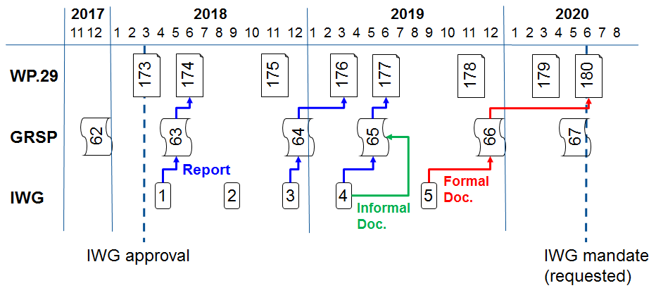

Annex III

**[Français seulement]**

**Proposition d’amendements au Règlement no 11 (Serrures et organes de fixation des portes)**

**Texte adopté sur la base du document GRSP-63-02 (voir le paragraphe 14 du présent rapport)**

*Paragraphes 6.3.1 et 6.3.2,* modifier comme suit :

« 6.3.1 Chaque porte doit être équipée d'au moins un dispositif de verrouillage qui, lorsqu'il est en position fermée, bloque la poignée extérieure ou toute autre commande extérieure d'ouverture, et **qui dispose d’un moyen de manœuvre et d’un dispositif d’engagement / désengagement situé à** l'intérieur du véhicule.

6.3.2 Portes latérales arrière

Chaque porte latérale arrière doit être équipée d'au moins un dispositif de verrouillage qui, lorsqu'il est en position fermée, bloque la poignée intérieure ou toute autre commande intérieure d'ouverture, et qui nécessite **des manœuvres** **distinctes** pour **déverrouiller** **la porte et actionner la poignée intérieure ou toute autre commande intérieure d’ouverture**.»

Annex IV

Draft amendments to UN Regulation No. 14 (Anchorages of safety-belts)

Amendments adopted to ECE/TRANS/WP.29/GRSP/2018/12 (see para. 15 to the report)

*Annex 5,*

*Figure 1,* correct to read:

"



**510**

*Figure 1a,* correct to read:

"

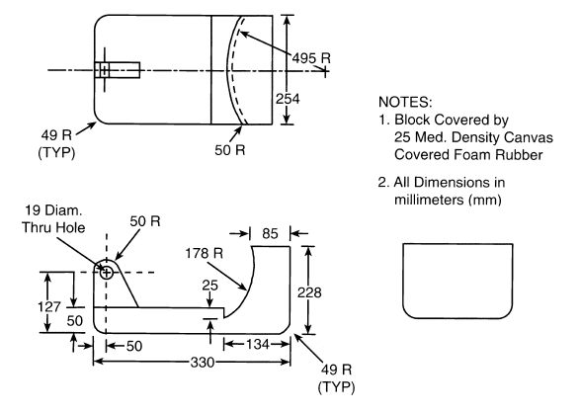  
"

Annex V

**[English only]**

Draft amendments to UN Regulation No. 16 (Safety-belts)

Amendments adopted on the basis of GRSP-62-04 (see para. 17 of this report)

*Annex XVI,* amend to read:"

| *Minimum requirements for safety-belts and Retractors* | | | | | | | | |
| --- | --- | --- | --- | --- | --- | --- | --- | --- |
| *Vehicle category* | *Forward facing seating positions* | | | | | | *Rearward-facing*  *seating positions* | *Side-facing seating position* |
| *Outboard seating positions* | | | *Centre seating position* | | |
| *Front* | | *Other than front* | *Front* | | *Other than front* |
| M1 | Ar4m | | Ar4m | Ar4m | | Ar4m | B, Br3, Br4m | - |
| M2 < 3.5 t | Ar4m, Ar4Nm | | Ar4m, Ar4Nm | Ar4m, Ar4Nm | | Ar4m, Ar4Nm | Br3, Br4m, Br4Nm | - |
| M2 > 3.5 t | Br3, Br4m, Br4Nm, or Ar4m or Ar4Nm ● | | Br3, Br4m, Br4Nm, or Ar4m or Ar4Nm ● | Br3, Br4m, Br4Nm or Ar4m or Ar4Nm ● | | Br3, Br4m, Br4Nm or Ar4m or Ar4Nm ● | Br3, Br4m, Br4Nm | - |
| M3 | Br3, Br4m, Br4Nm, or Ar4m or Ar4Nm ●  See para. 8.1.7. for conditions when a lap belt is permitted | | Br3, Br4m, Br4Nm, or Ar4m or Ar4Nm ●  See para. 8.1.7. for conditions when a lap belt is permitted | Br3, Br4m, Br4Nm or Ar4m or Ar4Nm ●  See para. 8.1.7. for conditions when a lap belt is permitted | | Br3, Br4m, Br4Nm or Ar4m or Ar4Nm ●  See para. 8.1.7. for conditions when a lap belt is permitted | **Br3, Br4m, Br4Nm** | B, Br3, Br4m, Br4Nm |
| N1 | Ar4m, Ar4Nm | | Ar4m, Ar4Nm, Br4m, Br4Nm Ø | B, Br3, Br4m, Br4Nm or A, Ar4m, Ar4Nm\* 1 | | B, Br3, Br4m, Br4Nm | B, Br3, Br4m, Br4Nm | - |
|  | | Para. 8.1.2.1. lap belt permitted if seat is inboard of a passageway | Para. 8.1.6. lap belt permitted if the windscreen is not in the reference zone | |  |  |  |
| N2 | Br3, Br4m, Br4Nm orAr4m, Ar4Nm\*  Para. 8.1.6. lap belt permitted if the windscreen is outside the reference zone and for the driver's seat | | B, Br3, Br4m, Br4Nm | B, Br3, Br4m, Br4Nm, or A, Ar4m, Ar4Nm\*  Para. 8.1.6. lap belt permitted if the windscreen is not in the reference zone | | B, Br3, Br4m, Br4Nm | B, Br3, Br4m, Br4Nm | - |
| N3 | Br3, Br4m, Br4Nm orAr4m, Ar4Nm\*  Para. 8.1.6. lap belt permitted if the windscreen is outside the reference zone and for the driver's seat | | B, Br3, Br4m, Br4Nm | B, Br3, Br4m, Br4Nm, or A, Ar4m, Ar4Nm\*  Para. 8.1.6. lap belt permitted if the windscreen is not in the reference zone | | B, Br3, Br4m, Br4Nm | B, Br3, Br4m, Br4Nm | - |
| A: three-point (lap and diagonal) belt 3: automatically locking retractor | | B: 2-point (lap) belt 4: emergency locking retractor | | | r: retractor N: higher response threshold | | m: emergency locking retractor with multiple sensitivity | |
| \*: Refers to para. 8.1.6. of this Regulation 2 | | Ø: Refers to para. 8.1.2.1. of this Regulation | | | ●: refers to para. 8.1.7. of this Regulation2 | | (see Regulation No. 16, paras. 2.14.3. and 2.14.5.) | |
| 1 Erratum to Supplement 12 to the 04 series of amendments, applicable "*ab initio*."  2 Erratum to Revision 4, applicable "*ab initio*."  *Note*: In all cases all S-type belts may be fitted in place of all possible A or B type belts, provided their anchorages comply with Regulation No. 14.  Where a harness belt has been approved as a S-type belt according to this Regulation, using the lap belt strap, the shoulder belt straps and possibly one or more retractors, one or two additional crotch straps including their attachments for their anchorages may be provided by the manufacturer/applicant. These additional anchorages need not meet the requirements of Regulation No. 14 (Erratum to Supplement 14 to the 04 series of amendments, applicable "*ab initio*.")." | | | | | | | | |

"

Annex VI

Draft amendments to UN Regulation No. 17 (Strength of seats)

Amendments adopted to ECE/TRANS/WP.29/GRSP/2018/4 (see para. 19 to the report)

…

*Paragraphs 5.16.1. and 5.16.2.*, amend to read:

"5.16.1. Seat-backs

…

During the … In case of damage to a **safety-belt** retractor, it shall be verified that the retractor is locked **as a result of the test** or that it can be locked by a manual pull out of the strap.

…

5.16.2. Partitioning systems

…

… be present. In case of damage to a **safety-belt** retractor, it shall be verified that the retractor is locked already or that it can be locked by a manual pull out of the strap."

…

*Annex 9, insert a new paragraph 2.1.1.7.*, to read:

"2.1.1.7. All seating … safety-belt **providing the restraining function** that are part of the seat."

Annex VII

Terms of Reference for the informal working group of Regulation No. 22 (Protective Helmets)

Adopted text based on GRSP-63-26 (see para. 21 to this report)

A. Introduction

1. In December 2017, the Working Party on Passive Safety (GRSP) agreed on the need to update the UN Regulation No. 22 according to the new research results in biomechanics on head protection and to seek the consensus from WP.29.

2. In March 2018, the World Forum for Harmonization of Vehicle Regulations (WP.29) gave its general support for the GRSP proposal to establish an informal working group (IWG) to work on updating the UN Regulation No. 22 under the framework of the 1958 Agreement.

3. The purpose of this document is to set forth the Terms of Reference (ToR) for the IWG including objective, scope, operating principles, timeline and deliverables.

B. Objective of the working group

4. Based on the accident data analysis available and experience, the objective of the IWG is to develop additional safety provisions that were either not ready to be included into UN Regulation No. 22 and/or required additional research. The IWG will also update/clarify existing requirements and test procedures in UN Regulation No. 22

5. The scope of work for the IWG shall include the following items. Should additional items be proposed, the IWG will decide by consensus on their inclusion:

(a) New test and criteria following the progress in research for head protection improvement (e.g.: Rotational Acceleration Protection, harmonization head form, etc.);

(b) Requirements for new features to take into account:

(i) Lightening equipment;

(ii) Cameras;

(iii) Removable chinbar;

(iv) Sunshield;

(v) Audio-phone equipment;

(vi) Design equipment;

(vii) Aeration (to improve helmet wearing).

(b) New Type Approval Marking System to prevent counterfeit, to backup enforcement and police control, and to provide complementary information to the consumer (e.g. year of production).

C. Operating principles

(a) The IWG is a sub-group of the Working Party on Passive Safety (GRSP) and it is open to all participants of GRSP including contracting parties and non-governmental organizations to the 1958 and 1998 Agreements;

(b) The IWG will report to the GRSP and WP.29;

(c) The official language of the IWG will be English;

(d) All documents must be submitted to the Secretary of the group in a suitable electronic format at least (10) working days before the meeting. The documents will be posted on the United Nations website at least (5) working days in advance of the meetings;

(e) The Secretary of the IWG will distribute a draft meeting minutes to all members within (15) working days after the meetings with a view to formal adoption at the next meeting;

(f) Decisions and proposals of the group shall be reached by consensus. When consensus cannot be reached, the Chairs of the group may present the different points of view and seek guidance from GRSP, as appropriate;

(g) Meetings shall be held in agreement with the majority of the participants based on the joint proposal by the Chairs of the IWG. Meetings may be in person or virtual using web-based technology;

(h) A provisional agenda shall be drawn up by the IWG leadership. The first item of the provisional agenda for each session shall be the adoption of the agenda. The second item shall be the minutes of the previous session followed by technical discussions and miscellaneous items.

D. Timeline and deliverables

May 2018: First IWG meeting, report to GRSP and adoption of the ToR;

November 2018: Report to the World Forum for Harmonization of Vehicle Regulations (WP.29) and adoption of ToR;

December 2018: Second IWG meeting and report to GRSP – informal proposal;

March 2019: Report to WP.29 on the IWG progress of work;

May 2019: Third IWG meeting and report to GRSP – official proposal;

June 2019: Report to WP.29 on the IWG progress of work (announcing the official proposal for the November 2019 session);

November 2019: Submission of the official proposal to the World Forum for Harmonization of Vehicle Regulations (WP.29) and the Executive Committee for the 1958 Agreement (AC.1) for consideration and vote;

Between meetings of the IWG meetings some task forces may be arranged by IWG participant to speed up and detail the preparation of the proposal.

Annex VIII

Draft amendments to UN Regulation No. 95 (Lateral collision)

Amendments adopted to ECE/TRANS/WP.29/GRSP/2017/40 (see para. 27 to the report)

*Paragraph 5.3.1*., amend to read:

"5.3.1. No door shall open during the test.

**This requirement is deemed to be fulfilled:**

**(a) if it is clearly visible, that the door lock is latched; or**

**(b) if the door does not open under a static tractive force of at least 400 N in the y-direction applied to the door, according to the Figure below, as close as possible to the window sill and to the edge of the door opposite to the hinged side, except to the door handle itself.**

**Figure**

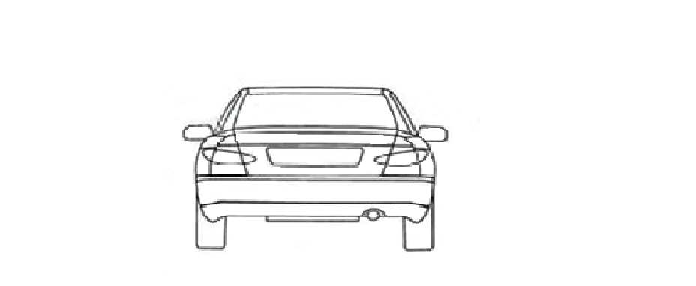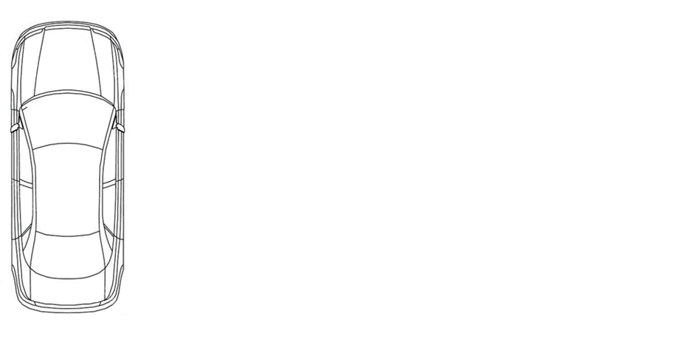

90° +/- 5°

90° +/- 5°

90° +/- 5°

400N

400N

400N

Z

Y

X

Y

"

**…**

Annex IX

Draft amendments to UN Regulation No. 129 (Enhanced Child Restraint Systems)

Amendments adopted to ECE/TRANS/WP.29/GRSP/2018/14, ECE/TRANS/WP.29/GRSP/2018/15 and ECE/TRANS/WP.29/GRSP/2018/16 (see para. 31 of this report)

*Paragraph 6.7.1.4*. amend to read:

"6.7.1.4. It shall be possible to release the child from the restraint by a single operation on a single buckle**. A further single operation may be used to release a** shoulder strap positioner, if any. **In such cases, it shall be possible to release the shoulder strap positioner before as well as after release of the buckle, or simultaneously.** It is allowed to remove the child together with devices such asinfant carrier/carry-cot/carry-cotrestraints if the Enhanced Child Restraint System can be released by operation of a maximum of two release buttons."

Adopted text based on GRSP-63-08-Rev.1 (see para. 34 to this report)

**I. Proposal for Supplement 8 to the 00 series of amendments Supplement 5 to the 01 series of amendments to UN Regulation No. 129**

*Paragraph 14.2.2*. amend to read:

"14.2.2. For Specific vehicle category Enhanced Child Restraint Systems**,** information on the applicable vehicle**, in at least a physical version,** shall …;"

*Paragraph 14.2.3*. amend to read:

"14.2.3. The Enhanced Child Restraint manufacturer shall provide information on the exterior packaging as to the address **in a physical or a digital version** to which ..;"

**II. Proposal for Supplement 4 to the 02 series of amendments**

**to Regulation No. 129**

*Paragraph 14.2.3*. amend to read:

"14.2.3. For Specific vehicle category Enhanced Child Restraint Systems**,** information on the applicable vehicle**, in at least a physical version,** shall ...;"

*Paragraph 14.2.4*. amend to read:

"14.2.4. The Enhanced Child Restraint manufacturer shall provide information on the exterior packaging as to the address **in a physical or a digital version** to which …;"

**III. Proposal for Supplement 1 to the 03 series of amendments to Regulation No. 129**

*Paragraph 14.2.4*. amend to read:

"14.2.4. For Specific vehicle category Enhanced Child Restraint Systems, information on the applicable vehicle**, in at least a physical version,** shall ...;"

*Paragraph 14.2.5*. amend to read:

"14.2.5. The Enhanced Child Restraint manufacturer shall provide information on the exterior packaging as to the address **in a physical or a digital version** to which …;"

Adopted text based on GRSP-63-10-Rev.1 (see para. 35 to this report)

**I. Proposal for Supplement 5 to the 01 series of amendments and Supplement 4 to the 02 series of amendments to UN Regulation No. 129**

*Paragraph 6.6.4.4.1.2.1. amend to read:*

"6.6.4.4.1.2.1. Head excursion: … first.

Except when testing using Q6 dummy where:

The value in relation to the FD plane is 840 mm.

**In the case of contact of such an Enhanced Child Restraint System with the 100 mm diameter bar and all injury assessment and dummy head displacement criteria are met, there shall be one further dynamic test (front impact) with the heaviest dummy intended for the given range of size indication and without the 100 mm diameter bar; the requirements for this test are that all criteria other than forward displacement shall be met.**

Where a test is ...

…"

**II. Proposal for Supplement 1 to the 03 series of amendments**

**to Regulation No. 129**

*Paragraph 6.6.4.4.1.2.1.,* amend to read:

"6.6.4.4.1.2.1. Head excursion: … first.

Except when testing using Q6 or Q3 dummy where the value in relation to the FD plane is 840 mm.

**In the case of contact of such an Enhanced Child Restraint System with the 100 mm diameter bar and all injury assessment and dummy head displacement criteria are met, there shall be one further dynamic test (front impact) with the heaviest dummy intended for the given range of size indication and without the 100 mm diameter bar; the requirements for this test are that all criteria other than forward displacement shall be met.**

Where a test is ...

…"

Annex X

Collective draft amendments to UN Regulations Nos. 16, 44, 94, 129 and 137

Amendments adopted to ECE/TRANS/WP.29/GRSP/2017/27 (see para. 42 to this report)

I. Proposal for the 08 series of Amendments to UN Regulation No. 16 (Safety belts)

*Insert new paragraph 8.1.7.4.*, to read:

"**8.1.7.4. Paragraphs 8.1.7.1. – 8.1.7.3. shall not apply to a driver’s seat.**"

*Insert new paragraphs 8.1.8. and 8.1.8.1.,* to read:

"**8.1.8. The vehicle shall carry information to the effect that it is equipped with frontal protection airbags for seats.**

**8.1.8.1. For a vehicle fitted with an airbag assembly intended to protect the driver, this information shall consist of the inscription "AIRBAG" located in the interior of the circumference of the steering wheel; this inscription shall be durably affixed and easily visible**"

*Paragraph 8.1.8.*, **renumber as 8.1.8.2.** and amend to read:

"8.1.8.2. Every passenger seating position which is fitted with a frontal protection airbag shall …"

*Paragraph 8.1.9.*, renumber as 8.1.8.3. and amend to read:

"8.1.8.3. In the case of a frontal protection airbag **placed before** the front passenger seat**s**, the warning shall be durably affixed … interior of the vehicle.

If the vehicle … at all times.

In the case of a frontal protection airbag for other **passenger** seats in the vehicle … child restraint on that seat.

**This paragraph and paragraph** **8.1.8.2.** do not apply to those **passenger** seating positions equipped with a device ..."

*Paragraph 8.1.10.*, **renumber as 8.1.8.4.** and amend to read:

"8.1.10. Detailed information, … as a minimum, **this information shall include at least** **the following text**:

"NEVER … can occur" **[[1]](#footnote-2)9**

The text shall …"

*Paragraph 8.1.11.*, renumber as paragraph 8.1.9.

*Paragraph 8.4.1.1., the reference to footnote 9and footnote 9,* renumber asfootnote 10

*Paragraph 15.5. to 15.10.*, renumber as paragraphs 15.4.1. to 15.4.6.

*Insert new paragraphs 15.5. to 15.5.7.*, to read:

"**15.5. As from the official date of entry into force of the 08 series of amendments, no Contracting Party applying this UN Regulation shall refuse to grant or refuse to accept UN type approvals under this UN Regulation as amended by the 08 series of amendments.**

**15.5.1. As from 1 September 2020, Contracting Parties applying this UN Regulation shall not be obliged to accept UN type approvals to the preceding series of amendments that were first issued on or after 1 September 2020.**

**15.5.2. Until 1 September 2022, Contracting Parties applying this UN Regulation shall accept UN type approvals to the preceding series of amendments that were first issued before 1 September 2020.**

**15.5.3. As from 1 September 2022, Contracting Parties applying this Regulation shall not be obliged to accept type approvals issued to the preceding series of amendments to this Regulation.**

**15.5.4. Notwithstanding paragraph 15.5.3., Contracting Parties applying the UN Regulation shall continue to accept UN type approvals of safety-belts and restraint systems to the preceding series of amendments to the UN Regulation.**

**15.5.5. Notwithstanding paragraph 15.5.3., Contracting Parties applying the UN Regulation shall continue to accept UN type approvals to the preceding series of amendments to the UN Regulation, for vehicles which are not affected by the changes introduced by the 08 series of amendments.**

**15.5.6. Contracting Parties applying this UN Regulation shall not refuse to grant UN type-approvals according to any preceding series of amendments to this UN Regulation or extensions thereof.**"

*Annex 2*, amend to read:

"Annex 2

…

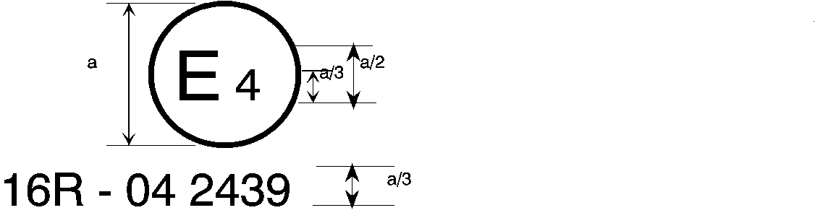

08 2439

The above … amended by the **08** series of amendments.

…

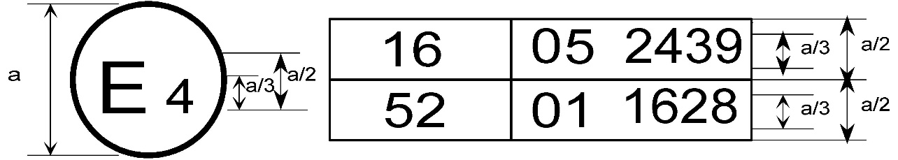

08 2439

The above … included the **08** series of amendments and Regulation No. 52 the 01 series of amendments.

…

2. Arrangements of the safety-belt approval marks (see paragraph 5.3.5. of this Regulation)



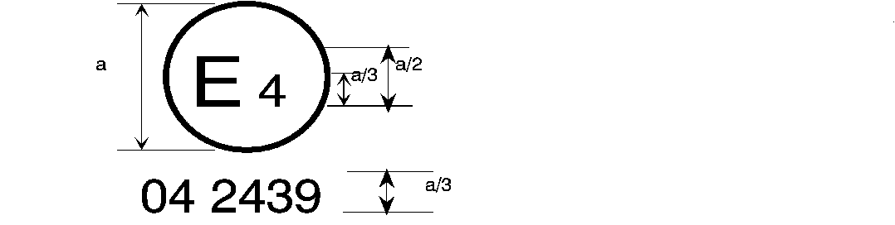

08 2439

a = 8 mm min.

The belt … the 06**, 07 or 08** series of amendments at the time of approval.

###### B → 4 m



08 2489

The belt … 06**, 07 or 08** series of amendments at the time of approval.

…

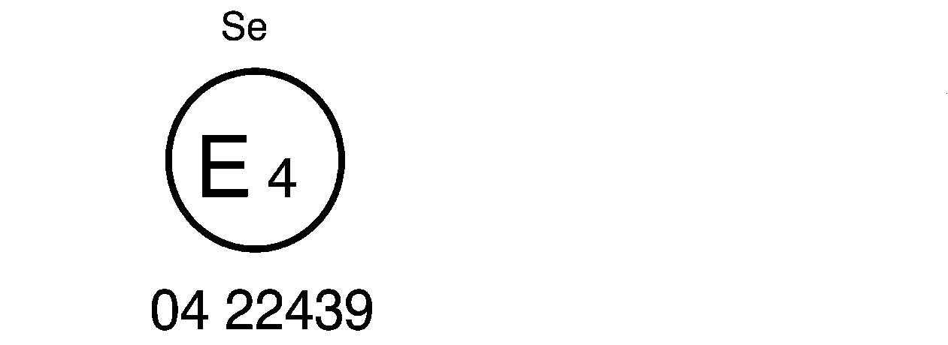

08 22439

The belt bearing … the 06**, 07 or 08** series of amendments at the time of approval.

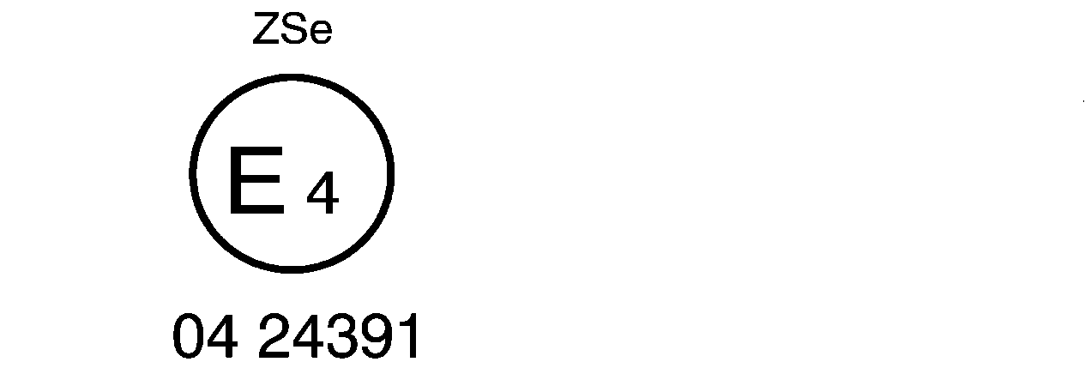

08 24391

5

The belt … the 06**, 07 or 08** series of amendments at the time of approval.



a ≥ 8 mm

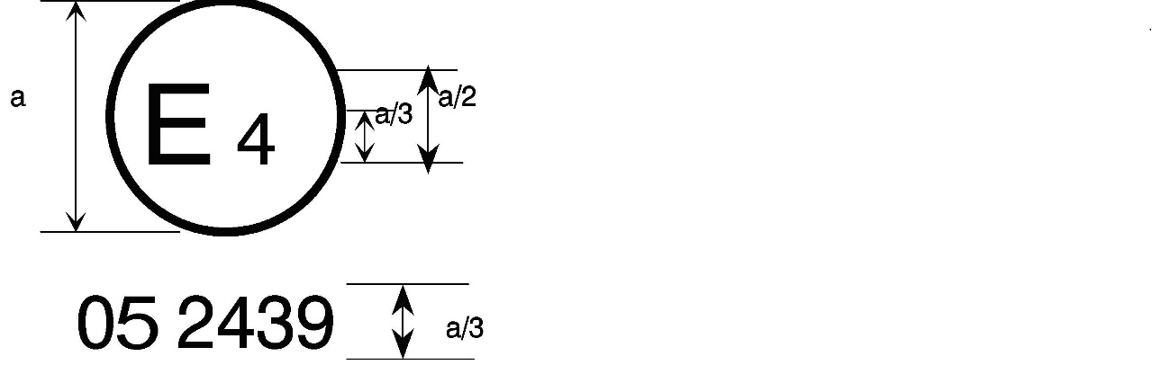

08 2439

a = 8 mm min.



The belt … the 06**, 07 or 08** series of amendments at the time of approval. This belt shall not be fitted to vehicles of category M1.

**Aer4m**

**E4**

**AIRBAG**

**082439**

The … 06**, 07 or 08** series of amendments at the time of the approval. This safety-belt has to be fitted to a vehicle equipped with an airbag in the given seating position."

II. Proposal for Supplement 15 to the 04 series of Amendments to UN Regulation No. 44 (Child Restraint Systems)

*Paragraph 4.4.*, amend to read:

"4.4. On the visible inner surface (including the **inside surface of a** side wing beside the child's head) …"

III. Proposal for Supplement 1 to the 03 series of Amendments to UN Regulation No. 94 (Frontal collision protection)

*Paragraphs 6.1. to 6.1.1.*, shall be deleted.

*Paragraph 6.1.2.*, renumber as 6.1. and amend to read:

"**6.1.** For a vehicle fitted **with airbag** **assemblies** intended to protect **the driver** **and** occupants other than the driver, **compliance with paragraphs 8.1.8. to 8.1.9. of UN Regulation No 16 as amended by the 08 Series of amendments shall be demonstrated as from 1 September 2020 for new vehicle types. Before this date the relevant requirements of the preceding Series of amendments apply**."

…

IV. Proposal for Supplement 5 to the 01 series of Amendments, Supplement 4 to the 02 series of Amendments and Supplement 1 to the 03 series of amendments to UN Regulation No. 129 (Enhanced Child Restraint Systems)

*Paragraph 4.4.*, amend to read:

"4.4. On the visible inner surface (including the **inside surface of a** side wing beside the child's head) …"

V. Proposal for Supplement 2 to the 01 series of Amendments to UN Regulation No. 137 (Frontal collision with focus on restraint systems)

*Paragraphs 6.1. to 6.1.1.*, shall be deleted.

*Paragraph 6.1.2.*, renumber as 6.1. and amend to read:

"**6.1.** For a vehicle fitted with **airbag assemblies** intended to protect **the driver** **and** occupants other than the driver, **compliance with paragraphs 8.1.8. to 8.1.9. of UN Regulation No. 16 as amended by the 08 Series of amendments shall be demonstrated as from 1 September 2020 for new vehicle types. Before this date the relevant requirements of the preceding Series of amendments apply**."

…

Annex XI

[English only]

List of GRSP informal working groups

|  |  |  |  |
| --- | --- | --- | --- |
| *Informal working group* | *Chair* | *Expiry date of the mandate [pending WP.29 decision]* | *Secretary* |
| Harmonized side impact dummies | Mr. David Sutula (USA)  Phone: +1 202 366 32 73  Fax: +1 202 493 29 90  Email: david.sutula@dot.gov | December 2017 |  |
| Head Restraints  (GTR7-Phase 2) | Mr. Bernard Frost (UK)  Phone: +44‑(0)207 9442107  Fax: +44‑(0)207 9449623  Email: [bernie.frost@dft.gsi.gov.uk](mailto:bernie.frost@dft.gsi.gov.uk_) | June 2018 | OICA |
| UN GTR No. 9 on Pedestrian Safety Deployable – Pedestrian Protection Systems (DPPS) | Mr. Jin Seop Park (Republic of Korea)  Email: jspark@kotsa.or.kr | [June 2020] | OICA |
| UN GTR No. 9 (Pedestrian Safety)  (GTR9-Phase 2) | Mr. Richard Damm (Germany)  Phone: +49 (0) 228 99 300 4302 Fax: +49 (0) 228 99 300 807 4302 Email: richard.damm@bmvi.bund.de | December 2018 | OICA |
| UN GTR No. 20 (EVS) – Phase 2 | Mr. N. Nguyen (USA), (vice-chaired by the European Union and China) Phone: +1 202 366 69 34 Fax: +1 202 493 29 90 Email: [nha.nguyen@dot.gov](mailto:nha.nguyen@dot.gov) | December 2021 | Japan |
| Three-dimensional H-point machine | Mr. L. Martinez (Spain)  Phone: +34 91 336 53 00  Fax: +34 91 336 53 02  Email: [luis.martinez@upm.es](mailto:luis.martinez@upm.es) | […] |  |
| UN GTR No. 13 (HFCV) | Mr. N. Nguyen (USA)  Phone: +1 202 366 69 34 Fax: +1 202 493 29 90 Email: [nha.nguyen@dot.gov](mailto:nha.nguyen@dot.gov) Mr. M. Takahashi (Japan) | December 2020 | […] |
| Protective helmets | Mr. Luca Rocco  Phone: +39 06 4158 3268  Fax: +39 06 4158 3253  Email: [luca.rocco@mit.gov.it](mailto:luca.rocco@mit.gov.it) | [December 2019] |  |

1. **9 Unrelated to type approval, Contracting Parties may specify in which languages the text shall be provided with each vehicle placed on the market at the point of sale within their territory**." [↑](#footnote-ref-2)