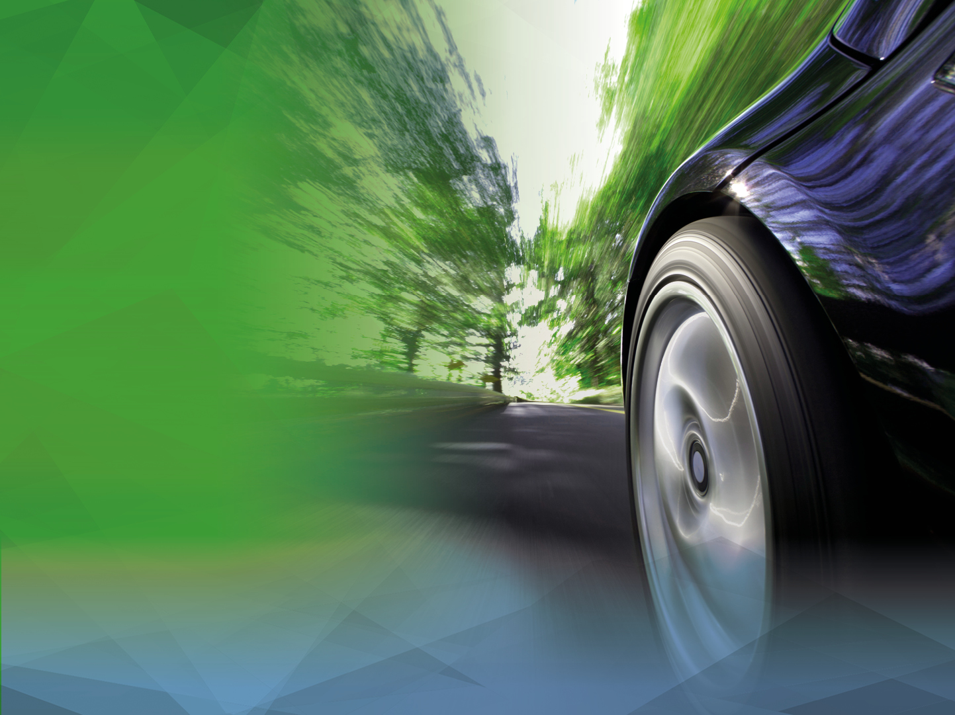
TPMS Fitment and Tyre Inflation Pressures

Field Study
EU 2016/2017

1. Executive Summary 4
2. Background 5
3. Purpose of the Study 6
4. Approach 6
4.1 Tyre temperature 6
4.2 Load state 7
4.3 Locations 8
4.4 Equipment 8
4.4.1 Pressure gauges 8
4.4.2 Thermometers 8
4.5 Vehicle data 8
4.6 TPMS fitment 8
5. Statistics 8
5.1 Study design: Sample sizes 8
5.2 Standard deviations, sample sizes and resolutions 9
6. Proceedings 10
6.1 Staff education 10
6.2 Locations 10
6.2.1 Sweden 10
6.2.2 Germany 10
6.2.3 Spain 10
6.3 Data collection on location 11
6.4 Exclusion of vehicles 11
6.5 Data check 11
7. Results 11
7.1 Data structure 11
7.2 Vehicle age and Tyre pressure maintenance 12
7.3 Average inflation pressures: CO₂-saving 12
7.4 Pressure distribution: Road safety 13
7.5 Dangerous under-inflation and TPMS reset function 14

8. Certification 14
8.1 Linköping, Sweden: TÜV Nord Sweden AB 14
8.2 Hanau, Germany: DEKRA Assurance Services GmbH 14
8.3 Madrid, Spain: TÜV Süd 15
9. “Open source” and further steps 15
10. References 15
11. Appendices: 15

Executive Summary

A field study on tyre inflation pressures and TPMS fitment on passenger cars has been carried out in Sweden, Germany and Spain between November 2016 and August 2017. The study was initiated by NIRA Dynamics AB and Dunloptech GmbH, both known as suppliers for indirect Tyre Pressure Monitoring Systems. A total of 1470 randomly selected cars have been checked mainly at filling stations and shopping malls. While in the beginning the data collection was conducted by the companies themselves, already at an early stage of the study technical services (TÜV Nord and DEKRA) had been involved to certify the data collection. Furthermore, the entire data collection in Spain was conducted by TÜV Süd.

The study was the first of its kind worldwide covering all types of TPMS and taking into account the specific tyre inflation pressure recommendations for cold tyres as well as the actual tyre temperatures at the time of measurement.

Key findings:

- TPMS fitment increases the average inflation pressure by at least 3% and reduces the likelihood of tyres being operated severely underinflated by more than 75%.

- dTPMS and iTPMS are equally effective.

- When vehicles with pressure of 150 kPa or below have been observed, the vehicle was not equipped with TPMS or, for TPMS equipped vehicles, a pressure warning was issued.

Background

A Tyre Pressure Monitoring System (TPMS) is defined as

“…a system fitted on a vehicle, able to perform a function to evaluate the inflation pressure of the tyres or the variation of this inflation pressure over time and to transmit corresponding information to the user while the vehicle is running;” [1]

In the European Union the mandatory fitment of Tyre Pressure Monitoring Systems (TPMS) for vehicles of category M1 (passenger cars) is required by the General Safety Regulation R(EC) No. 661/2009 Since 1 November 2012 all new types of passenger cars and since 1 November 2014 all passenger cars being registered for the first time have to be equipped with Tyre Pressure Monitoring Systems complying with UN Regulation No. 64.
In addition to the European Union other contracting parties to the United Nations Economic Commission for Europe (UN ECE) 1958 Agreement signed and apply this Regulation, either by mandating TPMS complying to UN Regulation No. 64 or as “if-fitted” requirement. Signatories include countries such as Japan, the Russian Federation, Turkey, Malaysia, Georgia and Egypt.

In June 2016 UN ECE’s World Forum for Harmonization of Vehicle Regulations (WP.29) adopted a new Regulation on TPMS which entered into force on 22 January 2017, since a split of UN Regulation No. 64 became necessary in view of the upcoming United Nations International Whole Vehicle Type Approval (I-WVTA) process. Therefore, the new UN Regulation No. 141 is to be seen as a stand-alone regulation on Tyre Pressure Monitoring Systems and will replace in the future the existing UN Regulation No. 64. While the majority of the TPMS content was taken from UN Regulation No. 64 to the new UN Regulation No. 141 without changes, some amendments had been made. Such changes included a clarification that TPMS should work not only under test conditions, but over a wide range of environmental conditions.

Still, the two main issues addressed by TPMS Regulation are benefits for road safety and the reduction of CO₂ emission.

Currently, there are two competing TPMS technologies in place, both complying to the UN Regulations and delivering the required performance:

iTPMS:

Indirectly measuring, software-based systems, which by evaluating and combining existing sensor signals like wheel speeds, accelerometers, driveline data, etc. estimate and monitor the tyre pressure without physical pressure sensors in the wheels.

dTPMS:

Directly measuring, hardware-based systems. In each wheel, most often on the inside of the valve, there is a battery-driven pressure sensor which transfers pressure information to a central control unit.

Purpose of the Study

Since the mandatory introduction of TPMS, there have been discussions about the two competing technologies and their advantages and disadvantages, but most of these discussions were based on constructed scenarios often with roots in the knowledge of technical details with little or no relation to user relevant scenarios and empirical findings.

The ultimate purpose of a TPMS can only be that the driver who receives an inflation pressure warning from the TPMS takes adequate corrective actions like driving carefully, stopping the vehicle safely and checking the tyres, changing a wheel or filling up pressure.

This leads to the conclusion that the effectiveness of TPMS can be objectively measured only by studying the inflation pressures of vehicles without TPMS and comparing them with vehicles equipped with TPMS in the same market and run under comparable conditions. Furthermore, in this scenario the effectiveness of iTPMS and dTPMS can be compared with each other.

This is for the first time possible in a large market like the EU where all three variants of vehicles can be found on the streets simultaneously (no TPMS fitment, iTPMS or dTPMS respectively).

The present study will hence contribute to a constructive and fact-based discussion about the effects of the existing TPMS regulation and potential motivations and approaches for its review.

Approach

A TPMS shall issue a warning as soon the inflation pressure in one or several of the tyres is below a certain threshold relative to the recommended pressure. For TPMS compliant to R64 (R141 as follow up regulation), this warning threshold is 20% below the recommended pressure, see the original regulation for more details. The tyre pressure recommendation can differ mainly depending on the following factors:

- Tyre dimension and type
- Position on the vehicle (front or rear axle)
- Load state of the vehicle
- Expected driving speed range

Without properly determining these factors, a correct determination of the tyre inflation pressure recommendation is not possible. This leads then to the situation that the current under/over inflation status cannot be determined either.

Tyre temperature
As tyres warm up during driving - which increases the tyre pressure - and the amount of warm-up is depending on many varying factors, the recommended tyre pressure is always given for cold tyres. This means that tyres shall be at ambient temperature when adjusting their pressure.

To measure whether a tyre is underinflated or not, one needs to compare the recommended tyre pressure for the current situation with the actual cold pressure. This is reliably possible only after the vehicle has been standing still at least for one hour and been protected from sunlight and other heating or cooling influences. For a field study, where large numbers of vehicles need to be checked in short time, this is a major difficulty.

Earlier studies have tried to solve this for example by assuming a constant offset of 30 kPa between warm and cold tyres. This can be appropriate for very coarse measurements of tyre pressure, but for the investigation of small differences of the magnitude of 1% or smaller, this is not sufficient.

An alternative approach which was used for this study is to measure not only the actual pressure, but also the tyre and ambient temperatures and compensate the measured warm pressure with the temperature difference to obtain a calculated cold pressure.

A number of simple tests showed that if the tyre temperature is measured on the outer sidewall of the tyre and several measurements (>2) per tyre get averaged, this value and its difference to the ambient temperature can be used for a sufficiently accurate and reliable calculation of the cold pressure. The following formula based on the gas equation for a constant amount of ideal gas enclosed in a constant volume has been used:

$$P_{cold}=\frac{\left(P_{measured}+P_{a}\right)*\left(t_{a}+273K\right)}{\left(t_{tire}+273K\right)}-P_{a}$$

with

P_{a}: Ambient atmospheric pressure (standard pressure 101,5 kPa at sea level)
P_{cold}: (Calculated) cold tyre inflation pressure relative to P_{a}
P_{measured}: Measured tyre inflation pressure relative to P_{a}
t_{a}: Ambient temperature in ºC
t_{Tyre}: Tyre temperature in ºC

This method has been verified according to the following procedure:

- Measure the ambient temperature, cold pressures and tyre temperatures of a car which has been parked outdoors in the shadow for more than 1 hour
- Drive the car for at least 20 min (best above 40 km/h).
- Stop the car and repeat the measurements.
- Calculate the cold pressures using the above formula and compare with the measured cold pressures.

Significant deviations could only be noticed in cases when the outside of a tyre intentionally had been exposed to intensive sunshine for a short while directly before taking the measurements.

Load state
The vehicle’s load state has been determined subjectively by trained staff. A measurement of the vehicle axle loads would not have been realistic for a field study, especially taking into account that the recommendations given in the owner’s manuals and with the placard pressure stickers on the vehicle are not given as exact load figures but simplifying pictograms.

The following guidelines have been used:

“Empty”: 1-2 adults in the front seats, only light luggage (briefcase, small sports bag), empty trunk.
“Full”: 1-3 adults in the rear seats and/or heavy luggage in the trunk.

In cases of doubt, the vehicle should rather be regarded as “full”.

A “medium” load state, which was used early in the campaign, has been given up later as it turned out that too few vehicles had placard pressures for three load categories.

Locations
To cover data that is as representative as possible for the whole EU, three locations were chosen, one in Scandinavia (Linköping, S) with severe winter conditions and a usual switch between summer and winter wheels, one in southern Europe (Madrid, E) where drivers normally do not switch between summer and winter wheels and one intermediate (Hanau, D) where some drivers switch, some do not. The tyre or wheel switch is an important factor as it is assumed that at least at each switch the opportunity is taken to check and adjust the tyre pressure.

Equipment

Pressure gauges
In Sweden and in Spain, pressure gauges of the type Keller Leo II were used. In Germany, pressure gauges of the type PCE-P50 were used.

Thermometers
For the tyre and environmental temperature measurements in Sweden and Spain, Fluke 62 MAX thermometers have been used. For the tyre and environmental temperature measurements in Germany, a PCE-880 thermometer was used.

Vehicle data
In Sweden, only the registration numbers were documented. Technical data of the car like first registration, type approval date, VIN etc. can then be looked up based on the registration number on a publicly available homepage of the road authorities. In Germany, both the registration number and the model year (MY) derived from the VIN were documented. Same applies to the data from Spain.

TPMS fitment
The general method used to verify TPMS fitment of a vehicle was to put the ignition into “ON” position and check whether a TPMS warning symbol lights up in the instrument cluster (legally mandated lamp check function). Once a car was identified as TPMS-fitted, the data collector noted a preliminary judgement which type of TPMS is presumably fitted. This preliminary judgement was mainly based on the brand, model and age of the vehicle. Example: A MY 2015 VW Golf in the EU is known to be fitted with an iTPMS whereas a MY 2016 BMW can only be fitted with a dTPMS. Each data set got then verified with respect to TPMS fitment and type by experts from NIRA Dynamics and Dunlop Tech. In case of doubt or data inconsistencies, data sets got excluded from the study.

Statistics

Study design: Sample sizes
For a large vehicle population, a normal distribution of pressures is assumed to be a good approximation of the pressure distribution. Aiming at a confidence level of 95% (z = 1,96), and a target resolution of 1% = 0,01, the following applies for the sample size

$$n≥\frac{z^{2}*s^{2}}{e^{2}}$$

with $s=\frac{MAX-MIN}{3,5}$ and expected values of MAX = 1,5 and MIN = 0,5 one receives s = 0,28571
as initial value before the study.
A minimum sample size of $n≥3136$ should hence be reached. A key issue for sample sizes is the question whether a vehicle with four tyres and their averaged pressures shall be regarded as one individual sample or whether each tyre shall be regarded as one individual sample. The inflation pressure is very, but not entirely, dependent on the habits of the vehicle user and hence, the four tyre samples for each vehicle are not fully independent.

On the other hand, there are phenomena like punctures and uneven pressures on the same axle – especially without TPMS, which for example can compromise vehicle stability. The fact that all four tyres on a vehicle have correct pressures on average does not mean that not one tyre is severely underinflated whereas another has much too high pressure.

It was decided to regard every tyre as an individual sample and collect data from at least 400 vehicles (=1600 samples) at each location to reach a total sample size of about 4800 tyres.

Additionally, each total subsample (iTPMS, dTPMS) from all locations should cover around 300 cars (1200 tyres) each.

Standard deviations, sample sizes and resolutions
The following standard deviations can be calculated from the collected data for the total sample and various subsamples:

Total sample s = 0,2065
without TPMS s = 0,2620
TPMS s = 0,1097
iTPMS s = 0,1084
dTPMS s = 0,1115

Table 1: Standard deviations for total sample and subsamples

Based on these standard deviations, the theoretical minimum and factual sample sizes are

Theor. Min. Factual
without TPMS n > 2638 n = 3152
TPMS n > 463 n = 2728
iTPMS n > 452 n = 1256
dTPMS n > 478 n = 1472

Table 2: Minimum and factual sample sizes

With the standard deviation and the factual sample sizes known, the achieved resolutions for the subsamples can now be re-determined with z = 1,96 from
$$e=√\left(\frac{z^{2}*s^{2}}{n}\right)$$

STDDEV Sample size Resolution
without TPMS s = 0,2620 n = 3152 e = 0,91%
TPMS s = 0,1097 n = 2728 e = 0,41%
iTPMS s = 0,1084 n = 1256 e = 0,60%
dTPMS s = 0,1115 n = 1472 e = 0,57%

Table 3: Achieved resolutions for subsamples, based on Tables 1 and 2

Proceedings

Staff education
All data collection staff had been educated and trained before the study to ensure the best possible efficiency and data quality. The education covered at least the following issues and was carried out by qualified engineers with experience in the TPMS business:
- Basic tyre information
- Tyre thermodynamics: Pressure & temperature
- Basic principles of dTPMS, iTPMS and RFWS.
- Legal requirements on TPMS: Warning symbols, warning thresholds, etc.
- Correct operation of the measuring equipment
- Where to find the recommended tyre pressure(s)
- Load state estimation
- Data documentation: VIN, registration number, etc.

Locations

Sweden
The data got collected between November 2016 and February 2017 mainly at three different filling stations around Linköping (Shell Valla, Shell Herrbeta North, Shell Herrbeta South). As in Sweden winter tyres are mandated in case of “wintery road conditions”, only very few vehicles had not already been equipped with winter tyres (wheels).

Germany
The data got collected between December 2016 and August 2017 at five different filling stations in the Hanau/Frankfurt area. As in Germany winter tyres are mandatory in case of “wintery road conditions”, only few vehicles had not already been equipped with winter tyres (wheels) or all-season tyres (wheels).

Spain
The Spain data has been collected by TÜV Süd at various locations around Madrid during July and August 2017. Most of the cars have been equipped with summer tyres, some with all season tyres.

Data collection on location
On arrival of a vehicle, a team of 2-3 technicians approached the driver of the vehicle asking for permission to join the study and get the tyre pressure checked. Once the permission was given, one or two team members checked TPMS fitment and status, load state, tyre dimension and recommended pressures whereas the remaining team member documented the data which was transmitted orally. This team member also had the responsibility for data quality, integrity and completeness. In case of inappropriate tyre inflation pressures, the team offered the driver to correct the pressures.

Exclusion of vehicles
Only M1 vehicles and N1 vehicles not equipped with C-tyres and four single tyres were included in the study as only for these R64/141 applies.

Also vehicles with severely underinflated tyre(s) were excluded if they were TPMS equipped and the TPMS had already issued a warning. As the TPMS in such cases obviously was working correctly, either the driver had been ignoring the warning or not have had the opportunity to take care of it. In the first case, the TPMS is ineffective, in the latter case it is effective. A necessary objective differentiation between the two cases would entirely be dependent on the subjective perspective of the driver about the urgency of a TPMS warning. It was hence decided to exclude such vehicles from the study.
So-called run-flat-warning systems (RFWS) were excluded from the study as they cannot monitor all four tyre positions simultaneously and serve partly different purposes than current full-scale TPMS. Older dTPMS and iTPMS types potentially not being R64/141-compliant, but offering a four tyre monitoring function were included in the study as they can be supposed to have very similar effects to current TPMS.

Vehicles where the recommended pressure could not be reliably determined – for example with tyre dimensions not covered by the placard sticker or different dimensions mounted on the same axle – were also excluded from the study.

Data check
If the data had been collected on paper, it then got entered into a standardized excel spreadsheet which automatically performed analysis functions like pressure normalization, averaging and classification. Every data set got checked again by expert personnel not involved in the actual collection for consistency and plausibility. Typical examples of errors removed in this stage were obviously wrong TPMS classifications (see Section 6), but also typos. In case of remaining doubt, the data set got excluded.

Results

Data structure
1470 valid data sets (vehicles) have been collected, whereof 738 (50,2%) in Germany, 421 (28,6%) in Spain and 311 (21,2%) in Sweden.

Despite the mandatory fitment of TPMS to new vehicles since November 2014, the majority of passenger cars (54%) still has no TPMS. This figure is not entirely representative as in the latter part of the study, younger vehicles most likely equipped with TPMS have been preferred over older vehicles wherever possible. Purpose was to achieve sufficient subsamples for iTPMS and especially dTPMS. The fraction of vehicles without TPMS is supposedly higher in the total population.

Vehicle age and tyre pressure maintenance
A common assumption is that tyre pressure maintenance would correlate with vehicle age. The underlying hypothesis is that owners or users of newer vehicles are more thorough with maintenance and hence check the tyre pressures more frequently. If this was true, the study results could be biased as younger vehicles are much more likely to be equipped with TPMS and hence would be over-represented in the subsamples with TPMS.

To verify this, a sufficiently large and homogenous subsample is needed meaning that it should be as free as possible from other potential influences, like TPMS fitment or cultural and regional factors. Therefore, the data collected in Germany from all vehicles without TPMS has been analyzed (391 vehicles, n=1564). If younger vehicles were better taken care of than older ones in terms of Tyre pressure, they should have higher average inflation pressures.

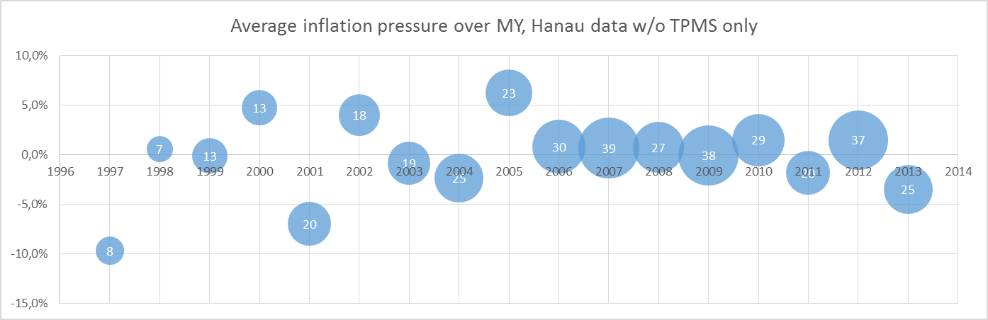

Figure 1: Relative inflation pressure over vehicle age (bubble size/white figures: No. of vehicles).

As can be seen from Figure 1, the sample sizes for ~2000 and older are too small to allow reliable conclusions and at least the samples for 2001 and 2005 are dominated by single outliers. But there is no recognizable correlation between vehicle age and inflation pressure and hence, any such differences between TPMS-equipped vehicles and those without TPMS cannot be explained by vehicle age.

Average inflation pressures: CO₂-saving
A key indicator for the effectiveness of TPMS regarding CO₂-saving is whether they influence the average inflation pressure.

Average inflation pressure
(relative to recommendation)
Total sample +1,69%
without TPMS +0,11%
with TPMS +3,51%
iTPMS +3,50%
dTPMS +3,53%

Table 4: Average relative inflation pressures

Main finding is that TPMS fitment in general increases the average inflation pressure by more than 3%. Together with a significantly smaller standard deviation (see Table 1), this is a clear indication that TPMS work as intended and help improving tyre pressure maintenance.

Pressure distribution: Road safety
Regarding traffic safety, a reduction in tyres run with severe under-inflation is the major indicator for TPMS to be effective.

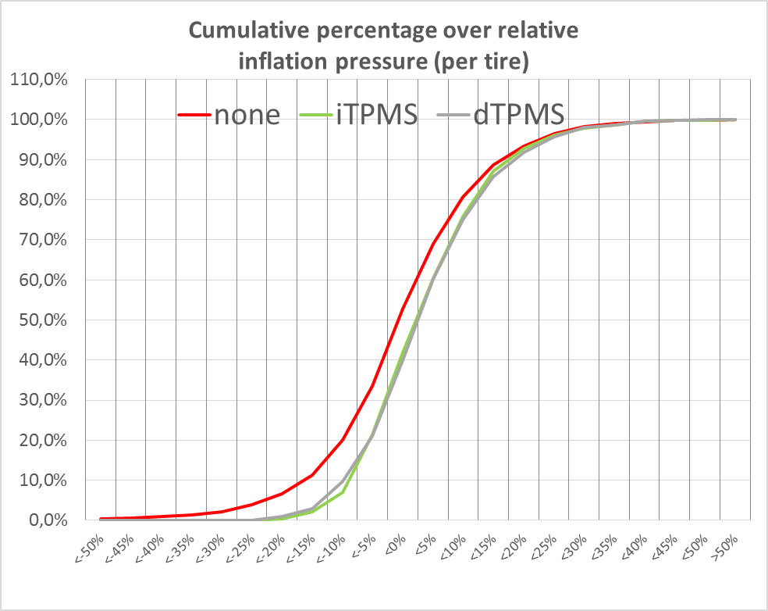

Figure 2: Cumulative fractions (vert.) of total sample over relative tyre inflation (horiz.)

Severe under-inflation can be defined as pressures which are at least below 80% (meaning 20% under-inflation) of the recommended pressure corresponding to the warning threshold according to R64/141. Whereas 6,5% of all tyres on vehicles without TPMS are severely underinflated, the corresponding figure for TPMS fitted vehicles is 0,6%, which is a reduction by more than 90%.
This figure though needs to be regarded as less reliable due to small sample sizes, but to assume a minimum reduction of 75% appears realistic.
The 2012 NHTSA study [2] showed a 55% reduction, but the effective warning thresholds for R64/141 are approximately 50% tighter than those of FMVSS 138 [3].
In general, under-inflation is significantly reduced as can be seen from the horizontal distance between the curves in the left half of Figure 2, whereas over-inflation is only moderately increased. This corresponds well with the smaller standard deviations of the data from vehicles with TPMS.
The differences between dTPMS and iTPMS are not statistically relevant, see also the achieved resolutions in Table 3.

Dangerous under-inflation and TPMS reset function
A special analysis has been done for tyres with pressures below 150 kPa. Passenger car tyres are designed for minimum pressures around 150 kPa which means that below this pressure, there is an imminent risk that the tyres will slide from their beads into the rim when for example cornering hard, losing all their pressure instantaneously. This is a definitely dangerous scenario.

Most vehicles have varying pressure recommendations and hence, many TPMS have a so-called reset function which allows the driver to adapt the TPMS warning threshold to the inflation pressure recommended for the current tyre choice or driving situation. An absolute minimum reset pressure of 150 kPa is therefore currently being discussed for R141 under which a TPMS shall not accept a reset. Whereas for dTPMS with their absolute pressure measurements, this appears at least feasible, for iTPMS, this was impossible to implement as the technology does not allow the measurement of absolute pressures. A key question is hence whether there are vehicles where the TPMS reset function has been used inadequately and hence are running with at least one tyre below 150 kPa and no TPMS warning.

In the whole study, there were 46 tyres at or below a normalized pressure of 150 kPa found on vehicles without TPMS. In all the cases where such tyres were found on TPMS-equipped vehicles, a low pressure warning had already been issued and hence, the vehicles were excluded from the study database (see Section 9).

It can be concluded that a total sample of 682 TPMS-fitted cars did not deliver any indication that the introduction of an absolute minimum pressure of 150 kPa in R141 would increase traffic safety.

Certification

Linköping, Sweden: TÜV Nord Sweden AB
During data collection in Sweden, an employee of TÜV Nord Sweden AB was temporarily present verifying that the used procedures, equipment, collected data, analysis tools and calculations are correct and appropriate for the purpose. The data collected in Sweden under direct supervision of TÜV Nord and that collected without supervision show no statistical differences. See Appendix 3 for further details.

Hanau, Germany: DEKRA Assurance Services GmbH
During data collection in Germany, an employee of DEKRA Assurance was temporarily present verifying that the used procedures, equipment, collected data, analysis tools and calculations are correct and appropriate for the purpose.

Madrid, Spain: TÜV Süd
All data collection in Spain has been carried out by TÜV Süd Spain staff using the same procedures, data sheets and methods as for the other data.

“Open source” and further steps
The study is intended to be continued and/or repeated also by other parties than those involved until now, be it to verify the current results or to further monitor the situation.
For this purpose, the data sheets including all calculation schemes and analysis functions will be made available on demand to any interested party. The same applies for the raw data with the only limitation that VIN and registration numbers cannot be published as these must be considered personal data of the vehicle drivers who have not consented to such a publication.

References
[1]: UN ECE R 141: ‘Regulation No. 141 - Uniform provisions concerning the approval of vehicles with regard to their Tyre Pressure Monitoring Systems (TPMS)’, http://www.unece.org/fileadmin/DAM/trans/main/wp29/wp29regs/2017/R141e.pdf

[2]: ’Evaluation of the Effectiveness Of TPMS in Proper Tyre Pressure Maintenance’ (DOT HS 811 681), NHTSA 2012, https://crashstats.nhtsa.dot.gov/Api/Public/ViewPublication/811681

[3]: FMVSS No. 138: ‘49 CFR 571.138 - Standard No. 138; Tyre pressure monitoring systems’, https://www.gpo.gov/fdsys/granule/CFR-2011-title49-vol6/CFR-2011-title49-vol6-sec571-138

Appendices:

Appendix 1: Raw vehicle data (PDF)
Appendix 2: Calculation and analysis sheet (MS Excel)
Appendix 3: TÜV Nord report (Sweden)
Appendix 4: DEKRA report (Germany)
Appendix 5: TÜV Süd report (Spain)

