|  |  |
| --- | --- |
| Submitted by the IWG on WLTP | Informal document **GRPE-77-17**  77th GRPE, 6-8 June 2018,  agenda item 3(b) |

**Proposal for amendments to GRPE-76-26r1e**

The text reproduced below was prepared by the IWG on Worldwide harmonized Light vehicles Test Procedure (WLTP). The modifications to the current text of GRPE-76-26r1e are marked in bold for new or struck through for deletion.

Proposal

*I. Statement of technical rationale and justification, A. Introduction, 1.*,amend to read:

"The compliance with emission standards is a central issue of vehicle certification worldwide. Emissions comprise criteria ~~pollutants~~ **emissions** having a direct (mainly local) negative impact on health and environment, as well as pollutants having a negative environmental impact on a global scale. Regulatory emission standards typically are complex documents, describing measurement procedures under a variety of well-defined conditions, setting limit values for emissions, but also defining other elements such as the durability and on-board monitoring of emission control devices."

Correction/justification: The term "emissions" more correctly represents the various compounds emitted from vehicles.

Proposal

*II.Text of the global technical regulation, 3. Definitions*,amend to read:

"3.1.15. "*Zero gas*" means a gas containing no analyte**,** which is used to set a zero response on an analyser."

Correction/justification: Editorial (comma deleted).

Proposal

*II.Text of the global technical regulation, 3. Definitions*,amend to read:

"3.3. Pure electric, **pure ICE**, hybrid electric, fuel cell and alternatively-fuelled vehicles"

Correction/justification: Adds those vehicles which have no element of electric propulsion.

Proposal

*II.Text of the global technical regulation, 3. Definitions*,amend to read:

"3.4.3. "*Peripheral devices*" means **any** energy consuming, converting, storing or supplying devices, where the energy is not ~~primarily~~ **directly or indirectly** used for the purpose of vehicle propulsion **but**~~, or other parts, systems and control units,~~ which are essential to the operation of the powertrain **and are therefore considered to be part of the powertrain**."

Correction/justification: The current definition of peripheral devices does not say that they are part of the powertrain. They were clearly intended to be so as seen in Mutual Resolution (M.R.2) containing Vehicle Powertrain Definitions.

Furthermore, the last phrase is for consistency with the definition of *auxiliary devices*.

Proposal

*II.Text of the global technical regulation, 4. Abbreviations*,amend to read:

"**CFD Computational fluid dynamics**"

Correction/justification: The term "computational fluid dynamics" is used in GTR 15 but the abbreviation CFD is a widely-used term in engineering.

Proposal

*II. Text of the global technical regulation, 5. General requirements*,amend to read:

"5.3.2. The type of fuel for emissions testing shall be as specified in Annex 3 ~~to~~ **of** this UN GTR."

Correction/justification: Editorial.

Proposal

*II. Text of the global technical regulation, 7. Rounding,* amend to read:

"**7. Rounding**

**7.1. When the digit immediately to the right of the last place to be retained is less than 5, that digit shall remain unchanged.**

**Example:**

**If a result is 1.234 grams but only two places of decimal are to be retained, the final result shall be 1.23 grams.**

**7.2. When the digit immediately to the right of the last place to be retained is greater than or equal to 5, that digit shall be increased by 1.**

**Example:**

**If a result is 1.236 grams but only two places of decimal are to be retained, and because 6 is greater than 5, the final result is 1.24 grams."**

Correction/justification: The term "rounding" and "rounded" are often used in the GTR. This proposal defines a consistent rounding procedure.

Proposal

*Annex 1, paragraph 1.*,amend to read:

"The cycle resulting from the requirements described in this annex shall be referred to in other parts of ~~the~~ **this** UN GTR as the "applicable cycle".

Correction/justification: Editorial.

Proposal

*Annex 1, paragraph 8.3.*,amend to read:

"The resulting fdsc ~~is~~ **shall be** ~~mathematically~~ rounded **according to paragraph 7. of this UN GTR** to 3 places of decimal and ~~is~~ **shall be** applied only if it exceeds 0.010."

Correction/justification: Amended to include reference to paragraph 7. on rounding.Also, editorial amendments.

Proposal

*Annex 1, paragraph 9.2.2.1.*,amend to read:

"The number of time samples nadd,medium with vi = vcap to be added to the medium speed phase of the interim capped speed cycle equals Δtmedium, ~~mathematically~~ rounded **according to paragraph 7. of this UN GTR** to the nearest integer (e.g. 1.4 shall be rounded to 1, 1.5 shall be rounded to 2)."

Correction/justification: Amended to include reference to paragraph 7. on rounding.

Proposal

*Annex 1, paragraph 9.2.2.2.*,amend to read:

"The number of time samples nadd,exhigh with vi = vcap to be added to the extra high speed phase of the interim capped speed cycle equals Δtexhigh, ~~mathematically~~ rounded **according to paragraph 7. of this UN GTR** to the nearest integer."

Correction/justification: Amended to include reference to paragraph 7. on rounding.

Proposal

*Annex 1, paragraph 9.2.2.3.*,amend to read:

"The number of time samples nadd,exhigh with vi = vcap to be added to the extra high speed phase of the interim capped speed cycle equals Δtexhigh, ~~mathematically~~ **rounded according to paragraph 7. of this UN GTR** to the nearest integer."

Proposal

*Annex 1, paragraph 9.2.3.2.1.*,amend to read:

"The length of the final capped speed cycle is equivalent to the length of the base cycle except for differences caused by the rounding process **according to paragraph 7. of this UN GTR** for nadd,medium, nadd,high and nadd,exhigh.

Correction/justification: Amended to include reference to paragraph 7. on rounding.

Proposal

*Annex 1, paragraph 9.2.3.2.2.*,amend to read:

"The length of the final capped speed cycle is equivalent to the length of the base cycle except for differences caused by the rounding process **according to paragraph 7. of this UN GTR** for nadd,high and nadd,exhigh."

Correction/justification: Amended to include reference to paragraph 7. on rounding.

Proposal

*Annex 1, paragraph 9.2.3.2.3.*,amend to read:

"The length of the final capped speed cycle is equivalent to the length of the base cycle except for differences caused by the rounding process **according to paragraph 7. of this UN GTR** for nadd,exhigh."

Correction/justification: Amended to include reference to paragraph 7. on rounding.

Proposal

*Annex 2, paragraph 2.(c).*,amend to read:

"The value to be used in this annex shall be the arithmetic average over the measuring period, rounded ~~or truncated~~ to the nearest 10 min-1;"

Correction/justification: Amended to include reference to paragraph 7. on rounding.

Proposal

*Annex 2, paragraph 2.(e).*,amend to read:

"(n/v)i, the ratio obtained by dividing the engine speed n by the vehicle speed v for each gear i, for i = 1 to ng~~max~~ , min-1/(km/h). (n/v)i shall be calculated according to the equations in paragraph 8. of Annex 7;"

Correction/justification: Consistency in the use of ng as in paragraph 2.(d). Agreed by experts at IWG #22, Ispra.

Proposal

*Annex 2, paragraph 2.(g)*, amend to read:

nmax2 = (n/v)(ng~~max~~) × vmax,cycle

nmax3 = (n/v)(ng~~max~~) × vmax,vehicle

Correction/justification: In the aim of consistency with paragraph 2.(d), ng is used instead of ngmax. Agreed by experts at IWG #22, Ispra.

Proposal

*Annex 2, paragraph 2.(g)*, amend to read:

"~~ng~~~~vmax~~ ~~is defined in paragraph 2.(i) of this annex;~~

vmax,cycle is the maximum speed of the vehicle speed trace according to Annex 1, km/h;

vmax,vehicle is the maximum speed of the vehicle according to paragraph 2.(i) of this annex, km/h;

(n/v)(ngvmax) is the ratio obtained by dividing engine speed n by the vehicle speed v for the gear ngvmax, min-1/(km/h );

**ngvmax is defined in paragraph 2.(i) of this annex**;

nmax is the maximum of nmax1, nmax2 and nmax3, min-1."

Correction/justification: The equation is not changed but the order of defining the parameters is more logical.

Proposal

*Annex 2, paragraph 2.(i).*,amend to read:

"Vehicle speed values **rounded according to paragraph 7. of this UN GTR** to one place of decimal shall be used for the determination of vmax and ngvmax."

Correction/justification: Amended to include reference to paragraph 7. on rounding.

Proposal

*Annex 2, paragraph 2.(i).*,amend to read:

"The available power at vehicle speed vmax in gear ng, gear ng - 1 or gear ng-2 ~~may~~ **shall** be determined from the full load power curve, Pwot(n), by using the following equations:"

Correction/justification: The available power shall be determined from the full load power curve using the specified equations, and not optionally as the word "may" implies.

Proposal

*Annex 2, paragraph 2.(i)*,amend to read:

" ngvmax = ng~~max~~ and vmax = nlim / (n/v)(ng~~max~~)"

Correction/justification: In the aim of consistency with paragraph 2.(d), ng is used instead of ngmax. Agreed by experts at IWG #22, Ispra.

Proposal

*Annex 2, Figure A2/1a, Title*,amend to read:

"An example where ng**v**max is the highest gear"

Correction/justification: Incorrect title (ngmax is replaced by ngvmax). Agreed by experts at IWG #22, Ispra.

Proposal

*Annex 2, Figure A2/1b, Title*,amend to read:

"An example where ng**v**max is the 2nd highest gear"

Correction/justification: Incorrect title (ngmax is replaced by ngvmax). Agreed by experts at IWG #22, Ispra.

Proposal

*Annex 2, paragraph 2.(k).*,amend to read:

"The final results for nmin_drive shall be rounded **according to paragraph 7. of this UN GTR** to the nearest integer. ~~Example: 1199.5 becomes 1200, 1199.4 becomes 1199.~~"

Correction/justification: Amended to include reference to paragraph 7. on rounding.

Proposal

*Annex 2, paragraph 3.2.*,amend to read:

"For each vj ≥ 1 km/h of the cycle trace and each gear i, i = 1 to ng~~max~~, the engine speed, ni,j,shall be calculated using the following equation:"

Correction/justification: For consistency, ngmax is replaced by ng.

Proposal

*Annex 2, paragraph 3.3.*,amend to read:

"(a) All gears i < ngvmax where nmin_drive ≤ ni,j ≤ **nmax1**~~n~~~~max_95~~;

(b) All gears i ≥ ngvmax where nmin_drive ≤ ni,j ≤ **nmax2**~~n~~~~max(~~~~ng~~~~vmax)~~;

Correction/justification: Agreed by experts at IWG #22, Ispra.

Proposal

*Annex 2, paragraph 3.3.*,amend to read:

"3.3. Selection of possible gears with respect to engine speed

The following gears may be selected for driving the speed trace at vj:

(a) All gears i < ngvmax where nmin_drive ≤ ni,j ≤ nmax1;

(b) All gears i ≥ ngvmax where nmin_drive ≤ ni,j ≤ nmax2;

(c) Gear 1, if n1,j < nmin_drive.

~~If a~~~~j~~ ~~≤ 0 and n~~~~i,j~~ ~~≤ n~~~~idle~~~~, n~~~~i,j~~ ~~shall be set to n~~~~idle~~ ~~and the clutch shall be disengaged.~~

**If aj < 0 and ni,j ≤ nidle, ni,j shall be set to nidle and the clutch shall be disengaged.**

~~If a~~~~j~~ ~~> 0 and n~~~~i,j~~ ~~≤ (1.15 × n~~~~idle~~~~), n~~~~i,j~~ ~~shall be set to (1.15 × n~~~~idle~~~~) and the clutch shall be disengaged.~~

**If aj ≥ 0 and ni,j < max(1.15 × nidle ; min. engine speed of the Pwot(n) curve), ni,j shall be set to the maximum of 1.15 × nidle or (n/v)i x vj and the clutch shall be set to “undefined”.**

**“undefined” covers any status of the clutch between disengaged and engaged, depending on the individual engine and transmission design. In this case the real engine speed may deviate from the calculated engine speed.**"

Correction/justification: The minimum engine speed of the power curve was changed from nidle to nmin_drive_set. The amendments are necessary since no power check can be performed in this engine speed range. Agreed by experts at IWG #22, Ispra.

Proposal

*Annex 2, paragraph 4.(a)*,amend to read:

"If a one step higher gear (n+1) is required for only 1 second and the gears before and after are the same (n) or one of them is one step lower (n – 1), gear (n + 1) shall be corrected to gear n.

Examples:

Gear sequence i - 1, i, i - 1 shall be replaced by:

i - 1, i - 1, i - 1;

Gear sequence i - 1, i, i - 2 shall be replaced by:

i - 1, i - 1, i - 2;

Gear sequence i - 2, i, i - 1 shall be replaced by:

i - 2, i - 1, i - 1.

Gears used during accelerations at vehicle speeds ≥ 1 km/h shall be used for a period of at least 2 seconds.

**Examples:**

~~(e.g. a g~~**G**ear sequence 1, 2, 3, 3, 3, 3, 3 shall be replaced by:

1, 1, 2, 2, 3, 3, 3~~)~~.

**Gear sequence 1, 2, 3, 4, 5, 5, 6, 6, 6, 6, 6 shall be replaced by:**

**1, 1, 2, 2, 3, 3, 4, 4, 5, 5, 6.**

**This requirement shall not be applied to downshifts during an acceleration phase or if the use of a gear for just one second follows immediately after such a downshift. SuchIn these cases, the downshifts shall be corrected first according to paragraph 4.(b) of this annex.**

**Example:**

**Gear sequence 4, 4, 3, 4, 5, 5, 5, where the first second determines the start of an acceleration phase, shall be replaced by:**

**4, 4, 4, 4, 5, 5, 5.**

Gears shall not be skipped during acceleration phases.

However, an upshift by two gears is permitted at the transition from an acceleration phase to a constant speed phase if the duration of the constant speed phase exceeds 5 seconds."

Correction/justification: Clarification of the gears to use during accelerations at vehicle speeds ≥ 1 km/h for a period of at least 2 seconds, and to avoid misinterpretations. Agreed by experts at IWG #22, Ispra.

Proposal

*Annex 2, paragraph 4.(b)*,amend to read:

"If a downshift is required during an acceleration phase, the gear which is required during this downshift ~~is~~ **shall be** noted (iDS). **The starting point of a correction procedure is defined by either the last previous second when iDS was identified or by the starting point of the acceleration phase if all time samples before have gears > iDS.** ~~The last previous second where i~~~~DS~~ ~~shall be identified and defines the start point of a correction procedure.~~ **The highest gear of the time samples before the downshift determines the reference gear iref for the downshift. A downshift where iDS = iref – 1 is referred to as a one step downshift, a downshift where iDS = iref – 2 is referred to as a two step downshift.** The following check shall then be applied.

Working ~~backwards~~ **forward** from the **starting point of the correction procedure to the** end of the acceleration phase, the latest occurrence of a 10 second window containing iDS for either 2 or more consecutive seconds, or 2 or more individual seconds, shall be identified. The last usage of iDS in this window defines the end point of the correction procedure. Between the start and end of the correction period, all requirements for gears greater than iDS shall be corrected to a requirement of iDS.

**If one step downshifts as well as two step downshifts occur during an acceleration phase, two step downshifts shall be corrected before one step downshifts are corrected. In this case, the starting point of the correction procedure for the one step downshifts is the second immediately following the end of the correction period for the two step downshifts. If a two step downshift occurs after a one step downshift, it shall overrule the one step downshift in the time period before the two step downshift.**

From the end of the correction period **(in case of 10 second windows containing iDS for either 2 or more consecutive seconds, or 2 or more individual seconds) or from the starting point of the correction procedure (in case all 10 second windows contain iDS only for one second or some 10 second windows contain no iDS at all)** to the end of the acceleration phase, **if the downshift was a one step downshift,** all downshifts with a duration of only one second shall be removed.~~, if the downshift was a one step downshift.~~ If the downshift was a two step downshift, all requirements for gears greater than or equal to iDS up to the latest occurrence of iDS shall be corrected to (iDS + 1).

~~This final correction shall also be applied from the start point to the end of the acceleration phase, if no 10 second window containing iDS for either 2 or more consecutive seconds or 2 or more individual seconds was identified.~~

Examples **are shown in Tables A2/2 to A2/6.**~~:~~

~~(i) If the initially calculated gear use is:~~

~~2, 2, 3, [3, 4, 4, 4, 4, 3, 4, 4, 4, 4], 4, 4, 3, 4, 4, 4,~~

~~the gear use shall be corrected to:~~

~~2, 2, 3, 3, 3, 3, 3, 3, 3, 3, 3, 3, 3, 3, 3, 3, 4, 4, 4.~~

~~(ii) If the initially calculated gear use is:~~

~~2, 2, 3, [3, 4, 4, 3, 4, 4, 4, 4, 4, 4], 4, 4, 4, 4, 3, 4,~~

~~the gear use shall be corrected to:~~

~~2, 2, 3, 3, 3, 3, 3, 4, 4, 4, 4, 4, 4, 4, 4, 4, 4, 4, 4.~~

~~(iii) If the initially calculated gear use is:~~

~~2, 2, 3, [3, 4, 4, 4, 4, 4, 4, 4, 4, 4], 4, 4, 4, 3, 3, 4,~~

~~the gear use shall be corrected to:~~

~~2, 2, 3, 3, 3, 3, 3, 3, 3, 3, 3, 3, 3, 3, 3, 3, 3, 3, 4.~~

~~The first 10 second windows are indicated by square brackets in the examples above.~~

~~The underlined gears (e.g. 3) indicate those cases which could lead to a correction of the gear before it.~~

This correction shall not be performed for gear 1.

**After the application of paragraph 4.(b) of this annex, a downshift by more than one gear could occur at the transition from a deceleration or constant speed phase to an acceleration phase.**

**In this case, the gear for the last sample of the deceleration or constant speed phase shall be replaced by gear 0 and the clutch shall be disengaged. If the “suppress gear 0 during downshifts” option according to paragraph 4.(f) of this annex is chosen, the following lower gear shall be used instead of gear 0.**"

Correction/justification: A downshift by more than 1 gear could occur at the transition from a deceleration or constant speed phase to the acceleration phase. In these cases, the necessary computer program, ACCESS, replaces the gear for the last sample of the deceleration or constant speed phase by gear 0 and sets the clutch “disengaged”. Some text is also required for reasons of clarity. Agreed by experts at IWG #22, Ispra.

Proposal

*Annex 2, Table A2/2, (new table)*, amend to read:

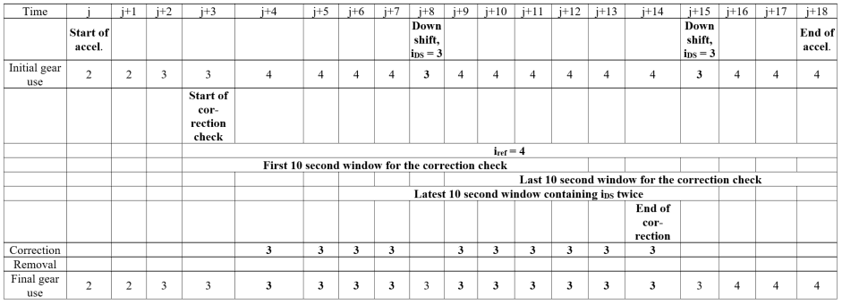

Correction/justification: Clarifies gear use. Agreed by experts at IWG #22, Ispra.

Proposal

*Annex 2, Table A2/3*, *(new table)* amend to read

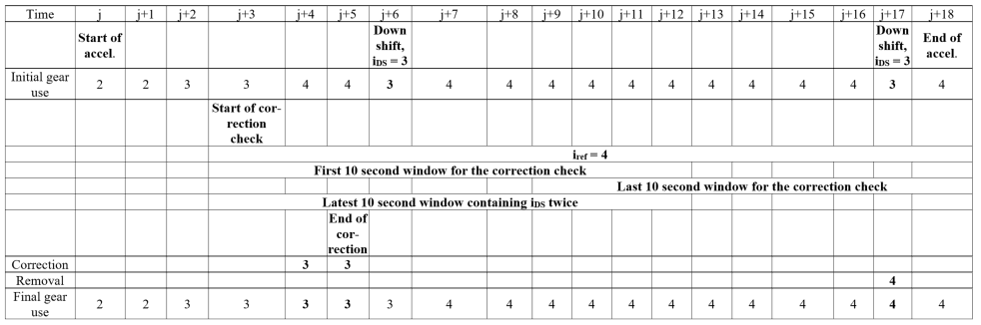

Correction/justification: Clarifies gear use. Agreed by experts at IWG #22, Ispra.

Proposal

*Annex 2, Table A2/4*, *(new table)*,amend to read:

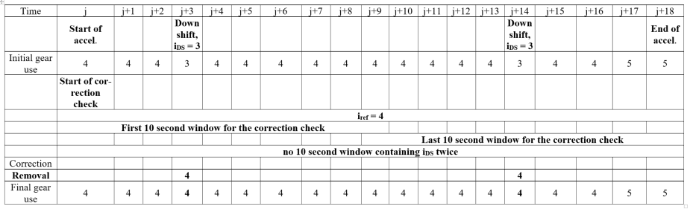

Correction/justification: Clarifies gear use. Agreed by experts at IWG #22, Ispra.

Proposal

*Annex 2, Table A2/5*, *(new table)*,amend to read:

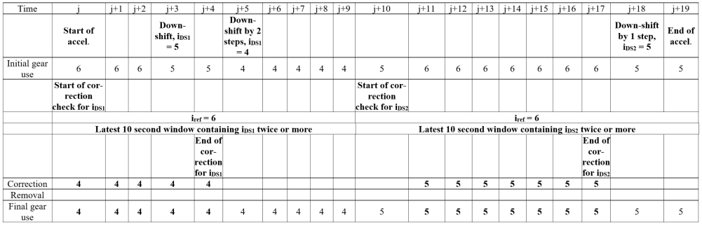

Correction/justification: Clarifies gear use. Agreed by experts at IWG #22, Ispra.

Proposal

*Annex 2, Table A2/6*, *(new table)*,amend to read:

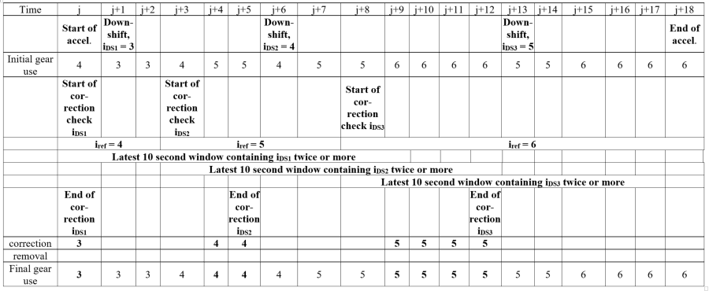

Correction/justification: Clarifies gear use. Agreed by experts at IWG #22, Ispra.

Proposal

*Annex 2, paragraph 4.(c)*,amend to read with this first paragraph:

"**The modification check described in paragraph 4.(c) of this annex shall be applied to the complete cycle trace twice prior to the application of paragraphs 4.(d) to 4.(f) of this annex."**

Correction/justification: Checks the modifications prior to further application of gear shifting requirements. Agreed by experts at IWG #22, Ispra.

Proposal

*Annex 2, paragraph 5.*,amend to read:

"In order to enable the assessment of the correctness of the calculation, the average gear for v ≥ 1 km/h, rounded **according to paragraph 7. of this UN GTR** to four places of decimal, shall be calculated and recorded."

Correction/justification: Amended to include reference to paragraph 7. on rounding.

Proposal

*Annex 4, paragraph 2.4.*,amend to read:

"f0 is the constant road load coefficient and shall be rounded **according to paragraph 7. of this UN GTR** to one place of decimal, N;

f1 is the first order road load coefficient and shall be rounded **according to paragraph 7. of this UN GTR** to three places of decimal, N/(km/h);

f2 is the second order road load coefficient and shall be rounded **according to paragraph 7. of this UN GTR** to five places of decimal, N/(km/h)²."

Correction/justification: Amended to include reference to paragraph 7. on rounding.

Proposal

*Annex 4, paragraph 4.3.1.4.4.*,amend to read:

"The following equation shall be used to compute the arithmetic average of the road load where the harmonic average of the alternate coastdown times shall be used:

$$F_{j }=\frac{1}{3.6} × \left(m_{av}+ m_{r}\right) × \frac{2 × ∆v}{{∆t}_{j}}$$

where:

**Δv is 5 km/h**;"

Correction/justification: Consistent with the equations in paragraphs 8.1.3.2. and paragraph 8.2.4.3. Agreed by experts at IWG #22, Ispra.

Proposal

*Annex 4, paragraph 4.4.3.1.*,amend to read:

" $α_{j}$ is the arithmetic average acceleration, m/s2, ~~which~~ calculated using the following equation:"

Correction/justification: Editorial.

Proposal

*Annex 4, paragraph 4.5.2.*,amend to read:

"The correction factor K0 for rolling resistance, in **Celsius-1** ~~Kelvin-1~~ (**°C-1**~~K~~~~-1~~), may be determined based on empirical data and approved by the responsible authority for the particular vehicle and tyre **combination to be** test**ed**, or may be assumed to be as follows:

~~"~~

Correction/justification: GTR 15 uses °C and not Kelvin. Also, editorial. Agreed by experts at IWG #22, Ispra.

Proposal

*Annex 4, paragraph 4.5.4.*,amend to read:

"K1 = ~~f~~~~0~~ ~~×~~ (1-TM/mav )

where:

~~f~~~~0~~ ~~is a constant term, Nm;~~"

Correction/justification: Incorrect equation.

Proposal

*Annex 4, paragraph 4.5.5.1.*,amend to read:

~~F~~~~*~~~~= ((f~~~~0~~ ~~- w~~~~1~~~~-~~ **~~f~~~~0~~ ~~×~~** ~~K~~~~1~~~~) + f~~~~1~~~~v) × (1 + K~~~~0~~ ~~(T - 20)) + K~~~~2~~~~f~~~~2~~~~v~~~~2~~

"

where:

is the corrected road load, N;

$f_{0}$ is the **constant road load coefficient**, N;

$f_{1}$ is the **first order road load** coefficient, N/(km/h);

$f_{2}$ is the **second order road load** coefficient, N/(km/h)2;"

Correction/justification: First, the equation was corrected as it had an error, the equation was then written more mathematically correct, and propeer terminology was introduced.

Proposal

*Annex 4, paragraph 4.5.5.1.*,amend to read:

"The result of the calculation ~~((f~~~~0~~ ~~– w~~~~1~~ ~~–~~ **~~f~~~~0~~ ~~×~~** ~~K~~~~1)~~ ~~× (1 + K~~~~0~~ ~~× (T-20)))~~ shall be used as the target road load coefficient At in the calculation of the chassis dynamometer load setting described in paragraph 8.1. of this annex."

Correction(/justification: Amendment of the equation based on the preceeding amendment proposal.

Proposal

*Annex 4, paragraph 4.5.5.2.1.*,amend to read:

${"C}^{*}= \left(\left(c_{0}-w_{2}-{c_{0}×K}_{1}\right)+c_{1}v\right) ×\left(1+K_{0}\left(T-20\right)\right)+K_{2}c_{2}v²$"

$C^{*}=\left(\left(c_{0}\left(1-K_{1}\right)- w_{2}\right)+ c_{1}v\right)×\left(1+K_{0}\left(T-20\right)\right)+K_{2}f_{2}v^{2}$"

Correction/justification: First, the equation was corrected as it had an error, and has been written more mathematically correct. Amendment based on the amendments to paragraph 4.5.5.1.

Proposal

*Annex 4, paragraph 4.5.5.2.3.*,amend to read:

"The result of the calculation ~~((c~~~~0~~ ~~– w~~~~2~~ ~~–~~ **~~c~~~~o~~ ~~×~~** ~~K~~~~1~~~~) × (1 + K~~~~0~~ ~~× (T-20)))~~ shall be used as the target running resistance coefficient at in the calculation of the chassis dynamometer load setting described in paragraph 8.2. of this annex."

Correction/justification: Amendment based on the preceeding proposal.

Proposal

*Annex 4, paragraph 5.1.2.1.*,amend to read:

"c1 is the first order ~~road load~~ **running resistance** coefficient, Nm/(km/h), and shall be set to zero;"

Correction/justification: The torque meter method refers to running resistance and not to road load.

Proposal

*Annex 4, paragraph 8.1.3.2.*,amend to read:

"The measured road load shall be calculated using the following equation:

$F_{mj}= \frac{1}{3.6} × \left(TM+ m_{r}\right) × \frac{2 × ∆v}{{∆t}_{j}}$

where:

**Δv is 5 km/h**;"

Correction/justification: Alignment of the use of Δv in equations 8.1.3.2. and 8.2.4.3. Amendments approved at the IWG meeting in Ispra.

Proposal

*Annex 4, paragraph 8.1.3.3.*,amend to read:

"The **coefficients As, Bs and Cs in the road load equation of the** simulated road load on the chassis dynamometer shall be calculated **using a least squares regression analysis:** ~~according to the method as specified in paragraph 4.3.1.4. of this annex, with the exception of measuring in opposite directions:~~

~~F~~~~s~~ ~~= A~~~~s~~ ~~+ B~~~~s~~~~×v + C~~~~s~~~~× v²"~~

Correction/justification: Clarification how road load coefficients As, Bs and Cs are calculated. The equation has been written with the introduction of parentheses for better readability. Amendments approved at IWG 22 (Ispra).

Proposal

*Annex 4, paragraph 8.1.3.3.*,amend to read:

" $F_{sj}=A_{s}+{(B}_{s}×v_{j})+{(C}_{s}×v_{j}^{2}$**)"**

Correction/justification: Introduction of parentheses in the equation for better readability.

Proposal

*Annex 4, paragraph 8.2.4.3.*,amend to read:

"

and additionally: "∆v = ~~10~~**5** km/h"

Correction/justification: Consistency with equation 8.1.3.2.

Proposal

*Annex 5, paragraph 2.2.3.*,amend to read:

"The dynamometer shall have a time measurement system for use in determining acceleration rates and for measuring vehicle/dynamometer coastdown times. This time measurement system shall **not exceed** ~~have~~ an accuracy of ~~at least~~ ±0.001 per cent **after at least 1000 seconds of** operation. ~~and.~~ **This** shall be verified upon initial installation."

Correction/justification: Definition as to when the dyno must fulfil a specified accuracy.

Proposal

*Annex 5, paragraph 2.2.6.*,amend to read:

"The base inertia of the dynamometer shall be stated by the dynamometer manufacturer and shall be confirmed to within ±~~0.5~~**1.0** per cent for each measured base inertia and ±0.2 per cent relative to any arithmetic average value by dynamic derivation from trials at constant acceleration, deceleration and force."

Correction/justification: The value of 1.0 per cent corresponds to that in CFR Title 1066. Agreed by experts at IWG #22, Ispra.

Proposal

*Annex 5, paragraph 2.3.1.2.*,amend to read:

"The speed difference between the front and rear rollers ~~is~~ **shall** be assessed by applying a 1 second moving average filter to roller speed data acquired at a minimum frequency of 20 Hz."

Correction/justification: Editorial.

Proposal

*Annex 5, paragraph 3.3.5.3.*,amend to read:

"A temperature sensor shall be installed immediately before the volume measuring device. This temperature sensor shall have an accuracy of ±1 °C and a response time of **1 second or less** ~~0.1 seconds~~ at 62 per cent of a given temperature variation (value measured in **water or** silicone oil)."

Correction/justification: A response time of less than 1.0 seconds was proposed in Ispra. Yet to be confirmed.

Proposal

*Annex 5, paragraph 3.4.2.4.*,amend to read:

"Ambient temperature, T ±0.2 ~~K~~**°C**

Air temperature at LFE, ETI ±0.15 ~~K~~**°C**

Air temperature at CVS pump inlet, PTI ±0.2 ~~K~~**°C**

Air temperature at CVS pump outlet, PTO ±0.2 ~~K~~**°C**"

Correction/justification: The units of the four temperature-related variables are changed from K to °C in keeping with the rest of GTR 15. Agreed by experts at IWG #22, Ispra.

Proposal

*Annex 5, paragraph 3.4.3.2.*,amend to read:

"LFE air temperature, flow meter, ETI ±0.15 ~~K~~**°C**,

Temperature at venturi inlet, Tv ±0.2 ~~K~~**°C**."

Correction/justification: The units of the two temperature-related variables are changed from K to °C in keeping with the rest of GTR 15. Agreed by experts at IWG #22, Ispra.

Proposal

*Annex 5, paragraph 3.4.5.6.*,amend to read:

"LFE air temperature, flow meter, ETI ±0.15 ~~K~~**°C**,

Temperature at UFM inlet, $T_{act}$ ±0.2 ~~K~~**°C**."

Correction/justification: The units of the two temperature-related variables are changed from K to °C in keeping with the rest of GTR 15. Agreed by experts at IWG #22, Ispra.

Proposal

*Annex 5, paragraph 4.2.2.4.*,amend to read:

" ${Pem}_{f}= {Pem}_{uncorr}×\left(\frac{1-\frac{ρ_{a}}{ρ_{w}}}{1-\frac{ρ_{a}}{ρ_{f}}}\right)$"

Correction/justification: The original variables in the equation and in their definition did not correlate.

Proposal

*Annex 5, Table A5/3*,amend to read:

|  |  |  |
| --- | --- | --- |
| Gas analyser linearization (calibration) | Every 6 months **or after major maintenance** | ±2 per cent of reading |
| Mid-span | Every 6 months **or after major maintenance** | ±2 per cent |
| CO NDIR:  CO2/H2O interference | Monthly **or after major maintenance** | -1 to 3 ppm |
| NOx converter check | Monthly **or after major maintenance** | > 95 per cent |
| CH4 cutter check | Yearly **or after major maintenance** | 98 per cent of ethane |
| FID CH4 response | ~~Yearly~~ **Not applicable** | See paragraph 5.4.3. of this annex. |

Correction/justification: Clarifies the calibration intervals of instruments. Agreed by experts at IWG #22, Ispra.

Proposal

*Annex 6, paragraph 1.2.3.8.*,amend to read:

"Determination of **the acceptance values** dCO21, dCO22 and dCO23"

Correction/justification: The variables dCO21, dCO22 and dCO23 were not defined. Agreed by experts at IWG #22, Ispra.

Proposal

*Annex 6, Table A6/1*,amend to read:

"(1) The declared value shall be the value to which the necessary corrections are applied (i.e. Ki correction and the other regional corrections)

(2) Rounding **according to paragraph 7. of this UN GTR** ~~xxx.xx~~

(3) **Rounding according to paragraph 7. of this UN GTR** ~~xxx.x~~"

Correction/justification: Amended to include reference to paragraph 7. on rounding.

Proposal

*Annex 6, Figure A6/1*,amend to read:

"Any of criteria ~~pollutant~~ **emissions** > Limit" changed in the boxes below "First test", "Second test" and "Third test".

Proposal

*Annex 6, paragraph 2.3.2.3.*,amend to read:

"At the request of the manufacturer and with approval of the responsible authority, the interpolation line may be extrapolated to a maximum of 3 g/km above the CO2 emission of vehicle H and/or below the CO2 emission of vehicle L. **This extension is valid only within the boundaries of the interpolation range specified in this paragraph**."

Correction/justification: Clarification of the magnitude of the extension of the extrapolation line.

Proposal

*Annex 6, paragraph 2.6.6.1.*,amend to read:

"Vehicles equipped with a predominant mode shall be tested in that mode. At the request of the manufacturer, the vehicle may ~~also~~ **alternatively** be tested with the driver-selectable mode in the worst case position for CO2 emissions."

Correction/justification: Clarifies that a vehicle may optionally be tested in a worst-case position for CO2 emissions. Agreed by experts at IWG #22, Ispra.

Proposal

*Annex 6, paragraph 2.6.6.3.*,amend to read:

"At the request of the manufacturer, the vehicle may ~~also~~ **alternatively** be tested with the driver-selectable mode in the worst case position for CO2 emissions."

Correction/justification: Clarifies that a vehicle may optionally be tested in a worst-case position for CO2 emissions. Agreed by experts at IWG #22, Ispra.

Proposal

*Annex 7, paragraph 1.3.2.*,amend to read:

"The final criteria emission results shall be rounded **according to paragraph 7. of this UN GTR** in one step to the number of places to the right of the decimal point indicated by the applicable emission standard plus one additional significant figure."

Correction/justification: Amended to include reference to paragraph 7. on rounding.

Proposal

*Annex 7, paragraph 1.3.3.*,amend to read:

"The NOx correction factor, KH, shall be rounded **according to paragraph 7. of this UN GTR** to two decimal places."

Correction/justification: Amended to include reference to paragraph 7. on rounding.

Proposal

*Annex 7, paragraph 1.3.4.*,amend to read:

"The dilution factor, $DF$, shall be rounded **according to paragraph 7. of this UN GTR** to two decimal places."

Correction/justification: Amended to include reference to paragraph 7. on rounding.

Proposal

*Annex 7, paragraph 1.3.6.*,amend to read:

"~~Rounding of CO~~~~2~~ ~~and fuel consumption results is described in paragraph 1.4. of this annex.~~"

Correction/justification: Paragraph not necessary as paragraph 7. of UN GTR 15 covers rounding.

Proposal

*Annex 7,Table A7/1, step 8,* amend to read:

"For CO2 and FC, the values derived in step 8 shall be used, and CO2 values shall be rounded **according to paragraph 7. of this UN GTR** to two decimal places, and FC values shall be rounded **according to paragraph 7. of this UN GTR** to three decimal places."

Correction/justification: Amended to include reference to paragraph 7. on rounding.

Proposal

*Annex 7,Table A7/1, step 9,* amend to read:

"FC values shall be rounded **according to paragraph 7. of this UN GTR** to one decimal place, expressed in (l/100 km)."

Correction/justification: Amended to include reference to paragraph 7. on rounding.

Proposal

*Annex 7, paragraph 3.2.1.1.1.*, amend to read:

"The mean concentration of a gaseous compound shall be calculated using the following equation:

$$\overline{C_{i}}=\frac{\sum_{phase=1}^{n}{\left(C_{i,phase}×V_{mix,phase}\right)}}{\sum_{phase=1}^{n}{V_{mix,phase}}}$$

where:

$C_{i}$ is mean concentration of a gaseous compound;

$C_{i,phase}$ is the concentration of each phase;

$V_{mix,phase}$ is the Vmix of the corresponding phase;

**n is the number of phases**."

Correction/justification: The definition of "n" was missing. Agreed by experts at IWG #22, Ispra.

Proposal

*Annex 7, paragraph 3.2.1.1.3.2.*,amend to read:

"Rf has been amended to RfCH4 and rf has been amended to RfCH4 in the following six cases:

Case 1: ${ C}_{CH4}=\frac{C_{HC\left(w/NMC\right)}-C_{HC\left(w/oNMC\right)}×\left(1-E_{E}\right)}{R_{fCH4}×\left(E_{E}-E_{M}\right)}$

Case 2: If Rf**CH4** < 1.05, it may be omitted from the equation above for CCH4.

Case 3: $C_{CH4}= \frac{C_{HC\left(w/NMC\right)}×{r_{h}R}_{fCH4}×\left(1-E_{M}\right)-C_{HC\left(w/oNMC\right)}×\left(1-E_{E}\right)}{R_{fCH4}×\left(E_{E}-E_{M}\right)}$

Case 4: $C_{NMHC}=\frac{C_{HC\left(w/oNMC\right)}×\left(1-E_{M}\right)-C_{HC\left(w/NMC\right)}×{r_{h}R}_{fCH4}×\left(1-E_{M}\right)}{E_{E}-E_{M}}$

Case 5: Rf**CH4** is the methane response factor as determined per paragraph 5.4.3.2. of Annex 5;

Case 6: If ${ R}_{fCH4}$ < 1.05, it may be omitted in the equations for case (b) above for CCH4 and CNMHC."

Correction/justification: In two steps, rf (small r) should have been originally written as Rf (capital R). And, Rf should have been written as RfCH4. Agreed by experts at IWG #22, Ispra.

Proposal

*Annex 7, paragraph 3.2.1.1.4.*,amend to read:

" $C_{e}$ is the flow-weighted arithmetic average concentration;

$q_{VCVS}(i)$ is the CVS flow rate at time $t=i×∆t$, m³/min;

$C(i)$ is the concentration at time $t=i×∆t$, ppm;

$∆t$ sampling interval, s;

$V$ total CVS volume, m³;

$n$**is the test time, s.**"

Correction/justification: The counter "n" was not defined. Agreed by experts at IWG #22, Ispra.

Proposal

*Annex 7, paragraph 3.2.3.2.2.3.2.(a)*,amend to read:

**"CFD** ~~Computational Fluid Dynamics"~~

Correction/justification: Editorial.

Proposal

*Annex 7, paragraph 6.1.*,amend to read:

"The fuel characteristics required for the calculation of fuel consumption values shall be taken from Annex 3 ~~to~~ **of** this UN GTR."

Correction/justification: Editorial.

Proposal

*Annex 7, Table A7/2,* amend to read:



Correction/justification: The value "3.570" in the column under 700 K and in the row 53 bar should have three places of decimal, the same as all other entries in the table.

Proposal

*Annex 7, paragraph 8*.*,* amend to read:

"Udyn shall be rounded **according to paragraph 7. of this UN GTR** to whole millimetres."

Correction/justification: Amended to include reference to paragraph 7. on rounding.

Proposal

*Annex 8, Table A8/2*, *third column, all entries*,amend to read:

| *Precision of final test result* |
| --- |
| Rounded **according to paragraph 7. of this UN GTR** to nearest whole number |
| Rounded **according to paragraph 7. of this UN GTR** to the first place of decimal |
| Rounded **according to paragraph 7. of this UN GTR** to the second place of decimal |
| Rounded **according to paragraph 7. of this UN GTR** to the nearest whole number |
| Rounded **according to paragraph 7. of this UN GTR** to the nearest whole number |
| Rounded **according to paragraph 7. of this UN GTR** to the first place of decimal |

Correction/justification: Amended to include reference to paragraph 7. on rounding.

Proposal

*Annex 8, paragraph 3.4.3.*,amend to read:

"For vehicles equipped with a driver-selectable mode, the mode for the test shall be selected according to paragraph ~~3~~**4**. of Appendix 6 to this annex."

Correction/justification: Incorrect reference. Agreed by experts at IWG #22, Ispra.

Proposal

*Annex 8, Table A8/5*, *second last row labelled "Output from steps Nos. 6 and 7 of this table"*, amend to read:

"CO2 values shall be rounded **according to paragraph 7. of this UN GTR** to two decimal places."

Correction/justification: Amended to include reference to paragraph 7. on rounding.

Proposal

*Annex 8, Table A8/6, second row*, amend to read:

"FC values shall be rounded **according to paragraph 7. of this UN GTR t**o three decimal places."

Correction/justification: Amended to include reference to paragraph 7. on rounding.

Proposal

*Annex 8, paragraph 4.4.2.1.1.*,amend to read:

" ${EC}_{DC,WLTC,j}$ is the electric energy consumption for the applicable WLTP test cycle **of** DSj of the shortened Type 1 test procedure according to paragraph 4.3. of this annex, Wh/km;"

Correction/justification: Clarification that the test cycle is not called DSj but that ECDC,WLTC,j refers to a test cycle which is part of DSj. Agreed by experts at IWG #22, Ispra.

Proposal

*Annex 8, paragraph 4.5.1.*,amend to read:

"**The maximum delta CO2 allowed over the applicable cycle resulting from the calculation of the charge-sustaining CO2 mass emission, MCO2,CS, from step 8 of Table A8/5 of Annex 8, between test vehicles L and H shall be 20 per cent of the CO2 emissions from vehicle H plus 5 g/km, but shall be at least 15 g/km and not exceed 20 g/km.**

~~The interpolation method shall only be used if the difference in charge-sustaining CO~~~~2~~ ~~mass emission, M~~~~CO2,CS~~~~, according to Table A8/5, step No. 8 between test vehicles L and H is between a minimum of 5 g/km and a maximum of 20 g/km or 20 per cent plus 5 g/km of the charge-sustaining CO~~~~2~~ ~~mass emission, M~~~~CO2,CS~~ ~~, according to Table A8/5, step No. 8 for vehicle H, whichever value is smaller.~~"

Correction/justification: Clarification of the allowable maximum delta CO2.

Proposal

*Annex 8, paragraph 4.5.1.*,amend to read:

"**The maximum** ~~absolute boundary~~ **boundaries of the interpolation range specified in this paragraph** ~~20 g/km charge-sustaining CO2 mass emission difference between vehicle L and vehicle H or 20 per cent of the charge-sustaining CO2 mass emission for vehicle H, whichever is smaller,~~ may be extended by 10 g/km if a vehicle M is tested. Vehicle M is a vehicle within the interpolation family with a cycle energy demand within ±10 per cent of the arithmetic average of vehicles L and H."

Correction/justification: Clarification of the maximum boundaries of the interpolation range.

Proposal

*Annex 8, Table A8/8, step 16*,amend to read:

"Intermediate rounding **according to paragraph 7. of this UN GTR**."

Correction/justification: Amended to include reference to paragraph 7. on rounding.

Proposal

*Annex 8, Table A8/8, step 17*,amend to read:

"Interpolation of individual values based on input from vehicle L, M and H, and final rounding **according to paragraph 7. of this UN GTR**."

Correction/justification: Amended to include reference to paragraph 7. on rounding.

Proposal

*Annex 8, Table A8/9, step 8*,amend to read:

"Averaging and intermediate rounding **according to paragraph 7. of this UN GTR**."

Correction/justification: Amended to include reference to paragraph 7. on rounding.

Proposal

*Annex 8, Table A8/9, step 9*,amend to read:

"Interpolation of individual values based on input from vehicle low, medium and high according to paragraph 4.5. of this annex, and final rounding **according to paragraph 7. of this UN GTR.**"

Correction/justification: Amended to include reference to paragraph 7. on rounding.

Proposal

*Annex 8, Table A8/9, step 9 at "Output step 4"*,amend to read:

|  |  |  |  |  |
| --- | --- | --- | --- | --- |
| Output step 8  Output step 4 | AERcity,final, km;  AERfinal, km;  MCO2,weighted,final, g/km;  FCweighted,final, l/100 km;  ECfinal, Wh/km;  ECp,final, Wh/km;  EAERfinal, km;  EAERp,final, km;  AER-interpolation availability. | Interpolation of individual values based on input from vehicle low, medium and high according to paragraph 4.5. of this annex, and final rounding.  Output available for individual vehicles. | AERcity,ind, km;  AERind, km;  MCO2,weighted,ind, g/km;  FCweighted,ind, l/100 km;  ECind, Wh/km;  ECp,ind, Wh/km;  EAERind, km;  EAERp,ind, km. | 9 |

Correction/justification: Insertion of a carriage return to align "Output step 4" with "AER-interpolation availability".

Proposal

*Annex 8, Table A8/10, step 9*,amend to read:

"Intermediate rounding **according to paragraph 7. of this UN GTR**."

Correction/justification: Amended to include reference to paragraph 7. on rounding.

Proposal

*Annex 8, Table A8/10, step 10*,amend to read:

"Interpolation according to paragraph 4.5. of this annex, and final rounding **according to paragraph 7. of this UN GTR**."

Correction/justification: Amended to include reference to paragraph 7. on rounding.

Proposal

*Annex 8, Table A8/11, step 8*,amend to read:

"Intermediate rounding **according to paragraph 7. of this UN GTR**."

Correction/justification: Amended to include reference to paragraph 7. on rounding.

Proposal

*Annex 8, Table A8/11, step 9,* amend to read:

"Interpolation according to paragraph 4.5. of this annex and final rounding **according to paragraph 7. of this UN GTR**."

Correction/justification: Amended to include reference to paragraph 7. on rounding.

Proposal

*Annex 8, Appendix 2, paragraph 2.3.1.,* amend to read:

"The fuel consumption correction coefficient shall be rounded **according to paragraph 7. of this UN GTR** to four significant figures. The statistical significance of the fuel consumption correction coefficient shall be evaluated by the responsible authority."

Correction/justification: Amended to include reference to paragraph 7. on rounding.

Proposal

*Annex 8, Appendix 2, paragraph 2.3.2.,* amend to read:

"The CO2 mass emission correction coefficient shall be rounded **according to paragraph 7. of this UN GTR** to four significant figures. The statistical significance of the CO2 mass emission correction coefficient shall be evaluated by the responsible authority."

Correction/justification: Amended to include reference to paragraph 7. on rounding.

Proposal

*Annex 8, Table A8.App5/1*,amend to read:

|  |  |  |
| --- | --- | --- |
| *Parameter* | *Europe* | *Japan* |
| dn | 800 km | 400 km |
| C1 | 26.25 | ~~11.9~~**11.8** |

Correction/justification: The value in this cell should be 11.8 and not 11.9. Agreed by experts at IWG #22, Ispra.

