Submitted by the expert from The Netherlands and Italy | Informal document GRE-79-29  (79th GRE, 24-27 April 2018,  agenda item 6 (b))

Proposal for a new 07 series of amendments to Regulation No. 48 (Installation of lighting and light-signalling devices)
The text reproduced below was jointly prepared by the experts from The Netherlands and Italy to serve as a discussion document for the possible introduction of new requirements for headlamp levelling, in particular regarding the vertical inclination in relation to the dipped-beam headlamp mounting height.
The proposal is based on the original proposal of the Informal Working Group on ‘Visibility, Glare and Levelling’ (IWG-VGL) (informal documents GRE-78-23-Rev.1, GRE-78-32, GRE-78-36) and reflecting the positions on this matter expressed by the Experts during the 78th session of GRE (document ECE/TRANS/WP.29/GRE/78, paragraphs 25 to 27). For clear understanding of the document, in particular the various positions expressed, please read the specific notes in the “justification”.
The modifications to the existing text of the Regulation are marked in bold for new or strikethrough for deleted characters.
I. Proposal
Paragraph 4.2., amend to read:
4.2. An approval number shall be assigned to each type approved. Its first two digits (at present 07, corresponding to the 07 series of amendments) shall indicate the series of amendments incorporating the most recent major technical amendments made to the Regulation at the time of issue of the approval. The same Contracting Party shall not assign this number to another vehicle type or to the same vehicle type submitted with equipment not specified in the list referred to in paragraph 3.2.2. above, subject to the provisions of paragraph 7. of this Regulation.
Paragraph 6.2.6. and related sub-paragraphs, amend to read:
6.2.6. Orientation.
Towards the front.
6.2.6.1. Vertical orientation
6.2.6.1.1. The initial downward inclination of the cut-off of the dipped-beam to be set in the unladen vehicle state with one person in the driver's seat shall be specified within an accuracy of 0.1 per cent by the manufacturer and indicated in a clearly legible and indelible manner on each vehicle close to either headlamp or the manufacturer's plate by the symbol shown in Annex 7.
The value of this indicated downward inclination shall be defined in accordance with by the vehicle manufacturer in the range prescribed in paragraph 6.2.6.1.2. in relation to the dipped-beam headlamp mounting height.
[Different values of initial downward vertical orientation for different variants/versions of the same vehicle type can be defined, provided that only the pertinent value is indicated on each variant/version.]
6.2.6.1.2. Depending on the mounting height in metres (h) of the lower edge of the apparent surface in the direction of the reference axis of the dipped-beam headlamp, measured on the unladen vehicles, the vertical inclination of the cut-off of the dipped beam, starting from the initial inclination value set by the vehicle manufacturer as prescribed in paragraph 6.2.6.1.1. above, shall under all the static conditions of Annex 5, remain between the following limits, under all the stating loading conditions of Annex 5:
for 0.5 m < h < 0.9 m, between:
-0.2 % and -1.8 %;
for 0.9 m < h < 1.2 m, between:
the minimum vertical inclination limit increasing linearly, in relation to the dipped-beam headlamp mounting height,
from - 0.2 % to - 0.8[5] %
and
the maximum vertical inclination limit increasing linearly, in relation to the dipped-beam headlamp mounting height,
from - 1.8 % to - 2.4[5] %;
[For In the case of category N₃G (off-road) vehicles: , where the headlamps exceed a height of 1,200 mm the limits for the vertical inclination of the cut-off shall be between: -1.5 per cent and -3.5 per cent
for 1.2 m < h < 1.5 m, between:
the minimum vertical inclination limit increasing linearly, in relation to the dipped-beam headlamp mounting height, from
- 0.8[5] % to - 1.5 %
and
the maximum vertical inclination limit increasing linearly, in relation to the dipped-beam headlamp mounting height, from
- 2.4[5] % to - 3.1 %.]
The above limits and the initial aiming values are summarized in the diagram below.
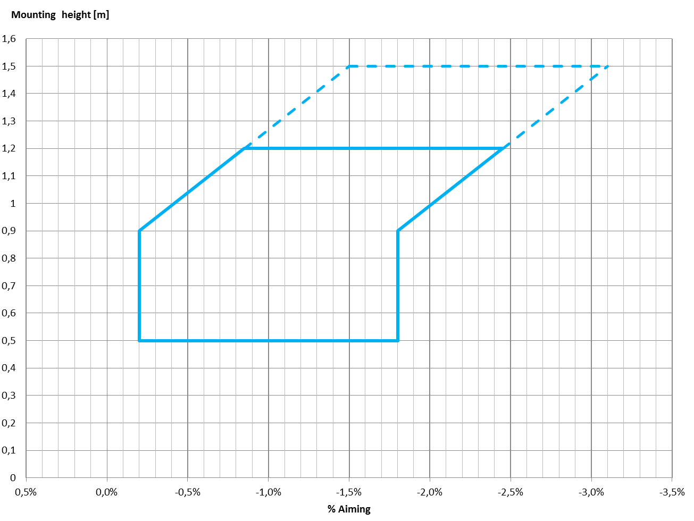
6.2.6.2. Headlamp levelling device
6.2.6.2.1. In the case where a headlamp levelling device is necessary to satisfy the requirements of paragraphs 6.2.6.1.1. and 6.2.6.1.2., the device shall be automatic.
6.2.6.2.2. However, devices which are adjusted manually, either continuously or non-continuously, shall be permitted, provided [that] they have a stop position at which the lamps can be returned to the initial inclination defined in paragraph 6.2.6.1.1. by means of the usual adjusting screws or similar means.
These manually adjustable devices shall be from the driver's seat.
Continually adjustable devices shall have reference marks indicating the loading conditions that require adjustment of the dipped-beam.
The number of positions on devices which are not continuously adjustable shall be such as to ensure compliance with the range of values prescribed in paragraph 6.2.6.1.2. in all the loading conditions defined in Annex 5.
For these devices also, the loading conditions of Annex 5 that require adjustment of the dipped-beam shall be clearly marked near the control of the device (Annex 8).
6.2.6.2.3. In the event of a failure of devices described prescribed in paragraphs 6.2.6.2.1. and 6.2.6.2.2., the dipped-beam shall not assume a position in which the dip vertical orientation is less downward than it was at the time when the failure of the device occurred.
6.2.6.3. Measuring procedure
6.2.6.3.1. After adjustment of the initial downward vertical inclination, the vertical inclination of the dipped-beam, expressed in per cent, shall be measured in static conditions under all the loading conditions defined in Annex 5.
6.2.6.3.2. The measurement of the variation of dipped-beam downward vertical inclination as a function of load shall be carried out in accordance with the test procedure set out in Annex 6.
Paragraph 6.2.9., amend to read:
6.2.9. Other requirements
The requirements of paragraph 5.5.2. shall not apply to dipped-beam headlamps.
[Dipped-beam headlamps with a light source or LED module( s) producing the principal dipped-beam and having a total objective luminous flux which exceeds 2,000 lumen shall only be installed in conjunction with the installation of headlamp cleaning device(s) according to Regulation No. 45.¹³]
With respect to vertical inclination the provisions of paragraph 6.2.6.2.2. above shall not be applied for dipped-beam headlamps with a light source or LED module(s) producing the principal dipped beam and having an objective luminous flux which exceeds 2,000 lumens.
[In the case of filament lamps for which more than one test voltage is specified, the objective luminous flux which produces the principal dipped-beam, as indicated in the communication form for the type approval of the device, is applied.
In the case of dipped-beam headlamps equipped with an approved light source, the applicable objective luminous flux is the value at the relevant test voltage as given in the relevant data sheet in the Regulation, according to which the applied light source was approved, without taking into account the tolerances to the objective luminous flux specified on this datasheet.]
Only dipped-beam headlamps according to Regulation Nos. 98 or 112 may be used to produce bend lighting.
If bend lighting is produced by a horizontal movement of the whole beam or the kink of the elbow of the cut-off, it shall be activated only if the vehicle is in forward motion; this shall not apply if bend lighting is produced for a right turn in right hand traffic (left turn in left hand traffic).

Paragraph 6.22.6.1. and related sub-paragraphs, amend to read:
6.22.6.1. Vertical orientation:
6.22.6.1.1. The initial downward inclination of the cut-off of the basic passing dipped-beam to be set in the unladen vehicle state with one person in the driver's seat shall be specified within an precision accuracy of 0.1 per cent by the manufacturer and indicated in a clearly legible and indelible manner on each vehicle, close to either the front lighting system or the manufacturer's plate, by the symbol shown in Annex 7.
Where differing initial downward inclination are specified by the manufacturer for different lighting units that provide or contribute to the cut-off of the basic passing dipped-beam, these values of downward inclination shall be specified within an precision accuracy of 0.1 per cent by the manufacturer and indicated in a clearly legible and indelible manner on each vehicle, close to either the relevant lighting units or on the manufacturer's plate, by the symbol shown in Annex 7 in such a way that all the lighting units concerned can be unambiguously identified.
The value(s) of this (these) indicated vertical orientation(s) shall be defined by the vehicle manufacturer in the range prescribed in paragraph 6.2.6.1.2. in relation to the mounting height of the lighting units that provide or contribute to the cut-off of the basic dipped-beam.
[Different values of initial downward vertical orientation for different variants/versions of the same vehicle type can be defined, provided that only the pertinent value is indicated on each variant/version.]
6.22.6.1.2. The downward inclination of the horizontal part of the "cut-off" of the basic passing dipped-beam shall remain between the limits indicated in paragraph 6.2.6.1.2. of this Regulation under all the static loading conditions of the vehicle of Annex 5 of this Regulation; and the initial aiming shall be within the specified values.
6.22.6.1.2.1. In case the passing dipped-beam is generated by several beams from different lighting units, the relevant requirements provisions according to paragraph 6.22.6.1.2. as above indicated apply to each said beam's "cut-off" (if any), which is designed to project into the angular zone, as indicated under item 9.4. of the communication form conforming to the model in Annex 1 to Regulation No. 123.
6.22.6.2. Headlamp levelling device
6.22.6.2.1. In the case where a headlamp levelling device is necessary to satisfy the requirements of paragraph 6.22.6.1.2., the device shall be automatic.
6.22.6.2.2. In the event of a failure of this the device prescribed in paragraphs 6.22.6.2.1., the basic passing dipped-beam shall not assume a position in which the downward inclination dip vertical orientation is less downward than it was at the time when the failure of the device occurred.

Paragraph 6.22.9.1., amend to read:
[6.22.9.1. An AFS shall be permitted only in conjunction with the installation of headlamp cleaning device(s) according to Regulation No. 45 for at least those lighting units, which are indicated under item 9.3. of the communication form conforming to the model in Annex 1 to Regulation No. 123, if the total objective luminous flux of the light sources of these units exceeds 2,000 lm per side, and which contribute to the class C (basic) passing-beam.]
Annex 2, amend to read:

Model A

(See paragraph 4.4. of this Regulation)

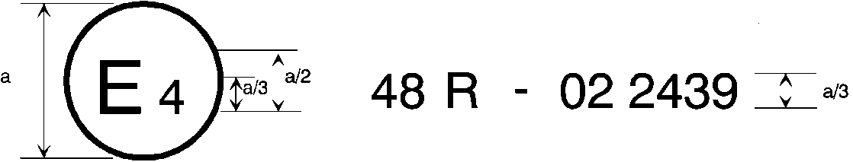
07
a = 8 mm min.

The above approval mark affixed to a vehicle shows that the vehicle type concerned has, with regard to the installation of lighting and light-signalling devices, been approved in the Netherlands (E 4) pursuant to Regulation No. 48 as amended by the 06 07 series of amendments. The approval number indicates that the approval was granted in accordance with the requirements of Regulation No. 48 as amended by the 06 07 series of amendments.

Model B

(See paragraph 4.5. of this Regulation)

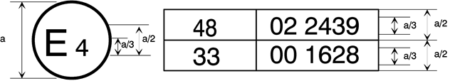
0706
a = 8 mm min.
The above approval mark affixed to a vehicle shows that the vehicle type concerned has been approved in the Netherlands (E 4) pursuant to Regulation No. 48 as amended by the 06 07 series of amendments and Regulation No. 33.¹ The approval number indicates that, at the dates when the respective approvals were given, Regulation No. 48 was amended by the 06 07 series of amendments and Regulation No. 33 was still in its original form.
------------------------------------
1 The second number is given merely as an example.

Annex 9, paragraph 1.3. and related sub-paragraphs, amend to read:
1.3. Alignment Vertical orientation of dipped-beam headlamps and class "F3" front fog lamps towards the front.
1.3.1. The vertical orientation of a dipped-beam headlamp and of a basic dipped-beam of an AFS shall be checked respectively in accordance with paragraphs 6.2.6. and 6.22.6.1. (and related sub-paragraphs and referenced Annexes) of this Regulation. [No CoP tolerances shall be applied to the limits prescribed in the above-cited paragraphs.]
1.3.2. The vertical orientation of a front fog lamp shall be checked in accordance with the following requirements.
1.3.2.1. Initial downward inclination
The initial downward inclination of the cut-off of the dipped-beam and the class "F3" front fog lamps shall be set to the plated figure as required and shown in Annex 7.
Alternatively the manufacturer shall set the initial aim to a figure that is different from the plated figure where it can be shown to be representative of the type approved when tested in accordance with the procedures contained in Annex 6 and in particular paragraph 4.1.
1.3.2.2. Variation of inclination with load
The variation of the dipped-beam downward inclination as a function of the loading conditions specified within this section shall remain within the range:
0.2 per cent to 2.8 per cent for headlamp mounting height h < 0.8;
0.2 per cent to 2.8 per cent for headlamp mounting height 0.8 ≤ h ≤ 1.0;
or
0.7 per cent to 3.3 per cent (according to the aiming range chosen by the manufacturer at the approval);
0.7 per cent to 3.3 per cent for headlamp mounting height 1.0 < h ≤ 1.2 m;
1.2 per cent to 3.8 per cent for headlamp mounting height h > 1.2 m.
In the case of a class "F3" front fog lamp with (a) light source(s) having a total objective luminous flux which exceeds 2,000 lumens, the variation of the downward inclination as a function of the loading conditions specified within this section shall remain within the range:
0.7 per cent to 3.3 per cent for front fog lamp mounting height h ≤ 0.8 ;
1.2 per cent to 3.8 per cent for front fog lamp mounting height h > 0.8 m.
The states of loading to be used shall be as follows, as indicated in Annex 5 of this Regulation, for every system adjusted accordingly.
1.3.2.2.1. Vehicles in category M₁:
Paragraph 2.1.1.1.
Paragraph 2.1.1.6. taking into account
Paragraph 2.1.2.

1.3.2.2.2. Vehicles in category M₂ and M₃:
Paragraph 2.2.1.
Paragraph 2.2.2.
1.3.2.2.3. Vehicles in category N with load surfaces:
Paragraph 2.3.1.1.
Paragraph 2.3.1.2.
1.3.2.2.4. Vehicles in category N without load surfaces:
1.3.2.2.4.1. Drawing vehicles for semi-trailers:
Paragraph 2.4.1.1.
Paragraph 2.4.1.2.
1.3.2.2.4.2. Drawing vehicles for trailers:
Paragraph 2.4.2.1.
Paragraph 2.4.2.2.

II. Justification
General comments
The GRE IWG VGL was established during the 74th GRE Session in October 2015. Its 1st task is to “Define technology neutral requirements as instructed by WP.29, in particular to find a general solution for glare and visibility issues, and to review all levelling requirements” (see Annex III - “Adopted Terms of Reference and Rules of Procedure for the Informal Working Group on Visibility, Glare and Levelling (IWG VGL)” to document ECE/TRANS/WP.29/GRE/74).
The mandate of the IWG ended in April 2017 but was renovated for 1 year to complete the study and provide a final proposal for the GRE 79th session in April 2018.
The text here above is based on the concepts finally agreed at the 10th meeting of the VGL and on the discussion that the Experts had during the 10 meetings hold since the IWG was established.
The main technical changes agreed by the IWG apply to paragraphs 6.2.6 and related sub-paragraphs, for dipped beam headlamps orientation.
The corresponding paragraph 6.22.6.1. and related sub-paragraphs, for AFS dipped beam orientation, has been changed accordingly.
Due to the basic changes agreed by the IWG, also some other paragraphs needed to be changed and added.

Detailed comments
For the technical justification for the two main changes please refer to the following documents:
- “Justification for the new aiming limits and diagram”. (informal document GRE-78-23-Rev.1)
- “Justification for deletion of the 2000 lm criterion”. (informal document GRE-78-32)
In addition the following comments provide explanations to the proposed text:
4.2. This paragraph is modified to update the reference to the new series of amendment 07.
6.2.6.1.1. Second indent is modified to better prescribe how to define the initial aiming value.
Last indent is added to clarify how to correctly indicate the initial aiming value in case where it is different for different variants/versions of the same vehicle type. This paragraph is in square brackets since it was not agreed during the VGL works.
6.2.6.1.2. The range of vertical orientation has been modified based on the IWG VGL decisions. IWG VGL decided to present a proposal in which this range is from 0% to -1.6 %; it was also agreed that, if requested by GRE Experts, the 0 % limit will be moved to the -0.2 % limit maintaining the 1.6 % range (i.e. shifting in parallel the upper limit to -1.8 %). UK and PL requested OICA to provide better justifications for the need to have a range at least 1.6 % wide.
At GRE 78 some Experts requested to shift the 0 % limit to -0.2 % and no Expert opposed the parallel shifting of the -1.6 % limit to -1.8 % limit. UK and PL reiterated their request for better justification for the need to have a range at least 1.6 % wide.
As far as the range of vertical orientation for N3G category vehicles having headlamps installed at more than 1.2 m from the ground is concerned, IWG VGL did not took any decision, even if the idea to follow the same parameters used for the other vehicles categories was discussed. The proposed values are then put in square brackets; in any case they provide an improvement, from illumination distance point of view, in respect to the present requirements.
Finally, among the proposed orientation limit values, two of them should have, from calculation, 2 digits after the coma, while only 1 digit after the coma is indicated in the present R48 text. Consequently the second digit is always indicated in square brackets, to decide whether to maintain it or round the first digit to the nearest value.
6.2.9. IWG VGL decided to delete all references to 2000 lumen, since consider it no more correct; as a replacement of these requirement, the improvements of the levelling range were adopted. Japan expressed concerns about the deletion of this limit without replacing it with another specific parameter for the mandatory fitment of automatic headlamp levelling.
However IWG VGL did not decided how to treat the headlamp cleaning system in relation to the 2000 lumen limit. Consequently the second, fourth and fifth indent of this paragraph, deleting the mandatory fitting of the headlamps cleaning system in case of light sources having a luminous flux higher than 2000 lumen, are in square brackets, while the deletion of the third indent is already fully in line with the IWG VGL decision on this topic.
6.3.6.1. This paragraph is dealing with the vertical orientation of front fog lamp and in the present text of R48 the 2000 lumen limit, deleted for the orientation conditions of the dipped beam, is also used. Since no decision was taken by IWG VGL about vertical orientation of the front fog lamps paragraph 6.3.6.1. is not included in the present proposal. This note has the scope to point out to GRE Experts the above situation and to request indication about the amendment of this paragraph, where it is supposed that the 2000 lumen limit should also be deleted.
6.22.6.1. All the changes to paragraph 6.22.6.1. and related sub-paragraphs are made to align the requirements to paragraph 6.2.6.1. and related subparagraphs (with the small adaptations necessary for AFS application). For AFS the auto-levelling remains mandatory, as decided by the IWG VGL.
6.22.9.1. For coherence with the changes proposed for paragraph 6.2.9., the deletion of the headlamp cleaning system in relation to the 2000 lumen limit is proposed in square brackets, since no decision was taken by the IWG VGL.
Annex 2 This annex is amended to update the marking examples and related description to the introduction of the 07 series of amendments.
1.3 in Annex 9 The changes to paragraph 1.3. and related sub-paragraph in Annex 9 are linked to the decision of IWG VGL to establish, for the dipped-beam headlamp and the basic dipped-beam of an AFS, an absolute range of levelling, to be fulfilled by the whole vehicle production without CoP tolerances.

--------------------------------------------

Contracting Parties to the respective Regulations can still prohibit the use of mechanical cleaning systems when headlamps with plastic lenses, marked 'PL', are installed.

