Transmitted by the expert from the India | Informal document GRE-79-22  (79th GRE, 24 - 27 April 2018,  agenda item 4)

India’s comments on underlying principles of approval marking for LSD regulation
Document no GRE-78-35-Rev.1
The text reproduced below is prepared by the experts from India to propose a marking requirement for lamps to be approved under the LSD regulation. This proposal is to take care of specific concerns being observed in the marking of the combined lamps for identification, indication of particular series of amendment for each device and to take care of certain difficulties as seen in the proposal submitted by IWG-SLR document no GRE-78-35-Rev.1

- The marking proposal given in slide 2 of GRE-78-35 Rev. 1 (below) may be replaced by the following figure :

Proposed Figure
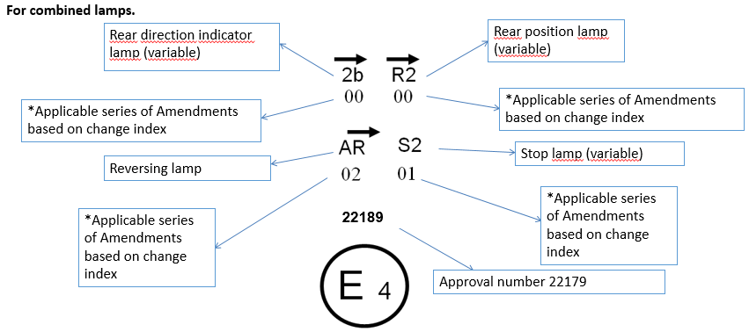
Series of amendment mandatory as per 1958 agreement Rev 3 , In this figure it can be linked to change index See table in Sr No 2

Figure existing in 78-35 Rev1
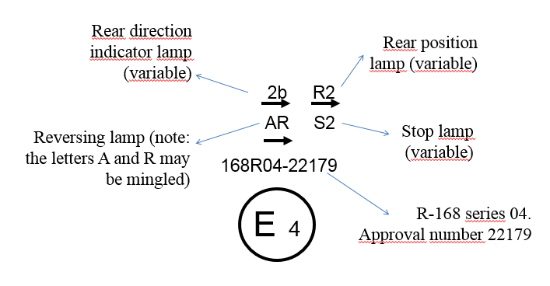
Marking UNECE R no is not mandatory …see Annex 1 ( Item no 1)

- Introduce the following table to indicate change index & the marking series of amendment in following format.
These tables are based on the example given in GR-78-35 Rev. 1 Slide 2
S.No | Table for 00 Series of Amendments to the regulation | Change index | Marking of Series of amendment |  | S.No | Table for 01 Series of Amendments to the regulation | Change index | Marking of Series of amendment
 | Function (Lamp) |  |  |  |  | Function (Lamp)
1 | Rear Direction Indicator Lamp | 0 | 0 |  | 1 | Rear Direction Indicator Lamp | 0 | 0
2 | Rear Direction Indicator Lamp (Vehicle category L) | 0 | 0 |  | 2 | Rear Direction Indicator Lamp (Vehicle category L) | 1 | 1
3 | Rear end-outline marker lamp | 0 | 0 |  | 3 | Rear end-outline marker lamp | 0 | 0
4 | Rear fog lamp | 0 | 0 |  | 4 | Rear fog lamp | 0 | 0
5 | Rear Position Lamp | 0 | 0 |  | 5 | Rear Position Lamp | 0 | 0
6 | Rear Position Lamp (Vehicle category L) | 0 | 0 |  | 6 | Rear Position Lamp (Vehicle category L) | 0 | 0
7 | Rear registration plate illumination lamp | 0 | 0 |  | 7 | Rear registration plate illumination lamp | 0 | 0
8 | Rear registration plate illumination lamp (Vehicle category L) | 0 | 0 |  | 8 | Rear registration plate illumination lamp (Vehicle category L) | 0 | 0
9 | Reversing Lamp | 0 | 0 |  | 9 | Reversing Lamp | 0 | 0
10 | Side direction indicator lamp | 0 | 0 |  | 10 | Side direction indicator lamp | 0 | 0
11 | Side marker lamp | 0 | 0 |  | 11 | Side marker lamp | 0 | 0
12 | Stop Lamp | 0 | 0 |  | 12 | Stop Lamp | 0 | 0
13 | Stop Lamp (Vehicle category L) | 0 | 0 |  | 13 | Stop Lamp (Vehicle category L) | 0 | 0
14 | Stop Lamp (Central high mounted) | 0 | 0 |  | 14 | Stop Lamp (Central high mounted) | 0 | 0

S.No | Table for 02 Series of Amendments to the regulation | Change index | Marking of Series of amendment |  | S.No | Table for 03 Series of Amendments to the regulation | Change index | Marking of Series of amendment
 | Function (Lamp) |  |  |  |  | Function (Lamp)
1 | Rear Direction Indicator Lamp | 0 | 0 |  | 1 | Rear Direction Indicator Lamp | 0 | 0
2 | Rear Direction Indicator Lamp (Vehicle category L) | 2 | 2 |  | 2 | Rear Direction Indicator Lamp (Vehicle category L) | 1 | 1
3 | Rear end-outline marker lamp | 0 | 0 |  | 3 | Rear end-outline marker lamp | 0 | 0
4 | Rear fog lamp | 0 | 0 |  | 4 | Rear fog lamp | 0 | 0
5 | Rear Position Lamp | 0 | 0 |  | 5 | Rear Position Lamp | 0 | 0
6 | Rear Position Lamp (Vehicle category L) | 0 | 0 |  | 6 | Rear Position Lamp (Vehicle category L) | 0 | 0
7 | Rear registration plate illumination lamp | 0 | 0 |  | 7 | Rear registration plate illumination lamp | 0 | 0
8 | Rear registration plate illumination lamp (Vehicle category L) | 0 | 0 |  | 8 | Rear registration plate illumination lamp (Vehicle category L) | 0 | 0
9 | Reversing Lamp | 2 | 2 |  | 9 | Reversing Lamp | 3 | 3
10 | Side direction indicator lamp | 0 | 0 |  | 10 | Side direction indicator lamp | 0 | 0
11 | Side marker lamp | 0 | 0 |  | 11 | Side marker lamp | 0 | 0
12 | Stop Lamp | 0 | 0 |  | 12 | Stop Lamp | 3 | 3
13 | Stop Lamp (Vehicle category L) | 0 | 0 |  | 13 | Stop Lamp (Vehicle category L) | 0 | 0
14 | Stop Lamp (Central high mounted) | 0 | 0 |  | 14 | Stop Lamp (Central high mounted) | 0 | 0

S.No | Table for 04 Series of Amendments to the regulation | Change index | Marking of Series of amendment |  | S.No | Table for 05 Series of Amendments to the regulation | Change index | Marking of Series of amendment
 | Function (Lamp) |  |  |  |  | Function (Lamp)
1 | Rear Direction Indicator Lamp | 0 | 0 |  | 1 | Rear Direction Indicator Lamp | 5 | 5
2 | Rear Direction Indicator Lamp (Vehicle category L) | 1 | 1 |  | 2 | Rear Direction Indicator Lamp (Vehicle category L) | 5 | 5
3 | Rear end-outline marker lamp | 0 | 0 |  | 3 | Rear end-outline marker lamp | 5 | 5
4 | Rear fog lamp | 4 | 4 |  | 4 | Rear fog lamp | 5 | 5
5 | Rear Position Lamp | 0 | 0 |  | 5 | Rear Position Lamp | 5 | 5
6 | Rear Position Lamp (Vehicle category L) | 0 | 0 |  | 6 | Rear Position Lamp (Vehicle category L) | 5 | 5
7 | Rear registration plate illumination lamp | 0 | 0 |  | 7 | Rear registration plate illumination lamp | 5 | 5
8 | Rear registration plate illumination lamp (Vehicle category L) | 0 | 0 |  | 8 | Rear registration plate illumination lamp (Vehicle category L) | 5 | 5
9 | Reversing Lamp | 4 | 4 |  | 9 | Reversing Lamp | 5 | 5
10 | Side direction indicator lamp | 0 | 0 |  | 10 | Side direction indicator lamp | 5 | 5
11 | Side marker lamp | 0 | 0 |  | 11 | Side marker lamp | 5 | 5
12 | Stop Lamp | 3 | 3 |  | 12 | Stop Lamp | 5 | 5
13 | Stop Lamp (Vehicle category L) | 0 | 0 |  | 13 | Stop Lamp (Vehicle category L) | 5 | 5
14 | Stop Lamp (Central high mounted) | 0 | 0 |  | 14 | Stop Lamp (Central high mounted) | 5 | 5

Justification
1. Markings:
1.1 Expectations on SLR markings:
  - A new series of amendment should not call for a change in marking if the device is not affected. GRE-78-35 Rev. 1 takes care of this.
  - Marking more than one regulation number will cause space constraints in case of combined lamps, where more than one SLR is referred (e.g. If Head lamp, front position lamp and front white reflectors are combined, this would mandate 3 separate regulation numbers to be marked on the lamp).
  - As per the 1958 Agreement, mentioning regulation number is not mandatory.
    - See Annex I (Sr.No 1) of this document.
    - Similar convention is currently followed for markings on combined lamps.

1.2. INDIA has attempted study of marking requirements detailed in:

  - 1958 Agreement Rev. 3
  - General Guidelines for United Nations regulatory procedures and transitional provisions document ECE/TRANS/WP.29/2017/107.

1.3 Difficulties to the proposal given in the marking as per GRE-78-35- Rev. 1:

- In the proposed marking, marking of regulation number gets mandated.
- We presume the Series of Amendment “04” is the latest applicable to the devices indicated and not the last one of UN R 168.
- The 1958 Agreement Rev. 3 gives freedom to CP to follow earlier series of amendment for each device within the combined lamp. Identification of earlier series of amendment is not possible.
- Hence there is a need to indicate the Series of Amendments for each device.
- Information contained in the change index is not fully utilized.

1.3.1 Therefore, advantages of the Indian proposal:

- The actual series of applicable amendment to which the device is approved is clearly identifiable.
- The change index table correlating with the series of amendment provides the full information. Hence the requirement of Rev.3 of 1958 Agreement are complied with.
- For ready reference an additional table, correlation for change index and series of amendments has been added.
- The space constraint for marking the regulation number is addressed as 1958 Agreement does not mandate having Regulation No.

Annex I
Schedule 4, incorporated in Rev 3 of 1958 Agreement covers the scheme of approval number and marking requirement. The understanding of requirements of paragraphs 2 and 3 are as below.
S.No | Para | Requirement specified in Schedule 4 (Applicable portion highlighted) |  | Understanding / Comments of the requirement
1 | 2 | As from the entry into force------- otherwise, the manufacturer shall affix an approval mark, if requested, according the provisions of the relevant UN Regulations, however, utilizing in that marking the first two digits of Section 2 and the digits of Section 3 of the approval number as mentioned in this Schedule as approval number to each wheeled vehicle, equipment ---- omitted. |  | Para 2 of the approval number describes the Regulation number and series of amendments.
2 | 3 | An approval number shall be assigned to each type approved. The type approval number shall consist of 4 sections. Each section shall be separated by the '*' character. |  | No comments
 |  | Section 1: The ---approval. |  | No comments
 |  | Section 2: The number of the relevant UN Regulation, followed by the letter 'R', successively followed by: |  | An example of section 2, for LSD regulation would
 |  |  |  |  |  | Described in (a) | Described in (b)
 |  |  |  |  | 168 R | 00
 |  | (a) | Two digits (with leading zeros as applicable) indicating the series of amendments incorporating the technical provisions of the UN Regulation applied to the approval (00 for the UN Regulation in its original form); |  | Regulation No. | Series of amendment | Implementing stage not applicable, may be relevant to UN R 83
 |  |  |  | Reference to the ‘first two digits of Section 2” cannot be in connection with the regulation, since two digits can represent UN regulations only up to 99. Hence it can be presumed that the reference is to what is being described in para (a) that is the series of amendment.
 |  | (b) | A slash and two digits (with indicating the implementing stage, if applicable.) | No comments
 |  | Section 3: A four-digit sequential number (with leading zeros as applicable). The sequence shall start from 0001. |  | This is as per current practice.
 |  | Section 4: A two-digit sequential number (with leading zeros if applicable) to denote the extension. The sequence shall start from 00. |  | Marking of Extension number is also not mandatory.

-----

