|  |  |  |  |
| --- | --- | --- | --- |
|  | United Nations | ECE/TRANS/WP.29/2018/162 | |
| Description: _unlogo | **Economic and Social Council** | | Distr.: General  22 August 2018  Original: English |

**Economic Commission for Europe**

Inland Transport Committee

**World Forum for Harmonization of Vehicle Regulations**

**176th session**

Geneva, 13-16 November 2018

Item 18.5 of the provisional agenda

**Progress on the development of new UN GTRs   
and of amendments to established UN GTRs:  
UN GTR No. 9 (Pedestrian safety)**

Terms of Reference of the Informal Working Group on Deployable Pedestrian Protection Systems (IWG-DPPS)

Submitted by the representative of the Republic of Korea [[1]](#footnote-2)\*

The text reproduced below was prepared by the representative of the Republic of Korea. It is based on informal document WP.29-175-06, distributed at the 175th session (ECE/TRANS/WP.29/1139, paragraphs 142-144). This document, if adopted, shall be appended to the UN GTR in accordance with the provisions of paragraphs 6.3.4.2., 6.3.7. and 6.4. of the 1998 Agreement.

Terms of Reference for the Informal Working Group on Deployable Pedestrian Protection Systems (IWG-DPPS)

A. Introduction

1. During the fifty-sixth session of GRSP in December 2014, the Republic of Korea suggested clarifying the test procedure for Deployable Pedestrian Protection Systems (DPPS), e.g. active bonnets. Before that, only a working document from 2005 from the discussion leading to UN GTR No. 9 existed which proposed a “Certification Standard for Type Approval Testing of Active Deployable Systems of the Bonnet Area” (document INF GR/PS/141 Rev. 1). Several contracting parties had used this document as a guideline to certify such systems. However, the Republic of Korea explained that, seeing the upcoming popularity of such deployable systems, a more detailed and binding procedure would be needed that could also functions in a self-certification environment.

2. The suggestion of the Republic of Korea resulted in WP.29 and AC.3 authorizing, during their 170th and forty-eighth sessions in November 2016, a Task Force to develop an amendment for UN GTR No. 9. The Republic of Korea provided a Chair for the Task Force, OICA the Secretary. The intention was to develop a new annex to UN GTR No. 9 that would cover the test procedure for DPPS, to amend the corresponding paragraphs in the current text of GTR No. 9 and to add some procedure specific paragraphs, where needed.

3. The Task Force on Deployable Pedestrian Protection Systems met: (a) 7 – 8 February 2017 in Paris, (b) 28 – 29 March 2017 in Paris, (c) 7 Sept. 2017 in a web meeting, and (d) 21 – 23 Nov. 2017 in Berlin.

4. During the discussions of the TF-DPPS, it was soon noted that some new requirements may need definition. The Republic of Korea therefore requested GRSP, as well as WP.29 and AC.3, to transform the TF-DPPS into an Informal Working Group on Deployable Pedestrian Protection Systems (IWG-DPPS). WP.29 and AC.3 approved this request during their 174th and fifty-second sessions in March 2018.

B. Objective of the proposal

5. The objective of the IWG-DPPS was to develop proposals for test procedures for DPPS. The procedure will test such systems, i.e. deployable bonnets or external airbags, for compliance with the requirements of UN GTR No. 9. However, the IWG will also develop new and more detailed requirements, where needed, so that the new procedure guarantees that deployable systems are correctly activated as designed to protect pedestrians and other vulnerable road users, and provide at least the same level of protection to pedestrians and other vulnerable road users as non-deployable systems. Consequently, a proposal for the amendment to the relevant sections of UN GTR No. 9 will be provided.

6. Finally, IWG-DPPS shall also consider developing a corresponding proposal to amend the UN Regulation No. 127 on Pedestrian Safety.

C. Operating principles

(a) The Informal Working Group on Deployable Pedestrian Protection Systems (IWG-DPPS) is a subgroup of GRSP and is open to all participants of GRSP including contracting parties and non-governmental organizations to the 1958 and 1998 Agreements.

(b) The IWG-DPPS will be sponsored by the Republic of Korea. A Chair (Republic of Korea) and a Secretary (OICA) will manage the informal working group.

(c) The official language of the informal working group will be English.

(d) All documents must be submitted to the Secretary of the group in a suitable electronic format and will be posted on the website of the IWG-DPPS prior to the meetings. The group may postpone discussion of any item or proposal, which was not provided five (5) working days in advance of the scheduled meeting.

(e) The Secretary of the group will aim to distribute the meeting minutes to the IWG members within fifteen (15) working days after the meetings of the group.

(f) Decisions and proposals of the group shall be reached by consensus. When consensus cannot be reached, the Chair of the group or their representative shall present the different points of view to GRSP. The Chair may seek guidance from GRSP as appropriate.

(g) Sessions shall be held in agreement with the majority of the participants. Sessions may be in person or virtual using web-based technology.

(h) A provisional agenda shall be provided by the Secretary in advance to each meeting and will be finalized in accordance with the participants of the IWG-DPPS. The first item upon the provisional agenda for each session shall be the adoption of the agenda.

(i) The second item on the provisional agenda will be the discussion, matters arising and adoption of the minutes of the previous session.

D. Work plan and time schedule

April 2018 Final proposal for ToR at 1st meeting (5th meeting of DPPS group)

May 2018 Proposal of ToR and Progress Report to GRSP

June (or Nov.) 2018 Proposal of ToR and Progress Report to WP.29

Sept. 2018 2nd IWG-DPPS meeting

December 2018 3rd IWG-DPPS meeting

December 2018 Progress Report to GRSP

March 2019 4th IWG-DPPS meeting (tbc)

May 2019 Submit informal proposal to GRSP

Dec. 2019 Submit a formal document for adoption by GRSP

June 2020 Adoption by WP.29

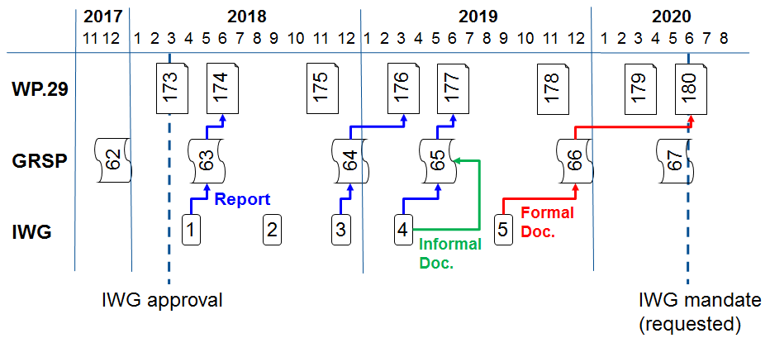

1. \* In accordance with the programme of work of the Inland Transport Committee for 2018–2019 (ECE/TRANS/274, para. 123 and ECE/TRANS/2018/21/Add.1, cluster 3.1), the World Forum will develop, harmonize and update UN Regulations in order to enhance the performance of vehicles. The present document is submitted in conformity with that mandate. [↑](#footnote-ref-2)