|  |  |  |  |
| --- | --- | --- | --- |
|  |  | **UN/SCEGHS/36/INF.30** | |
| **Committee of Experts on the Transport of Dangerous Goods and on the Globally Harmonized System of Classification and Labelling of Chemicals**  **Sub-Committee of Experts on the Globally Harmonized System of Classification and Labelling of Chemicals**  **Thirty-sixth session**  Geneva, 5-7 December 2018  Item 4 (a) of the provisional agenda  **Hazard communication: labelling of small packagings** | | | **27 November 2018** |

Digitalization and GHS hazard communication: utility and benefits in labelling of very small consumer packages

Submitted by the International Paint and Printing Ink Council (IPPIC)

Introduction

1. IPPIC welcomes and supports the proposal from A.I.S.E. and RPMASA in informal document INF.14 (36th session) for a work item in the biennium 2019-2020 to explore how digital means can be used effectively for GHS hazard communication.
2. In informal document INF.15 CEFIC proposes to host consideration of this issue within the informal working group on labelling of small packagings, and to extend the scope of the working group accordingly. IPPIC similarly supports this proposal.
3. The purpose of this informal document from IPPIC is to provide an example illustrating how such digital solutions would assist in the labelling of very small packages placed on the market particularly (but not exclusively) for the general public, as a contribution to initiating discussion of the applications and benefits.

Background

1. Colours for the creative sector are traditionally sold in very small containers to enable the users to arrange their own set of colours. Although the amount is small it could still be sufficient colour for years. These products are formally mixtures which may fall under the classification and labelling requirements traced back to the GHS.
2. These products however belong to both the chemical and the consumer world, and all these products share a limited area to apply labelling. Therefore they have to carry commercial product information and hazard-related information for chemicals.
3. Depending on the intended market region all information has to appear in the appropriate languages. Mainly due to the need for efficient warehousing and logistics this can encompass more than one country, normally 5-7 different languages. If one thinks of online sales the system is pushed to its limits by requiring a global language set. In distribution via internet the manufacturer has only limited control over the final destination. This potential safety gap cannot be resolved by traditional means of customer information.

Objectives of digital communication

1. Effective information for customers: both an internet link and QR code will guide the user to a unique product page. This page, either revised regularly or connected with the company’s ERP system, will automatically update the information provided. This can include hazard and use information for consumers as well as safety data sheets for professionals, and will enable the user always to access the most current version of that information.
2. Readiness to enter a global market: consumers need to be informed in their own country’s language. In a global internet-based market this is a challenge if companies are bound to communication practices of the last millennium. In fact it would be no challenge if the legal environment would integrate internet based information as part of the information pathways.
3. Minimising packaging as far as possible: There is no use in supplying booklets together with containers of 50 ml or less. In light of sustainability and increasing calls for reduction in plastics packaging it is highly recommended to use “waste-free” electronic means of information distribution.

Possible options to address labelling problems encountered

Justification for innovation

10. The idea to adapt labelling requirements to the shape of the individual container is not entirely new. At least in Europe the predecessor of the CLP Regulation already included elements which allowed exemptions for very small packaging, defined as < 125 ml in volume. The adoption of GHS, along with other relevant product legislation, has increased the amount of information required on labels. Larger packagings like drums, cans, big bags or barrels have plenty of surface to include all required labelling elements. For consumer products with smaller packagings the available surface area becomes a limiting factor. This is especially the case for artists’ colours, which traditionally use very small containers to market their products. The inevitable labelling difficulties due to surface space limitations have previously been described in INF.5 submitted to the 34th session by A.I.S.E..

11. To address this issue we propose to use a flexible evaluation concept to justify more adapted labelling requirements, as foreseen in Annex 5 to GHS. As an example we would like to refer to the predecessor of CLP, the EU ‘Dangerous Preparations Directive’ 1999/45/EC[[1]](#footnote-2), which provides constructive aspects for the labelling of very small packaging intended for the general public (hereafter ‘pubVSP’). The main advantage of Directive 1999/45/EC was its flexibility of implementation. It granted deviations that gave companies enough flexibility to choose an appropriate method for each specific packaging without permanently creating non-compliances. In combination with an online information component for hazard communication, consumers’ needs, health protection concerns of legislators and market access for companies could all be satisfied.

Examples from Directive 1999/45/EC

12. Article 12 (‘Exemptions from the labelling and packaging requirements’), paragraph 3 allowed Member States to:

“*permit the labelling …* ***to be applied in some other appropriate manner on packages*** *which are either too small or otherwise unsuitable for labelling …”*

*“permit the packaging of [certain] dangerous preparations …* ***to be unlabelled or to be labelled in some other way,*** *if they contain such small quantities that there is no reason to fear any danger to persons handling such preparations or to other persons / no reason to fear any dangers to the environment”.*

Identification of digital information source

13. Since some kind of attraction icon would be useful to indicate electronically available information, this topic is proposed for further discussion. Example of an attraction icon combined with a product-specific microsite link:



In the case of an even surface the inner icon could be replaced by a QR code or, for smaller containers, by an ECC200 code[[2]](#footnote-3). Example layout for a combined label:



14. Annex 1 to this document shows a compilation of typical consumer product packages identified as ‘pubVSP’ which could benefit from the approach described. Annex 2 lists possible options to address the difficulties of labelling ‘pubVSP’ with an analysis of their pros and cons.

Proposal

15. IPPIC proposes that in the 2019-2020 biennium the informal working group on labelling of small packagings/practical labelling issues discuss the development of some specific examples in Annex 7 of the GHS to resolve labelling issues observed for products in very small packagings/containers as described above.

Annex 1

| **Collection of consumer products which could be addressed in labelling examples within the UN GHS** | | | | |
| --- | --- | --- | --- | --- |
| Example | Product examples | Size | Labelling problems encountered | On-market examples |
| Liquid artist colours |  | 50ml | Not possible to put all applicable GHS label elements and instructions for use on the immediate container in all languages due to its size and shape |  |
| Liquid artist colours |  | 15ml  LWH (mm):  29 x 29 mm x 44 mm  Label (LW(mm): 107x27 |  | C:\Users\v\Desktop\FAKE_15ml_Etikett_Porcelain_gesamt_131_4c.jpg |
| Liquid artist colours |  | 25ml |  |  |
| Liquid artist colours |  | 2 ml |  |  |
| Opaque paints replacement products |  | 7 ml |  | Ersatzfarbe Neu schwarz |
| Pastels |  | Label area =  660mm² | Very small area. No space for any pictogram, like GHS09, e.g. if pigment has an environmental hazard |  |
| Watercolour paints 1/1  (solid) | 16  8  30 | 3,2ml product volume  Label area = 1479 mm² | Very small area. No space for any pictogram, like GHS09, e.g. if pigment has an environmental hazard. Use of additional information may be necessary e.g. related to biocide content. |  |
| Watercolour paints ½ (solid) | 8  16  19 | 1,6ml product volume  Label area = 756 mm² | Very small area. No space for any pictogram, like GHS09, e.g. if pigment has an environmental hazard. Use of additional information may be necessary e.g. related to biocide content. |  |
| Aquarelle paints (soft) |  | 5,0ml  Label area: 2470 mm²  15 ml  Label area: 3500 mm² | Very small area. No space for any pictogram, like GHS09, e.g. if pigment has an environmental hazard. Use of additional information may be necessary e.g. related to biocide content. |  |
| Marker refill products |  | 15 ml | Required labelling elements lead to very small letters and subsequently reduced readability |  |

Annex 2

Options to address general issue for these products: not possible to put all applicable GHS label elements and instructions for use on the immediate container in all required languages due to its size and shape.

| **Proposal #** | **Possible options** | **Comments** |
| --- | --- | --- |
| 1 | Provide label elements in a fold-out label | Not an option – size of the container is too small for a fold-out label where all the information are well arranged and easy to read  Increasing the fold-out label would lead to the risk that the fold-out label cannot be securely attached to such small packaging/container. Also need to take account of sustainability considerations (e.g. packaging reduction, environmental footprint, etc.) as than the fold-out label would be bigger (more resources) as the original packaging/label |
| 2 | Provide label elements on a tie-on tag | * Not practical as tie-on tag would need to be very large to accommodate all required labelling even with printing on both sides of the tag. Large tag may impede use of the product. * Could possibly attach a fold-out label to the tie-on tag but no guarantee the tag would remain attached to the container – may impede user during application thus could possibly be removed. * General principles require all applicable label elements to appear on immediate container where possible; also some label elements on the immediate container may need to be accessible to users throughout life of product. Would therefore also need to include minimum label elements on immediate container just in case the tie-on tag is removed by the user. |
| 3 | Provide label elements on an outer packaging | * Not an option – product is not supplied in outer packaging * Also need to take account of sustainability considerations (e.g. packaging reduction, environmental footprint, etc.) |
| 4 | Subset of labelling element on the product and comprehensive information on paper at point of sales | * This would solve the “limited surface issue”, however it will not work for very small containers. Separate paper work must be updated and distributed. |
| 5 | Increase the size of the container so that a larger label can be affixed | * Increasing the size of the container is not practical from the intended use perspective. * Current retailer displays contain hundreds of colour shades in different product variants. Shop logistics will not be able to present the same amount of brands as they currently do. * Increasing the size of the container without increasing product volume may be misleading to the consumer. |
| 6 | Implement smaller GHS symbols for pubVSP | * Reason: The required surface for the current symbols (min. 10x10mm) is simply non-existent. * Justification: Compared to the accepted letter size, the GHS symbols are very large. A reduction of 50 % (min. 5x5mm) would still be sufficient for the intended signal effect |
| 7 | Blister packaging of small objects | * Increase of packaging waste. See examples in Appendix to this annex. * If using a blister you need for the same amount of colour 200% of packaging material. Take account of sustainability considerations (e.g. packaging reduction, environmental footprint, etc.) |
| 8 | Implement QR code / ECC200 code into a symbol | * 2D codes like QR or ECC200 in combination with a symbol are an easy choice to use a web address and show all labelling in all languages. For QR code a symbol with min. 10x10mm is necessary, for ECC200 a symbol with 5x5mm is technically feasible. |
| 9 | Web link / microsite | * Together with the previous solution, this is the preferred and most comprehensive option. But it needs online access (by the consumer or provided at point of sale) to get the information. |
| 10 | Use of labelling limit values to reduce required labelling elements | * For products sold in amounts with no effects on human health or environment, e.g. for a selection of hazard statements no labelling of this hazard. * Examples : * H225 highly flammable liquid , below 25 ml * H226 flammable liquid , below 125 ml * H315 causes skin irritation , below 25 ml * H411 H412 H413 toxic/harmful to aquatic life with long lasting effects; May cause long lasting effects to aquatic life, below 50 g * Exempted a combination of very toxic to aquatic life/long lasting effects H400 and H410 |

**Appendix to Annex 2 – increased packaging to accommodate labelling**

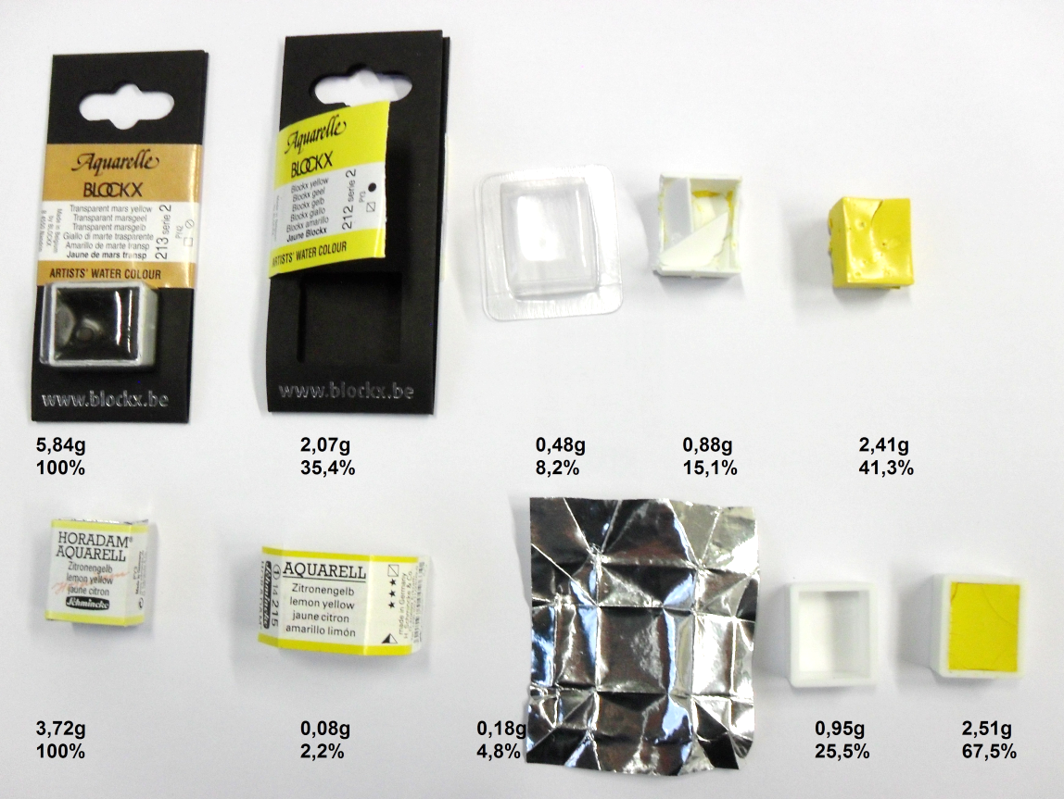

1. DIRECTIVE 1999/45/EC OF THE EUROPEAN PARLIAMENT AND OF THE COUNCIL of 31 May 1999 concerning the approximation of the laws, regulations and administrative provisions of the Member States relating to the classification, packaging and labelling of dangerous preparations (OJ L 200, 30.7.1999 p.1) [↑](#footnote-ref-2)
2. ECC 200 is the newest version of Data Matrix, a two-dimensional matrix symbology described in international standard ISO/IEC 16022:2006 *inter alia*. [↑](#footnote-ref-3)