|  |  |  |  |
| --- | --- | --- | --- |
|  | United Nations | ST/SG/AC.10/C.3/2018/67−ST/SG/AC.10/C.4/2018/17 | |
| _unlogo | **Secretariat** | | Distr.: General  12 September 2018  Original: English |

**Committee of Experts on the Transport of Dangerous Goods  
and on the Globally Harmonized System of Classification  
and Labelling of Chemicals**

|  |  |
| --- | --- |
| **Sub-Committee of Experts on the Transport  of Dangerous Goods** | **Sub-Committee of Experts on the Globally Harmonized System of Classification and Labelling of Chemicals** |
|  |  |
| **Fifty-fourth session** | **Thirty-sixth session** |
| Geneva, 26 November-4 December 2018  Item 2 (b) of the provisional agenda  **Recommendations made by the Sub-Committee on its fifty-first, fifty-second and fifty-third sessions and pending issues:** **Explosives and related matters** | Geneva, 5-7 December 2018  Item 3 (a) of the provisional agenda  **Classification criteria and related hazard communication: Work of the Sub-Committee of Experts on the Transport of Dangerous Goods (TDG) on matters of interest to the GHS Sub-Committee** |
|  |  |

Recommendations for Test Series 8

Transmitted by the expert from Canada and the Institute of Makers of Explosives (IME)[[1]](#footnote-2)\*

Introduction

1. As described in “Background” below, the Working Group on Explosives (EWG) of the TDG Sub-Committee has concluded that the Koenen Test (UN Test 8(c)) is unsuitable for evaluating certain emulsion candidates for classification as UN 3375; Division 5.1; AMMONIUM NITRATE EMULSION or SUSPENSION or GEL, intermediate for blasting explosives (ANE). The matter has been the subject of discussion within the EWG since the forty-seventh session and a possible solution, the minimum burning pressure (MBP) test has been identified. However, at the last session, despite general support for the MBP test, the EWG concluded “… that a consensus is unlikely and suggested that IME go ahead and prepare a formal proposal for the next [fifty-fourth] session so that the issue can be put to a vote.”[[2]](#footnote-3). As the original developer and a current user of the MBP test for classification of ANE candidates, Canada offered to assist IME in the preparation of the formal proposal and proposed test procedure.

Background

2. When initially establishing the Test Series 8 for ANE candidates, the Koenen Test was included as it was in Test Series 2 which is used to determine whether substances/mixtures are explosives. A more intense shock test (8(b)) was also included to ensure a lower level of sensitivity for these explosives precursors.

3. However, over the years problems have been experienced in conducting the Koenen Test for certain formulations of this specific range of substances/mixtures because of the long reaction times and/or blockage of the orifice. At the forty-seventh session it was concluded by the EWG that the Koenen Test (Test 8(c)) was unsuitable for ammonium nitrate emulsions (ANEs)[[3]](#footnote-4). Previous studies conclusively showed that for ANEs, and specifically emulsions that have a high water content and low volatility oils, the extended time required for a response in the Koenen Test has the effect of weakening the steel tube. This weakening of the steel and the corresponding tube failure gives a test result as a positive (fail) albeit a false positive since the fragmentation pattern of the tube is caused by the weakened steel and not by the reaction of the substance under test.

4. Emulsion manufacturers are presently in a position where one of the classification tests has been deemed unsuitable for that form of ANEs making meaningful or accurate classification of that form of ANEs impossible.

5. At the fifty-first session it was proposed that IME lead work to investigate the possibility of modifying the 8(c) Koenen Test, and to determine the suitability of the MBP as an alternative test within Test Series 8[[4]](#footnote-5).

6. Emulsions can be reformulated with lower water content and/or higher volatility oils, which in turn will make them show a negative result (pass) with the Koenen Test. However, this will have a deleterious effect in the downstream process where the emulsion product will be pumped, since these reformulations will produce emulsions with a lower MBP.

7. There will undoubtedly be changes in emulsion formulations that will need classification testing. Without a suitable test for emulsions, manufacturers will not be able to subject the new formulations to appropriate testing.

8. Most, if not all, ANE manufacturers use the MBP as a basis of safety since pumping is the primary means of transferring ANEs including loading bore-holes with explosives manufactured using ANEs.

9. Canada, since 2008, has based some regulatory approvals according to MBP requirements for ANEs.

Discussion

10. ANEs have been manufactured and safely transported for over four decades. Incidents noted where there have been accidental explosions are also those in which there is adequate doubt as to whether the substance involved is a bona fide UN 3375 ANE. The relatively “inert” behaviour of an ANE in a fire is largely attributed to its high water content. This high water content combined with use of a low volatility oil is what contributes to a longer testing time in the Koenen Test, typically over 100 seconds. In contrast, the substances used for experimental testing during the validation and development of the Koenen Test were of the order of 1 to 10 seconds. The longer heating time of the steel tube results in weakening the steel and produces a false positive (fail).

11. The MBP is an intrinsic property of an energetic material. At pressures below the MBP the material cannot sustain a stable combustion irrespective of its size and the amount of energy used to ignite it, i.e. will not propagate an explosion. The MBP test therefore provides insight into ANE behaviour, especially for emulsions, which have relatively high MBPs.

12. The studies shown in the Appendix to informal document INF.22 (fifty-third session) further demonstrate that, for ammonium nitrate emulsions, the Koenen test does not differentiate between those with high and low water contents, unlike the MBP Test. ANEs, typically with high MBPs from high water content and low volatility oils, will behave differently in a fire.

13. Examples of MBP test results are also provided in the proposed test description in Annex 2:

(a) Examples 1. and 2. do not qualify as ANE since they are void sensitized (MBP < 2.2 MPa (300 psig));

(b) Examples 3. and 4. show the effect of low (5-12%) and medium (13-16%) water content (2.2 MPa (300 psig) < MBP < 5.6 MPa (800 psig));

(c) Example 5. shows the effect of no chemical sensitization with low water content (MBP < 5.6 MPa (800 psig));

(d) Example 6. shows the effect of high water content (17-20%) (5.6 MPa (800 psig) < MBP < 7.0 MPa (1000 psig));

(e) Examples 7. to 9. show the effect of medium (13-16%), high (17-20%), and very high (> 20%) water content.

14. An analysis of these test results help support adopting a 5.6 MPa (800 psig) MBP threshold that would help discriminate all emulsions that are void sensitized (not ANE anyways), all emulsions with low (< 12%) water content and medium (13-16%) water.

Proposal

15. To enable emulsion manufacturers to test and correctly classify their products, the Sub-Committee should consider adopting the MBP test for emulsions within Test Series 8 with an agreed threshold, and specifically as Test 8(c)(ii) (and renumbering the current 8(c) Koenen test as 8(c)(i)). The test would only need to be run if the substance fails the current 8(c) Koenen Test.

16. Substances that pass the Koenen Test, and Tests 8(a) and 8(b) will continue to be classified as an ANE (UN 3375) without a requirement to perform the MBP test.

17. Specifically, the following is proposed:

(a) Amend Figure 10.4 of the Manual of Tests and Criteria by changing the reference to “8(c)” in the third decision box to read “8(c)(i)” and by adding the “New Box” as indicated in Annex I to this document;

(b) Amend Figure 2.1.4 of the GHS changing the reference to “8(c)” in the third decision box to read “8(c)(i)” and by adding the “New Box” as indicated in Annex I to this document;

(c) Amend the title of Section 18.6.1 in the Manual of Tests and Criteria to read “Test 8 (c)(i): Koenen test”, and

(d) Amend paragraph 18.6.1.4 as shown below:

“The result is considered “+” ~~and the substance should not be classified in Division 5.1~~ if three negative (-) results cannot be achieved within a minimum of five tests. In such a case, the candidate ammonium nitrate emulsion may either be assigned to the class of explosives or may be subjected to Test 8 (c) (ii) (as described in 18.6.2) to determine whether it may be classified in Division 5.1.”

(e) Add new section 18.6.2 to the Manual of Tests and Criteria as shown in Annex II to this document.

Annex I

A. Amendments to the Manual of Tests and Criteria

Amend Figure 10.4 of the Manual of Tests and Criteria as follows (*Text in blue and blue underscore = new element or text; Text in green = explanatory note for reference only):*

**Figure 10.4: PROCEDURE FOR AMMONIUM NITRATE EMULSION, SUSPENSION OR GEL, INTERMEDIATE FOR BLASTING EXPLOSIVES**

**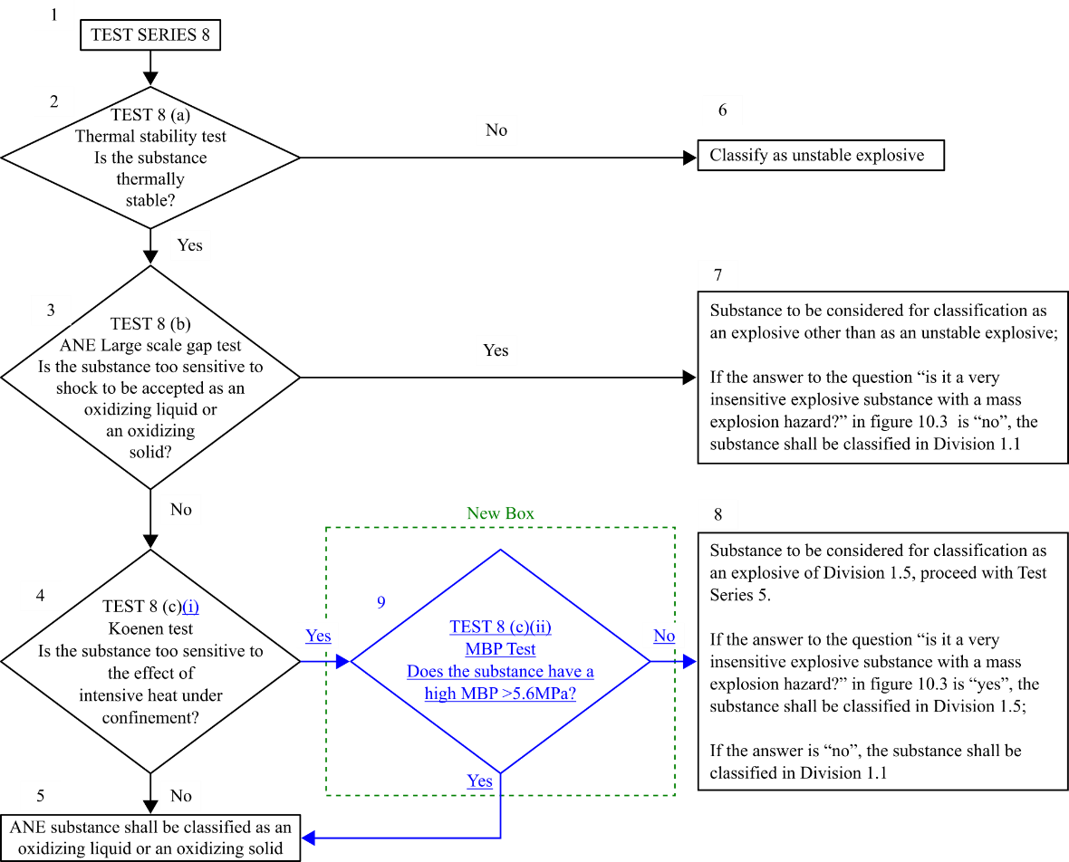**

B. Amendments to the GHS

Amend Figure 2.1.4 of the GHS as follows (*Text in blue and blue underscore = new element or text; Text in green = explanatory note for reference only):*



**Figure 2.1.4: Procedure for the classification of ammonium nitrate emulsion, suspension or gel (ANE)**

Annex II

Add a new section 18.6.2 to the Manual of Tests and Criteria, to read as follows:

**“18.6.2 *Test 8(c)(ii): CanmetCERL minimum burning pressure (MBP) Test***

18.6.2.1 *Introduction*

This test is used to determine the sensitiveness of a candidate ammonium nitrate emulsion or suspension or gel, intermediate for blasting explosive, to the effect of intense localised thermal ignition under high confinement. This test can be performed in case of a positive (“+”) result in Test 8(c)(i).

18.6.2.2 *Apparatus and materials*

18.6.2.2.1 The samples should be loaded in small cylindrical steel pipes (so-called test cells) having a length of 7.6 cm and an internal diameter of at least 1.6 cm. Each test cell should have a 3-mm wide slit machined along the axis to allow combustion gases to escape during the tests (Figure 18.6.2.1). The interior of each test cell should be painted with high-temperature non-conductive paint. Introduction of the sample into the cell should be done with caution to avoid causing crystallization of the sample and introducing air voids in the sample. Once the ignition wire has been introduced in the sample (see 18.6.2.2.2), the ends of the cell are closed off with No. 0 neoprene stoppers which must be reamed at their inside face to accommodate the splice connectors of the ignition wire assembly.

18.6.2.2.2 Ignition is provided by a 60/16 Ni/Cr wire having a diameter of 0.51 mm (nominal resistance of 5.5 Ω m-1 at 20°C) and a length of 7 cm. Both ends of the ignition wire should be spliced onto 50 cm lengths of 14 AWG (American Wire Gage) (1.628 mm) solid core bare copper wire using appropriate butt-end splice connectors. The ignition wire should be introduced in the sample, along the axis of the test cell. The neoprene stoppers are then inserted in place and the bare copper wires are pulled apart and bent at a 90° angle in order to ensure the ignition wire is held straight onto the axis.

18.6.2.2.3 The above test cell should be introduced in a pressure vessel so that the axis of the cell is held horizontal with the slit on top (Figure 18.6.2.2). A minimum volume of 4*l* and an operating pressure resistance of 20.8 MPa (or 3000 psig) are recommended for this pressure vessel. The vessel must be equipped with two insulated rigid feedthrough electrodes capable of carrying an electric current up to 20 A and sealed so as to have a pressure rating equivalent to that of the vessel itself. For safety reasons, it is recommended that the vessel be installed in a protected test room and should be equipped with a rupture disc assembly designed to vent the vessel at a pressure slightly lower than its maximum operating pressure. The vessel should also be equipped with an inlet and an outlet. In order to vent the vessel after a test, the outlet should be equipped with a high-pressure valve that can be operated remotely. The inlet should be used to pressurize the vessel to a predetermined initial pressure before the test. For convenience, it is recommended that the vessel also be equipped with a 0-25 MPa pressure transducer.

18.6.2.2.4 A gas manifold system operated from a nearby protected room (the instrument room) capable of pressurizing the pressure vessel to a chosen initial pressure using pressurized cylinders of argon. For convenience, this manifold should be equipped with a needle valve that can be used as a bleed valve to adjust the initial pressure in the vessel.

18.6.2.2.5 A constant current power supply capable of delivering a constant current up to 20 A. The current can be monitored by measuring the voltage across a high precision shunt resistor (few mΩ) connected in series with the ignition wire.

18.6.2.2.6 An oscilloscope or PC-based data acquisition system capable of acquiring the pressure transducer signal and the ignition wire current. Minimum acquisition rate should be 100 Hz for time periods up to 5 minutes.

18.6.2.2.7 A multi-meter capable of measuring electrical resistance in the range 0.1 Ω to 10 MΩ.

18.6.2.3 Procedure

18.6.2.3.1 A test cell prepared as in 18.6.2.2.1 and 18.6.2.2.2 is introduced in the pressure vessel with its axis being horizontal. The bare copper wires from the cell are connected to the vessel’s electrodes inside the vessel and the vessel is closed.

18.6.2.3.2 Using the multi-meter (see 18.6.2.2.7) the operator should check that there is no electrical contact between each electrode and the body of the pressure vessel. Once this has been established, the leads from the power supply (see 18.6.2.2.5) are connected to the electrodes. If any contact is detected between the electrodes and the body of the vessel, the reason(s) for it must be found and the contact eliminated before testing can proceed.

18.6.2.3.3 The operator exits the test room and enters the instrument room. The vessel outlet is closed while the vessel inlet in opened. The vessel is then remotely pressurized, from the instrument room, approximately to the required initial pressure for the test. If this is the first test with a given substance, this pressure should be an educated guess as the expected MBP, based on the formulation of the sample. The inlet is then closed and the vessel is left pressurized for several minutes before ignition in order to check that the system has no significant leaks. Once this is established, the pressure is finely adjusted to the required initial value and the vessel inlet is closed.

18.6.2.3.4 The data acquisition (or oscilloscope) is then started manually and a 10.5 A current is allowed to flow through the ignition wire. The current should remain on for a few seconds until the sample ignites and melts the ignition wire. When this happens, the power supply should be shut off.

18.6.2.3.5 If the sample burns completely (combustion front reaching wall of the test cell; small amount of sample can be left on the neoprene stoppers), the result is deemed to be a ‘go’. The pressure should be decreased for the next test. Otherwise the result is deemed to be a ‘no-go’ and the pressure should be increased for the next test (Figure 18.6.2.3). The pressure record from the transducer can also be used as evidence of sustained combustion or not (Figure 18.6.2.4).

18.6.2.3.6 Once the test is completed, the outlet valve is opened and all combustion gases should be vented to an exhaust system. A slow purge with argon for a few minutes is also recommended to remove all toxic gas species before opening the vessel.

18.6.2.3.7 The leads from the power supply are disconnected from the vessel’s electrodes and the vessel is opened. The test cell is recuperated and all visual observations are noted. These evidences can also be further documented by taking photographs. The vessel is then cleaned thoroughly.

18.6.2.3.8 Steps 18.6.2.3.1 to 18.6.2.3.7 are repeated while gradually decreasing the pressure increments (or decrements) until the MBP has been determined to the desired degree of precision (see typical examples below). A minimum of 12 tests using this ‘up-and-down’ methodology should be performed. The MBP should be quoted as the mean between the initial pressure of the highest ‘no-go’ event and that of the lowest ‘go’ event.

18.6.2.4 *Test criteria and method of assessing results*

18.6.2.4.1 The result of the test is considered negative (“–”) if the measured MBP of the candidate ammonium nitrate emulsion or suspension or gel, intermediate for blasting explosive is greater or equal to 5.6 MPa (or 800 psig). In this case the candidate ANE can be included in UN 3375, Division 5.1.

18.6.2.4.2 If the measured MBP is lower than 5.6 MPa (or 800 psig), the result is considered positive (“+”).

18.6.2.5 *Examples of results*

|  |  |  |  |
| --- | --- | --- | --- |
|  | **Substances** | **MBP/MPa\*(psig)** | ***Result*** |
| 1. | 72.5 ammonium nitrate / 6.1 sodium perchlorate / 8.1 water/5.3 oil+wax/5.0 aluminum/3.0 glass S\*\* | 0.93 (120) | + |
| 2. | 69.4 ammonium nitrate/5.7 sodium nitrate/6.4 sodium perchlorate/7.8 water/5.5 oil+wax/5.0 Aluminum/0.2plastic µS\*\* | 1.58 (215) | + |
| 3. | 72.1 ammonium nitrate/11.2 sodium nitrate/11.2 water/5.5 oil+wax | 3.03 (425) | + |
| 4. | 69.3 ammonium nitrate/10.5 sodium nitrate/14.7 water/5.5 oil+wax | 4.17 (590) | + |
| 5. | 83.0 ammonium nitrate/11.7 water/5.3 oil+wax | 4.48 (635) | + |
| 6. | 66.9 ammonium nitrate/10.4 sodium nitrate/17.2 water/5.5 oil+wax | 5.72 (815) | – |
| 7. | 79.9 ammonium nitrate / 14.6 water / 5.5 oil+wax | 6.82 (975) | – |
| 8. | 77.2 ammonium nitrate / 17.4 water / 5.4 oil+wax | 8.18 (1170) | – |
| 9. | 69.8 ammonium nitrate / 24.8 water / 5.4 oil+wax | 14.24 (2050) | – |

\* *The pressure in MPa units is absolute while the parenthetical pressure in psi units is gauge.*

*\*\* S refers to micro-spheres*

**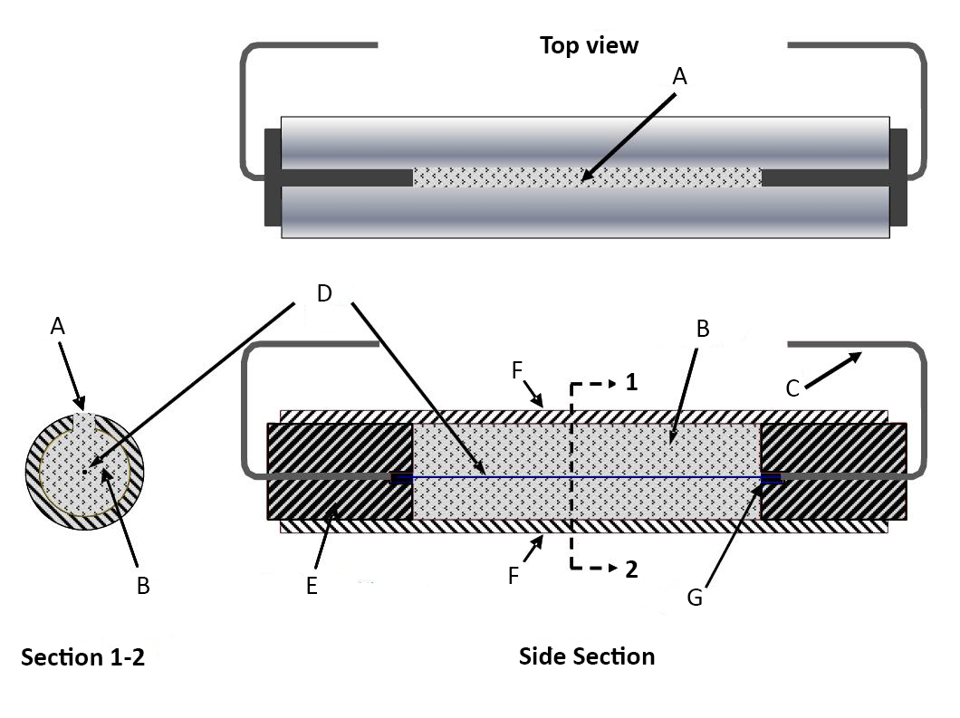**

|  |  |  |
| --- | --- | --- |
| (A) Slit  (B) Explosive  (C) Copper conductor | (D) Ni/Cr wire  (E) Rubber plug  (F) Steel pipe | (G) Splice |

**Figure 18.6.2.1**

**Test cell for Canmet/CERL MBP Test**

**Figure 18.6.2.2**

**Test cell mounted horizontally under the cover of the pressure vessel (copper conductors connected to vessel’s fixed electrodes)**

**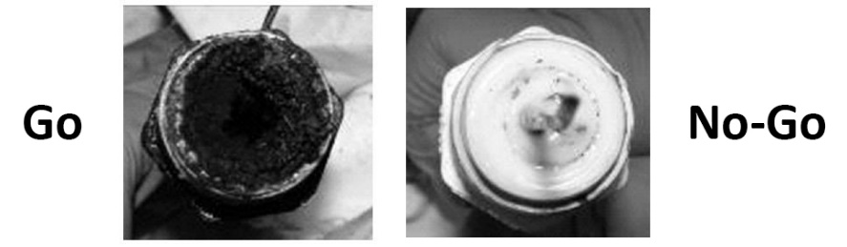Figure 18.6.2.3**

**Typical aspect of the test cell after a ‘go’ (left) and ‘no-go’ (right) event**

**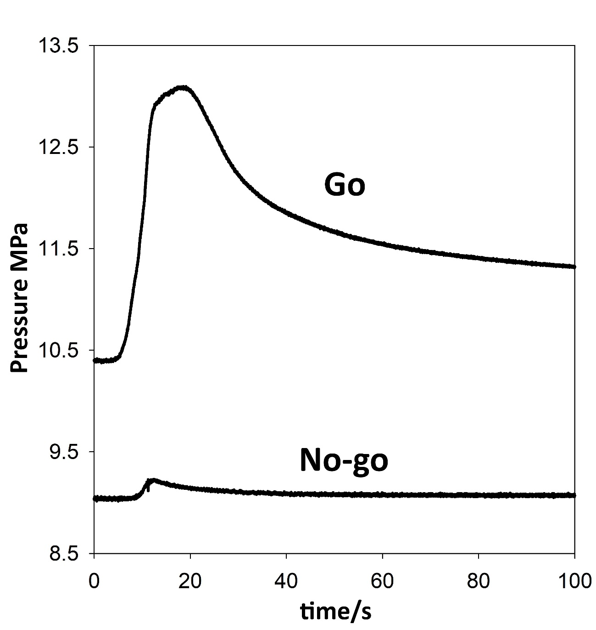Figure 18.6.2.4**

**Typical pressure records for ‘Go’ and ‘No-go’ events**

\_\_\_\_\_\_\_\_\_\_\_\_\_\_\_\_\_

1. \* In accordance with the programme of work of the Sub-Committee for 2017–2018 approved by the Committee at its eighth session (see ST/SG/AC.10/C.3/100, paragraph 98 and ST/SG/AC.10/44, para. 14). [↑](#footnote-ref-2)
2. Informal document INF.67 (fifty-third session), para. 4. [↑](#footnote-ref-3)
3. Informal document INF.53 (forty-seventh session), para. 6. [↑](#footnote-ref-4)
4. Informal document INF.38 (fifty-first session), para. 5. [↑](#footnote-ref-5)