UN/SCETDG/53/INF.30

Committee of Experts on the Transport of Dangerous Goods
and on the Globally Harmonized System of Classification
and Labelling of Chemicals 12 June 2018
Sub-Committee of Experts on the
Transport of Dangerous Goods
Fifty-third session

Geneva, 25 June-4 July 2018
Item 11 of the provisional agenda
Other business
Scope of 1.1.1.2: summary of discussions
Transmitted by the expert from the Netherlands
1. Reference is made to ST/SG/AC.10/C.3/2018/57. Informal discussions during the 52nd session of the Sub-Committee and in teleconferences in March 2018 have resulted in a good overview of the various opinions and considerations on dangerous goods that are not consignment, and in particular on data loggers in use during transport.
2. In line with the provisions of 1.1.1.2 (c) provisionally adopted at the 51st session in July 2017 (ST/SG/AC.10/C.3/102/Add.1), there is a general agreement that data loggers inside, attached to or integrated into containers, IBCs, large packaging or packaging should not be considered to be (fully) regulated dangerous goods.
3. Some of the major points in these discussions have been:
(a) whether data loggers in operation (inside, attached to or integrated into containers, IBCs, large packagings and packagings) should be considered to be dangerous goods at all;
(b) whether data loggers in use should be regulated in the Model Regulations or whether that should be left to the modal regulations;
(c) whether data loggers in use should be excluded from the Model Regulations via 1.1.1.2 or via some other part of the Regulations;
(d) whether specific testing or construction requirements should be made a prerequisite for exempting data loggers from the scope; and
(e) whether exemptions should be limited to data loggers containing lithium batteries, or be more broad in scope to include all equipment with other means of energy storage, or even to all dangerous goods that are used as equipment during transport.
4. The expert from the Netherlands has attempted to restructure and simplify the information to facilitate further considerations. Annex I contains two schemes based on some of the information provided in the discussions. Scheme 1 shows where and how data loggers are encountered in the Model Regulations. Scheme 2 depicts a representation of the scope of the Model Regulations. A summary of the minutes of the discussions at the 52nd session and during the teleconferences, are in Annex II and III, respectively.
5. The expert of the Netherlands looks forward to further discussions during the 53rd session.
Annex I
Scheme 1: Data loggers in the Model Regulations.
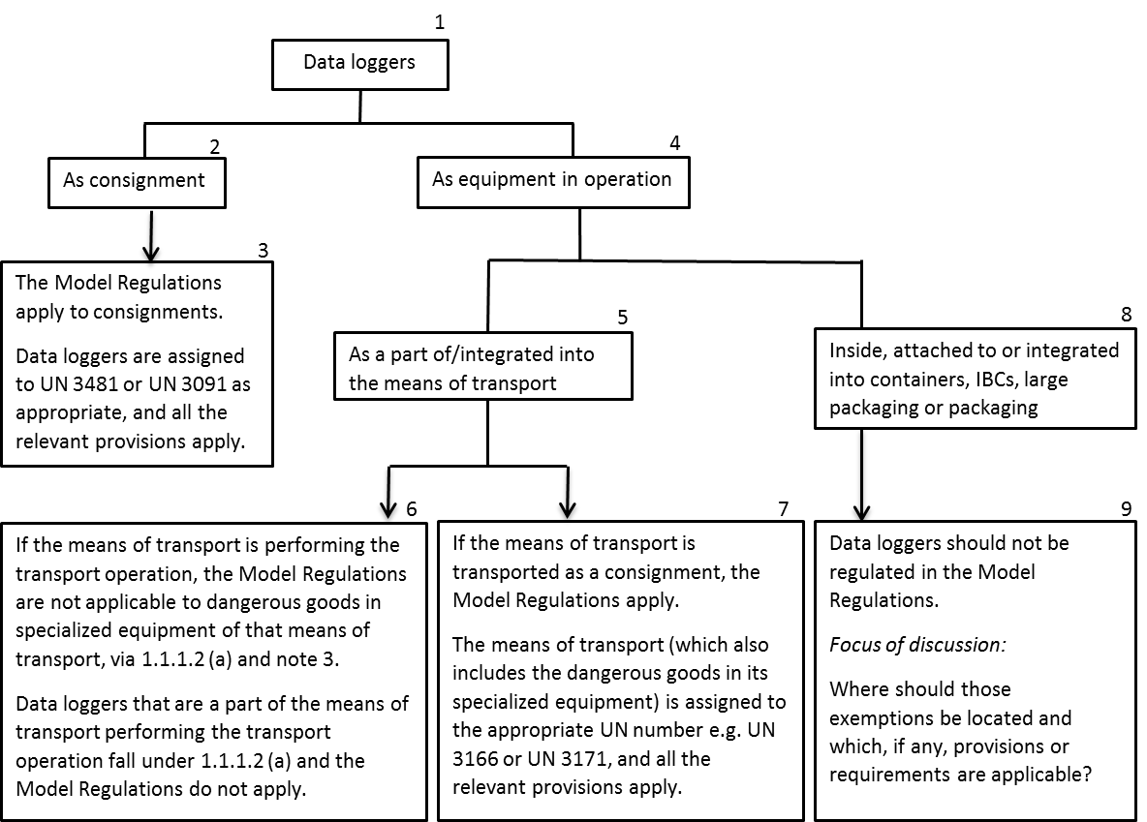

Scheme 2: The scope of the Model Regulations. The Model Regulations either apply or do not apply to dangerous goods. Where the Model Regulations do apply, there are different ways to set the appropriate regulatory attention for the goods being transported.

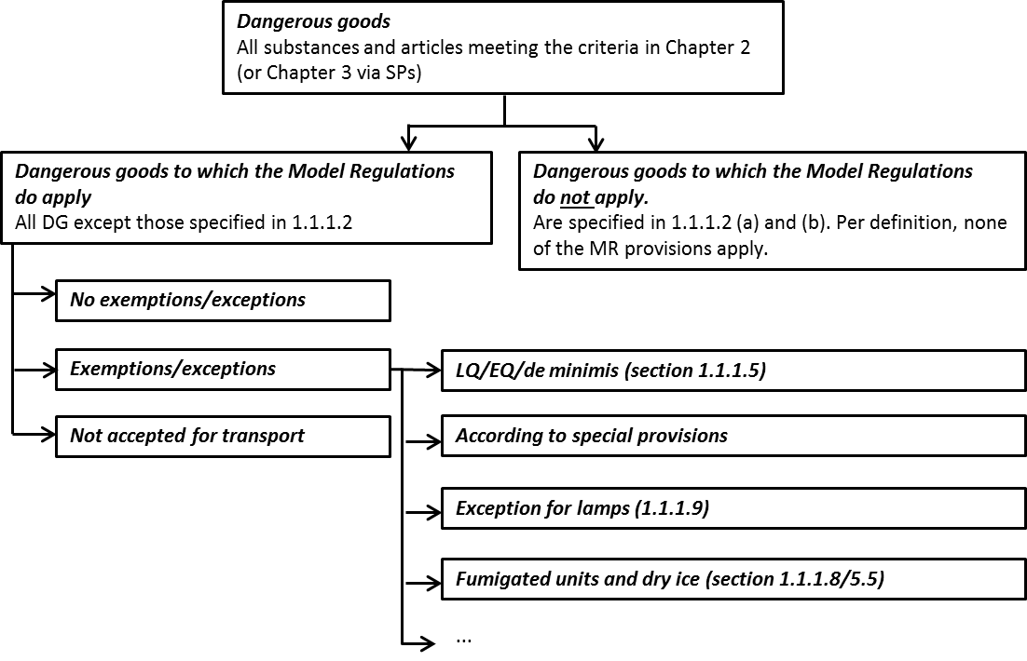
Annex II
Summary of the major points brought up during informal discussions (2x) during the 52nd session of the UN SCE TDG in December 2017
Note: Data loggers will be abbreviated as DLs thoughout Annex II and III
- Although the discussion is for the time being focusing on DLs containing lithium batteries, this should be seen in the context of the bigger discussion on clarification on the scope of the regulations with regard to dangerous goods that are not the consignment.
- The regulatory status of DLs today is unclear; some believe that in the field they are considered exempted from the Regulations. Everybody in the transport chain (including the developers of DLs) benefits from regulatory clarity. Setting limits and regulatory requirement may also help to drive development.
- Some consider DLs to be dangerous goods since they contain a lithium battery, and exempting the DLs when they are not cargo goes too far. Others do not consider DLs that are not consignment to be dangerous goods because they are not being consigned, which would make this into an operational issue.
- DLs are used for transport of all sorts of goods. It was pointed out that the regulations on the transport of dangerous goods are for transport of dangerous goods and that it is outside the scope of these regulations to regulate transport of non-dangerous goods. Some regulations require the use of DLs for transport. In some instances, e.g. for ULDs in the air mode, the DLs are considered as a part of the ULD and are out of the transport regulations. The regulations on transport of DG are additional requirements on top of general safety regulations for transport of all goods. It needs to be clear what is regulated where.
- It is clear that a DL being transported as consignment or commodity, the regulations apply as they do for any other consignment. There was also a common understanding that the Model Regulations should not (fully) regulate DLs that are not consignment. The question is how these DLs should be considered and which, if any, conditions should be attached to their exclusion from scope. The Model Regulation can specify general requirement but leave it to the modes to decide on the specifics, such as the size of the battery or other operational conditions.
- Scope can be regulated by including everything and then have specific exemptions for specific items. For many, this is not desirable as it can lead to long lists of exemptions that may have limited rational and need constant updating. Another way is to define the scope more narrowly with generalized exemptions or general conditions. Some thought it would be difficult to find the right general conditions and situation.
- The current exemptions in 1.1.1.2 do not cover DLs on cargo containers because 1.1.1.2 (a) is restricted to the means of transport and not the ‘means of containment’. As section 1.1.1.2 excludes a lot of things from the scope of the Regulations, some considered that DLs when not transported as consignment (commodity) can be excluded as well.
- However, some consider it necessary that the Model Regulations include manufacturing and/or design requirements to guarantee safety and sufficient level of protection when the DL is on the outside of the package/container. Manufacturers would need to know the requirements. There is concern about data loggers containing untested batteries.
- It is undesirable to have very specific exemptions in 1.1.1.2 since the technology will continue to develop, requiring more and more specific exemptions. General exemptions or exemptions related to the means of transport belong in the general part whereas exemptions related to consignments are located with other provisions for consignments. Most are reluctant to use special provisions to regulate DLs due to rapid development of the technology.
- DLs are used in the transport of DG as well as non-DG. The Model Regulations are for transport of DG, regulating transport of non-DG will broaden the scope considerably.
- Some pointed out that reference to 2.9.4 have been included in other places in the Regulations to ensure that batteries have been tested, and therefore, a reference to 2.9.4 should also be included for the DL for consistency. However, others mentioned that the references to 2.9.4 applied to goods transported as a consignment. Also, all batteries would need to comply with 2.9.4 anyway when transported earlier in the chain.
- Some are reluctant to call DLs ‘lithium battery in equipment’ since that triggers many requirements such as marking. Others are reluctant to regulate by function as new applications emerge every day.
- A specialized equipment is often small relative to the total object or transport unit whereas there can be DLs in many small packages in a transport unit. Many DLs only contain button cells.
- It was noted that if a DL fulfils the criteria for transport under SP 188 when transported as DG, that it would be illogical to subject that DL to more severe requirements when in use as a DL. Because of changes to the special provisions 188, some see little difference between marking of consignment of lithium batteries, and consignment of medicine accompanied by data loggers.
- When DLs are used in the transport of DG, there may be additional requirements needed to prevent initiation of reaction with the DG. DL in operation should not be the source of an incident. If the DL is a part of the packaging for DG, that may fall within the scope of the regulations. Further provisions (e.g. special packing provisions) may need to be developed when a DL is transported with DG, e.g. special packing provisions for packagings to which a DL is attached. More information is needed on what could go wrong when a DL is attached to a container.
- One suggestion was to create an entry (UN number) for data loggers, or packaging containing data loggers, with specific requirements and nothing else applies. Data loggers would then be treated in a similar way as fumigated CTUs. Whether this is successful depends on the requirements. This approach would extend the scope considerably since these provisions would then also apply to packages without DG. The provisions would have to be in a self-contained text in the general part, or in a specific chapter like 5.5.
- A second suggestion was to consider DLs as specialized equipment of the ‘means of containment’ that is in use or intended for use for tracking purposes during transport, i.e. equipment in operation. As specialized equipment in operation, it should not be regulated as a commodity. Equipment in operation must be robust enough without packaging to withstand the stressed during its intended activity. There are other specialized equipment in use during transport, that is part of operator responsibilities. The Model Regulations can give guidance and facilitate harmonization between the modes but they cannot set requirements for operational procedures. The modes already do have regulations on operational issues. And the modes have different needs and concerns. Further information on how the modes deal with operational issues and DG now may help in the discussion.
- A third suggestion was to create general provisions to cover DL in anything they are attached to, including non-DG. This would be parallel to transport of dry ice as coolant. These provisions would need to be in part 1 of the DG regulations for those that do not know the regulations. This could be achieved with an additional paragraph outside the main body text, and also in part 4 with some performance criteria. Others expressed reluctance in regulating empty packaging. Another question is whether and then how to take DLs into account during testing and certification of packaging. Further down the road, the modal bodies may need to develop segregation requirements
- It was also suggested that many of the problems for the industry would be solved if SP 188 (f) got a new iii) saying that the marking requirements do not apply to data loggers containing small batteries. Others did not want to regulate data loggers in a special provision.
- It was mentioned that there may be no good global framework to regulate DLs that are not consignment. It was suggested that the Manual of Tests and Criteria could be referenced in different regulations and become an international standard. If this idea were to be developed, some work may be needed on the Manual.

Annex III
Summary of teleconferences on the scope of 1.1.1.2 on 6 and 8 March 2018
Tuesday March 6
- There are different views and interpretations on many aspects of this discussion. It was therefore suggested that it might be easier to focus on the aim or the concept instead of different interpretations.
- Consignment and offered for transport. There was discussion whether data loggers in use attached to tanks, overpacks and packages are consignment and also whether they can or should be considered as being offered for transport when attached to tanks, overpacks and packages. Data loggers in use are by many not considered to be a consignment. However, views differ more on whether they are being offered for transport.
- SP188. Many consider that since many of the data loggers in use today are small enough, they can be considered to fall under the exemptions provided in SP188 which exempts lithium batteries in equipment from almost all of the regulatory requirements, including documentation, labelling and marking. For some, data loggers in packages became ‘visible’ when the Model Regulations were modified to require the lithium battery marking for packages containing no more than four cells or two batteries installed in equipment. Another problem is the situation when the battery is too big to qualify for the exemption in SP 188. Others pointed out that SP 188 is not a stand alone provision but part of the transport provision for UN 3481 and UN 3091 and linked to provisions in 2.9.4 and other provisions for consignments of dangerous goods.
- Some are of the opinion that since data loggers in use attached to tanks, overpacks and packages have the same hazard properties as data loggers transported as consignment, some minimum basic requirements are needed to ensure safety. The question was brought up whether lithium batteries should ever be excluded from the Model Regulations. Other pointed out that if data loggers are considered equipment in use, then the provisions in the Model Regulations for dangerous goods are not appropriate as they are not consignment. Also, other regulations also contain applicable requirements to ensure product safety. The data loggers should be regulated as equipment.
- All data loggers have already been tested according to Chapter 38.3 of the Manual of Tests and Criteria and they have to meet all the requirements of the Model Regulations when transported as consignment. It was pointed out that data loggers in use are active during transport. Also, if the data logger is attached to a solar panel, it may also be recharged during transport. Chapter 38.3 of the Manual does not take those situations into account. It was mentioned that some shippers want documentation on data loggers on containers.
- By including data loggers used as equipment in the scope of the Model Regulation and then excluding them again, we are treating data loggers differently than other equipment in operation such as fire extinguishers. There are no requirements that exclude fire extinguishers from scope when they are in use as equipment.
- It was brought up that there was a difference between the English and French version with regard to 1.1.1.2 (a). The English version uses the term ‘means of transport’ whereas the French version uses the term ‘cargo transport unit’. Reference to refrigeration units may seem to suggest that 1.1.1.2 (a) was also applicable to cargo transport units whereas the reference to dangerous goods necessary for propulsion seems to exclude at least some cargo transport units. This difference in terminology needs to be clarified in the UN Sub-Committee. If 1.1.1.2 (a) was indeed referring to the ‘means of transport’, then it would be acceptable to most to add data loggers and other lithium battery containing equipment to 1.1.1.2 (a) under the examples of specialized equipment. However, some considered that if lithium battery containing equipment were added to 1.1.1.2 (a) without any conditions, it would go against the intention of the original proposal (and provisionally adopted text).
- Some concerns were brought up with the text that the Sub-Committee provisionally adopted. The reference to 2.9.4 caused difficulties from the legal perspective. Also, it was not entirely clear which provisions were applicable. It was pointed out that other locations had been suggested, such as special provisions and chapter 5.5 which may give more flexibility. This could be discussed. A basic framework is needed to avoid data loggers to be included in the Regulations; the modes can add their own requirements if any are needed.
- It was pointed out that the Model Regulations contain requirements for the means of transport to ensure safe conditions during transport of dangerous goods, e.g. requirements for electrical systems. Some considered that devices used during transport of dangerous goods should be fulfil similar requirements. Similarly, containment systems for dangerous goods need to fulfill construction and testing requirements as specified in the Model Regulations. Some standard or requirements for data loggers are needed to ensure safe conditions during transport. Others pointed out the hazards of data loggers during transport were also relevant for transport of non-dangerous goods; the Model Regulations should ideally only contain requirements that are relevant for transport of dangerous goods and not all goods. Some did not agree with this and considered that distinguishing between transport of dangerous goods and non-dangerous goods was not relevant as the data logger itself was the issue. Another problem is that, to our knowledge, there are no global standards for data loggers in use during transport. Global standards relevant for all types of transport in which data loggers are used are preferred.
- It was briefly discussed whether data loggers and cargo tracing devices should be be called data loggers and cargo tracing devices or whether a different term, such as information tracking systems is more appropriate. Some considered data loggers to be a sufficiently clear term, especially if its function was described, whereas others thought that a broader but not yet identified term would be better. Especially if other products containing lithium batteries such as cooling boxes containing lithium batteries are to be included as well. If a better term were to be identified, it would be communicated.
- In summary, there are still different views on some of the basic ideas underlying this discussion: what is covered under 1.1.1.2 (a) – the means of transport or a cargo transport unit; what is considered a consignment and what is offered for transport, whether the data loggers are dangerous goods within the scope of the Model Regulations or not. Most agree that it would be acceptable to exclude data loggers from the scope of the Model Regulations if they are a part of the means of transport performing the transport operations. But there are still divided opinions on excluding data loggers attached to tanks, overpacks and packages.
Thursday 8 March 2018
- There was discussion on fumigated cargo transport units and the provisions for dry ice in chapter 5.5. The fumigated units were included in the Model Regulations because of the hazard they pose to workers. These provisions are the odd ducks in the Model Regulations, they would preferably be located elsewhere but as there doesn’t seem to be another framework available, they are in the Model Regulations.
- Fire extinguishers as equipment are not very dangerous since there is only one or two per transported unit but when transported as consignment, you have many more fire extinguishers and thus a bigger hazard. There was some support for not regulating aspects of equipment that are used for transport of non-dangerous goods.
- There was support for excluding data loggers that are a part of the means of the transport from the Model Regulations. This would be consistent with other specialized equipment in use, e.g. refrigeration units which are also not subject to the requirements of the Model Regulations. However, there is some discussion on the status of e.g. refrigeration units on cargo transport units on a trailer that is performing the transport operation. The Model Regulations are not written around batteries and other articles/devices.
- There was support for leaving it to the modes to regulate data loggers attached to cargo transport units, overpacks and packages. This is already done now e.g. in the air mode which also needs to consider whether these data loggers are active in use or not. Data loggers change during transport due to discharging and possibly charging, but are considered to be stagnant entities. Some considered that the basis for multi-modal transport is that the scope is generally the same with regard to the transported goods. It would be unusual to have data loggers not in the scope of the Model Regulations but in the scope for the modal regulations. Not regulating it in the Model Regulations but regulating it in the modes can lead to difficulties. This had more to do with multi-modal transport and harmonization than with safety. Others pointed out that this is already the case in the current regulations e.g. 1.1.1.2 note 1.
- From the point of view of safety, there is a difference in numbers but there was deemed to be little difference between data loggers attached to tanks vs those being a part of the means of transport.There was general agreement that all data loggers would have been tested and type approved according to Chapter 38.3 of the Manual of Tests and Criteria at some point earlier in their life cycle, when transported as cell/battery from cell manufacturer to data logger manufacturer, or from data logger manufacturer to the user of data logger. Additional requirements for compliance with 38.3 would therefore not be necessary.
- With regard to what to call data loggers, there were no suggestions but a data logger was considered to be something else than a cargo tracking device since a data logger may not necessary transmit data whereas a cargo tracking device may monitor and transmit.

