|  |  |  |  |
| --- | --- | --- | --- |
|  | United Nations | ST/SG/AC.10/C.3/2018/85−ST/SG/AC.10/C.4/2018/20 | |
| _unlogo | **Secretariat** | | Distr.: General  5 September 2018  Original: English |

**Committee of Experts on the Transport of Dangerous Goods  
and on the Globally Harmonized System of Classification  
and Labelling of Chemicals**

|  |  |
| --- | --- |
| **Sub-Committee of Experts on the Transport  of Dangerous Goods** | **Sub-Committee of Experts on the Globally Harmonized System of Classification and Labelling of Chemicals** |
| **Fifty-fourth session** | **Thirty-sixth session** |
| Geneva, 24 November - 4 December 2018  Item 2 (b) of the provisional agenda  **Recommendations made by the Sub-Committee on its fifty-first, fifty-second and fifty-third sessions  and pending issues: explosives and related matters** | Geneva, 5-7 December 2018  Item 3 (b) of the provisional agenda  **Classification criteria and related hazard communication: review of Chapter 2.1** |

Proposed criteria for an amended classification system for Explosives in the GHS

Transmitted by the expert from Sweden and the Chairman of the Working Group on Explosives[[1]](#footnote-2)\*

Background

1. The review of Chapter 2.1 of the GHS, which is the chapter that governs the classification and labelling for explosives, has been on-going since 2015. The reason for the review is that the current classification system, which was taken over from the transport sector, is ill-suited for classifying explosives that are not in their transport packaging or configuration, as the classification frequently depends on that particular packaging/configuration. This drawback of the current system and its negative effects has been further elaborated in several previous documents on the subject, most recently in document ST/SG/AC.10/C.3/2018/33−ST/SG/AC.10/C.4/2018/7 from the expert from Sweden.

2. The work on the review of Chapter 2.1 is done within an informal correspondence group (ICG) consisting of experts from the Sub-Committee of Experts on the GHS (SCEGHS) and from the Working Group on Explosives (EWG) of the Sub-Committee of Experts on the Transport of Dangerous Goods (SCETDG). The ICG is led by the expert from Sweden and he has continuously reported on the progress of the work to both sub‑committees via status reports to their every session throughout the current and most of the previous. biennium.[[2]](#footnote-3)1

3. The discussions within the ICG have led to a possible amended classification system for explosives in the GHS, which has generally found acceptance within the group and continued work on it was endorsed by the SCEGHS at its July 2018 session.[[3]](#footnote-4)2 The amended system overlays categories and sub-categories onto the currently existing divisions, in this way creating a layer of classification that does not depend on the particular (transport) packaging or configuration.[[4]](#footnote-5)3 The divisions thus remain in the system, which ensures consistency with the transport sector and other sectors where the divisions constitute the basis, such as storage.

4. At the category-level, Category 2 of the amended system would be identical in scope to Class 1 of the Model Regulations, and the divisions within this category remain the same as those within this transport class. Category 1 would comprise all other explosives so that the two categories combined span exactly the current scope of the hazard class Explosives in the GHS. At the sub-category level, sub-category 2A, 2B and 2C would sort explosives within Category 2 into high, medium and low hazard, respectively.

|  |  |  |  |  |
| --- | --- | --- | --- | --- |
| **Category** | **1** | **2** | | |
| **Division\*** | *not applicable* | 1.1, 1.2, 1.3, 1.4, 1.5 and 1.6 | | |
| **Sub-category** | *not applicable* | 2A | 2B | 2C |

\* *According to Part I of the Manual of Tests and Criteria, i.e. normally as packaged or configured for transport.*

5. The point of the amended system is that the categories and sub-categories would not be dependent on the particular packaging or configuration in which the divisions are assigned, which is usually that for transportation purposes. In this way it is made possible to classify explosives that are not packaged/configured for transport and to provide GHS hazard communication that describes the effect of the explosive when not in the particular (transport) package/configuration in which they were assigned the division, e.g. for the supply and use sectors.[[5]](#footnote-6)4 This would solve the two major problems of the current Chapter 2.1, namely that[[6]](#footnote-7)5:

(i) In practice, divisions cannot be assigned to explosives outside of their transport packaging/ configuration, so classification of these according to the GHS is, strictly speaking, not possible (e.g. in manufacturing and processing).

(ii) GHS hazard communication is tied to the division as assigned in the transport packaging/ configuration, which is often designed to provide mitigation of the explosive hazard and hence leads to understatement of the hazard for inner packages and articles as such.

6. Naturally, the amended system needs criteria for the categories and sub-categories introduced. The boundaries are that the current scope of the hazard class Explosives remains intact, that there is consistency with the Model Regulations (i.e. the transport sector) and that no new testing requirements are imposed. Tentatively agreed criteria for the amended system fulfilling these requirement were set at the ICG meeting that took place in November 2017.[[7]](#footnote-8)6 At the joint meeting of the EWG and ICG in late June 2018, the criteria for the sub-categories were further discussed and agreed in principle amongst the attendees, recognising that some further work would be needed.[[8]](#footnote-9)7

7. The outcome of the joint meeting of the ICG and EWG was subsequently presented and discussed at the joint session of the SCETDG and the SCEGHS on 3 July 2018. In that session, as well as in the ICG-meeting that same evening, it was suggested that an attempt be made to settle on the final criteria within the current biennium - a suggestion that was subsequently endorsed by the SCEGHS.[[9]](#footnote-10)8 This working document constitutes the foundation of that attempt.

8. There was also an explicit wish from the SCEGHS that examples be provided to illustrate what the amended system would mean in practice, in particular regarding which kinds of explosives would end up in the various sub-categories within Category 2.[[10]](#footnote-11)9 The intention is that such examples will be provided in an forthcoming document that will supplement this working document. The expert from Sweden reminds that a draft of his view of a potential new Chapter 2.1 with examples of new GHS labels was presented to the Sub-Committees for their June/July 2018 sessions, which may aid further in illustrating the potential effects in practice.[[11]](#footnote-12)10

State of play

9. The deadline for submission of documents to the Sub-Committees for their December 2018 sessions meant that there were only two months for the ICG to work on refining and agreeing on criteria, which in addition are the summer vacation months for most members. Despite this fact an effort was made to improve the criteria for the two categories by the expert from Sweden with the aid of the Chairman of the EWG and a few other ICG members, and to put them into a flowchart form in order to provide clarity. A group of other ICG members have made an effort to further specify the principally agreed criteria for the sub-categories, and a forthcoming document on this is expected.[[12]](#footnote-13)11

10. Although time constraints and many member’s vacations have not made it possible to agree on the criteria within the ICG before submission of this document, the expert from Sweden and the Chairman of the EWG believe that criteria based on those presented herein, together with the further input expected, could potentially be fixed with some further discussion and possible fine-tuning. This being said, the long-standing fundamental issue of whether Category 1 should be split into two sub-categories (1A and 1B) is still pending (see paragraphs 13-14 below).

Proposal

11. In annexes 1 and 2 to this document, two flowcharts are presented which contain suggested criteria for the categories (Annex 1) and the sub-categories (Annex 2) of the amended classification system. The flowchart of Annex 1 is based on the tentatively agreed criteria in November 2017.[[13]](#footnote-14)12 The flowchart of Annex 2 contains the criteria which were agreed at the joint meeting of the ICG and EWG in June 2018, which were stated in the report to need some further clarification.[[14]](#footnote-15)13 The flowchart form of representing the criteria is chosen herein for clarity and does not mean that this is necessarily the form to be used in a future new Chapter 2.1 of the GHS.

12. It is proposed that the criteria be further discussed by the ICG and the EWG in December 2018, for possible agreement and subsequent adoption by the SCEGHS. It is expected that discussions will continue within the ICG through correspondence also before the December sessions of the sub-committees, and that further documents will be put forward on the subject in particular regarding further specification of the criteria for the sub-categories within Category 2 and regarding examples of products and their resulting classifications.[[15]](#footnote-16)14

Additional option for Category 1

13. Some ICG members are of the opinion that Category 1 should be split into two sub-categories (1A and 1B), where sub-category 1A would correspond to the current classification “Unstable explosives”, which are explosives that are mechanically sensitive or thermally unstable.[[16]](#footnote-17)15 In this way it would be possible to assign separate hazard communication elements to these explosives, so that those handling them are informed.[[17]](#footnote-18)16

|  |  |  |  |  |  |
| --- | --- | --- | --- | --- | --- |
| **Category** | **1** | | **2** | | |
| **Division** | *not applicable* | | 1.1, 1.2, 1.3, 1.4, 1.5 and 1.6 | | |
| **Sub-category** | 1A | 1B | 2A | 2B | 2C |

14. While the majority of ICG-members appear not to see the need for or usefulness of this split, Annex 3 of this document contains a flowchart with criteria for this option in order to bring this issue up on the table for resolution. The criteria for Sub-category 1A are assumed to be straight forward and need no in-depth discussion, as they would simply reflect the current classification “Unstable explosives”. It is suggested that the ICG discuss and try to conclude on the principle matter of whether Category 1 should be split.

Comment on re-assessment of classifications

15. It is recognised that the degree and type of explosion hazard is largely dependent on external (i.e. non-intrinsic) factors such as amount, confinement, configuration, packaging etc. Any change in such factors may result in a changed explosion hazard and hence require a new assessment of the classification. In particular, the division level of classification is intimately tied to the particular packaging and/or configuration in which the explosive was tested (usually that for transport) and is, in general, not valid when that packaging and/or configuration is broken, changed or removed. It should be considered to emphasize this in a future Chapter 2.1.

Annex I

Proposed criteria for assigning Categories 1 and 2 in amended GHS classification system for explosives

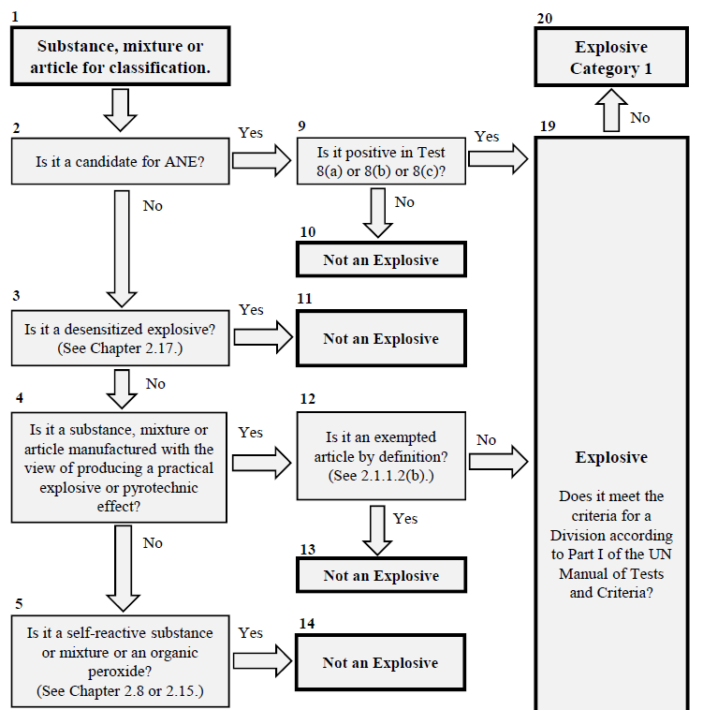

****

Comments to the flowchart of Annex I

* **Box 2 and 9:** ANEs are ammonium nitrate based emulsions, suspensions and gels that are intermediates for blasting explosives. Tests 8(a), (b) and (c) are currently used in the GHS (and in transport) to determine whether candidates for ANE are insensitive enough for exclusion from the hazard class explosives (Class 1 for transport). The tests, which are specific for candidates for ANE, are found in Part I, Section 18, of the Manual of Tests and Criteria. If all three tests are negative the product is an ANE and classified as an oxidizing solid or oxidizing liquid (Class 5, Division 5.1 for transport)
* **Box 3:** Desensitized explosives are explosives that have been wetted, diluted, dissolved or suspended to supress the explosive properties, and have a dedicated GHS hazard class (Chapter 2.17). They are currently exempted from classification as Explosives by virtue of NOTE 2 in Section 2.1.2.2 of Chapter 2.1.
* **Box 5:** The GHS hazard classes self-reactive substances and mixtures (Chapter 2.8) and Organic peroxides (Chapter 2.15) include the possibility that the substance/mixture is explosive (Types A and B). They are therefore not considered in the hazard class explosives, unless the explosive effect is intentional (which in practice is not the case). Some experts are of the view that this box should be moved upwards.
* **Box 6 and 7:** Test series 2 currently determines whether a substance or mixture that is not intended to be explosive/pyrotechnic is sensitive enough for provisional inclusion in the hazard class Explosives in the GHS (and for provisional inclusion in Class 1 for transport). Before doing these tests the screening methods contained in sub-section 2.1.4.2 of GHS Chapter 2.1 can be applied, which avoids unnecessary testing, and it is intended that these are retained.
* **Box 7:** Some experts believe that articles that are explosive but have not been manufactured with the view of producing an explosive or pyrotechnic effect do not exist (and will never exist), while other experts think that they may (come to) exist. If the former is true, Box 7, and hence also Box 17 and 18, can be removed from the flowchart. However, it could be considered to keep them in as a precaution so that such articles are included in the hazard class of Explosives, should they (come to) exist.
* **Box 12 and 17:** While the GHS currently does not provide criteria for exemption of certain explosive articles in 2.1.1.2(b), the Model Regulations do so in the corresponding definition 2.1.1.1(b) in Chapter 2.1. The criteria for exclusion of articles from Class 1 are found in Sub-section 2.1.3.6.4 of this chapter in the Model Regulations.
* **Box 19:** It needs to be discussed how to appropriately word the reference to the divisions, i.e. whether reference should be to Part I of the Manual (as written), to Class 1 of the Model Regulations or worded in some other way (e.g. “transport divisions”).

Annex II

Proposed criteria for assigning sub-categories 2A, 2B and 2C in new GHS classification system for explosives

****

Comments to the flowchart of Annex II

* **Box 3:** Use of dividers and spacers are examples of commonly used methods intended to mitigate the explosive effect, as is special placing of articles to partly cancel out an explosive effect. It could be discussed whether the intention of mitigating the explosive effect needs to be added as a criterion.
* **Box 4:** It needs to be clarified what a “violent” reaction means in the three tests mentioned, and a forthcoming paper is expected to address this in more detail.
* **Box 5:** Compatibility groups are assigned according to Section 2.1.2 in Chapter 2.1 of the Model Regulations and are intended to indicate how explosives can be transported together. While they are not used in the GHS, compatibility group S does appear in Figure 2.1.2 of GHS Chapter 2.1. Compatibility group S can only be assigned when there are no hazardous effects outside the package, see further details in the Model Regulations.

Annex III

Criteria for the additional option of splitting Category 1 into sub-categories 1A and 1B in amended GHS classification system for explosives

**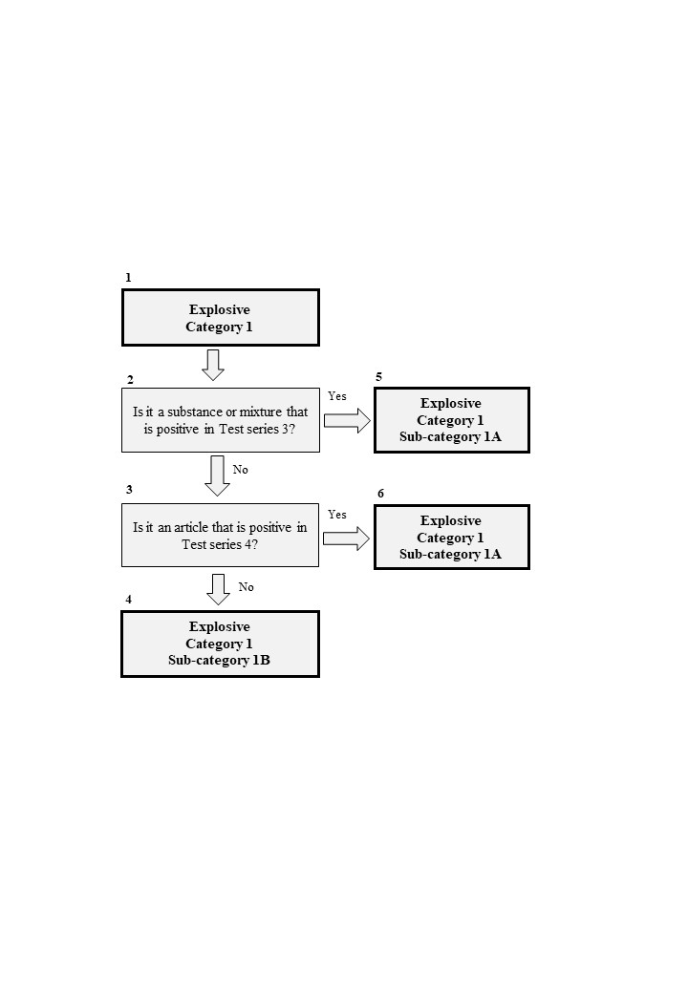**

Comments to the flowchart in Annex III

* **Box 2:** Test series 3 is currently used in the GHS to distinguish substances and mixtures that are unstable explosives, which are positive in this test series (rejected from Class 1 of transport because they are too dangerous to transport).
* **Box 3:** Test series 4 is currently used in the GHS to distinguish articles that are unstable explosives, which are positive in this test series (rejected from Class 1 of transport because they are too dangerous to transport).

1. \* In accordance with the programme of work of the SCEGHS for 2017–2018 approved by the Committee at its eighth session (ST/SG/AC.10/C.4/64, paragraph 67, and ST/SG/AC.10/44, paragraph 14). [↑](#footnote-ref-2)
2. 1 See the latest status reports informal document INF.16 (GHS, thirty-fifth session) - INF.46 (TDG, fifty-third session). All previous status reports are listed in footnote 2 of ST/SG/AC.10/C.3/2018/33−ST/SG/AC.10/C.4/2018/7. [↑](#footnote-ref-3)
3. 2 See the report from the thirty-fifth session of the SCEGHS (ST/SG/AC.10/C.4/70), paragraphs 24-27. [↑](#footnote-ref-4)
4. 3 See ST/SG/AC.10/C.3/2018/33−ST/SG/AC.10/C.4/2018/7. [↑](#footnote-ref-5)
5. 4 In many (if not most) cases, the (transport) packaging or configuration is decisive for the division assigned, as the packaging/configuration is designed to mitigate the explosive effect. Whenever the explosive is out of that particular packaging/configuration the division is, in general, no longer valid. [↑](#footnote-ref-6)
6. 5 See ST/SG/AC.10/C.3/2018/33−ST/SG/AC.10/C.4/2018/7 for further elaboration on this. [↑](#footnote-ref-7)
7. 6 See informal document INF.20 (GHS, thirty-fourth session) - INF.57 (TDG, fifty-second session). [↑](#footnote-ref-8)
8. 7 Informal document INF.67 (TDG, fifty-third session), paragraph 18. [↑](#footnote-ref-9)
9. 8 See the report from the joint TDG/GHS-session (ST/SG/AC.10/C.3/106), paragraphs 163-165, the report from the ICG-meeting (informal document INF.30 (GHS, thirty-fifth session) as well as the report from the SCEGHS (ST/SG/AC.10/C.4/70), paragraphs 24-27. [↑](#footnote-ref-10)
10. 9 See the report from the SCEGHS (ST/SG/AC.10/C.4/70), paragraphs 24-27. [↑](#footnote-ref-11)
11. 10 See informal documents INF.9 (GHS, thirty-fifth session) - INF.10 (TDG, fifty-third session). [↑](#footnote-ref-12)
12. 11 Referring to those in the report from the EWG meeting, informal document INF.67 (TDG, fifty-third session), paragraph 18. [↑](#footnote-ref-13)
13. 12 See the Annex of ST/SG/AC.10/C.3/2018/33−ST/SG/AC.10/C.4/2018/7. [↑](#footnote-ref-14)
14. 13 See the report from the EWG meeting, informal document INF.67 (fifty-third session),  
     paragraph 18. [↑](#footnote-ref-15)
15. 14 It was also noted in the report from the EWG in June 2018 that some consideration may be required to categorise very small amounts of materials that have not yet been characterised. [↑](#footnote-ref-16)
16. 15 According to the Model Regulations, these are rejected from Class 1 and not allowed for transport. [↑](#footnote-ref-17)
17. 16 See further discussion in the report from the ICG meeting in July 2018, informal document INF.30 (thirty-fifth session). It was recognised that there are other ways of achieving the aim of informing on mechanical sensitivity/thermal instability that would not need splitting of the category. [↑](#footnote-ref-18)