|  |  |  |  |
| --- | --- | --- | --- |
|  | United Nations | ST/SG/AC.10/C.3/2018/78 | |
| _unlogo | **Secretariat** | | Distr.: General  12 September 2018  Original: English |

**Committee of Experts on the Transport of Dangerous Goods  
and on the Globally Harmonized System of Classification  
and Labelling of Chemicals**

**Sub-Committee of Experts on the Transport of Dangerous Goods**

**Fifty-fourth session**

Geneva, 26 November-4 December 2018  
Item 2 (b) of the provisional agenda **Recommendations made by the Sub-Committee on its fifty-first,   
fifty-second and fifty-third sessions and pending issues:  
explosives and related matters**

Transport of energetic samples for further testing

Transmitted by the European Chemical Industry Council (CEFIC)[[1]](#footnote-2)\*

Introduction

1. Research and development in industry, public institutes, and universities frequently need to transport substances for the purpose of testing, i.e. the determination of physical, chemical, biological, toxicological or ecotoxicological properties and behavior, fitness for use or application.
2. These substances usually consist of organic molecules, which are building blocks, intermediates, or active ingredients for pharmaceutical or agricultural chemicals. Although not designed to be explosives of Class 1, many of these substances carry functional groups listed in tables A6.1 and/or A6.3 in Annex 6 (screening procedures) of the Manual of Tests and Criteria, indicating potential explosive or self-reactive properties.
3. The amounts of substance handled in the research phase are small (typically in the range 10 to 100 g), and reliable information about the proper classification is not available due to the lack of test data. Larger amounts first become available in process scale-up and development.
4. Table 1 below specifies the amount of substance needed for classification testing of explosives and self-reactive substances. Obviously, the amount required for this purpose by far exceeds the availability of such substances in research. On the other hand, at a later stage of development, amounts of 2 – 4 kg have to be transported to the test lab to fulfil the legal requirements for classification.
5. Furthermore, many small companies and institutes are not aware of the dangerous good regulations, and therefore these substances might be frequently transported by regular mail or other delivery services under completely inappropriate conditions.
6. Due to this situation, CEFIC emphasizes the need for a practical solution in this matter that is readily understood and applied by organizations less familiar with dangerous goods regulations.

**Table 1: Typical amounts of substance required for classification testing**

|  |  |  |  |  |  |
| --- | --- | --- | --- | --- | --- |
| Class 1 Acceptance procedure | | | Testing of self-reactive substances | | |
| UN Test | Name | Amount (g) | UN Test | Name | Amount (g) |
| 2 (a) | UN gap test | 1000 | A.1 | BAM 50/60 steel tube | 2000 |
| 2 (b) | Koenen test | 200 | C.1 | Time/pressure test | 15 |
| 2 (c) (i) | Time/pressure test | 15 | C.2 | Deflagration test | 350 |
| 3 (a) (ii) | BAM Fallhammer | 1 | E.1 | Koenen test | 200 |
| 3 (b) (i) | BAM friction apparatus | 1 | E.2 | Dutch pressure vessel test | 200 |
| 3 (c) (i) | Thermal stability test | 50 | F.3 | BAM Trauzl test | 10 |
| 3 (d) | Small scale burning test | 220 | H.4 | Heat accumulation storage test (SADT) | 1000 |
| Sum |  | 1587 | Sum |  | 3775 |

1. As a first step towards resolving this issue, CEFIC’s proposal ST/SG/AC.10/C.3/2016/61 was adopted in the last biennium. The new provisions in section 2.0.4.3 allow for the transport of small amounts of samples (up to 1 g / 1 ml) as self-reactive substances type C under certain restrictions in a very specific package.
2. In the current biennium, CEFIC has taken the next step towards a comprehensive solution by introducing their concept for samples in larger amounts. Encouraged by discussions both in the International group for Unstable Substances: energetic and oxidizing substances (IGUS EOS Working Group) and the Working Group on Explosives of the TDG Sub-Committee, CEFIC submitted a proposal for a flow chart along with detailed justifications. As a result of these discussions, the Working Group on Explosives requested more time to examine the issue and suggested that CEFIC submit a formal proposal to facilitate the discussions.

Discussion

Explosives, self-reactive substances and energetic substances

1. An overview of the current classification criteria is shown in figure 1. For reasons of simplification, special cases such as pyrotechnics, articles and ammonium nitrate emulsions, suspensions or gels (ANEs) are summarized as “intentional explosives” and not discussed in this document since they are not relevant for the context.
2. As already mentioned in the introduction of this document, the samples under consideration contain substances carrying functional groups indicating potential explosive or self-reactive properties (tables A6.1 and A6.3 in Annex 6 of the Manual of Tests and Criteria).
3. Whereas the transport of samples of self-reactive substances and organic peroxides is permitted under the provisions of 2.4.2.3.2.4 (b) and 2.5.3.2.5.1, respectively, substances considered to meet the criteria for Class 1 are prohibited for transport by 2.0.4.2 (b).
4. According to 2.1.1.5 of the Model Regulations and 10.2.1 (b) of the Manual of Tests and Criteria, any substance should be first considered for inclusion in Class 1.
5. The so-called “acceptance procedure” is described in sections 2.1.3.2 and 2.1.3.3 of the Model Regulations, and a flow chart is given in figure 10.2 of the Manual of Tests and Criteria. For possible non-intentional explosives, test series 2 determines whether a substance is to be considered for Class 1 (Box 8 of that flow chart).
6. Subsequently, the thermal stability and mechanical sensitivity of the substance are determined (test series 3 and 4). If the substance is not thermally stable, Class 1 is rejected (box 12). However, section 10.3.3.3 of the Manual of Tests and Criteria suggests that for “a substance, not designed to have an explosive effect … it is more appropriate to start the testing procedure with test series 3”.
7. If Class 1 is rejected due to insufficient thermal stability, a classification as a self-reactive substance will apply (see below).

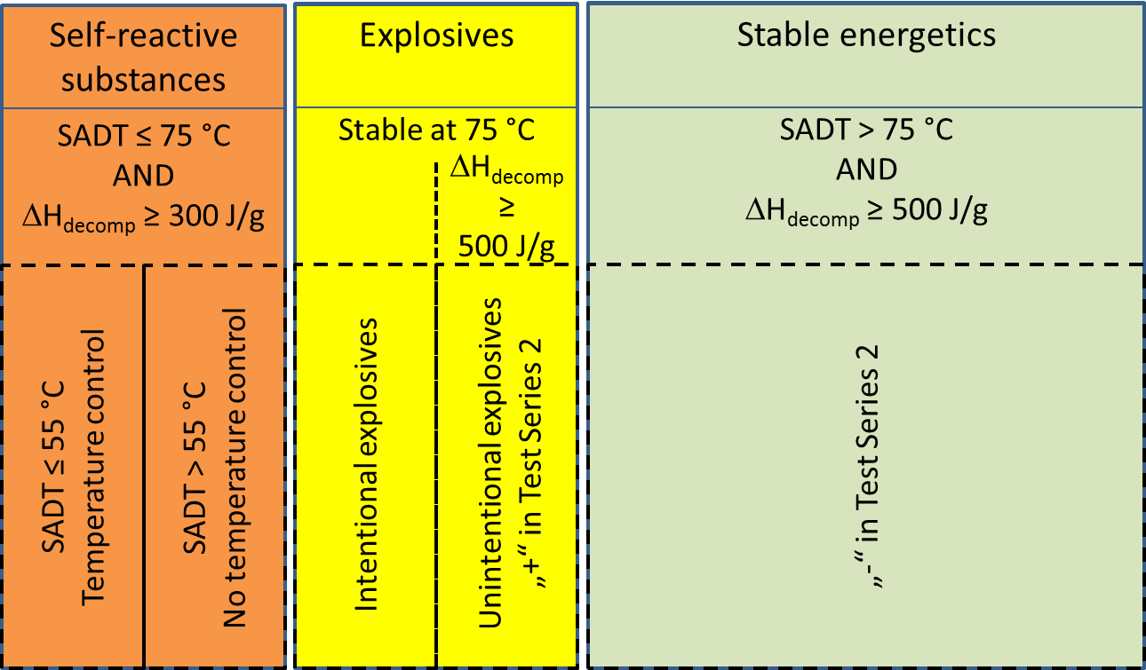

Figure 1: Classes of energetic substances

1. Appendix 6, section 3.3 (c) of the Manual of Tests and Criteria states that for organic substances containing chemical groups associated with explosive properties the Class 1 acceptance procedure does not have to be applied:
   1. When the exothermic decomposition energy is less than 500 J/g, or
   2. When the onset of exothermic decomposition is 500 °C or above as indicated by Table A6.2.
2. This text was adopted for the Manual of Tests and Criteria at the forty-third session of the Sub‑Committee (June 2013) as a result of a proposal submitted by Sweden (see ST/SG/AC.10/C.3/2013/8) with the intention of clarification. However, in this context an important information in the original text was lost with respect to the temperature limit of 500 °C: “The temperature limit is to prevent the procedure being applied to a large number of organic materials which are not explosive but which will decompose slowly above 500 ºC to release more than 500 J/g”.
3. That means the upper range for the evaluation of the decomposition energy should be 500 °C. Substances with a decomposition energy less than 500 J/g in a temperature range up to 500 °C should not be classified as explosive of Class 1.
4. Self-reactive substances are defined in 2.4.2.3.1.1 of the Model Regulations as “thermally unstable substances liable to undergo a strongly exothermic decomposition even without participation of oxygen (air)”. Apart from differentiation criteria from other classes, substances should be classified as self-reactive if they have a decomposition energy of 300 J/g or more in combination with an SADT of 75 °C or less. The decomposition energy should be determined by differential scanning calorimetry (DSC) according to section 20.3.3.3 of the Manual of Tests and Criteria.
5. Section 5.1 (b) in Appendix 6 of the Manual of Tests and Criteria states that classification as a self-reactive substances does not apply if either one of the two criteria described above is not fulfilled. Temperature control applies if the self-accelerating decomposition temperature (SADT) is less than or equal to 55 °C (see 2.4.2.3.4) as shown in figure 1 above.
6. If a substance is thermally stable at 75 °C and passes Test Series 2, a classification as explosive (Class 1) and self-reactive (Division 4.1) is not applicable. Such substances would be assigned to the box denoted “stable energetics” in figure 1.
7. Experience in industry has shown that the vast majority (95-98 %) of substances in the scope of this document would be characterized as such stable energetics, a small percentage (2-5 %) as self-reactive and a negligible amount (less than 0,1 %) explosive.

Issues to be solved for the transport of energetic samples

1. The classification depicted above as presented in figure 1 works on the presumption that all necessary data are available for a proper classification.
2. Section 2.4.2.3.2.4 (b) permits the transport of self-reactive substances as type C provided that
   1. Available data indicate that the sample would not be more dangerous than type B;
   2. Packing method OP2 is applied with a upper limit of 10 kg per cargo transport unit; and
   3. Temperature control and dangerous phase separation are considered.
3. As the text is written, it presumes that a classification as self-reactive is already established, i.e. decomposition energy ≥ 300 J/g and SADT ≤ 75 °C and subsequent measurements for temperature control have been determined by measurement. What has to be done in order to transport the sample to the test lab for SADT determination in the first step?
4. On the other hand, for a substance that is thermally stable, about 2 kg of material are necessary to perform test series 2. Application of UN 0190 in such cases would be an intolerable burden both for industry and competent authorities and by no means appropriate, especially during the research phase when only amounts of 10 to 100 g are to be carried.
5. Following numerous discussions with competent authorities, CEFIC has developed the concept of transporting energetic samples under the regime of self-reactive substances of division 4.1. Reasons are

(a) Provisions for the transport of self-reactive substances already exist (see above and 2.0.4.2 (c));

(b) Self-reactive substances may have explosive properties (see 2.4.2.3.1.2), and appropriate packing instructions (P520) are prescribed;

(c) Temperature control is applicable for substances of low thermal stability.

1. It should be also noted that type B self-reactives may be carried in limited quantities of 100 g (solids, UN 3222) and 25 ml (liquids, UN 3221), respectively.
2. The Sub-Committee has supported this approach and adopted CEFIC’s proposal ST/SG/AC.10/C.3/2016/61 in the last biennium. The new provisions in section 2.0.4.3 allow for the transport of small amounts of samples (up to 1 g or 1 ml) as self-reactive substances type C under certain restrictions in a very specific package.
3. The adopted solution in section 2.4.0.3 for small samples (up to 1 g scale) is built on a safe design:
   1. The package is sufficiently strong to survive the detonation even of an intentional explosive (see ST/SG/AC.10/C.3/2016/61), and

(c) The inner design prevents a propagation of detonation from one sample to another.

31. For larger amounts of samples, this concept is obviously not applicable. Therefore, further proceedings have to be based on increased knowledge about safety-relevant properties of the sample.

1. Generally, the decomposition energy and the onset of decomposition can be easily determined by DSC methods (see Manual of Tests and Criteria, section 20.3.3.3). This document describes how this information may be used as the basis for a preliminary assessment of the samples.

Decomposition energy

1. A representative set of samples (369 substances) was investigated with respect to their decomposition energy. For this purpose, screening DSCs were measured at heating rates of 3-5 K/min in agreement with the requirements lined out in the Manual of Tests and Criteria, section 20.3.3.3.
2. For comparison, the self-reactive substances listed in section 2.4.2.3.2.3 of the Model Regulations were evaluated with respect to their decomposition energies. Where available, measurement data were taken; in other cases, literature data were used or bond increment methods applied (see figure 2 and table 3 in the annex to this document).

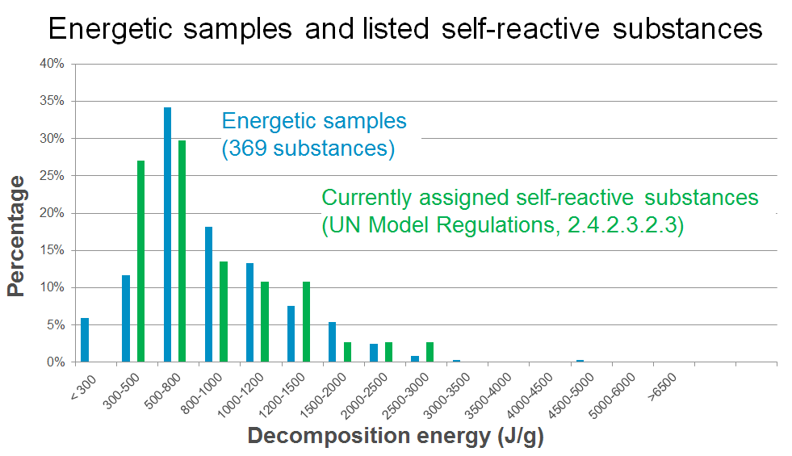

Figure 2: Decomposition of energetic samples vs. listed self-reactives

1. Evidently, the shape and position of the distributions form an excellent match. The coherence with the curve for the self-reactive substances justifies the treatment of energetic samples under this entry and strongly confirms the approach taken by CEFIC (see section 27 above).
2. Furthermore, literature data for known explosives were compiled and evaluated (J. Köhler, R. Meyer, Explosivstoffe, Wiley-VCH). The results are shown in figure 3:

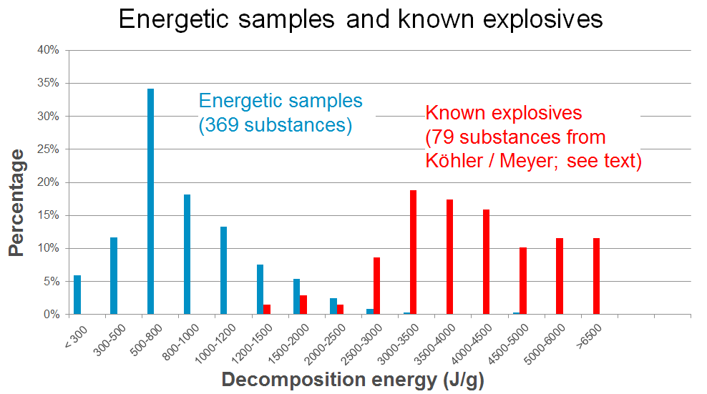

Figure 3: Decomposition of energetic samples vs. known explosives

1. Figure 4 shows a similar evaluation for desensitized explosives and for stable energetic compounds (both taken from the Model Regulations; see tables 4 and 5 in the annex to this document). The stable energetics in the context of this document are substances exhibiting a decomposition energy of more than 1000 J/g outside of Class 1 and Self-reactives of Division 4.1. Note that some of these products such as nitromethane and derivatives of nitrobenzene are produced and transported in huge volumes. Numerous polymerizing substances exhibit large heats of reaction as well (see informal document INF.27, forty-seventh session).

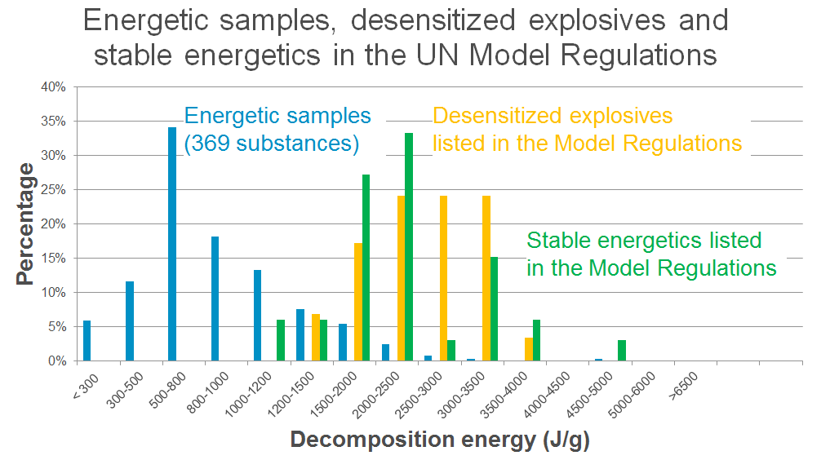

Figure 4: Decomposition of energetic samples vs. desensitized explosives and stable energetics

1. Evidently, the energetic samples form a group of lower decomposition energies clearly separated from the explosives with much higher energies. Except for one substance (lead trinitroresorcinate, 1480 J/g), no known explosive could be identified with a decomposition energy <1500 J/g. In the group of the desensitized explosives, silver picrate, zirconium picramate and barium azide exhibit similar low decomposition energies. As intentional initiating explosives, these substances are clearly outside of the scope of 2.0.4.3.
2. Sodium pricramate, ammonium perchlorate, and sodium dinitrocresolate are found in the range 1900-2000 J/g. All these compounds can be chemically characterized as salts. For 4-Nitrophenylhydrazine and 1-Hydroxybenotriazole in their desensitized form, a lower energy limit of 2000 J/g is found as well. This leads to the conclusion that for the samples as described in 2.4.0.3 a safe transport is warranted for decomposition energies:

(a) Below 1500 J/g for salts, and

(b) Below 2000 J/g for substances other than salts.

1. The large majority of known explosives have a decomposition energy of 2000 J/g or more. Samples exhibiting such energies have an increased chance of being an explosive substance, and would need closer inspection before transport.
2. Therefore, it appears justified to allow the transport of energetic samples as self-reactive substances Type C under the provisions of 2.4.2.3.2.4 (b) depending on their energy content (decomposition enthalpy ΔHdecomp) as follows:

Table 2: Suggested thresholds for testing of energetic samples

|  |  |  |
| --- | --- | --- |
|  | Salts | Other substances |
| No testing required | ΔHdecomp < 1500 J/g | ΔHdecomp < 2000 J/g |
| Additional testing required | ΔHdecomp ≥ 1500 J/g | ΔHdecomp ≥ 2000 J/g |

1. Considering that only limited amounts of substance are available in early stages for such testing, it is suggested to obtain a preliminary assessment for the sample transport based on the test for explosive power (Test F.3) and time/pressure test for assessing the ability to deflagrate rapidly (Test C.1). Since soft packagings are prescribed in packing instruction P520, the Koenen test (Test E.1) appears less useful in this context.
2. If in Test C.1 the result “yes, rapidly” OR in Test F.3 the result “not low” would be obtained, a special permit by the competent authority would be required, otherwise the available data would justify a sample transport under the provisions of 2.4.2.3.2.4 (b) as self-reactive substance Type C, packing method OP2, packing instruction P520.
3. Based on these considerations, a tentative flowchart incorporating already existing provisions has been drafted (see figure 5).
4. Boxes 1 through 9, 11 and 12 refer to already existing provisions in the Model Regulations
5. Box 4 refers to section 5.1 (b) of Appendix 6 of the Manual of Tests and Criteria. Since the approach applies the self-reactives regime for all energetic compounds, the SADT criterion is not relevant in this context. Below a decomposition energy of 300 J/g, a classification as a self-reactive substance or as explosive can be ruled (see also figure 1 above).
6. Box 4 is not meant to have a mandatory measured value for the substance under concern. A possible valid way to escape to box 5 would be also experience with data from similar compounds or an extrapolation from data of a small molecule to a larger one etc.
7. Boxes 6 through 9 refer to the provisions in section 2.4.0.3.
8. Box 10 would be new text requiring the determination of the decomposition behavior (energy and onset) of the sample for amounts exceeding 1 g or 1 ml per sample.
9. Box 11 identifies low energy samples that

(a) Are not candidates for self-reactive substances due to their thermal stability (see below), and

(b) Do not require the Class 1 acceptance procedure based on the criteria outlined in table 6.2 of Annex 6 of the Manual of Tests and Criteria.

1. According to the “100 K rule” applied in worldwide chemical safety assessment, keeping a distance of 100 K from the decomposition onset has proven a practical rule of thumb to avoid thermal runaway reactions. For a decomposition onset of 180 °C, a handling temperature of 80 °C is considered safe. Therefore, the SADT is expected to be greater than 75 °C and consequently, a classification as self-reactive according to 2.4.2.3.1.1 (e) can be ruled out.
2. For explosives, a lower energy limit of 500 J/g applies according to section 3.3 (c) in appendix 6 of the Manual of Tests and Criteria (yellow box in figure 1). In this context, see the discussion in paragraphs 16 to 18 in this document.
3. In box 13, possible temperature control requirements are determined (see discussion below).
4. Boxes 14 to 20 establish the criteria suggested in sections 40 to 42 above. Boxes 15 and 19 refer to the existing provisions concerning the transport of samples of self-reactive substances.

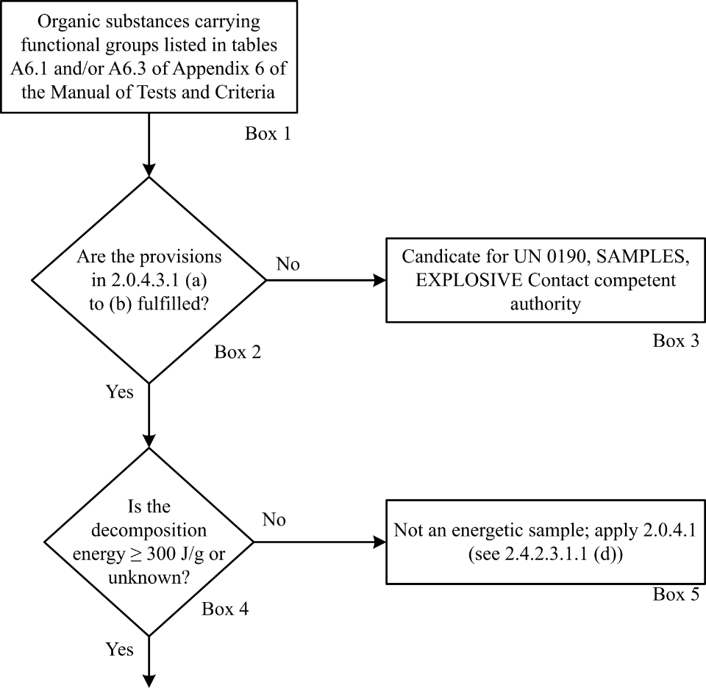

Figure 5: Tentative flowchart for energetic samples

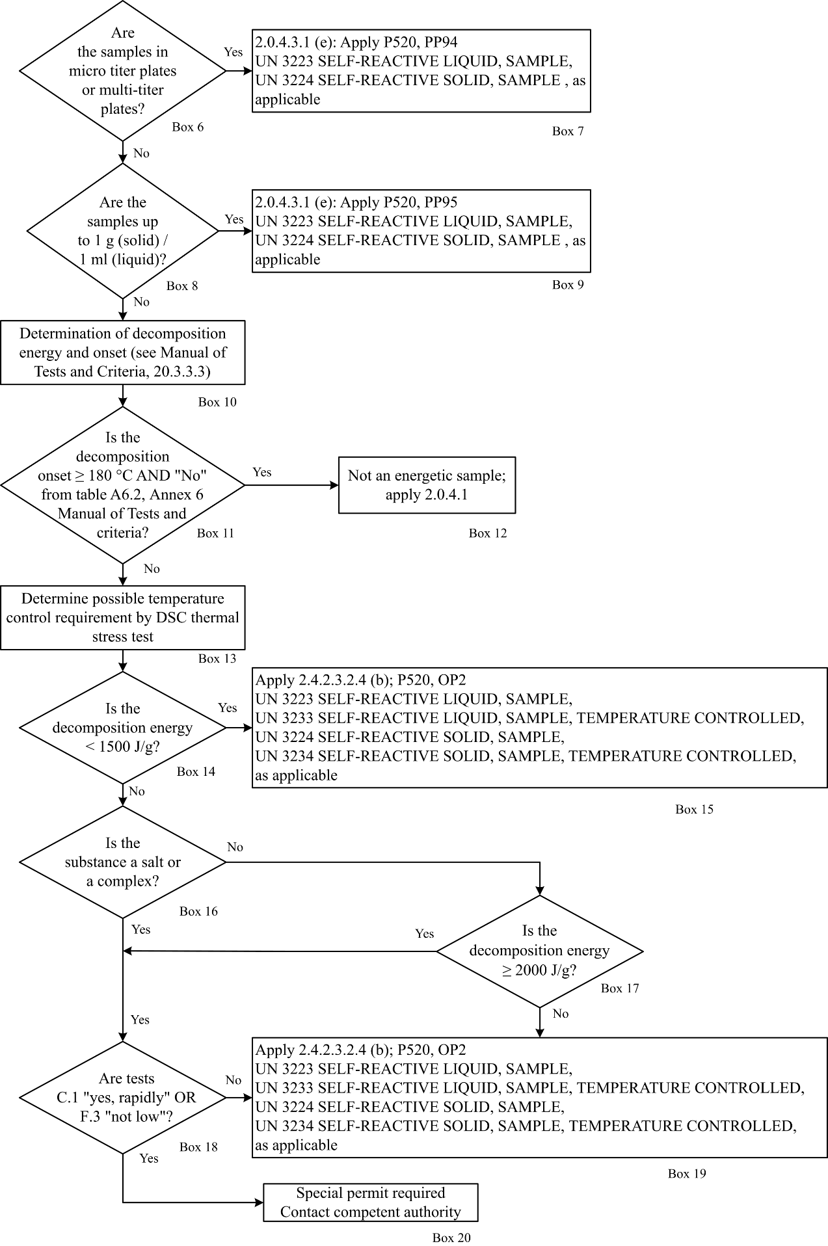

Figure 5: Tentative flowchart for energetic samples (continued)

Thermal stability

1. The remaining issues to be solved are thermal stability and, in this context, any possible temperature control requirements (see box 13 of the flowchart).
2. According to 2.4.2.3.4, temperature control is not required if the substance is thermally stable, i.e. SADT ≥ 60 °C. By applying the “100 K rule” described in paragraph 50 of this document, sufficient thermal stability may be assumed if the decomposition onset in the screening DSC is 160 °C or above, thus not requiring temperature control.
3. Since SADT tests H.1 to H.4 are not designed for small sample amounts, a thermal stress test is suggested as alternative method which can be easily performed by DSC measurements. Such an approach has been successfully applied in establishing temperature limits for the safe operation of chemical plants.
4. The concept is to determine whether the decomposition behavior changes upon the application of thermal stress during a defined period of time. For practical reasons, 24 hours are suggested.
5. A screening DSC (heating rate 2-5 K/min in a closed crucible; see Manual of Tests and Criteria, section 20.3.3.3) is measured for the sample as offered for transport. A second sample is taken, and thermal stress is applied (practically realized by tempering the sample in a DSC crucible at a defined constant temperature over a certain period of time; see above), and subsequently a DSC of the stressed sample is measured at the same heating rate as before.
6. If the decomposition behavior remains unchanged in terms of decomposition onset, shape of curve, and energy within a measurement uncertainty of 10%, then the sample is stable at the applied stress temperature. If the stress test is passed at 60 °C, no temperature control is required.
7. For a conservative approach, the decomposition onset should be taken as the temperature of the first noticeable exothermic effect (i.e. the heat production signal leaves the baseline).



Figure 6: Example of a sample passing the thermal stress test

1. In case the stress test at 60 °C is not passed, the same procedure should be applied at decreasing temperatures in steps of 10 K until the decomposition behavior remains unchanged. That temperature should be deemed the estimated SADT of the sample, and the control and emergency temperatures may then be derived in accordance with section 28.2.3 and table 28.2 of the Manual of Tests and Criteria.
2. An example of a sample passing the thermal stress test as described above is given in figure 6. It is obvious that the shape, the location of the curve, as well as the energy values remain unchanged within the tolerance of measurement. Also, the endothermic melting peak has not changed.
3. An example of a negative outcome of the thermal stress test is given in figure 7: Upon thermal stress, the shape of the curve has changed dramatically. The first peak at about 100 °C has completely disappeared, and the decomposition energy has decreased by about 20%. These findings are clear evidence that a reaction has taken place under the conditions of thermal stress applied, and thus temperature control would be necessary.

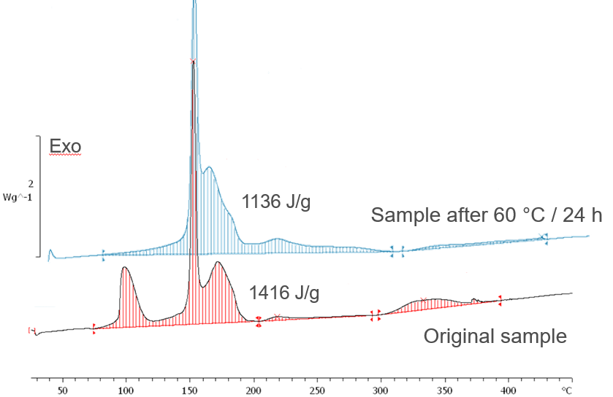

Figure 7: Example of a sample failing the thermal stress test

1. A flowchart for the procedure described above is shown in figure 8

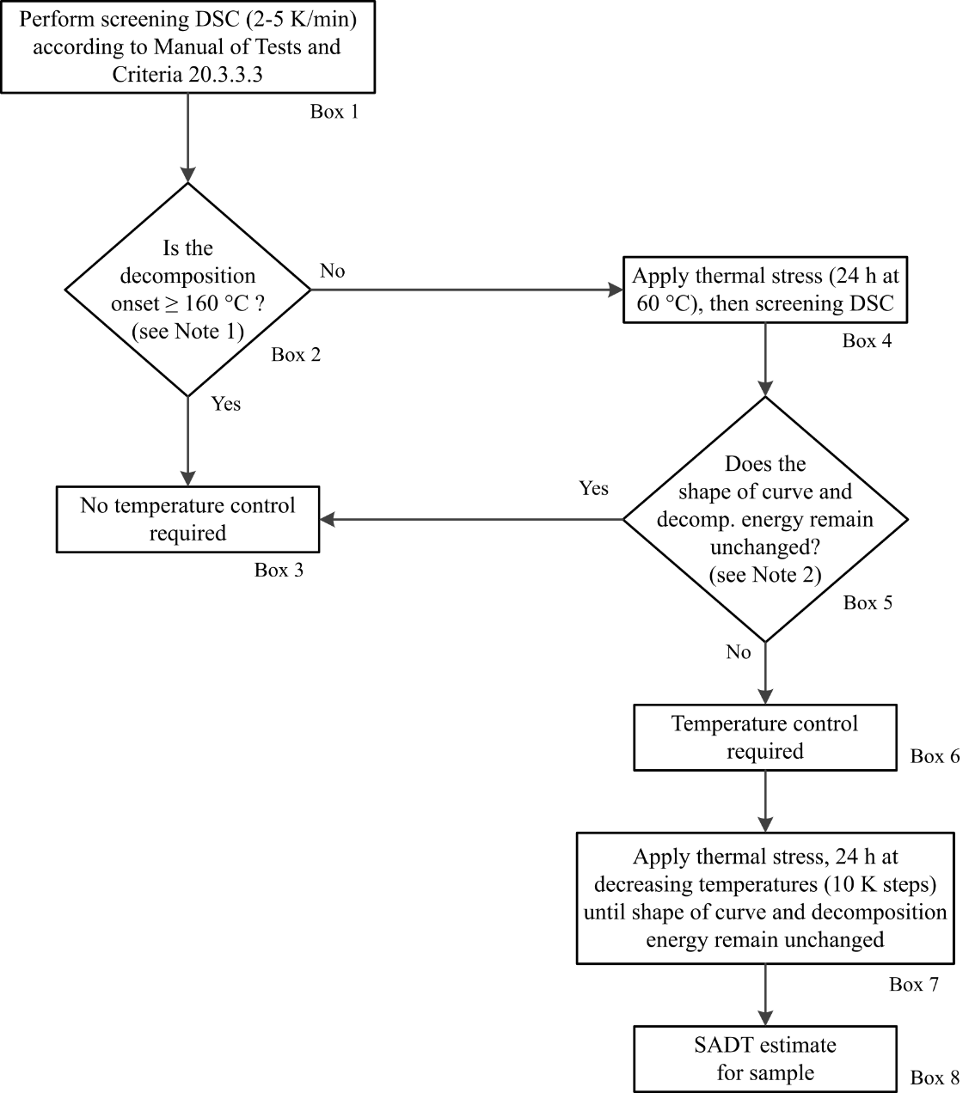

***Note 1:*** *Separate small exotherm (< 20 J/g) preceding the main decomposition may be neglected;*

***Note 2:*** *Within measurement uncertainty of 10%;*

Figure 8: Suggested flowchart for determination of temperature control

Proposal

1. Reintroduce the explanatory text about the temperature limit in the Manual of Tests and Criteria, Appendix 6, section 3.3 (c) to read (new text is underlined; deleted text is ~~crossed out~~):

“(c) For the organic substance or a homogenous mixture of organic substances containing chemical group (or groups) associated with explosive properties:

- when the exothermic decomposition energy is less than 500 J/g, or

- when the onset of exothermic decomposition is 500 °C or above as indicated by Table A6.2 (the temperature limit is to prevent the procedure being applied to a large number of organic molecules which are not explosive but which will decompose slowly above 500 °C to release more than 500 J/g.)

**Table A6.2 DECISION TO APPLY THE ACCEPTANCE PROCEDURE FOR CLASS 1 FOR AN ORGANIC SUBSTANCE OR A HOMOGENOUS MIXTURE OF ORGANIC SUBSTANCES**

|  |  |  |
| --- | --- | --- |
| **Decomposition energy (J/g)** | **Decomposition onset temperature (**°C) | **Apply acceptance procedure for Class 1?**  **(Yes/No)** |
| < 500 | < 500 | No |
| < 500 | ≥ 500 | No |
| ≥ 500 | < 500 | Yes |
| ≥ 500 | ≥ 500 | No |

The exothermic decomposition energy may be determined using a suitable calorimetric technique (see 20.3.3.3); or”

1. Modify the first sentence in section 2.0.4.3.1 to read:

“Samples of organic substances carrying functional groups listed in tables A6.1 and/or A6.3 in Appendix 6 (Screening Procedures) of the Manual of Tests and Criteria may be transported in small amounts under UN 3224 (self-reactive solid type C) or UN 3223 (self-reactive liquid type C), as applicable, of Division 4.1 provided that:”

1. Insert a new section 2.0.4.3.2 to read:

“Samples of organic substances carrying functional groups listed in tables A6.1 and/or A6.3 in Appendix 6 (Screening Procedures) of the Manual of Tests and Criteria may be assigned to one of the appropriate entries for self-reactive substances type C (UN 3223, UN 3224, UN 3233, UN 3234 as applicable) of Division 4.1 and transported under the provisions of 2.4.2.3.2.4 (b) provided that:

* 1. They fulfil the criteria of 2.0.4.3.1 (a) through (c), and
  2. Their decomposition energy is

1. Less than 1500 J/g for salts or complexes, or

(ii) Less than 2000 J/g for other substances, or

* + - 1. 1500 J/g or more for salts or complexes, and in test UN C.1 the result is not “yes, rapidly” and in test UN F.3 the result is not “not low”, or
      2. 2000 J/g or more for other substances, and in test UN C.1 the result is not “yes, rapidly” and in test UN F.3 the result is not “not low”.

The assessment in (iii) and (iv) may be based on a single test C.1 and F.3 each. If the criteria in (b) above are fulfilled, it can be assumed that the sample is not more dangerous that self-reactive substances type B.

An appropriate method to determine temperature control requirements is described in section 20.3.4 of the UN Manual of Tests and Criteria.

Samples not passing the criteria in (iii) or (iv) above may be transported only by an approval issued by the competent authority of the country of origin. The statement of approval shall be based on the available information and contain the classification and the relevant transport conditions.”

1. Insert a new section 2.0.4.3.3 to read:

“A flow chart describing the classification of energetic samples is shown in figure 2.0.4.”

1. Insert the flow chart in figure 5 of this proposal as figure 2.0.4.
2. Insert for explanatory purposes “(DSC)” in the first sentence of section 20.3.3.3 in the Manual of Tests and Criteria to read:

“20.3.3.3 Thermal stability may be estimated using a suitable calorimetric technique such as differential scanning calorimetry (DSC) or adiabatic calorimetry.”

1. Modify the last sentence of the same section to read:

“If differential scanning calorimetry is used, the extrapolated onset temperature is defined as ~~being the point of intersection of the tangent drawn at the point of greatest slope on the leading edge of the peak with the extrapolated baseline~~ the temperature of the first noticeable exothermic effect (i.e. the heat production signal leaves the baseline).

1. Insert a new section 20.3.4 in the Manual of Tests and Criteria to read

“**20.3.4 Thermal stability of samples and temperature control assessment**

20.3.4.1 The provisions in this section are only applicable to samples of sections 2.0.4.3.2, 2.4.2.3.2.4 (b) and 2.5.3.2.5.1 in cases where the SADT is not known.

20.3.4.2 If the decomposition onset in a DSC measured in accordance with 20.3.3.3 is found at 160 °C or above, the estimated SADT of the sample may be assumed to be greater than 55 °C. According to 2.4.2.3.4 of the Model Regulations, temperature control is not required in such cases. Separate small exotherms less than 20 J/g preceding the main decomposition may be neglected.

20.3.4.3 For purposes of temperature control, a thermal stress test based on DSC measurements may be applied as follows: A DSC is measured as outlined in 20.3.3.3 for the sample as offered for transport. A second sample is taken, and thermal stress is applied by tempering the sample in the closed DSC crucible at a defined constant temperature over a certain period of time. In standard cases, a 24 hour stress time is deemed sufficient. Subsequently, a DSC is measured of the stressed sample at the same heating rate as before. If the decomposition behavior remains unchanged by comparison of the two DSCs in terms of decomposition onset, shape of curve, and energy within a measurement uncertainty of 10%, the sample is considered stable at the applied stress temperature. If the stress test is passed according to these criteria at 60 °C, no temperature control is required.

20.3.4.4 In case the stress test at 60 °C is not passed, the same procedure should be applied at decreasing temperatures in steps of 10 K until the decomposition behavior remains unchanged. That temperature should be deemed the estimated SADT of the sample, and the control and emergency temperatures may then be derived in accordance with section 28.2.3 and table 28.2 of the Manual of Tests and Criteria.

20.3.4.5 Examples for passing and failing the thermal stress test are shown in figures 20.1 (a) and 20.1 (b), respectively. A flow chart for the procedure is given in figure 20.2.”

1. Insert figure 6 of this proposal as figure 20.1 (a), figure 7 as figure 20.1 (b) and figure 8 as figure 20.2. Renumber the figures in subsequent chapters accordingly.

Justification

1. The proposal presents a comprehensive and practical solution for the transport of energetic samples.
2. In the discussion above, it has been shown that these samples match the regime of existing self-reactive substances (figure 2 of this document) whereas intentional explosives are found at much higher energies. The discussion has further led to the conclusion that below the energy values listed in table 2 candidates for Class 1 can be excluded for substances in the scope of this proposal.
3. For samples of higher energies, further tests in limited amounts allow a safe assessment. In critical cases, an approval by the competent authority will be required.
4. By referring to the regime of self-reactive substances, existing provisions and packing instructions are applied. This should facilitate the implementation in the modal regulations.
5. Further, this proposal contains a practical and easily applicable approach to determine thermal stability and possible temperature control requirements. For this purpose, a new section in the Manual of Tests and Criteria suggested.
6. The proposed flow charts guide classifiers through the relevant steps. This is deemed helpful especially for organizations less familiar with dangerous goods regulations.

Annex

Table 3: Decomposition energies of self-reactive substances  
(Model regulations, section 2.4.2.3.2.3)

| Name | Concen-tration  (%) | Packing method | UN generic entry | Decom-position energy (estimate) (J/g) | Type |
| --- | --- | --- | --- | --- | --- |
| ACETONE-PYROGALLOL COPOLYMER 2-DIAZO-1-NAPHTHOL-5-SULPHONATE | 100 | OP8 | 3228 | 521 | E |
| AZODICARBONAMIDE FORMULATION TYPE B | 100 | OP5 | 3232 | 1400 | B |
| AZODICARBONAMIDE FORMULATION TYPE C | 100 | OP6 | 3224 | 1400 | C |
| AZODICARBONAMIDE FORMULATION TYPE D | 100 | OP7 | 3226 | 1400 | D |
| 2,2' -AZODI(2,4-DIMETHYL- 4-METHOXYVALERONITRILE) | 100 | OP7 | 3236 | 584 | D |
| 2,2' -AZODI(2,4-DIMETHYL- VALERONITRILE) | 100 | OP7 | 3236 | 725 | D |
| 2,2' -AZODI(ETHYL- 2-METHYLPROPIONATE) | 100 | OP7 | 3235 | 697 | D |
| 1,1-AZODI(HEXAHYDROBENZONITRILE) | 100 | OP7 | 3226 | 768 | D |
| 2,2'-AZODI(ISOBUTYRONITRILE) | 100 | OP6 | 3234 | 1096 | C |
| 2,2'-AZODI(2-METHYLBUTYRONITRILE) | 100 | OP7 | 3236 | 936 | D |
| BENZENESULPHONYL HYDRAZIDE | 100 | OP7 | 3226 | 1061 | D |
| 4-(BENZYL(ETHYL)AMINO)-3-ETHOXY-BENZENEDIAZONIUM ZINC CHLORIDE | 100 | OP7 | 3226 | 396 | D |
| 4-(BENZYL(METHYL)AMINO)-3-ETHOXYBENZENEDIAZONIUM ZINC CHLORIDE | 100 | OP7 | 3236 | 409 | D |
| 3-CHLORO-4-DIETHYLAMINOBENZENE-DIAZONIUM ZINC CHLORIDE | 100 | OP7 | 3226 | 508 | D |
| 2-DIAZO-1-NAPHTHOL-4- SULPHONYL-CHLORIDE | 100 | OP5 | 3222 | 930 | B |
| 2-DIAZO-1-NAPHTHOL-5- SULPHONYL CHLORIDE | 100 | OP5 | 3222 | 930 | B |
| 2,5-DIBUTOXY-4-(4-MORPHOLINYL) BENZENEDIAZONIUM, TETRACHLOROZINCATE (2:1) | 100 | OP8 | 3228 | 411 | E |
| 2,5-DIETHOXY-4-MORPHOLINO- BENZENEDIAZONIUM ZINC CHLORIDE | 100 | OP7 | 3236 | 376 | D |
| 2,5-DIETHOXY-4-MORPHOLINO- BENZENEDIAZONIUM TETRAFLUOROBORATE | 100 | OP7 | 3236 | 458 | D |
| 2,5-DIETHOXY-4-(4-MORPHOLINYL)- BENZENEDIAZONIUM SULPHATE | 100 | OP7 | 3226 | 508 | D |
| 4-(DIMETHYLAMINO)-BENZENE-DIAZONIUM TRICHLOROZINCATE (-1) | 100 | OP8 | 3228 | 563 | E |
| 4-DIMETHYLAMINO-6-(2-DIMETHYL-AMINOETHOXY) TOLUENE- 2-DIAZONIUM ZINC CHLORIDE | 100 | OP7 | 3236 | 427 | D |
| N,N'-DINITROSO-N,N'-DIMETHYL TEREPHTHALAMIDE, | 72 | OP6 | 3224 | 1755 | C |
| N,N'-DINITROSOPENTAMETHYLENE-TETRAMINE | 82 | OP6 | 3224 | 2687 | C |
| DIPHENYLOXIDE-4,4'-DISULPHONYL HYDRAZIDE | 100 | OP7 | 3226 | 1020 | D |
| 4-DIPROPYLAMINOBENZENE- DIAZONIUM ZINC CHLORIDE | 100 | OP7 | 3226 | 479 | D |
| N-FORMYL-2-(NITROMETHYLENE) -1,3-PERHYDROTHIAZINE | 100 | OP7 | 3236 | 2261 | D |
| 2-(2-HYDROXYETHOXY)-1- (PYRROLIDIN-1-YL)BENZENE-4- DIAZONIUM ZINC CHLORIDE | 100 | OP7 | 3236 | 443 | D |
| 3-(2-HYDROXYETHOXY)-4- (PYRROLIDIN-1-YL)BENZENE DIAZONIUM ZINC CHLORIDE | 100 | OP7 | 3236 | 443 | D |
| 2-(N,N-METHYLAMINOETHYL- CARBONYL)-4-(3,4-DIMETHYL- PHENYLSULPHONYL)BENZENE- DIAZONIUM HYDROGEN SULPHATE | 96 | OP7 | 3236 | 368 | D |
| 4-METHYLBENZENESULPHONYL- HYDRAZIDE | 100 | OP7 | 3226 | 981 | D |
| 3-METHYL-4-(PYRROLIDIN-1-YL) BENZENEDIAZONIUM TETRAFLUOROBORATE | 95 | OP6 | 3234 | 622 | C |
| 4-NITROSOPHENOL | 100 | OP7 | 3236 | 1210 | D |
| PHOSPHOROTHIOIC ACID, O-[(CYANOPHENYL METHYLENE) AZANYL] O,O-DIETHYL ESTER | 82-91 | OP8 | 3227 | 1100 | E |
| SODIUM 2-DIAZO-1-NAPHTHOL- 4-SULPHONATE | 100 | OP7 | 3226 | 661 | D |
| SODIUM 2-DIAZO-1-NAPHTHOL- 5-SULPHONATE | 100 | OP7 | 3226 | 661 | D |
| TETRAMINE PALLADIUM (II) NITRATE | 100 | OP6 | 3234 | 857 | C |

**Table 4: Decomposition energies of desensitized explosives  
in Dangerous Goods List of Model Regulations**

| Name | Concen-tration  (%) | UN generic entry | Decomposition energy (estimate)  (J/g) |
| --- | --- | --- | --- |
| AMMONIUM PICRATE, WETTED with not less than 10% water, by mass | <90 | 1310 | 2538 |
| DINITROPHENOL, WETTED with not less than 15% water, by mass | <85 | 1320 | 3195 |
| DINITRORESORCINOL, WETTED with not less than 15% water, by mass | <85 | 1322 | 2939 |
| NITROGUANIDINE (PICRITE), WETTED with not less than 20% water, by mass | <80 | 1336 | 2450 |
| NITROSTARCH, WETTED with not less than 20% water, by mass | <80 | 1337 | 3251 |
| TRINITROPHENOL (PICRIC ACID), WETTED with not less than 30% water, by mass | <70 | 1344 | 2482 |
| SILVER PICRATE, WETTED with not less than 30% water, by mass | <70 | 1347 | 1244 |
| SODIUM DINITRO-o-CRESOLATE, WETTED with not less than 15% water, by mass | <85 | 1348 | 1968 |
| SODIUM PICRAMATE, WETTED with not less than 20% water, by mass | <80 | 1349 | 1895 |
| TRINITROBENZENE, WETTED with not less than 30% water, by mass | <70 | 1354 | 2749 |
| TRINITROBENZOIC ACID, WETTED with not less than 30% water, by mass | <70 | 1355 | 2078 |
| TRINITROTOLUENE (TNT), WETTED with not less than 30% water, by mass | <70 | 1356 | 2608 |
| UREA NITRATE, WETTED with not less than 20% water, by mass | <80 | 1357 | 2570 |
| ZIRCONIUM PICRAMATE, WETTED with not less than 20% water, by mass | <80 | 1517 | 1848 |
| BARIUM AZIDE, WETTED with not less than 50% water, by mass | <50 | 1571 | 1078 |
| NITROCELLULOSE WITH WATER (not less than 25% water, by mass) | <75 | 2555 | 3266 |
| DIPICRYL SULPHIDE, WETTED with not less than 10% water, by mass | <90 | 2852 | 3191 |
| ISOSORBIDE DINITRATE MIXTURE with not less than 60% lactose, mannose, starch or calcium hydrogen phosphate | <60 | 2907 | 2046 |
| 2-AMINO-4,6-DINITROPHENOL, WETTED with not less than 20% water, by mass | <80 | 3317 | 2104 |
| TRINITROPHENOL (PICRIC ACID), WETTED, with not less than 10% water by mass | <90 | 3364 | 3191 |
| TRINITROCHLOROBENZENE (PICRYL CHLORIDE), WETTED, with not less than 10% water by mass | <90 | 3365 | 3042 |
| TRINITROTOLUENE (TNT), WETTED, with not less than 10% water by mass | <90 | 3366 | 3353 |
| TRINITROBENZENE, WETTED, with not less than 10% water by mass | <90 | 3367 | 3534 |
| TRINITROBENZOIC ACID, WETTED, with not less than 10% water by mass | <90 | 3368 | 2672 |
| SODIUM DINITRO-o-CRESOLATE, WETTED, with not less than 10% water by mass | <90 | 3369 | 2083 |
| UREA NITRATE, WETTED, with not less than 10% water by mass | <90 | 3370 | 2892 |
| 4-NITROPHENYLHYDRAZINE, with not less than 30% water, by mass | <70 | 3376 | 1960 |
| 1-HYDROXYBENZOTRIAZOLE MONOHYDRATE | <88 | 3474 | 1993 |
| NITROGLYCERIN MIXTURE, DESENSITIZED, LIQUID, FLAMMABLE, N.O.S. with not more than 30% nitroglycerin, by mass | <30 | 3343 | 2003 |

**Table 5: Decomposition energies of energetic compounds  
in Dangerous Goods List of Model Regulations**

|  |  |  |
| --- | --- | --- |
| Name | UN generic entry | Decomposition energy (estimate) (J/g) |
| DIMETHYLHYDRAZINE, UNSYMMETRICAL | 1163 | 1148 |
| METHYLHYDRAZINE | 1244 | 2152 |
| NITROMETHANE | 1261 | 4811 |
| p-NITROSODIMETHYLANILINE | 1369 | 1931 |
| GUANIDINE NITRATE | 1467 | 2449 |
| CHLORODINITROBENZENES, LIQUID | 1577 | 3209 |
| CHLORONITROBENZENES, SOLID | 1578 | 2063 |
| CHLOROPICRIN | 1580 | 1977 |
| DINITROANILINES | 1596 | 3331 |
| DINITROBENZENES, LIQUID | 1597 | 3510 |
| DINITRO-o-CRESOL | 1598 | 3079 |
| DINITROTOLUENES, MOLTEN | 1600 | 3459 |
| NITROANILINES (o-, m-, p-) | 1661 | 2208 |
| NITROBENZENE | 1662 | 2356 |
| NITROPHENOLS (o-, m-, p-) | 1663 | 2085 |
| NITROTOLUENES, LIQUID | 1664 | 2297 |
| NITROXYLENES, LIQUID | 1665 | 2084 |
| AMMONIUM DINITRO-o-CRESOLATE, SOLID | 1843 | 2928 |
| HYDRAZINE, ANHYDROUS | 2029 | 2340 |
| DINITROTOLUENES, LIQUID | 2038 | 3459 |
| CHLORONITROANILINES | 2237 | 1767 |
| NITROBENZENESULPHONIC ACID | 2305 | 1723 |
| NITROBENZOTRIFLUORIDES, LIQUID | 2306 | 1596 |
| 3-NITRO-4-CHLOROBENZOTRIFLUORIDE | 2307 | 1352 |
| DIMETHYLHYDRAZINE, SYMMETRICAL | 2382 | 1148 |
| CHLORONITROTOLUENES, LIQUID | 2433 | 1836 |
| NITROCRESOLS, SOLID | 2446 | 1992 |
| NITROTOLUIDINES (MONO) | 2660 | 2005 |
| NITROANISOLES, LIQUID | 2730 | 2057 |
| NITROBROMOBENZENES, LIQUID | 2732 | 1510 |
| NITROETHANE | 2842 | 3930 |
| AZODICARBONAMIDE | 3242 | 1400 |
| ISOSORBIDE-5-MONONITRATE | 3251 | 1596 |
| NITROBENZOTRIFLUORIDES, SOLID | 3431 | 1596 |
| NITROCRESOLS, LIQUID | 3434 | 1992 |
| DINITROBENZENES, SOLID | 3443 | 3510 |
| NITROTOLUENES, SOLID | 3446 | 2297 |
| NITROXYLENES, SOLID | 3447 | 2084 |
| DINITROTOLUENES, SOLID | 3454 | 3459 |
| CHLORONITROTOLUENES, SOLID | 3457 | 1836 |
| NITROANISOLES, SOLID | 3458 | 2057 |
| NITROBROMOBENZENES, SOLID | 3459 | 1510 |

1. \* In accordance with the programme of work of the Sub-Committee for 2017–2018 approved by the Committee at its eighth session (see ST/SG/AC.10/C.3/100, paragraph 98 and ST/SG/AC.10/44, para. 14). [↑](#footnote-ref-2)