|  |  |  |  |
| --- | --- | --- | --- |
|  | United Nations | ST/SG/AC.10/C.3/2018/77 | |
| _unlogo | **Secretariat** | | Distr.: General  7 September 2018  Original: English |

**Committee of Experts on the Transport of Dangerous Goods  
and on the Globally Harmonized System of Classification  
and Labelling of Chemicals**

|  |
| --- |
| **Sub-Committee of Experts on the Transport of Dangerous Goods** |
| **Fifty-fourth session** |
| Geneva, 26 November-4 December 2018  Item 2 (e) of the provisional agenda  **Recommendations made by the Sub-Committee on its fifty-first,  fifty-second and fifty-third sessions and pending issues: transport of gases** |

Chemicals under pressure: extinguishing agents (UN 3500)

Transmitted by the European Chemical Industry Council (CEFIC)[[1]](#footnote-2)\*

Situation

1. Chemicals under pressure without any subsidiary risks (UN No. 3500) are widely used in the area of gas based suppression systems (see Annex), and other terms connected to fire control. UN No.1044 FIRE EXTINGUISHERS were initially considered to be assigned to this product. Nevertheless, this UN number cannot be used for this type of extinguishing agents because they are carried separately and meet the Note of special provision SP225:

“Pressure receptacles which contain gases for the use in the above-mentioned fire extinguishers or for use in stationary fire-fighting installations shall meet the requirements of Chapter 6.2 and all requirements applicable to the relevant dangerous goods when these pressure receptacles are carried separately.”.

Therefore, they do not meet the definition of a fire extinguisher.

2. Most of the gas based suppression systems products are assigned to UN No. 1956 compressed gas, as they are gas/gas mixtures. These have a maximum test period for periodic inspection of 10 years, whereas the liquid/gas system must be assigned to UN No. 3500 and therefore has a maximum test period for periodic inspection of 5 years, although the pressure in the receptacle with the liquid/gas mixture is less. Before the implementation of the UN numbers for chemicals under Pressure assigned to UN1956 as well. This means that the maximum test period has been reduced for these systems to 50%.

3. This is, at least for the gas suppression systems and other fire extinguishing systems, which are known to have no subsidiary hazards, not reasonable.

4. This means that these products are generally of inert nature and the generally accepted practice of these devices is that they are used in protected storage with minimal handling.

5. These two factors work in combination to profoundly reduce:

(a) internal corrosion, and degradation of “wetted component” of the units;

(b) internal mechanical wear of valves; and

(c) external damage from nicks, scuffs and abrasion of receptacle

6. For fire extinguishing agents there are also huge pressure receptacles used. Therefore, we also ask to allow tubes of a maximum water capacity of 450 l.

7. The proposal was submitted as an informal document INF.11 (CEFIC) (fifty-third session). This informal document included 2 options to change the packing instruction P206:

* Option 1: Allow a periodic inspection for UN3500 of 10 years and add tubes of a maximum water capacity of 450 l.
* Option 2: Add a special packing provision for fire extinguishing agents not meeting the provisions of Note 2 of special provision 225, which extends the periodic inspection to 10 years and allows Tubes of a water capacity of 450 L.

8. There was broad support for Option 2 and therefore the proposal now contains this second option.

Proposal

9. Amend P206 as follows *(deleted text is ~~struck through~~; new text is underlined)*:

|  |
| --- |
| **P206 PACKING INSTRUCTION P206** |
| This instruction applies to UN Nos. 3500, 3501, 3502, 3503, 3504 and 3505 |
| Unless otherwise indicated in these Regulations, cylinders and pressure drums conforming to the applicable requirements of Chapter 6.2 are authorized.  (1) The general packing requirements of **4.1.6.1** shall be met.  (2) The maximum test period for periodic inspection shall be 5 years.  (3) …. |
| **Special packing provisions:**  **PP89** ….  **PPXX** For fire extinguishing agents assigned to UN No. 3500 the maximum test period for periodic inspection shall be 10 years and the following packing should be allowed: tubes of a maximum water capacity of 450 l. |

Annex

Example of a gas based suppression system

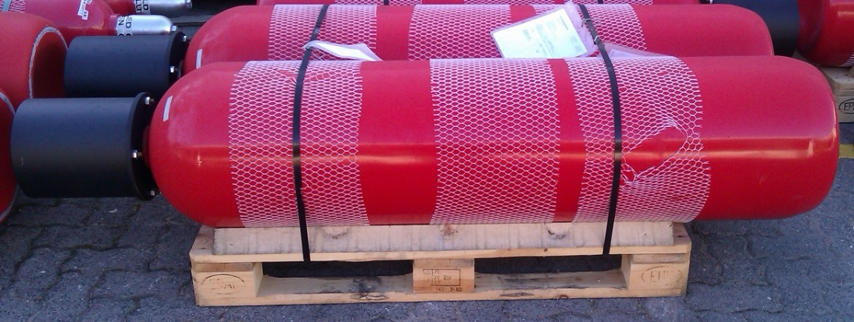

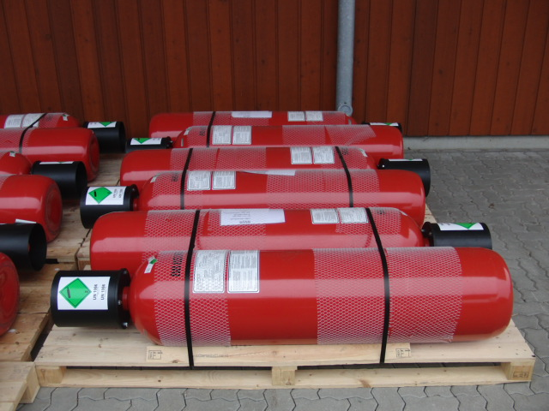

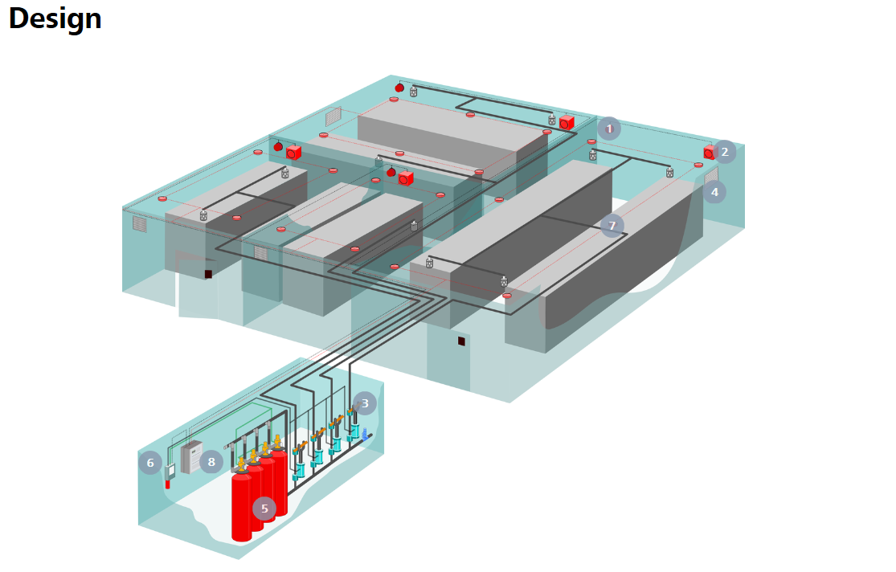

|  |  |  |  |  |  |
| --- | --- | --- | --- | --- | --- |
| 1 | Flash | 2 | Electric horn | 3 | Selector valve |
| 4 | Extinguishing nozzle | 5 | Extinguishing agent cylinder | 6 | Pneumatic control device |
| 7 | Fire detector | 8 | Fire detection and extinguishing control panel |  |  |

\_\_\_\_\_\_\_\_\_\_\_\_\_\_\_\_\_\_\_

1. \* In accordance with the programme of work of the Sub-Committee for 2017-2018 approved by the Committee at its eighth session (see ST/SG/AC.10/C.3/100, paragraph 98 and ST/SG/AC.10/44, paragraph 14) [↑](#footnote-ref-2)