|  |  |  |  |
| --- | --- | --- | --- |
|  | United Nations | ST/SG/AC.10/C.3/2018/46 | |
| _unlogo | **Secretariat** | | Distr.: General 6 April 2018  Original: English |

**Committee of Experts on the Transport of Dangerous Goods  
and on the Globally Harmonized System of Classification  
and Labelling of Chemicals**

**Sub-Committee of Experts on the Transport of Dangerous Goods**

**Fifty-third session**

Geneva, 25 June-4 July 2018  
Item 6 (b) of the provisional agenda

**Miscellaneous proposals for amendments to the**

Model Regulations on the Transport of Dangerous Goods:  
packagings

Marking of the date of manufacture on packagings of types 1H and 3H and inner receptacles of composite intermediate bulk containers (IBC’s)

Transmitted by the expert from Belgium[[1]](#footnote-2)

Introduction

1. In 2011, the International Confederation of Plastics Packagings manufacturers (ICCP) in documents ST/SG/AC.10/C.3/2011/17 and ST/SG/AC.10/C.3/2011/36 to adapt for plastic packaging the mark of the clock indication as follows: *“The marking of the month of manufacture of packaging types 1H and 3H according to 6.1.3.1 (e) has proved itself in practice. During the last years many manufacturers added to this clock the year of manufacture. The use of a clock showing the month and the year of manufacture for packaging types 1 H and 3 H has become more and more established and was practised with and without the admission of national competent authorities”.*
2. Based on their proposal the decision was taken in 2012 to modify paragraph 6.1.3.1 (e) as follows:

“(e) The last two digits of the year during which the packaging was manufactured. Packagings of types lH and 3H shall also be appropriately marked with the month of manufacture; this may be marked on the packaging in a different place from the remainder of the marks. An appropriate method is:

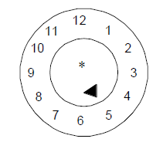

\* The last two digits of the year of manufacture may be displayed at that place. In such a case, the two digits of the year in the type approval mark and in the inner circle of the clock shall be identical.”.

3. In addition, in paragraph 6.5.2.2.4 is mentioned that:

“*Inner receptacles that are of composite IBC design type shall be identified by the application of the marks indicated in 6.5.2.1.1 (b), (c), (d) where this date is that of the manufacture of the plastics inner receptacle, (e) and (f). The UN packaging symbol shall not be applied. The marks shall be applied in the sequence shown in 6.5.2.1.1. It shall be durable, legible and placed in a location so as to be readily visible when the inner receptacle is placed in the outer casing.*

*The date of the manufacture of the plastics inner receptacle may alternatively be marked on the inner receptacle* ***adjacent to the remainder of the marks****. In such a case, the two digits of the year in the mark and in the inner circle of the clock shall be identical. An example of an appropriate marking method is:”*



1. The question has been raised by the industry why the date of the manufacture in the UN-mark of IBC’s is still required when the date of manufacture is alternatively allowed adjacent to the remainder of marks and appears beside the UN-mark. It seems a repetition of information.
2. Although the modification of 2012 was a first step in the good direction, it seems that within the plastic industry a lot of confusion exists about the correct application of the date of manufacture. During road inspections or verifications in the harbours, the inspection services encounter a lot of different ways how the marks on plastic packagings are applied. Although not always in compliance with the regulations it starts to become common practice. (See pictures in annex). But as it is not officially authorized this practice leads to shipments being stopped by inspectors because of different interpretations.
3. An additional modification for all plastic packagings which would allow the use of the clock included in or adjacent to the UN-mark, would be welcomed.   
   Some countries allow already for more than 10 years the use of only the clock identification as month/year reference in the UN-mark and this seems for many manufacturers the common so-called authorised practice. More and more companies, merged within bigger groups, adopt this system and are using it as a harmonised system in a lot of different countries.
4. The following options would be welcomed:

|  |  |  |
| --- | --- | --- |
|  |  | Clock may be on another place on the packaging (ex. Bottom) |
|  |  | Clock within the UN-mark |
|  |  | Clock adjacent or close to the UN- mark |

Proposal

1. Amend 6.1.3.1 (e) as follows (new text underlined, ~~deleted text stricken trough~~):

“The last two digits of the year during which the packaging was manufactured. Packagings of types lH and 3H shall also be appropriately marked with the month of manufacture; this may be marked on the packaging in a different place from the remainder of the marks. An appropriate method is:

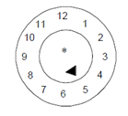

\* The last two digits of the year of manufacture may be displayed at that place. In this case and under condition the clock is placed adjacent to UN design type mark, the indication of the year in the type approval mark may be waived. However, in case the clock is not placed adjacent to the UN design type mark, ~~In such a case,~~ the two digits of the year in the ~~type approval~~ mark and in ~~the inner circle of~~ the clock ~~should~~ shall be identical.

***NOTE****: Other methods that provide the minimum required information in a durable, legible and visible form are also acceptable.”*

9. Amend the second paragraph of 6.5.2.2.4 as follows (new text underlined, ~~deleted text stricken trough~~):

“The date of the manufacture of the plastics inner receptacle may alternatively be marked on the inner receptacle adjacent to the remainder of the marks. In such a case, the date may be waived from the remainder of the marks~~the two digits of the year in the mark and in the inner circle of the clock shall be identical~~. An example of an appropriate method is: ...”. [*the* *marking and related notes 1 and 2 remain unchanged*].

Annex

Pictures taken at inspection locations and production verifications

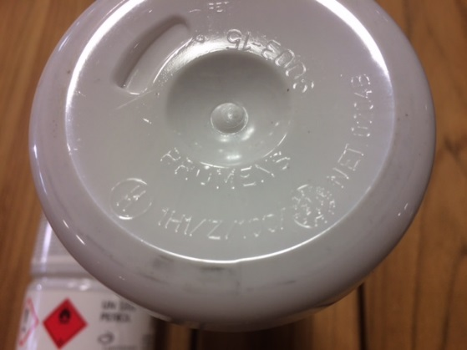

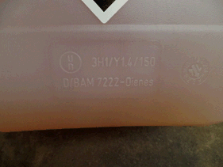

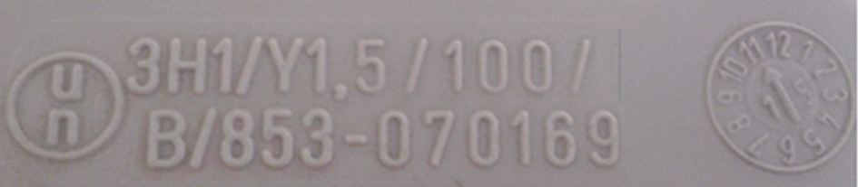

**Actual described application of a mark**

|  |  |
| --- | --- |
| On the side of the packaging | On a different location on the packaging |
|  |  |

\_\_\_\_\_\_\_\_\_\_\_\_\_\_\_\_\_

1. In accordance with the programme of work of the Sub-Committee for 2017–2018 approved by the Committee at its eighth session (see ST/SG/AC.10/C.3/100, paragraph 98 and ST/SG/AC.10/44, para. 14). [↑](#footnote-ref-2)