Proposal for supplement 14 to the 04 series of amendments to UN Regulation No. 44 (Child Restraint Systems)
Submitted by the expert from the European Association of Automotive Suppliers*
The text reproduced below was prepared by the expert from the European Association of Automotive Suppliers (CLEPA) for UN Regulation No. 44 to amend document ECE/TRANS/WP.29GRSP/2017/38. The modifications are marked in bold for new characters.
I. Proposal
Paragraph 6.1.8., amend to read:
"6.1.8. Integral child restraint … without a dummy.
Figures for the explanation of the measurement procedure
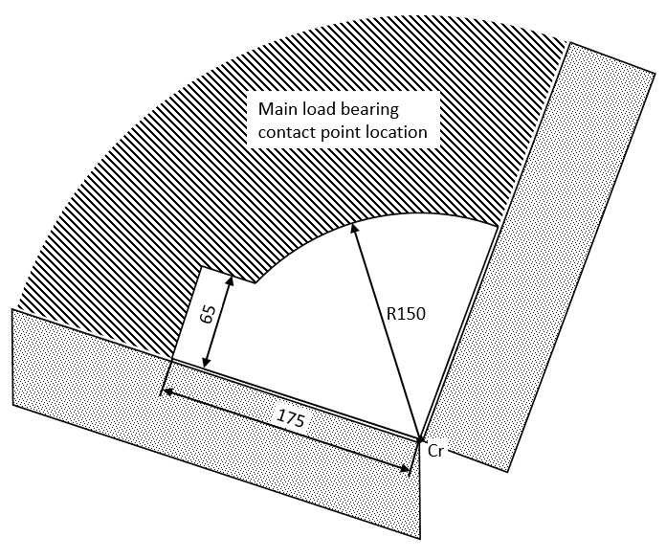

II. Justification
The proposal clarifies the test procedure in the amended paragraph 6.1.8 in document ECE/TRANS/WP.29/GRSP/2017/38 by adding one dimension (175 mm) . This dimension is in line with the dimensions of the fixture from Regulation 16 to check the vehicle safety belt length (Annex 17-Appendix 1, Figure 1) and also in line with document GRSP 61 14 Rev.1 that was adopted at the 61st session.

* In accordance with the programme of work of the Inland Transport Committee for 2016–2017 (ECE/TRANS/254, para. 159 and ECE/TRANS/2016/28/Add.1, cluster 3.1), the World Forum will develop, harmonize and update Regulations in order to enhance the performance of vehicles. The present document is submitted in conformity with that mandate.

