Proposal for amendments of Regulation No. 29 (Cabs of commercial vehicles)
Submitted by the expert from Germany
The text reproduced below was prepared by the expert from Germany. It introduces amendments to Regulation No. 29 (Cabs of commercial vehicles). The modifications to the existing text of the UN Regulation are marked in bold for new or strikethrough for deleted characters.
I. Proposal
Annex 3 Appendix 1, amend to read:
Annex 3 - Appendix 1
Instructions for securing vehicles to the test bed
- General instructions for securing
1.1 Measures shall be taken to ensure that the vehicle does not shift appreciably during the test. For this purpose the hand-brake shall be applied, a gear engaged and the front wheels wedged with chocks
1.2. Anchoring chains or ropes
Each anchoring chain or rope shall be of steel and shall be capable of withstanding a tractive load of at least 10 tons.
1.3. Blocking of the chassis frame
The longitudinal members of the chassis frame shall be supported on wooden blocks, rigid composite blocks and/or metal brackets across their full width and over a length of not less than 150 mm. The front edges of the blocks must not be situated forward of the rearmost point of the cab, nor rearward of the mid-point of the wheel base. At the manufacturer’s request the chassis frame shall be set in the attitude it takes up when loaded.
1.4. Longitudinal attachment
Rearward movement of the chassis frame shall be limited by chains or ropes A attached to the front of the chassis frame symmetrically in relation to its longitudinal axis, the points of attachment being not less than 600 mm apart. The chains or ropes shall when tensioned form a downward angle of not more than 25° with the horizontal and their projection on a horizontal plane shall form an angle of not more than 10° with the longitudinal axis of the vehicle. The chains or ropes may cross one another.

1.6. Tensioning of chains or ropes and rear attachment
The chain or rope С shall, to begin with, be placed under a load of approximately 1 kN. All slack in the four chains or ropes A and В shall then be taken up and chain or rope С shall be subjected to a tensile stress of not less than 10 kN. The angle of chain or rope С with the horizontal shall not exceed 15°. A vertical blocking force of not less than 500 N shall be applied at point D between the chassis frame and the ground.
1.7. Equivalent mounting
At the request of the manufacturer the test may be carried out with the cab mounted on a special frame, on condition that this method of mounting is shown to be equivalent to mounting on the vehicle.
2. Frontal impact
Test A shall be applied to a cab mounted on the vehicle as described under paragraph 1.
2.1. Lateral attachment
Lateral movement shall be limited by chains or ropes В attached to the chassis frame symmetrically in relation to its longitudinal axis. The points of attachment to the chassis shall be not more than 5 m and not less than 3 m from the front of the vehicle. The chains or ropes shall when tensioned form a downward angle of not more than 20° with the horizontal and their projection on a horizontal plane shall form an angle of not less than 25° and not more than 45° with the longitudinal axis of the vehicle (see figure 1 below).
3. Front pillars impact
3.1. Cab mounted on the vehicle.
Test B shall be applied to a cab mounted on the vehicle as described under paragraph 1
.
3.1.1. Lateral attachment
Lateral movement shall be limited by chains or ropes В attached to the chassis frame symmetrically in relation to its longitudinal axis. The points of attachment to the chassis shall be not more than 5 m and not less than 3 m from the front of the vehicle. The chains or ropes shall when tensioned form a downward angle of not more than 20° with the horizontal and their projection on a horizontal plane shall form an angle of not less than 25° and not more than 45° with the longitudinal axis of the vehicle (see figure 1 below).
3.2 Cab mounted on a frame
Measures shall be taken to ensure that the cab does not shift appreciably during the test.
4. Roof strength
4.1. Cab mounted on the vehicle
Test C shall be applied to a cab mounted on the vehicle as described under paragraph 1

4.1.1. Blocking of the chassis frame
Notwithstanding paragraph 1.3 an additional support shall be placed under both sides of the longitudinal members of the chassis frame’s front end.
4.1.2. Lateral attachment
Lateral movement shall be limited by chains or ropes E and F attached to the chassis frame symmetrically in relation to its longitudinal axis.
The points of attachment of chains or rope E to the chassis shall be not more than 5 m and not less than 3 m from the front of the vehicle.
The points of attachment of chains or rope F to the chassis shall be between the center of the front axle and the front of the vehicle.
The chains or ropes shall when tensioned form a downward angle of not more than 20° with the horizontal and their projection on a horizontal plane shall form an angle 90°±5° with the longitudinal axis of the vehicle (see figure 2 below).
3.2. Cab mounted on a frame
Measures shall be taken to ensure that the frame does not shift appreciably during the test.

Figure 1 - Front impact test and front pillars impact test
The cab is mounted on the vehicle
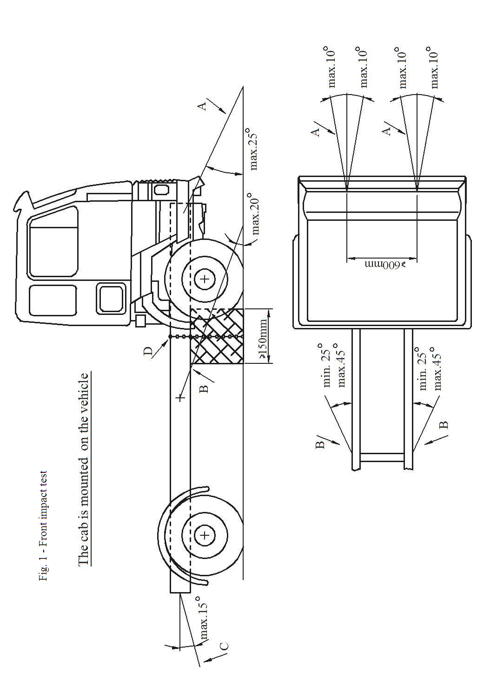

Figure 2 Roof strength test
The cab is mounted on the vehicle

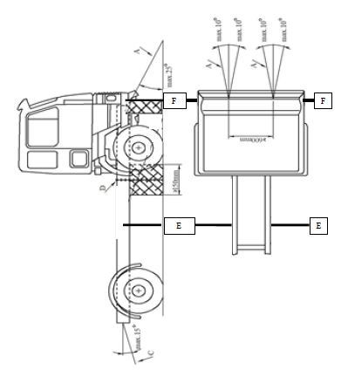
II. Justification
Currently only for test A Regulation No. 29 contains detailed specifications how to secure a cab mounted on a vehicle on the test rig. The proposed amendments will fill that gap and give the necessary specifications also for test B and test C to improve the repeatability of the tests.
The proposal also gives freedom instead of the wooden block shown in Figure 1 to use rigid composite blocks and/or (adjustable) metal brackets to make the fixation of the vehicle on the test rig more convenient.

