|  |  |  |  |
| --- | --- | --- | --- |
|  | United Nations | ECE/TRANS/WP.29/GRSP/2017/27 | |
| _unlogo | **Economic and Social Council** | | Distr.: General  22 September 2017  Original: English |

**Economic Commission for Europe**

Inland Transport Committee

**World Forum for Harmonization of Vehicle Regulations**

**Working Party on Passive Safety**

**Sixty-second session**

Geneva, 12-15 December 2017

Item 22 of the provisional agenda

**Collective amendments to UN Regulations Nos. 16, 44, 94, 129   
and 137**

Collective amendments to UN Regulations Nos. 16, 44, 94, 129 and 137

Submitted by the expert from the European Commission[[1]](#footnote-2)\*

The text reproduced below was prepared by the expert from the European Commission to harmonize information in the airbag warning label on the correct installation of Child Restraint Systems (CRS) on a passenger seat with an activated frontal airbag. It is based on informal document GRSP-61-29 distributed during the sixty-first session of the Working Party on Passive Safety (GRSP) (ECE/TRANS/WP.29/GRSP/61, para. 43). The modifications to the current text of the UN Regulations are marked in bold for new or strikethrough for deleted characters.

I. Proposal for Supplement 11 to the 06 series of amendments and Supplement 3 to the 07 series of Amendments to UN Regulation No. 16 (Safety belts)

*Paragraph 8.1.8.*, amend to read:

"8.1.8. Every passenger seating position which is fitted with a frontal protection airbag shall be provided with a warning against the use of a rearward-facing child restraint in that seating position. ~~As a minimum~~, This information shall consist of a label containing clear warning pictograms as indicated below:

**Figure 1**

**Warning label**

…

The overall dimensions **of the label** shall be at least 120 x 60 mm or the equivalent area.

The label ~~shown above~~ may be adapted in such a way that the layout differs from the example **shown here** ~~above~~; however, the content shall meet the **precise** ~~above~~ prescriptions. **Furthermore, no other type of information shall be included on the label unless it is placed outside a clearly marked rectangle with at least the overall dimensions as required above. In derogation to the aforementioned, a part number, bar code or similar identification mark not exceeding 8 mm x 35 mm or the equivalent area may be placed on the label.**

**It shall also be ensured that no deviations in the shape and orientation of the provided pictograms are permitted, notably that any customised appearance of the prescribed pictogram images shall be prohibited, with the exception of the hand with pointing index finger and the open face booklet with letter 'i' on its right page provided that they are clearly recognisable as such.**

**Small irregularities concerning line thickness, label imprinting and other relevant production tolerances shall be accepted.**

**Figure 2**

**Pictogram according to ISO 2575:2004 - Z.01 that shall be used and that shall have an outer diameter of at least 38 mm**

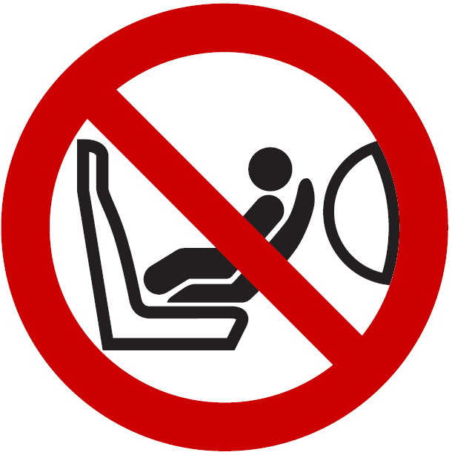

**Figure 3**

**Pictogram depicting airbag deployment danger that shall be used and that shall measure 40 mm in width and 28 mm in height or proportionally larger**



"

*Paragraph 8.1.10.*, amend to read:

"8.1.10. Detailed information, making reference to the warning, shall be contained in the owner's manual of the vehicle; as a minimum, the following text in all official languages of the country or countries where the vehicle could reasonably be expected to be registered (~~e.g.~~ **i.e.** within the territory of the European Union– **all 24 official languages**, in Japan – **Japanese**, in Russian Federation – **Russian, in Egypt** – **Modern Standard Arabic** or in New Zealand – **English**, etc.), shall at least include:

…"

II. Proposal for Supplement 14 to the 04 series of Amendments to UN Regulation No. 44 (Child restraint systems)

*Paragraph 4.4.*, amend to read:

"4.4. On the visible inner surface (including the **inside surface of any** side wing beside the child's head) in the approximate area where the child's head rests within the child restraint system, rearward facing restraints shall have the ~~following~~ **shown** label permanently attached ~~(the information shown is a minimum)~~.

~~Label minimum size: 60 x 120 mm.~~

**The overall dimensions of the label shall be at least 120 x 60 mm or the equivalent area.**

**The label may be adapted in such a way that the layout differs from the example shown here; however, the content shall meet the precise prescriptions. Furthermore, no other type of information shall be included on the label unless it is placed outside a clearly marked rectangle with at least the overall dimensions as required above. In derogation to the aforementioned, a part number, bar code or similar identification mark not exceeding 8 mm x 35 mm or the equivalent area may be placed on the label.**

**It shall also be ensured that no deviations in the shape and orientation of the provided pictograms are permitted, notably that any customised appearance of the prescribed pictogram images shall be prohibited, with the exception of the hand with pointing index finger and the open face booklet with letter 'i' on its right page provided that they are clearly recognisable as such.**

**Small irregularities concerning line thickness, label imprinting and other relevant production tolerances shall be accepted.**

The label shall … any configuration.

**Figure A**

**Warning label**

…

**Figure B**

**Pictogram according to ISO 2575:2004 - Z.01 that shall be used and that shall have an outer diameter of at least 38 mm**



**Figure C**

**Pictogram depicting airbag deployment danger that shall be used and that shall measure 40 mm in width and 28 mm in height or proportionally larger**



"

III. Proposal for Supplement 6 to the 01 series of Amendments, Supplement 6 to the 02 series of Amendments and Supplement 1 to the 03 series of Amendments to UN Regulation No. 94 (Frontal collision protection)

*Paragraph 6.1.2.*, amend to read:

"6.1.2. For a vehicle fitted with a passenger airbag intended to protect occupants other than the driver, **compliance with paragraphs 8.1.8. to 8.1.11. of UN Regulation No 16 as amended by Supplement 3 to the 07 Series of amendments or subsequent amendments shall be demonstrated.**"

*Paragraphs 6.2. to 6.2.3.*, shall be deleted.

*Paragraph 8*, amend to read:

"8. Conformity of production

The conformity of production procedures shall comply with those set out in the Agreement, ~~Appendix 2~~ **Schedule** **1** (E/ECE/324 - E/ECE/TRANS/505/Rev.**3**), with the following requirements:"

IV. Proposal for Supplement 4 to the 01 series of Amendments and Supplement 3 to the 02 series of Amendments of UN Regulation No. 129 (Enhanced child restraint systems)

*Paragraph 4.4.*, amend to read:

"4.4. On the visible inner surface (including the **inside surface of any** side wing beside the child's head) in the approximate area where the child's head rests within the child restraint system, rearward facing restraints shall have the ~~following~~ **shown** label permanently attached ~~(the information shown is a minimum)~~.

~~Label minimum size: 60 x 120 mm.~~

**The overall dimensions of the label shall be at least 120 x 60 mm or the equivalent area.**

**The label may be adapted in such a way that the layout differs from the example shown here; however, the content shall meet the precise prescriptions. Furthermore, no other type of information shall be included on the label unless it is placed outside a clearly marked rectangle with at least the overall dimensions as required above. In derogation to the aforementioned, a part number, bar code or similar identification mark not exceeding 8 mm x 35 mm or the equivalent area may be placed on the label.**

**It shall also be ensured that no deviations in the shape and orientation of the provided pictograms are permitted, notably that any customised appearance of the prescribed pictogram images shall be prohibited, with the exception of the hand with pointing index finger and the open face booklet with letter 'i' on its right page provided that they are clearly recognisable as such.**

**Small irregularities concerning line thickness, label imprinting and other relevant production tolerances shall be accepted.**

The label shall … any configuration.

**Figure A**

**Warning label**

…

**Figure B**

**Pictogram according to ISO 2575:2004 - Z.01 that shall be used and that shall have an outer diameter of at least 38 mm**



**Figure C**

**Pictogram depicting airbag deployment danger that shall be used and that shall measure 40 mm in width and 28 mm in height or proportionally larger**



"

*Paragraph 10*, amend to read:

"10. Conformity of production and routine tests

The conformity of production procedures shall comply with those set out in the Agreement, ~~Appendix 2~~ **Schedule** **1** (E/ECE/324 - E/ECE/TRANS/505/Rev.**3**), with the following requirements:"

V. Proposal for Supplement 1 to the original series of Amendments and Supplement 1 to the 01 series of Amendments to UN Regulation No. 137 (Frontal collision with focus on restraint systems)

*Paragraph 6.2.1.*, amend to read:

"6.1.2. For a vehicle fitted with a passenger airbag intended to protect occupants other than the driver, **compliance with paragraphs 8.1.8. to 8.1.11 of UN Regulation No. 16 as amended by Supplement 3 to the 07 Series of amendments or subsequent amendments shall be demonstrated.**"

*Paragraphs 6.2. to 6.2.3.*, shall be deleted.

*Paragraph 8*, amend to read:

"8. Conformity of production

The conformity of production procedures shall comply with those set out in the Agreement, ~~Appendix 2~~ **Schedule** **1** (E/ECE/324 - E/ECE/TRANS/505/Rev.**3**), with the following requirements:"

VI. Justification

1. It has become evident that some vehicle manufacturers are adding random information to the airbag warning label to the detriment of child safety. This dilutes the compulsory information aimed to protect children transported in cars.

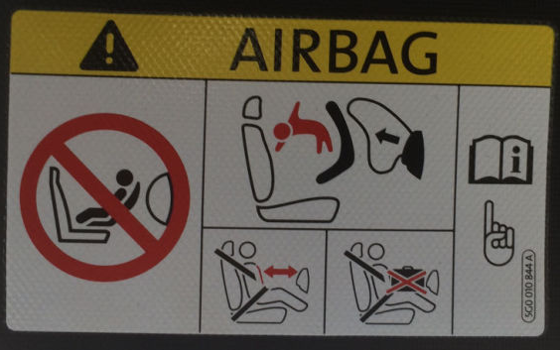

**This intrusive information is not related to child safety and thus reduces the clarity, putting children at risk**

2. The text on the warning to not use a rearward facing child restraint on a seat protected by an active airbag shall be included in the owner’s manual. Moreover, this warning shall be provided in all official languages of the country or countries where the vehicle could reasonably be expected to be registered. However, certain vehicle types are sold in the European Union market with the important warning only in one official language of the country where the vehicle is initially shipped by the manufacturer. Since, child safety should be one of the top priorities for all vehicle manufacturers, the relevant requirements are more explicitly clarified.

3. Moreover, it seems that there are diverging interpretations on the wording: ‘pictogram images shall be grouped, exact or larger’. Notably, pictogram images do not appear exactly as prescribed by the relevant regulations. It seems that altered versions are being authorised despite the clear rules, as shown in the examples below.

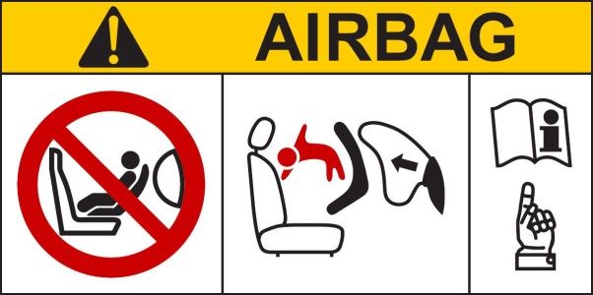

**Label as prescribed in the regulations**

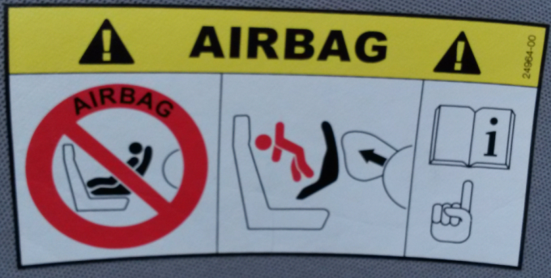 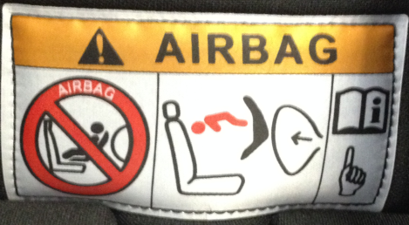

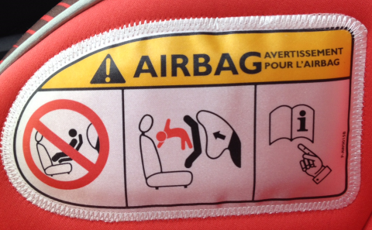 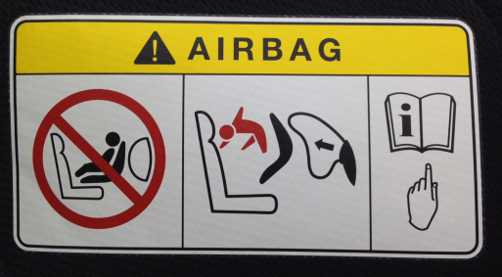

**Labels as found in the field with altered pictogram images**

4. Only in very rare cases the warning label is in conformity

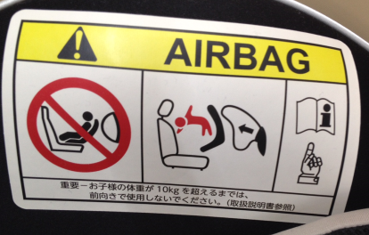

**Label as found in the field with exact pictogram images and additional information outside the prescribed area**

5. To provide the same harmonized basis for all those involved in the development, production and approval process of the warning labels, clarifications on what is and what is not permitted are deemed necessary.

6. For simplification purposes, it was requested to include the relevant provisions only in Regulation No. 16, and to delete them from Regulations Nos. 94 and 137. To avoid an unintended omission of the warning label that protects small children in motor vehicles, a dynamic reference to the new provisions in Regulation No. 16 has been included in both Regulations.

7. Where possible, the provisions are proposed only for the series of amendments in the relevant regulations that have transitional provisions to be applied in the future.

1. \* In accordance with the programme of work of the Inland Transport Committee for 2012–2016 (ECE/TRANS/224, para. 94 and ECE/TRANS/2012/12, programme activity 02.4), the World Forum will develop, harmonize and update Regulations in order to enhance the performance of vehicles. The present document is submitted in conformity with that mandate. [↑](#footnote-ref-2)