Proposal for Supplement 15 to the 01 series of amendments to
Regulation No. 67 (LPG vehicles)

The text reproduced below was prepared by the experts from the Netherlands and the European Liquefied Petroleum Gas Association (AEGPL) to amend the provisions on the type approval of accessories for Liquefied Petroleum Gas (LPG) containers. It is based on ECE/TRANS/WP.29/GRSG/2017/30 as amended and adopted at the 113th session of the Working Party on General Safety Provisions (GRSG). The modifications to the current text of UN Regulation No. 67 are marked in bold characters.

- Proposal

Part I, paragraph 4.2., amend to read:

"4.2. All equipment shall have a space large enough to accommodate the approval mark including the classification of the component (see Annex 2A) and in case of components of Class 0 also the working pressure (WP); this space shall be shown on the drawings referred to in paragraph 3.2.2. above. In the case of limited space for the approval mark(s), other means of identification that link it to the approval mark shall be provided.

Annex 2A, amend to read:

"Annex 2A

Arrangement of the LPG equipment type approval mark

(See paragraph 5.4. of this Regulation)

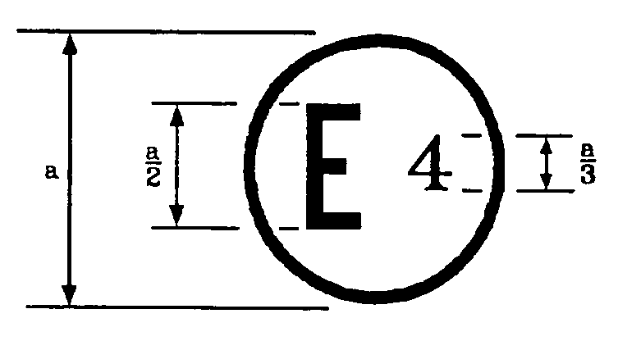 67 R—012439 CLASS #1 * A2
a  5 mm
1 Class 0, 1, 2, 2A or 3.
2 Indication mark of technical modification to be marked only on multivalve or, when approved separately, on pressure relief valve (discharge valve) and pressure relief device.

The above approval mark affixed to the LPG equipment shows that this equipment has been approved in the Netherlands (E4), pursuant to Regulation No. 67 under approval number 012439. The first two digits of the approval number indicate that the approval was granted in accordance with the requirements of Regulation No. 67 as amended by the 01 series of amendments. The indication mark of technical modification (A in the example), preceded by the star symbol, is required only for the approval mark of the accessories of the container (multivalve or, when approved separately, pressure relief valve (discharge valve) and pressure relief device,)."

Annex 2B, Appendix, Table 1, amend to read (inserting a new column for the indication mark of technical modification):

"Table 1
No. | Item | Type | Approval No. | Extension No. | Indication mark(s)1
a | 80 per cent stop valve
b | Level indicator
c | Pressure relief valve
d | Remotely controlled service valve with excess valve
e | Fuel pump
f | Multi-valve
g | Gas-tight housing
h | Power supply bushing
i | Non return valve | e
j | Pressure relief device
1 The indication marks of technical modification apply only to Multivalve, or, when approved separately, to Pressure relief valve (discharge valve) and Pressure relief device."

Annex 10, paragraph 2.6.1. (Bonfire test), amend footnote 1 to read: "2.6.1. General
The bonfire test is designed to demonstrate that a container complete with the fire protection system, specified in the design, will prevent the burst of the container when tested under the specified fire conditions. The manufacturer shall describe the behaviour of the complete fire protection system including the designed drop to atmospheric pressure. The requirements of this test shall be deemed to be fulfilled for any container having the following characteristics in common with the parent container:

(a) Same type approval owner,

(b) Same shape (cylindrical, special shape), (c) Same material,
(d) Same or greater wall thickness,

(e) Same or smaller diameter (cylindrical container),

(f) Same height or smaller height (special container shape), (g) Same or smaller external surface,
(h) Same configuration of accessories fitted to the container.1

1 Additional accessories, modifications and extensions of the accessories fitted to the container is possible without retesting, if notified to the Type Approval Authority which approved the container, considered to be unlikely to have an appreciable adverse effect. The Type Approval Authority may require a further test report from the Technical Service responsible. The container and its configurations of accessories will be indicated in the appendix to Annex 2B. Multivalve or, when approved separately, pressure relief valve (discharge valve) and pressure relief device, extended for technical modifications and marked in accordance to Annex 2A need to have a new bonfire test. The container and its configurations of accessories will be indicated in the appendix to Annex 2B."

II. Justification

1. ECE/TRANS/WP.29/GRSG/2017/10 raises concerns on LPG containers and its accessories as approved according to UN Regulation No. 67. The Regulation requires a specific test (bonfire) of the container equipped with a specific configuration of accessories (combined in a multi-valve or separated devices).

2. For each container, a list of the possible configurations of accessories fitted to the container is approved and communicated by means of Table 3 in the appendix of Annex 2B to the Regulation. This list comprises also the extension number of each accessory.

3. As correctly highlighted in the justification of ECE/TRANS/WP.29/GRSG/2017/10 (see point 8): "the manufacturer (of the accessory) is obliged to mark the product with the type approval number, but is not obligate to mark it with the number of justification (Regulation No. 67, para. 4.1.). This means that holding in the hand a component approved according to Regulation No. 67 you cannot be sure of the actual extension of approval". Therefore, it is unclear whether this accessory is approved to be fitted to a specific container.

5. To solve this issue, as correctly raised by the experts from Poland, AEGPL proposes to mark the extension number on the accessories relevant to the bonfire test (multivalve or, when approved separately, pressure relief valve (discharge valve) and pressure relief device,), so that the fitting of any accessory not listed in the aforesaid list of approved configurations will be prevented/forbidden.

6. As an alternative to the proposal contained in ECE/TRANS/WP.29/GRSG/2017/10, the present solution would imply a new requirement in Annex 2A for the marking of the accessories fitted to the containers, but it would avoid an overload of paperwork and a proliferation of accessories' type approval numbers. The safety of the system is not affected.

7. For components having not sufficient space to accommodate the marking in line with the general specifications from paragraph 4.2 the wording used in UN Regulation No. 46 for small components is integrated for all components as requested by contracting parties of the GRSG during its 113 meeting.

